ShowAnafiLog  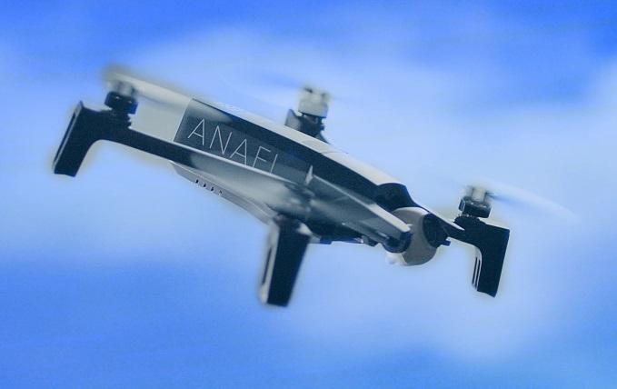  Many thanks to all contributors and testers. It was and is still fun to work with you together. Happy flying!  Initiated and supported by Parrot Pilots Drone Forum  h-elsner 02/2019 |  | Summary  "ShowAnafiLog" is an application to show JSON log files from Parrot's "Anafi" quad-copter in a readable format, display charts from selected data columns and convert JSON logs into KML flight tracks, GPX files or CSV files for other usage.  Installation  No installation needed, this is a portable application. But you need write access to the directory where the application located. "ShowAnafiLog" will store its settings in an XML file there.  Usage  Retrieve flight logs (*.json) from your controller device and save it in a directory on your PC.  Open this directory or simply drop it to the application. A list of JSON log files will be created (see Overview) and the first file will be loaded. You can select any file in the list to load and display it in the other pages (Log data, Charts, Details).  Enjoy.

Overview
Convert the file in use
to the output format
defined in Settings.
Select the directory where all the
JSON log files are located.
Double-click opens the file manager
with this directory. The converted
files will be saved there.
Take screenshot
for documentation.

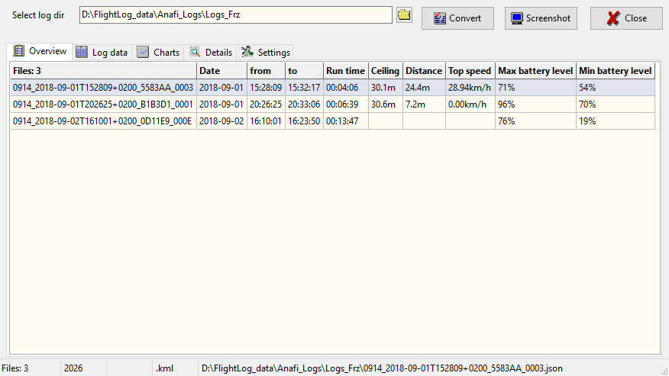
List of JSON files. Click on a row to
select the file in use. File will be loaded and
displayed. Table will be updated in the
background.
Status or error messages,
i.e. file name of file in use.
Number of JSON log files
Position of selection = position of cursor
Output format for conversion
Number of data sets
file in use contains

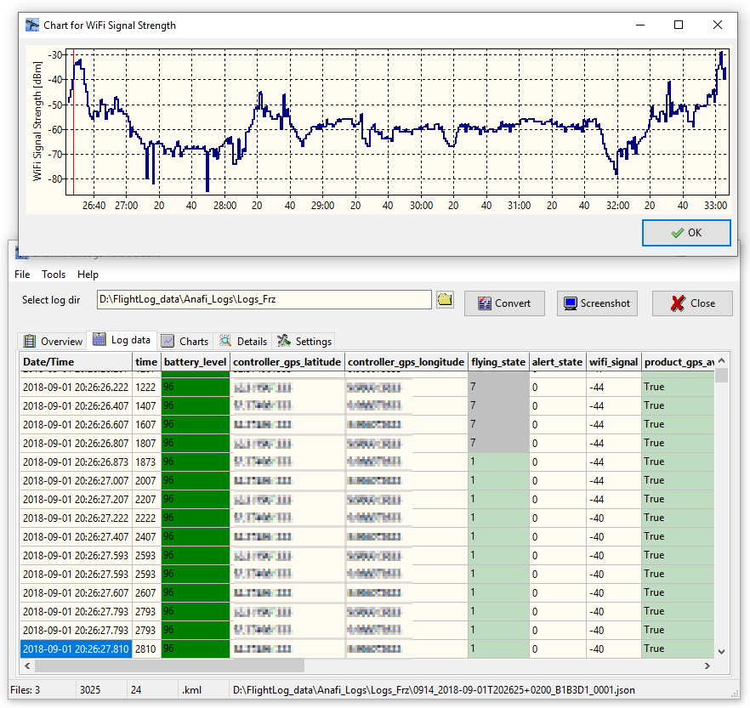
Log data

Cursor shows which row in
the data table is selected. You
can move forward by mouse
wheel.

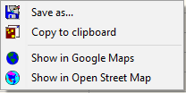
Second chart or value counter table
called by click on the related
column header.
Hold the mouse pointer over
a cell to get more information
(a cell related hint).

Right mouse button opens
a context menu to open
coordinates in Google Maps or
Open Street Map.
Selected cell means also
selected data set.
Line number of selected data set =
position of the red cursor
in the second chart above.

Charts
Zoom chart by mouse wheel,
pan with left mouse button hold,
horizontal cursor by Ctrl-key.
Reset zoom and/or pan by middle
mouse button.

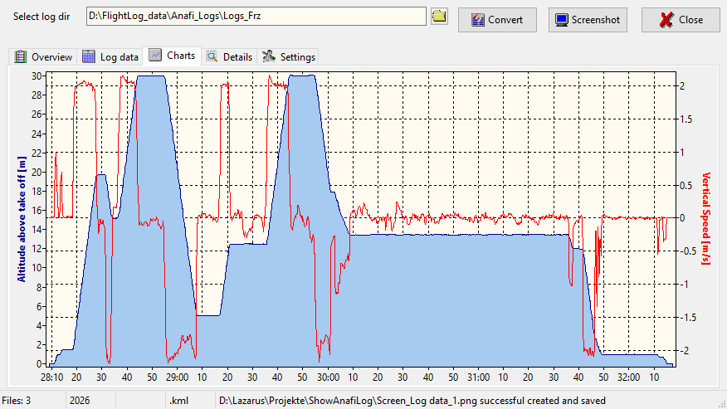
Filled chart shows the altitude
relative to take off location.
Red line is a second chart
depending on selected data
column in settings.
Status message about a former saved file.

Details
In older firmware versions the column
"speed" was not filled. The main menu
offer a possibility to recompute speed
(True air speed) by vx, vy and vz.

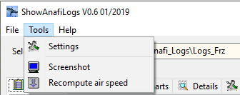

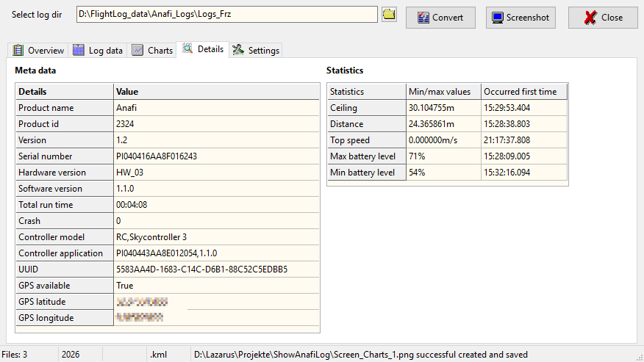
Some min/max values found during file load
with time stamp when it first occurred.
Ctrl+C copies the whole table to clipboard.
Meta data taken from the file in use.
Ctrl+C copies the whole table to
clipboard.
I think this is the home point.
Double-click on the table opens this
point in Google Maps.

Settings
Measurement units for data presentation.
Currently I think the input from JSON log
files is always metric, no matter what you
have set on your device. But this is only an
assumption.

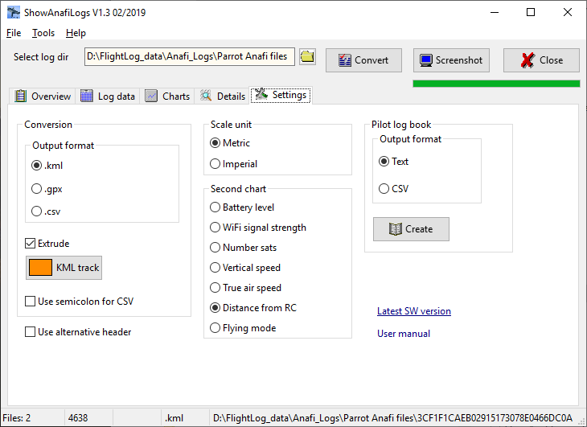
Settings for
KML tracks.
Use semicolon instead
of comma as data
seperator in CSV files.
Use more descriptive
column header instead
of header from JSON
log files.
Select data column for the red line chart in Charts.
Create a Pilot log book from all JSON files in
selected directory.
Select output format of the Pilot log book
Main menu

Internals

Output format CSV Pilot log book:

Disclaimer

This software is freeware. You can use this software royalty-free for private and commercial purposes.

But use this application on your own risk.
There is no guaranty for correctness and/or completeness of the results of the evaluation of flight log data or interpretation of the values in the flight logs.

Contact: helmut.elsner@live.com

