ShowAnafiLog  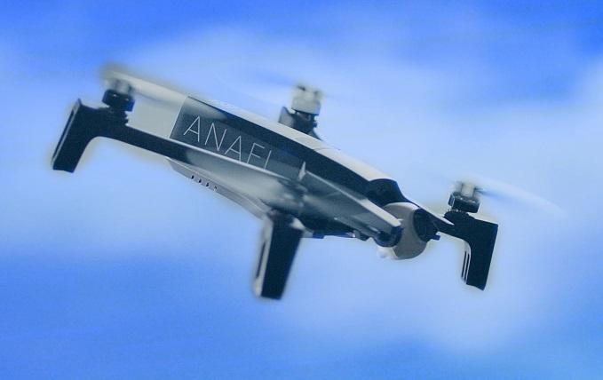  Dank an alle Tester. Guten Flug!  Programm auf Wunsch aus dem Parrot Pilots Drone Forum  h-elsner 10/2024 |  | Übersicht  "ShowAnafiLog" ist ein Programm zum Anzeigen der JSON Logdateien und Black-Box-Daten von Parrot's "Anafi" in besser lesbarem Format, das zeigen von Diagrammen ausgewählter Datenspalten und Konvertierung in KML oder GPS Flugpfaden. Außerdem ist ein Export der Daten als CSV-Datei möglich.  Installation  Keine Installation. Dies ist eine portable Anwendung, man braucht nur Schreibzugriff auf das Verzeichnis, wo sich das Programm befindet, da es dort in einer XML-Datei die Einstellungen speichert.  Benutzung  Kopiere die flight logs (*.json) oder BlackBox Logs vom Mobiltelefon in einen Ordner auf dem PC. BlackBox Logs müssen erst ausgepackt und in *.JSON umbenannt werden.  Öffne dieses Verzeichnis zum Beispiel per Drag&Drop auf das Programm. Eine Liste der JSON Logdateien wird in der Übersicht angelegt. Und die letzte Datei in der Liste wird zur Anzeige ausgewählt.  Man kann dann jede Datei auswählen und die detaillierten Daten in den verschiedenen Reitern anzeigen.

Übersicht
Convert the file in use
to the output format
defined in Settings.
Select the directory where all the
JSON log files are located.
Double-click opens the file manager
with this directory. The converted
files will be saved there.
Take screenshot
for documentation.

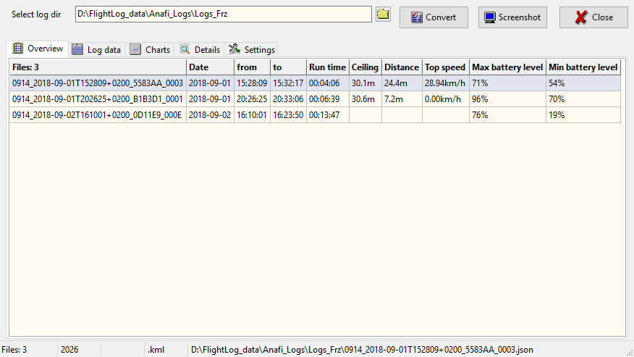
List of JSON files. Click on a row to
select the file in use. File will be loaded and
displayed. Table will be updated in the
background.
Status or error messages,
i.e. file name of file in use.
Number of JSON log files
Position of selection = position of cursor
Output format for conversion
Number of data sets
file in use contains

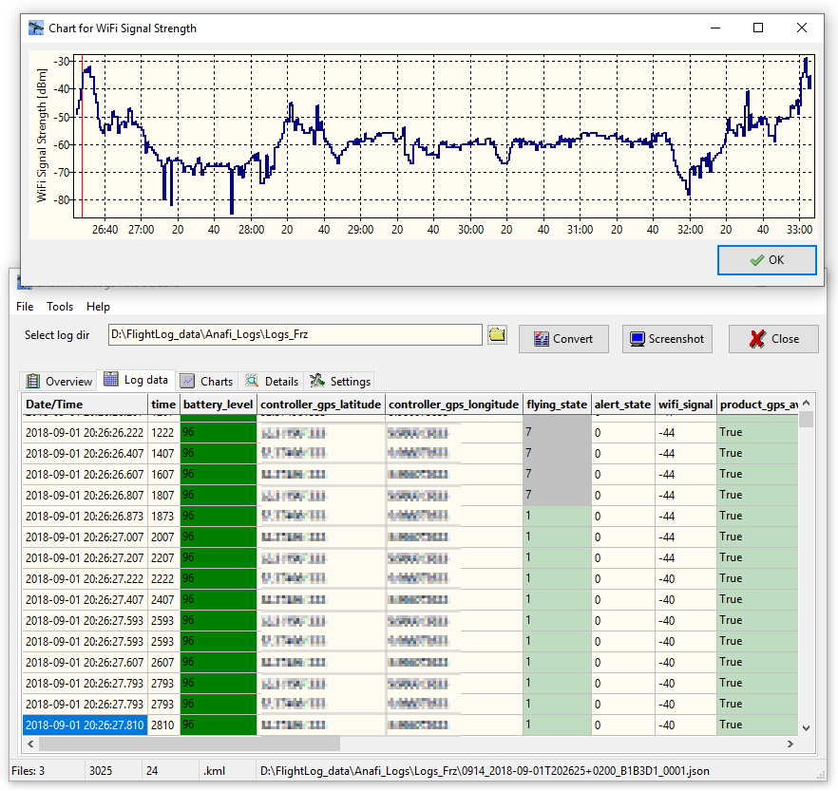
Log data

Cursor shows which row in
the data table is selected. You
can move forward by mouse
wheel.

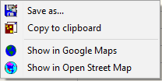
Second chart or value counter table
called by click on the related
column header.
Hold the mouse pointer over
a cell to get more information
(a cell related hint).

Right mouse button opens
a context menu to open
coordinates in Google Maps or
Open Street Map.
Selected cell means also
selected data set.
Line number of selected data set =
position of the red cursor
in the second chart above.

Charts attitude
Slider to shift or hide the list of charts.
Zoom chart by mouse wheel,
pan with left mouse button hold.
Reset zoom and/or pan by middle
mouse button.

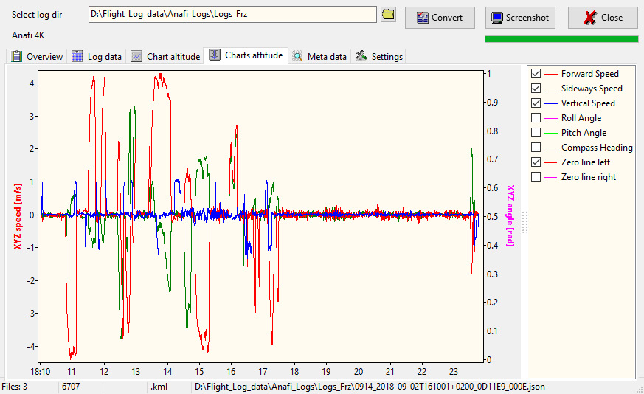
List of Charts. Double click to toggle Attitude charts:
All → only speed → only angle → only nick/roll → all

Charts attitude
Zoom chart by mouse wheel,
pan with left mouse button hold.
Reset zoom and/or pan by middle
mouse button.

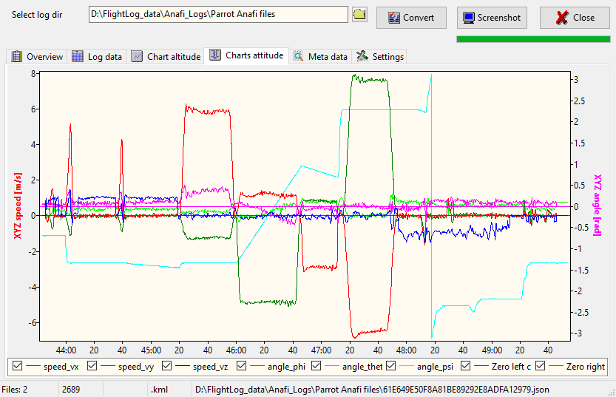
Double click to toggle Attitude charts:
All → only speed → only angle → only nick/roll → all

Meta data from JSON log file
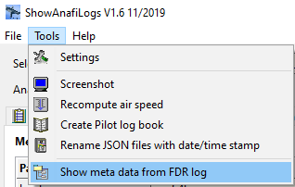

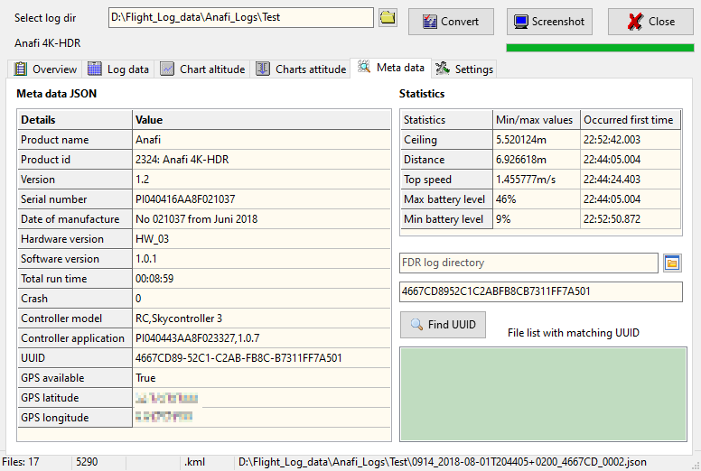
Some min/max values found during file load
with time stamp when it first occurred.
Ctrl+C copies the whole table to clipboard.
Meta data taken from the file in use.
Ctrl+C copies the whole table to
clipboard.
I think this is the home point.
Double-click on the table opens this
point in Google Maps.

Metadata from FDR log files

Log files in the FDR folder contains more detailed data compared to JSON log files but it is an undocumented binary format. Thus, the files keep their secrets. But some of the meta data at the beginning of the files are readable such as battery serial number or firmware versions.
FDR directory for recursive search
for matching FDR log files.
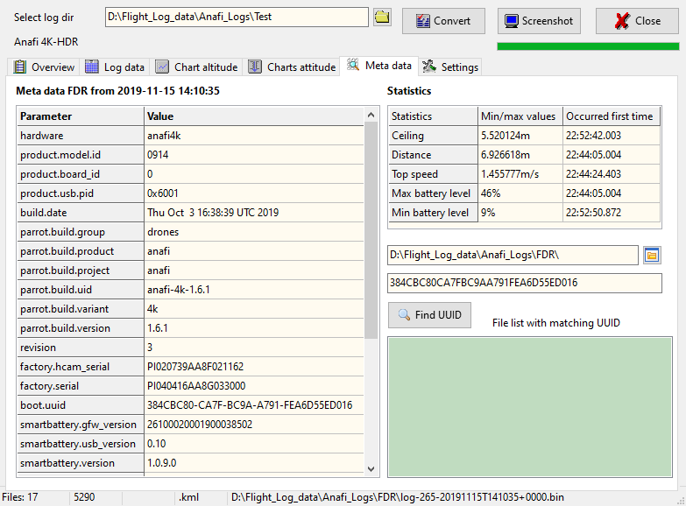

The UUID we are looking for.

Main menu > Tools:
Open FDR log file (*.bin) to read
the meta data. Result will be shown
in the Details table.
Find FDR log files matchin
the UUID from JSON log files.

Meta data taken from the open FDR log file.
Ctrl+C copies the whole table to clipboard.
Result list. Click on a file name to get
matching meta data from FDR log files.

Settings
Measurement units for data presentation.
Currently I think the input from JSON log
files is always metric, no matter what you
have set on your device. But this is only an
assumption.

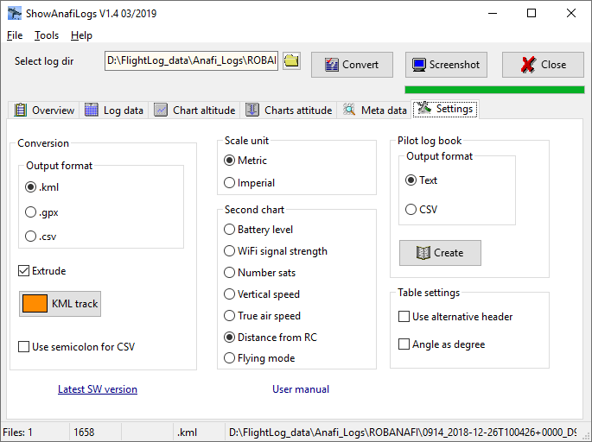
Main menu

Settings for
KML tracks.
Use semicolon instead
of comma as data
seperator in CSV files.
Use more descriptive
column header instead
of header from JSON
log files.
Select data column for the
red line chart in Charts.
Create a Pilot log book from all
JSON files in selected directory.
Select output format
of the Pilot log book

Internes

Siehe auch: https://developer.parrot.com/docs/olympe/arsdkng_ardrone3_piloting.html

Output format CSV Pilot log book:

Disclaimer
This software is freeware. You can use this software royalty-free for private and commercial purposes.

Use this application on your own risk.
There is no guaranty for correctness and/or completeness of the results of the evaluation of flight log data or interpretation of the values in the flight logs.

Kontakt: helmut.elsner@live.com

