(received 4/28/2000)
April 26, 2000
Collisional correlation time measurement by use of repeated and compensating pulsed magnetic field gradients.
Dear Barry,
We describe a method for estimating parameters 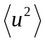 and 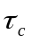 of the velocity autocorrelation function 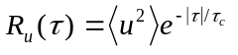, which describes the velocity of a Brownian particle. The diffusion coefficient for such a process is given by 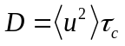. Two pulse sequences are used: a) a repeated version of the standard bipolar pulsed gradient spin-echo sequence (PGSE) with two cycles (RSPG), and b) a flow compensated pulsed gradient spin-echo sequence with two cycles (CPG) (Fig. 1). The flow compensated pulsed gradient sequence has its first moment zero, 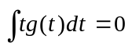, where 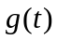 is the effective gradient, and is akin to the even spin echo. It has the property that the magnetization of a spin moving with constant velocity accumulates no net phase during the sequence. Even for stochastic motion with correlations, such as turbulent flow, even echoes refocus spins partially and reduce signal loss. We use this sensitivity towards correlated motion to improve correlation time measurements.
For a train of ( = 2 in Fig. 1) bipolar gradient pulse pairs whose polarity is chosen to probe spin dynamics we define the apparent diffusion coefficient 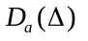 measured by
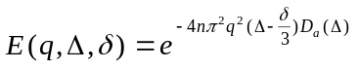. [1]

The factor in the exponent (Eq. [1]) ensures that we have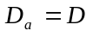 for any number of bipolar pulses for uncorrelated Brownian motion (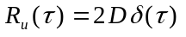).
The functional form of the two apparent diffusion coefficients can be calculated in terms of velocity autocorrelation parameters.

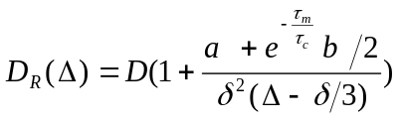 , RSPG sequence [2]
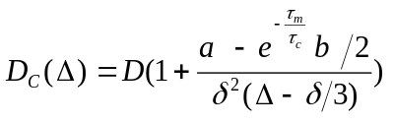 , CPG sequence [3]
where
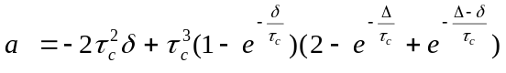, 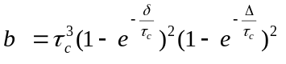 and , 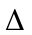, and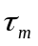 are defined in Fig. 1.
In Fig. 2 we compare the two apparent diffusion coefficients for a small and 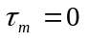. Both the apparent diffusion coefficients tend to the asymptotic diffusion coefficient 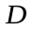 for 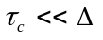. In other words if the spin motion is uncorrelated in the time scale of our pulsed gradient sequence, then both the apparent diffusion coefficients measure the same quantity . For highly correlated motion within the time (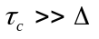) Eq. [3] implies that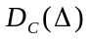 approaches zero for any as 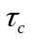 tends to infinity. In other words, there is no attenuation in image intensity because of motion. This is the distinguishing feature of the compensated CPG sequence. It compensates for correlations in motion and increases sensitivity for correlation time measurements. In addition, for , we have 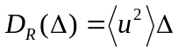, the ballistic (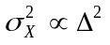) short time motion.
We have also plotted the normalized difference 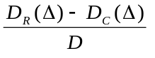 of the apparent diffusion coefficients for the repeated and the compensated pulse sequences for 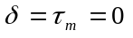 in Fig. 2. It is a measure of the spin phase refocusing by the CPG sequence and depends on the relative values of 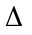 and . The difference is a linear function of for , because 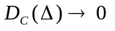 and 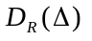 is linear. It has the interesting property of having a maximum at 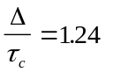. It approaches zero for 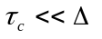 because the particle motion appears random. Thus we immediately know the range of in our experiment from the difference of 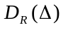 and 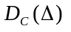 as a function of .
Some of the results of correlation time measurement for granular materials (2 mm hard plastic spherical beads) rotated in a half-filled horizontal cylinder are contained in a paper published in Phys. Rev.Lett. Vol, 84, 266-269 and other details will be published in J. Mag. Res. later this year.
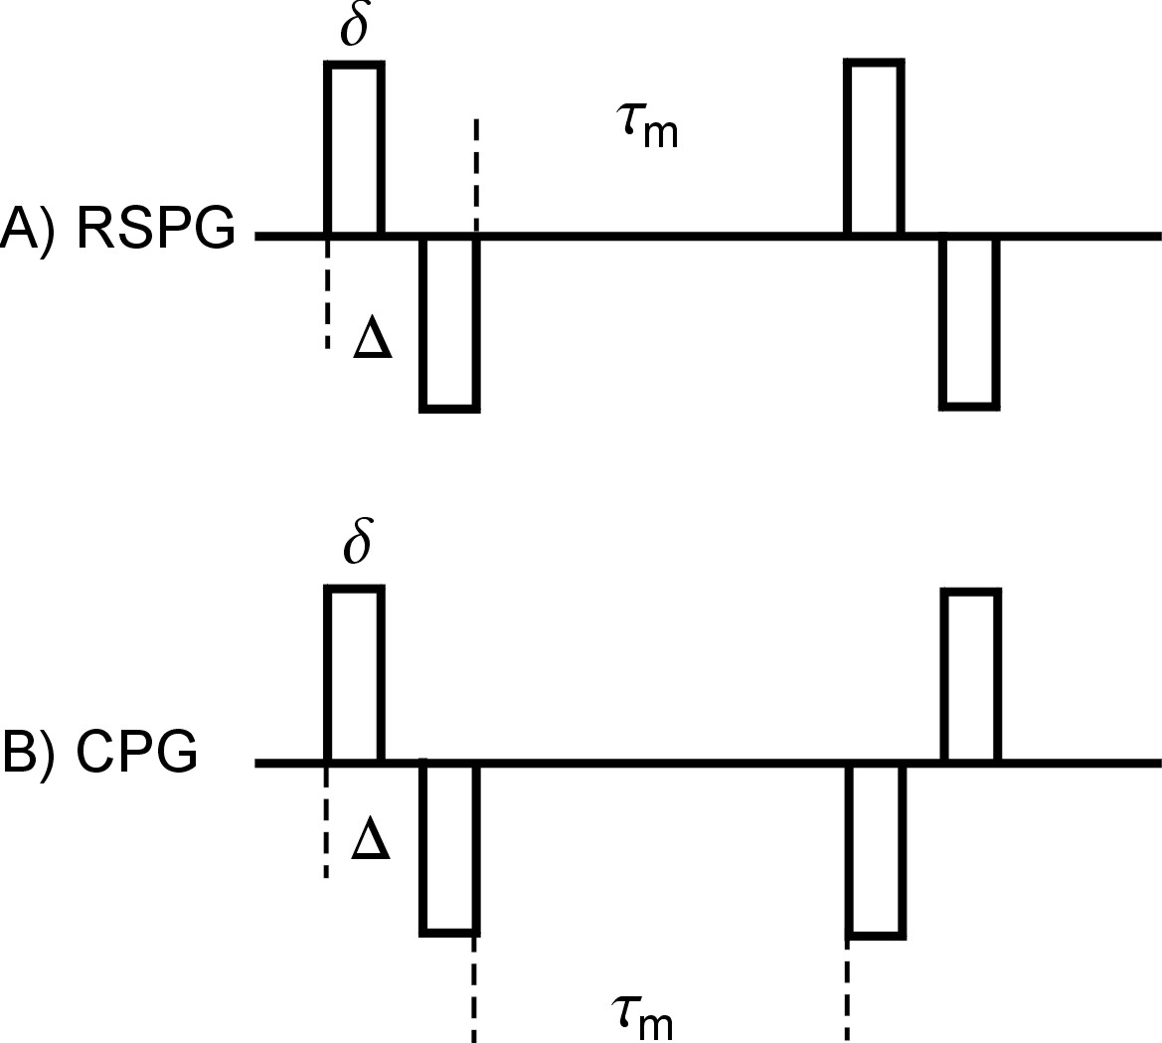
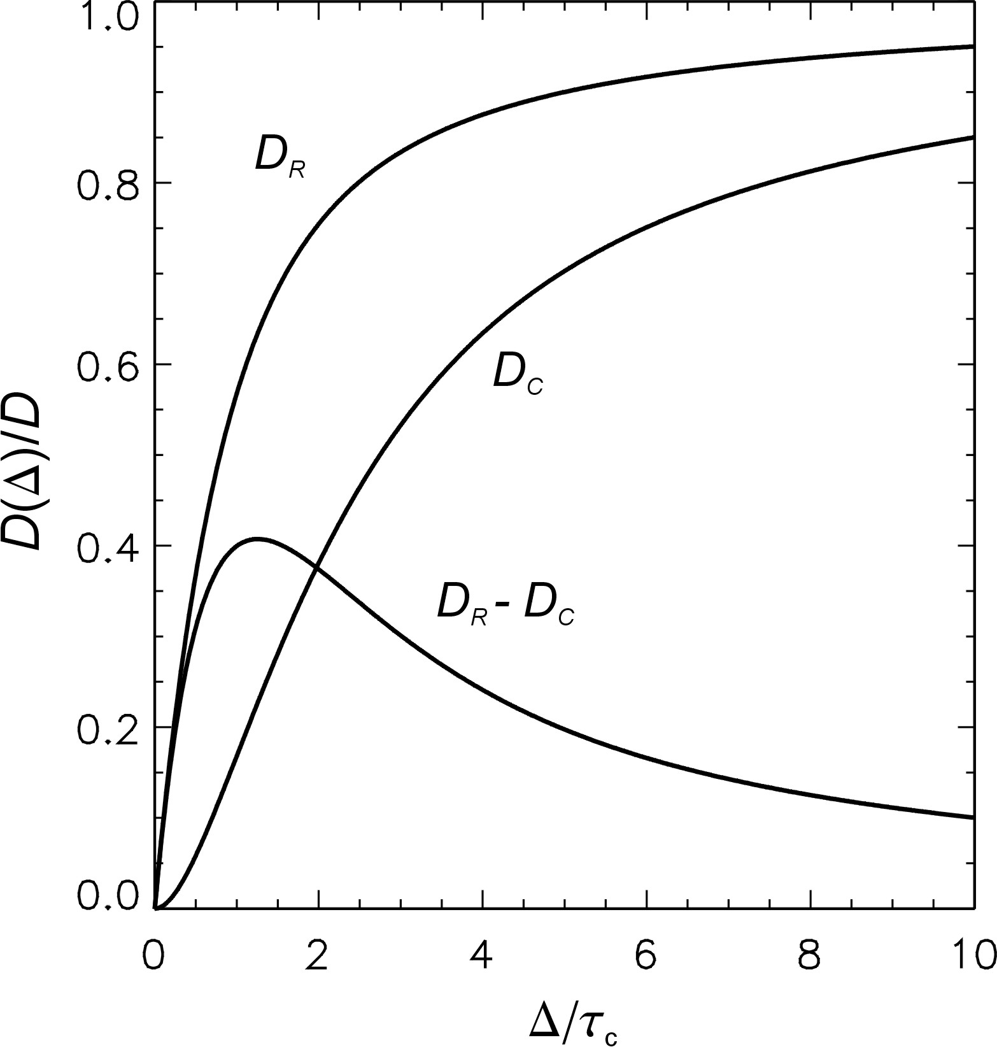
Fig. 1 Fig. 2
Sincerely,

S.A. Altobelli, A. Caprihan, J.D. Seymour, and E. Fukushima

