Agenda 2063 Progress Analysis

Hussam Hanafi

11/3/2019

# Introduction

[Agenda 2063](https://au.int/en/agenda2063/overview) is the African Unions’ Strategic framework for delivering inclusive and and sustainable development signed on May 2013.

As part of this agenda the AU has set over-arching goals and more granular targets to be achieved in the 50 years from 2013 to 2063.

The purpose of this report is to evaluate progress on two of those targets in the medium term [First Ten Year Implementation Plan](https://au.int/sites/default/files/documents/33126-doc-ten_year_implementation_book.pdf) by analysing Indicator data from the [World Bank Open Data](https://data.worldbank.org/) Initiative.

## First Ten Year Implementation Plan Targets

The Two Targets were selected partially arbitrarily in the hope that they would be indicative of each other; however, the selection was also driven by the completeness of the data sets as there is often large gaps in data sets dealing with progress indicators due to a number of factors mostly affecting the data collection stage.

For this Report the two targets/indicators chosen were as follows:

* As part of the first Goal: A High Standard of Libing, Quality of Life and Well Being for All; the FTYIP sets a target of reducing Unemployment by at leasst 25%
* As Part of the fourth Goal: Transfromed Economies and Job Creation; the FTYIP sets a target of 7% Annual growth

This Report will use those two indicators to attempt to analyse progress and attempt to predict the value of these indicators by 2023.

# Data Analysis

We will analyse each of these indicators Seperately using the following steps:

1. Accessing the data from the World Bank Open Data web-site
2. Filtering out AU Memeber States
3. Wrangling the data into tidy format
4. Initial Visualization
5. Wrangling the data to minimize the effect of missing data points
6. Visualizing the Data for Analysis Purposes
7. Subsetting a Test Set to be used with our models

## Unemployment Rate

We Will start the Unemployment Rate Loading the Data from the World Bank Website with the code below:

### Loading Unemployment Rate  
## Creating Raw Data Folder  
Raw_Data_Folder <- file.path(getwd(),"Raw_Data")  
dir.create(Raw_Data_Folder)  
  
##Downloading and Unpacking the File  
download.file("http://api.worldbank.org/v2/en/indicator/SL.UEM.TOTL.ZS?downloadformat=csv", file.path(Raw_Data_Folder,"API_SL.UEM.TOTL.ZS_DS2_en_csv_v2_422140.zip"), mode = "wb")  
Unemployment_zip <- "API_SL.UEM.TOTL.ZS_DS2_en_csv_v2_422140.zip"  
Unemployment_csv <- "API_SL.UEM.TOTL.ZS_DS2_en_csv_v2_422140.csv"  
unzip(file.path(Raw_Data_Folder,Unemployment_zip), exdir = file.path(Raw_Data_Folder,"Unemployment"))  
  
##Reading the File into R  
Unemployment <- read_csv(file.path(Raw_Data_Folder,"Unemployment",Unemployment_csv), skip = 3)

Wrangling our Data into tidy format with the follwing code:

## Tidying the Data  
colnames(Unemployment) <- str_replace(colnames(Unemployment), " ", "_")   
Unemployment <- Unemployment %>%  
 filter(Country_Name %in% AU) %>%   
 gather(key = "Year", value = "Unemployment", `1960`:`2019`, convert = TRUE) %>%   
 select(-c(X65,Indicator_Code)) %>%   
 filter(Country_Name %in% AU) %>%   
 select(-Country_Code, -Indicator_Name)

Our Initial Visualization of the data shows some clear places where we have missing data which we’ll work to remove:

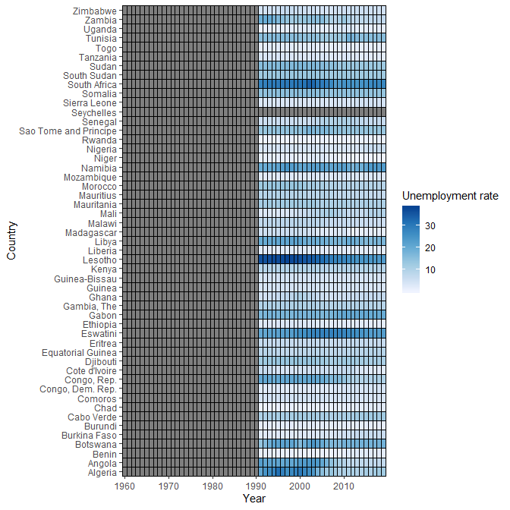

### Visualizations and analysis