Beacon Market Analysis 2019Q4

Hussam Hanafi

17 December, 2019

# Introduction

The following report is a snapshot of the market conditions during the last quarter of 2019. It focuses on the quantity, categories and market prices of courses available during this period.

It’s Important however to note the limitations of the report before we dive in:

* It is impossible to see market trends without additional time series data; any discussion of trends throughout the report are based on larger trends within and without the country.
* While it was easy to find the number of courses each centre this is not a reflection of either the quality of the courses or the number of trainees signing up for each course.
* There is a significant chunk of missing data when it comes to market prices and we should be wary of making generalisations in certain categories as can be seen below:

|  |  |
| --- | --- |
| Certification | % of missing Data |
| External Exam | 22 |
| No | 35 |
| Yes | 58 |

|  |  |
| --- | --- |
| Categories | % of missing Data |
| Sales/Marketing | 75 |
| Health and Safety | 70 |
| Logisitcs/Procurement/Supply Chain | 67 |
| Soft Skills | 67 |
| Project Management | 57 |
| HR | 50 |
| Risk Management | 50 |
| IT/Networking | 33 |
| Architechture/Design | 30 |
| Engineering | 21 |

# Analysis

## By Categories

First we start by looking at the Categories of Courses divided by the Centres:

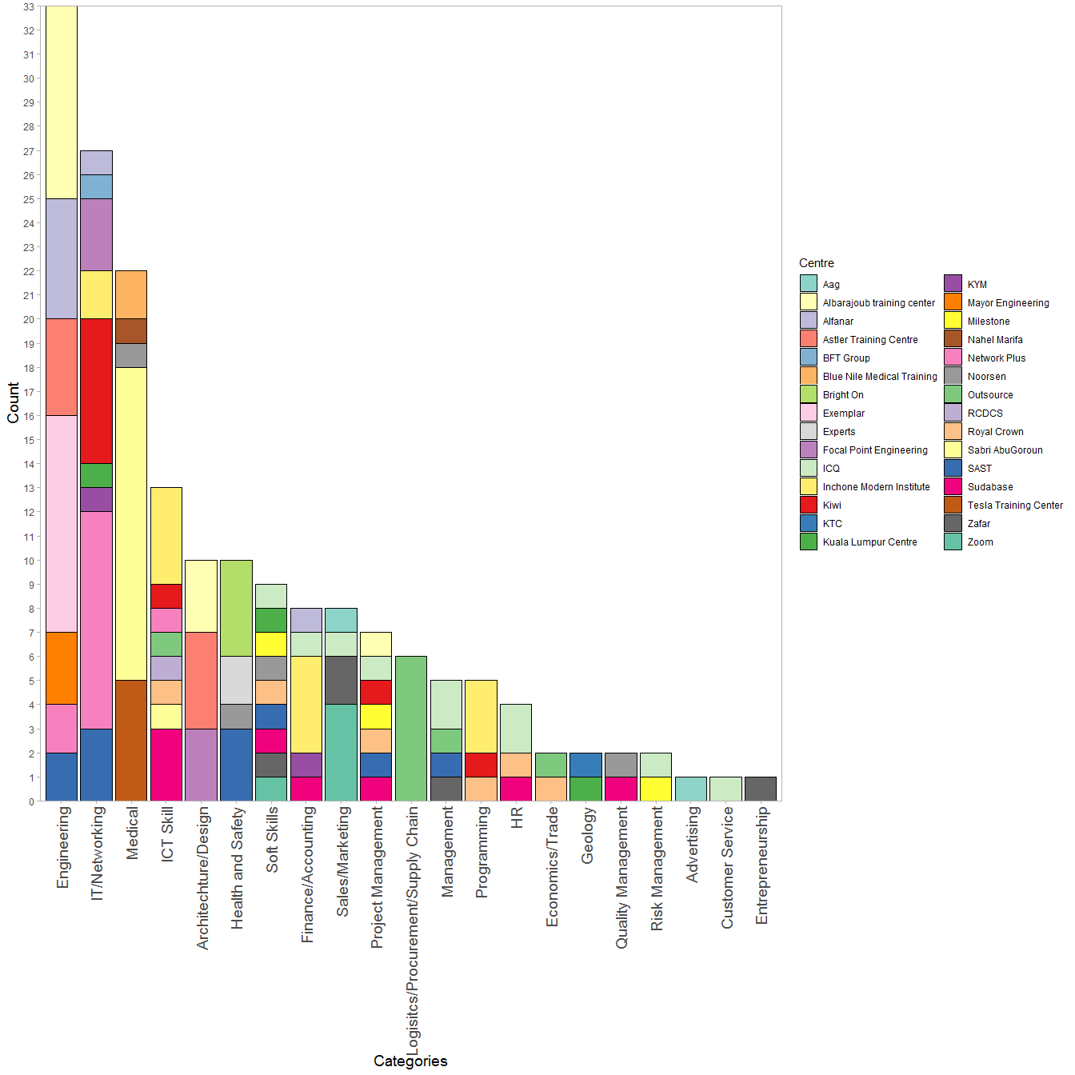

At the high end of the Count, we see a lot of technical Categories with crowded competition. Soft Skills and Project managment also show crowded competition spaces despite being middle of the pack, indicating we might need to put more effort to capture a piece of those markets.

The lower end of the count shows some suprising information. While it is expected that highly specialised spaces such as Geology or Economics would have fewer courses we see a lack of courses specialising in the below categories:

* Entrepreneurship
* Customer Service
* Advertising/Social Media; this is in spite of a sizeable number of Sales/Marketing Courses
* Risk and Quality Management

And to a lesser extent:

* HR
* Programming
* Management
* Sales/Marketing

Implying that the above are ripe for a strong push in 2020

Of relevance to us is that there is only one Centre present in the Logistics/Supply Chain sector where we have an opportunity to leverage our history to both take a piece of the existing market as well grow it.

Finally I want to bring attention to Health and Safety, there are only 4 players in the field with only half of the courses OSHA or NEBOSH Certified:

|  |  |
| --- | --- |
| Centre | # of Health and Safety Courses |
| Bright On | 4 |
| SAST | 3 |
| Experts | 2 |
| Noorsen | 1 |

|  |  |
| --- | --- |
| Certified | # of Health and Safety Courses |
| No | 5 |
| Yes | 5 |

Considering recent events it’s safe to assume that companies will be putting a bigger focus on health and safety and thus we can take advantage of the market expansion that will accompany that renewed focus.

On a related note Medical Courses tend to be geared towards Med students and Residents, a Keyword search only one first aid course creating a possible opportunity to package such courses with Health and Safety.

## Competition Pricing

First We look at the Market averages before diving into breakdowns so we can have a baseline:

|  |  |
| --- | --- |
| Market Average | Market Median |
| 2946 | 1500 |

The Market Average skews higher than the Median, indicating a gap between more expensive courses and the ‘average’ course. This is visible when we look at the distribution of course fees:

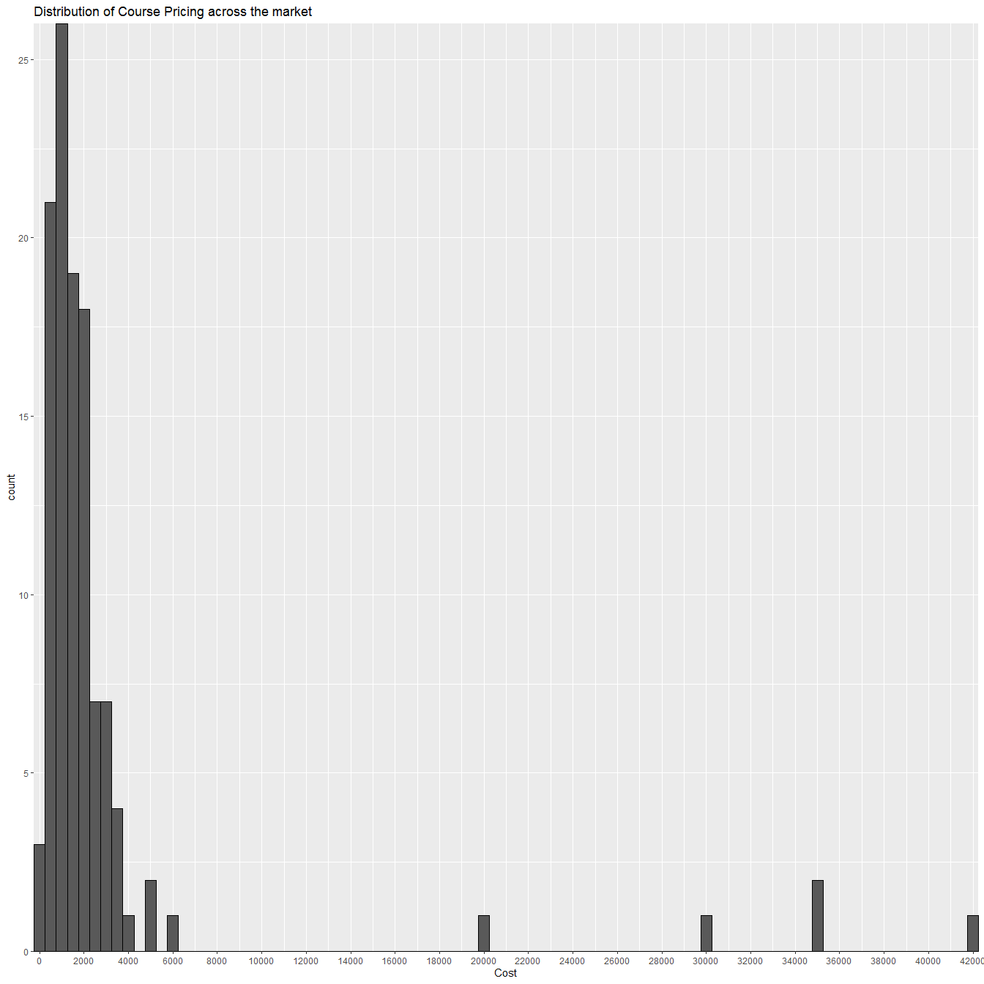

From here we see that while the majority of courses hover around 1,500 SDG per head we see the expected gap between price ranges hovering around the median and the higher end of the Spectrum.

A quick overview of the distrubition across categories does little to explain this gap. Some of the individual categories such as the ICT skills, and Medicine showing similar distributions to the market wide plot, others do no have enough data to draw any conclusions:

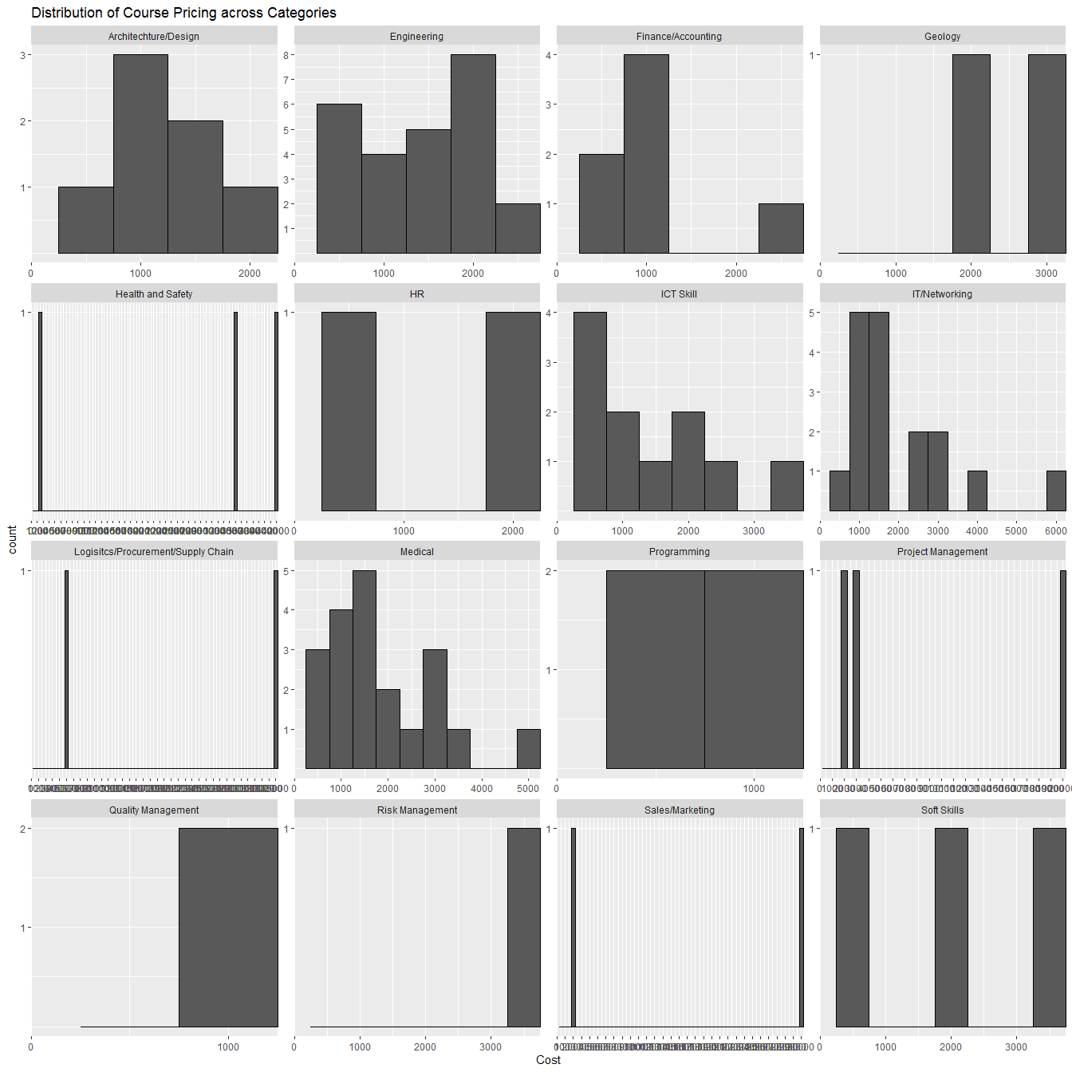

Breaking it down by certification status gives us a more enlightening picture:

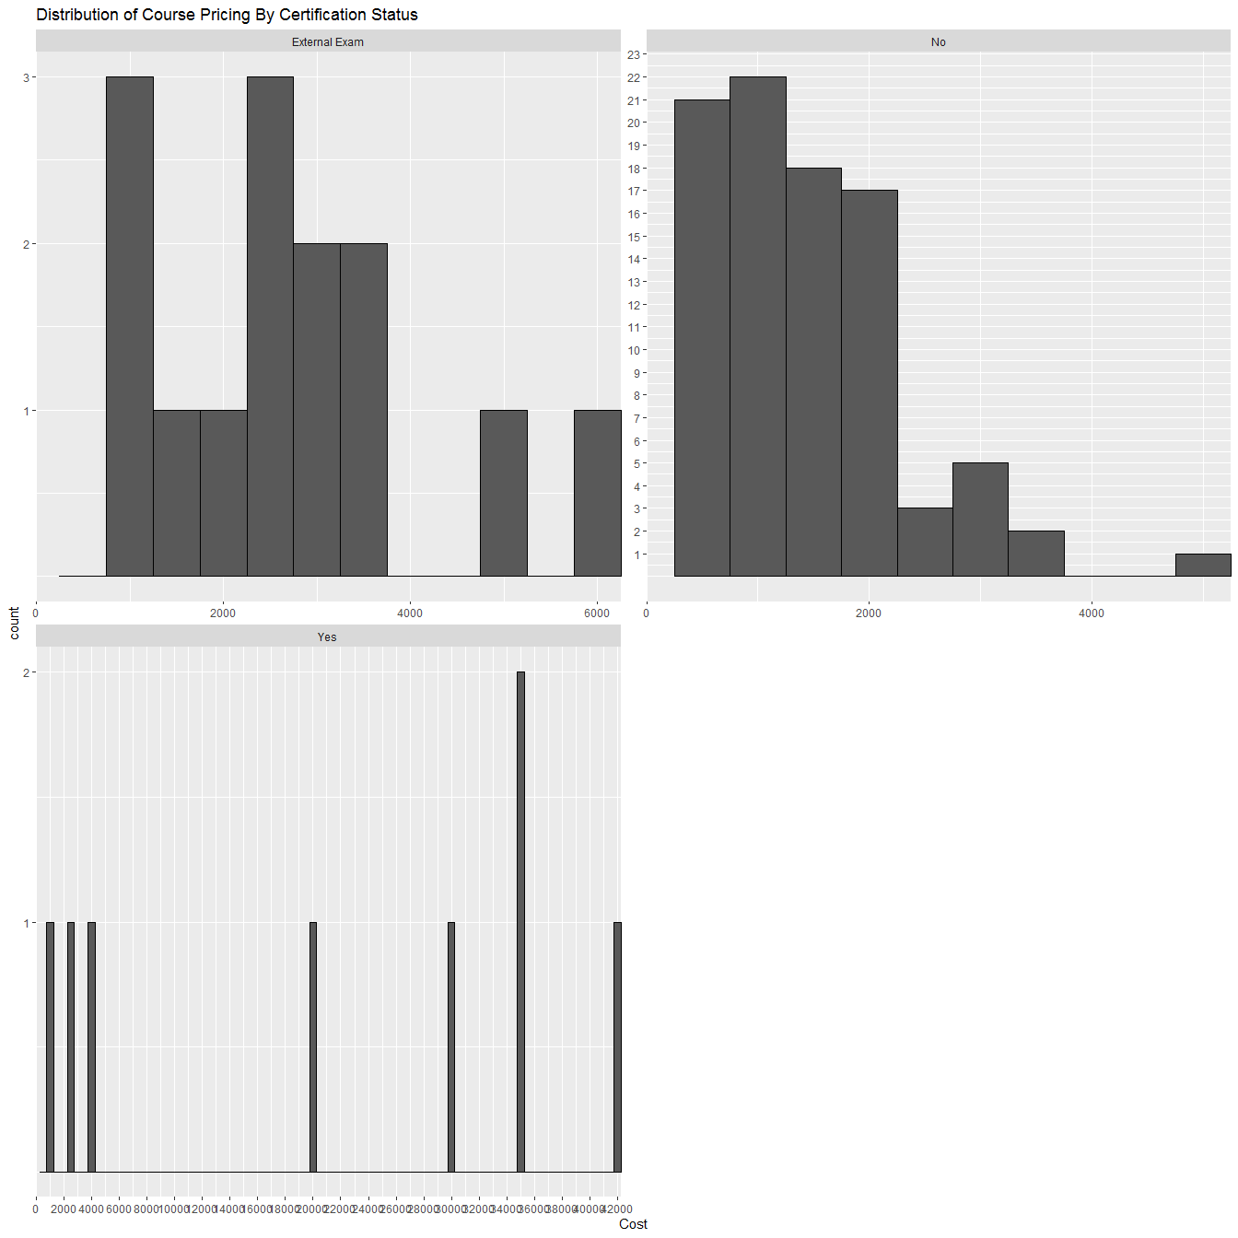

Uncertified Courses are both numerous and display a distribution skewed towards lower cost as expected. Prep Courses for external exams tend to hover around 2,500 SDG; however, the source of our gap is Courses that include the certification process. Calls to Centre’s regarding these programs confirm that the cost is inclusive of materials and the Exam Fees.

We can confirm our conclusions by running a simple algorithim that segments the data based on the variable that most affect the cost, then makes a prediction of the cost based on this. We won’t go into technical details of the below plot but provide conclusions underneath.

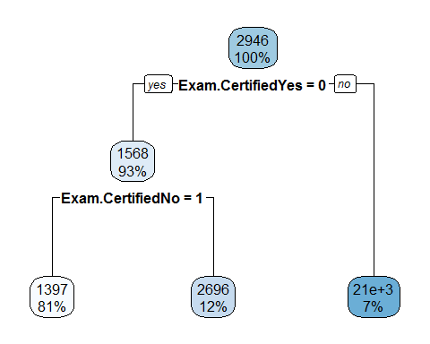

Our earlier assumptions regarding segmentation are confirmed here, looking at the 3 most important Variables and their importance as a percentage:

|  |  |
| --- | --- |
| Variable | Overall |
| Exam.Certified.Yes | 100 |
| Exam.Certified.no | 69 |
| Location | 24 |

And the results are as follows:

* Courses that include Certificates:
  + 7% of the Courses
  + Predicted to cost 21,000 SDG
* Courses with External Exams
  + 12% of the Courses
  + Prediction to cost 2,700 SDG
* Remainder of the courses
  + 81% of the Courses
  + Prediction to cost 1,400 SDG

# Deep Dive

It is clear then that the easiest way to segment the market is through Course Fees, which indirectly leads to a division based on whether or not a course is certified. Below we focus on the courses that either include certification or act as prepartory courses for certification.

## Certified or External Examination Preparation Course

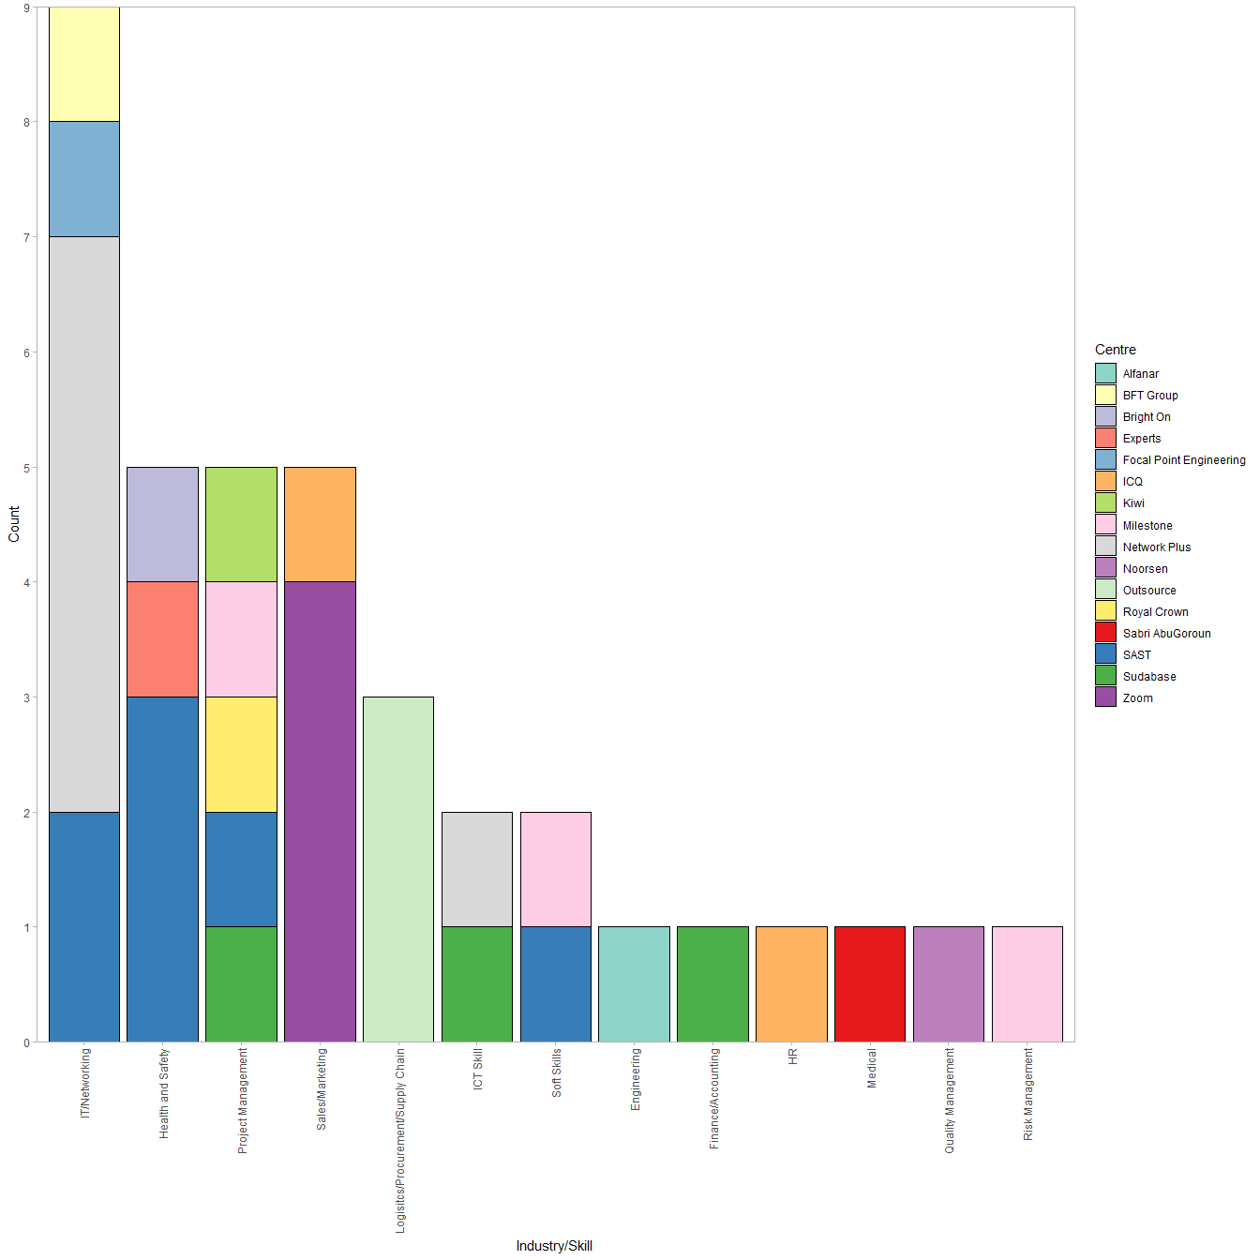

This Plot shows a different picture from our original histogram. Here we can see that while IT/Networking courses still show the highest count, other technical programs are not showing the same levels. While this may be a possible opportunity, We are of the opinion that there are probably good reasons for this discrepency and that this requires more research.

Meanwhile; previously middle of the pack courses are now leading. Most prominently Health and Safety, Project Management, Sales/Marketing and Logistics. Of these Project Management presents a crowded field while the remainder remain opportune places to focus.

A Keyword search of the Sales/Marketing Category shows us that the Certified Courses are in Marketing.

The bottom end of the spectrum also presents certain opportunities, such as prep courses for CPA/CFA hopefuls, as well as in the fields of Quality and Risk Management. However, this report will not go into those fields as they are smaller areas even in the more comprehensive view of the market; choosing instead to leave it for the 2020Q1 Market Analysis Report.

On a Final note, While Project Management does present a crowded field, a keyword search shows that all the courses are based on PMI® materials, with no presence from competing project management techniques such as AgilePM® and Six Sigma Lean® presenting another possible opportunity in the future.

## Uncertified Courses

Below We find the distribution of the remaining courses:

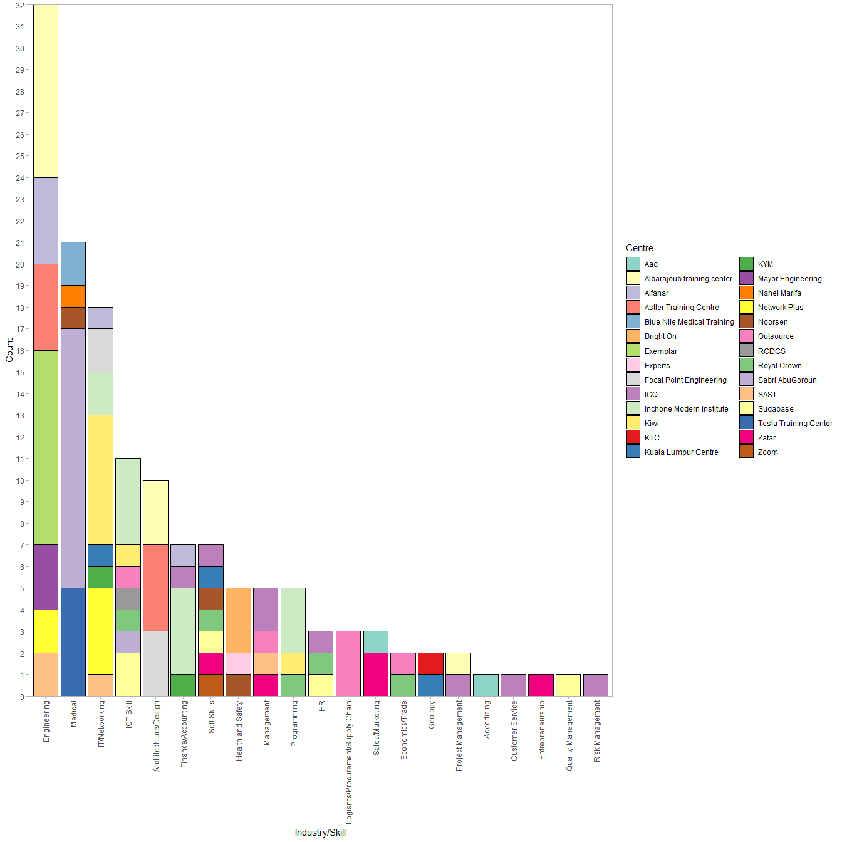

The picture here does not change much from our initial market wide assesment and no new insights can be gained.

# Conclusion

It is the reccomendation of the report that 2020Q1 Training Plan be based on a Price based Market Segmentation with a focus on the below; in no particular order:

* Entrepreneurship
* Customer Service
* Advertising/Social Media
* HR
* Management
* Sales/Marketing
* Logistics/Procurement/Supply Chain
* Health and Safety

With Particular focus on providing Certified courses in the below:

* HR
* Marketing
* Logistics/Procurement/Supply Chain
* Health and Safety

As for the remainder courses should be prepared so that we are ready to respond to customer inquiries and requirements; meanwhile, pilot courses can be prepared and advertised to guage actual market interest and test appropriate price points.