Block Plugin for Simultaneous Email Transmission (hsmail)

User manual

Human Science Co., Ltd.

2017

Contents

1. Overview of block plugin functions 2

2. Block setting screen 2

3. Email setting screen 3

4. Basic operations 5

# Overview of plugin functions

This plugin extracts users who fulfill certain delivery conditions at a predetermined date and time. Then, an email prepared in advance is sent to these extracted users.

The purpose of this function is to send a previously prepared email to students who have not yet completed their studies.

# Block setting screen

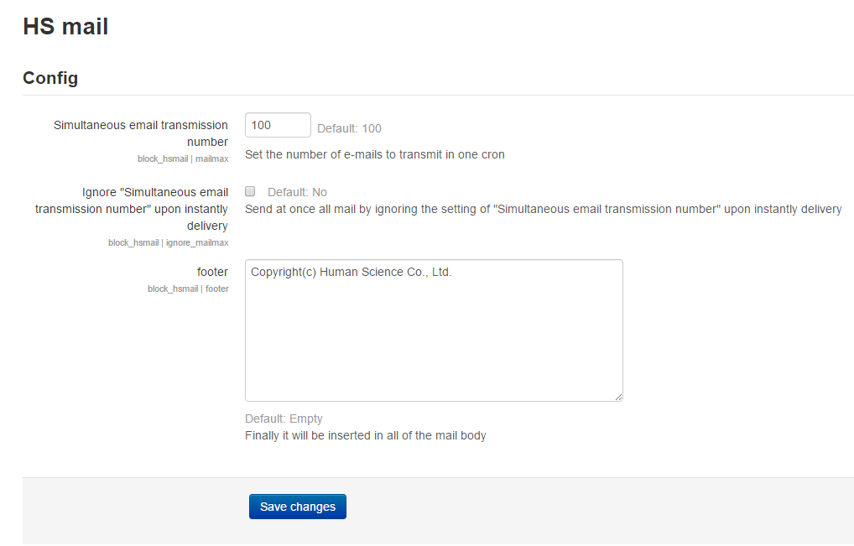

Explanation on setting items

Simultaneous email transmission number: number of emails to send at one time

Ignore "Simultaneous email transmission number" upon instantly delivery: option to ignore the maximum number of emails to send at one time when sending the email immediately Footer: show email footer

# Email setting screen

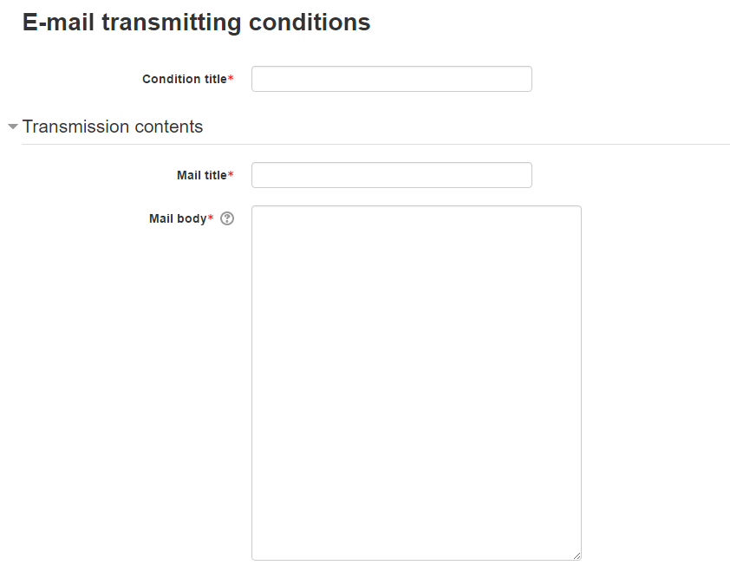

Explanation on setting items

Condition title: set condition for email delivery

Mail title: email subject

Mail body: body of email

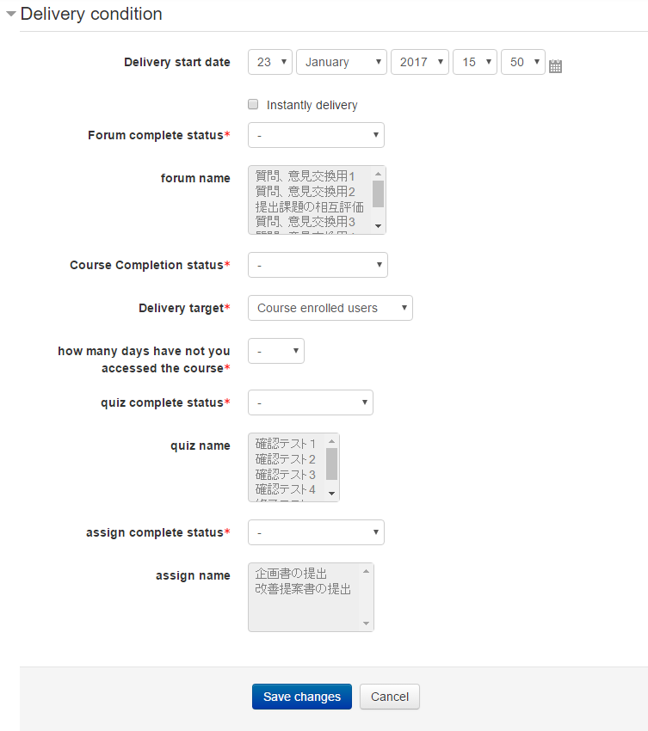

Explanation of delivery conditions

Delivery start date: delivery start date

Instantly delivery: option to send email immediately

Forum complete status: set whether users have completed the target forum module

Forum name: target forum module

Course Completion status: set whether the course is complete

Delivery target: target recipients for delivery (recipients, groups)

how many days have not you accessed the course: set the number of days users have not accessed the course within a predetermined number of days (1 – 30 days)

quiz complete status: set whether users have completed the target small text module

quiz name: target small text module

Assign complete status: set whether users have completed the target problem module

Assign name: target problem module

# Basic operations

There is only one email queue for the entire Moodle system. This system checks periodically (default: 5 minutes) to see if there are any emails that are past their predetermined delivery date/time and can be sent. If there are emails with such settings, then the preset email contents are sent to the target recipients. The extracted users and their corresponding emails are then registered into the email queue of the whole Moodle system. Delivery of emails occurs when the system extracts the maximum number of emails and their email contents from the queue as set in the block settings.

* Note: please set the maximum number of emails to correspond with the actual number of emails to be delivered.