Fundraiser for Talea Hasko-Stewart

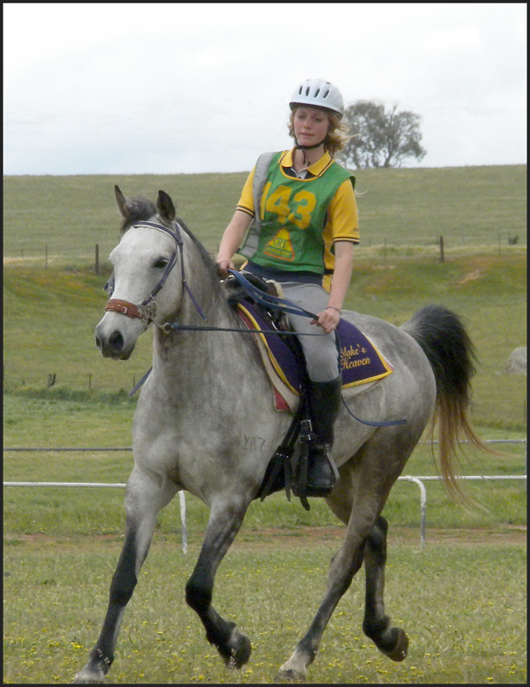
For further information contact:
Fia Hasko-Stewart
Phone: (02) 6282 2051 (h), (02) 6289 7348 (w)
Talea has been selected to represent Australia in the South African Endurance Championships in South Africa in July 2010.
To help Talea get there, would you kindly sponsor her in the upcoming 160 km Tom Quilty ride?
Sponsorship is per kilometre that Talea completes, or a nominated figure of your choice.
Your sponsorship or donation amount is entirely up to you.
Example: 160 km at $0.50 per km = $80.00
All money raised from this will go towards getting Talea to South Africa. Thank you for your kind support.

Name | Address | Signature | $ per km or donation | Paid

