Using sabinaHSBM for link prediction and network reconstruction using Hierarchical Stochastic Block Models

Example on how to use it to identify missing links with the binary_classifier method

The *sabinaHSBM* package provides tools for link prediction and network reconstruction using hierarchical stochastic block models (HSBM). This document demonstrates a simple use case based on the binary_classified method to identify missing links. We will use the example dataset dat included in the package to show key functionalities, including data preparation, link prediction, and network reconstruction.

# Loading Required Libraries

We begin by loading the required R packages. Missing packages are automatically installed.

# If the package is not installed, install it from GitHub  
# if (!requireNamespace("sabinaHSBM", quietly = TRUE)) {  
# library(remotes)  
# remotes::install_github("h-lima/sabinaHSBM")  
# }  
  
# Load the sabinaHSBM package  
#library(sabinaHSBM)  
devtools::load_all("/home/project_hsbm/graph_tool/sabinaHSBM/")

If the required packages are not already installed, install them from CRAN

list.of.packages <- c(  
 "dplyr",  
 "parallel",  
 "reshape2",  
 "reticulate",  
 "stringr",  
 "tidyr",  
 "ROCR",  
 "data.table"  
)  
  
new.packages <- list.of.packages[!(list.of.packages %in% installed.packages()[, "Package"])]  
if (length(new.packages) > 0) {  
 install.packages(new.packages, dependencies = TRUE)  
}  
  
for (package in list.of.packages) {  
 library(package, character.only = TRUE)  
}

# Record starting time (optional)  
start_time <- Sys.time()

# Load data

The dataset dat is a binary bipartite matrix representing a hypothetical species interactions network. Columns and rows correspond to two different types of nodes (e.g., hosts and parasites), and links (values of 1, in red) represent interaction between them while 0 (in black) represent lack of observed interaction. The network contains gaps, indicating potential missing links.

# Load the dataset  
data(dat, package = "sabinaHSBM")

# Plot the simulated matrix  
plot_interaction_matrix(dat, order_mat = FALSE)

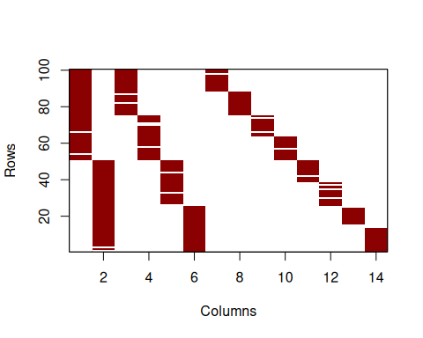

# Preparing Input data for HSBM

The hsbm.input function pre-processes the dataset, creating cross-validation folds and edge lists required for modeling. Here, we use 5-fold cross-validation.

# Prepare input object  
myInput <- hsbm.input(  
 dat, # Binary bipartite matrix of observed links  
 n_folds = 5 # Number of folds for cross-validation  
)

## [1] "Actual cross-validation rate is 0.199"  
## [2] "Actual cross-validation rate is 0.199"  
## [3] "Actual cross-validation rate is 0.199"  
## [4] "Actual cross-validation rate is 0.199"  
## [5] "Actual cross-validation rate is 0.202"

# Summarizes network characteristics  
summary(myInput)

## n_rows n_cols n_links rows_single_link cols_single_link possible_links  
## 1 100 14 277 1 0 1400

# Predicting Missing Links

The hsbm.predict function applies HSBM to predict link probabilities and group assignments in a network. The function works directly with the processed input created by hsbm.input. Here, we use the binary_classifier method. This method focuses on predicting probabilities for currently unobserved links (0s). Use this method if you want to identify missing links (unobserved links likely to exist) in partially incomplete networks.

# Predict missing links using HSBM  
myPred <- hsbm.predict(  
 myInput, # Input data processed by hsbm.input()  
 iter = 1000, # Number of iterations ...  
 wait = 1000, # Number of iterations for MCMC equilibration  
 method = "binary_classifier" # Prediction method  
)

## Computing predictions for fold 1   
## using binary_classifier  
## Collect marginals  
## Gather data  
## Computing predictions for fold 2   
## using binary_classifier  
## Collect marginals  
## Gather data  
## Computing predictions for fold 3   
## using binary_classifier  
## Collect marginals  
## Gather data  
## Computing predictions for fold 4   
## using binary_classifier  
## Collect marginals  
## Gather data  
## Computing predictions for fold 5   
## using binary_classifier  
## Collect marginals  
## Gather data

Predicted link probabilities and group assignments are stored for each fold. Below, we extract the probabilities (p) and groups for fold 1.

# View probabilities for fold 1  
probabilities_fold1 <- myPred$probs[[1]]  
head(probabilities_fold1)

## v1 v2 p v1_names v2_names edge_type  
## 1 0 101 1.401707e-04 sp1 SPB reconstructed  
## 2 0 103 1.349834e-02 sp1 SPD reconstructed  
## 3 0 104 4.843967e-05 sp1 SPE reconstructed  
## 4 0 105 5.356509e-05 sp1 SPF reconstructed  
## 5 0 107 5.059732e-03 sp1 SPH reconstructed  
## 6 0 108 4.891044e-03 sp1 SPI reconstructed

The group assignments provide the hierarchical clustering structure of nodes for each fold. Let’s extract and examine the group assignments for fold 1:

# View the group/block assignments for fold 1  
groups_fold1 <- myPred$groups[[1]]  
  
# Filter one type of nodes (e.g., hosts, in columns)  
vnames <- colnames(myPred$data)  
groups_fold1 <- groups_fold1 %>% filter(names %in% vnames)  
g_cols <- grep("^G", names(groups_fold1))  
groups_fold1[g_cols] <- lapply(groups_fold1[g_cols], sort)  
  
print(groups_fold1)

## nodes G1 G2 G3 G4 names  
## 1 100 10 74 1 0 SPA  
## 2 101 10 74 1 0 SPB  
## 3 102 10 74 1 0 SPC  
## 4 103 10 74 1 0 SPD  
## 5 104 10 74 1 0 SPE  
## 6 105 10 74 1 0 SPF  
## 7 106 10 74 1 0 SPG  
## 8 107 100 74 1 0 SPH  
## 9 108 100 74 1 0 SPI  
## 10 109 100 74 1 0 SPJ  
## 11 110 100 74 1 0 SPK  
## 12 111 100 74 1 0 SPL  
## 13 112 100 74 1 0 SPM  
## 14 113 100 74 1 0 SPN

Hierarchical group assignments provide insight into how nodes (e.g., hosts) are organized across multiple levels. At the first level (G1), nodes are divided into specific groups, reflecting fine-scale patterns. Moving to higher levels (G2, G3, G4), these groups are progressively aggregated, revealing broader patterns and relationships or communities.

# Network Reconstruction

The hsbm.reconstructed function generates a reconstructed binary interaction matrix by combining predictions from all folds. The predicted matrix is binarized using a user-specified threshold.

# Network reconstruction  
myReconst <- hsbm.reconstructed(  
 myPred, # Predictions processed by hsbm.predict  
 rm_documented = TRUE, # Use of documented entries during validation  
 threshold = "prc_closest_topright", # Binarization threshold  
 new_matrix_method = "average_thresholded" # Combine fold predictions  
)

This output includes the averaged probability matrix, the final reconstructed matrix, and evaluation metrics. These results highlight the predicted interactions, showcasing the method’s ability to detect missing links effectively. Let’s explore some of the key outputs in detail.

# View the reconstructed network summary and evaluation metrics  
summary(myReconst)

## $`Reconstructed Network Metrics`  
## obs_links unobs_links pred_links kept_links spurious_links missing_links  
## 1 277 1123 285 277 0 8  
##   
## $`Evaluation Metrics`  
## mean_RLRR mean_auc mean_aucpr mean_yPRC mean_prec mean_sens mean_spec  
## 1 0.4279221 0.9281172 0.5211286 0.04685102 0.6784577 0.446039 0.9866429  
## mean_ACC mean_ERR mean_tss  
## 1 0.9612974 0.03870262 0.4326819

The summary provides the number of missing links, as well as key evaluation metrics, such as the retained link recovery rate (RLRR).

# View the top potential missing links  
top_links_df <- top_links(myReconst,   
 n = 10,   
 edge_type = "undocumented") # Type of edge to rank  
print(top_links_df)

## v1_names v2_names p sd  
## 1 sp35 SPA 0.2410224 0.2355385  
## 2 sp47 SPA 0.2138241 0.2435099  
## 3 sp98 SPB 0.2015381 0.2092842  
## 4 sp100 SPB 0.1943825 0.1920466  
## 5 sp14 SPC 0.1625023 0.2608890  
## 6 sp19 SPC 0.1586800 0.2503762  
## 7 sp43 SPD 0.1555560 0.2631904  
## 8 sp31 SPD 0.1514594 0.2556404  
## 9 sp30 SPD 0.1354428 0.2347947  
## 10 sp79 SPN 0.1291181 0.2205208

The top-links functions identifies the undocumented links most likely to be missing links in a network predicted by HSBM.

# View the reconstructed binary matrix  
plot_interaction_matrix(myReconst$new_mat, order_mat = FALSE)

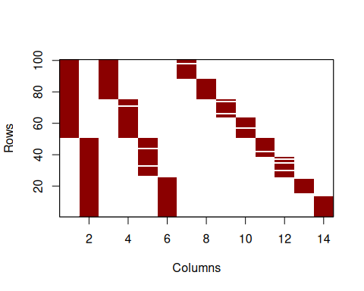

This document demonstrates the use of the *sabinaHSBM* package for network reconstruction. By applying the binary_classifier method, we showcased how missing links can be effectively identified and addressed in incomplete networks.

# Computing characteristics

# Show processing time and computer characteristics (optional)  
end_time <- Sys.time()  
cat("The processing time of this script took: ", end_time - start_time, "minutes\n")

## The processing time of this script took: 4.828225 minutes

This analysis was performed on a Dynabook with the following characteristics:

* Processor (CPU): Intel Core i7-1165G7 @ 2.80GHz (11th Gen)
* Memory (RAM): 32 GB
* Operating System: Windows 11 Pro, Version 24H2
* R Version: 4.3.3