**Master unit testing with NUnit, XUnit and MOQ with a real world N-Tier web application (.NET Core 6 and EF Core)**

**What is automated testing?**

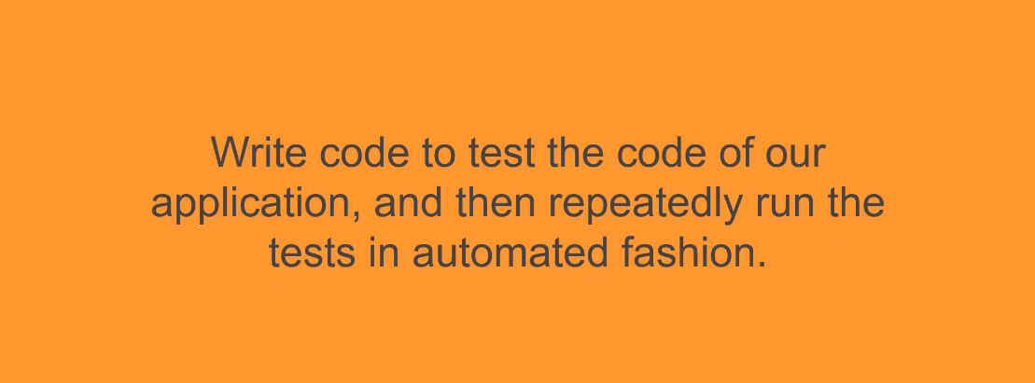

What are benefits of automated testing?

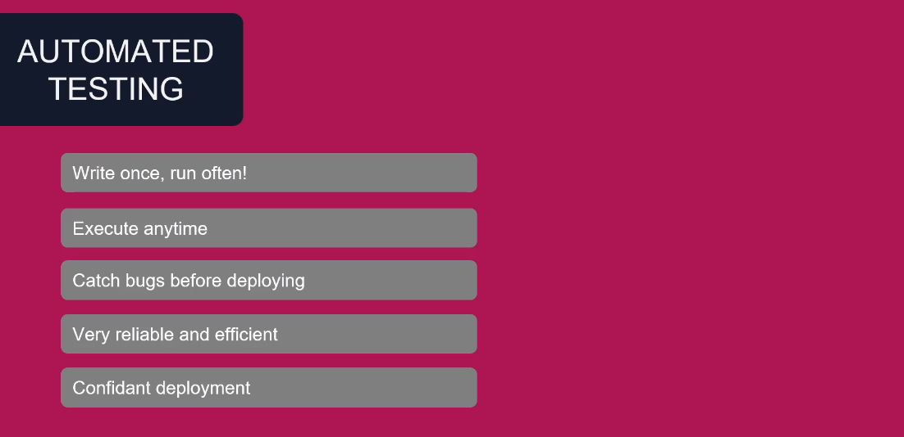

What are the different types of tests?

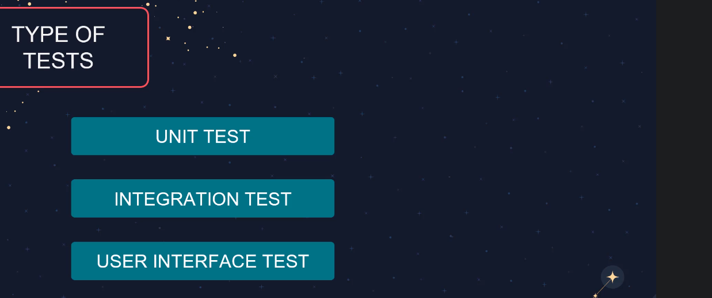Testing Pyramid

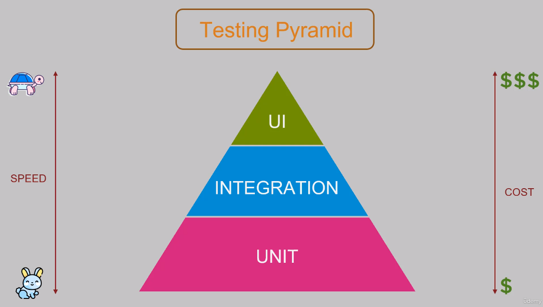

Three phases of testing ( AAA)

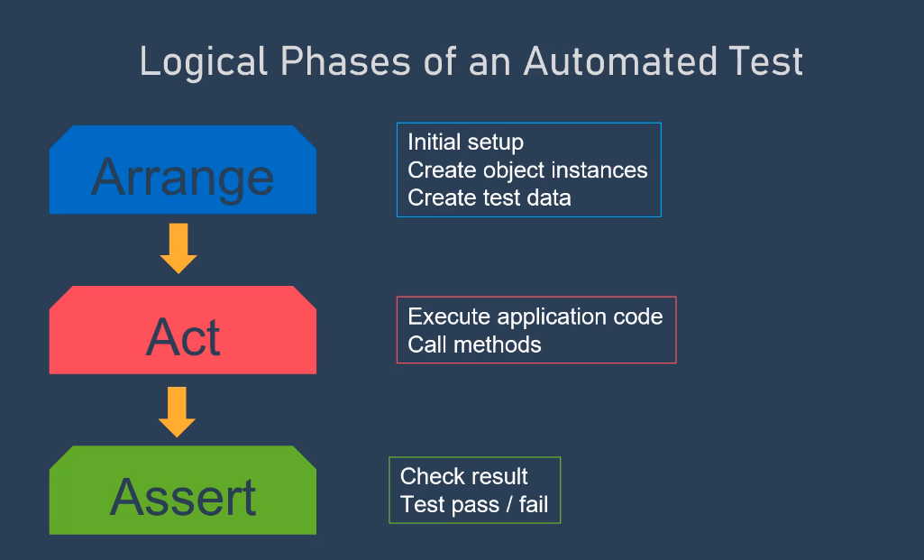

We have MS unit testing which it is for Microsoft. But we will use other unit test frameworks because they will give us more benefits.

For using NUnit framework we need to add NUnit, NUnit3TestAdapter, Microsoft.NET.Test.Sdk packages from NuGet Package Manager.

NUnit3TestAdapter is for starting tests in explorer.

NUnit Asser Models

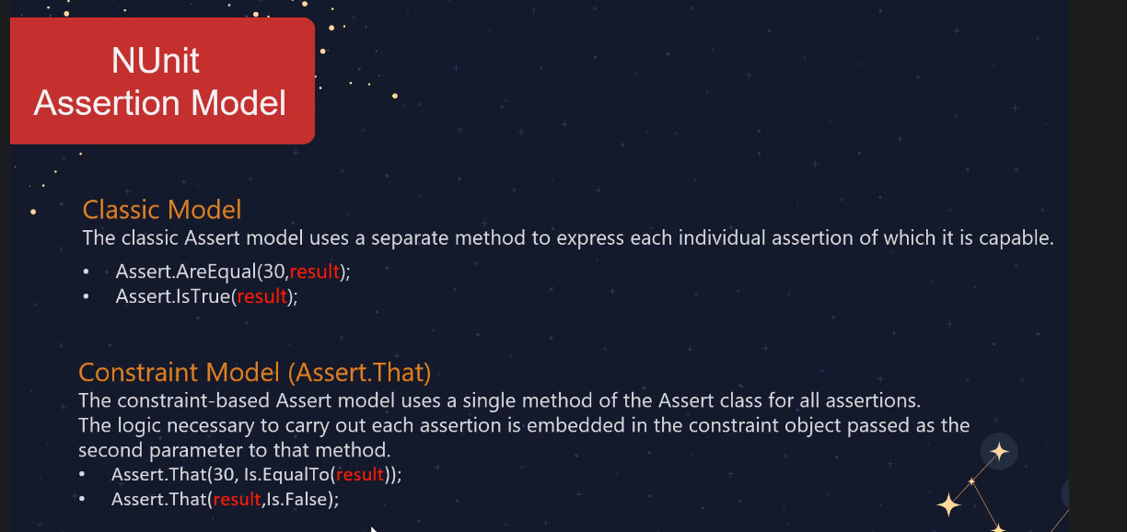

Test case attribute s used to pass different value to unit test.

[Test]

[TestCase(11)]

[TestCase(12)]

public void IsOddChecker_InputOddNUmber_ReturnTrue(int a)

When we work with double values, we have a delta variant in assert which makes an available range for us.

Assert.AreEqual(15.9, result,.1); //range between 15.8 – 16.00