ABSTRACT
Road safety is a serious issue in today’s world, especially in countries where road maintenance is not done regularly. Potholes and speed breakers are common problems on roads and they often cause accidents, damage vehicles, and make driving uncomfortable. In most places, road checking is done manually by workers, which takes a lot of time and effort. Because of this, many road problems remain unnoticed for a long period.
In this project, a Pothole and Speed Breaker Detection System is developed using image processing and deep learning techniques. One aim here stands out - spotting potholes and speed bumps using pictures from roads or real-time image. Here’s how it works - road conditions get split into three groups: fine, pitted, or bumpy from raised sections. A system based on CNN concepts takes charge of telling them apart. When MobileNetV2 steps in, accuracy gets a boost by using what it already knows, cutting down processing time because it isn’t learning everything fresh.
Before anything else started, the learning process used street images adjusted for scale, rotated angles, or altered brightness. From the camera feed, each snapshot enters OpenCV individually during real-time operation. Following that instant, every image passes through a trained recognition model. The result reflects only what the system believes it recognizes with confidence. Truth stands out when noise fades. Yet spotting patterns across images reveals what lasts.
A fresh interface made using Tkinter lets users switch monitoring live with ease. Should cracks or dents appear, alerts flash directly into sight. Learning-based tech proves it can keep an eye on pavement conditions. Early signals from automated checks make travel just a bit safer.
Out in the field, this setup links up GPS with phone apps to get things running where people actually live. While location tools plug into handheld devices, everyday use becomes possible beyond theory. Overall, the project gives a practical and cost-effective solution for automatic road hazard detection.

CHAPTER 01

INTRODUCTION

Road transportation plays a very important role in day-to-day life, but road safety has become a major problem due to poor road conditions. What often catches a driver's eye isn’t just traffic, but uneven road surfaces. Heavy rain weakens pavement over time, especially when materials used during building were substandard. Maintenance delays make small cracks turn into deep holes. Speed humps add another layer of concern - some appear without warning signs or clear outlines. Poor visibility at night worsens their impact. Vehicles may suffer tire wear, alignment shifts, or suspension harm after hitting them. Riders feel sudden jolts that disrupt comfort. Even routine commutes become less predictable because of these flaws.
Manual inspection of road conditions happens across numerous regions. Such checks demand significant time along with physical labor, yet fail to cover every roadway consistently. Consequently, cracks and deteriorated surfaces often go undetected for extended periods. Given growing vehicle numbers, early detection through automation has become increasingly essential.
Nowhere is automation more useful than in analyzing visual data for infrastructure checks. These systems spot details in pictures and moving footage through smart algorithms. Where traditional methods need people watching screens, machines now handle the task nonstop. Features inside photos get recognized because software trains itself on many examples. One type of network, good at this work, builds understanding layer by layer. Its design copies how eyes send signals to brains. Predictions grow sharper each time the model sees new cases.
Aiming to build a tool capable of spotting potholes and speed breakers, this effort centers around image analysis. Through automatic detection, it seeks to alert drivers while supporting repair teams with timely data. Instead of complex setups, the approach favors simplicity - Keeping costs low while ensuring customer satisfaction performance. Functioning under real-world demands, the method prioritizes responsiveness and reliability. By turning visual input into actionable insights, safety gains ground where it matters most.
Project Description
The Pothole and Speed Breaker Detection System is developed to automatically detect road hazards using a camera and deep learning techniques. This approach avoids manual inspections and expensive tools by analyzing images of road surfaces. When the system detects cracks, bumps, or smooth road sections, it automatically classifies them into appropriate categories. At one moment, it may identify a dip in the pavement, and at another, a raised ridge designed to slow vehicles. Images act as visual clues, helping the system determine the type of road surface ahead without human intervention.
The system demonstrates how a deep learning model based on convolutional neural networks processes street-view images. Through training, the model learns to detect different roadway patterns over time. Instead of building the model from scratch, a pre-trained MobileNetV2 is fine-tuned to improve speed and accuracy. Before being fed into the network, images are resized and pixel values are standardized.
A camera continuously captures live street scenes for real-time analysis. Each frame from the stream is processed by the trained algorithm. Predictions are accepted only when the confidence level exceeds a predefined threshold. To avoid false alerts, multiple consecutive frames must confirm the presence of a pothole or speed breaker.
A graphical user interface developed using Tkinter provides easy access to the system’s functions. When hazards are detected, warning messages are displayed instantly. Users can start or stop the detection process using clearly visible buttons. Color-coded indicators enhance clarity during operation, helping users understand the road conditions ahead.
This project provides a practical system designed to improve road safety and support smart transportation systems. In the future, the system can be enhanced by integrating GPS functionality, mobile application support, and automatic reporting of road conditions to authorities.

CHAPTER 02

LITERATURE SURVEY

For decades, tracking how roads hold up has drawn attention due to effects on both travel safety and traffic flow. Detection of issues like potholes or raised crossings once relied heavily on people walking routes or vehicles collecting data through sensors. Inspectors would move along streets, using minimal equipment to spot cracks or uneven surfaces. Despite being straightforward, those techniques demanded extensive labor, took long durations, came with high expenses - and struggled when applied across vast highway systems.
Afterward, scientists began relying on sensor-driven tools to spot road defects. Instead of manual checks, machines picked up irregularities through motion shifts. Accelerometers and vibration detectors, combined with GPS units fixed inside cars, tracked how vehicles responded when crossing rough patches. A bump or dip caused noticeable jolts - these were captured by onboard equipment. As wheels hit cracks or raised surfaces, data patterns changed sharply. Though automation increased, performance still faced hurdles. Not every flaw was caught consistently across different driving conditions. Speed influenced precision more than expected. Where sensors were mounted mattered almost as much. Road surface played a role too, though less obvious at first glance. Visual proof of cracks or potholes remained out of reach regardless of approach.
Faster image handling opened doors to camera-driven street oversight tools. Using lenses, these setups grabbed roadway visuals, then applied approaches like boundary spotting, level sorting, or shape tracking. Though effective under steady settings, shifts in brightness, shade patterns, or surface details broke their accuracy. Detection of intricate pavement flaws remained weak - errors appeared frequently.
These days, deep learning sees frequent use in sorting images and spotting objects. Starting with raw pixels, CNNs learn useful patterns without manual setup. Some studies apply these networks to find street issues - cracks, holes, uneven surfaces. Unlike older techniques, they adjust more easily when lighting or texture changes. Performance often improves because the model handles variation on its own.
Heavy deep learning architectures like VGG and ResNet appear in several studies focused on identifying road damage. Despite strong performance, their demand for processing power limits practical speed. Because of these constraints, alternatives emerged using lighter designs. Models built on MobileNet process information more quickly while using less storage space. Their efficiency fits well within live analysis settings, including hardware with limited capacity.
Some studies looked at boosting speed through transfer learning. Using models already trained on vast image collections helps adapt them quickly to spotting road damage. Fine-tuning these cuts down computation needs, delivering better results when data is limited. Certain papers emphasized setting clear confidence levels - paired with checking across consecutive frames - to minimize errors in real-time image processing.
Looking at past research, vision-driven deep learning stands out in automating road assessment tasks. Still, several current solutions come off as bulky, costly, or hard to operate. Building on earlier findings, this work introduces a streamlined CNN approach capable of live analysis alongside an intuitive visual display. As a result, deployment becomes easier, costs drop, and everyday usability improves.

Existing and Proposed System
Nowadays, most road checks still rely on people going out by foot. Workers travel to various spots, looking closely at surfaces to spot cracks or holes. Because it takes so much time and effort, coverage tends to be spotty. Without enough staff or hours in the day, problems often stay hidden for weeks. Observation alone struggles to keep up with wear across wide regions.
A few current setups rely on sensors - accelerometers and vibration detectors mounted inside cars. As the car moves over bumps or damaged pavement, shifts in motion trigger readings. Even though automation plays a role here, their operational efficiency can change based on driving speed, where the sensor sits, and what kind of surface is involved. On top of that, without actual images of the roadway, confirming if a bump was really a pothole becomes guesswork.
Some systems began relying on image analysis, applying basic tools like edge identification or brightness cutoffs to street visuals. When light levels shift unpredictably, their performance drops sharply. Changes in surface patterns, shade placement, or rainfall disrupt accuracy consistently. Mistaken alerts appear frequently under these circumstances.
Facing issues like poor precision, expensive setups, delays in processing, reliance on human input stands out as a key drawback of current methods.
Proposed System
A new method steps in where human checks fall short - by spotting potholes and speed bumps through deep learning. Road footage, either recorded or streaming live, feeds into the model instead of depending on physical sensors. Visual analysis takes over, guided by algorithms trained to recognize surface changes. Detection runs without direct oversight once the setup processes incoming frames.
A different approach begins here - using a Convolutional Neural Network to sort road surface types into one of three groups: typical pavement, potholes, or raised speed control units. Instead of building from scratch, knowledge transfers over through a previously trained MobileNetV2 framework, boosting performance without long waits. Images feed directly into the system, allowing patterns to emerge on their own during analysis. This automatic feature extraction works better than older techniques based purely on manual image rules.
A live feed from a webcam supplies image frames instantly. Following capture, each image moves through processing before reaching the predictive model. Instead of immediate alerts, checks based on confidence levels filter out weak signals. Consistency matters - only repeated outcomes over several frames count as valid. Detection becomes official once agreement appears across successive images.A simple graphical user interface is developed using Tkinter to make the system easy to use. The interface allows users to start and stop detection and displays visual alerts when potholes or speed breakers are detected. The proposed system is cost-effective, accurate, and suitable for real-time applications, making it useful for road safety and smart transportation systems.
Feature | Existing System | Proposed System
Detection Method | Manual / Sensor-based | Deep Learning (CNN)
Accuracy | Low to Medium | High
Real-time Detection | Not reliable | Yes
Cost | High | Low
Visual Confirmation | Not available | Available
Scalability | Limited | High
Human Effort | Required | Minimal

Table 2.1: Comparison Between Existing and Proposed Systems

Feasibility Study
Before developing the pothole and speed breaker detection system, a feasibility study was carried out to check whether the project can be successfully implemented using available resources. The feasibility study helps in understanding the practicality of the system from different aspects such as technical, economic, and operational feasibility.
Technical Feasibility
The proposed system is technically feasible as it uses well-known and widely supported technologies. The proposed system is developed using Python programming language along with several libraries like TensorFlow, OpenCV, NumPy, and Tkinter. All the above-mentioned libraries are freely available, and users can download them on any computer system.
The deep learning algorithm that will be utilized in this project is based on the MobileNetV2 algorithm, which is light and resource-efficient. Moreover, it is not necessary to have advanced hardware setup to execute this algorithm. An ordinary webcam is enough for ingesting live image feeds. As all software and hardware components are readily accessible, this is a technically possible task.
Economic Feasibility
The project is economically feasible because it does not involve any expensive hardware or paid software. All the software tools used in this project are open-source and free of cost. The system uses a regular webcam instead of costly sensors or special cameras.
There is no need for large investment, making the project affordable for students and small organizations. Hence, the overall development and implementation cost of the system is very low, which proves its economic feasibility.
Operational Feasibility
The proposed system is easy to operate and user-friendly. A simple graphical user interface is designed using Tkinter, which allows users to start and stop the detection process without any technical difficulty. The system provides clear visual alerts for potholes and speed breakers, making it easy to understand the output.
The system does not require skilled operators or special training. Anyone with basic computer knowledge can use the application. Therefore, the project is operationally feasible and suitable for real-world usage.
Conclusion of Feasibility Study
Conclusion drawn from the above analysis reveals that the pothole and speed breaker detection system design consideration is technically, economically, and practically possible. This project would be successfully implemented utilizing available resources, thereby offering an optimal solution towards improving the safety aspect of the road system.

Tools and Technologies Used
The project involves the combination of multiple software tools and technologies to build an efficient pothole and speed breaker detection system. All the software tools chosen are easily available, trustworthy, and perfect for use in the development of a real-time application.
Python
Programming in Python is utilized as the primary language for accomplishing this task. It is easy to learn, understand, and implement with various libraries for machine learning and image processing. Additionally, it improves the malleability of the task, combining aspects of the system, which may include model development, real-time detection, and designing the user interface.
TensorFlow and Keras
TensorFlow and Keras are used to build and train the deep learning model. Apart from offering an accessible way to build models, Keras works alongside TensorFlow for efficient computation behind the scenes. This setup supports a Convolutional Neural Network here, drawing on pre-trained knowledge through MobileNetV2 via transfer techniques.
MobileNetV2
Starting off, MobileNetV2 serves as a pre-trained deep learning system designed for identifying images. Despite its compact design, it demands significantly lower processing resources than many similar frameworks. Road scenes are applied during tuning so the network can sort surfaces into three types: intact pavement, potholes, or raised speed controls. Accuracy stays high because adjustments balance responsiveness with efficiency.
OpenCV
Starting off, OpenCV handles operations involving images. Through it, image streams come directly from a webcam feed. One frame at a time gets pulled out for analysis. Resizing those frames adjusts them properly for further steps. The system then shows where hazards like potholes or speed bumps are found. Detection happens quickly because processing occurs in near real time. Visual feedback appears instantly on screen during operation.
NumPy
NumPy deals with numerical computations and array operations. It assists in image preprocessing, handling the input/output operations of the model, and manipulating the data. NumPy enhances the performance of the application.
Tkinter
Tkinter is used to design the graphical user interface of the system. It provides a simple window with buttons to start and stop the detection process. Tkinter makes the application user-friendly and easy to operate without requiring technical knowledge.
Hardware Components
The hardware required for this project is minimal. A standard computer system with a webcam is sufficient to run the application. No additional sensors or special equipment are needed.

Hardware and Software Requirements
The pothole and speed breaker detection system is designed to work with minimal hardware and commonly available software tools. This makes the system cost-effective and easy to implement.

Haware(H/W) Requirements
Component | Description
Processor | Intel i3 or higher
RAM | Minimum 8 GB
Storage | Minimum 20 GB free space
Webcam | Built-in or external webcam
Display | Standard monitor
Operating System | Windows 10 / Linux

Table 2.4.1: Hardware Requirements

Software Requirements

Software | Description
Operating System | Windows 10 or Linux
Programming Language | Python 3.8 or higher
Deep Learning Framework | TensorFlow with Keras
Image Processing Library | OpenCV
Numerical Library | NumPy
GUI Tool | Tkinter
IDE | VS Code or PyCharm

Table 2.4.2: Software Requirements

2.4.3 JUSTIFICATION OF REQUIREMENTS

The selection of hardware and software requirements for the pothole and speed breaker detection system is done based on the needs of the project, availability of resources, and ease of implementation. Each requirement plays an important role in the successful delivery of the system.

Hardware Justification

A standard personal computer or laptop is sufficient to run the application because the deep learning model used in this project is lightweight. The system operates without high-end processors or special hardware. A minimum of 8 GB RAM is recommended to ensure smooth execution of model training and real-time image processing.
A webcam is required to pick real images from the road so that real-time detection can be possible. The webcams are available inbuilt or external, and image quality is not an issue; therefore, the system does not involve any special cameras or sensors, which makes the cost-effective process easier.

Software Justification

A favorite among developers, Python stands out due to its gentle learning curve. Popularity grows from widespread use in fields like image processing and machine learning. Open-source tools add strength, giving users access to many ready-made resources. Flexibility emerges through community-driven packages that support diverse tasks.
A framework known as TensorFlow supports the creation and training of the deep learning system. The Keras tool works alongside it, simplifying design tasks. Building a Convolutional Neural Network becomes easier through their combined capabilities. Knowledge gained in one setting moves into another thanks to transfer methods.
Because OpenCV offers efficient tools, it handles tasks such as capturing image, resizing images, then showing results. What stands out is how smoothly these operations run during visual data work.
One feature lets it record footage. Another adjusts picture dimensions. A third handles file conversion automatically
Working with numbers often means turning to NumPy. Because it speeds up calculations on arrays, tasks take less time. Though built for simplicity, its impact shows clearly in processing efficiency. When handling large datasets, the improvement becomes noticeable almost immediately. This library supports a wide range of mathematical functions naturally. As computation demands grow, reliance on such tools increases quietly.
When you see "import numpy as np", it means a shortcut is created to bring in the package
A basic graphical interface takes shape with Tkinter. Lightweight by design, it arrives ready-made with Python installations. Simplicity in structure makes setup straightforward. For these reasons, the current project builds on this framework.

CHAPTER 03

SOFTWARE REQUIREMENTS SPECIFICATION (SRS)
3.1 Users
The Pothole and Speed Breaker Detection System is developed for users who require an easy and reliable way to identify road conditions. The system is implemented to allow it to be used by people without technical knowledge in programming, machine learning, or image processing. A simple graphical user interface is provided so that users can interact with the system comfortably.
The primary users of this system are vehicle drivers who want to be aware of potholes and speed breakers while traveling. By using this system, drivers can become more cautious and avoid sudden braking or vehicle damage. Finding your way becomes easier for motorcyclists as well as car operators whenever routes feel unfamiliar. Navigating unknown streets can turn less stressful thanks to real-time guidance tailored to each traveler's path.
Another group using the system includes traffic regulators alongside repair crews. While monitoring pavement states, it allows them to spot broken sections needing repairs. Detection becomes faster because problems are highlighted without walking every stretch by hand. Efficiency improves when assessments happen through digital feedback rather than physical walkthroughs taking days. Time once spent on foot inspections now shifts toward quicker responses.
Although designed broadly, learners find it useful during study tasks. One way it helps involves showing practical uses of deep learning combined with image analysis techniques. Because the structure stays clear and broken into parts, adapting it feels natural over time. Some choose to modify components while others build new sections around existing ones.
Starting off, users should know how to work a computer - typing, clicking, handling a webcam. Getting started with the app requires no extra instruction. Pressing one button turns the scanning on or stops it. Information from each scan appears plainly onscreen. Understanding what shows up there comes naturally to anyone.
Fundamentally built, the platform serves diverse users thanks to its straightforward design that works well without complexity.The focus is on usability and clarity so that the system can be effectively used in real-time scenarios.

3.2 Functional Requirements

Functional requirements define the main operations that the pothole and speed breaker detection system must perform. These requirements describe the core functionality expected from the system to achieve its objectives.
The system should be capable of capturing road images streams using a webcam or camera device. It must continuously read image frames during real-time operation and handle image input from stored files for offline testing. Each captured image or frame should undergo preprocessing such as resizing, color conversion, and normalization before being sent to the trained deep learning model.
The system should classify road conditions into three categories: normal road, pothole, and speed breaker. Based on the model’s prediction, the system must display the detected road condition clearly on the screen. A confidence threshold should be applied to ensure that alerts are generated only when the prediction confidence exceeds a predefined value.
The system should support real-time detection and must process image frames continuously without interruption. To avoid false alerts caused by noise or temporary camera movement, the system should verify predictions across multiple consecutive frames before confirming a pothole or speed breaker.
A simple and interactive graphical user interface should be provided using Tkinter. The interface should allow users to start and stop the detection process easily. The system should also display visual alerts and messages to inform the user about detected road hazards. Additionally, the system should handle invalid inputs such as missing camera access or unsupported image formats gracefully.

Non-Functional Requirements
Non-functional requirements describe the quality attributes of the system rather than specific operations. These requirements focus on usability, efficiency, reliability, and overall system behavior.
The system should be user-friendly and easy to operate, even for users with limited technical knowledge. Clear instructions and simple controls should be provided to ensure smooth interaction. The application should run efficiently on standard computers without requiring specialized or expensive hardware.
The system should also maintain consistent performance during extended usage and should not consume excessive system resources. These non-functional aspects ensure that the system is practical for real-world use.

Performance and Responsiveness
Performance and responsiveness are critical for a real-time road hazard detection system. The system should process each image frame quickly and display detection results with minimal delay. The time taken between capturing a frame and displaying the prediction should be very small so that alerts are meaningful to the user.
Kick things off by loading the deep learning model just one time when the app starts - saves waiting later. Instead of reloading each time, prepare images faster so predictions keep up with live image flow. Smooth performance stays steady only if processing matches camera speed. Running nonstop? Then stability can’t slip, ever.
The system should also be capable of handling temporary slowdowns without crashing, ensuring uninterrupted detection during real-time usage.

Scalability

Scalability refers to the ability of the system to grow and handle future requirements. The system should support the addition of new road condition categories such as cracks, damaged lanes, or road debris without requiring a complete redesign.
The architecture should allow the use of larger datasets for training to improve accuracy. With further development, the system can be integrated with cloud platforms or smart city systems for large-scale road monitoring. The scalable design ensures that the system remains useful as technology and requirements evolve.

Security and Privacy

What happens inside the device stays there - every image frame gets handled directly on your machine, never sent elsewhere unless you say so. Only what’s needed for spotting things shows up during use; nothing else sticks around afterward. Nobody gains entry without proper checks, keeping misuse at bay. How it runs matters just as much as what it does: private by design, clear in purpose. Trust builds when details stay shielded, especially with visuals involved.

Reliability and Availability

The system should be reliable and consistently produce correct results under normal operating conditions. It should be able to handle unexpected situations such as temporary camera disconnection, poor lighting, or corrupted input images without crashing.
The application should remain available whenever required and should recover smoothly from minor errors. The use of confidence thresholds and consecutive frame validation improves detection reliability and reduces incorrect alerts. High availability ensures that the system can be trusted during real-time operation.

Portability and Cross-Platform Support
The system is developed using Python and widely supported libraries, making it portable across different platforms. It must operate with current operating systems like windows and Linux with minimum changes in configuration settings.
The system should also work in other machines provided that the necessary software requirements are installed. This ease of deployment and testing in diverse environments without significant compatibility problems is possible due to this portability.

Maintainability
How easy it is to fix or change a system ties directly to its design. Clear separation between parts - like training models, spotting issues, and what users see - helps keep things manageable. When improvements come up, say boosting prediction quality or adjusting how alerts work, everything shouldn’t fall apart. Long-term fixes stay simpler when the layout makes sense and notes explain key choices. Structure matters most when updates arrive without warning.

Extensibility

Extensibility guarantees that one can add new features to the system in future. They must have the capability of integrating some other features like GPS-based location tagging, mobile application support, or automatically report any road problem they detect to the authorities.
It can be enhanced in terms of detection accuracy by adding new deep learning models or better algorithms. The system is modular, thereby making it flexible and easy to change according to the future developments and reality.

CHAPTER 04

SYSTEM DESIGN

System Perspective
A fresh way to watch roads comes alive - using pictures to spot trouble like potholes and bumps. Instead of people checking every inch, machines now take over the task bit by bit. Shaped in separate pieces, each part plays its own role without stepping on toes. One piece grabs images straight from cameras rolling down streets. Another dives into those visuals, hunting flaws hidden under tires and sunlight. Finally, results emerge where needed most, clear and timely. Together, they form a chain - not loud but sharp, not flashy yet steady.
Input Module
The input module is responsible for collecting road data. In this system, road images frames are captured using a webcam or camera device. The camera continuously records the road surface while the vehicle is moving or while testing is being done. These captured frames act as raw input for the system. Since road images can vary in lighting, angle, and resolution, raw input cannot be directly used for detection and must be processed further.
Processing Module
The processing module is the core part of the system. Once images arrive, they undergo preparation steps. Resizing ensures uniform dimensions across all samples. Color settings shift into a consistent scheme preferred by the system. Pixel values adjust to fit a common range through normalization. These adjustments help maintain compatibility with the structure expected by the deep learning setup.
Next comes preprocessing - after which, the processed visuals move into a CNN built on MobileNetV2. Training involved examples of potholes, speed bumps, along with regular roadway surfaces. Looking at pixel arrangements, the system judges what condition the road is in. Finally, it outputs its assessment based on learned features.To improve the accuracy and reliability of detection during real-time operation, the system applies confidence thresholding. Predictions are verified across multiple consecutive frames before confirming the presence of a pothole or speed breaker. This approach helps reduce false detections caused by sudden camera movement, shadows, or noise.
Output Module
The output module displays the final detection result to the user. A screen display makes it easy to see what road conditions have been found. When bumps or rough patches appear, warning signs pop up right away. These signals help drivers stay alert without delay. Starting or pausing the scan happens through built-in buttons on the same screen. Each update appears instantly, keeping pace with changing surfaces.
Overall System Flow
From a broad view, information moves step by step - from image capture through processing to screen presentation. One part connects to another, yet each works on its own, which simplifies troubleshooting when issues arise. Because pieces fit together loosely, adding new features later - like location tracking or phone access - is less disruptive. Updates could include live pavement feedback without reworking core functions.

Driver/ Camera User

Road Images

Pothole & Speed Breaker Detection System

Detection Results Alerts

Researcher/ Analyst
Report / Display System

Image 4.1: System Perspective Diagra

Context Diagram

The context diagram provides a clear and high-level representation of the Pothole and Speed Breaker Detection System by showing how the system interacts with external entities. In this diagram, the entire detection application is represented as a single process, without exposing internal technical details such as preprocessing steps or deep learning model operations.

What stands out first is how the context diagram shows where the system ends and what lies outside it. One thing becomes clear when looking at it: incoming data flows into the system from specific sources. Outputs go back out to those same areas, forming connections worth noting. A person reviewing this sees exactly who interacts with the system and why. What matters most is understanding these links without getting lost in details..

In this project, the detection system operates by receiving visual road data in the form of images streams. These inputs are provided by external entities such as drivers or camera users. The system then analyzes the input data internally and produces meaningful outputs such as detection results and alerts. These outputs are sent to other external entities like display systems or researchers.

The context diagram is useful during system design because it avoids unnecessary complexity and focuses only on interactions. It also helps in understanding the role of each external entity and how the system communicates with them. For academic projects, especially under VTU guidelines, the context diagram plays an important role in explaining system behavior in a simple and structured manner.

Components of the Context Diagram

A single core unit sits at the center of the pothole and speed breaker detection setup. Around it, outside pieces connect in different ways. One part sends data into the system while another pulls information out. Every piece has its own job to do. Some feed details in, others take results out.

1.External Entities

Apart from the system itself, some pieces interact by sharing information even though they sit beyond its edges. These parts skip any inner computations but still matter greatly when things run. What happens externally often shapes what follows inside.

Driver / Camera User

The Driver or Camera User is the primary external entity that supplies input data to the system. This entity uses a camera or webcam to capture road images of the road surface. The captured data may include different road conditions such as smooth roads, potholes, and speed breakers under various lighting and environmental conditions.

The camera user does not control how the system processes the images. Instead, the user simply provides the visual input and receives alerts or visual messages from the system. These alerts help the driver become aware of potential road hazards in advance.

Researcher / Analyst

The Researcher or Analyst is an external entity that mainly interacts with the system output. This entity is involved in studying the system’s performance, analyzing detection accuracy, and evaluating how well the system identifies potholes and speed breakers.

The researcher may use the detection results to compare different test cases, identify areas for improvement, or document findings for academic purposes. This entity does not provide real-time input during detection but relies on the output generated by the system.

Report / Display System

The Report or Display System is responsible for presenting the detection results generated by the system. A warning appears through images, along with labels that sort information clearly. The layout makes understanding fast without effort.

Easy understanding comes from how this part works. At times, findings get saved for future testing or review. Reporting what happens matters when sharing outcomes with people who check or use the system.

2. Context-Level Data Flow

Information moves between outside elements and the detection setup through context data flow. This movement shows how data travels, along with its characteristics. The method does not describe what happens inside the system after receipt. Direction and type of exchange are outlined clearly beforehand.

Input Data Flow

The main input to the system is road images frames. This data flows from the Driver / Camera User to the Pothole and Speed Breaker Detection System. Finding potholes and speed bumps relies on visual details within the input, which show what state the road is in. Although not always clear at first glance, these images carry key clues needed for detection. Where lighting varies, certain features still stand out enough to allow analysis. Because shadows may hide defects, multiple views help confirm their presence. Even small contrasts in texture give hints about irregular surfaces. When processed carefully, such visuals support accurate identification of roadway issues.
While operating in real time, data enters without pause because cameras capture multiple frames every second. During offline tests, stored images provided by users serve as input instead.

System Processing (High-Level View)

A signal arrives, then the system begins working behind the scenes. Image handling follows, followed by categorization using trained models. Still, none of that appears in the overview sketch. What matters is that outcomes turn out accurate. The drawing leaves those parts out on purpose. Complexity drops when only connections between components show up. Clarity grows when inner mechanics stay unseen.

Output Data Flow

Once processing is complete, the system produces output in the form of detection results. These results indicate whether the road is normal or contains a pothole or speed breaker.
The detection results are sent to the Researcher / Analyst for evaluation and performance analysis. At the same time, alerts and visual messages are sent to the Report / Display System to provide users with a clear view of the detected road condition.

Control and Feedback Flow

In some cases, feedback may flow indirectly from the user to the system, such as starting or stopping the detection process through the interface. This control flow helps manage system operation but does not affect the detection logic directly.

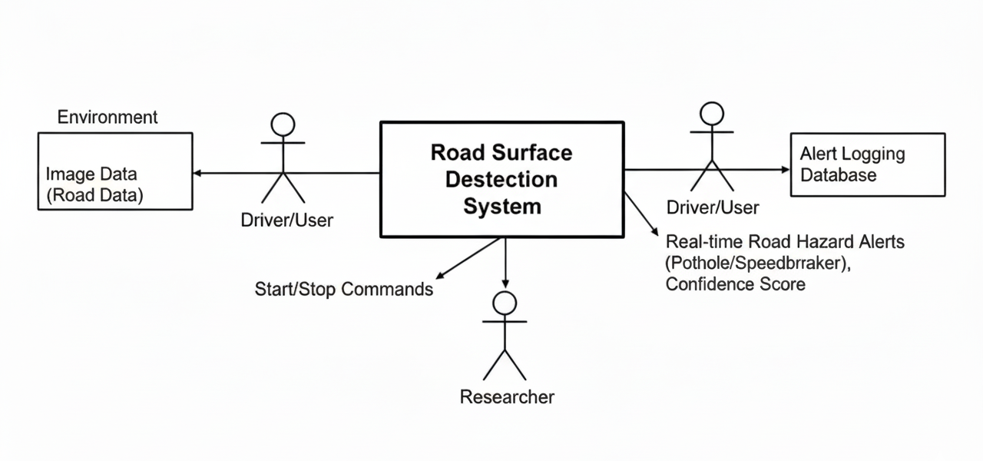
Context Diagram
Figure 3.2.2: Context Diagram

3.2.3 Explanation
The context diagram represents the overall interaction between the Pothole and Speed Breaker Detection System and its external entities. It provides a clear understanding of how the system communicates with users and external components without showing internal processing details.
In the context diagram, the Driver / Camera User is shown as the primary input provider. The driver captures road images using a camera or webcam. These images frames are sent to the detection system for analysis. The driver does not directly interact with the internal working of the system and only provides visual input.
The Pothole and Speed Breaker Detection System acts as the central component of the diagram. It receives road images data from the camera user and processes them internally using image preprocessing and deep learning techniques. Based on the analysis, the system identifies whether the road condition is normal or contains a pothole or speed breaker.
The Admin interacts with the system to manage and monitor its operation. The admin receives predictions and reports generated by the system and is responsible for system maintenance activities such as updates, log monitoring, and performance checks. This ensures that the system functions correctly and efficiently.
The Researcher uses the detection results generated by the system for evaluation and analysis purposes. The researcher may study detection accuracy, test the system under different conditions, or use the results for academic documentation and improvement of the system.
The Report / Display System receives alerts and reports from the detection system and presents them in a clear visual format. This component ensures that detection results are easily understandable by users and helps in providing timely warnings about road hazards.
Overall, the context diagram explains the interaction between external entities and the detection system in a simple and structured manner. It clearly defines the system boundary and highlights the flow of data, making it easy to understand the role of each component in the system.

CHAPTER 05

DETAILED DESIGN
The detailed design phase explains how the proposed Pothole and Speed Breaker Detection System works at the functional level. This chapter focuses on user interaction with the system and describes the actions performed by different users. It provides a clear understanding of system behavior using use case diagrams and explanations.
The detailed design helps in translating system requirements into practical system operations. It also makes the system easier to understand for evaluators and users by clearly defining responsibilities of each actor involved in the system

Use Case Diagram

A picture shows how people work with a machine. Watch how they move toward what they want. That shows who handles which tasks. People using the scanner daily connect in certain ways. Others step in to guide or adjust how it works. Each role fits around bumps and dips found along roads.
The main actors involved in the system are:
- User (Driver / Camera User)
- Administrator
A single part belongs to each performer - what they do matters most. Seeing it drawn out makes the connections obvious, suddenly.

User Use Cases

Driving the vehicle, someone relies on a device to see the road ahead. Outside the system’s core, this operator pays attention solely to visuals on display. Simple buttons guide actions, leaving internal functions untouched. The image stands out more than the unseen programming beneath. From their seat, clarity comes through sight, never software.

1. Start Detection

A click on the screen kicks things off. After that choice, the camera wakes up. Then it pulls in moving footage from roads straight away. What happens next shows what's going on out there at that moment.

2. Capture Road Images

I do not need to go out and take pictures. Such use case guarantees constant feeding into the system to be detected.

3. View Detection Results

Once the input data has been processed, the system will show the results of the detection on the screen. The user is able to view whether the road is normal or in case there is a pothole or speed breaker. The visual indicators and alert messages are used to present the results.

4. Receive Alerts

The system emits an alert when it is able to identify a pothole or a speed breaker with enough confidence. This warning system reminds the user of the road risks beforehand and take the required precaution.

5. Stop Detection

In this case, the user chooses to end the detection process through the interface. The system subsequently releases the camera and stops the process. Thus, the user is able to safely exit the application.

6. Test with Stored Images

The user can also test the system using stored road images. This use case is useful for offline testing and demonstration of the system without live image input.

Administrator Use Cases

The Administrator is responsible for managing and maintaining the system. The administrator ensures that the system functions correctly and efficiently.

1. Monitor System Operation

The administrator monitors the overall functioning of the system. This includes checking whether the camera, model, and interface are working properly during detection.

2. View Logs and Reports

The system generates logs and reports related to detection results and system activity. The administrator can view these logs to understand system behavior and performance.

3. Update Detection Model

The administrator can update the deep learning model when improved datasets or better-trained models are available. This helps in improving detection accuracy over time.

4. Manage System Configuration

The administrator can manage system parameters such as confidence thresholds, detection intervals, and alert settings. This ensures optimal system performance in different environments.

5. Handle Errors and Maintenance

In case of errors such as camera failure or software issues, the administrator is responsible for resolving them. Regular maintenance helps keep the system reliable and available.

Use Case Diagram
Show Camera Feed
Capture Road Image
Start Detection Session

Process Road Image

Exit Detection Session

Image 5.1 : Use Case Diagram

Explanation

The Use Case Diagram illustrates the interaction between different actors and the Pothole and Speed Breaker Detection System. It provides a functional view of how users and administrators interact with the system to achieve specific objectives. The diagram helps in understanding the responsibilities of each actor and the services offered by the system.
In this system, two main actors are identified: User (Driver / Camera User) and Administrator. A single purpose shapes what each participant does; their engagement with the process appears through distinct scenarios. How they act depends on structured tasks, while outcomes emerge from specific interactions across functions.
Starting off, the main person involved here is the User - the one operating the detection setup. From a visual control panel, the process kicks in by activating the camera to begin pulling in current street footage. Once running, incoming visuals get analyzed without requiring expert skills from the individual watching. Frame by frame, scanning happens continuously, with findings shown instantly as they emerge. If a pothole or speed bump is clearly identified, visual alerts appear immediately. Whenever desired, the user can stop detection tasks at once. Stored pictures allow testing without an active connection running.
A person in charge handles supervision and upkeep within the system. Oversight includes monitoring how well the entire setup performs, ensuring each part works correctly. Checking logs comes into play, along with reviewing alerts and watching live activity. Whenever progress occurs - such as improved data or a more effective method - the person responsible adjusts the detection approach accordingly. When performance needs improvement, configuration changes - like tweaking confidence levels or notification rules - are within the administrator’s control. System issues, if they arise, get addressed through active maintenance and problem solving by the same role.
A clearer picture emerges when operational tasks stay separate from administrative ones in the Use Case Diagram. Because responsibilities are mapped distinctly, confusion drops away - security tightens while upkeep becomes more straightforward. Each interaction drawn out in the model adds transparency, shaping how easily someone can grasp, build, or manage the system.
Overall, the Use Case Diagram along with its explanation gives a clear view of what the system does and how users engage with it. Because of this, those assessing or building the system can see how it behaves in real situations while ensuring every required function is included.

Sequence Diagrams
A timeline of actions shows how parts talk to each other when finding potholes or speed bumps. Messages pass back and forth in a set order, one after another. This setup maps out every move the system makes while working live. Each piece responds at the right moment, keeping things flowing without delay.
The main purpose of the sequence diagram is to clearly show how a user request is handled by the system, how data flows between components, and how the final result is delivered to the user. This diagram helps in understanding the dynamic behavior of the system.
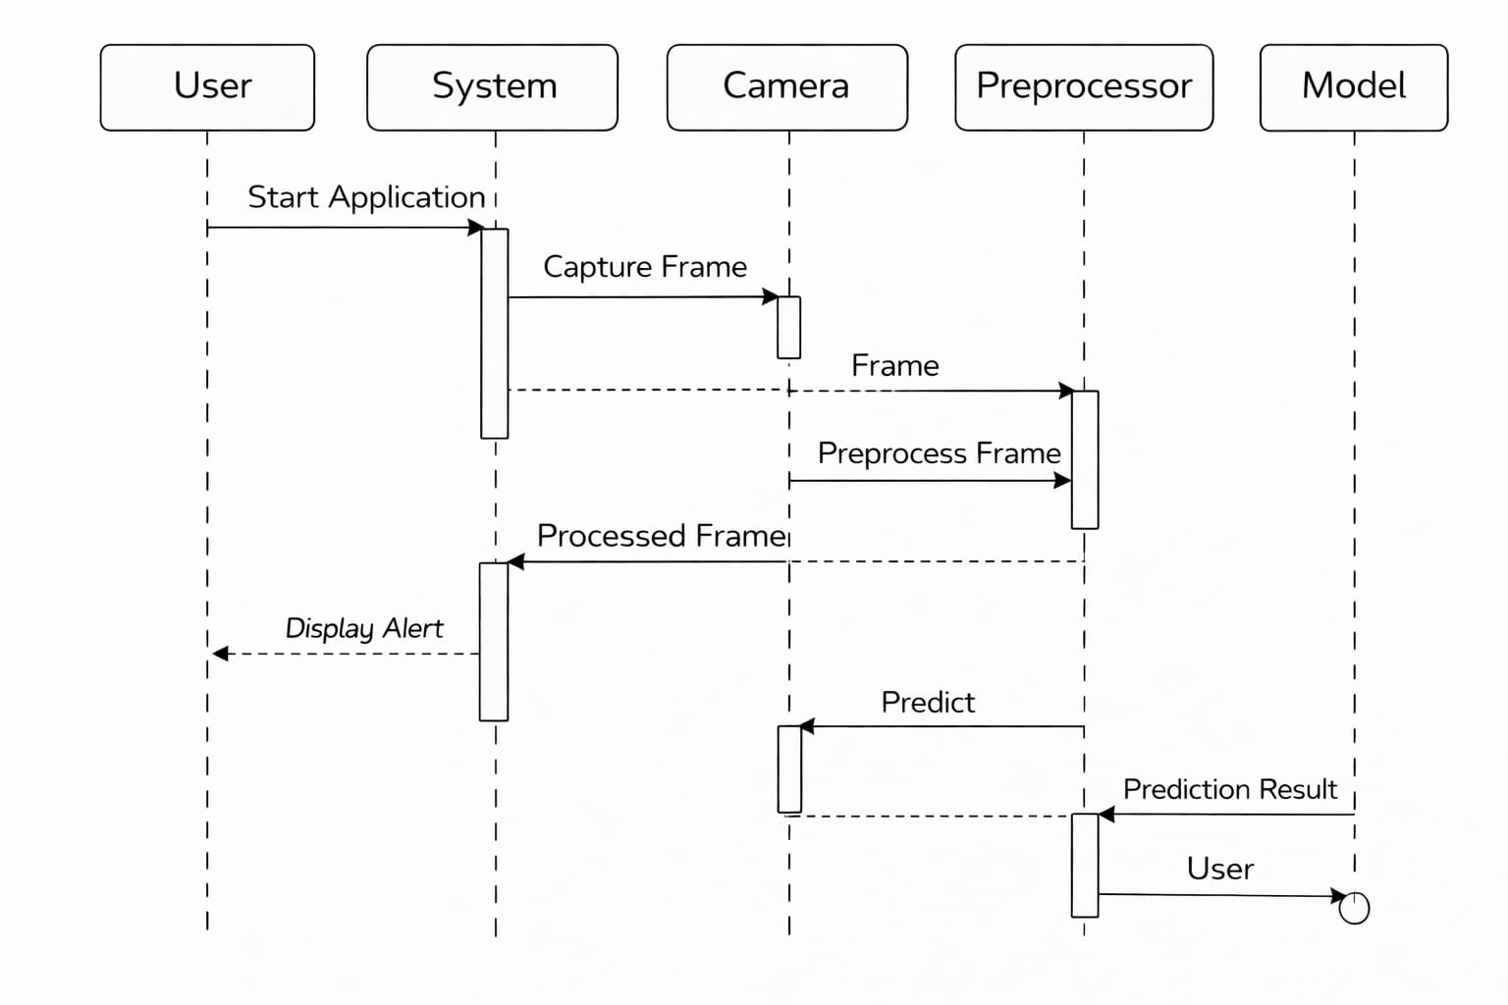
Sequence Diagram Description
The sequence of operations in the Pothole and Speed Breaker Detection System starts when the user initiates the detection process. The interaction between the User, Camera, Detection System, Deep Learning Model, and Display System is explained below.
User starts detection
The user clicks the Start option in the graphical user interface. This action sends a request to the detection system to begin real-time monitoring.
Camera captures road image
Once the detection starts, the camera is activated and continuously captures live road image frames. These frames are forwarded to the detection system.
Image preprocessing
The detection system preprocesses each captured frame. This includes resizing the image, converting it to the required format, and normalizing pixel values. Preprocessing ensures that the image is suitable for analysis by the deep learning model.
Model prediction
The preprocessed frame is sent to the trained CNN model (MobileNetV2). The model analyzes the image and predicts the road condition as normal road, pothole, or speed breaker.
Decision and validation
The detection system checks the prediction confidence and validates results across multiple consecutive frames. This step helps reduce false detections and ensures reliable output.
Display results and alerts
After validation, the detection result is sent to the display module. Visual alerts and messages are shown to the user indicating the detected road condition.
User stops detection
When the user selects the Stop option, the system stops capturing image, releases the camera, and ends the detection process.

Collaboration Diagrams
A Collaboration Diagram (also known as a Communication Diagram) shows how different objects or components of a system interact with each other to perform a specific task. Unlike sequence diagrams, which focus mainly on the order of execution over time, collaboration diagrams focus on the relationship between objects and message exchange among them.
In the Pothole and Speed Breaker Detection System, the collaboration diagram is used to explain how different system components such as the user, camera, detection module, deep learning model, and display module work together to achieve real-time road hazard detection.
This diagram helps in understanding how responsibilities are distributed among system components and how they cooperate to produce the final output.
Purpose of Collaboration Diagram in This Project
The main purpose of using a collaboration diagram in this project is:
- To identify the objects involved in the detection process
- To show communication between system components
- To explain how detection results are produced through cooperation
- To complement the sequence diagram with structural interaction details
Objects Involved in the Collaboration Diagram
The following objects participate in the collaboration process:
User (Driver / Camera User)
The user initiates and controls the detection process. The user starts and stops the system using the graphical interface and receives alerts about detected road conditions.
Camera
The camera captures live road images frames. It acts as the source of input data for the detection system.
Detection System
This is the core object responsible for managing the detection workflow. It receives input from the camera, performs preprocessing, sends data to the deep learning model, and validates predictions.
Deep Learning Model
The trained CNN model analyzes preprocessed images and predicts the road condition. It returns classification results and confidence values to the detection system.
Display / Alert Module
This module displays detection results, warnings, and alerts to the user in a clear visual format.
Interaction and Message Flow
The interaction between objects occurs as follows:
- The User sends a request to the Detection System to start detection.
- The Detection System activates the Camera.
- The Camera sends captured image frames to the Detection System.
- The Detection System preprocesses the frames and forwards them to the Deep Learning Model.
- The Deep Learning Model analyzes the images and sends prediction results back to the Detection System.
- The Detection System validates the predictions and sends final results to the Display Module.
- The Display Module shows alerts and messages to the User.

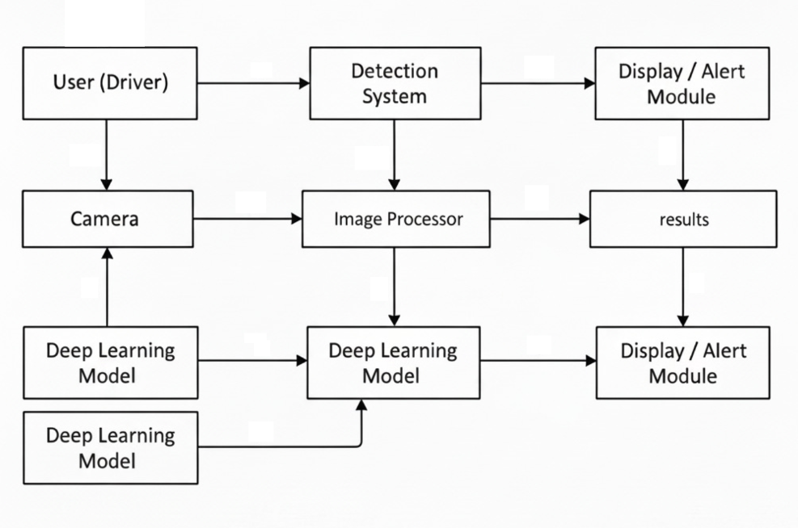
Image 5.3 : Collaboration Diagrams

Activity Diagrams -Pothole and Speed Breaker Detection System

Activity diagrams describe the flow of control between steps in a process. Below are four main workflows modeled for the Pothole and Speed Breaker Detection System.

5.4.1 Activity Diagram 1 — User Capturing Road Image

This activity diagram describes the steps involved when a user captures road images for detection.
The activity starts when the user launches the application and selects the option to start detection. The system activates the camera and begins capturing road images frames automatically. The user does not need to manually capture each image. The captured data is continuously forwarded to the detection system for further processing.
If the user decides to stop detection, the system releases the camera and ends the process.

User opens applications

System initializes camera

User positions camera

User captures road image

Clear
Image quality check
Not clear

Accept image
Ask user to recapture

User opens applications

End

5.4.2 Activity Diagram 2 — Image Preprocessing and Road Condition Classification

Step by step, this system follows how images move through the structure. Next comes a close look at each picture's outside details. After that check, results link up based on road traits. Only after confirming clarity and accuracy does grouping happen. These grouped pieces then feed into broader monitoring jobs automatically.
From road images, scaling happens first, then values are adjusted evenly across samples. After that, data moves into a model built to recognize shapes found in grids. What lies within pixel arrangements gets studied carefully, leading to conclusions on how asphalt is holding up.
When reliability crosses a threshold, it begins to guide how the system handles known issues. What people believe comes out depends on how solid the numbers look. Outcomes get approved based on how strong the confidence appears.

Receive captured image

Resize image

Normalize image

Send image to CNN model

Check confidence value
Low

High

Ignore result
Confirm classification

Send result for alert display

End

5.4.3 Activity Diagram 3 — Alert Generation and Result Visualization

A flash sets it off, followed by a small sign appearing just behind. When caught, every step reveals how raw data shifts into an alert. Step by step, they map the path from first signal to warning note, missing none of the pieces.
A jolt on the pavement makes warnings flash into view. Bright symbols show up alongside brief words, pointing out what's off. If the ground below stays even, nothing lights up. Without a single shake, the screen sits blank and quiet.
Most times, spotting begins right away because the process runs nonstop.

Receive classification result

Check road condition

Normal
Abnormal

Check confidence
Continue monitoring

Check alert
No
Yes
Is the confidence>threshold?

Display result on screen
Yes
Ignore result

Continue monitoring

Stop/Exit

End

5.4.4 Activity Diagram 4 — Admin Model and Report Management

This activity diagram explains the role of the administrator in managing the system.
Someone watches how well the system runs, checks logs showing what it caught, then goes through automated summaries. If adjustments are needed, that person tweaks the model so guesses get better over time. Settings like sensitivity levels and rules for spotting items fall under their control too.

Admin login into system

Authentication check

Valid
Invalid

Show error message
Access dashboard

Upload training data

Train/ Update model

View detection reports

Generate / Export report

Logout

End

Database Design
From the start, you will find zero databases tucked into this pothole and speed bump sensor. It works by catching road flaws live, powered by deep learning that eats up image feeds. Thanks to this design, logins never show up, nor do saved user details stick around. Tables meant for data storage? Those never made it into the design.
Instead of a database, the project uses a file-based storage approach, where required data such as trained models, datasets, and test images are stored in folders. This approach matches the actual implementation and is sufficient for the scope of the project.
Data Storage Approach Used
Based on the code implementation, the system uses the following storage components:
- Image datasets stored in folders
- Trained deep learning model file (.h5)
- Temporary image frames (in memory only)
- Console and screen output (no persistent logs)
5.5.1 Design goals
The dataset used for training and validation is stored in a directory structure. The system reads images directly from folders using Keras image generators.
Used in code:
- dataset/train/
- dataset/validation/
Each folder contains subfolders for:
- normal
- pothole
- speedbreaker
These folders act as class labels during model training.
2. Model Storage
The trained deep learning model is stored as a single file.
Used in code:
- models/road_detection_model.h5
This model file is loaded during:
- Live camera detection
- Single image testing
No versioning or metadata files are used.
3. Test Image Storage
For offline testing, the system reads images from a folder.
Used in code:
- test_images/
Only image files (.jpg, .jpeg, .png) are read and processed.
4. Temporary Data Handling
During live detection:
- Camera frames are captured
- Processed in memory
- Immediately discarded after prediction
No frames or predictions are stored permanently.

5.5.4 Directory mapping (physical layout)
project_root/
├── dataset/
│ ├── train/
│ │ ├── normal/
│ │ ├── pothole/
│ │ └── speedbreaker/
│ └── validation/
├── models/
│ └── road_detection_model.h5
├── test_images/
├── train_model_transfer.py
├── detect_live.py
└── detect_image.py
5.5.5 Conceptual ER/relationship notes (file-based)
- Dataset images → used to train the model
- Trained model → used for prediction
- Camera frames → processed temporarily
- Detection output → displayed on screen
TEMPORARY DATA
TEST IMAGES
TRAINED MODEL
DATASET IMAGES

Image 5.5.5 :Conceptual Data Flow Diagram

CHAPTER 06

IMPLEMENTATION
Ahead of everything stands Python, running with tools like TensorFlow, Keras, OpenCV, NumPy, and Tkinter. Images - either snapped live or pulled from storage - are examined closely. Road states come into view one at a time: flat stretches show up just as clearly as potholes or raised speed bumps do. Behind it all sits a setup built to tell them apart.
implementation consists of three main stages:
- Model Training
- Real-Time Detection
- Image-Based Testing

Model Training Implementation

The model training is implemented in the file train_model_transfer.py. At this stage, a backbone consisting of a pre-trained MobileNetV2 was used. Transfer learning has assisted me in enhancing efficiency and accuracy. I fed in database road images in the folders of the dataset into the training and validation splits.

In order to make the model stronger, I used data augmentation that included rotation, zoom, shifting, and the adjustment of brightness.

After the training was completed I saved the model as a .h5 file so that I would be able to load it back in the detection phase.

Real-Time Detection Implementation
Webcam access is realized by real-time detection through OpenCV. Then, a previously trained model will be loaded, and live frames will be continuously captured from the camera. Each captured frame is resized, normalized, and passed to the loaded trained model for prediction.
The system displays the detected road condition on screen, based on the prediction confidence and class label. Once a pothole or speed bump appears, warnings pop up visually. Processing happens instantly while detection data never gets saved long term.
Image-Based Testing Implementation
A single picture at a time gets analyzed when running detect_image.py. The process pulls road images from a stored directory. Each one passes through the model for evaluation separately. Running it this way skips real-time image input entirely. Results show how well the model works after training ends.
A label showing what was identified appears alongside its certainty level, shown both in terminal output and overlaid visually within the image frame.
6.2 Folder Structure
project_root/
├── dataset/
│ ├── train/
│ │ ├── normal/
│ │ ├── pothole/
│ │ └── speedbreaker/
│ └── validation/
│ ├── normal/
│ ├── pothole/
│ └── speedbreaker/
├── models/
├── test_images/
└── temp/
6.3 Data Preprocessing Module
The Data Preprocessing Module prepares road images before they are used for training and detection in the Pothole and Speed Breaker Detection System. Preprocessing maintains that all images have a uniform size, format, and pixel range so that they can be correctly processed by the deep learning model.
In this project, preprocessing is implemented directly inside the training and detection code using Keras, OpenCV, and NumPy. No separate preprocessing files or database storage are used.
6.3.1 Preprocessing During Model Training
During training, preprocessing is handled using ImageDataGenerator. This includes image normalization, resizing, and data augmentation.
Model Code Example (train_model_transfer.py):
train_datagen = ImageDataGenerator(
rescale=1./255,
rotation_range=20,
width_shift_range=0.12,
height_shift_range=0.12,
shear_range=0.08,
zoom_range=0.15,
horizontal_flip=True,
brightness_range=(0.6, 1.4),
fill_mode='nearest'
)val_datagen = ImageDataGenerator(rescale=1./255)
6.3.2 Image Resizing and Loading
Images are resized automatically while loading from folders.
Training Code (train_model_transfer.py):
train_gen = train_datagen.flow_from_directory(
TRAIN_DIR,
target_size=(224, 224),
batch_size=BATCH_SIZE,
class_mode='categorical',
shuffle=True
)
val_gen = val_datagen.flow_from_directory(
VAL_DIR,
target_size=(224, 224),
batch_size=BATCH_SIZE,
class_mode='categorical',
shuffle=False
)
6.3.3 Model Loading
The trained model is loaded before detection begins.
model = load_model(MODEL_PATH, compile=False)
MODEL_PATH = 'models/road_detection_model.h5'
6.3.4 Live Detection Using Camera
Live image frames are captured using OpenCV and processed continuously.
cap = cv2.VideoCapture(0)
ret, frame = cap.read()
6.3.5 Preprocessing During Live Detection
Each camera frame is preprocessed before prediction.
Preprocess Code (preprocess() function):
def preprocess(roi):
img = cv2.resize(roi, FRAME_SIZE)
img = cv2.cvtColor(img, cv2.COLOR_BGR2RGB)
return np.expand_dims(img.astype("float32") / 255.0, 0)
6.3.6 Prediction Logic
The model predicts the road condition and confidence score.
pred = model.predict(preprocess(roi), verbose=0)[0]
idx = int(np.argmax(pred))
label = labels[idx]
confidence = float(pred[idx])
labels = ['normal', 'pothole', 'speedbreaker']
6.3.7 Preprocessing During Image-Based Testing
Stored images are preprocessed before prediction.
detect_image.py
img = load_img(path, target_size=FRAME_SIZE)
x = img_to_array(img).astype('float32') / 255.0
x = np.expand_dims(x, 0)
6.3.8 Output Display
Detection results are displayed on the screen using OpenCV.
cv2.putText(
frame,
f"{label} {confidence:.2f}",
(10, 30),
cv2.FONT_HERSHEY_SIMPLEX,
1.0,
(0, 0, 255),
2
)

6.4 Snapshots

6.4.1 Application Home Window

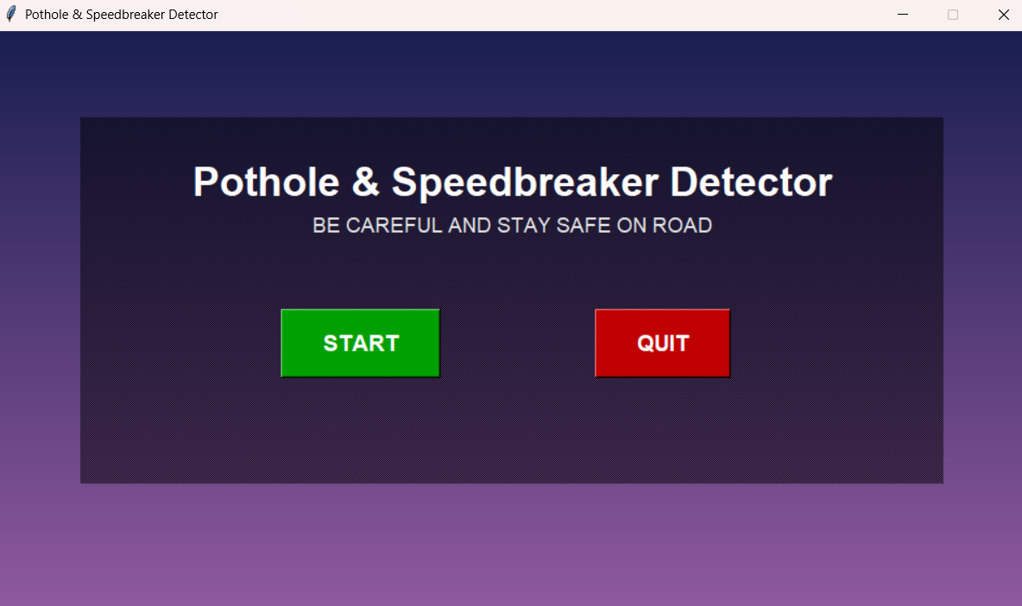

Home screen of the Pothole & Speedbreaker Detection System
6.4.2 Normal Road Detection window

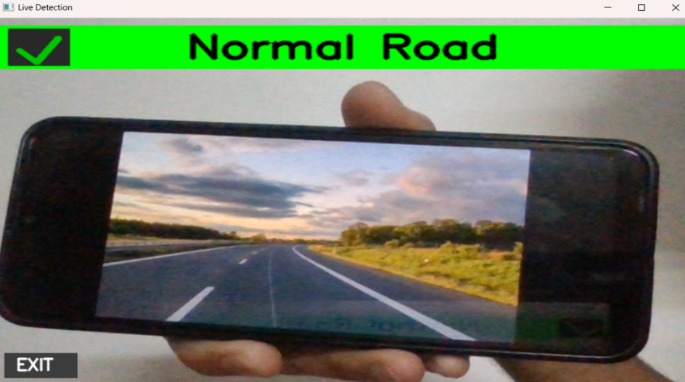

Live detection showing a normal road

6.4.3 Speed breaker Detection Window

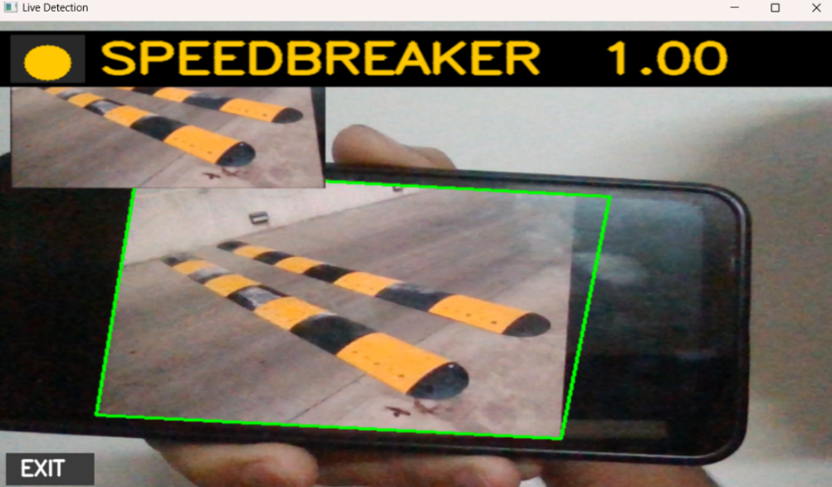

Live camera detection identifying a speedbreaker

6.4.4 Pothole Detection Window

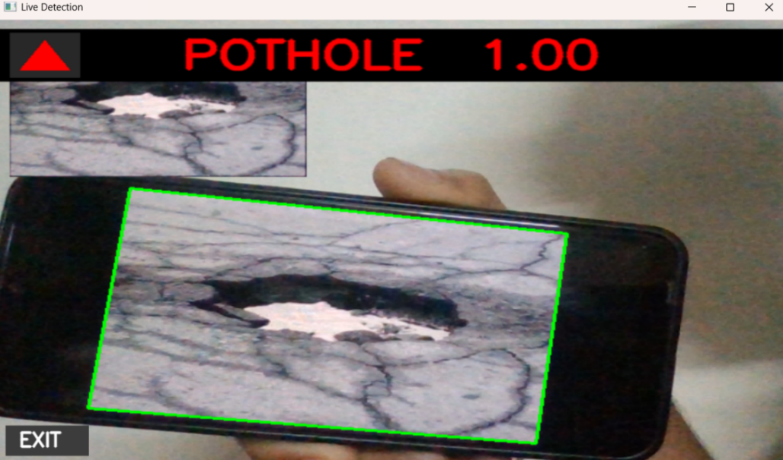

Live camera detection identifying a pothole

CHAPTER 07

SOFTWARE TESTING
Software testing is carried out to verify that the Pothole and Speed Breaker Detection System works correctly and meets the expected functionality. Testing ensures that the trained model loads properly, images are processed correctly, and detection results are displayed accurately during execution.
In this project, testing is performed manually by executing the training and detection programs and observing the outputs. No automated testing frameworks or database-based testing methods are used, as the system is a real-time computer vision application.
7.1 Testing Objectives
The main objectives of software testing in this project are:
- To verify that the trained model loads without errors
- To ensure correct preprocessing of images frames
- To test live detection using a camera
- To validate image-based detection using stored images
- To confirm correct prediction and display of results
7.2 Testing Environment
The system was tested under the following environment:
- Operating System: Windows
- Programming Language: Python
- Libraries Used: TensorFlow, Keras, OpenCV, NumPy
- Input Device: Webcam
- Hardware: Laptop / Desktop system
7.3 Types of Testing Performed
7.3.1 Model Loading Test
This test verifies whether the trained deep learning model loads successfully before detection starts.
from tensorflow.keras.models import load_model
MODEL_PATH = 'models/road_detection_model.h5'
model = load_model(MODEL_PATH, compile=False)
print("Model loaded successfully")
7.3.2 Image-Based Testing
This test checks whether the system correctly predicts road conditions using stored images.
img = load_img(path, target_size=FRAME_SIZE)
x = img_to_array(img).astype('float32') / 255.0
x = np.expand_dims(x, 0)
pred = model.predict(x, verbose=0)[0]
idx = int(np.argmax(pred))
label = labels[idx]
confidence = float(pred[idx])

7.3.3 Live Detection Testing Using Camera
A camera connected to the system checks activity as it happens.
cap = cv2.VideoCapture(0)
ret, frame = cap.read()
if not ret:
print("Camera not accessible")

7.3.4 Preprocessing Testing (Live Detection)
Before any predictions occur, the system checks whether incoming image frames have been correctly scaled and adjusted. Verification happens automatically each time data enters the pipeline. Correct dimensions and uniform values must be confirmed first. Only then does processing continue further down the line.
def preprocess(roi):
img = cv2.resize(roi, FRAME_SIZE)
img = cv2.cvtColor(img, cv2.COLOR_BGR2RGB)
return np.expand_dims(img.astype("float32") / 255.0, 0)

7.3.5 Prediction Logic Testing
With this result, it becomes clear the system pulls correct labels along with their matching
confidece scores through its prediction process.
pred = model.predict(preprocess(roi), verbose=0)[0]
idx = int(np.argmax(pred))
label = labels[idx]
confidence = float(pred[idx])

7.3.6 Output Display Testing

Whether the screen shows what was detected is checked by this test.
cv2.putText(
frame,
f"{label} {confidence:.2f}",
(10, 30),
cv2.FONT_HERSHEY_SIMPLEX,
1.0,
(0, 0, 255),
2
)
7.4 Integration testing:
Testing how modules work together checks their combined performance. Throughout this project, the full detection process served as the framework for those tests.
Modules Integrated
- Model Loading Module
- Preprocessing Module
- Live Detection Module
- Prediction Logic
- Output Display Module
Integration Testing Process
- The trained model was loaded from the models folder
- Live camera frames were captured using OpenCV
- Frames were preprocessed and passed to the model
- Predictions were generated
- Results were displayed on the screen

Example Integration Test
model = load_model(MODEL_PATH, compile=False)
pred = model.predict(preprocess(roi), verbose=0)[0]
label = labels[np.argmax(pred)]

7.5 System Testing
System testing verifies the complete functionality of the project as a whole. The system was tested by executing the detection programs end-to-end.
System Testing Activities
- Running model training script
- Executing live detection script
- Testing image-based detection
- Observing output accuracy and stability
7.6 Performance Testing
Performance testing evaluates the responsiveness of the system during execution.
Performance Criteria Tested
- Real-time frame processing
- Model prediction speed
- Camera response
Observation
- Predictions were generated within acceptable time
- No noticeable lag during live detection
- System performance depends on hardware capability
7.7 User Acceptance Testing (UAT)
User Acceptance Testing (UAT) was successfully conducted by executing the system from the user’s perspective.
- UAT Scenario
- User starts the detection program
- Camera activates automatically
- Road condition is displayed
- User stops the detection
- Acceptance Result
- System was easy to use
- No manual configuration required
- Output was clear and understandable
  - Test Case Design
Design Test case design was carried out based on the requirements functional system behavior of the system. Each test case directly corresponds to a module implemented in the code.
Test Cases:
TC ID | Description | Expected Result | Status
TC001 | Load trained model | Model loads without error | Pass
TC002 | Preprocess image | Image resized and normalized | Pass
TC003 | Live camera detection | Prediction displayed in real time | Pass
TC004 | Image-based testing | Correct label with confidence | Pass
TC005 | Output display | Result shown on | Pass
Test Environment
HARDWARE REQUIREMENTS
The hardware requirements for implementing and testing the Pothole and Speed Breaker Detection System are minimal and easily available.
- Processor: Intel / AMD processor (minimum dual-core)
- RAM: Minimum 8 GB
- Storage: Minimum 20 GB free disk space
- Camera: Built-in webcam or external USB camera
- Display: Standard monitor or laptop display
- System Type: Laptop / Desktop
The camera is used to capture live road images for real-time detection.
SOFTWARE REQUIREMENTS
The software requirements include programming tools, libraries, and frameworks used to develop, train, and test the system.
Operating System
- Windows OS
Programming Language
- Python 3.10
Libraries and Frameworks
- TensorFlow – Model training and prediction
- Keras – Deep learning model implementation
- OpenCV – Image processing and live camera handling
- NumPy – Numerical operations
- Pillow (PIL) – Image handling
- Tkinter – Graphical user interface.

CHAPTER 08

CONCLUSION
The Pothole and Speed Breaker Detection System developed in this project demonstrates the practical application of deep learning and computer vision techniques in addressing real-world road safety problems. Bumpy surfaces, along with unclear speed humps, often lead to car troubles and collisions on roads. Because of this, a system has been built that automatically spots these issues - helping lower danger over time.
A fresh start was made with Python, choosing a MobileNetV2-inspired convolutional network. Pre-existing patterns were tapped into through transfer learning, shaping the model toward identifying road states. Image inputs underwent changes - resized, adjusted for balance, enriched - to strengthen how well predictions held up under variation. What emerged stood on better footing thanks to these layered improvements.
It was integrated with two detecting modes: image-based testing and real-time live detection with the help of a camera. Image-based testing had helped to validate the accuracy of the model with stored road images, while live detection demonstrated the real-world time capability of the system. These systems were successful in classifying the road conditions into normal road, pothole, and speed breaker categories and also showed confidence scores of results.
Running the system used a webcam along with test images to simulate actual usage. When light levels stayed steady and cameras worked properly, outcomes showed consistent operation. If illumination shifted, image clarity dropped, or data quality slipped, effectiveness might decline. Still, overall performance matched what the project originally asked for.
With just files and no database, the system stays clear and straightforward. Built in separate parts, it can grow later without rewriting what already works. A minimal setup means less to manage, fewer points of failure. Changes fit naturally because pieces connect loosely, yet function together.
So far, progress shows clear results - The system has been constructed to reliable performance. Deep learning works well here, handling road assessment without constant human input. Moving ahead, upgrades could include sharper cameras or broader image collections. Performance might improve even more when fine-tuned under real traffic conditions. Future use in vehicle support tools or smart transit networks seems possible, given current outcomes.

CHAPTER 09

FUTURE ENHANCEMENTS
The Pothole and Speed Breaker Detection System presented in this project demonstrates the effective use of deep learning and computer vision techniques for identifying road surface irregularities. Even though the present code meets the requirements and works correctly in the tested use cases, there is still considerable scope for improvement and enhancement in the future.
One of the key areas for enhancing the proposed solution in the future is the addition of more images to the training set. The current approach uses a set of images pertaining to the normal road, pothole, and speed breaker, and the classifier is trained using this set of images Visual variety - like diverse road types, varying light conditions, or rainy scenes - may boost performance of the proposed approach. Including these elements during evaluation can lead to higher precision.
One major aspect centers on boosting both accuracy and efficiency. While MobileNetV2 shows solid results in precision, exploring other compact models may yield stronger performance. Shifting parameters or refining current setups has potential to reveal gains. Rather than relying solely on established methods, cutting unnecessary components can streamline the system. Speed also improves when numerical ranges are narrowed, maintaining effectiveness while easing demands.
Nowadays, most webcams come equipped with built-in motion sensing. Detection happens directly through the device itself. Moving ahead, upgrades could allow vehicle-installed cameras to take part - perhaps even a smartphone lens. With that setup, road surfaces get watched nonstop during travel, which makes the whole approach more usable in real situations.
Now comes a key upgrade: adding geographic data. When detection outcomes link with positional details, the setup logs where each pothole and speed bump sits. Such records make mapping possible - helping agencies manage repairs while feeding real-time updates into navigation tools.
Right away, a noticeable upgrade could come from including instant alerts. Currently, visuals appear only on display screens. Instead of waiting, drivers might hear warnings when road hazards like potholes show up ahead. Immediate feedback - through sound cues, for example - could make travel noticeably safer
Finding additional road issues could become part of upcoming studies - things like surface splits, bumpy sections, puddles in holes, or scattered trash on pavement. Expanding the types recognized might grow the category range, helping systems track road conditions with greater detail a
nd usefulness over time.
A shift toward cloud-based systems could offer a practical next step. Information gathered from detecting road wear might go into centralized storage, making patterns clearer over time. Where problems repeat most often becomes visible through consistent logging. Attention from maintenance teams can then align more closely with actual need. Resources move where they are most effective, based on evidence.
Improving the system begins with integration into intelligent transportation networks. Once embedded, smart vehicles or urban traffic setups could take advantage of its capabilities. Further optimization opens doors to mobile application use. Safer, more efficient commutes become possible when these updates are applied.
Ultimately, improvements suggested here aim to boost accuracy while expanding capacity and real-world usefulness. Such upgrades can be useful to upgrade the prototype to a full-fledged solution for road safety and infrastructure monitoring.

CHAPTER 10

APPENDIX A-BIBLIOGRAPHY

- Ian Goodfellow, Yoshua Bengio, and Aaron Courville,
Deep Learning, MIT Press, 2016.
- Andrew G. Howard et al.,
“MobileNets: Efficient Convolutional Neural Networks for Mobile Vision Applications,”
arXiv preprint arXiv:1704.04861, 2017.
- Sandler, M., Howard, A., Zhu, M., Zhmoginov, A., and Chen, L. C.,
“MobileNetV2: Inverted Residuals and Linear Bottlenecks,”
Proceedings of the IEEE Conference on Computer Vision and Pattern Recognition (CVPR), 2018.
- TensorFlow Documentation,
“TensorFlow: An End-to-End Open Source Platform for Machine Learning,”
Available: https://www.tensorflow.org
- Keras Documentation,
“Keras: Deep Learning for Humans,”
Available: https://keras.io
- OpenCV Documentation,
“Open Source Computer Vision Library,”
Available: https://opencv.org
- Gonzalez, R. C., and Woods, R. E.,
Digital Image Processing, 4th Edition, Pearson Education, 2018.
- NumPy Documentation,
“NumPy: A primary package supporting scientific computation in Python”
Available: https://numpy.org
- Python Software Foundation,
“Python Programming Language Documentation,”
Available: https://www.python.org
- Szeliski, R.,
Computer Vision: Algorithms and Applications, Springer, 2011.

APPENDIX B-USER MANUAL
This user manual explains how to install, configure, and use the Pothole and Speed Breaker Detection System. The system is designed to be simple and can be operated by users with basic computer knowledge.
B.1 System Requirements
Hardware
- Laptop or Desktop Computer
- Minimum 8 GB RAM
- Built-in or external Webcam
- Minimum 20 GB free storage
Software
- Windows Operating System
- Python 3.10
Required Python Libraries
- TensorFlow
- Keras
- OpenCV
- NumPy
- Pillow
- Tkinter
B.2 Installation Steps
- Install Python 3.x on the system.
- Copy the complete project folder to the local machine.
- Open Command Prompt inside the project directory.
- Install required libraries.
- Ensure the folder structure is maintained correctly:
- dataset/
- models/
- test_images/
B.3 Using the Application
The application supports three modes of operation:
1. Model Training
- Place training images in the dataset folders.
- Run the training script:
- python train_model_transfer.py
- After training, the model file is saved in the models folder.
2. Image-Based Testing
- Copy test images into the test_images folder.
- Run the command:
- python detect_image.py
- The detected road condition and confidence score are displayed.
3. Live Detection Using Camera
- Ensure the webcam is connected.
- Run the live detection script:
- python detect_live.py
- The camera window opens and shows real-time detection.
- Press ‘q’ or click EXIT to stop detection.
B.5 SAMPLE SCREENSHOTS
The following screenshots are included in the project report:
- Model training output in console
- Dataset folder structure
- Trained model file saved
- Image-based detection result
- Live detection showing:
  - Normal Road
  - Pothole detected
  - Speed Breaker detected

B.6 TROUBLESHOOTING

Issue 1: Camera Not Opening
- Ensure no other application is using the webcam.
- Check camera permissions.
Issue 2: Model File Not Found
- Ensure the model is trained successfully.
- Verify road_detection_model.h5 exists in the models folder.
Issue 3: Low Detection Accuracy
- Ensure good lighting conditions.
- Use clear and properly focused images.
- Improve dataset quality if required.
Issue 4: Module Import Error
- Ensure all required libraries are installed correctly.
- Reinstall missing packages using pip.

