RetailQ
End-to-End Modern Data Engineering on Databricks
Implementation, Architecture & Trade-offs — a Reusable Project Blueprint
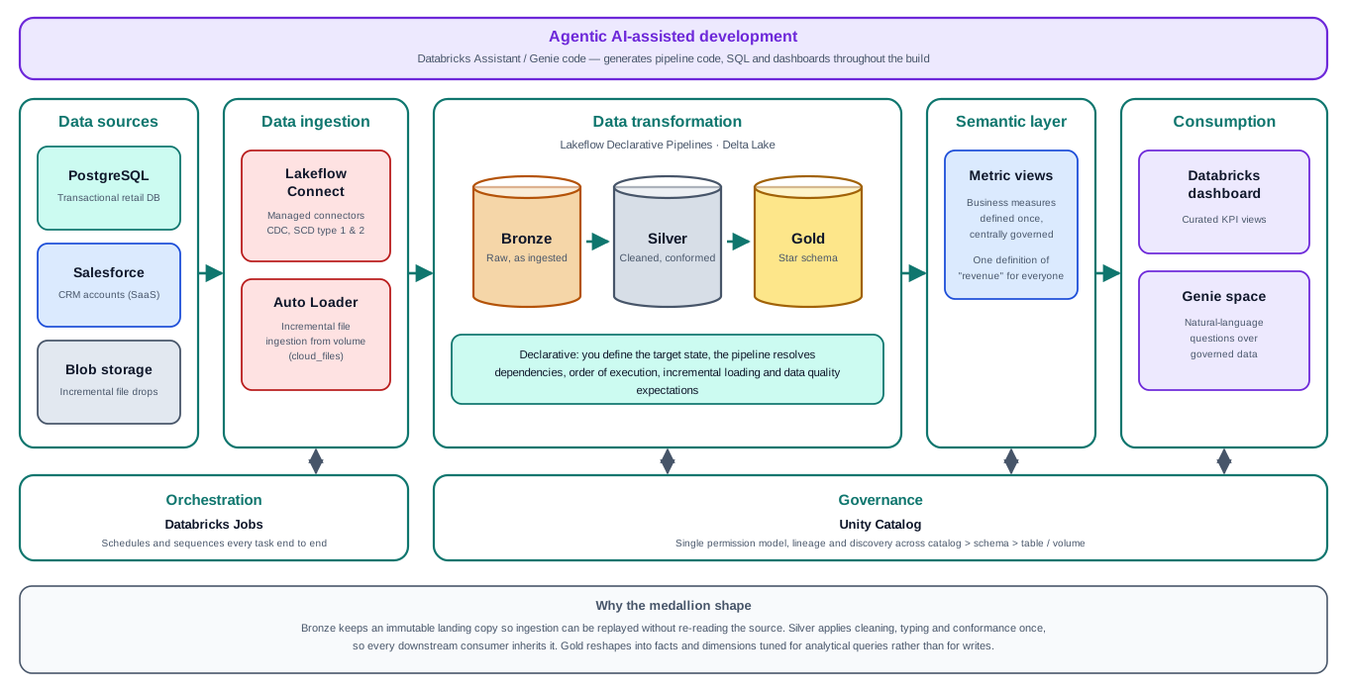
A multi-source lakehouse: three ingestion patterns into a medallion architecture,
a dimensional gold layer, a governed semantic layer, self-service analytics, orchestrated end to end.
Project summary & future-build reference
Based on the Databricks retail project by Narender Kumar, implemented and extended.

Contents

1. How to use this document
This is two things at once: a record of what was built, and a blueprint for building a similar platform again. Read it in either order.
- As a blueprint — Section 2 is the reusable spine: the phases every modern data-engineering project moves through, independent of this particular retail use case. Mind-map from Section 2; use the rest as the detail behind each branch.
- As a record — Sections 4–7 walk the build in the order it happened, with the code, the decisions, and every trade-off that was made or deferred.
- As a study aid — Section 9 maps each part of the project onto the Databricks Certified Data Engineer Associate exam, separating what is examinable from what is portfolio-only.

The one-line summary
Three heterogeneous sources (PostgreSQL, Salesforce, cloud files) ingested by three different patterns into a medallion lakehouse, modelled as a star schema, governed by a semantic layer, consumed through a dashboard and natural-language Genie, and run as one scheduled job — all under Unity Catalog governance.

2. The reusable blueprint — the spine to mind-map from
Any modern data-engineering project on a lakehouse moves through the same phases. The technologies change; the sequence and the questions do not. This is the part to internalise.

The seven phases
# | Phase | The question it answers | In this project
0 | Use case & architecture | What are we building, and why? What is the grain of the core fact? | Retail analytics; grain = one transaction
1 | Source setup | What are the sources, and what class of ingestion does each need? | Postgres (DB), Salesforce (SaaS), CSV (files)
2 | Ingestion → bronze | Get raw data in, incrementally, without losing or duplicating. | Lakeflow Connect + Auto Loader
3 | Transform → silver | Clean, type, conform, quality-check. Once, for everyone. | Declarative pipelines + expectations
4 | Model → gold | Reshape into facts & dimensions tuned for reading. | Star schema
5 | Semantic layer | Define each business metric once, centrally. | Metric view
6 | Consumption | Let people get answers — curated and ad-hoc. | Dashboard + Genie
7 | Orchestration | Run it all in order, on a schedule, reliably. | Databricks Job

Two concerns run across every phase, never confined to one: governance (Unity Catalog — one permission and lineage model over catalog > schema > table/volume) and orchestration (the Job that sequences the phases). Governance is a prerequisite, not a final step: the managed connectors, metric views and Genie all require Unity Catalog to function.

The decision at each phase
A blueprint is only useful if it tells you what to decide. At each phase, the load-bearing question:
- Phase 0 — What is the grain of the fact table? Decide this before anything else; every downstream choice follows from it.
- Phase 1 — For each source: is it a database (CDC), a SaaS app (API connector), or files (Auto Loader)? The source type picks the ingestion tool.
- Phase 2 — Managed connector or code? If a connector exists, use it (no code, CDC & SCD for free). If the source is files, Auto Loader in code.
- Phase 3 — For each table: streaming table or materialized view? And what are the data-quality rules, derived with the business, not guessed by an AI?
- Phase 4 — Which columns are measures (how much) and which are attributes (by what)? Natural or surrogate keys? SCD type 1 or 2?
- Phase 5 — Which measures are additive, and at what grain? This is where you design out the mixed-grain traps.
- Phase 6 — Point consumption at the semantic layer, not the raw tables, so every tool inherits one definition.
- Phase 7 — What runs in parallel, what is serial? What must be refreshed (tables) vs what is live (views)? What is the schedule and the retry policy?

3. Architecture
The platform reads along one horizontal path and is held up by two vertical concerns.
The RetailQ reference architecture
- Horizontal — the data path: sources → ingestion → medallion transformation → semantic layer → consumption.
- Vertical — two cross-cutting concerns touching every stage: Databricks Jobs orchestrates them; Unity Catalog governs them.
- Top band — the Databricks Assistant used to accelerate development. Not a runtime component; nothing in production depends on it.

Why three sources — the design decision worth understanding
The three sources are not arbitrary. They are the three ingestion archetypes found in almost any real platform:
Source | Ingestion pattern | Real-world class of problem | AWS parallel
PostgreSQL | Managed CDC connector | Operational DB — rows change, need change capture | DMS
Salesforce | Managed SaaS connector | API-based SaaS — no DB access, object model | AppFlow / Glue connector
Cloud files | Auto Loader | File drops — arrive continuously, must not reprocess | S3 events → SQS → consumer

Resume framing
"Integrated three heterogeneous source types using the appropriate ingestion pattern for each" is a far stronger claim than "built a pipeline". The project teaches three patterns, not three datasets.

4. The data model — gold star schema
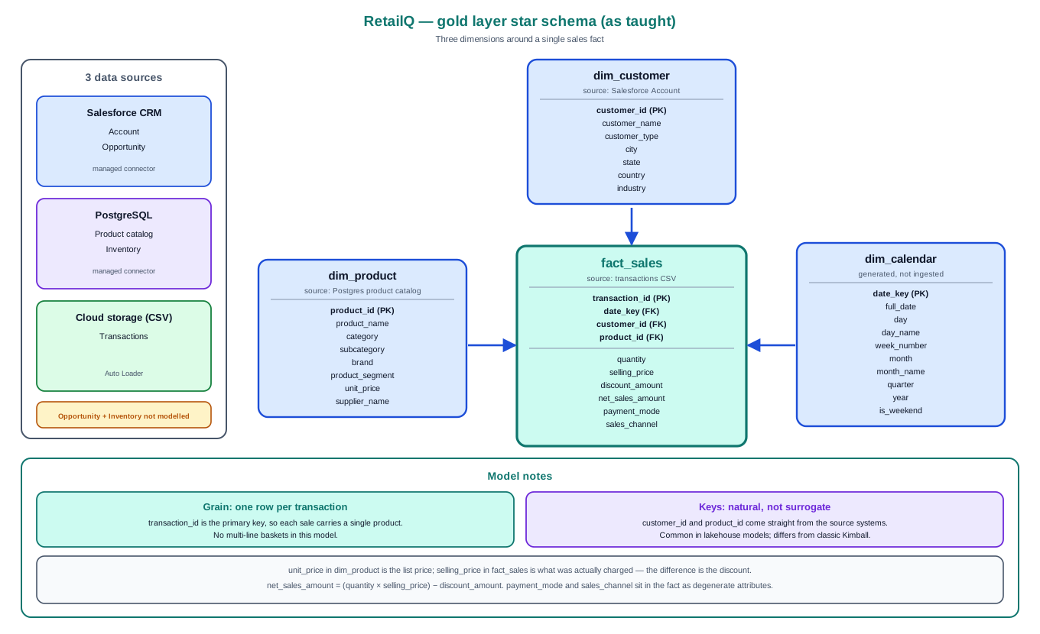
The target star: one sales fact, three dimensions
Grain: one row per transaction (transaction_id is the primary key). Each sale carries a single product — simplified versus real retail baskets, but it keeps the joins clean.

Attribute vs measure — the test that places every column
Why does unit_price sit on dim_product while selling_price sits on fact_sales? Because one describes the product and the other measures the sale. The three-question test:
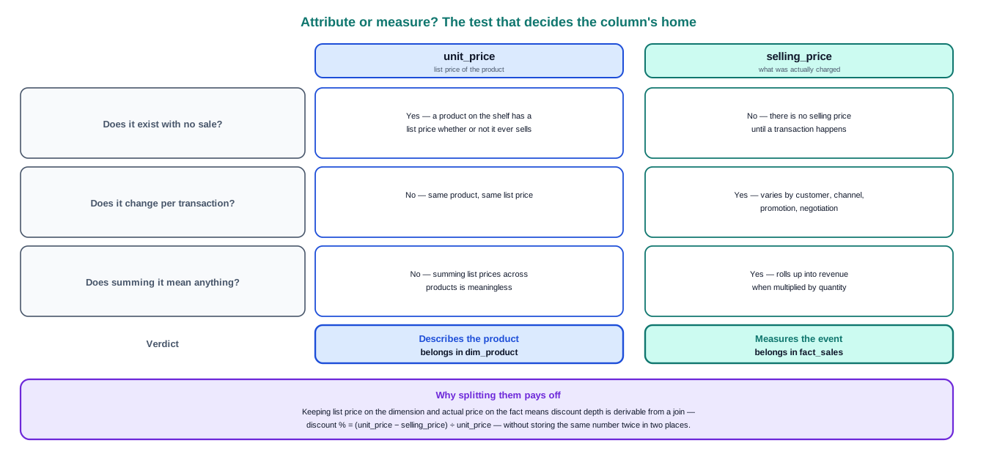
Does it exist with no sale? Does it change per transaction? Does summing it mean anything?
List price lives on the dimension; actual price charged lives on the fact; the gap between them is the discount. This separation is what lets you compute discount depth from a join without storing the same number twice.

5. The build, phase by phase

5.1 Source setup (Phase 1)
PostgreSQL on Neon (free tier); Salesforce Developer Edition; CSV files for transactions. Two PostgreSQL tables were authored by hand.
Trap fixed: positional INSERTs
The tutorial’s "invalid records" blocks used INSERTs with no column list, placing a timestamp in a boolean column and integers into VARCHAR primary keys — which fail outright, because a primary key is implicitly NOT NULL and cannot hold a NULL or a type-mismatched value.
Fix: always name the columns, quote the IDs, and keep deliberately-bad rows in NON-key columns. A managed CDC connector requires a primary key on the source, so the defects had to live elsewhere.
Lesson: write the column list in every INSERT. Positional inserts fail silently when types happen to line up — a swapped city/state would corrupt data with no error.

5.2 Ingestion → bronze (Phase 2)
Two tools, chosen by source type. Understanding the taxonomy is the point:
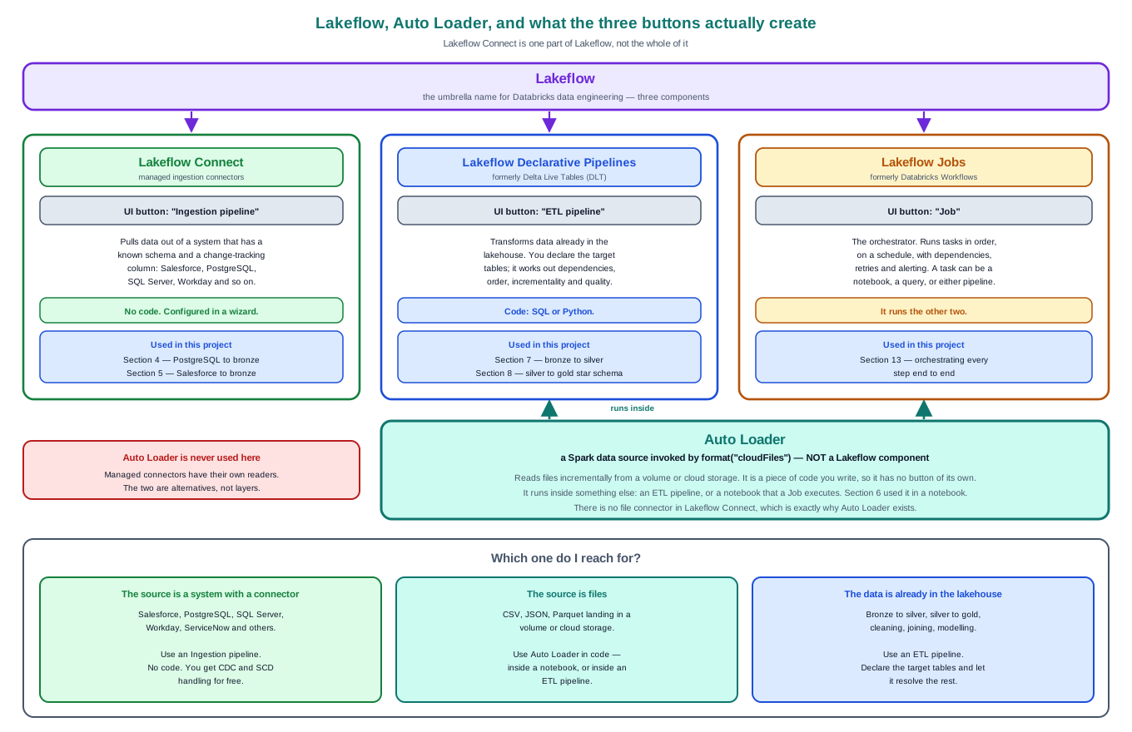
Lakeflow is the umbrella; Connect, Declarative Pipelines and Jobs are its parts. Auto Loader is a Spark data source, not a Lakeflow component.
UI button | Creates | Lakeflow component
Ingestion pipeline | managed connector ingestion | Lakeflow Connect
ETL pipeline | declarative transformation | Declarative Pipelines (was DLT)
Job | orchestration | Jobs (was Workflows)

Lakeflow Connect — PostgreSQL & Salesforce
No code. A UI wizard: connection (a Unity Catalog securable holding credentials), pipeline, source tables, destination. Per table you choose a cursor column (the watermark for incremental extraction) and a history-tracking toggle.
The toggle is the whole SCD lesson. The same source change produces two different target behaviours:
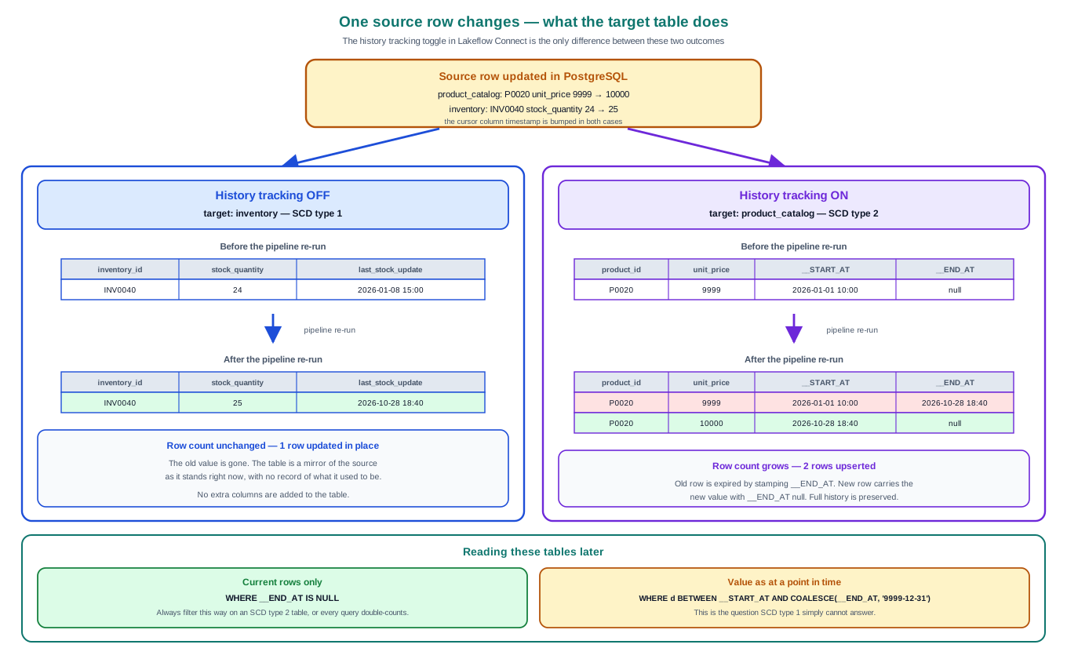
History tracking OFF = SCD type 1 (overwrite in place). ON = SCD type 2 (expire old row, insert new).
The query rule you must not forget
On an SCD type 2 table, always filter WHERE __END_AT IS NULL unless you deliberately want history. Forget it and every aggregate silently double-counts anything that has ever changed. This is the most common SCD bug in production.
Limitation worth stating: this is watermark-based incremental extraction, not log-based CDC. Deletes in PostgreSQL are not propagated (a deleted row has no timestamp to detect), and a row updated without bumping the cursor column is missed. Salesforce avoids the delete blind spot via its IsDeleted soft-delete flag.

Auto Loader — the transactions files
No connector exists for arbitrary files, so Auto Loader is used in a notebook, invoked by format("cloudFiles"). It is a Spark data source, not a Lakeflow component.
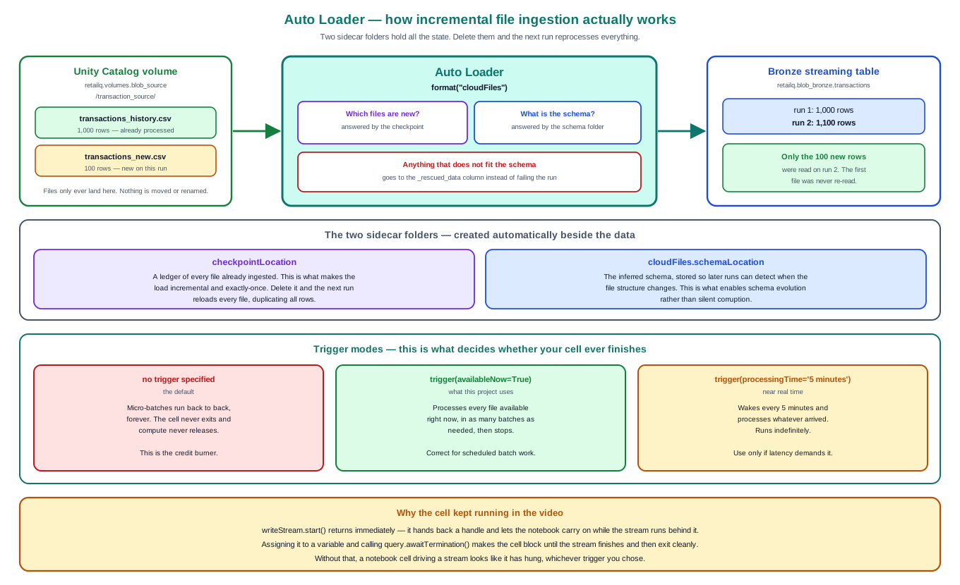
Two sidecar folders hold all the state. Delete them and the next run reprocesses everything.
- checkpointLocation — the ledger of files already processed. This is what makes the load incremental and exactly-once.
- cloudFiles.schemaLocation — the inferred schema, enabling schema evolution.
- _rescued_data — anything that does not fit the schema lands here rather than failing the run.
Trigger choice decides whether the cell ever finishes. availableNow=True processes what is there and stops (used here); omit the trigger and it micro-batches forever. And query.awaitTermination() is required for the cell to block until the batch completes and exit cleanly — without it, a streaming write returns immediately and the cell appears to hang.
Type inference gotcha
For CSV/JSON, Auto Loader types every column as STRING unless cloudFiles.inferColumnTypes = true. The CSV reader’s inferSchema is NOT the equivalent option. Because the schema is cached in the schema location, fixing the option later needs the schema & checkpoint folders cleared and a reload.

5.3 Transform → silver (Phase 3)
Built with a Lakeflow Declarative (ETL) pipeline: you declare each target table as a decorated function; the framework infers dependencies, order, incrementality and quality. No CREATE TABLE, no MERGE, no checkpoint management.

Expectations — data quality as code
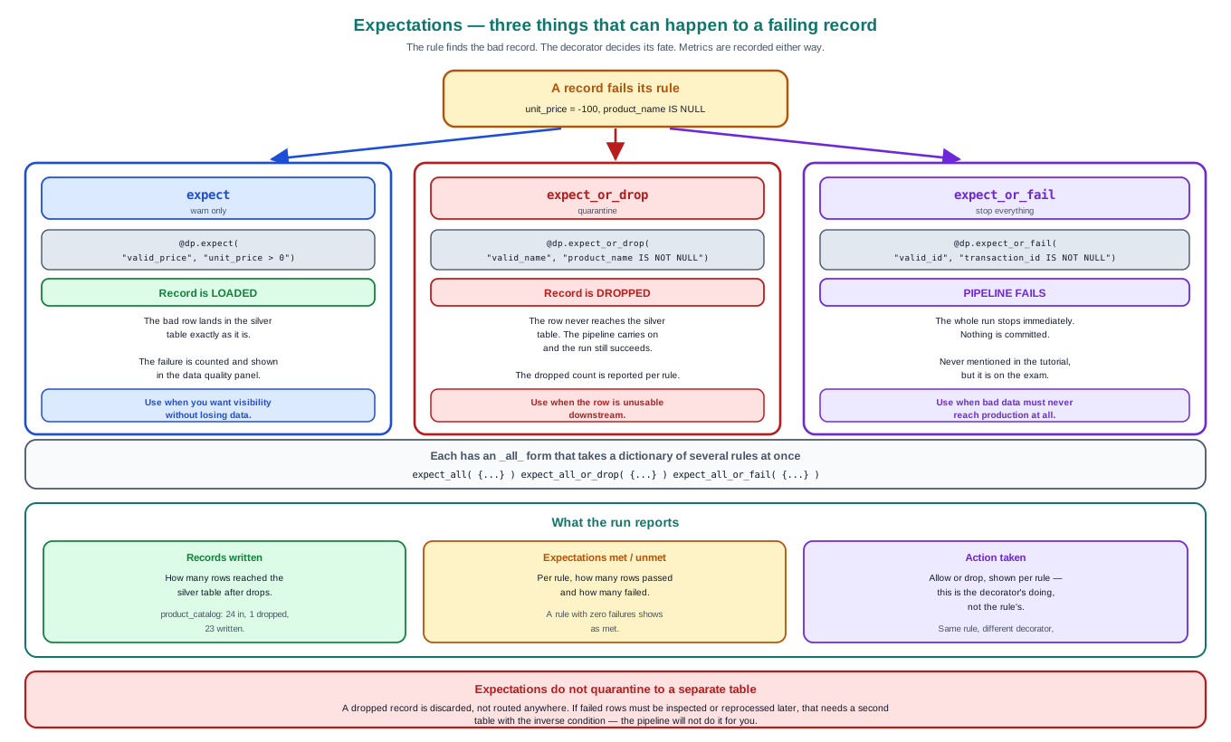
The rule finds the bad record; the decorator decides its fate.
Decorator | Failing record | Pipeline
@dp.expect | loaded anyway, counted | continues
@dp.expect_or_drop | dropped | continues
@dp.expect_or_fail | — | run fails immediately

Each has an _all_ variant taking a dict of rules. Prefer individual rules over the grouped form: grouped rules share one action and report as one metric; individual rules let each condition have its own action and show separately in the data-quality panel.
Data quality is a business decision, not an AI one
An AI reading a schema can propose STRUCTURAL rules (not null, length, positive, enum). It cannot infer SEMANTIC rules (a Closed-Won opportunity must have a past close date) — those come from the business. And the ACTION (warn / drop / fail) encodes organisational tolerance, which an AI has no basis to choose.
Workflow used: profile with AI to surface anomalies → validate with the data owner, who assigns each action → generate the implementation → review every line. The AI is used twice and decides nothing. The artifact is a data-quality register: table, column, rule, action, owner, rationale.

Streaming table vs materialized view — the choice that governs refresh
Each silver/gold table is one or the other. The read style decides it, and it shows up later in the pipeline’s "Incrementalization" column as "N/A" (streaming) or "Full recompute" (materialized view).
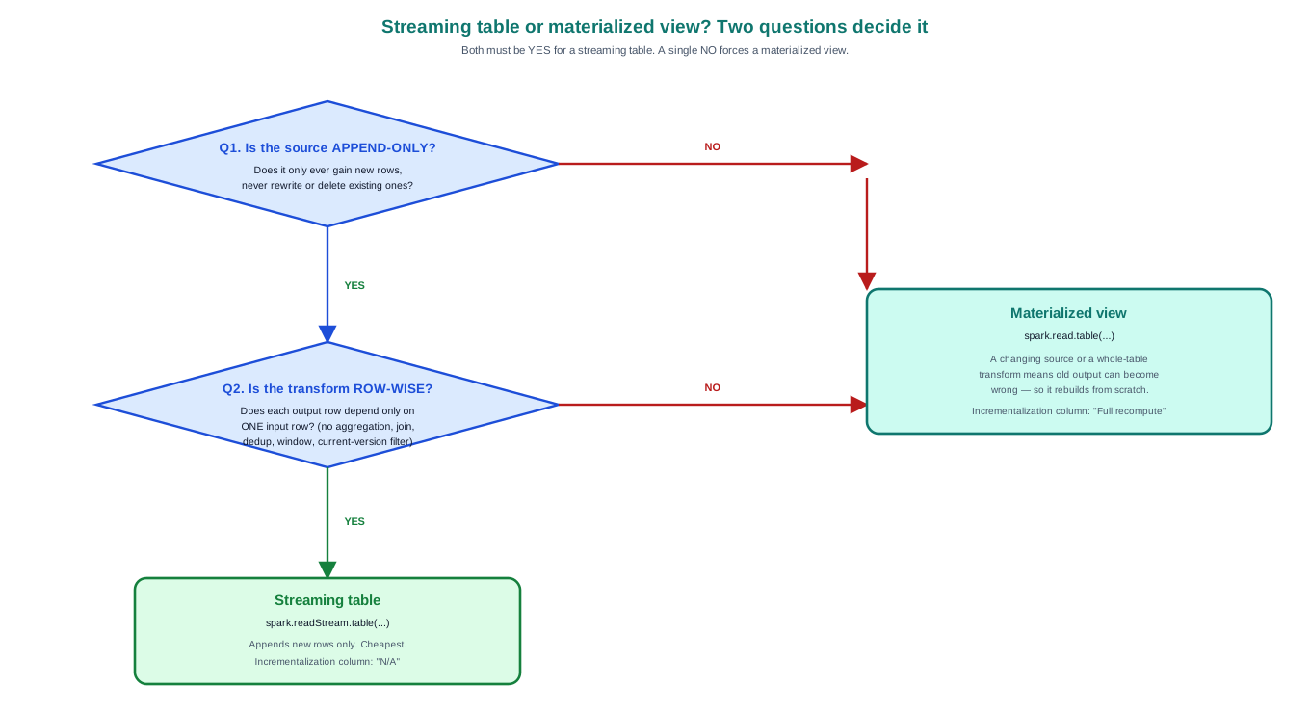
Both questions must be YES for a streaming table; one NO forces a materialized view.
- Streaming table — spark.readStream. Append-only source, each row processed once, checkpoint-backed. Only ever adds rows.
- Materialized view — spark.read. A changing source or a whole-table transform means old output can go stale, so it rebuilds from scratch each run.
Rule of thumb: facts and append-only file sources can stream; anything built on a merge-maintained SCD source should be a materialized view. Streaming trusts the past; merges rewrite the past; the two don’t mix.
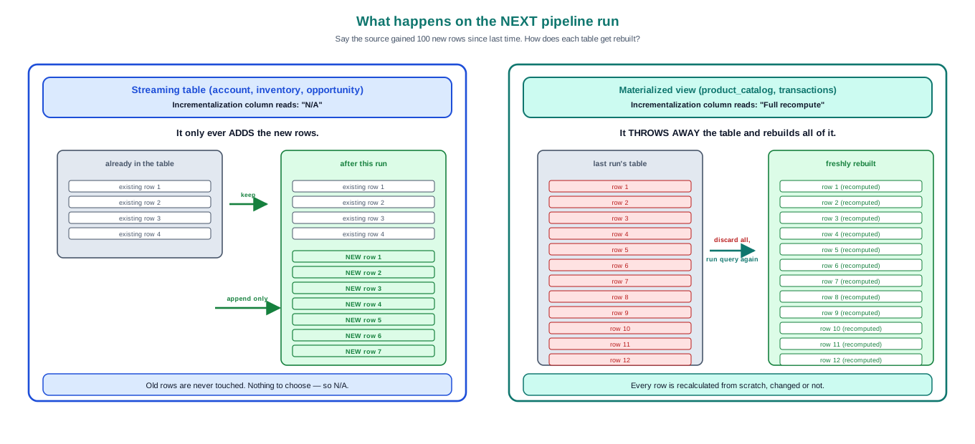
What each does on the next run: append new rows (N/A) vs discard and rebuild all (Full recompute).

Audit columns — three clocks
The silver product table carries three timestamps, each written by a different actor. The gaps between them are diagnostics.
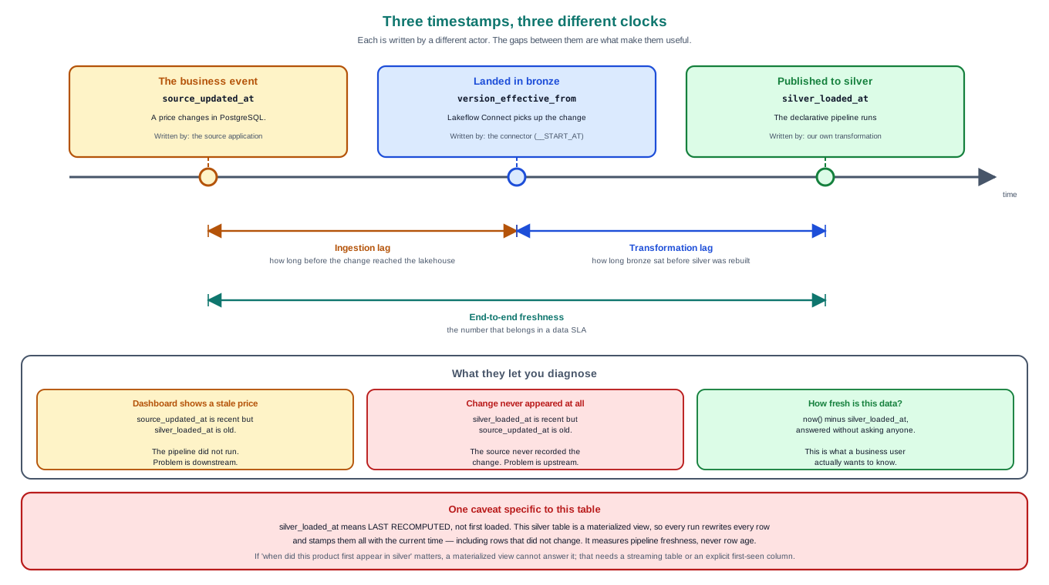
source_updated_at (the business event) · version_effective_from (landed in bronze) · silver_loaded_at (published to silver).
If a dashboard shows a stale value: recent source_updated_at but old silver_loaded_at means the pipeline didn’t run (downstream problem); the reverse means the source never recorded the change (upstream problem). Note silver_loaded_at means "last recomputed", because the table is a materialized view rebuilt every run.

5.4 Model → gold (Phase 4)
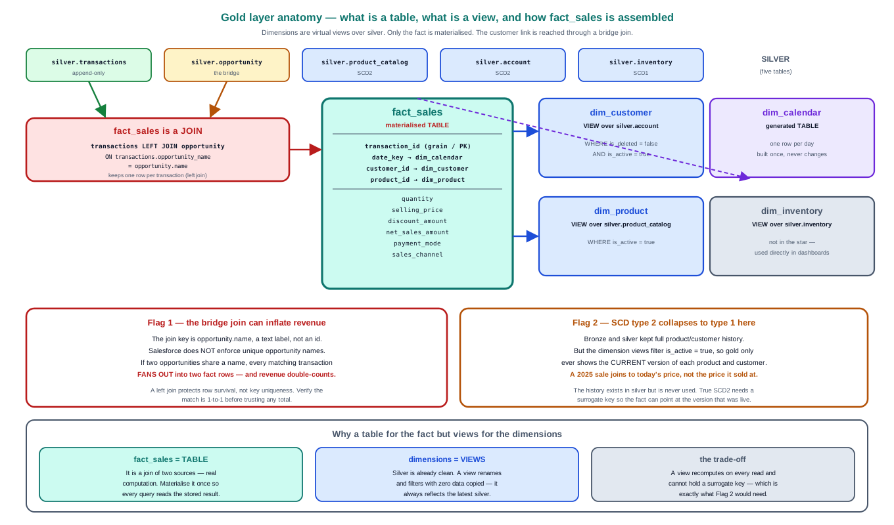
One materialised fact, three virtual dimension views, one generated calendar.
Gold object | Built as | Why
fact_sales | materialised TABLE (in pipeline) | a real join — compute once, store
dim_customer / dim_product | VIEW over silver | silver already clean — no copy
dim_inventory | VIEW (named fact_inventory) | not in the star; for dashboards
dim_calendar | generated TABLE | no source; built once

The dimension views filter is_deleted = false AND is_active = true, which quietly fixes the two silver gaps (soft-deletes and SCD2 duplicates). fact_sales is assembled by a LEFT JOIN of transactions to opportunity on opportunity_name — opportunity is a bridge table resolving the customer, because transactions carry no customer id.
Flag 1 — the bridge join can inflate revenue
The join key is opportunity.name, a text label; Salesforce does not enforce unique opportunity names. If two share a name, every matching transaction fans out into multiple fact rows and revenue double-counts. A left join protects row survival, not key uniqueness. Verify fact_rows ≤ txn_rows before trusting any total.
Flag 2 — SCD type 2 collapses to type 1 at gold
Bronze and silver keep full history, but the dimension views filter is_active = true, so gold only ever shows the CURRENT version. A six-month-old sale joins to today’s price, not the price it sold at. The history exists in silver and is never read. This is a valid "current-value dimension" choice — but it means the SCD2 machinery is latent. Realising it needs surrogate keys so the fact can point at the version that was live.

Mixed-grain measure (Flag 3)
The fact carries amount — the opportunity’s total deal value — onto a transaction-grain fact, repeated across every transaction of a deal. SUM(amount) therefore multi-counts. The transaction-grain measures (quantity, quantity * selling_price) are additive and safe; amount is not. This is exactly what the semantic layer exists to govern.

5.5 Semantic layer (Phase 5)
A semantic layer is the place where each business term is defined once, so no two queries re-invent it.
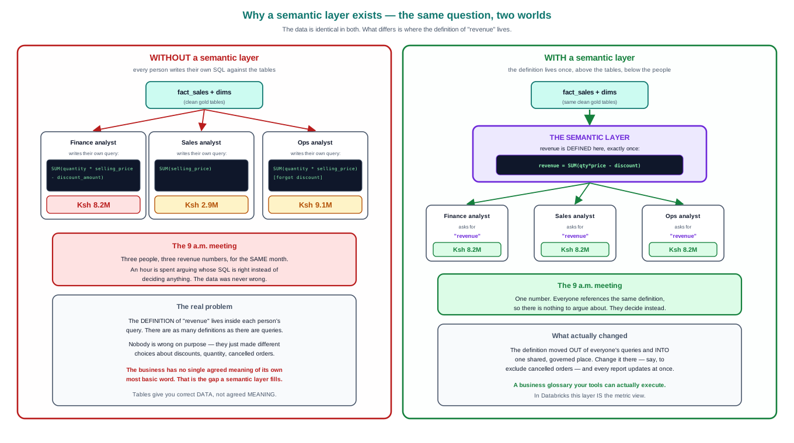
The same revenue question, with and without a semantic layer. The data is identical; only where the definition lives differs.
Without it, "revenue" lives inside each analyst’s SQL and three dashboards disagree. A metric view defines it once; every consumer inherits it. It is a business glossary your tools can execute — governance of meaning, the complement to Unity Catalog’s governance of access.
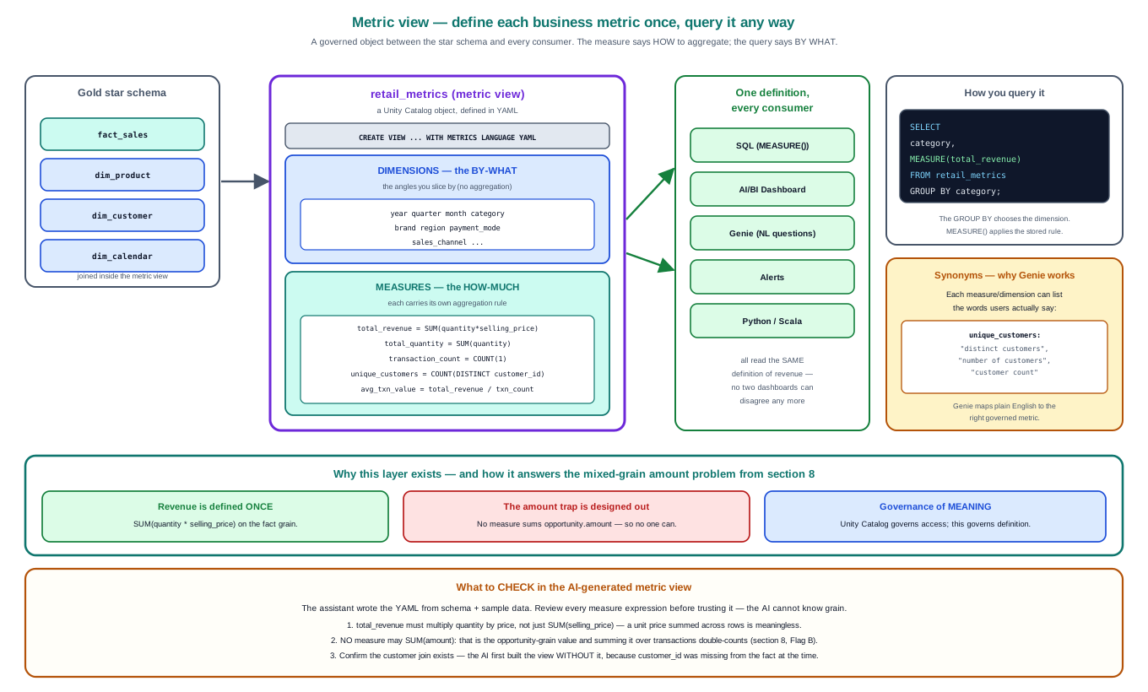
A metric view: dimensions (the by-what), measures (the how-much, each with its own aggregation), queried with MEASURE().
Defined in YAML via CREATE VIEW ... WITH METRICS LANGUAGE YAML (the "matrix language ML" of the transcript is a mishearing). Queried as SELECT dim, MEASURE(`Total revenue`) FROM mv GROUP BY dim — the measure says how to aggregate, the query says by what. Synonyms on each measure are what make Genie work.
The three checks on any AI-generated metric view
1. Revenue must be SUM(quantity * selling_price), not SUM(selling_price) — a unit price summed across rows is meaningless.
2. No measure may SUM(amount) — the mixed-grain trap from gold.
3. Confirm the customer join exists — the AI first built the view without it, because customer_id was missing from the fact at the time.

5.6 Consumption (Phase 6)

Dashboard
A dashboard reads the metric view and renders measure × dimension tiles — no SQL. "Revenue by payment mode" and "revenue by category" are two widgets with no extra queries, each resolved at render time. This is the clearest demonstration of why the semantic layer exists.
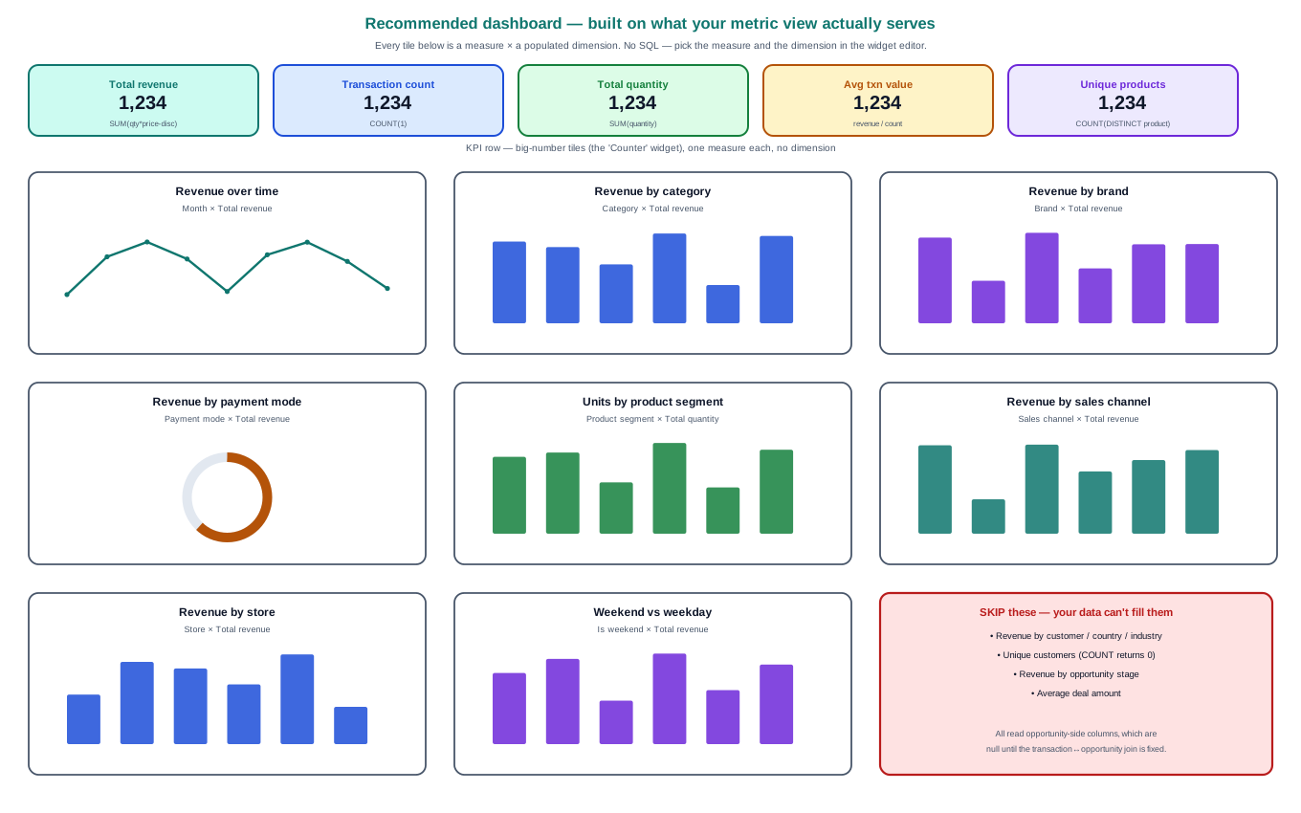
A dashboard layout built on what the metric view actually serves.

Genie — natural language, and where its accuracy comes from
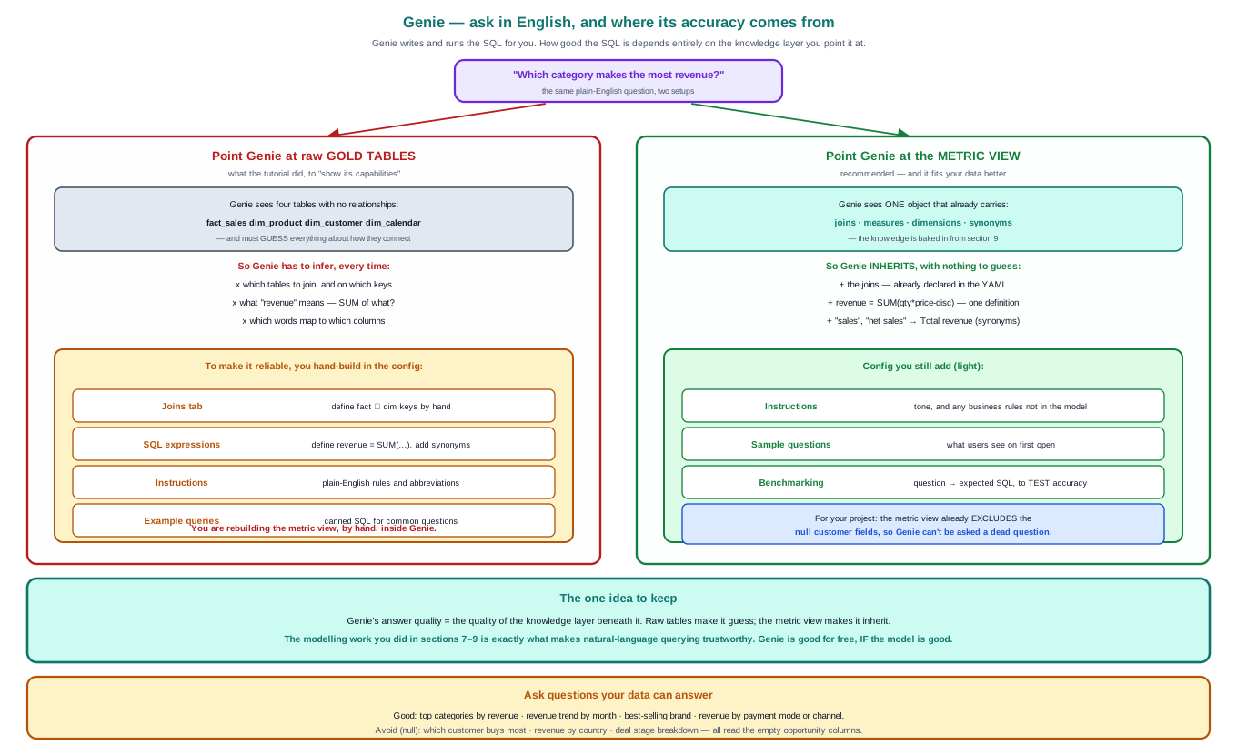
Genie on raw tables makes it guess joins and definitions; Genie on the metric view makes it inherit them.
Genie writes and runs SQL from an English question. Its accuracy equals the quality of the knowledge layer beneath it. Pointed at raw tables it must guess joins and what "revenue" means (and you end up hand-rebuilding the metric view inside Genie’s config). Pointed at the metric view it inherits the joins, the one definition, and the synonyms. Benchmarking (question → expected SQL) is how a natural-language layer is QA’d rather than merely demoed.

The three things called "Genie"
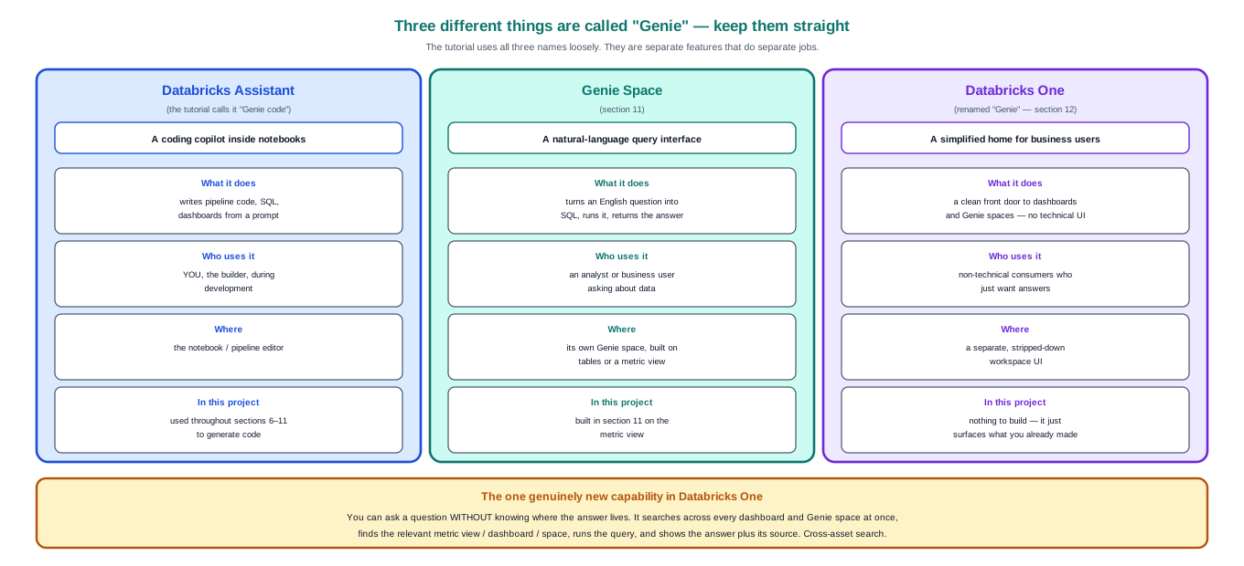
Databricks Assistant (the in-notebook copilot) · Genie Space (NL querying) · Databricks One (the business-user home, renamed "Genie").

The DE / analyst handoff
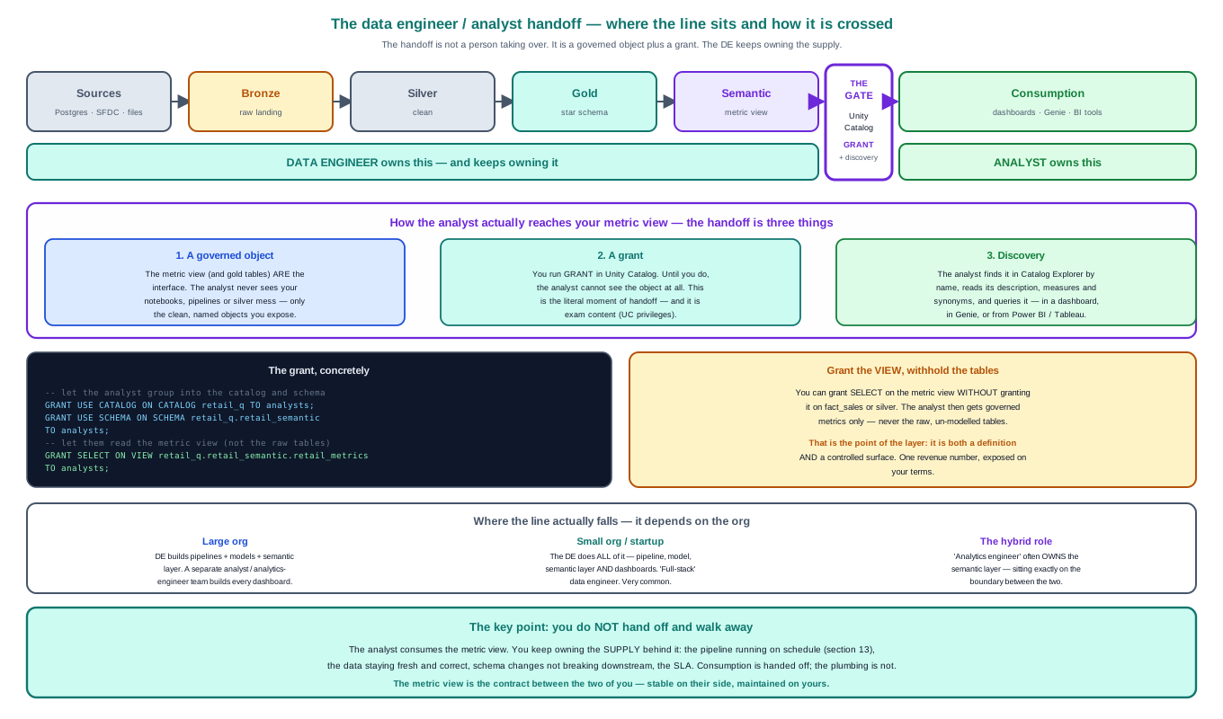
The handoff is a governed object plus a grant — not a person walking away.
The metric view is the contract. The analyst consumes it via a Unity Catalog GRANT (you can grant the view WITHOUT the raw tables). The data engineer keeps owning the supply — the pipeline running, the data fresh, the SLA. Consumption is handed off; the plumbing is not.

5.7 Orchestration (Phase 7)
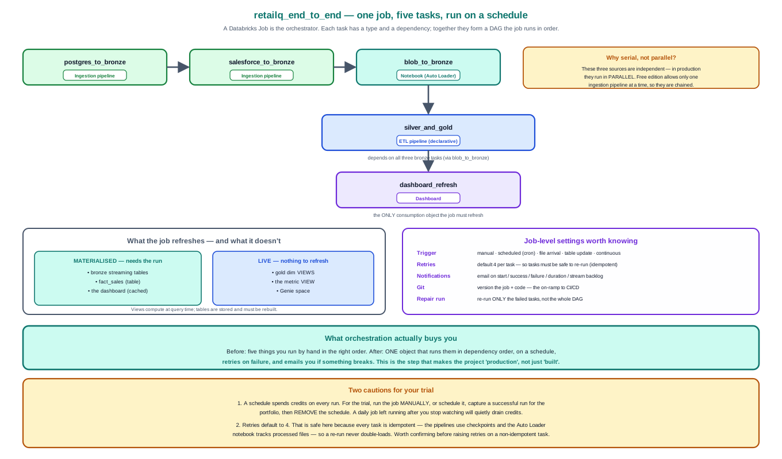
One job, five tasks, a dependency DAG, run on a schedule.
# | Task | Type | Depends on
1 | postgres_to_bronze | Ingestion pipeline | —
2 | salesforce_to_bronze | Ingestion pipeline | 1 *
3 | blob_to_bronze | Notebook (Auto Loader) | 2 *
4 | silver_and_gold | ETL pipeline | 3
5 | dashboard_refresh | Dashboard | 4

* Serial only because of a free-edition limit (one ingestion pipeline at a time). The three bronze ingests are independent; in production they run in parallel, all feeding silver_and_gold.
The key concept: what gets refreshed
Stored objects (tables) must be rebuilt by the job: bronze streaming tables, silver tables, fact_sales, and the dashboard (which caches its result). Views are live and need no refresh: the gold dimension views, the metric view, Genie. That is why the job has a dashboard-refresh task but no metric-view refresh.
Settings that matter: triggers (manual, scheduled/cron, file arrival, table update, continuous); retries (default 4 — safe here because every task is idempotent via checkpoints); notifications (email on failure); Git (the on-ramp to CI/CD); and Repair run — re-run only the failed tasks, not the whole DAG.

6. Trade-offs & decisions register
Every deliberate choice and known limitation, in one place. For a real project this is the document a reviewer reaches for.
Decision / limitation | Choice made | Consequence
Ingestion mechanism | Watermark-based (cursor column) | Deletes not propagated; depends on source updating its timestamp
SCD handling location | At bronze, by the managed connector | Bronze is not a pure raw copy; carries dimensional history
Dimension keys | Natural keys, not surrogate | Common in lakehouse; blocks true point-in-time SCD2 at gold
Gold dimensions | Virtual views over silver | No copy, always current; but cannot hold surrogate keys
SCD2 consumption | Current-value only (is_active filter) | History retained but unused; effectively type 1 downstream
fact_sales join key | opportunity_name (text) | Fan-out risk if names not unique; verify fact_rows ≤ txn_rows
opportunity.amount on fact | Carried through | Mixed grain — must never be SUM’d; excluded from metric view
Opportunity & inventory | Ingested, not modelled into star | Deliberate scope boundary (both are extensions)
Bronze parallelism | Serial | Free-edition limit, not design; parallel in production
AI-assisted development | Used, then reviewed | Generated code functional but needed fixing (trigger, DQ)

7. Key concepts — quick reference
Concept | One-line definition
Medallion | Bronze (raw, replayable) → silver (clean, conformed) → gold (modelled for reads)
Lakeflow Connect | Managed, no-code ingestion connectors for sources that have a connector
Auto Loader | cloudFiles Spark source; incremental file ingestion via a checkpoint
Streaming table | readStream; append-only source, each row once, checkpoint-backed
Materialized view | read; recomputed (or incrementally refreshed) from a query
Declarative pipeline | Declare target tables; framework infers order, incrementality, quality
Expectation | A data-quality rule; decorator decides warn / drop / fail
SCD type 1 | Overwrite in place; no history
SCD type 2 | Expire old row (__END_AT), insert new; full history
Cursor column | The watermark for incremental extraction
Star schema | Central fact + denormalised dimensions (vs normalised snowflake)
Degenerate dimension | A dimension attribute living on the fact (payment_mode)
Semantic layer | One governed definition of each business metric
Metric view | Databricks’ semantic layer: dimensions + measures in YAML
Unity Catalog | Governance: one permission & lineage model over catalog > schema > table
Databricks Job | The orchestrator: tasks in a dependency DAG, scheduled, retried

8. Databricks Data Engineer Associate — coverage map
This project maps unusually well onto the exam. What is examinable vs portfolio-only:

Heavily examined — covered by the build
- Unity Catalog three-level namespace; connections as securables; GRANT model
- Delta Lake; streaming tables vs materialized views
- Auto Loader (cloudFiles), checkpointing, schema evolution, _rescued_data, trigger modes
- Declarative pipelines / DLT; expectations (expect / drop / fail); APPLY CHANGES / AUTO CDC
- SCD type 1 vs type 2 semantics
- Jobs / Workflows: multi-task DAGs, dependencies, task types, triggers (cron, file arrival, continuous), retries, repair run, notifications

Portfolio-only — not exam content
- Metric views / semantic layer (newer than the blueprint)
- Dashboards, Genie, Databricks One
- Deep dimensional modelling (grain declaration, snapshot fact types)

Note on naming
The exam predates the Lakeflow rebrand. Expect to see Delta Live Tables / DLT and Workflows, not "Declarative Pipelines" and "Jobs". Same products; know both names.

9. Extensions — to build independently
Deliberately out of scope for the tutorial build. Each is a genuine portfolio upgrade and a strong interview answer.
- fact_inventory — a second fact table. Inventory (stock per product per store per day) is a periodic snapshot fact, not a dimension. Building it demonstrates conformed dimensions — two facts sharing dim_product and dim_calendar — which is what makes a set of stars a warehouse.
- Surrogate-key SCD type 2 dimensions. Give dimensions a surrogate key per version and resolve the fact join to the version live at the transaction date — realising the history that currently sits unused in silver.
- fact_opportunity — accumulating snapshot. Model the CRM pipeline as a deal moving through stages, a different grain from a completed sale.
- Metadata-driven ingestion framework. Replace one notebook per file source with a single parameterised notebook plus a config table. Adding a source becomes an insert, not a code change. Answers "how would this scale to twenty sources?"
- Fix the customer linkage. Regenerate the transactions CSV so opportunity_name matches real opportunities, so customer_id populates and the customer dimension and its metrics come alive.
- Data-quality monitoring dashboard. Build on the pipeline event log: trend expectation failure rates over time and alert when any rule crosses a threshold.

Built section by section with AI assistance, every piece of generated code reviewed before use. The diagrams in this document are reproducible from their source in 00-docs/.

