Final Year Design Project System Requirements Specification
A Web-Based Unified School Management System for Academic and Administrative Operations with Role-Based Access
__________________________________________

Software Design Specification Document

by

SAIHA ATIQ | BCS22007
MALAIKA ASHRAF | BCS22015
KHADIJA MUSTAFA | BCS22043
ZAINAB KHAWAJA | BCS22049

Project Advisor:
Sir Salman Naseer

Department of Information Technology
University of the Punjab, Gujranwala Campus, Gujranwala, Pakistan
(2026)

A Web-Based Unified School Management System for Academic and Administrative Operations with Role-Based Access

Executive Summary

This Software Design Specification (SDS) document presents the design of a Web-Based Unified School Management System aimed at integrating academic and administrative operations within a single, centralized platform. The system is designed to streamline core school processes such as student information management, academic records handling, class and subject organization, attendance tracking, and administrative data management. By providing a unified digital environment, the system reduces manual workload, improves data accuracy, and enhances overall operational efficiency. The design follows an object-oriented approach and emphasizes modularity, scalability, and maintainability to ensure long-term usability.

The document details the system architecture, design models, data structures, and user interface considerations that collectively define how the system will function. Key design aspects include the use of standardized UML diagrams, a structured database design, and a layered architectural approach to support secure data access and efficient communication between system components. This SDS ensures that all functional requirements identified in the Software Requirements Specification (SRS) are systematically addressed and traceable. Overall, the proposed design provides a reliable and scalable foundation for implementing a robust school management system capable of supporting future enhancements and evolving institutional needs.

Table of Contents
A Web-Based Unified School Management System for Academic and Administrative Operations with Role-Based Access 2
Executive Summary 2
System Design 5
1. Design Considerations 5
2. Requirements Traceability Matrix 6
3. Design Models 7
3.1 Architectural Design 7
3.2 Data Design 12
3.3 User Interface Design 32
3.3.1 Screen Images 33
3.3.2 Screen Objects and Actions 35
3.4 Behavioral Model 36
4. Design Decisions 42
5. Summary 46
References 46

List of Tables

Table 1 Requirements Traceability Matrix 6
Table 2 Components Mapping 11
Table 3 Data Dictionary 13
Table 4 Functions and Function Parameters 21
Table 5 Attributes and methods of object User 23
Table 6 Attributes and methods of Teacher object 24
Table 7 Attributes and methods of Admin object 25
Table 8 Attributes and methods of Attendance object 25
Table 9 Attributes and methods of Marks object 26
Table 10 Attributes and methods of Complain object 27
Table 11 Attributes and methods of StudentPortfolio object 27
Table 12 Attributes and methods of Achievement object 28
Table 13 Attributes and methods of BehaviorRemark object 29
Table 14 Attributes and methods of Fee object 29
Table 15 Attributes and methods of Message object 30
Table 16 Attributes and methods of Notification object 31
Table 17 Attributes and methods of AuditLog object 31

Tables of Figures

Figure 1 System Architecture Diagram 8
Figure 2 UML Component Diagram 9
Figure 3 UML Class Diagram 10
Figure 4 Screen Image 1- Login Screen 33
Figure 5 Screen Image 2- Student Portfolio 33
Figure 6 Screen Image 3- Attendance Mangement 34
Figure 7 Screen Image 4- Complain Feedback 34
Figure 8 Screen Image 5- Student Portfolio Generation 35
Figure 9 Sequence Diagram 1- User Flow Login 36
Figure 10 Sequence Diagram 2- Teacher Academic Management Flow 36
Figure 11 Sequence Diagram 3- Student Portfolio Generation Flow 37
Figure 12 State Diagram 1- Attendance Record 38
Figure 13 State Diagram 2- Complain Mangement 39
Figure 14 State Diagram 3- Student Portfolio 40
Figure 15 State Diagram 4- fee Payment 41
Figure 16 State Diagram 5- User account 42

System Design
Product Perspective
The Web-Based Unified School Management System is designed as a centralized, web-based application that integrates academic and administrative operations of an educational institution. The system operates as an independent platform accessible through standard web browsers and does not require client-side installation. It interacts with a centralized database server for storing and retrieving academic and administrative data and may integrate with external services such as email or notification systems for communication purposes.
The system follows a layered architecture where the presentation layer handles user interaction, the application layer manages business logic, and the data layer is responsible for persistent storage. This separation ensures scalability, maintainability, and ease of future enhancements. All system components communicate through well-defined interfaces to ensure reliable and secure data exchange.
Design Constraints
Several constraints influenced the system design. Performance constraints require the system to handle multiple concurrent users with minimal response time. Security constraints demand secure authentication, authorization, and data protection mechanisms to safeguard sensitive academic and administrative information. Compatibility constraints ensure that the system functions across commonly used web browsers and devices. Additionally, the design must be scalable to accommodate increasing numbers of users and records without major architectural changes.

Design Considerations
Assumptions and Dependencies:
It is assumed that users will have access to a stable internet connection and modern web browsers. The system depends on the availability of a reliable database management system and web server for proper functionality. It is also assumed that institutional data provided to the system is accurate and maintained regularly. The design assumes adherence to standard web technologies and frameworks to ensure smooth development and deployment.

Limitations:
The system is dependent on internet availability and may not function in offline environments. Performance may be affected under extremely high loads without additional server resources. Integration with third-party systems is limited to predefined interfaces and may require further customization for advanced interoperability. Additionally, the system’s functionality is constrained by the scope defined in the Software Requirements Specification (SRS).

Risks:
Potential risks include data security breaches, system performance degradation, and improper data handling by users. These risks are mitigated through secure authentication mechanisms, role-based access control, regular data backups, and optimized database design. Proper validation and error-handling mechanisms are incorporated to minimize system failures and ensure reliable operation.

Requirements Traceability Matrix

Table 1 Requirements Traceability Matrix

Requirement ID | Requirement Description | Design Specification
R1 | The system shall provide secure authentication and role-based access for Admin, Teacher, Student, and Parent users. | Authentication Controller, Role-Based Authorization Middleware, ASP.NET Core Identity, User & Role Tables
R2 | The system shall allow administrators to manage users, classes, subjects, and teacher–subject mappings. | Admin Management Module, User Management Service, ClassController, SubjectController, EF Core Repositories
R3 | The system shall allow teachers to mark and manage student attendance digitally. | Attendance Management Module, AttendanceController, AttendanceService, Attendance Table
R4 | The system shall allow teachers to enter, update, and manage student exam marks. | Marks Management Module, MarksController, ExamService, Marks Table
R5 | The system shall provide students and parents with real-time access to attendance and academic results. | Student Dashboard, Parent Dashboard, Academic Records API, React UI Components
R6 | The system shall generate a centralized digital student portfolio including attendance, grades, achievements, and certificates. | Student Portfolio Module, PortfolioService, PortfolioController, Portfolio Aggregation Logic
R7 | The system shall enable secure parent–teacher communication through private messaging. | Communication Module, MessagingController, MessageService, Messages Table
R8 | The system shall provide a digital noticeboard for school-wide announcements. | Noticeboard Module, AnnouncementController, Notification Service
R9 | The system shall allow administrators and teachers to post announcements and notifications. | Admin Panel, Teacher Panel, Announcement Management Service
R10 | The system shall allow students to submit complaints or behavior-related concerns. | Complaint Management Module, ComplaintController, Complaint Submission UI
R11 | The system shall allow teachers to add remarks and administrators to resolve and track complaints. | Complaint Workflow Engine, ComplaintStatus Enum, Complaint Resolution Service
R12 | The system shall track and maintain complaint and behavior history for audit and transparency. | Complaint History Table, Audit Logs, EF Core Change Tracking
R13 | The system shall display fee status and reminders to students and parents. | Fee Management Module, FeeController, FeeStatus Table
R14 | The system shall analyze attendance and academic performance to highlight student risk indicators. | Risk Analysis Service, Performance Evaluation Logic, Dashboard Alerts
R15 | The system shall provide centralized dashboard notifications for users based on their roles. | Notification Engine, Role-Based Notification Service, React Notification Components
R16 | The system shall maintain secure storage and retrieval of academic and administrative records. | SQL Server Database, EF Core ORM, Data Access Layer
R17 | The system shall support responsive web access across desktop and mobile devices. | React Frontend, Responsive UI Design, Tailwind CSS / Bootstrap
R18 | The system shall ensure data privacy, integrity, and controlled access to sensitive information. | Authorization Policies, HTTPS, JWT Tokens, Secure API Endpoints

Design Models
The system design is described using standard UML design models to clearly represent its structure and behavior under an object-oriented development approach.

3.1 Architectural Design
The proposed School Management System follows a layered, MVC-based client–server architecture. The client side handles presentation and user interaction, while the server side manages business logic, security, and data persistence. This architectural approach ensures separation of concerns, scalability, maintainability, and secure role-based access to system functionalities.

Component Structure and Inter-Module Relationships:

The system architecture is designed using a layered and component-based approach, following the MVC and client–server architectural patterns. The architecture separates concerns across presentation, application, and data tiers, enabling scalability, maintainability, and secure role-based access. Each layer communicates with the adjacent layer through well-defined interfaces and APIs to ensure controlled data flow and modular development.

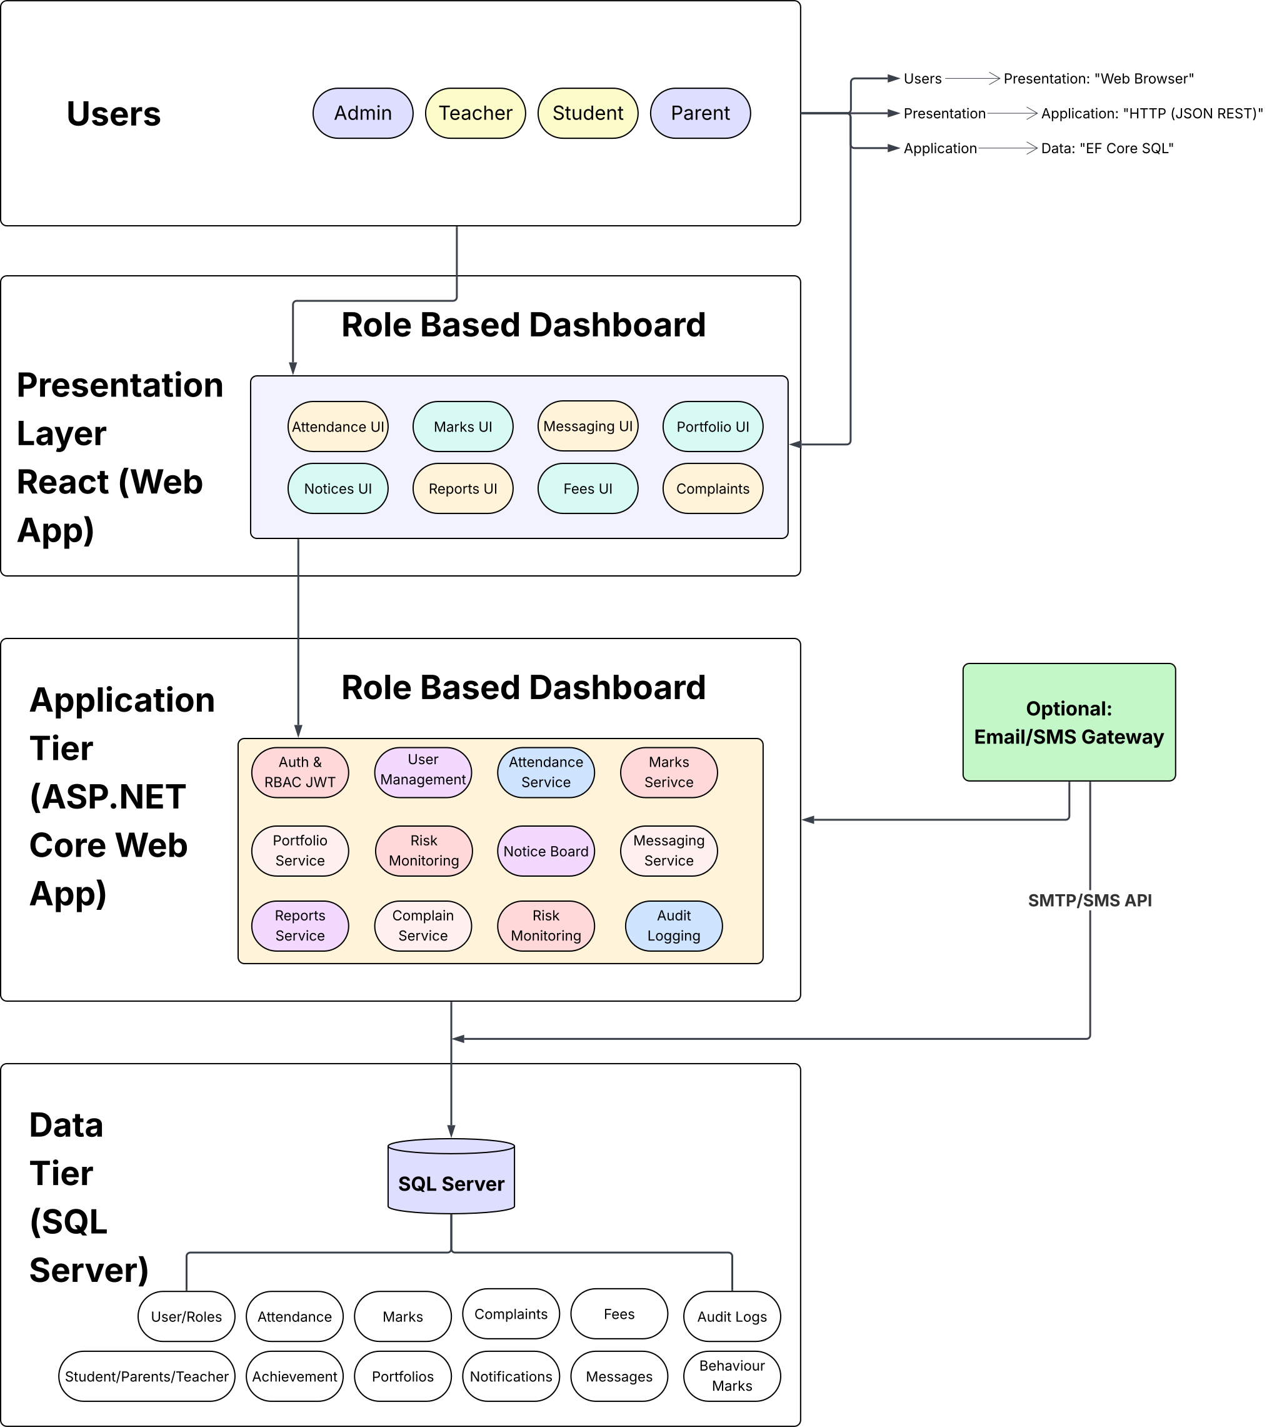

Figure 1 System Architecture Diagram

Fig explanation: This figure illustrates the system interaction flow in which user requests originate from the client-side interface and are processed by application services through the presentation layer. Business logic execution and data persistence are handled via the data access layer. Role-Based Access Control (RBAC) and authentication mechanisms are enforced prior to any operation, ensuring secure and authorized access to system functionalities.

UML Component Diagram

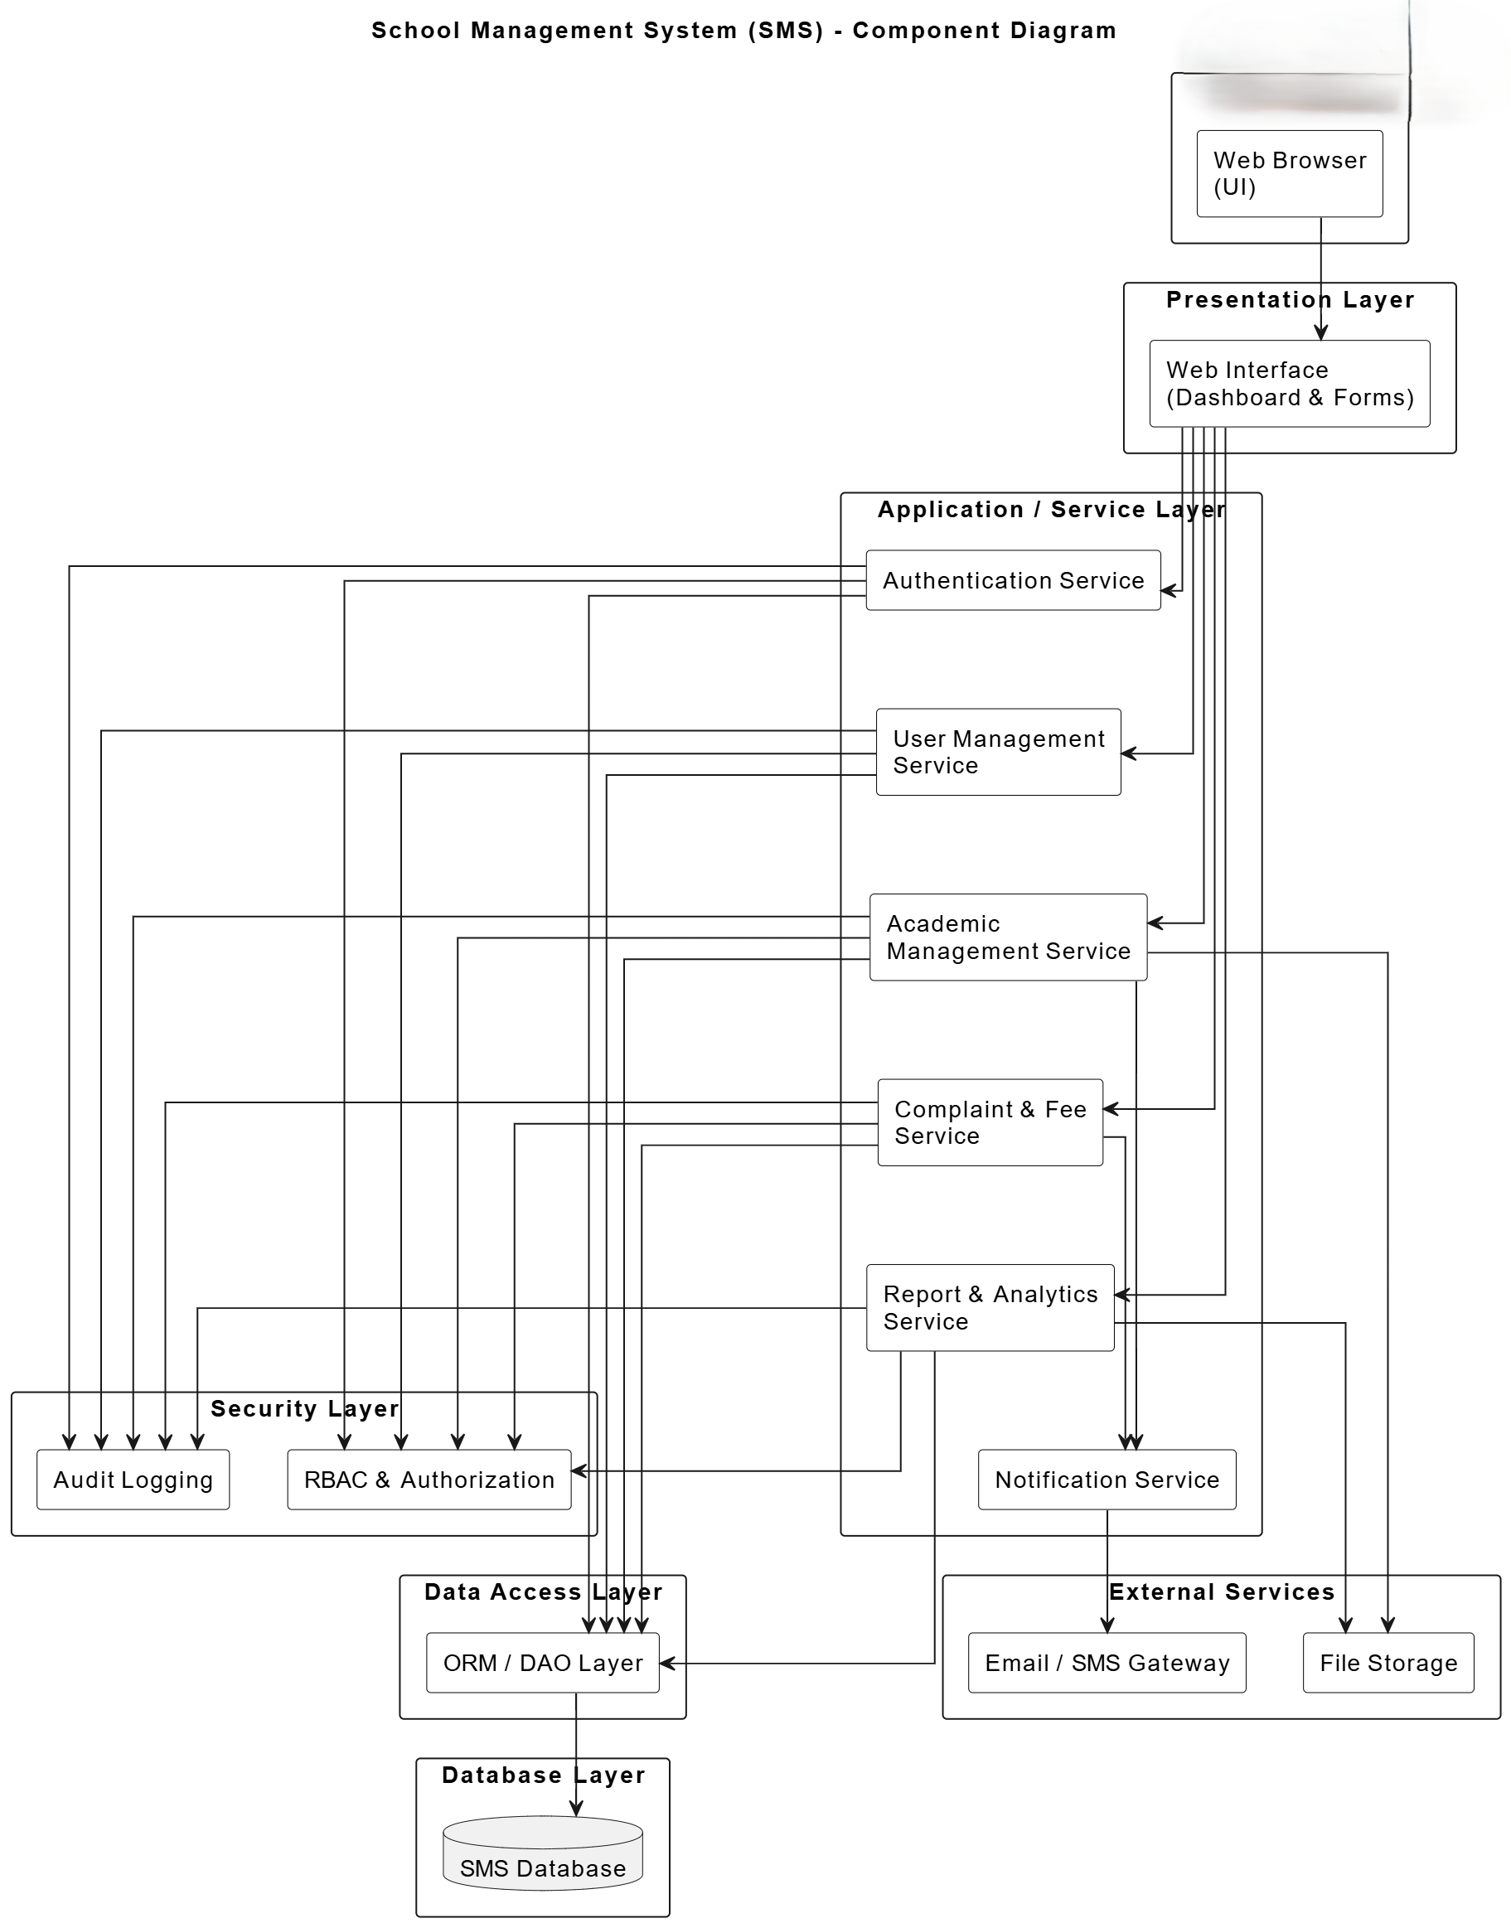

Figure 2 UML Component Diagram

Figure explanation: This Figure illustrates the UML Component Diagram of the School Management System, representing a layered MVC-based client–server architecture with integrated security, data access, and external services.

UML Class Relationship Diagram

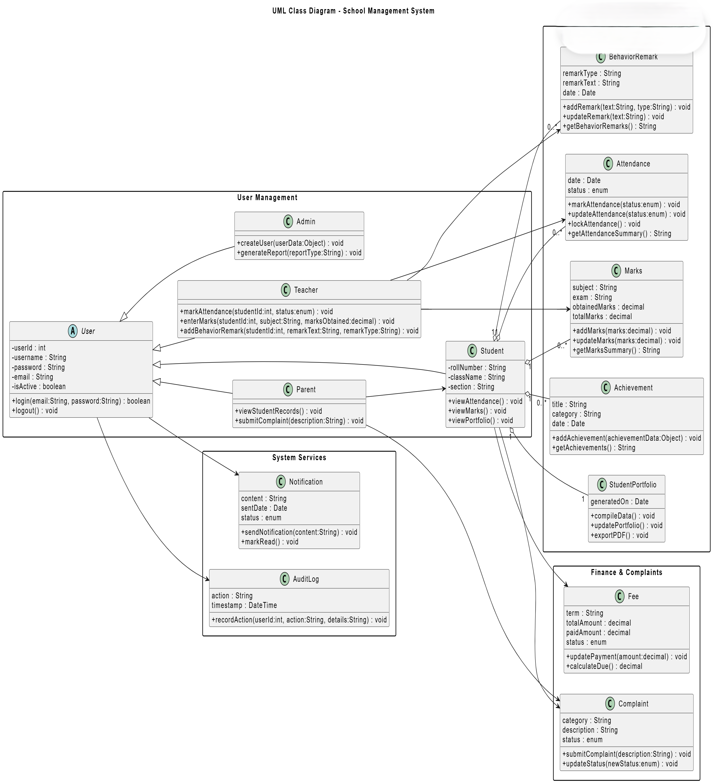

Figure 3 UML Class Diagram

Fig explanation: This figure presents the class structure of the School Management System, showing core user roles, academic modules, financial components, and system services. It defines attributes, operations, and relationships among classes, highlighting role-based access, academic record management, and supporting services such as notifications and audit logging.

Mapping Components to Architecture Layers

Table 2 Components Mapping

Architecture Layer | MVC Role | Component / Module | Description
Client Layer | View | Web UI / Browser | Provides user interface for Admin, Teacher, Student, and Parent to view dashboards, forms, and reports
Application Layer | Controller | Controllers (Authentication, Attendance, Marks, Complaint, Fee) | Handles user requests, input validation, and coordination between the presentation layer and business logic
Business Layer | Model | User Management | Manages user accounts, roles, authentication, and role-based access control
Business Layer | Model | Academic Users | Represents core system entities including Student, Teacher, Parent, and Admin along with their operations
Business Layer | Model | Academic Records | Handles attendance, marks, behavior remarks, achievements, and student portfolios
Business Layer | Model | Complaints & Fees | Manages complaint registration, tracking, resolution, and fee payment processing
Service Layer | — | System Services | Provides cross-cutting services such as notifications, risk monitoring, and audit logging
Data Layer | — | Relational Database | Stores all persistent system data including users, academic records, complaints, fees, logs, and reports

3.2 Data Design

Information Domain Transformation:
The information domain defined in the Software Requirements Specification (SRS) is transformed into structured data entities using a strictly Object-Oriented (OO) design approach. Each functional requirement is mapped to one or more domain objects that encapsulate both data (attributes) and behavior (methods). This mapping ensures full traceability between the SRS and the Software Design Specification (SDS).
The system strictly supports the four user roles defined in the SRS: Admin, Teacher, Student, and Parent. No additional actors or roles are introduced at the design level. Role-specific behavior is enforced through object methods and access control rather than dynamic role assignment.
Persistent data are stored in a relational database, while temporary data such as user sessions and notifications are handled at the application layer. Business rules and validations are implemented through object methods, ensuring separation between data persistence and application logic.

Data Storage and Organization:

- Database Type: Relational Database (MySQL / PostgreSQL)
- Design Paradigm: Object-Oriented domain model mapped to relational tables
- Normalization Level: Third Normal Form (3NF) to reduce redundancy
- Security Measures:
  - Encrypted password storage
  - Role-based access control
  - Audit logging of critical actions
- Data Processing:
  - CRUD operations performed via service-layer object methods
  - Referential integrity enforced using primary and foreign keys

Major System Entities:
The major system entities derived directly from the SRS are:
- User (Admin, Teacher, Student, Parent)
- Student
- Parent
- Teacher
- Admin
- Attendance
- Marks
- Achievement
- BehaviorRemark
- Complaint
- Fee
- Notification
- Message
- StudentPortfolio
- AuditLog

3.2.1 Data Dictionary:

Table 3 Data Dictionary

Terminology | Description
Achievement | Object representing student achievements. Attributes: achievementId:int (PK), studentId:int (FK → Student), title:String, category:String, date:Date, filePath:String. Used to store awards, certificates, and extracurricular accomplishments.
Achievement.date | Date of achievement. Type: Date
Achievement.filePath | File path for attachment/document. Type: String
Achievement.title | Name/title of achievement. Type: String
Achievement.category | Type/category of achievement (e.g., Sports, Academic). Type: String
Achievement.achievementId | Primary key identifier. Type: int
Achievement.studentId | Foreign key to Student. Type: int
Achievement.addAchievement() | Method to add a new achievement. Parameters: achievementData:Object
Admin | Object representing administrative user. Attributes: adminId:int (PK), userId:int (FK → User), firstName:String, lastName:String. Admin manages users, fees, notices, reports, and system settings.
Admin.adminId | Primary key identifier. Type: int
Admin.userId | Foreign key to User. Type: int
Admin.firstName | Admin first name. Type: String
Admin.lastName | Admin last name. Type: String
Admin.createUser(userData:Object) | Method to create a new user account.
Admin.generateReport(reportType:String) | Generates system reports. Parameters: reportType:String
Admin.updateSettings(settings:Object) | Updates system settings. Parameters: settings:Object
AuditLog | Tracks system actions for accountability. Attributes: logId:int, userId:int (FK → User), action:String, timestamp:Timestamp, details:String
AuditLog.logId | Primary key. Type: int
AuditLog.userId | User performing the action. Type: int
AuditLog.action | Description of action. Type: String
AuditLog.timestamp | Action timestamp. Type: Timestamp
AuditLog.details | Additional details about action. Type: String
AuditLog.recordAction(userId:int, action:String, details:String) | Logs an action in the system.
Attendance | Tracks student attendance. Attributes: attendanceId:int, studentId:int (FK), teacherId:int (FK), date:Date, status:enum {Present, Absent, Late}
Attendance.attendanceId | Primary key. Type: int
Attendance.studentId | Foreign key to Student. Type: int
Attendance.teacherId | Foreign key to Teacher. Type: int
Attendance.date | Date of attendance. Type: Date
Attendance.status | Attendance status. Type: enum {Present, Absent, Late}
Attendance.markAttendance(status:enum) | Marks attendance for a student.
Attendance.updateAttendance(status:enum) | Updates existing attendance record.
Attendance.lockAttendance() | Locks attendance to prevent further edits.
BehaviorRemark | Stores teacher comments about student behavior. Attributes: remarkId:int, studentId:int (FK), teacherId:int (FK), remarkType:String, remarkText:String, date:Date
BehaviorRemark.remarkId | Primary key. Type: int
BehaviorRemark.studentId | Foreign key to Student. Type: int
BehaviorRemark.teacherId | Foreign key to Teacher. Type: int
BehaviorRemark.remarkType | Type of remark (Positive/Negative). Type: String
BehaviorRemark.remarkText | Remark content. Type: Text
BehaviorRemark.date | Date of remark. Type: Date
BehaviorRemark.addRemark(text:String, type:String) | Adds a new behavior remark.
BehaviorRemark.updateRemark(text:String) | Updates remark content.
Complaint | Represents complaints submitted by students or parents. Attributes: complaintId:int, submittedByUserId:int (FK), assignedToUserId:int (FK), category:String, description:String, status:enum {Submitted, UnderReview, Resolved, Rejected, Closed}, dateSubmitted:Date, dateClosed:Date
Complaint.complaintId | Primary key. Type: int
Complaint.submittedByUserId | Foreign key to submitting User. Type: int
Complaint.assignedToUserId | Foreign key to assigned User (Teacher/Admin). Type: int
Complaint.category | Complaint category. Type: String
Complaint.description | Complaint details. Type: Text
Complaint.status | Current status. Type: enum
Complaint.dateSubmitted | Submission date. Type: Date
Complaint.dateClosed | Resolution date. Type: Date
Complaint.submitComplaint(description:String) | Submits a new complaint.
Complaint.updateStatus(newStatus:enum) | Updates complaint status.
Complaint.addRemarks(remarks:String) | Adds remarks to complaint record.
Fee | Tracks student fee payments. Attributes: feeId:int, studentId:int (FK), term:String, totalAmount:decimal, paidAmount:decimal, dueDate:Date, status:enum {Paid, Partial, Pending, Overdue}
Fee.feeId | Primary key. Type: int
Fee.studentId | Foreign key to Student. Type: int
Fee.term | Academic term/semester. Type: String
Fee.totalAmount | Total fee amount. Type: decimal
Fee.paidAmount | Amount paid. Type: decimal
Fee.dueDate | Payment due date. Type: Date
Fee.status | Payment status. Type: enum
Fee.updatePayment(amount:decimal) | Updates paid amount.
Fee.calculateDue() | Calculates remaining due.
Marks | Stores assessment/exam results. Attributes: marksId:int, studentId:int (FK), teacherId:int (FK), subject:String, exam:String, marksObtained:decimal, totalMarks:decimal
Marks.marksId | Primary key. Type: int
Marks.studentId | Foreign key to Student. Type: int
Marks.teacherId | Foreign key to Teacher. Type: int
Marks.subject | Subject name. Type: String
Marks.exam | Exam/assessment name. Type: String
Marks.marksObtained | Marks obtained. Type: decimal
Marks.totalMarks | Total possible marks. Type: decimal
Marks.addMarks(marks:decimal) | Adds marks for student.
Marks.updateMarks(marks:decimal) | Updates existing marks.
Message | Internal messaging. Attributes: messageId:int, senderUserId:int (FK), receiverUserId:int (FK), content:String, sentAt:DateTime
Message.messageId | Primary key. Type: int
Message.senderUserId | User sending message. Type: int
Message.receiverUserId | User receiving message. Type: int
Message.content | Message content. Type: String
Message.sentAt | Timestamp sent. Type: DateTime
Message.sendMessage(content:String, receiverId:int) | Sends a new message.
Message.readMessage() | Marks message as read.
Notification | Stores system notifications. Attributes: notificationId:int, userId:int (FK), type:String, content:String, dateSent:Date, status:enum {Unread, Read, Archived}
Notification.notificationId | Primary key. Type: int
Notification.userId | Recipient user. Type: int
Notification.type | Notification type (e.g., Info, Warning). Type: String
Notification.content | Message content. Type: Text
Notification.dateSent | Date sent. Type: Date
Notification.status | Read status. Type: enum
Notification.sendNotification(content:String) | Sends notification to user.
Notification.markRead() | Marks notification as read.
Parent | Represents a parent user. Attributes: parentId:int, userId:int (FK), studentId:int (FK), relation:String
Parent.parentId | Primary key. Type: int
Parent.userId | Foreign key to User. Type: int
Parent.studentId | Foreign key to Student. Type: int
Parent.relation | Relation to student (Father/Mother/Guardian). Type: String
Parent.viewStudentRecords() | Accesses linked student’s academic records.
Portfolio | Compiled academic record. Attributes: portfolioId:int, studentId:int (FK), attendanceSummary:String, marksSummary:String, achievementsSummary:String, behaviorSummary:String, generatedOn:Date
Portfolio.portfolioId | Primary key. Type: int
Portfolio.studentId | Foreign key to Student. Type: int
Portfolio.attendanceSummary | Text summary of attendance. Type: String
Portfolio.marksSummary | Text summary of marks. Type: String
Portfolio.achievementsSummary | Text summary of achievements. Type: String
Portfolio.behaviorSummary | Text summary of behavior remarks. Type: String
Portfolio.generatedOn | Date generated. Type: Date
Portfolio.compileData() | Compiles portfolio data from different modules.
Portfolio.updatePortfolio() | Updates existing portfolio record.
Portfolio.exportPDF() | Exports portfolio as PDF.
Report | System-generated reports. Attributes: reportId:int, type:String, generatedOn:Date, filePath:String, adminId:int (FK)
Report.reportId | Primary key. Type: int
Report.type | Type of report (Attendance, Marks, Portfolio, Risk). Type: String
Report.generatedOn | Date generated. Type: Date
Report.filePath | File location. Type: String
Report.adminId | Generated by Admin. Type: int
Report.generateReport(type:String) | Creates a report file.
RiskMonitoring | Monitors student risk. Attributes: riskId:int, studentId:int (FK), riskLevel:String {Low, Medium, High}, monitoredOn:Date, notes:String
RiskMonitoring.riskId | Primary key. Type: int
RiskMonitoring.studentId | Foreign key to Student. Type: int
RiskMonitoring.riskLevel | Risk rating. Type: String
RiskMonitoring.monitoredOn | Date of assessment. Type: Date
RiskMonitoring.notes | Additional info. Type: String
RiskMonitoring.assessRisk() | Evaluates current risk level.
RiskMonitoring.updateRisk(level:String, notes:String) | Updates risk details.
Student | Represents student. Attributes: studentId:int, userId:int (FK), firstName:String, lastName:String, class:String, section:String, rollNumber:String
Student.studentId | Primary key. Type: int
Student.userId | Foreign key to User. Type: int
Student.firstName | First name. Type: String
Student.lastName | Last name. Type: String
Student.class | Class/grade. Type: String
Student.section | Section/group. Type: String
Student.rollNumber | Roll number. Type: String
Student.viewAttendance() | Views attendance records.
Student.viewMarks() | Views marks.
Student.viewPortfolio() | Accesses compiled portfolio.
Student.submitComplaint(description:String) | Submits complaint.
Teacher | Represents teacher. Attributes: teacherId:int, userId:int (FK), firstName:String, lastName:String, assignedSubjects:String
Teacher.teacherId | Primary key. Type: int
Teacher.userId | Foreign key to User. Type: int
Teacher.firstName | First name. Type: String
Teacher.lastName | Last name. Type: String
Teacher.assignedSubjects | Subjects teacher is responsible for. Type: String
Teacher.markAttendance(studentId:int, status:enum) | Marks attendance for a student.
Teacher.enterMarks(studentId:int, subject:String, marksObtained:decimal) | Enters marks for a student.
Teacher.addBehaviorRemark(studentId:int, remarkText:String, remarkType:String) | Adds behavior remark.
Teacher.reviewComplaint(complaintId:int, status:enum) | Updates complaint status.
Teacher.postNotice(title:String, content:String) | Posts a notice.
User | Generic system user. Attributes: userId:int, username:String, email:String, password:String (encrypted), role:enum {Admin, Teacher, Student, Parent}, isActive:boolean
User.userId | Primary key. Type: int
User.username | Login username. Type: String
User.email | User email. Type: String
User.password | Encrypted password. Type: String
User.role | User role. Type: enum
User.isActive | Account status. Type: boolean
User.login(email:String, password:String) | Authenticates user.
User.logout() | Logs out user.
User.updateProfile(updatedData:Object) | Updates profile data.
UserRole | Maps users to roles. Attributes: userRoleId:int, userId:int (FK), roleId:int (FK)
UserRole.userRoleId | Primary key. Type: int
UserRole.userId | Foreign key to User. Type: int
UserRole.roleId | Foreign key to Role. Type: int
Role | Defines a system role. Attributes: roleId:int, roleName:String, description:String
Role.roleId | Primary key. Type: int
Role.roleName | Name of role. Type: String
Role.description | Role description. Type: String

Structured Approach: Functions and Function Parameters:

Table 4 Functions and Function Parameters

Function Name | Parameters | Description
login | email:String, password:String | Authenticates a user using email and password. Returns success/failure and role-based access.
logout | userId:int | Logs out the specified user, ending their session.
updateProfile | userId:int, updatedData:Object | Updates a user’s profile with the provided data. updatedData can contain username, email, password, etc.
markAttendance | studentId:int, date:Date, status:enum {Present, Absent, Late} | Marks attendance for a student on a given date.
updateAttendance | attendanceId:int, status:enum {Present, Absent, Late} | Updates an existing attendance record.
lockAttendance | attendanceId:int | Locks attendance for a particular date to prevent further edits.
addMarks | studentId:int, subject:String, exam:String, marksObtained:decimal, totalMarks:decimal | Adds a new marks entry for a student for a specific exam and subject.
updateMarks | marksId:int, marksObtained:decimal | Updates marks for an existing record.
submitComplaint | submittedByUserId:int, assignedToUserId:int, description:String, category:String | Creates a new complaint record in the system.
updateComplaintStatus | complaintId:int, newStatus:enum {Submitted, UnderReview, Resolved, Rejected, Closed} | Updates the status of a complaint.
addComplaintRemarks | complaintId:int, remarks:String | Adds remarks/comments to an existing complaint.
compilePortfolio | studentId:int | Gathers student data (attendance, marks, achievements, behavior) to generate portfolio.
updatePortfolio | portfolioId:int, updatedData:Object | Updates an existing portfolio with new data.
exportPortfolioPDF | portfolioId:int | Generates a PDF document of a student’s portfolio.
sendNotification | userId:int, content:String, type:String | Sends a notification to a user.
markNotificationRead | notificationId:int | Marks a notification as read.
recordAuditLog | userId:int, action:String, details:String | Records an action performed in the system for auditing purposes.
updateFeePayment | feeId:int, paidAmount:decimal | Updates the paid amount for a student fee record.
calculateFeeDue | feeId:int | Calculates the remaining due amount for a fee record.

Object-Oriented (OO) Approach: Objects, Attributes, Methods, & Method Parameters:

Object: User
Table 5 Attributes and methods of object User
Attributes
Attribute | Type | Description
userId | int | Unique system identifier
username | String | Login username
email | String | User email
password | String | Encrypted password
role | enum {Admin, Teacher, Student, Parent} | User role
isActive | boolean | Account status
Methods
Method | Parameters | Description
login | email:String, password:String | Authenticates user and grants access
logout | — | Ends user session
updateProfile | updatedData:Object | Updates user's profile attributes

Object: Teacher
Table 6 Attributes and methods of Teacher object
Attributes
Attribute | Type | Description
teacherId | int | Unique identifier
userId | int | FK → User
firstName | String | First name
lastName | String | Last name
assignedSubjects | String | Subjects taught
Methods
Method | Parameters | Description
markAttendance | studentId:int, status:enum {Present, Absent, Late} | Marks attendance for a student
enterMarks | studentId:int, subject:String, marksObtained:decimal | Records marks for a student
addBehaviorRemark | studentId:int, remarkText:String, remarkType:String | Adds behavioral remark
reviewComplaint | complaintId:int, status:enum | Updates complaint status
postNotice | title:String, content:String | Posts notice to students/parents

Object: Admin
Table 7 Attributes and methods of Admin object
Attributes
Attribute | Type | Description
adminId | int | Unique identifier
userId | int | FK → User
firstName | String | First name
lastName | String | Last name
Methods
Method | Parameters | Description
createUser | userData:Object | Creates a new system user
generateReport | reportType:String | Generates attendance, marks, portfolio, or risk report
updateSettings | settings:Object | Updates system settings

Object: Attendance
Table 8 Attributes and methods of Attendance object
Attributes
Attribute | Type | Description
attendanceId | int | PK
studentId | int | FK → Student
teacherId | int | FK → Teacher
date | Date | Attendance date
status | enum {Present, Absent, Late} | Attendance status

Methods
Method | Parameters | Description
markAttendance | status:enum | Records attendance
updateAttendance | status:enum | Updates existing attendance
lockAttendance | — | Locks record

Object: Marks
Table 9 Attributes and methods of Marks object
Attributes
Attribute | Type | Description
marksId | int | PK
studentId | int | FK → Student
teacherId | int | FK → Teacher
subject | String | Subject name
exam | String | Exam name
marksObtained | decimal | Marks obtained
totalMarks | decimal | Maximum marks
Methods
Method | Parameters | Description
addMarks | marks:decimal | Adds marks for a student
updateMarks | marks:decimal | Updates marks

Object: Complaint
Table 10 Attributes and methods of Complain object
Attributes
Attribute | Type | Description
complaintId | int | PK
submittedByUserId | int | FK → User
assignedToUserId | int | FK → User
description | String | Complaint description
status | enum {Submitted, UnderReview, Resolved, Rejected, Closed} | Current status
submittedDate | Date | Date of submission
closedDate | Date | Date of closure

Methods
Method | Parameters | Description
submitComplaint | description:String | Submit new complaint
updateStatus | newStatus:enum | Update complaint status
addRemarks | remarks:String | Add remarks to complaint

Object: StudentPortfolio
Table 11 Attributes and methods of StudentPortfolio object
Attributes
Attribute | Type | Description
portfolioId | int | PK
studentId | int | FK → Student
generatedOn | Date | Generation date
lastUpdated | Date | Last update
Methods
Method | Parameters | Description
compileData | — | Compile portfolio data from attendance, marks, achievements, behavior
updatePortfolio | — | Update portfolio with new data
exportPDF | — | Export portfolio to PDF

Object: Achievement
Table 12 Attributes and methods of Achievement object
Attributes
Attribute | Type | Description
achievementId | int | Unique identifier (PK)
studentId | int | FK → Student
title | String | Achievement title
category | String | Achievement category
date | Date | Date of achievement
filePath | String | Path to supporting document/file
Methods
Method | Parameters | Description
addAchievement | achievementData:Object | Adds a new achievement record for a student
updateAchievement | achievementId:int, updatedData:Object | Updates an existing achievement

Object: BehaviorRemark
Table 13 Attributes and methods of BehaviorRemark object
Attributes
Attribute | Type | Description
remarkId | int | Unique identifier (PK)
studentId | int | FK → Student
teacherId | int | FK → Teacher
remarkText | Text | Remark content
remarkType | String | Type of remark (e.g., Positive, Negative, Neutral)
date | Date | Date the remark was recorded
Methods
Method | Parameters | Description
addRemark | text:String, type:String | Adds a new behavioral remark for a student
updateRemark | text:String | Updates an existing remark

Object: Fee
Table 14 Attributes and methods of Fee object
Attributes
Attribute | Type | Description
feeId | int | Unique identifier (PK)
studentId | int | FK → Student
totalAmount | decimal | Total fee amount
paidAmount | decimal | Amount already paid
dueDate | Date | Payment due date
status | enum {Unpaid, Partial, Paid, Overdue} | Current fee status
Methods
Method | Parameters | Description
updatePayment | amount:decimal | Updates payment for the student fee
calculateDue | — | Calculates remaining amount due

Object: Message
Table 15 Attributes and methods of Message object
Attributes
Attribute | Type | Description
messageId | int | Unique identifier (PK)
senderId | int | FK → User (sender)
receiverId | int | FK → User (receiver)
content | Text | Message content
sentAt | DateTime | Timestamp when message is sent
status | String | Message status (e.g., Read, Unread)
Methods
Method | Parameters | Description
sendMessage | content:String, receiverId:int | Sends message to a user
readMessage | — | Marks message as read

Object: Notification
Table 16 Attributes and methods of Notification object
Attributes
Attribute | Type | Description
notificationId | int | Unique identifier (PK)
userId | int | FK → User (recipient)
content | Text | Notification content
dateSent | Date | Date notification was sent
status | String | Status (e.g., Unread, Read)

Methods
Method | Parameters | Description
sendNotification | content:String | Sends notification to a user
markRead | — | Marks notification as read

Object: AuditLog
Table 17 Attributes and methods of AuditLog object
Attributes
Attribute | Type | Description
logId | int | Unique identifier (PK)
userId | int | FK → User (who performed action)
action | String | Action description
timestamp | Timestamp | Time action was performed
details | Text | Additional details about the action

Methods
Method | Parameters | Description
recordAction | userId:int, action:String, details:String | Records an administrative or system action

3.3 User Interface Design
The system provides a role-based interface, tailored to each type of user: Admin, Teacher, Student, and Parent. After logging in, the user sees a dashboard that gives access only to features relevant to their role.
- Admin:
  - Can manage all users (students, teachers, parents)
  - Add/edit/delete records for fees, subjects, and classes
  - Generate reports (attendance, marks, portfolio, risk monitoring)
  - Review complaints and notifications
  - Audit logs to monitor system activity
- Teacher:
  - Record student attendance
  - Enter marks for exams and assignments
  - Add behavioral remarks
  - Upload student achievements
  - Review and resolve complaints
  - Post notices to students/parents
- Student:
  - View attendance, marks, and achievements
  - Access personal portfolio
  - Submit complaints
  - Receive notifications from teachers/admins
- Parent:
  - View their child’s academic records (attendance, marks, portfolio)
  - Communicate with teachers via messages
  - Submit complaints regarding their child
User Feedback:
- The system provides real-time feedback for user actions:
  - Success messages (e.g., “Attendance successfully recorded”)
  - Error messages (e.g., “Marks cannot exceed total marks”)
  - Validation messages for input fields
  - Notifications for important events (new message, new complaint, fee due)
The interface is designed for clarity, responsiveness, and ease of navigation, ensuring users can complete tasks efficiently.

3.3.1 Screen Images

Login Screen
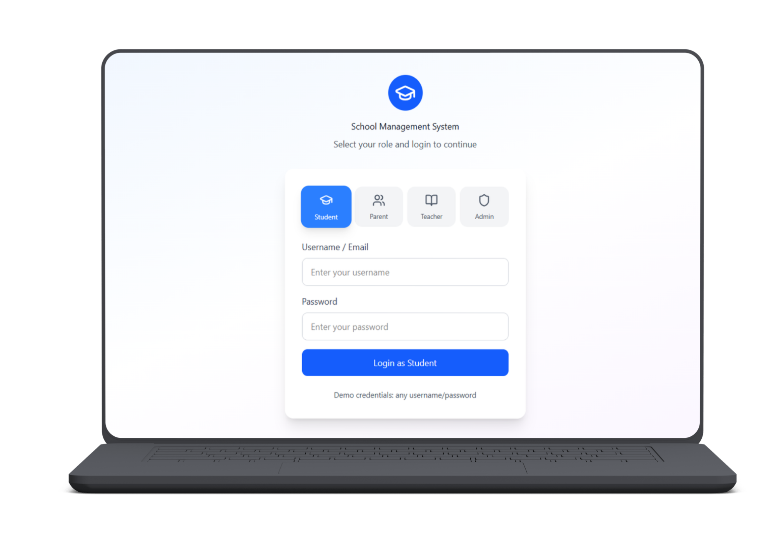
Figure 4 Screen Image 1- Login Screen
Student Portfolio Screen

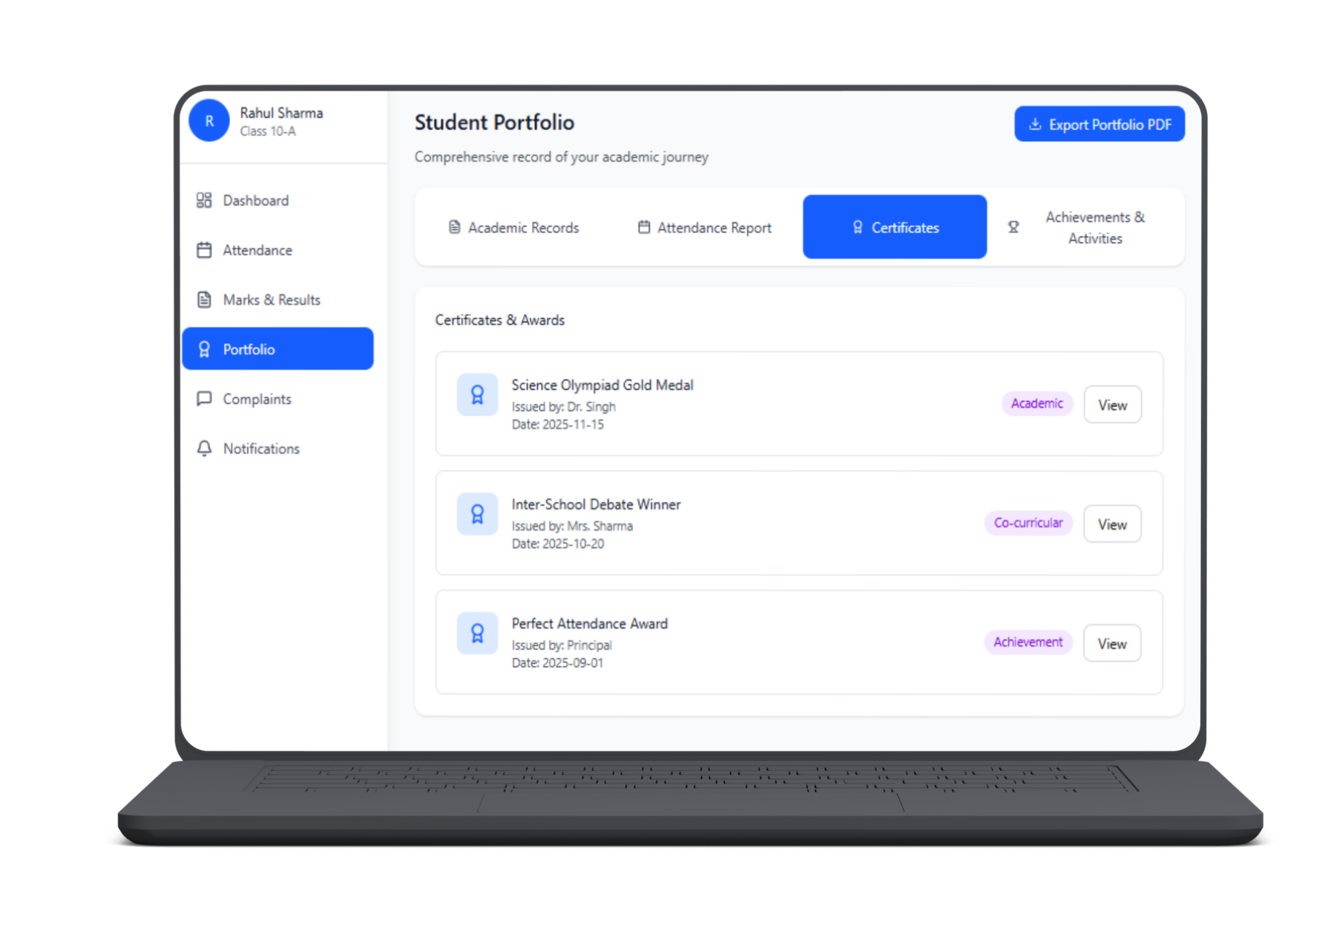
Figure 5 Screen Image 2- Student Portfolio

Attendance Management Screen(Teacher)
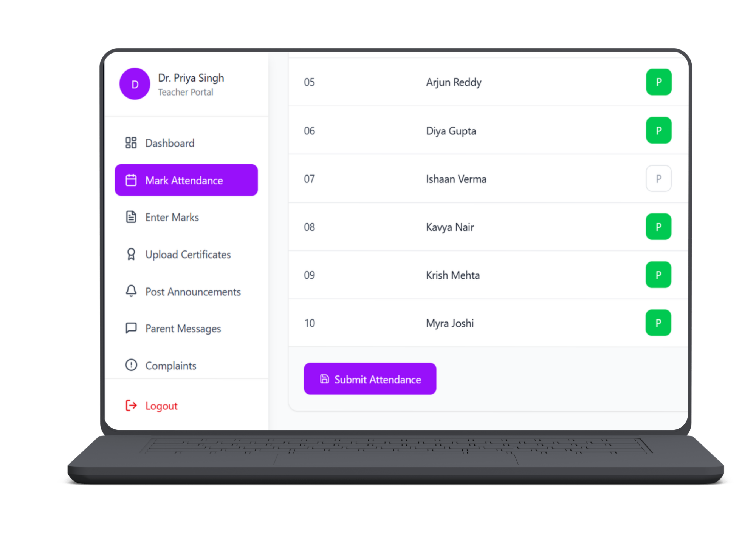
Figure 6 Screen Image 3- Attendance Mangement

Complaint Feedback Screen (Student)
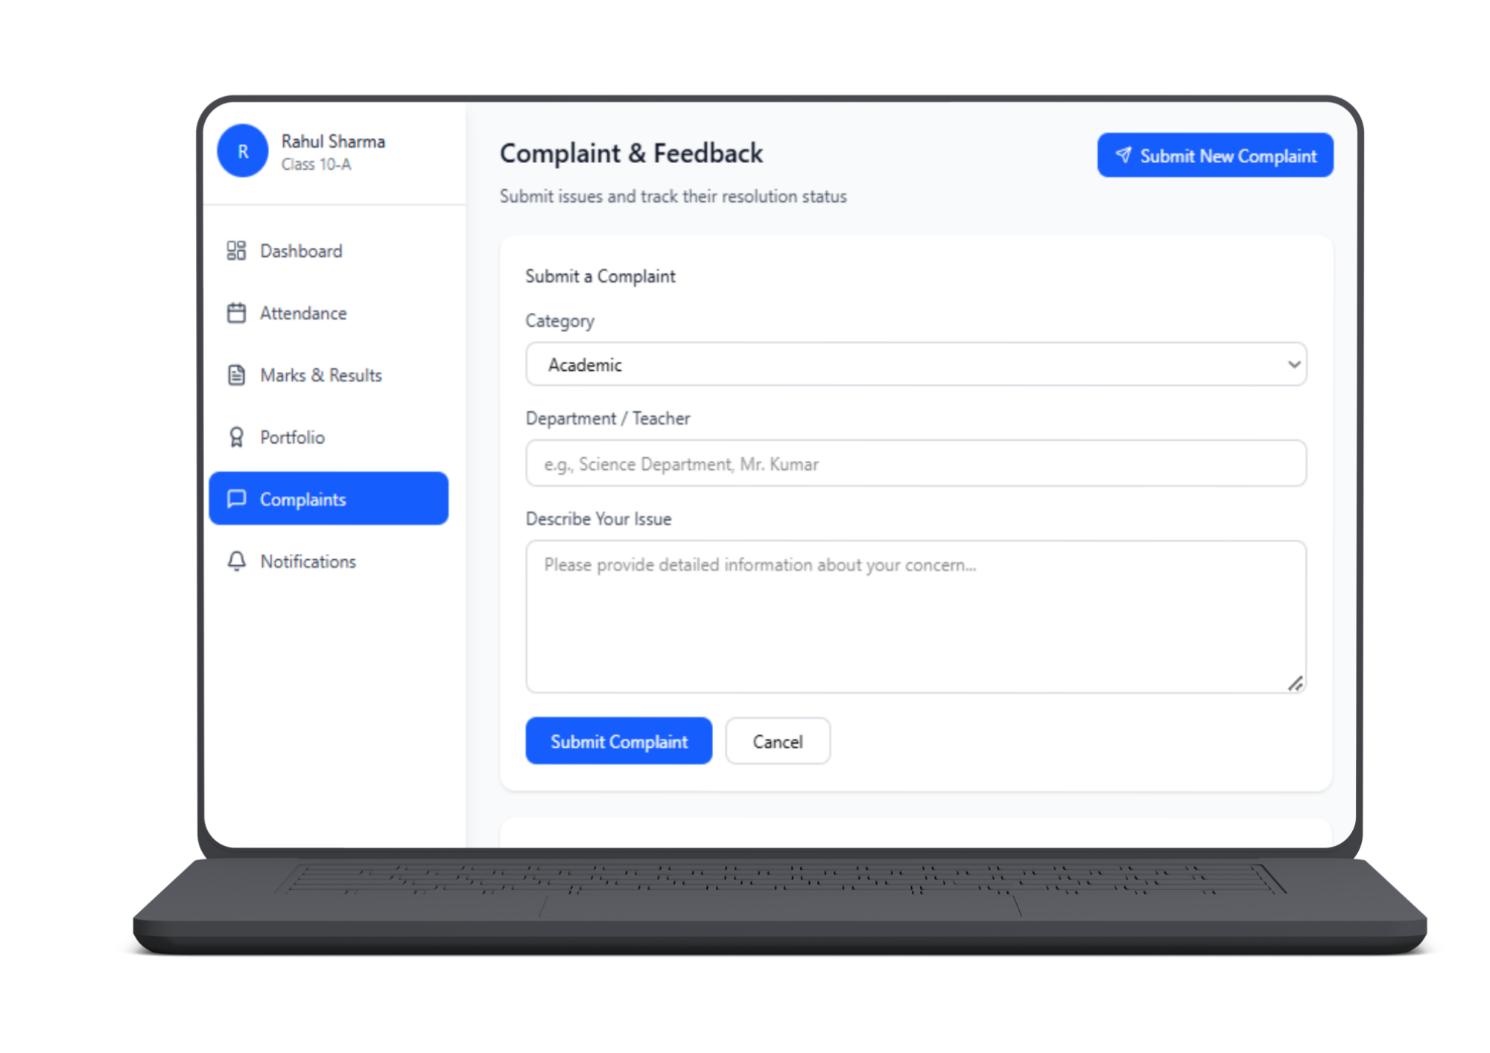
Figure 7 Screen Image 4- Complain Feedback

Student Portfolio Generation Screen
Figure 8 Screen Image 5- Student Portfolio Generation

3.3.2 Screen Objects and Actions

Use Case 1: Submit Complaint
- Screen Objects:
  - Complaint Text Area → where user types the complaint
  - Submit Button → submits complaint to system
  - Status Message Label → shows success/error
- Actions:
  - User enters complaint text
  - User clicks Submit
  - System validates input
  - System saves complaint
  - Status message shows confirmation

Use Case 2: Mark Attendance
- Screen Objects:
  - Student List Table → shows students’ names
  - Attendance Controls → dropdown or radio buttons: Present / Absent / Late
  - Submit Button → saves attendance
  - Message Area → shows success/error
- Actions:
  - Teacher selects status for each student
  - Teacher clicks Submit
  - System validates input
  - System updates attendance records
  - Success message appears

3.4 Behavioral Model
Interaction Diagrams:

User Flow login – Sequence Diagram
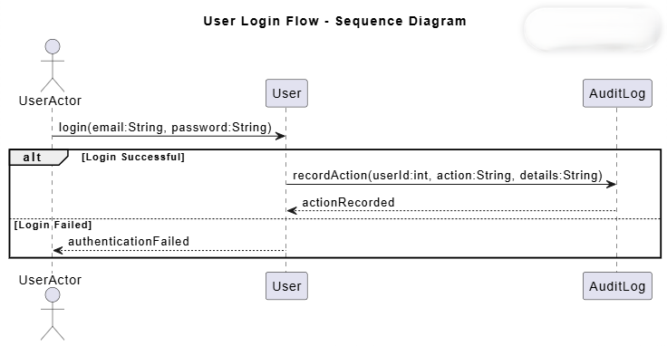
Figure 9 Sequence Diagram 1- User Flow Login
Fig explanation: This figure illustrates the user authentication process, where login credentials are validated and successful login activities are recorded through the audit logging service. It ensures secure access and accountability within the system.

Teacher Academic Management Flow – Sequence Diagram

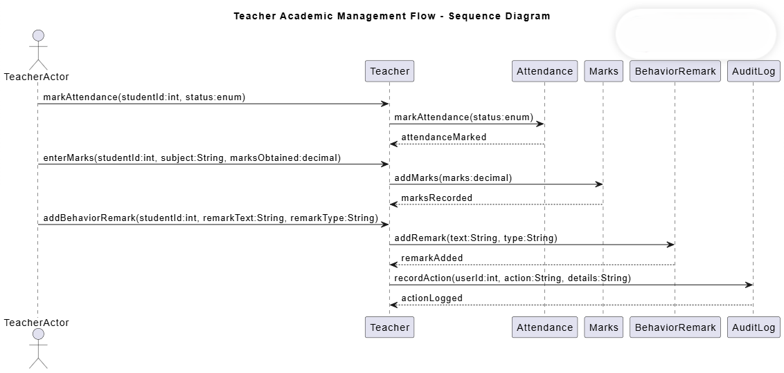
Figure 10 Sequence Diagram 2- Teacher Academic Management Flow

Fig explanation: This figure shows how a teacher manages academic activities, including marking attendance, entering marks, and adding behavior remarks. Each action is logged to maintain data integrity and accountability.
Student Portfoilio Generation Flow – Sequence Diagram

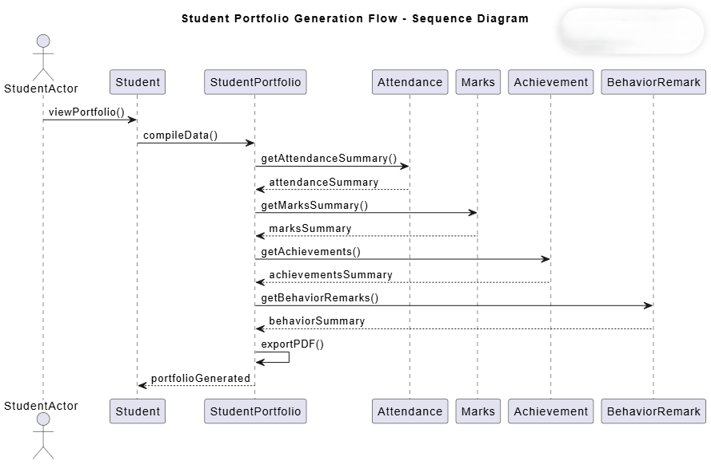
Figure 11 Sequence Diagram 3- Student Portfolio Generation Flow
Fig explanation: This figure depicts the process of generating a student portfolio by aggregating attendance, marks, achievements, and behavior records. The compiled data is then exported as a complete academic performance report.

State Diagrams:

Attendance Record State Diagram
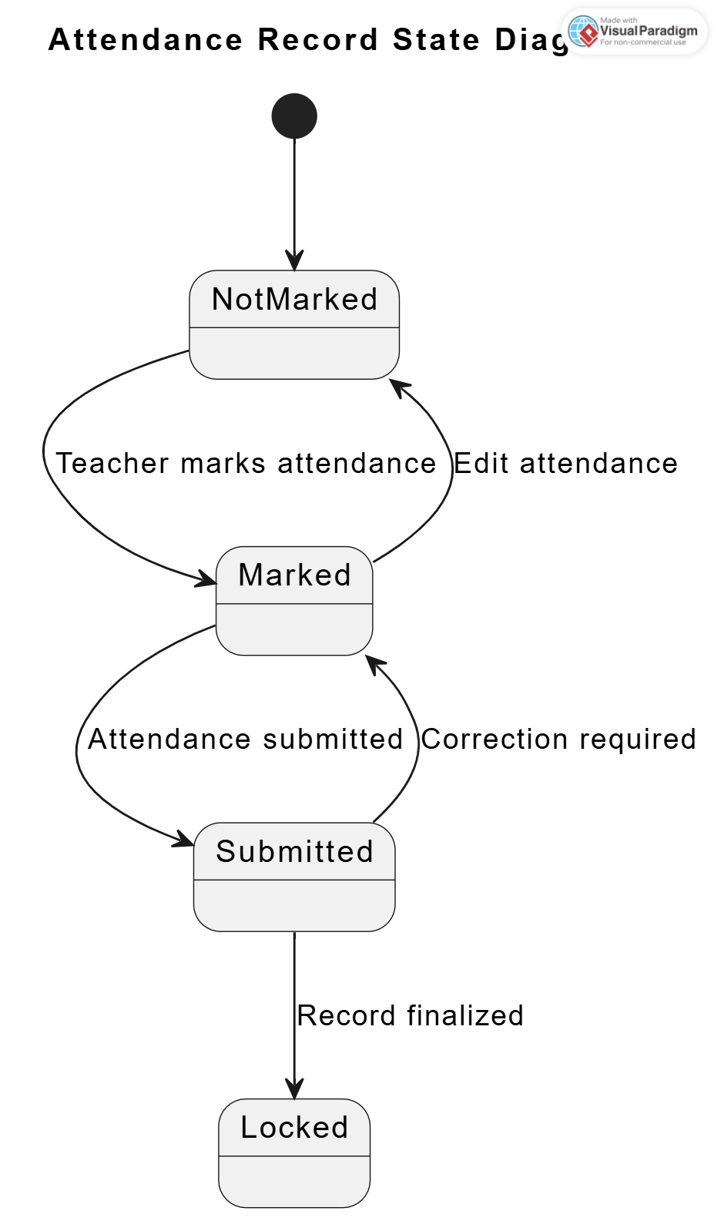

Figure 12 State Diagram 1- Attendance Record

Fig explanation: This state diagram models the attendance recording process. Attendance starts unmarked, is entered by the teacher, submitted for confirmation, and finally locked to prevent unauthorized changes.

Complaint Management State Diagram

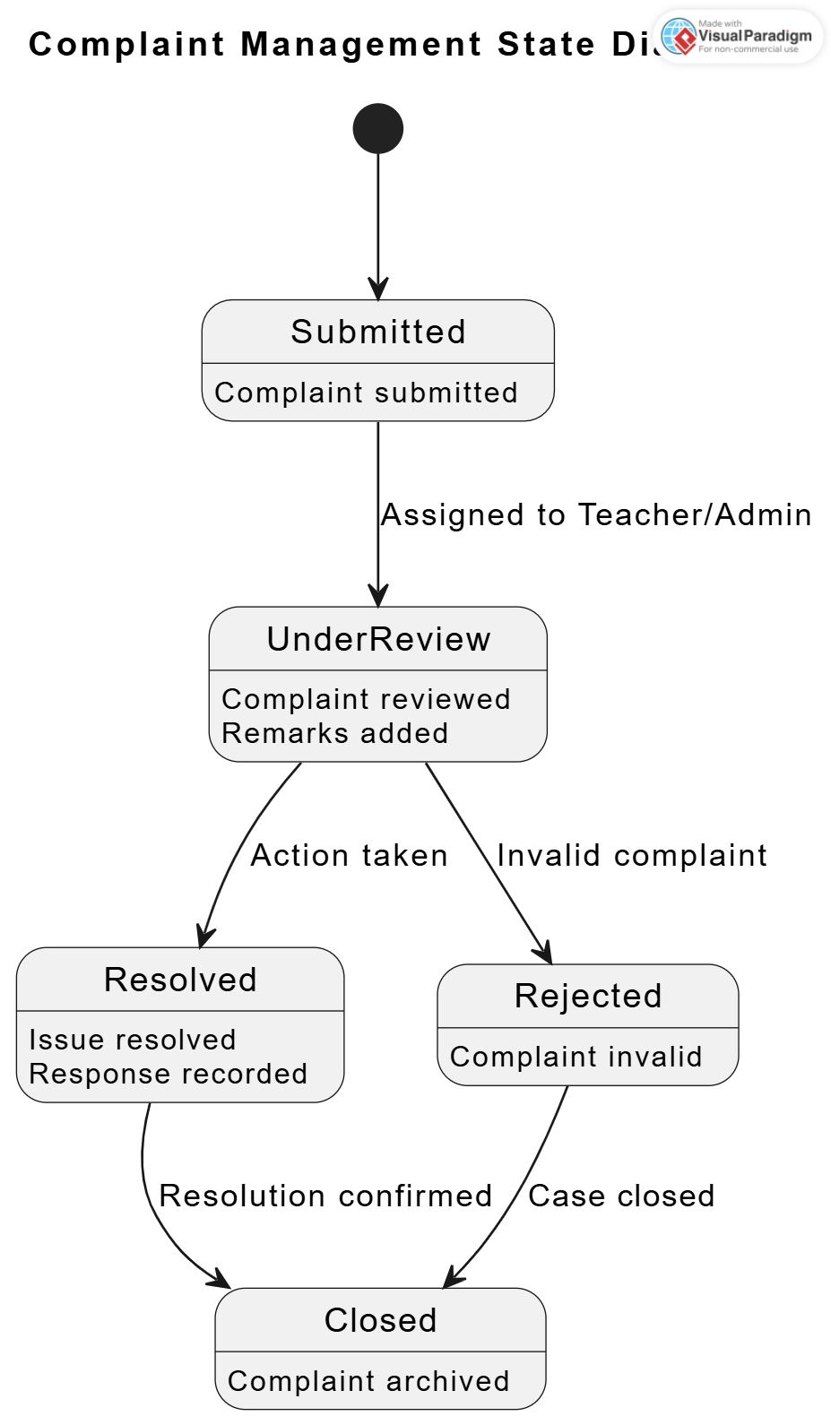

Figure 13 State Diagram 2- Complain Mangement
Fig explanation: This diagram illustrates the complaint handling workflow. A complaint is submitted by a student or parent, reviewed by staff, resolved or rejected, and finally closed after confirmation.

Student Portfolio State Diagram
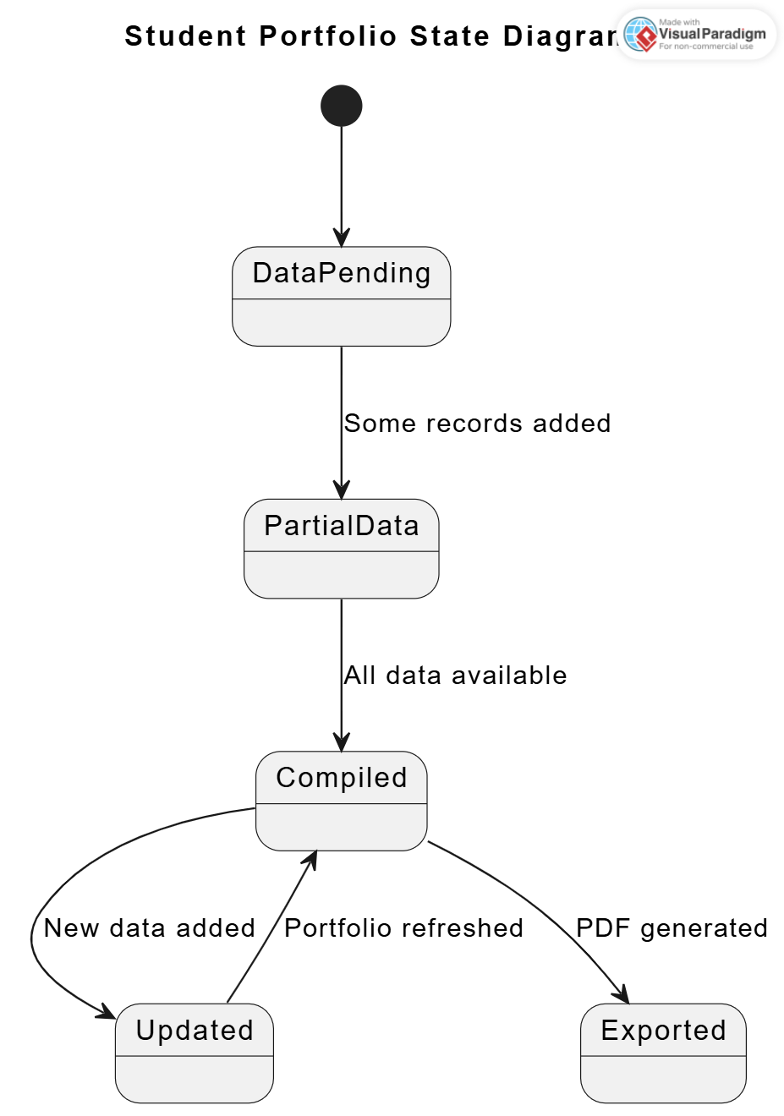

Figure 14 State Diagram 3- Student Portfolio

Fig explanation: This diagram represents the automated student portfolio generation process. The system collects academic data, compiles it into a portfolio, updates it when new data arrives, and allows export in PDF format.

Fee payment State Diagram

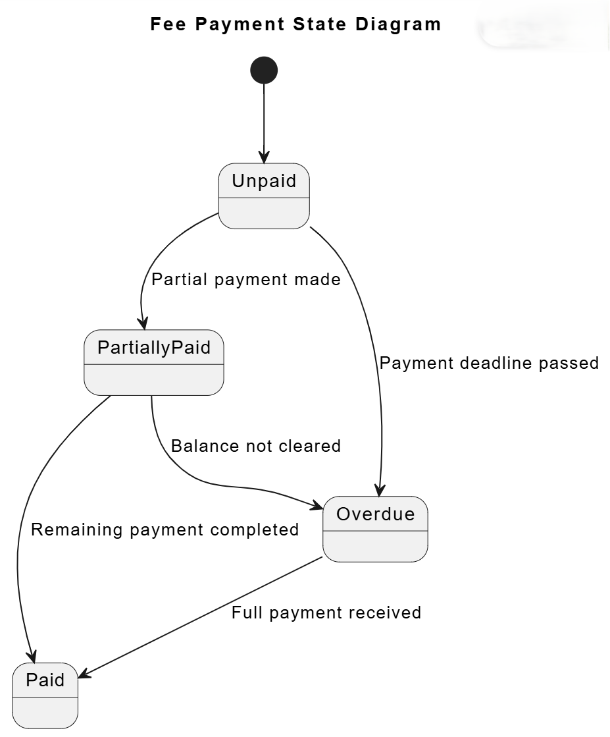
Figure 15 State Diagram 4- fee Payment

Fig explanation: This diagram shows the fee payment lifecycle of a student. It tracks payment status from unpaid to partially paid, overdue, and fully paid.

User Account State Diagram

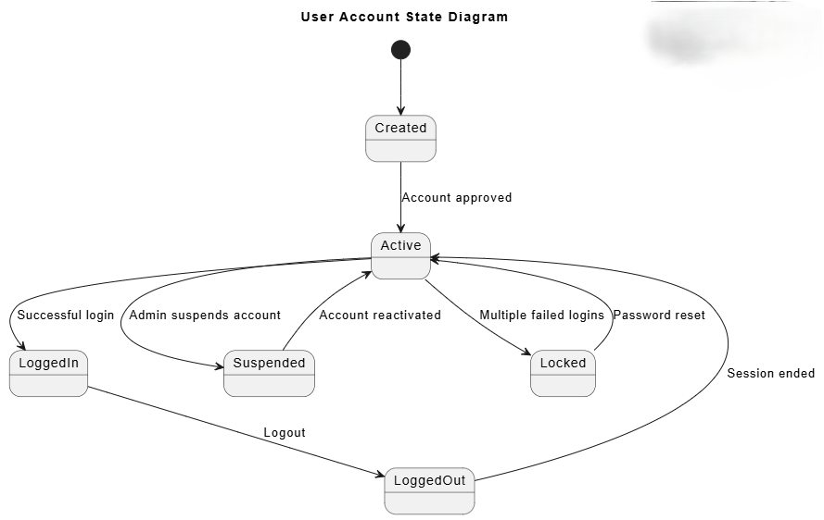

Figure 16 State Diagram 5- User account

Fig explanation: This state diagram represents the lifecycle of a user account in the system. It shows transitions from account creation to activation, login/logout behavior, and administrative actions such as suspension, locking, and reactivation.

Design Decisions
This section describes the major design decisions taken during the development of the School Management System (SMS). Each decision is aligned with the requirements specified in the SRS and justified based on system efficiency, maintainability, scalability, and security.
1. Design Paradigm
Decision: Object-Oriented Design (OOD)
Description:
The system is designed using an object-oriented approach where real-world entities such as User, Student, Teacher, Parent, Attendance, Marks, and Fee are modeled as objects with attributes and behaviors.
Justification:
- Improves modularity and reusability
- Simplifies maintenance and future enhancement
- Supports UML-based modeling (Class and Sequence Diagrams)
2. Architectural Style
Decision: Layered (Multi-Tier) Architecture
Description:
The system follows a layered architecture consisting of Presentation, Application, Data Access, and Database layers.
Justification:
- Ensures separation of concerns
- Allows independent modification of layers
- Enhances scalability and testability
3. User and Role Management
Decision: Role-Based Access Control (RBAC)
Description:
The system supports four predefined roles: Admin, Teacher, Student, and Parent, as defined in the SRS.
Justification:
- Ensures secure and controlled access
- Prevents unauthorized operations
- Simplifies permission management
4. Database Design Approach
Decision: Relational Database Design
Description:
A relational database is used to store persistent system data.
Justification:
- Ensures structured data storage
- Maintains referential integrity
- Supports transactional consistency
5. Normalization Level
Decision: Third Normal Form (3NF)
Description:
The database schema is normalized up to Third Normal Form.
Justification:
- Reduces redundancy
- Prevents update anomalies
- Improves data consistency
6. Object–Relational Mapping Strategy
Decision: Logical Mapping between Classes and Tables
Description:
Each UML class corresponds to a relational database table.
Justification:
- Maintains consistency between design and implementation
- Simplifies CRUD operations
- Improves traceability between ER and Class Diagrams
7. Algorithmic Approach
Decision: Rule-Based and Transaction-Oriented Logic
Description:
Business processes such as attendance management, fee calculation, and complaint handling use rule-based logic.
Justification:
- Avoids unnecessary computational complexity
- Enhances readability and maintainability
- Suitable for academic management systems
8. Behavioral Modeling Strategy
Decision: Use-Case Driven Sequence Modeling
Description:
Sequence diagrams are derived from major SRS use cases, particularly User Login & Role-Based Access.
Justification:
- Login is the primary system entry point
- Demonstrates interaction between multiple system components
- Ensures consistency with SRS workflows
9. Security Design
Decision: Application-Level Security Enforcement
Description:
Security is enforced through encrypted password storage, role validation, and audit logging.
Justification:
- Protects sensitive academic and personal data
- Ensures accountability
- Prevents unauthorized access
10. Modularity and Component Design
Decision: Component-Based Modular Design
Description:
The system is divided into logical components such as User Management, Academic Records, Complaints & Fees, and System Services.
Justification:
- Improves system organization
- Enhances maintainability and scalability
- Aligns with UML Component Diagram
11. Traceability and Documentation
Decision: Strict SRS-to-SDS Traceability
Description:
All design artifacts are derived directly from the SRS.
Justification:
- Ensures requirement coverage
- Prevents scope creep
- Supports academic validation
12. Technology Stack Selection
Decision: ASP.NET Core, React.js, and SQL Server
Description:
The backend of the system is implemented using ASP.NET Core Web API, the frontend using React.js, and SQL Server is used as the relational database.
Justification:
- Supports scalable web-based applications
- Enables secure and high-performance backend services
- Aligns with industry standards and university curriculum
- Facilitates maintainable and modular development
13. Communication Strategy
Decision: RESTful API Communication (JSON over HTTP)
Description:
The system follows a client–server model where the frontend communicates with the backend through RESTful APIs using JSON.
Justification:
- Decouples frontend and backend components
- Enables stateless communication
- Simplifies testing and system integration
14. Error Handling and Validation Strategy
Decision: Server-Side and Client-Side Validation
Description:
Input validation and error handling are implemented at both client and server levels.
Justification:
- Client-side validation improves user experience
- Server-side validation ensures data integrity and security
- Prevents invalid or malicious data submission

Summary
The Software Design Specification (SDS) for the School Management System defines the architectural design, component structure, data organization, and interaction mechanisms of the proposed system. The design adopts a modular and layered approach to ensure scalability, maintainability, and role-based access control. Core system functionalities are divided into user management, academic records, finance and complaints handling, and system services such as notifications and audit logging. UML diagrams, including class and sequence diagrams, are used to clearly represent static structures and dynamic behavior of the system. The SDS provides a strong foundation for implementation by ensuring consistency with system requirements, promoting code reusability, and supporting future system enhancements.

References
Book
Sommerville, I. Software Engineering. Boston: Pearson Education, 2016, pp. 85–140.
Pressman, R. S., and Maxim, B. R. Software Engineering: A Practitioner’s Approach. New York: McGraw-Hill Education, 2020, pp. 210–275.
Booch, G., Rumbaugh, J., and Jacobson, I. The Unified Modeling Language User Guide. Boston: Addison-Wesley, 2005, pp. 50–180.

Article in a Journal
Rumbaugh, J., Blaha, M., Premerlani, W., Eddy, F., and Lorensen, W. “Object-Oriented Modeling and Design.” Journal of Object-Oriented Programming, vol. 7, pp. 21–34, Jan. 1991.
Kitchenham, B., and Charters, S. “Guidelines for Performing Systematic Literature Reviews in Software Engineering.” Empirical Software Engineering Journal, vol. 14, pp. 131–164, Apr. 2009.
Bass, L., Clements, P., and Kazman, R. “Software Architecture in Practice.” IEEE Software, vol. 20, pp. 58–65, Sept. 2003.

Articles from Conference Proceedings (published)
Kruchten, P. “The 4+1 View Model of Architecture.” Proceedings of the IEEE International Conference on Software Engineering (ICSE), 1995, pp. 42–50.
Jacobson, I., Booch, G., and Rumbaugh, J. “The Unified Software Development Process.” Proceedings of the Conference on Object-Oriented Programming, Systems, Languages, and Applications (OOPSLA), 1999, pp. 1–12.

World Wide Web
Microsoft. “ASP.NET Core Web API Documentation.” Internet: https://learn.microsoft.com/aspnet/core, updated 2024 [accessed Jan. 2026].
React Team. “React – A JavaScript Library for Building User Interfaces.” Internet: https://react.dev, updated 2024 [accessed Jan. 2026].
PlantUML. “PlantUML UML Diagram Tool.” Internet: https://plantuml.com, updated 2024 [accessed Jan. 2026].

