Final Year Design Project System Requirements Specification

A Web-Based Unified School Management System for Academic and Administrative Operations with Role-Based Access

Final Year Design Project SRS

by

Saiha Atiq BCS22007
Malaika Ashraf BCS22015
Khadija Mustafa BCS22043
Zainab Khawaja BCS22049

Project Advisor:

Department of Information Technology
University of the Punjab, Gujranwala Campus, Gujranwala, Pakistan
(2026)

A Web-Based Unified School Management System for Academic and Administrative Operations with Role-Based Access

Executive Summary

This Software Requirements Specification (SRS) document defines the functional and non-functional requirements for the Web-Based School Management System (SMS) being developed as a Final Year Project. The system aims to streamline and centralize academic, administrative, and communication processes within a school environment. It is intended to serve multiple user roles, including Administrators, Teachers, Students, and Parents, by providing each with a dedicated, role-based interface and a unified platform for day-to-day operations.
The primary objectives of the system are to simplify attendance management, enable digital marks entry, generate structured student portfolios, facilitate parent–teacher communication, automate fee status visibility, support complaint submission and tracking, and provide a centralized noticeboard for all stakeholders. By integrating these core modules into a single system, the project improves efficiency, reduces paperwork, enhances transparency, and ensures timely access to essential academic information.
The system will be implemented using a modern technology stack comprising React for a responsive front-end, ASP.NET Core Web API for backend services, and SQL Server for secure data storage. The design emphasizes usability, data security, scalability, and performance, ensuring that the solution can support real-world school operations reliably. The SRS lays the foundation for subsequent phases of development, including system design, implementation, testing, and deployment.

Table of Contents
1. Executive Summary 2
2. Requirements Analysis 4
2.1 User classes and characteristics 5
2.2 Requirement Identifying Technique 5
2.3 Functional Requirements 6
2.1.1 User Authentication and Authorization 6
2.1.2 Attendance Management 8
2.1.3 Marks and Student Performance 9
2.1.4 Student Portfolio Generation 12
2.1.5 Noticeboard & Notifications 13
2.1.6 Parent–Teacher Messaging 15
2.1.7 Complaint and Behavior Management 16
2.1.8 Fee Reminder 17
2.1.9 Audit Logs & System Monitoring 18
2.4 Non-Functional Requirements 19
2.1.1 Reliability 19
2.1.2 Usability 19
2.1.3 Performance 20
2.1.4 Security 20
2.5 External Interface Requirements 21
2.1.1 User Interfaces Requirements 21
2.1.2 Software interfaces 23
2.1.3 Hardware interfaces 24
2.1.4 Communications interfaces 24
3. Use case Analysis 25
3.1 UC1 – User Login & Role-Based Access 26
3.2 UC2 – Account Management (Admin) 26
3.3 UC3 – Parent Account Verification 27
3.4 UC4 – Dashboard View 27
3.5 UC5 – View Attendance (Student) 28
3.6 UC6 – Mark Attendance (Teacher) 29
3.7 UC7 – Enter Marks (Teacher) 29
3.8 UC8 – Upload Achievements (Teacher) 30
3.9 UC9 – Record Behavior Remarks (Teacher) 31
3.10 UC10 – View Student Portfolio (Student/Parent) 31
3.11 UC11 – Student Risk Monitoring (System) 32
3.12 UC12 – Submit Complaint (Student/Parent) 32
3.13 UC13 – Resolve Complaint (Teacher/Admin) 33
3.14 UC14 – Notify Users (System) 34
3.15 UC15 – Post Notices (Teacher/Admin) 34
3.16 UC16 – Parent–Teacher Messaging 35
3.17 UC17 – View Fee Status (Student/Parent) 35
3.18 UC18 – Manage Fees (Admin) 36
3.19 UC19 – Manage Students (Admin) 36
3.20 UC20 – Manage Teachers & Subjects (Admin) 37
3.21 UC21 – Review Attendance & Marks (Admin) 38
3.22 UC22 – Compile Student Portfolio (System) 38
3.23 UC23 – Password Reset / Change 39
3.24 UC24 – Audit Logging (System) 39
3.25 UC25 – Generate Reports (Admin) 40
3.26 UC26 – Logout (User) 40
3.27 Use Case Diagram 42
4. Storyboards 43
45
46
4.1 Summary 47
5. References 47

List of Tables

Table 1 Defines the system requirements for secure user authentication and redirection to role-specific dashboards. 8
Table 2 Specifies administrative capabilities for creating, updating, deactivating, and managing user accounts and roles. 9
Table 3 Describes the functionality that allows teachers to record daily student attendance for assigned classes. 10
Table 4 Defines the requirements for teachers to enter and manage student marks for tests and examinations. 11
Table 5 Specifies the process for uploading and managing student achievements and certificates as part of the digital portfolio. 11
Table 6 Describes how teachers can record and manage student behaviour remarks for academic and disciplinary tracking. 12
Table 7 Defines automated analysis of attendance, marks, and behaviour to generate student risk indicators. 13
Table 8 Specifies the system’s ability to compile attendance, marks, behaviour, and achievements into a unified student portfolio. 14
Table 9 Describes the functionality for authorized staff to publish notices to students and parents. 15
Table 10 Defines the notification mechanism for informing users about notices and important system updates. 16
Table 11 Specifies secure communication requirements between parents and teachers within the system. 17
Table 12 Defines the process through which students and parents can submit formal complaints. 18
Table 13 Describes how teachers and administrators manage and resolve submitted complaints. 18
Table 14 Specifies the system requirements for displaying student fee status to authorized users. 19
Table 15 Defines the system’s logging requirements for tracking critical actions and ensuring accountability. 20
Table 16 UC1 – User Login & Role-Based Access – Authenticate users and route to role-specific dashboards 28
Table 17 UC2 – Account Management (Admin) – Enable administrators to create, update, deactivate, or delete user accounts and assign system roles. 28
Table 18 UC3 – Parent Account Verification – Verify parent accounts and activate secure login credentials. 29
Table 19UC4 – Dashboard View – Display a role-based dashboard with relevant widgets, shortcuts, and system information. 29
Table 20 UC5 – View Attendance (Student) – Allow students to view subject-wise attendance records and trends. 30
Table 21 UC6 – Mark Attendance (Teacher) – Allow teachers to record daily attendance for assigned classes. 31
Table 22 UC7 – Enter Marks (Teacher) – Enable teachers to enter and manage student marks for exams and assessments. 31
Table 23 UC8 – Upload Achievements (Teacher) – Allow teachers to upload student certificates and extracurricular achievements. 32
Table 24UC9 – Record Behavior Remarks (Teacher) – Record positive or negative behavior remarks for students. 32
Table 25UC10 – View Student Portfolio (Student/Parent) – Provide students and parents access to a consolidated student portfolio. 33
Table 26 UC11– Student Risk Monitoring (System) – Automatically analyze attendance, marks, and behavior to determine student risk levels. 34
Table 27 UC12 – Submit Complaint (Student/Parent) – Allow students and parents to submit formal complaints within the system. 34
Table 28UC13 – Resolve Complaint (Teacher/Admin) – Enable staff to review, manage, and resolve submitted complaints. 35
Table 29 UC14 – Notify Users (System) – Send automated notifications for system events and updates. 35
Table 30 UC15 – Post Notices (Teacher/Admin) – Allow authorized staff to publish notices on the digital noticeboard. 36
Table 31 UC16 – Parent–Teacher Messaging – Enable secure private communication between parents and teachers. 37
Table 32 UC17 – View Fee Status (Student/Parent) – Allow students and parents to view fee status and download challans. 37
Table 33 UC18 – Manage Fees (Admin) – Enable administrators to manage and update student fee records 38
Table 34 UC19 – Manage Students (Admin) – Allow administrators to add, update, and manage student profiles. 38
Table 35 UC20 – Manage Teachers & Subjects (Admin) – Enable administrators to manage teacher profiles and subject/class assignments. 39
Table 36 UC21 – Review Attendance & Marks (Admin) – Admin reviews and corrects student attendance and marks. 39
Table 37 UC22 – Compile Student Portfolio (System) – System compiles attendance, marks, behavior, and achievements into a portfolio. 40
Table 38 UC23 –Password Reset / Change – Users can securely reset or change their password. 40
Table 39 UC24 –Audit Logging (System) – System maintains immutable logs of all critical actions. 41
Table 40 UC25 –Generate Reports (Admin) – Admin generates academic and administrative reports in PDF/CSV format. 42
Table 41 UC26 – Logout (User) – Users can securely log out of the system. 42

Requirements Analysis
This SRS document presents the analysis and requirements gathered for developing the School Management System (SMS). It summarizes the problem domain, identifies the needs of different user roles, and defines the system’s functional and non-functional requirements. The work includes reviewing existing school workflows, studying user expectations, and outlining the features necessary to digitalize core academic and administrative processes. This section establishes the foundation for the system’s design and implementation in later stages.

User classes and characteristics

User Class | User Characteristics
Student | Accesses attendance, marks, results, and portfolio. Submits complaints and views notifications. Requires simple, intuitive interface.
Parent | Views child’s progress, attendance, fees, and teacher messages. Receives school notifications. Needs secure and easy-to-use dashboard.
Teacher | Marks attendance, enters exam results, uploads certificates and supporting learning materials, posts announcements, and communicates with parents/students. Requires efficient workflow and clear data access.
Administrator | Manages students, teachers, classes, subjects, fees, and overall system data. Monitors reports, complaints, and notices. Needs full system access, control, and reporting tools.

Requirement Identifying Technique

- The requirements for the School Management System (SMS) were identified using a combination of structured and semi-structured techniques to ensure comprehensive coverage of all stakeholder needs. Initial proposal analysis provided baseline functional expectations and clarified the project scope. Informal interviews and discussions with teachers, students, and administrative staff helped capture real-world workflows, typical challenges, and user-specific requirements.
- To further refine and validate requirements, use-case modeling was employed to describe system interactions from the perspective of each user role. Preliminary UI sketches and workflow storyboards assisted in visualizing essential functions and receiving early stakeholder feedback. Additionally, reference to existing school management processes and sample academic data enabled the identification of practical constraints and operational rules.
- These combined techniques ensure that the resulting requirements are realistic, complete, and aligned with actual institutional needs, forming a reliable foundation for system design and development.

Functional Requirements
This section defines the functional requirements of the School Management System (SMS). Functional requirements specify what the system shall do to support academic, administrative, and communication processes within a school environment.
Each requirement is stated in clear, testable, and unambiguous terms to ensure correct interpretation and verification. The requirements are grouped by major system modules, including Authentication, Student Management, Teacher Operations, Parent Interaction, Administration, and System Services.

User Authentication and Authorization

FR-1: User Login & Role-Based Access

Table 1 Defines the system requirements for secure user authentication and redirection to role-specific dashboards.
Identifier | FR-1
Title | User Authentication & Role-Based Routing
Requirement | The system shall authenticate users using email/username and password, and route them to a role-specific dashboard based on their assigned role (Admin, Teacher, Student, Parent).
Source | Project Proposal, Stakeholder Interviews (Teachers, Admin Staff)
Rationale | Ensures secure access and tailored system functionality.
Business Rule (if required) | - Only verified users with an active status may log in.  - Each user account must be associated with exactly one role at a time.  - Password must meet school-defined security standards (e.g., minimum length, complexity).  - Users with inactive or suspended accounts shall not be allowed to access the system.
Dependencies | None
Priority | High

Error Handling / Invalid Input Response:
- If incorrect credentials are entered → system displays “Invalid username or password”.
- If account is inactive → system displays “Your account is deactivated. Contact Admin.”
- If password does not meet requirements → reject and prompt valid format.
- System must block login after repeated failed attempts (security rule).

FR-2: User Management

Table 2 Specifies administrative capabilities for creating, updating, deactivating, and managing user accounts and roles.

Identifier | FR-2
Title | User Management by Admin
Requirement | The Admin shall be able to add, update, deactivate, or delete user accounts and assign appropriate roles.
Source | Admin Requirements, Proposal
Rationale | Ensures proper system access control and allows accurate management of school personnel and students.
Business Rule (if required) | - Only Admin can create or remove accounts.  - Roles must be assigned at account creation.
Dependencies | FR-1
Priority | High

Error Handling / Invalid Input Response:
- If mandatory fields (name, role, email) are missing → show validation error.
- If Admin tries to delete a user with existing linked records → system shall prevent deletion and show error.
- If duplicate email/username exists → system shall reject the account creation.

Attendance Management

FR-3: Mark Attendance

Table 3 Describes the functionality that allows teachers to record daily student attendance for assigned classes.

Identifier | FR-3
Title | Mark Attendance
Requirement | Teachers shall be able to mark daily attendance for students in assigned classes using Present/Absent/Late options.
Source | Teacher Interviews, Proposal
Rationale | Attendance is critical for academic tracking and portfolio generation.
Business Rule (if required) | - Only assigned teachers can mark attendance for their classes.  - Attendance must be recorded once per day per class.
Dependencies | FR-1, FR-2
Priority | High

Error Handling / Invalid Input Response:
- If a teacher attempts to mark attendance for a class not assigned → system shows “Unauthorized action.”
- If attendance already submitted → system shows “Attendance already marked for today.”
- If internet/server interruption occurs → partial entries should be autosaved (if feasible).

Marks and Student Performance

FR-4: Enter Marks

Table 4 Defines the requirements for teachers to enter and manage student marks for tests and examinations.

Identifier | FR-4
Title | Enter Marks
Requirement | Teachers shall be able to enter marks for tests, and exams for each student in their subjects.
Source | Teacher Input, Proposal
Rationale | Marks entry is vital for grading, performance evaluation, and portfolio compilation.
Business Rule (if required) | - Marks must be numeric.  - Marks may not exceed defined maximum for each exam/test.  - Only subject-assigned teachers may enter marks.
Dependencies | FR-2, FR-1
Priority | High
Error Handling / Invalid Input Response:
- If marks exceed allowed range → system rejects input.
- If teacher attempts to enter marks for unassigned subjects → system shows “Access denied.”
- If marks are missing for required fields → system prompts completion.

FR-5: Achievements Upload
Table 5 Specifies the process for uploading and managing student achievements and certificates as part of the digital portfolio.
Identifier | FR-5
Title | Achievements Upload
Requirement | Teachers shall be able to upload student achievements, certificates, awards, and extracurricular activity records to be included automatically in the student portfolio.
Source | Project Proposal – Portfolio Generator
Rationale | Supports a complete digital portfolio by storing all student accomplishments in one centralized location.
Business Rule (if required) | - Only Teachers assigned to the student’s class can upload achievements.  - Uploads must include title, date, category (Academic / Sports / Co-curricular / Certificates)  - Uploaded files must follow allowed size and type constraints.  - Students/Parents may view uploaded achievements but cannot modify them.
Dependencies | FR-2, FR-1
Priority | High

Error Handling / Invalid Input Response:
- If file size exceeds limit → system refuses upload and shows “File too large.”
- If file type is invalid → system displays allowed formats.
- If teacher tries uploading for unassigned student → access denied.
- If upload fails due to server error → display “Upload failed. Try again.” and log the error.

FR-6: Behavior remarks by teachers
Table 6 Describes how teachers can record and manage student behaviour remarks for academic and disciplinary tracking.
Identifier | FR-6
Title | Behavior Remarks by Teachers
Requirement | Teachers shall be able to record positive or negative behaviour remarks for each student, which will become part of the student's behaviour history and portfolio.
Source | Stakeholder Inputs – Behaviour & Complaint Management
Rationale | Provides a structured and formal way to track student behaviour trends, disciplinary issues, and positive contributions.
Business Rule (if required) | - Only assigned teachers may add behaviour remarks for their students.  - Behaviour remarks automatically appear in the student’s portfolio and may influence risk level.  - teachers can only edit their remarks.
Dependencies | FR-2, FR-1
Priority | High

Error Handling / Invalid Input Response:
- If mandatory fields (description/category) are missing → system shows validation error.
- If unauthorized user tries adding remarks → system denies action.
- If remark exceeds character limit → system prompts trimming.
- If behavior entry clashes with missing student record → system shows “Student not found.”

FR-7: Student Risk Monitoring
Table 7 Defines automated analysis of attendance, marks, and behaviour to generate student risk indicators.
Identifier | FR-7
Title | Student Risk Monitoring
Requirement | The system shall automatically analyze student attendance, marks, and behaviour records to generate risk indicators (Low Risk, Medium Risk, High Risk)
Source | Project Proposal – Risk Monitoring Objective
Rationale | Helps teachers and administration identify academically or behaviourally struggling students early and take corrective actions.
Business Rule (if required) | - Risk levels must be calculated based on predefined criteria (e.g., low attendance, poor marks, repeated complaints).  - Risk indicators must update automatically when new data (attendance/marks/complaints) is added.  - Only Admins and Teachers may view full risk analysis; Parents see only summarized indicators (if enabled).
Dependencies | FR-3, FR-4
Priority | High

Error Handling / Invalid Input Response:
- If required data is missing → system shows “Insufficient data to generate risk level.”
- If unauthorized user tries accessing the module → access denied.
- If risk calculation fails due to server error → log issue and display fallback status “Risk unavailable”.

Student Portfolio Generation

FR-8: Portfolio Compilation
Table 8 Specifies the system’s ability to compile attendance, marks, behaviour, and achievements into a unified student portfolio.
Identifier | FR-8
Title | Portfolio Compilation
Requirement | The system shall compile student attendance, marks, behavior notes, and achievements into a structured digital portfolio.
Source | Proposal
Rationale | Provides a consolidated view of student performance.
Business Rule (if required) | - Marks must be numeric .  - Only relevant stakeholders can generate/view portfolios.
Dependencies | FR-3, FR-4
Priority | Medium

Error Handling / Invalid Input Response:
- If any required data is missing, system shows “Portfolio incomplete—missing attendance/marks/etc.”
- If unauthorized user tries to access portfolio → deny access.

Noticeboard & Notifications

FR-9: Post Notices
Table 9 Describes the functionality for authorized staff to publish notices to students and parents.
Identifier | FR-9
Title | Post Notices
Requirement | Admin/Teachers shall be able to post school-wide or class-specific notices visible on user dashboards.
Source | Admin
Rationale | Improves communication across all stakeholders.
Business Rule (if required) | - Only authorized staff can create notices.  - Notice may be tagged as school-wide or class-specific.
Dependencies | FR-9
Priority | High

Error Handling / Invalid Input Response:
- If mandatory content is missing → system refuses publishing.
- If unauthorized user attempts posting → show “Permission denied.”

FR-10: Notify Users
Table 10 Defines the notification mechanism for informing users about notices and important system updates.
Identifier | FR-10
Title | Notify Users
Requirement | The system shall notify parents and students about new notices via dashboard alerts
Source | Parent Feedback
Rationale | Ensures timely communication of important announcements.
Business Rule (if required) | - Notifications shall follow user-specific communication settings.  - Notifications must be generated instantly after posting a notice.
Dependencies | FR-6
Priority | Medium

Error Handling / Invalid Input Response:
- If notification delivery fails → system logs the failure for Admin review.
- If user disables notifications → system respects settings.

Parent–Teacher Messaging

FR-11: Private Messaging
Table 11 Specifies secure communication requirements between parents and teachers within the system.
Identifier | FR-11
Title | Private Messaging
Requirement | The system shall allow parents and teachers to exchange private messages through a secure messaging interface.
Source | Parent–Teacher Meeting Notes
Rationale | Improves communication and student monitoring.
Business Rule (if required) | - Messaging only allowed between assigned parent ↔ teacher pairs.  - Messages must be stored securely for audit.
Dependencies | FR-1, FR2
Priority | High

Error Handling / Invalid Input Response:
- If unauthorized user attempts to message → access denied.
- If message body is empty → system rejects sending.

Complaint and Behavior Management

FR-12: Submit Complaint
Table 12 Defines the process through which students and parents can submit formal complaints.
Identifier | FR-12
Title | Submit Complaint
Requirement | Students/Parents shall be able to submit complaints
Source | Student Surveys
Rationale | Provides a formal channel for academic or behavioral concerns.
Business Rule (if required) | - Complaints shall be categorized (e.g., academic, discipline).
Dependencies | FR-1
Priority | Medium
Error Handling / Invalid Input Response:
- If mandatory fields are missing → display error.
- If user is not authenticated → deny submission.

FR-13: Complaint Resolution Workflow
Table 13 Describes how teachers and administrators manage and resolve submitted complaints.
Identifier | FR-13
Title | Complaint Resolution Workflow
Requirement | Teachers/Admin shall update complaint status (Pending, In Review, Resolved)
Source | Admin Decision
Rationale | Ensures transparent complaint handling.
Business Rule (if required) | - Only authorized staff may update status.
Dependencies | FR-9
Priority | Medium

Error Handling / Invalid Input Response:
- If unauthorized staff attempts update → system denies access.
- If complaint does not exist → show “Complaint not found.”

Fee Reminder

FR-14: Fee Status View
Table 14 Specifies the system requirements for displaying student fee status to authorized users.
Identifier | FR-14
Title | Fee Status View
Requirement | The system shall display the fee status (Paid/Unpaid/Pending) for each student.
Source | Finance Department
Rationale | Increases transparency for parents and students.
Business Rule (if required) | - Only Admin can update fee records.  - Students/Parents can only view their own fee data.
Dependencies | FR-1
Priority | Medium

Error Handling / Invalid Input Response:
- If user tries to view another student's fee → access denied.
- If fee data is missing → show “Fee record not available.”

Audit Logs & System Monitoring

FR-15: Audit Logging
Table 15 Defines the system’s logging requirements for tracking critical actions and ensuring accountability.
Identifier | FR-15
Title | Audit Logging
Requirement | The system shall record logs for login activity, attendance marking, marks entry, complaint updates, and account changes.
Source | Admin Security Policy
Rationale | Supports accountability and system monitoring.
Business Rule (if required) | - Logs must be kept for at least one year.  - Logs shall be immutable.
Dependencies | All functional modules
Priority | High

Error Handling / Invalid Input Response:
- If logging fails → system shows an Admin alert and stores error in backup log.
- Unauthorized access to logs → strictly denied.

Non-Functional Requirements
This section specifies the nonfunctional requirements (NFRs) of the School Management System (SMS), which define how the system should perform rather than specific functionalities. These requirements address system quality attributes, performance standards, security, usability, reliability, scalability, and maintainability.

Reliability
NFR-R1: System Uptime
The system shall maintain at least 98% uptime during school operational hours (7 AM – 6 PM).
NFR-R2: Backup Frequency
The system shall automatically create an incremental database backup every 24 hours at 9 PM, ensuring data protection.
NFR-R3: Data Integrity
The system shall ensure 99% data integrity, meaning records for attendance, marks, notices, and communication must not be lost or corrupted during CRUD operations.
NFR-R4: Recovery Time Objective (RTO)
In case of system failure, the system shall recover within 10 minutes after restoration procedures begin.
NFR-R5: Fault Tolerance
If a module fails (e.g., noticeboard service), the rest of the system shall continue working without interruption.

Usability
NFR-U1: Learning Curve
A new user (teacher/parent/student) shall be able to learn the system interface within 30 minutes without training.
NFR-U2: Task Completion
- A teacher shall be able to mark attendance in 3 clicks or fewer.
- A parent shall be able to check the student portfolio within 4 clicks.
- A student shall be able to submit a complaint within 3 clicks.
NFR-U3: Accessibility
The system shall be fully accessible on mobile, tablet, and desktop with responsive design (React + Tailwind/Bootstrap).
NFR-U4: Error Prevention
User input errors (e.g., missing required fields) shall be detected and user-friendly error messages displayed within 1 second.
NFR-U5: Language & Clarity
The interface shall maintain consistent terminology and iconography for all dashboards (Students, Teachers, Parents, Admin).

Performance
NFR-P1: Response Time
For all CRUD operations (attendance entry, portfolio view, noticeboard load, messaging), the system shall respond within:
- 2 seconds for simple operations
- 5 seconds for complex queries (e.g., portfolio generation)
NFR-P2: Concurrent Users
The system shall support 100 concurrent users without significant degradation in performance (since it is designed for a single school environment).
NFR-P3: Data Processing
The system shall process a full class attendance record (40–60 students) within 3 seconds.
NFR-P4: Page Rendering
95% of all pages shall load in under 3 seconds on a standard 4G connection.

Security
NFR-S1: Role-Based Access Control
The system shall enforce strict role-based access to protect sensitive data for Students, Teachers, Parents, and Admins.
NFR-S2: Unauthorized Access Prevention
Any unauthorized attempt to access another user's data shall be blocked and logged within 1 second.
NFR-S3: Data Protection
All sensitive data (student profiles, marks, attendance, complaints) shall meet basic confidentiality and integrity standards (no plaintext exposure).
NFR-S4: Session Management
User sessions shall automatically expire after 20 minutes of inactivity and require reauthentication.
NFR-S5: Audit Trail
The system shall maintain audit logs for:
- Attendance updates
- Marks entry
- Portfolio updates
- Complaint status changes
- Notice creation
- Each log shall include timestamp, user role, and action details.
NFR-S6: Communication Privacy
The Parent–Teacher messaging module shall ensure:
- Only sender and receiver can view messages
- No public or group message visibility.

External Interface Requirements

This section defines all interfaces through which the School Management System (SMS) interacts with its users, external hardware, external software components, communication mechanisms, and supporting platforms. These requirements ensure smooth communication, consistent user experience, and correct integration with external technologies.

User Interfaces Requirements
The School Management System is a web-based application used by four primary user roles: Admin, Teacher, Student, and Parent. The following logical user interface requirements apply to all modules.

GUI Design Standards

The system shall follow consistent UI/UX standards across all dashboards, including:
- Alignment with Google Material Design and React component styling conventions.
- Use of Bootstrap or Tailwind CSS for responsive and mobile-friendly layouts.
- Consistent use of fonts, icons, layouts, and interactive components across all pages.
- Standard button labels such as Save, Update, Submit, Cancel, Back, Upload, and Delete.
- A uniform color scheme representing institutional or educational themes (blue, green, white).
- A minimum screen resolution compatibility of 1366 × 768, with support for responsive adaptation to mobile devices.

Navigation & Controls
- A left-side or top navigation bar shall be present on every dashboard with clearly labeled links.
- Common navigation items include: Home, Notices, Messages, Attendance, Portfolio, and Logout.
- A Help or Support button will be accessible from every screen.
- Consistent placement of Back, Home, and Dashboard icons.
- Tab/field navigation shall follow left-to-right logical movement for form-based inputs.
- Forms shall support error highlighting, placeholder text, and tooltip hints where necessary.

Display Conventions
- Success messages shall appear in green; error or warning messages in red.
- System messages shall appear in toast alerts or modal dialogs.
- Required fields shall be marked with a red asterisk (*).
- Data tables shall support pagination, filtering, and search.
- Icons shall be used for common actions (edit pencil, delete bin, upload cloud, etc.).

Accessibility Requirements
- The interface shall comply with WCAG 2.0 Level AA accessibility guidelines.
- High-contrast mode shall be supported for users with visual impairments.
- Provide text alternatives for icons and images using alt-text attributes.
- Font size shall be adjustable using browser zoom (up to 200%).
- All buttons and links shall be keyboard-accessible (TAB, ENTER, SHIFT+TAB).

Localization & Language Support
- English shall be the primary interface language.
- The system shall allow easy integration of additional languages (e.g., Urdu) by using:
  - Unicode-supported fonts
  - Separated label constants
  - Right-to-left layout support (if Urdu is added)

Mockups & UI Documentation
- Screen mockups and wireframes shall be provided in a separate User Interface Design Document.
- Mockups included in the SRS serve only as illustrative examples and not final design.

Software interfaces
This section describes all interactions between the SMS and external software systems, libraries, frameworks, and databases.

Backend Framework
- The system shall use ASP.NET Core Web API v7.0+ for server-side logic.
- API endpoints shall follow RESTful conventions (GET, POST, PUT, DELETE).
- Authentication shall be implemented using JWT (JSON Web Tokens).

Frontend Framework
- The frontend shall be built using React.js v18+.
- Axios or Fetch API shall be used for server communication.

Database Interface
- The system shall use Microsoft SQL Server 2019+ as the primary database.
- Database interactions shall occur through:
  - Entity Framework Core v7.0+ (ORM)
  - Code-first migrations for schema generation
- SQL Server must support:
  - User tables
  - Attendance records
  - Marks records
  - Complaints and behaviour logs
  - Portfolio data
  - Audit logs

External Libraries
The system shall integrate the following libraries:
- JWT Authentication Library for secure login
- React Router for navigation
- React Icons / Lucide Icons for visual consistency
- Tailwind / Bootstrap for UI layouts
- Chart.js or Recharts for analytics dashboards

External Systems (Optional Integrations)
If enabled:
- Email service provider (SMTP) for sending alerts
- SMS Gateway API for fee reminders and notices
These interfaces will require:
- Valid API key
- Network availability
- Compliance with security policies

Hardware interfaces
The School Management System does not require specialized hardware. It must operate on standard computing devices meeting the following requirements:

Supported Devices
- Desktop computers
- Laptops
- Tablets
- Mobile phones
All devices must support:
- A modern web browser
- Minimum 2 GB RAM (recommended 4 GB for teachers/admin due to dashboards)

Server Hardware
If self-hosted, the backend server shall have:
- Minimum 8 GB RAM
- 100 GB storage
- Quad-core processor
- Windows Server or Linux environment

Hardware Integration
No direct hardware integrations (barcode scanners, biometric devices, etc.) are included in the current scope.
System architecture allows future extensions.

Communications interfaces
This section describes all communication protocols and network interactions of the SMS.

Network Protocols
The system shall communicate over:
- HTTPS (mandatory)
- TLS 1.2+ encryption
- RESTful API calls over port 443

Web Browser Compatibility
The system must support:
- Google Chrome
- Microsoft Edge
- Firefox
- Safari (for iOS)

Messaging Communication
- Parent–Teacher messaging shall use encrypted API calls.
- All messages shall be stored securely in the database.

API Communication
- All client-server communication shall follow JSON formatting.
- API responses must include:
  - Status code
  - Success/Failure message
  - Error details where applicable

System Availability Requirements
- The system shall be operable with internet speeds as low as 2 Mbps.
- Requests should time out only after 30 seconds of inactivity.

Use case Analysis

UC1 – User Login & Role-Based Access

Table 16 UC1 – User Login & Role-Based Access – Authenticate users and route to role-specific dashboards

UC Identifier | UC1
Requirements Traceability | FR-1
Purpose | Authenticate users and route them to role-specific dashboards
Priority | High
Preconditions | User account exists and is active
Postconditions | User logged in and redirected to dashboard
Actors | Student, Parent, Teacher, Admin
Extends | None
Main Success Scenario | 1. User enters credentials  2. System verifies credentials  3. Checks user role  4. Redirects to role-specific dashboard  5. Dashboard displays widgets
Alternate Flows | Password expired → prompt resetInactive user → show deactivated
Exceptions | Invalid credentials → errorAccount temporarily locked
Includes | UC24

UC2 – Account Management (Admin)

Table 17 UC2 – Account Management (Admin) – Enable administrators to create, update, deactivate, or delete user accounts and assign system roles.

UC Identifier | UC2
Requirements Traceability | FR-2
Purpose | Admin creates, updates, deactivates, or deletes user accounts and assigns roles
Priority | High
Preconditions | Admin logged in (UC1)
Postconditions | Accounts created/updated/deactivated successfully
Actors | Admin
Extends | None
Main Success Scenario | 1. Admin navigates to User Management  2. Selects “Add User”  3. Enters details and assigns role  4. System validates and creates account5. Action logged
Alternate Flows | Admin updates existing user / deactivates
Exceptions | Duplicate email/username → errorMandatory fields missing
Includes | UC3, UC24

UC3 – Parent Account Verification

Table 18 UC3 – Parent Account Verification – Verify parent accounts and activate secure login credentials.

UC Identifier | UC3
Requirements Traceability | FR-1, FR-2
Purpose | Verify parent accounts and activate login credentials
Priority | High
Preconditions | Parent account exists (created via UC2)
Postconditions | Parent account activated and credentials verified
Actors | Admin, Parent
Extends | None
Main Success Scenario | 1. Admin sends activation link2. Parent sets password3. System validates4. Account activated
Alternate Flows | Parent requests resend / manual reset
Exceptions | Expired activation link → prompt new linkIncorrect password setup
Includes | UC1, UC24

UC4 – Dashboard View

Table 19UC4 – Dashboard View – Display a role-based dashboard with relevant widgets, shortcuts, and system information.

UC Identifier | UC4
Requirements Traceability | FR-4, FR-5, FR-9, FR-10, FR-14
Purpose | Provide role-based dashboard with relevant widgets and shortcuts
Priority | High
Preconditions | User logged in (UC1)
Postconditions | Dashboard displays correct widgets and links based on role
Actors | Student, Parent, Teacher, Admin
Extends | None
Main Success Scenario | 1. System loads dashboard  2. Displays widgets (attendance, marks, portfolio, fee status, notifications)  3. Navigation to modules enabled
Alternate Flows | Widgets may hide sections if no data
Exceptions | System fails to load → retry option
Includes | UC5, UC6, UC7, UC10, UC14, UC16

UC5 – View Attendance (Student)

Table 20 UC5 – View Attendance (Student) – Allow students to view subject-wise attendance records and trends.

UC Identifier | UC5
Requirements Traceability | FR-3
Purpose | Allow students to view attendance records and trends
Priority | High
Preconditions | Student logged in (UC1) and enrolled in classes
Postconditions | Attendance data displayed with calendar and trend graphs
Actors | Student
Extends | UC4
Main Success Scenario | 1. Student selects “Attendance”  2. System shows calendar with status  3. Bar graph trends  4. Option to download report
Alternate Flows | View previous months’ attendance
Exceptions | Data unavailable → show message
Includes | UC14

UC6 – Mark Attendance (Teacher)

Table 21 UC6 – Mark Attendance (Teacher) – Allow teachers to record daily attendance for assigned classes.

UC Identifier | UC6
Requirements Traceability | FR-3
Purpose | Teachers record daily attendance for assigned classes
Priority | High
Preconditions | Teacher logged in (UC1) and assigned classes
Postconditions | Attendance recorded; notifications sent to students/parents
Actors | Teacher
Extends | UC4
Main Success Scenario | 1. Teacher selects class/section  2. Marks Present/Absent/Late  3. System validates entries  4. Records saved; notifications sent
Alternate Flows | Update attendance before submission deadline
Exceptions | Attempt to mark unassigned class → access deniedInternet interruption → autosave partial entries
Includes | UC14

UC7 – Enter Marks (Teacher)

Table 22 UC7 – Enter Marks (Teacher) – Enable teachers to enter and manage student marks for exams and assessments.

UC Identifier | UC7
Requirements Traceability | FR-4
Purpose | Teachers enter marks for exams/assessments
Priority | High
Preconditions | Teacher logged in (UC1) and assigned subjects
Postconditions | Marks recorded; grades and remarks stored
Actors | Teacher
Extends | UC4
Main Success Scenario | 1. Teacher selects exam and subject  2. Inputs marks per student  3. System validates and saves  4. Students/parents can view
Alternate Flows | Edit previously entered marks before final submission
Exceptions | Marks exceed max → rejectedUnauthorized class → denied
Includes | UC14

UC8 – Upload Achievements (Teacher)

Table 23 UC8 – Upload Achievements (Teacher) – Allow teachers to upload student certificates and extracurricular achievements.

UC Identifier | UC8
Requirements Traceability | FR-5
Purpose | Teachers upload certificates and extracurricular records
Priority | High
Preconditions | Teacher logged in (UC1) and assigned students
Postconditions | Achievements stored in student portfolio; visible to student/parent
Actors | Teacher
Extends | UC4
Main Success Scenario | 1. Teacher selects “Upload Achievements”  2. Uploads file with title, date, category  3. System validates and saves  4. Visible in portfolio
Alternate Flows | Edit title/remarks after upload; batch uploads
Exceptions | File type/size invalid → errorUnauthorized student → denied
Includes | UC14

UC9 – Record Behavior Remarks (Teacher)

Table 24UC9 – Record Behavior Remarks (Teacher) – Record positive or negative behavior remarks for students.

UC Identifier | UC9
Requirements Traceability | FR-6
Purpose | Record positive or negative student behavior remarks
Priority | High
Preconditions | Teacher logged in and assigned students
Postconditions | Behavior remarks saved; portfolio updated; risk monitoring triggered
Actors | Teacher
Extends | UC4
Main Success Scenario | 1. Teacher selects student  2. Adds remarks (positive/negative)  3. System saves and updates portfolio/risk
Alternate Flows | Edit remarks within allowed period
Exceptions | Mandatory fields missing → validation errorUnauthorized teacher → denied
Includes | UC11, UC14

UC10 – View Student Portfolio (Student/Parent)

Table 25UC10 – View Student Portfolio (Student/Parent) – Provide students and parents access to a consolidated student portfolio.

UC Identifier | UC10
Requirements Traceability | FR-8
Purpose | Students/parents view consolidated student portfolio (attendance, marks, behavior, achievements)
Priority | Medium
Preconditions | Student/parent logged in (UC1); student data exists
Postconditions | Portfolio displays attendance, marks, behavior, achievements; downloadable/exportable
Actors | Student, Parent
Extends | UC4
Main Success Scenario | 1. Student/parent selects “View Portfolio”  2. System compiles attendance, marks, behavior, achievements  3. Displays portfolio with PDF export option
Alternate Flows | Filter portfolio by semester/year
Exceptions | Missing data → “Portfolio incomplete” message
Includes | UC5, UC7, UC8, UC9

UC11 – Student Risk Monitoring (System)

Table 26 UC11– Student Risk Monitoring (System) – Automatically analyze attendance, marks, and behavior to determine student risk levels.

UC Identifier | UC11
Requirements Traceability | FR-7
Purpose | System calculates risk level based on attendance, marks, behavior
Priority | High
Preconditions | Teacher/Admin logged in; student data exists
Postconditions | Risk indicators updated; viewable by stakeholders
Actors | Admin, Teacher, System
Extends | UC4
Main Success Scenario | 1. System gathers attendance, marks, behavior  2. Computes Low/Medium/High risk  3. Updates dashboard/portfolio
Alternate Flows | Teacher sets manual overrides or notes
Exceptions | Insufficient data → “Risk unavailable”Unauthorized access → denied
Includes | UC5, UC7, UC9

UC12 – Submit Complaint (Student/Parent)

Table 27 UC12 – Submit Complaint (Student/Parent) – Allow students and parents to submit formal complaints within the system.

UC Identifier | UC12
Requirements Traceability | FR-12
Purpose | Students/parents submit formal complaints
Priority | Medium
Preconditions | Student/parent logged in (UC1)
Postconditions | Complaint stored with status “Pending”
Actors | Student, Parent
Extends | UC4
Main Success Scenario | 1. User selects “Submit Complaint”  2. Enters complaint details and category  3. Chooses relevant staff  4. System saves complaint
Alternate Flows | User edits complaint before assignment
Exceptions | Mandatory fields missing → validation errorUnauthorized submission → denied
Includes | UC13, UC14

UC13 – Resolve Complaint (Teacher/Admin)

Table 28UC13 – Resolve Complaint (Teacher/Admin) – Enable staff to review, manage, and resolve submitted complaints.

UC Identifier | UC13
Requirements Traceability | FR-13
Purpose | Staff review and resolve complaints
Priority | Medium
Preconditions | Complaint exists; teacher/admin logged in (UC1)
Postconditions | Complaint status updated; notifications sent
Actors | Teacher, Admin
Extends | UC12
Main Success Scenario | 1. Staff selects complaint  2. Updates status (In Review/Resolved)  3. Adds remarks  4. System notifies student/parent
Alternate Flows | Admin reassigns complaint before resolution
Exceptions | Unauthorized access → denied Complaint not found
Includes | UC14

UC14 – Notify Users (System)

Table 29 UC14 – Notify Users (System) – Send automated notifications for system events and updates.

UC Identifier | UC14
Requirements Traceability | FR-10, FR-14
Purpose | Send notifications for updates/events (marks, attendance, complaints, fee reminders)
Priority | High
Preconditions | Triggered by relevant events
Postconditions | Notifications delivered to intended recipients
Actors | System
Extends | None
Main Success Scenario | 1. Event occurs  2. System generates notification  3. Notification appears on dashboard/email/SMS
Alternate Flows | User disables notifications → respected
Exceptions | Delivery fails → logged for review
Includes | None

UC15 – Post Notices (Teacher/Admin)

Table 30 UC15 – Post Notices (Teacher/Admin) – Allow authorized staff to publish notices on the digital noticeboard.

UC Identifier | UC15
Requirements Traceability | FR-9
Purpose | Post notices to digital noticeboard
Priority | High
Preconditions | Teacher/Admin logged in (UC1) and authorized
Postconditions | Notice visible to users; notifications sent
Actors | Teacher, Admin
Extends | UC4
Main Success Scenario | 1. User selects “Post Notice”  2. Enters title/content/type  3. Submits notice  4. System saves and triggers notifications
Alternate Flows | Schedule notice for future date
Exceptions | Mandatory fields missing → rejectedUnauthorized posting → denied
Includes | UC14

UC16 – Parent–Teacher Messaging

Table 31 UC16 – Parent–Teacher Messaging – Enable secure private communication between parents and teachers.

UC Identifier | UC16
Requirements Traceability | FR-11
Purpose | Secure private messaging between parents and teachers
Priority | High
Preconditions | Parent/Teacher logged in (UC1); assigned pair exists
Postconditions | Message sent, received, and stored securely
Actors | Parent, Teacher
Extends | UC4
Main Success Scenario | 1. User opens chat with assigned counterpart  2. Types and sends message  3. System saves and delivers message
Alternate Flows | Messages can include attachments; retry if delivery fails
Exceptions | Unauthorized messaging → deniedEmpty message → rejected
Includes | UC14

UC17 – View Fee Status (Student/Parent)

Table 32 UC17 – View Fee Status (Student/Parent) – Allow students and parents to view fee status and download challans.
UC Identifier | UC17
Requirements Traceability | FR-14
Purpose | View fee payment status and download challans
Priority | Medium
Preconditions | Student/Parent logged in (UC1)
Postconditions | Fee information displayed; downloadable challans
Actors | Student, Parent
Extends | UC4
Main Success Scenario | 1. User selects “Fee Status”  2. System retrieves student fee records  3. Displays summary  4. Option to download challan
Alternate Flows | User filters by semester or year
Exceptions | Attempt to view another student’s fees → deniedData missing → “Fee record not available”
Includes | UC14

UC18 – Manage Fees (Admin)

Table 33 UC18 – Manage Fees (Admin) – Enable administrators to manage and update student fee records
UC Identifier | UC18
Requirements Traceability | FR-14
Purpose | Admin updates/adds/corrects student fee records
Priority | High
Preconditions | Admin logged in (UC1)
Postconditions | Fee records updated; notifications triggered
Actors | Admin
Extends | UC4
Main Success Scenario | 1. Admin selects “Manage Fees”  2. Updates student fee status  3. System saves changes and triggers notification
Alternate Flows | Bulk fee updates via CSV import
Exceptions | Invalid fee amount → validation errorUnauthorized access → denied
Includes | UC14

UC19 – Manage Students (Admin)

Table 34 UC19 – Manage Students (Admin) – Allow administrators to add, update, and manage student profiles.
UC Identifier | UC19
Requirements Traceability | FR-3
Purpose | Admin adds/updates/deactivates student profiles
Priority | High
Preconditions | Admin logged in (UC1)
Postconditions | Student profiles updated; records maintained
Actors | Admin
Extends | UC4
Main Success Scenario | 1. Admin selects “Manage Students”  2. Adds/updates/deactivates record  3. Assigns class, section, roll number  4. System validates and saves
Alternate Flows | Bulk import via CSV
Exceptions | Duplicate roll number/email → rejectedMandatory fields missing → validation error
Includes | UC14

UC20 – Manage Teachers & Subjects (Admin)

Table 35 UC20 – Manage Teachers & Subjects (Admin) – Enable administrators to manage teacher profiles and subject/class assignments.
UC Identifier | UC20
Requirements Traceability | FR-4
Purpose | Admin manages teacher profiles, assigns subjects, maps classes
Priority | High
Preconditions | Admin logged in (UC1)
Postconditions | Teacher profiles updated; assigned subjects/classes recorded
Actors | Admin
Extends | UC4
Main Success Scenario | 1. Admin selects “Manage Teachers”  2. Adds/updates/deactivates profile  3. Assigns subjects/classes  4. System saves changes
Alternate Flows | Bulk upload of teachers
Exceptions | Duplicate email → rejectedUnauthorized access → denied
Includes | UC14

UC21 – Review Attendance & Marks (Admin)

Table 36 UC21 – Review Attendance & Marks (Admin) – Admin reviews and corrects student attendance and marks.
UC Identifier | UC21
Requirements Traceability | FR-5
Purpose | Admin reviews and corrects attendance and marks
Priority | High
Preconditions | Admin logged in (UC1); data exists
Postconditions | Attendance/marks corrected; notifications triggered
Actors | Admin
Extends | UC4
Main Success Scenario | 1. Admin selects “Review Attendance & Marks”  2. Applies corrections  3. System validates and saves  4. Notifications sent (UC14)
Alternate Flows | Partial data → system flags missing info
Exceptions | Unauthorized access → deniedData validation fails
Includes | UC14

UC22 – Compile Student Portfolio (System)

Table 37 UC22 – Compile Student Portfolio (System) – System compiles attendance, marks, behavior, and achievements into a portfolio.
UC Identifier | UC22
Requirements Traceability | FR-8
Purpose | Compile attendance, marks, behavior, achievements into portfolio
Priority | Medium
Preconditions | Relevant data exists
Postconditions | Portfolio generated; available for viewing/export
Actors | System
Extends | UC10
Main Success Scenario | 1. System gathers attendance, marks, behavior, achievements  2. Compiles portfolio  3. Option to export PDF provided
Alternate Flows | Partial data → system flags missing info
Exceptions | Missing data → “Portfolio incomplete”
Includes | UC14

UC23 – Password Reset / Change

Table 38 UC23 –Password Reset / Change – Users can securely reset or change their password.
UC Identifier | UC23
Requirements Traceability | FR-1
Purpose | Reset or change password securely
Priority | High
Preconditions | User logged in
Postconditions | Password updated securely
Actors | Student, Parent, Teacher, Admin
Extends | None
Main Success Scenario | 1. User selects “Reset/Change Password”  2. System verifies identity  3. Password updated securely
Alternate Flows | Forgotten password → email verification link
Exceptions | Verification fails → cannot reset
Includes | Standalone; included by UC1, UC2, UC3

UC24 – Audit Logging (System)

Table 39 UC24 –Audit Logging (System) – System maintains immutable logs of all critical actions.
UC Identifier | UC24
Requirements Traceability | FR-15
Purpose | Maintain audit logs for all critical system actions to ensure accountability and traceability.
Priority | High
Preconditions | User performs any tracked action (login, attendance, marks, portfolio updates, complaints, notices).
Postconditions | Logs created with timestamp, user role, and action details.
Actors | System
Extends | None
Main Success Scenario | 1. User performs an action.  2. System records the event in audit logs.  3. Logs are stored securely and made immutable.
Alternate Flows | Logging service unavailable → queue logs and save once restored.
Exceptions | Unauthorized access attempt → denied and logged.
Includes | None

UC25 – Generate Reports (Admin)

Table 40 UC25 –Generate Reports (Admin) – Admin generates academic and administrative reports in PDF/CSV format.

UC Identifier | UC25
Requirements Traceability | FR-23, FR-24, FR-7, FR-22
Purpose | Enable admin to generate attendance, marks, portfolio, and student risk reports in PDF/CSV format.
Priority | High
Preconditions | Admin logged in (UC1); relevant data exists.
Postconditions | Reports generated and downloadable/printable.
Actors | Admin
Extends | UC4 (Dashboard View)
Main Success Scenario | 1. Admin selects report type.  2. Chooses filters (class, term, student).  3. System generates report.  4. Admin downloads or prints report.
Alternate Flows | Partial data → report flags missing information.
Exceptions | Report generation fails → error displayed; log updated.
Includes | UC24 (Audit Logging)

UC26 – Logout (User)

Table 41 UC26 – Logout (User) – Users can securely log out of the system.
UC Identifier | UC26
Requirements Traceability | FR-1 (Security)
Purpose | End user session securely and redirect to login page.
Priority | High
Preconditions | User is logged in.
Postconditions | Session terminated; action logged.
Actors | Student, Parent, Teacher, Admin
Extends | None
Main Success Scenario | 1. User clicks “Logout.”  2. System invalidates session.  3. Redirects to login page.
Alternate Flows | None
Exceptions | Session termination fails → system alerts user and retries
Includes | UC24 (Audit Logging)

Use Case Diagram

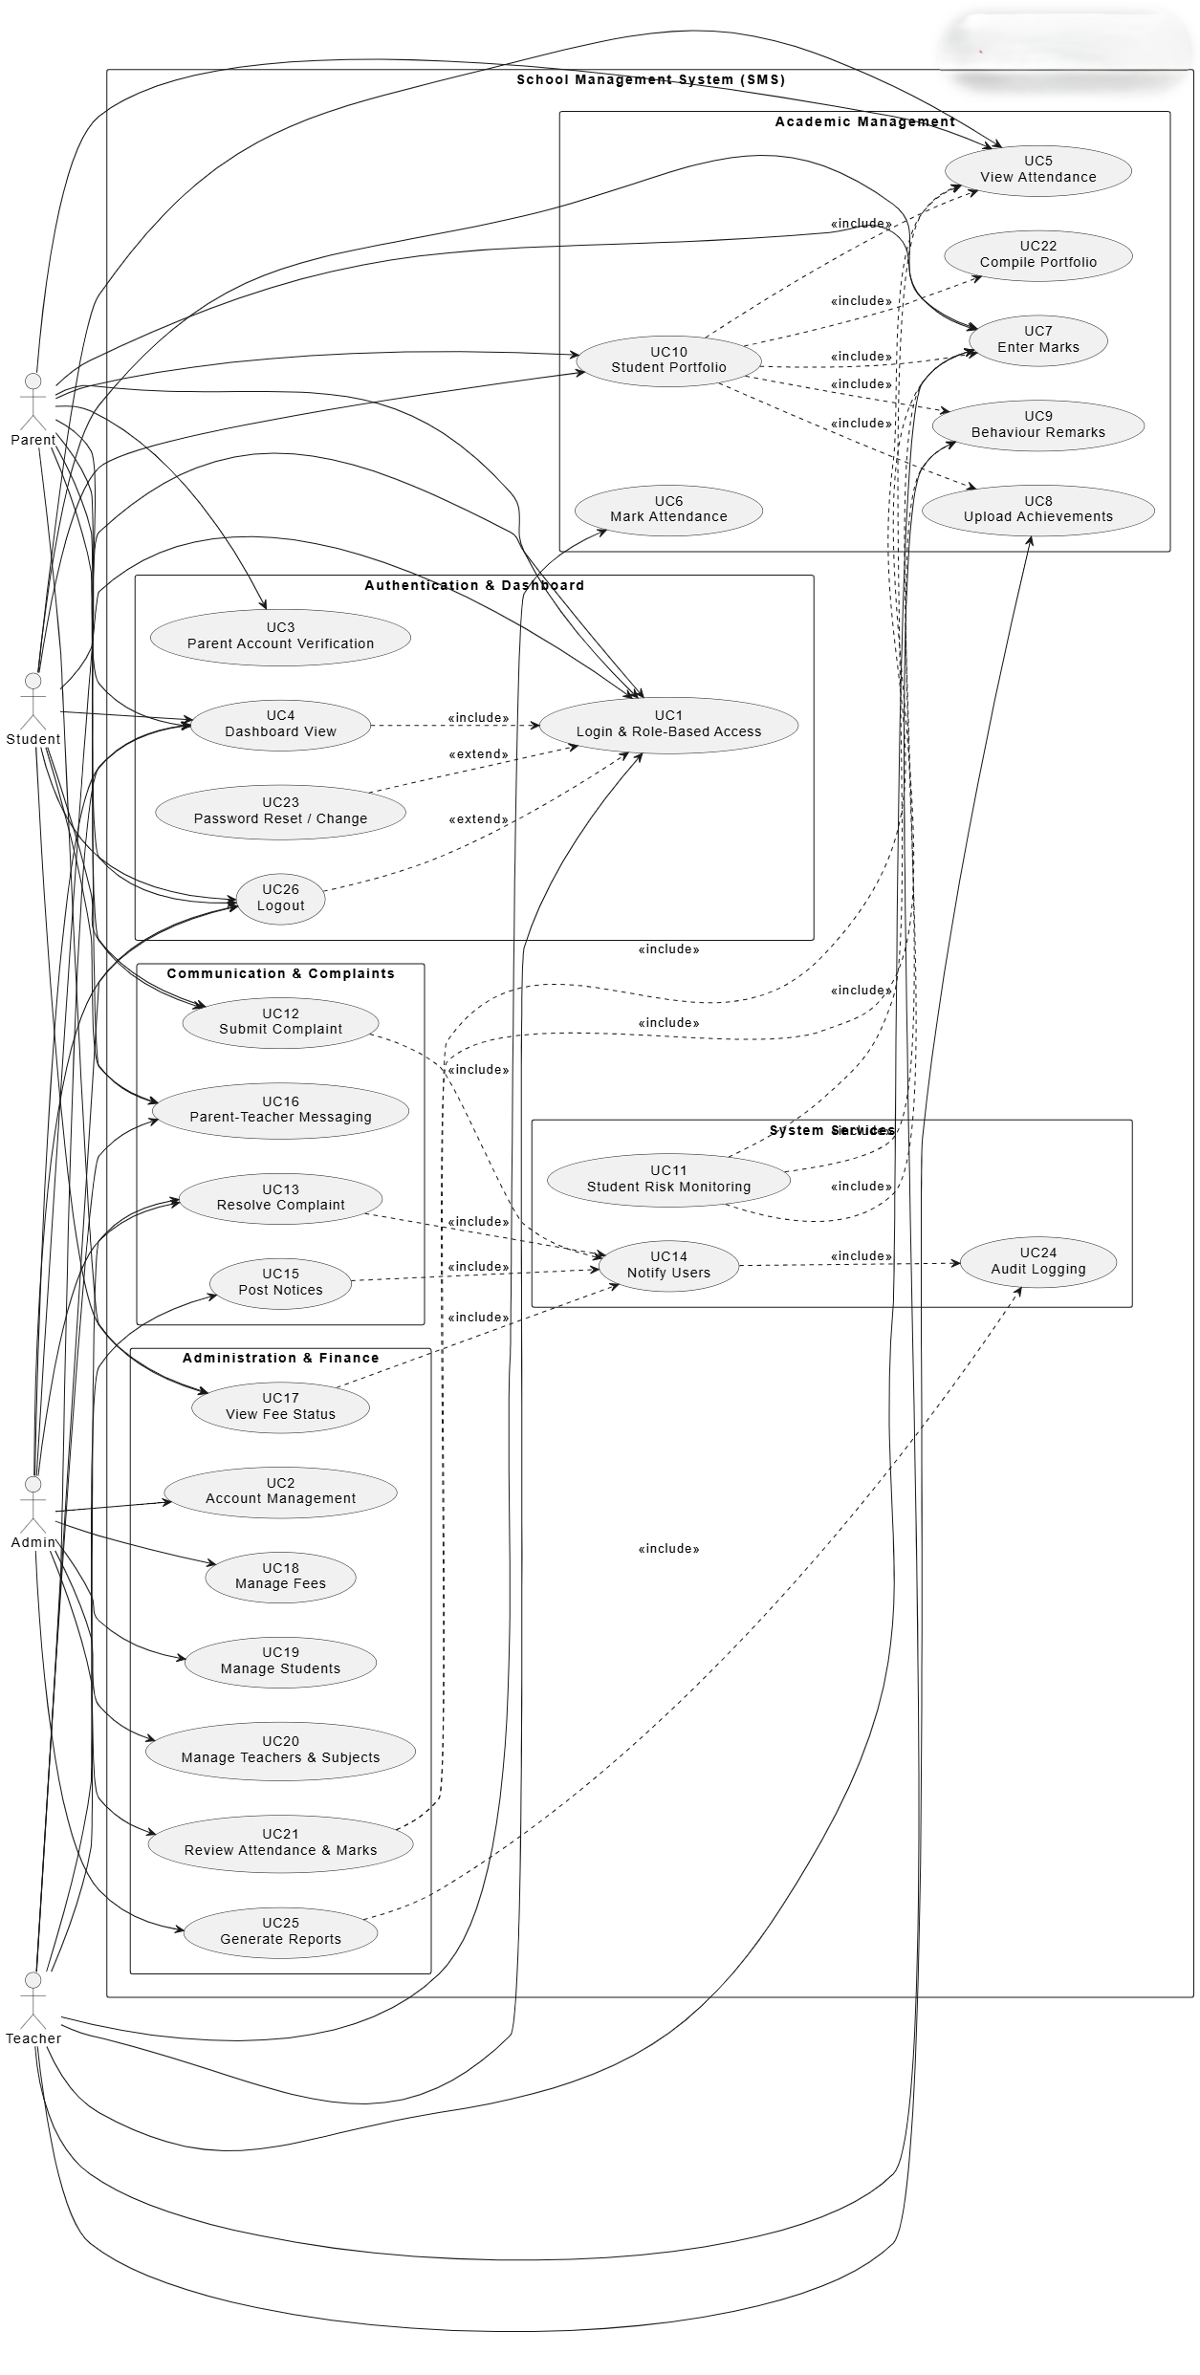

Storyboards
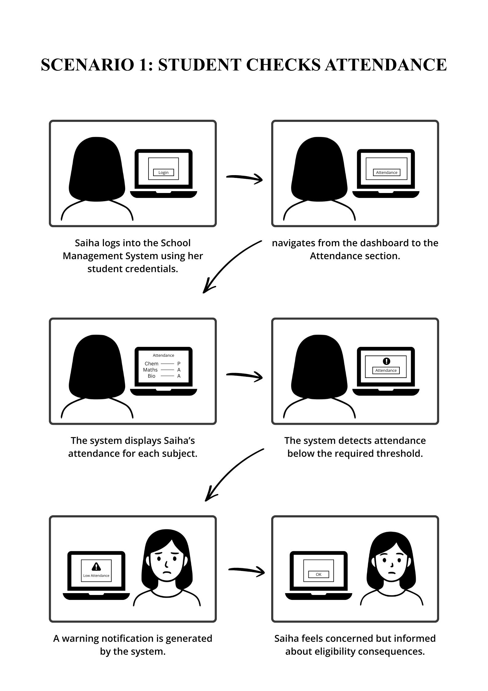
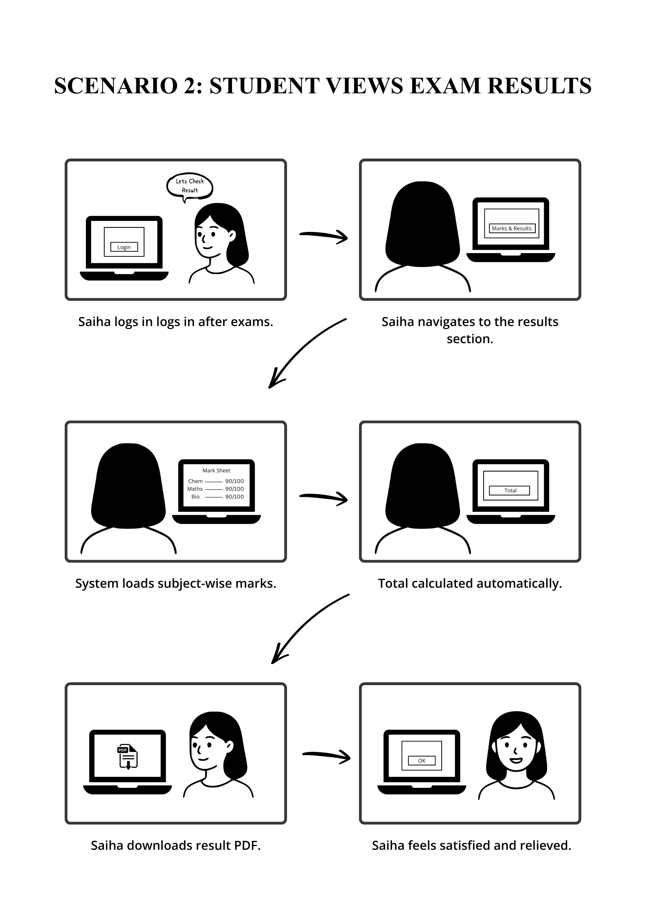

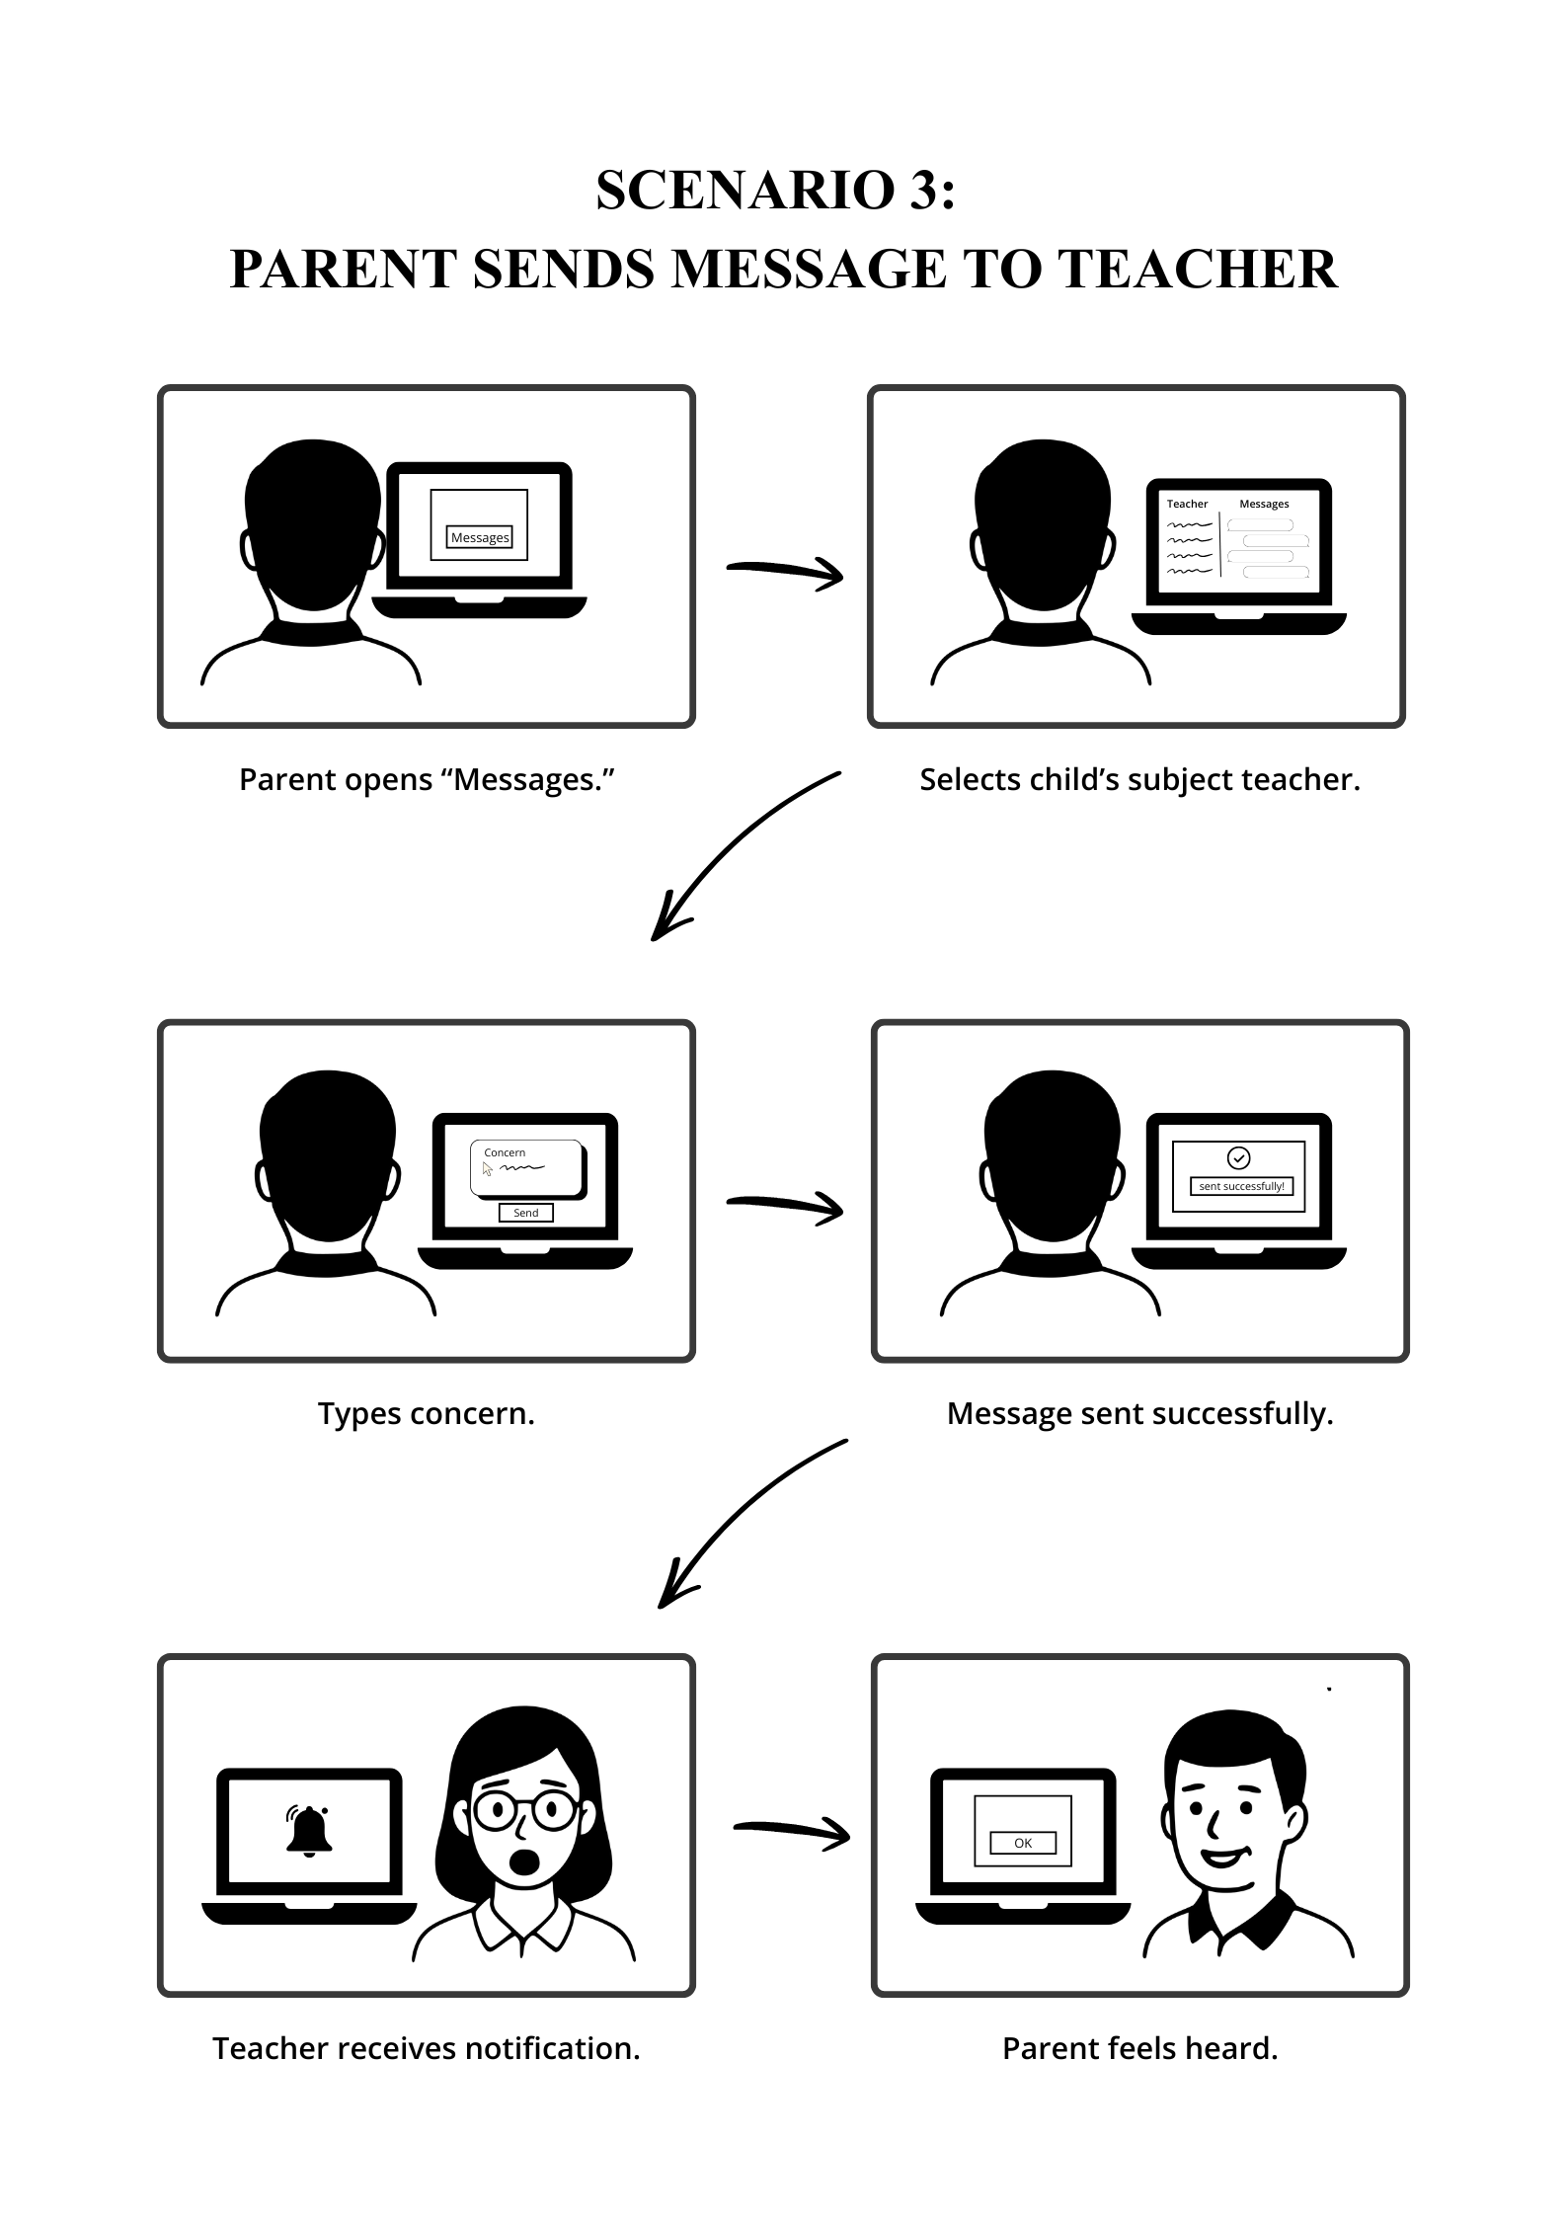

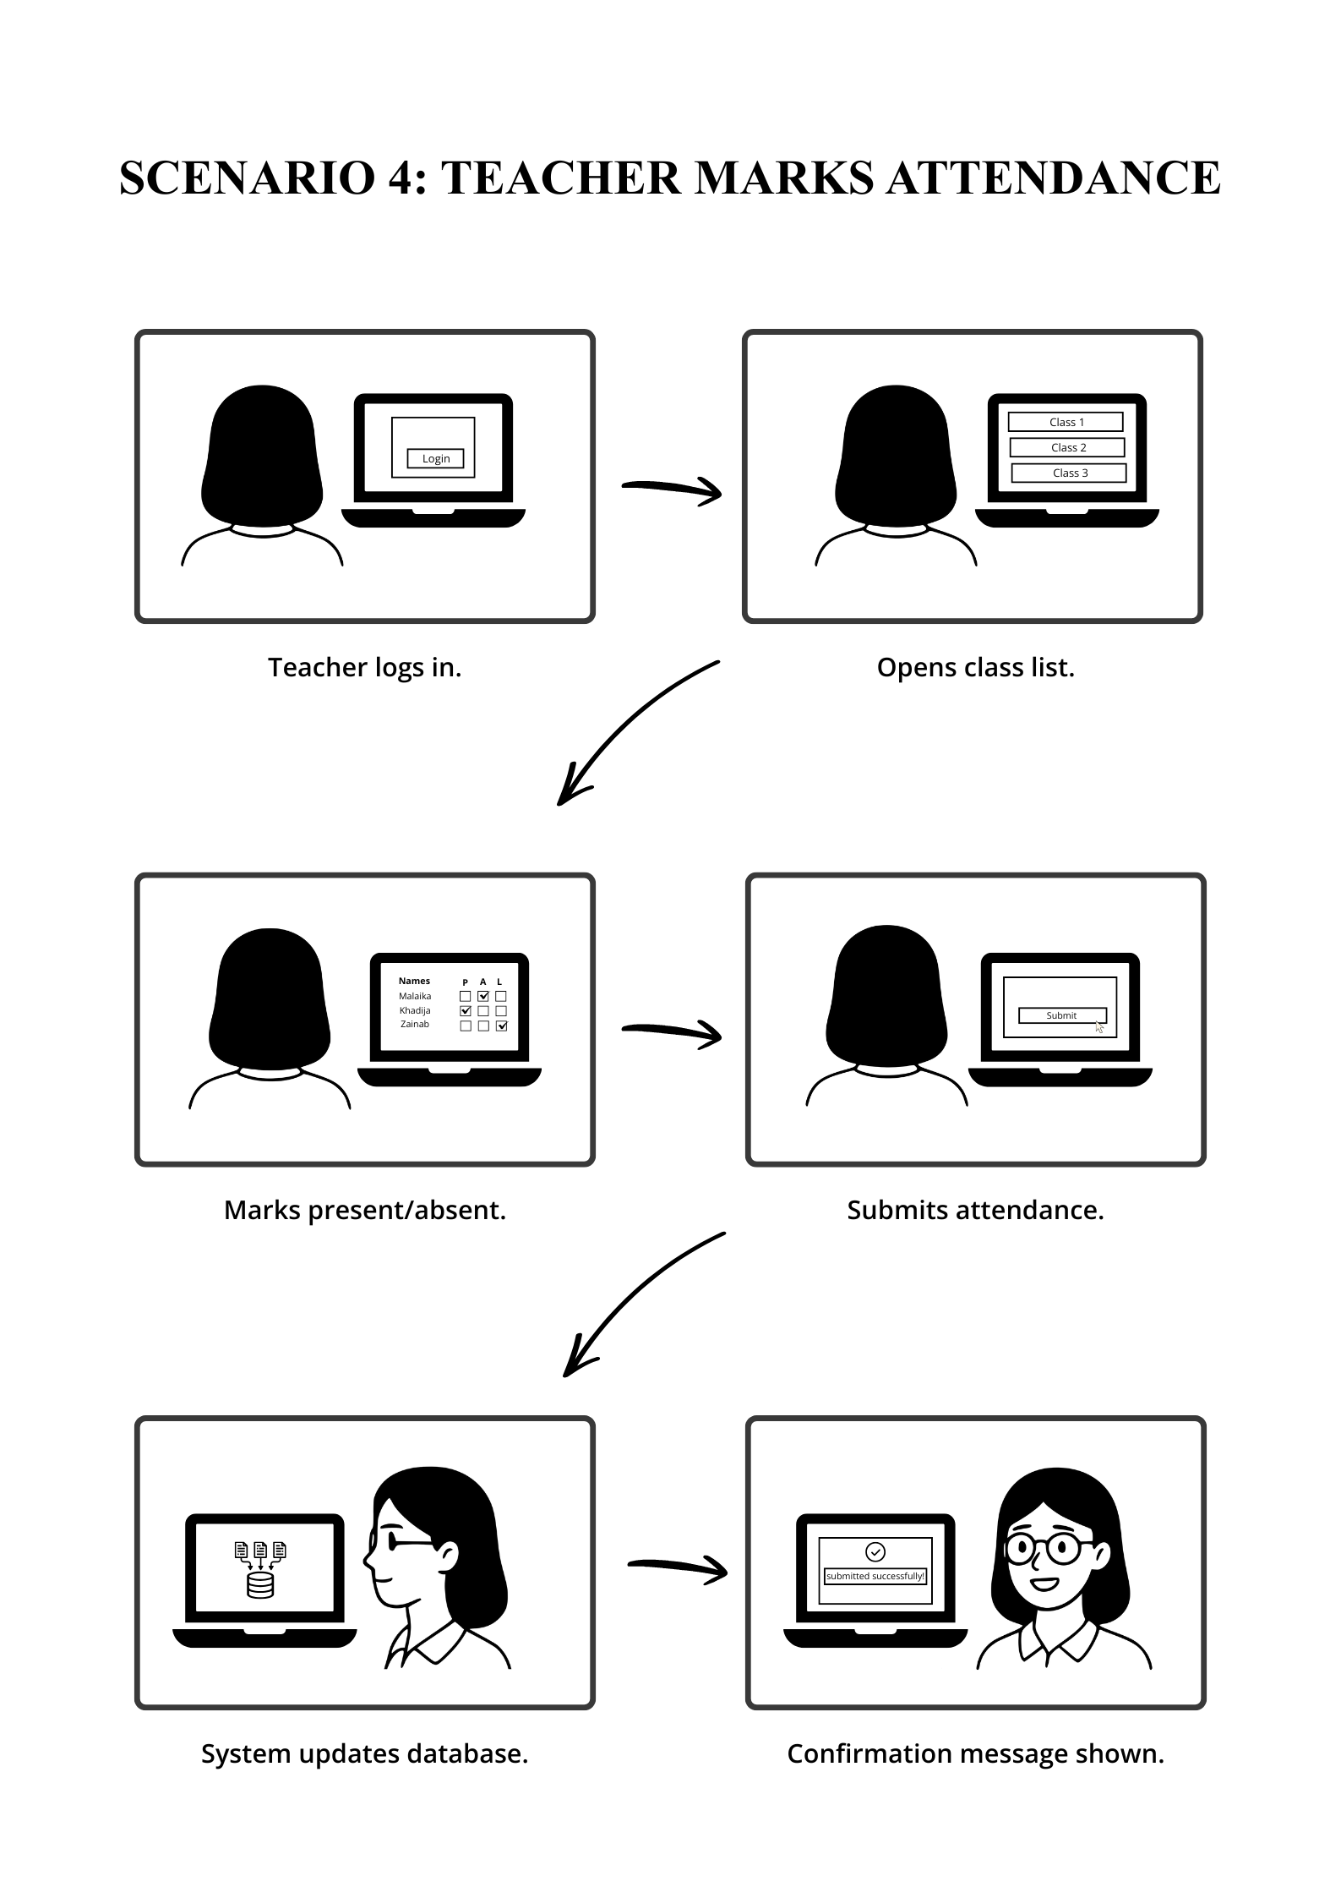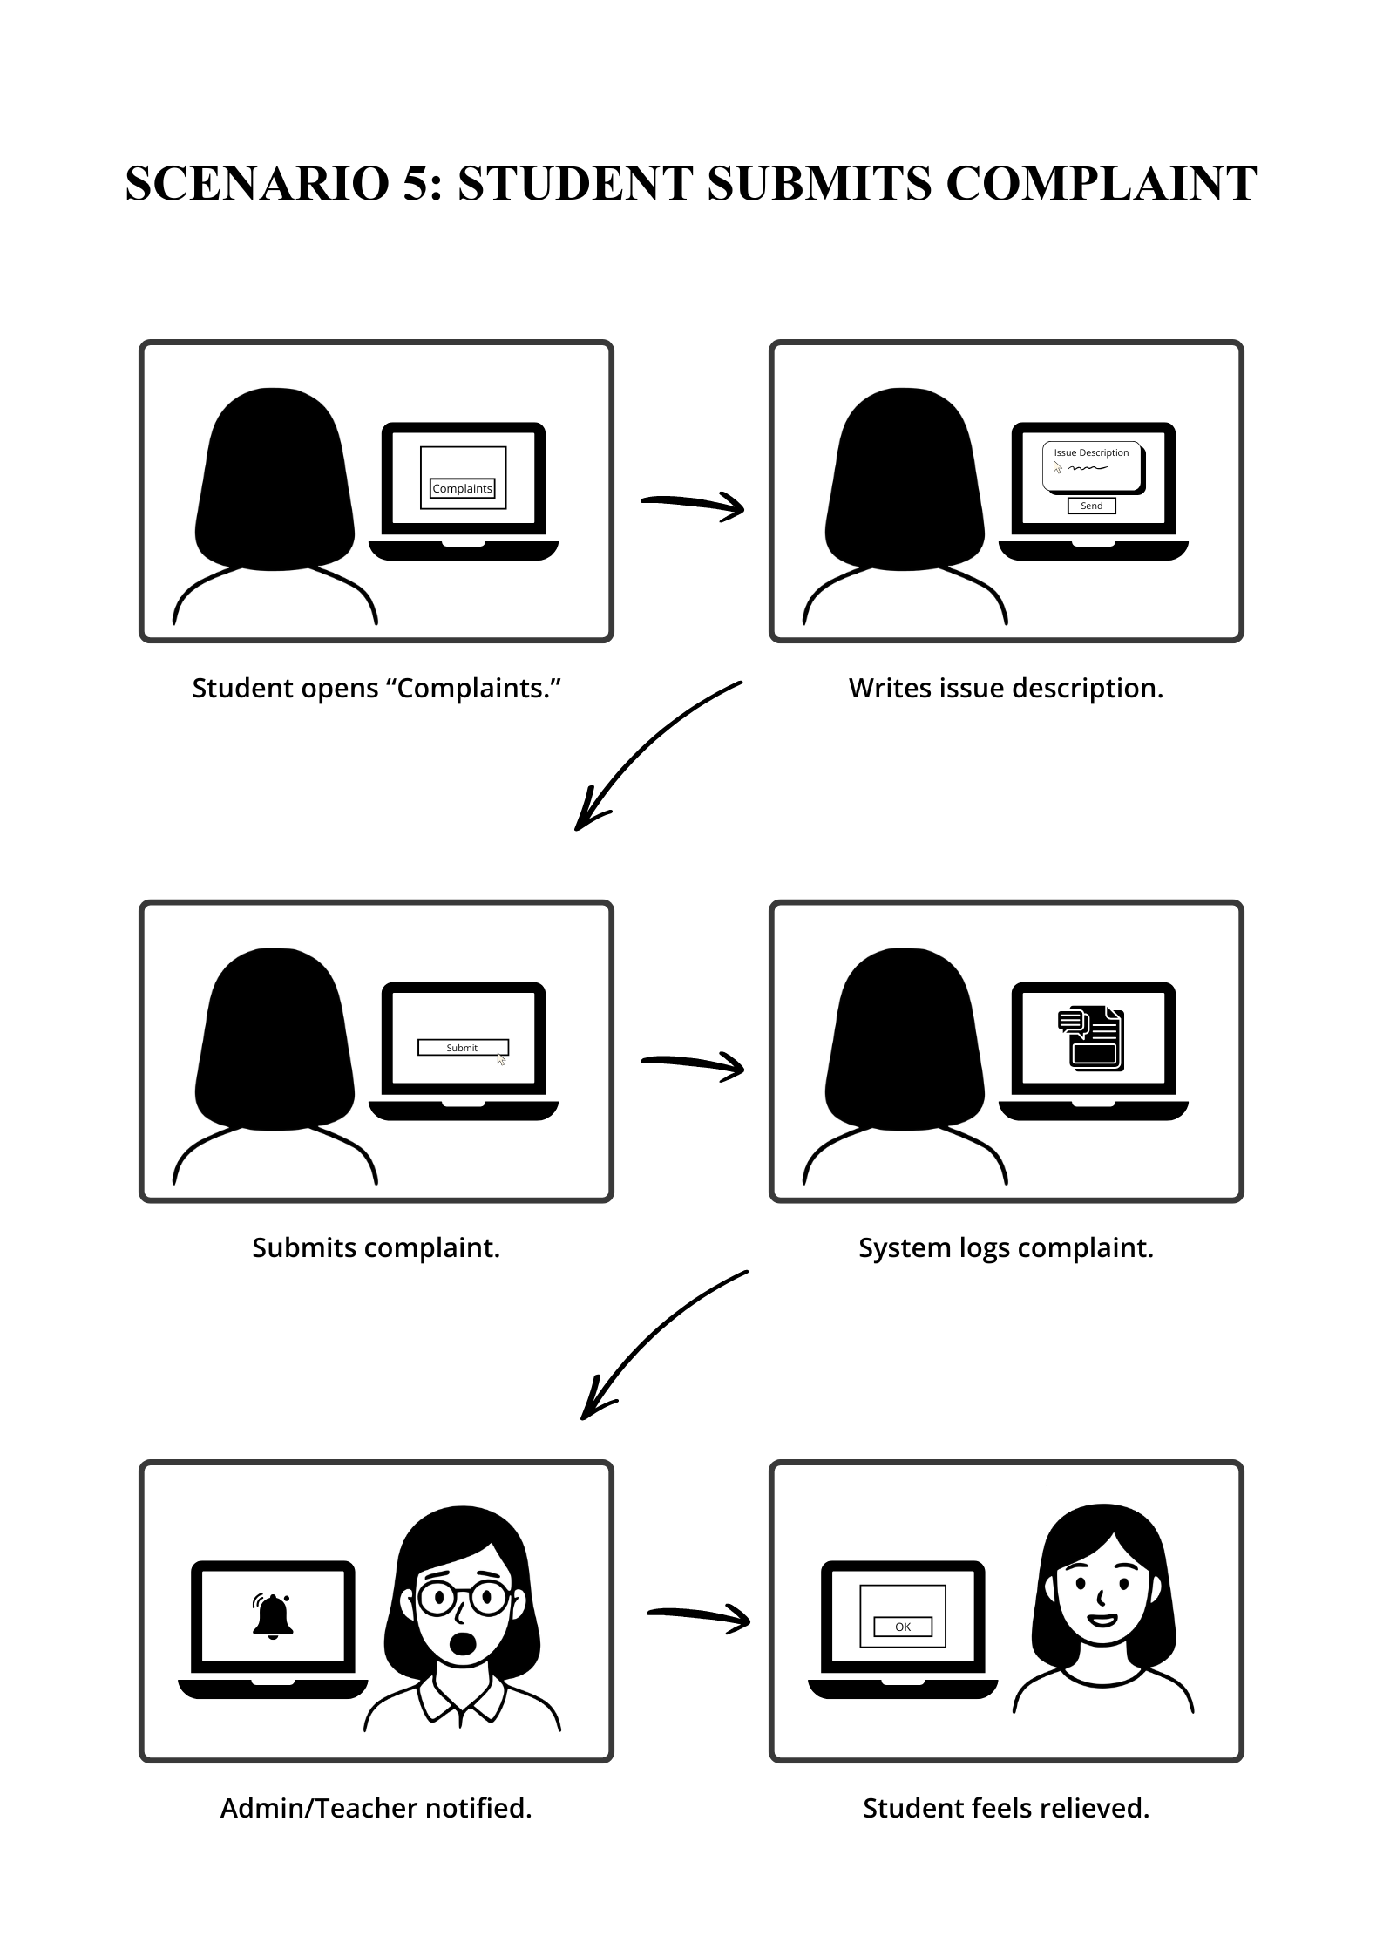

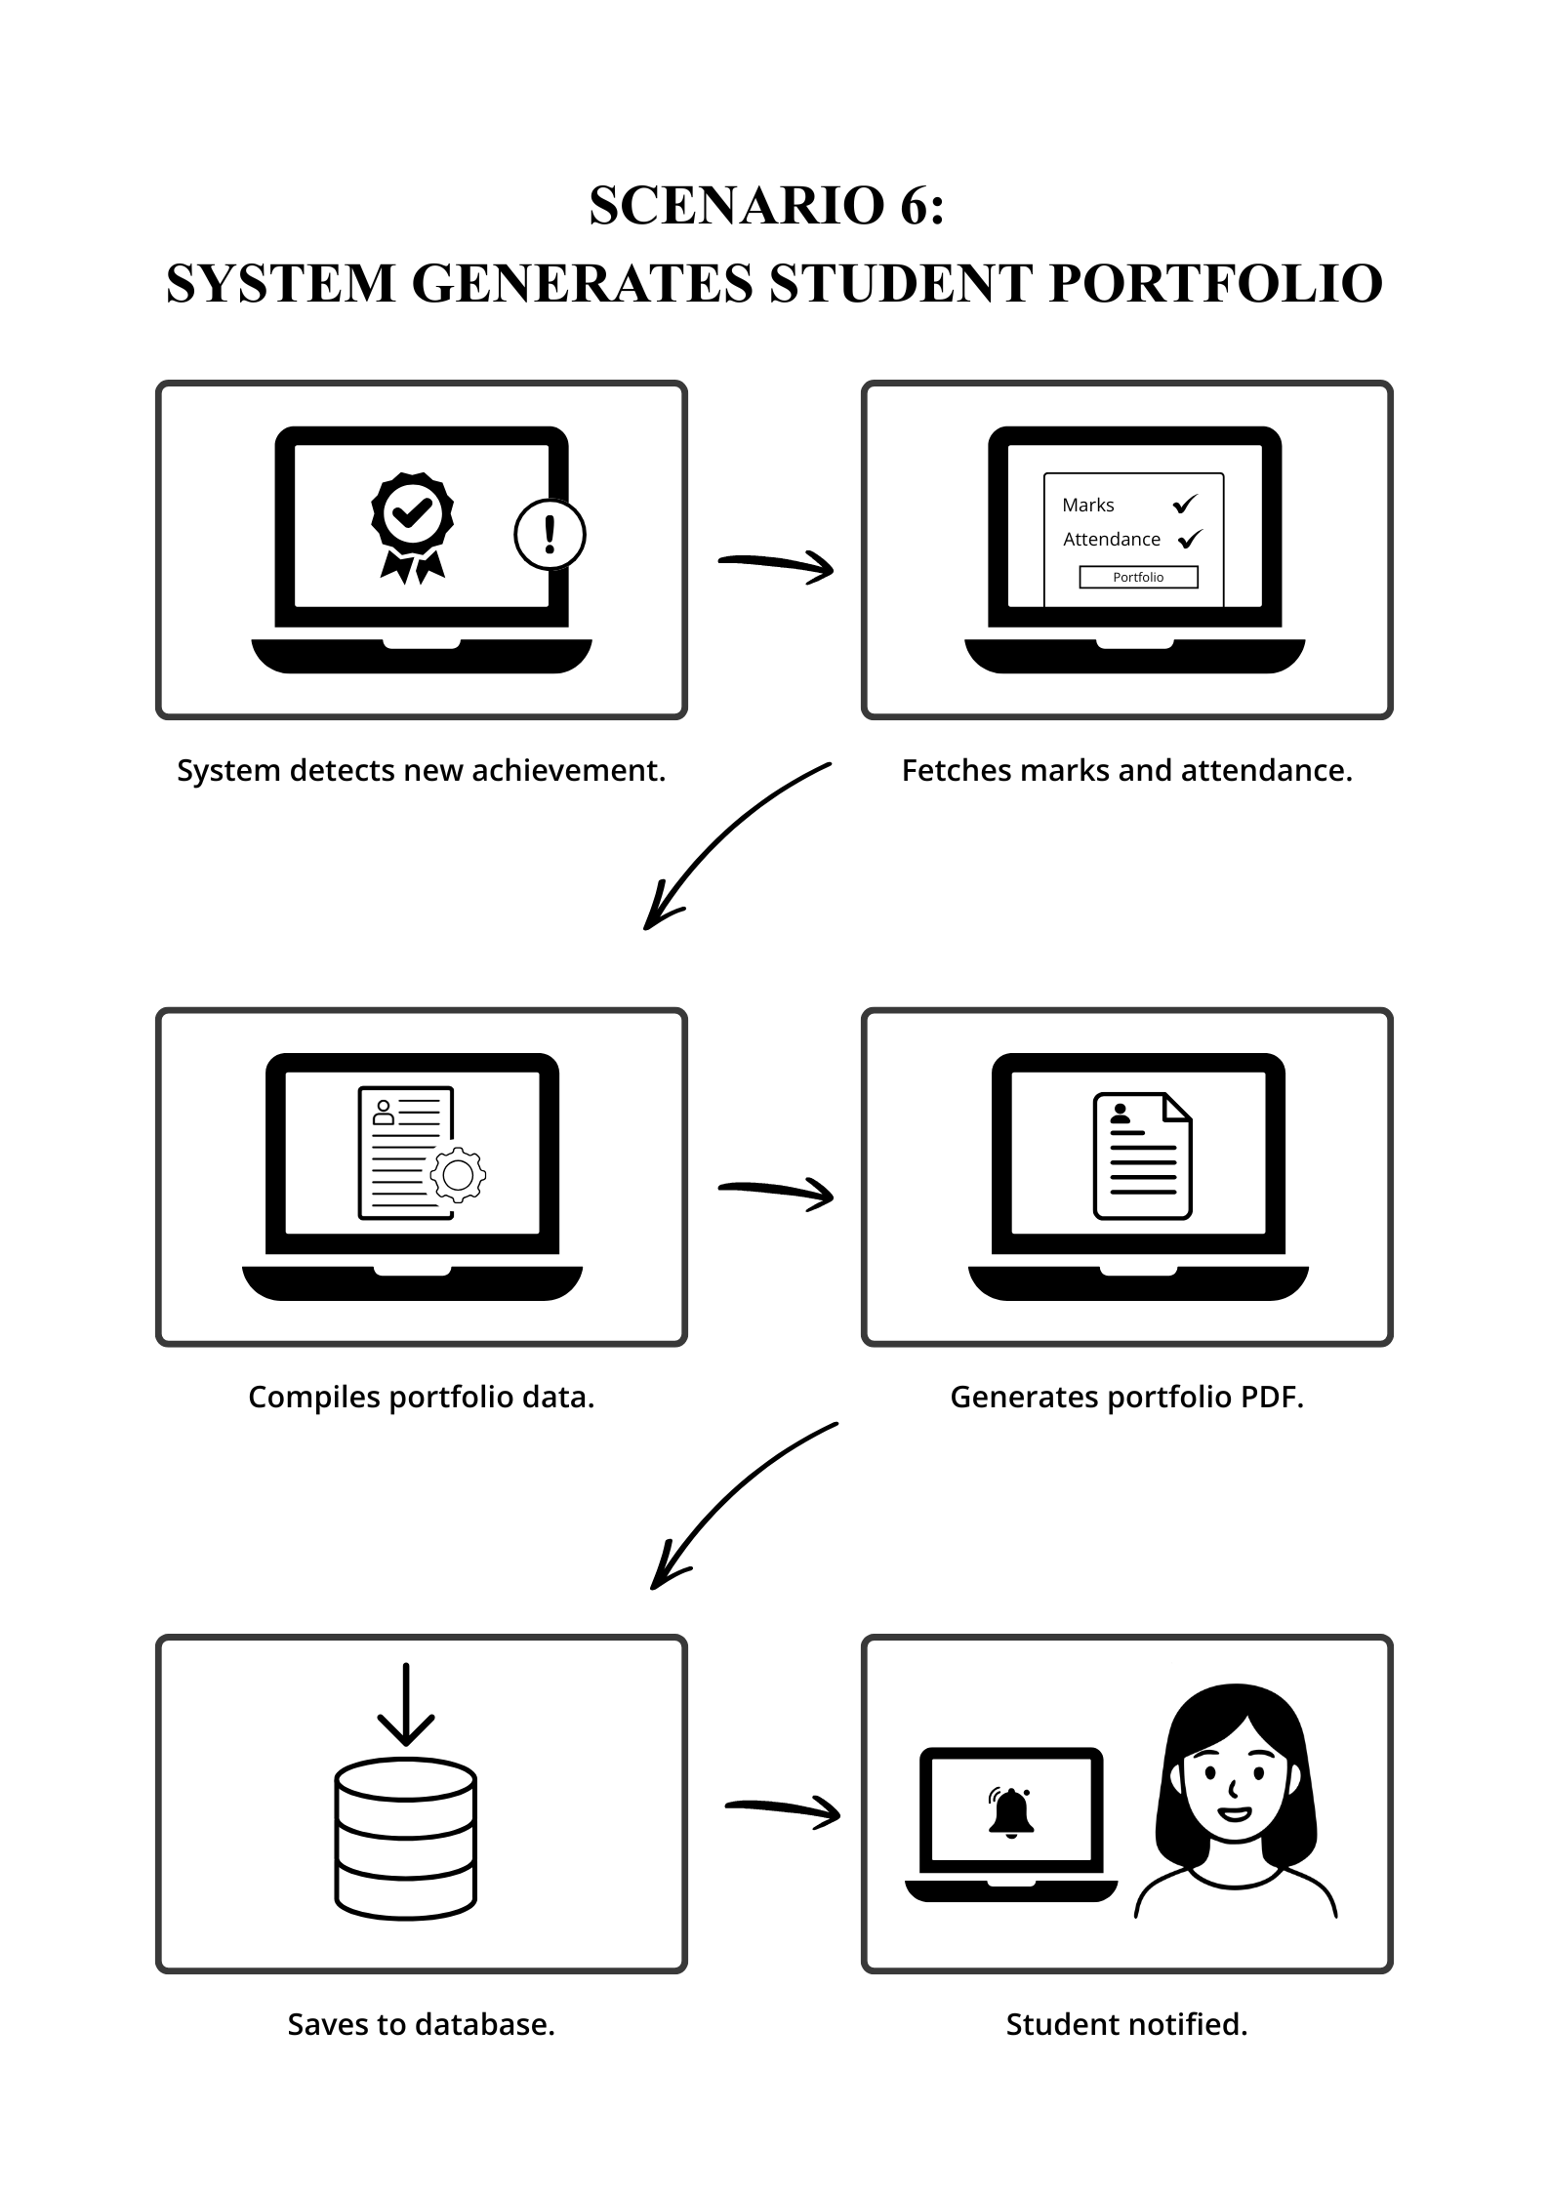

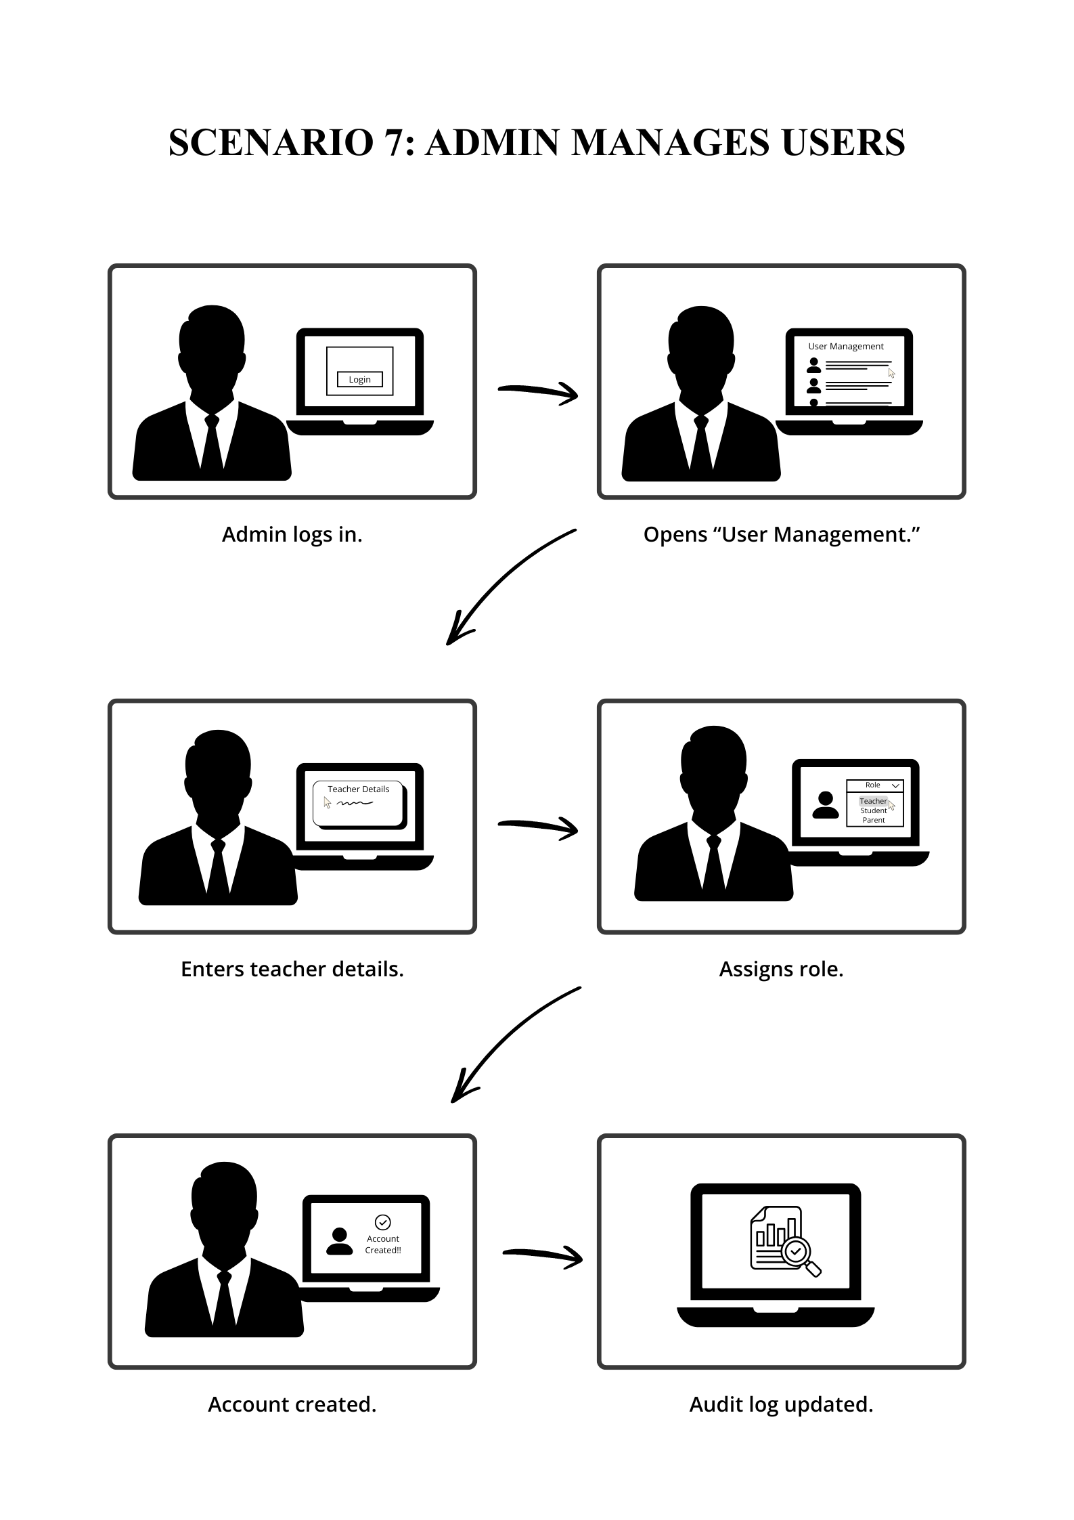

Summary
This Software Requirements Specification (SRS) documents the complete requirements engineering process carried out for the development of the Web-Based School Management System (SMS). The requirements were gathered and refined using multiple techniques, including stakeholder discussions, informal interviews, proposal analysis, use-case modeling, and storyboard-based workflow visualization. These techniques helped ensure that the identified requirements accurately reflect real-world academic and administrative processes within a school environment.
Functional requirements were systematically defined for all core modules, including user authentication, attendance management, marks entry, student portfolio generation, risk monitoring, complaint handling, fee status management, messaging, and notifications. Each requirement was documented with clear descriptions, business rules, dependencies, priorities, and error-handling conditions to ensure clarity, traceability, and testability.
Non-functional requirements were specified to address system quality attributes such as reliability, usability, performance, and security. These requirements were made measurable and verifiable to support validation during system testing. External interface requirements further defined how the system interacts with users, software components, hardware platforms, and communication protocols.
Use case analysis and storyboarding were employed to validate functional requirements from the perspective of different user roles and to visualize system behavior in practical scenarios. Overall, this requirements engineering process ensures that the proposed system aligns with project objectives, stakeholder expectations, and academic standards, providing a strong foundation for system design, implementation, and evaluation.

References

- IEEE Computer Society. IEEE Std 830-1998: IEEE Recommended Practice for Software Requirements Specifications. New York, NY: IEEE, 1998.
- Sommerville, I. Software Engineering, 10th ed. Boston, MA: Pearson Education, 2016, pp. 83–145.
- Pressman, R. S., and Maxim, B. R. Software Engineering: A Practitioner’s Approach, 8th ed. New York, NY: McGraw-Hill, 2015, pp. 97–165.
- ISO/IEC. ISO/IEC 25010: Systems and Software Engineering — Systems and Software Quality Requirements and Evaluation (SQuaRE). Geneva: ISO, 2011.
- World Wide Web Consortium (W3C). Web Content Accessibility Guidelines (WCAG) 2.0. Internet: https://www.w3.org/TR/WCAG20/, Dec. 2008 [Accessed: 15 May 2025].
- Microsoft Corporation. ASP.NET Core Documentation. Internet: https://learn.microsoft.com/aspnet/core/, 2024 [Accessed: 15 May 2025].
- Meta Platforms Inc. React Documentation. Internet: https://react.dev/, 2024 [Accessed: 15 May 2025].

