**1. Projects and Technical Challenges**

* *Question:* What projects have you worked on? What was the most technically challenging part you had to deal with?

**2. CSR vs SSR – Behavior of Server-Side Rendered Pages**

* *Question:* If HTML and CSS are rendered on the server using SSR (Server-Side Rendering), and a user clicks a button that triggers an event, will that result in a server call?
* *Follow-up:* When should I use CSR (Client-Side Rendering)? I said if I’m not concerned with SEO, then CSR is fine. But they responded by asking what happens in that case, to which I talked about interactivity.

**3. Table with Pagination and Infinite Scroll**

* *Scenario:* I’ve created a table with pagination and infinite scroll.
* *Question:* If a user goes to page 5 and deletes a record, how will I, as a developer, know what data is on which page? Should I delete the entire dataset or just request data for that specific page?

**4. HTTP Request – Sending Data in GET Body**

* *Question:* Can I send data in the body of a GET request? If not, what prevents me from doing so? Does fetch or axios stop me?

**5. CSS Theme Support**

* *Question:* How do you support multiple themes like dark, light, and a third custom option in your application using CSS?

**6. Cookies – Token Handling After Login**

* *Scenario:* When a user logs in, a token is generated on the backend.
* *Question:* What should I do with that token?
* *Your Answer:* I said store it in localStorage.
* *Interviewer’s Response:* They said I could also store it in cookies.
* *Your Reply:* I said cookies send data to the server with every request.
* *Interviewer’s View:* He said that’s actually a good thing – that the data goes to the server.

**7. Code Snippets – Output and Reasoning**

* *Task:* Two code snippets were given, and I was asked to determine their output along with an explanation of the logic behind them.
* 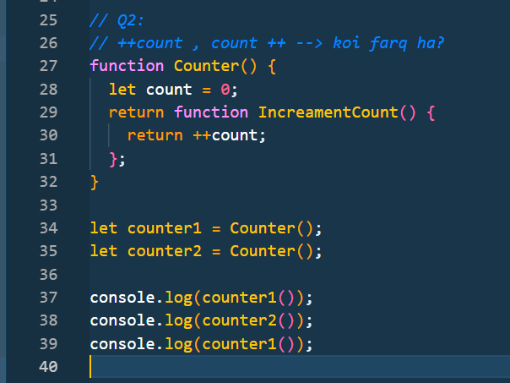
* 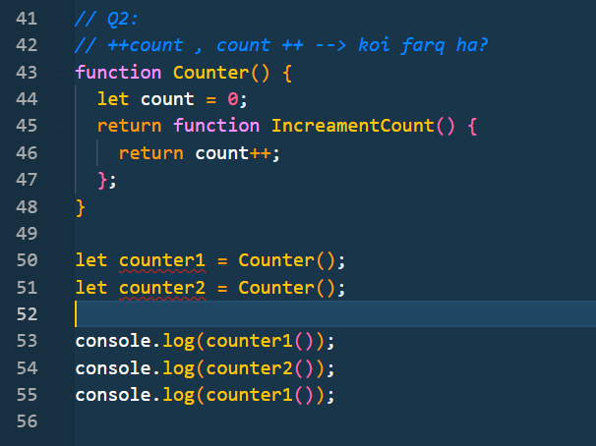
* 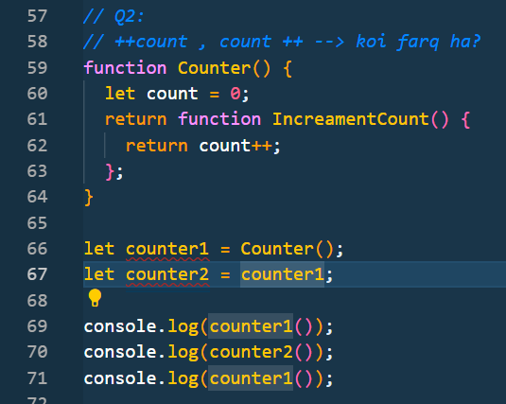
* 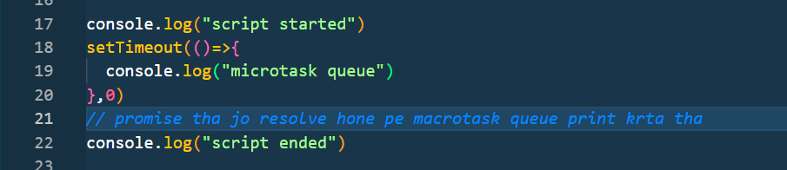

**8. Coding Question – Detect Meeting Conflicts**

* *Problem Statement:*

var timingsArray = [[0,30],[5,10],[15,20]]

This is a 2D array where each sub-array represents a meeting with a start and end time.

* *Task:* Write a program to identify if there are any conflicts (overlaps) in the meeting timings.