1. Konse projects pe kam kia wa ha? Kia challenging part tha technically jisko deal kia ,
2. **CSR and SSR** :agr SSR server end pe HTML CSS render horahi ha tou kia button pe maine click kia koi event trigger hua tou server ko call jayegi?
   1. CSR kab use krun ? If I am not concerned with SEO I said CSR but unhonekaha kia hogaya isse maine interactivity ki baatki
3. agr maine aik table banaya uspe pagination hui wi ha, infinite scroll ha , tou user ne jaake pg 5 pe delete krdia koi user tou as a developer hame pata chalega k konse page pe kia ha? Matlab ma poora data delete krun ya sirf us page ko mangwaun
4. **HTTP request**: GET ki body me data bhej sakti hun? If no kon rokega mujhe means fetch , axios kon rokega?
5. **CSS theme** questios 🡪 dark , light and 3rd option support
6. rem aur em ka difference
7. **Cookies**:user login krta ha tou backend se aik token generate hota ha uske sath kia krun ma , I told him to store it in local storage but unhone kaha k cookies me bhi tou krwasakte hain , I said wo her dafa data server ko bhejta ha , tou he said ye touc achi baat ha k data server ko chala jaye
8. **2 code snippets dye the aur unka output** poocha tha along with reasoning
   1. 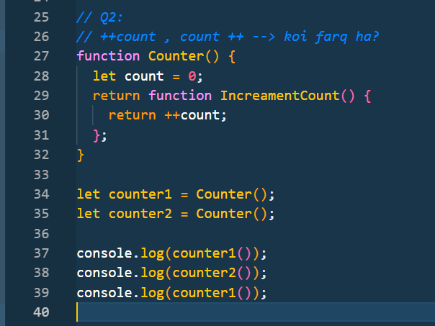
   2. 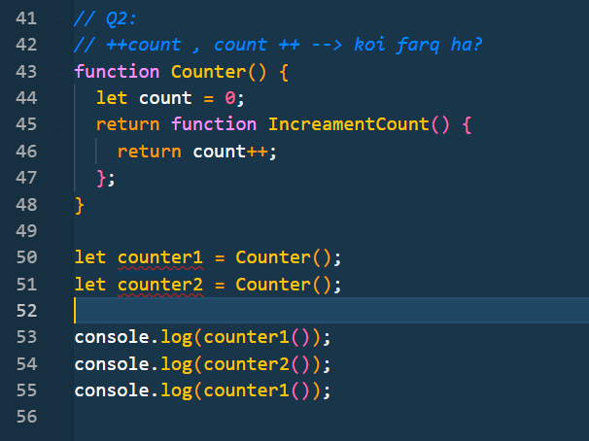
   3. 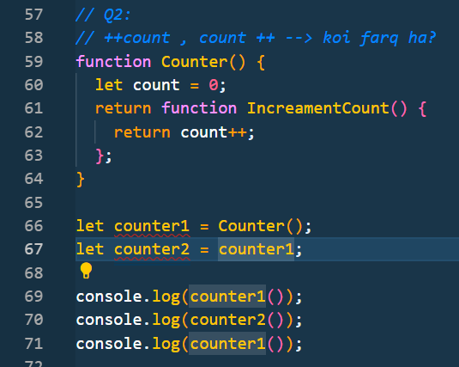
   4. 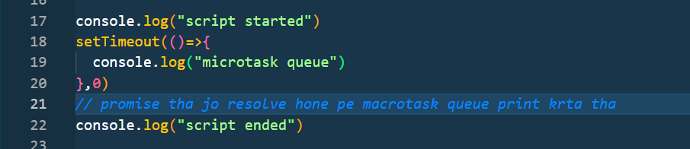
9. **Coding question:**

**Var timingsArray = [[0,30],[5,10],[15,20]]**

Ye 2D array ha isme pehli value meeting k start time ko bata rahi ha , doosri ending time ko bata rahi ha , write a code o identify conflict in meting timings