Hoanh Tran

Project: Geo Album

Date: 5/14/2015

# Overview

The GeoAlbum application allows user to take photos, display them on the map, and store them in a database for future retrieval. The photos are tagged with meta-data such as location where they are taken, title and description. The location is used to display the pictures on the Google map. User has ability to retrieve, delete and modify current photos.

The GeoAlbum requires the Android device to allow GPS and camera access. A Google Map token has been acquired and embedded in the application.

Since this application uses location to display on the map, unless the user moves around, all the photos taken will be at the same location on the map. So to make testing a bit easier, I add a random latitude and longitude to the position reported by GPS. This latitude and longitude will be associated with a photo taken. This allows the pictures to be “spread out”. The random scaling factor is in PicDetailFragment.java. Look for the line

final double reduceRandomizeFactor = 0.01;

This factor indicates we will vary the randomness by 0.01 degree which is approximately 0.72 miles. We can reduce this factor to make the photo position more accurate.

# Limitation

Due to a bit of time constrain, I’m only able to get the application works only in either Portrait or Landscape mode. The application may stop working if user rotates the phone while the application is running. The user should stop the app first, rotate the phone then restart the app. This is an improvement I like to make over the summer.

# 3rd Party Library

None.

# Screen Shots

## Main Screen

The following are the screen shots of the application. When the application starts, it retrieves existing photos from the database as follow.

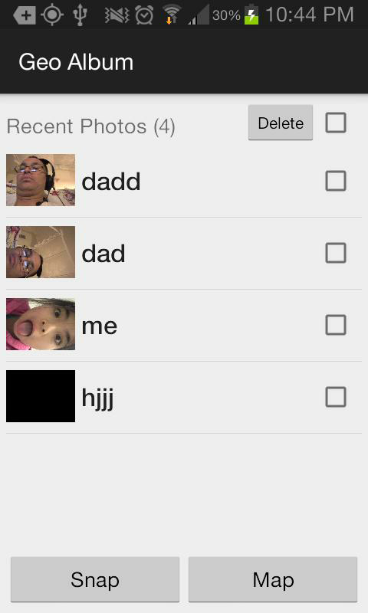

Figure 1 Main Screen

## Viewing of Photo Thumbnail

From this main screen, the user can tab on the thumbnail to view the photo as in Figure 2.

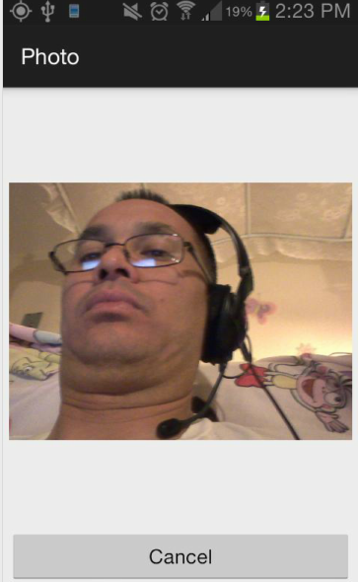

Figure 2 Photo Viewer

## Deleting Photos

Selecting the topmost checkbox selects all photos as in Figure 3. Unselecting the topmost checkbox deselects all photos. Select Delete will delete all selected photos.

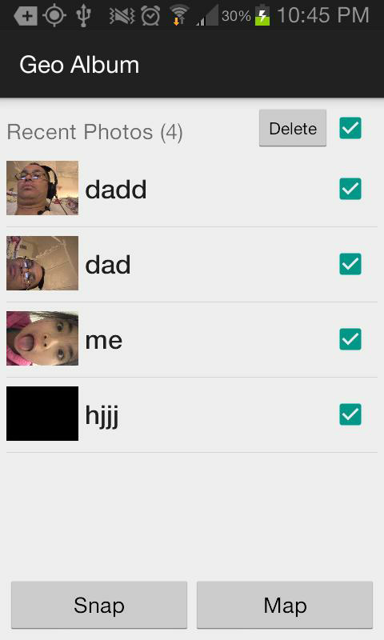

Figure 3 Photo Selections

## Viewing Photo Detail

From the Main screen, tapping on the photo item will bring up Photo Detail screen as follow. The user has the option to update either the title and description meta-data.

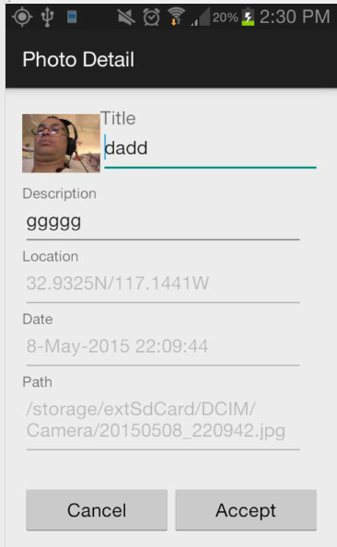

Figure 4 Photo Detail

## Using Camera to Take Photo

From the Main screen, selecting Snap will bring up the Camera screen to take photo.

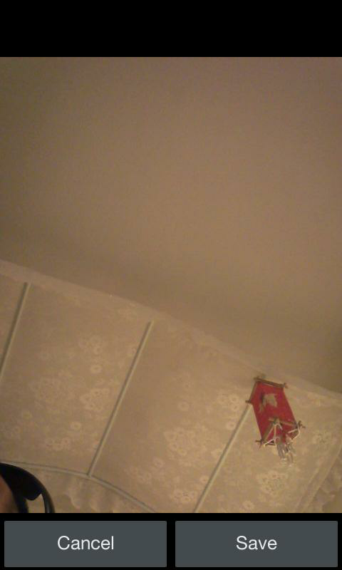

Once the photo is taken and Save is selected, the user can enter the Title and Description of the photo. The selecting Accept to save it to database.

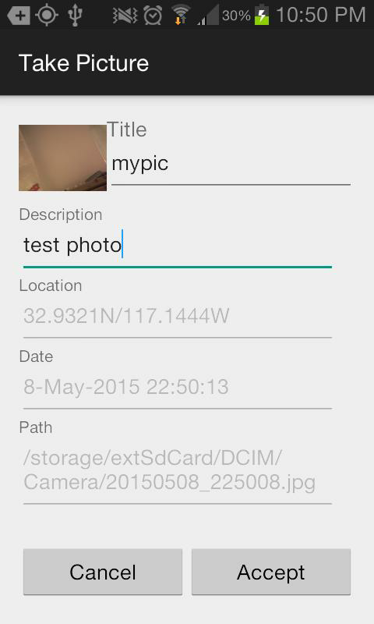

## Display Map

From the Main screen, select the Map button to bring up Google map displaying the location of all photos similar to the following. Tapping on the map marker brings up the Photo Detail screen similar to Figure 4.

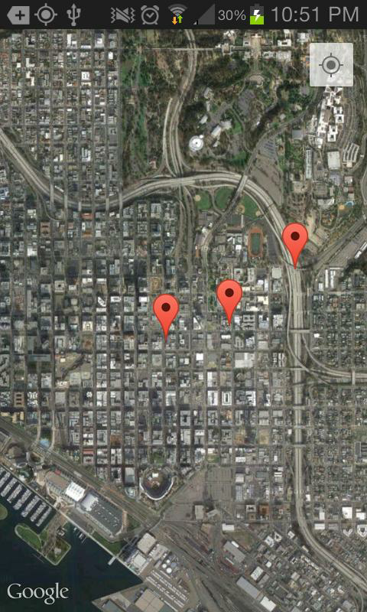

Figure 5 Map Screen