Subject: Data Structure and Algorithms

Code: CSD201

Assignment1 Report

Title: Booking Bus System

Group number: 02

Members:

1. Phạm Xuân Hùng - HE186353
2. Ngọ Yến Linh - HE187172
3. Quách Xuân Bách - HE180125
4. Đinh Gia Nam - HE180039
5. Bùi Thị Hoài Anh - HE180304
6. Nguyễn Công Thành Đạt -HE181284

**Tasks status**

| **Name/ Number** | **Content** | **Member** | **Status** |
| --- | --- | --- | --- |
| **1. Bus List** |  |  |  |
| 1.1. | Load data from file | Ngo Yen Linh | Done |
| 1.2. | Input and Add to the end | Ngo Yen Linh | Done |
| 1.3. | Display data | Ngo Yen Linh | Done |
| 1.4. | Save bus list to file | Ngo Yen Linh | Done |
| 1.5. | Search by bcode | Ngo Yen Linh | Done |
| 1.6. | Delete by bcode | Pham Xuan Hung | Done |
| 1.7. | Sort by bcode | Pham Xuan Hung | Done |
| 1.8. | Input & add to beginning | Pham Xuan Hung | Done |
| 1.9. | Add after position k | Pham Xuan Hung | Done |
| 1.10. | Delete position k | Pham Xuan Hung | Done |
| 1.11. | Search by name | Dinh Gia Nam | Done |
| 1.12. | Search booked by bcode | Dinh Gia Nam | Done |
| **2. Passenger List** |  |  |  |
| 2.1. | Load data from file | Quach Xuan Bach | Done |
| 2.2. | Input & Add to the end | Quach Xuan Bach | Done |
| 2.3. | Display data | Quach Xuan Bach | Done |
| 2.4. | Save passenger list to file | Quach Xuan Bach | Done |
| 2.5. | Search by pcode | Nguyen Cong Thanh Dat | Done |
| 2.6. | Delete by pcode | Nguyen Cong Thanh Dat | Done |
| 2.7. | Search by name | Nguyen Cong Thanh Dat | Done |
| 2.8 | Search buses by pcode | Nguyen Cong Thanh Dat | Done |
| **3. Booking List** |  |  |  |
| 3.1. | Load data from file | Bui Thi Hoai Anh | Done |
| 3.2. | Book Bus | Bui Thi Hoai Anh | Done |
| 3.3. | Display Data | Bui Thi Hoai Anh | Done |
| 3.4. | Save booking list to file | Bui Thi Hoai Anh | Done |
| 3.5. | Sort by bcode + pcode | Dinh Gia Nam | Done |
| 3.6. | Pay booking by bcode + pcode | Dinh Gia Nam | Done |

**Tasks results (Screen short):**

**Các Packet**

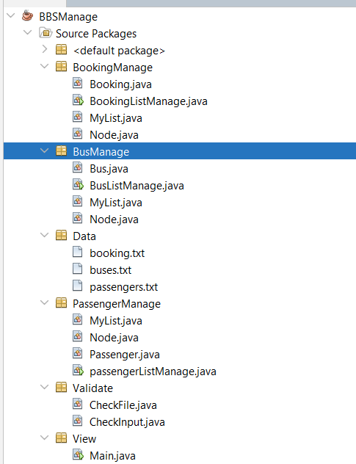

1. **Bus List**

**1.1 Load data from file**

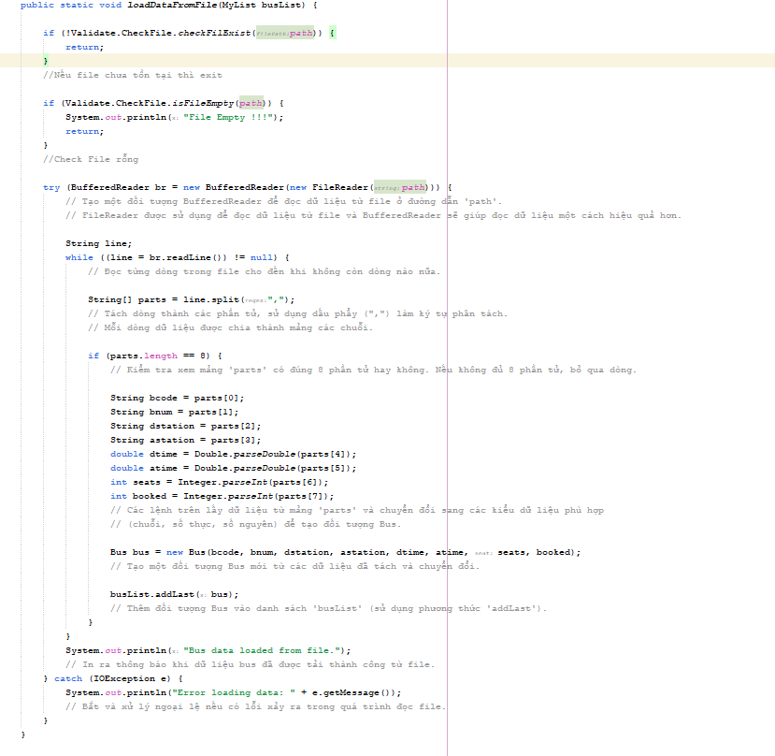

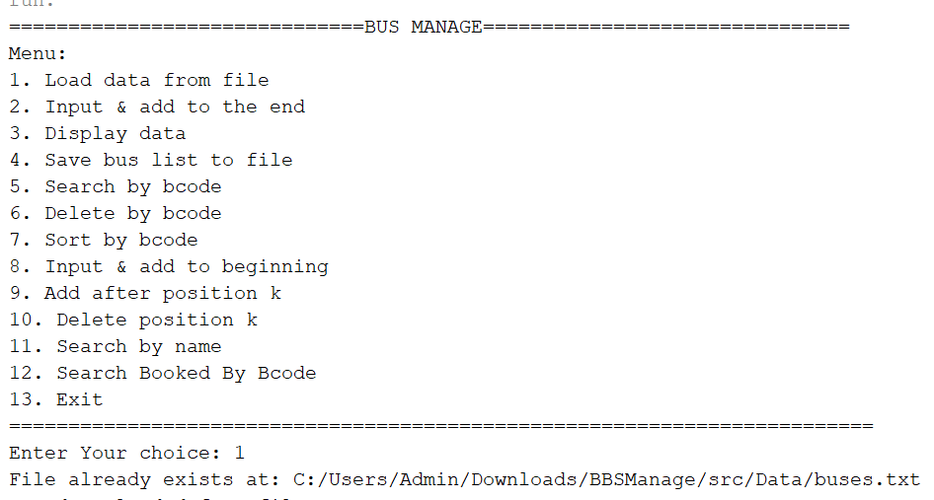

**1.2 Input & add to the end**

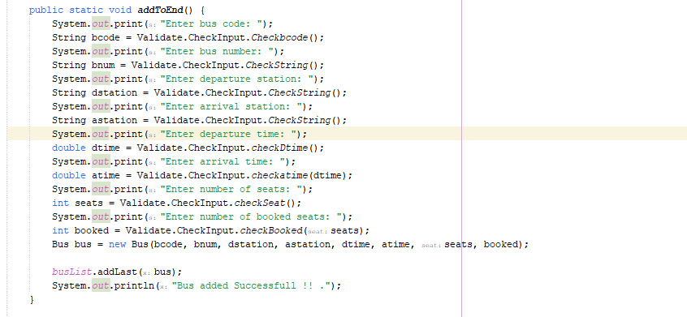

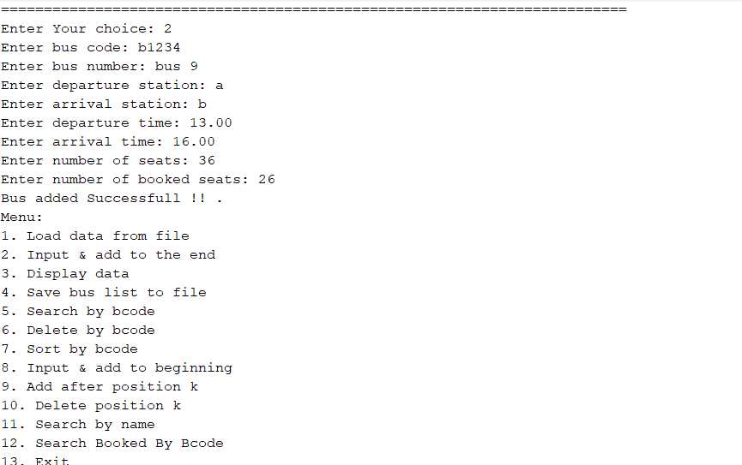

**1.3 Display data**

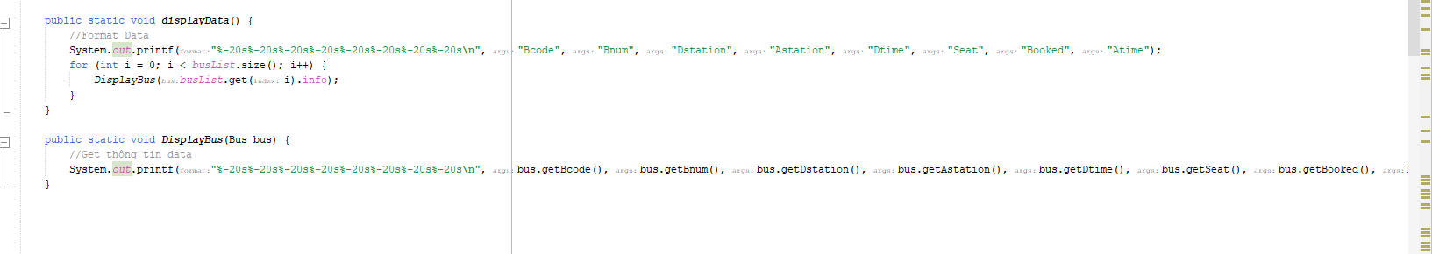

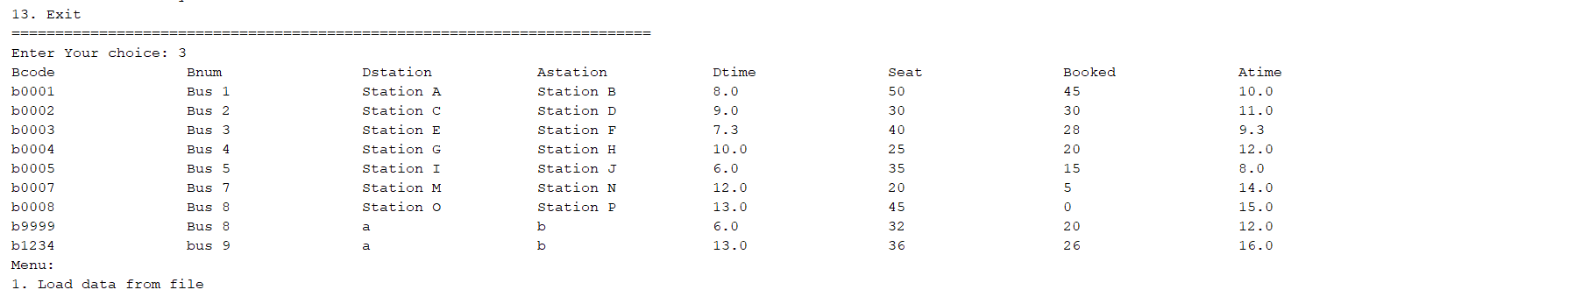

**1.4 Save bus list to file**

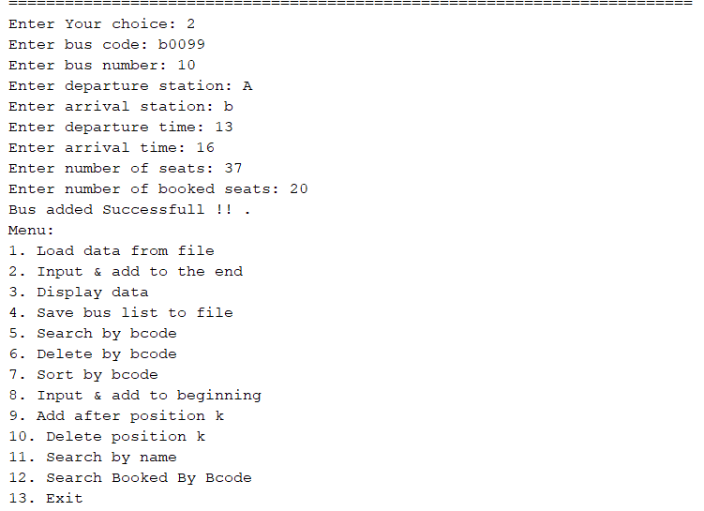

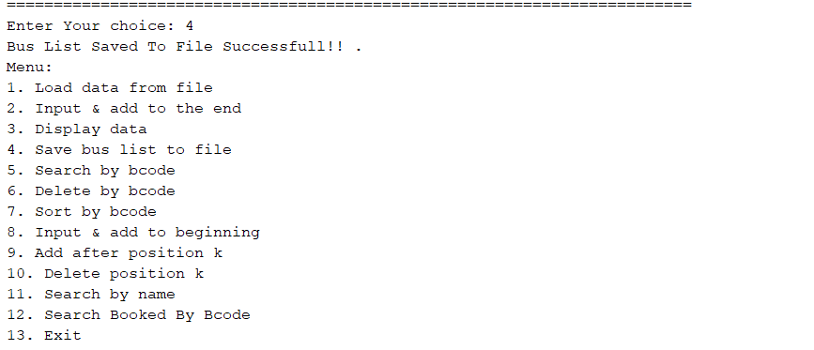

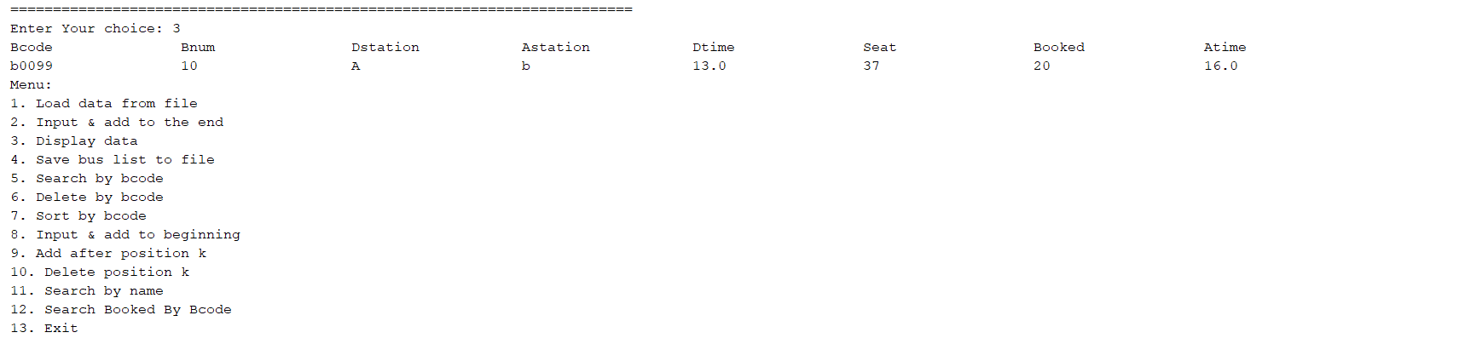

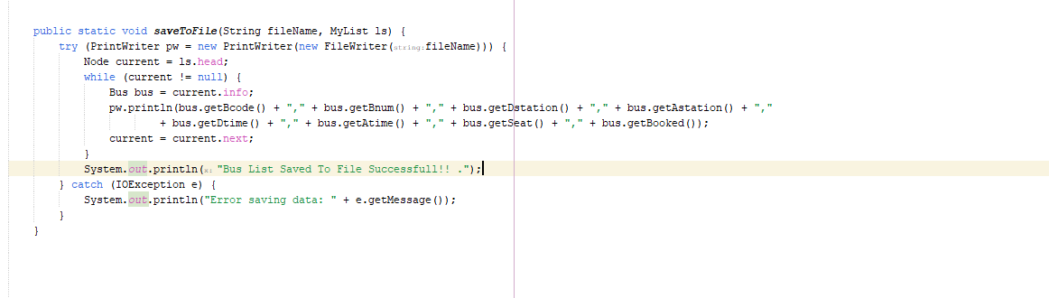

**1.5 Search by bcode**

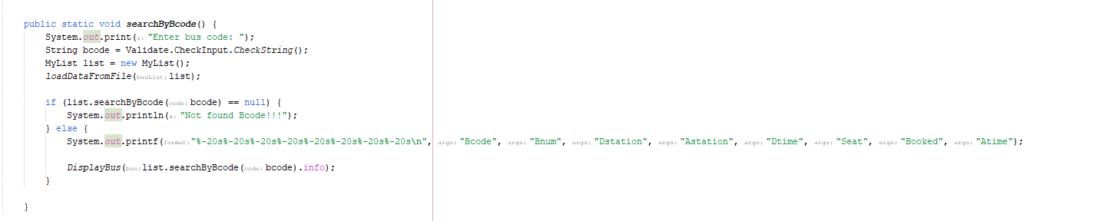

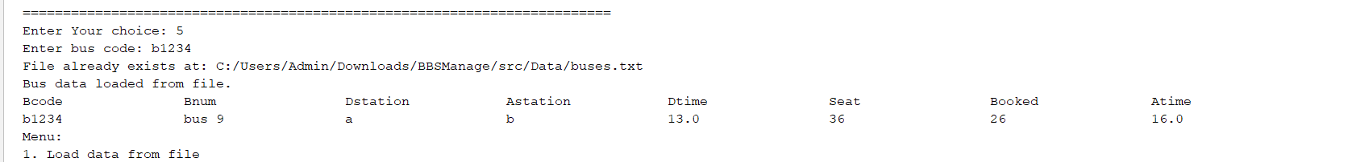

**1.6 Delete by bcode**

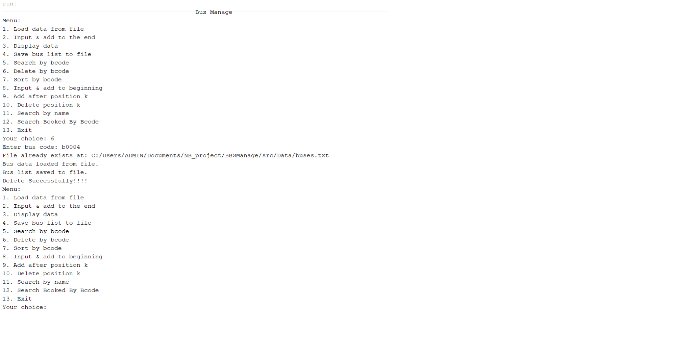

**1.7 Sort by bcode**

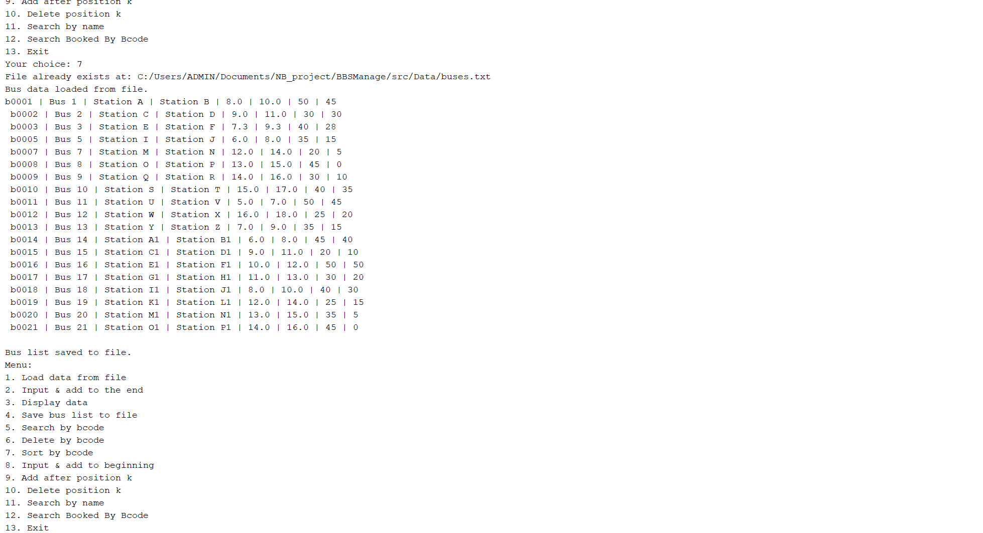

**1.8 Input & add to beginning**

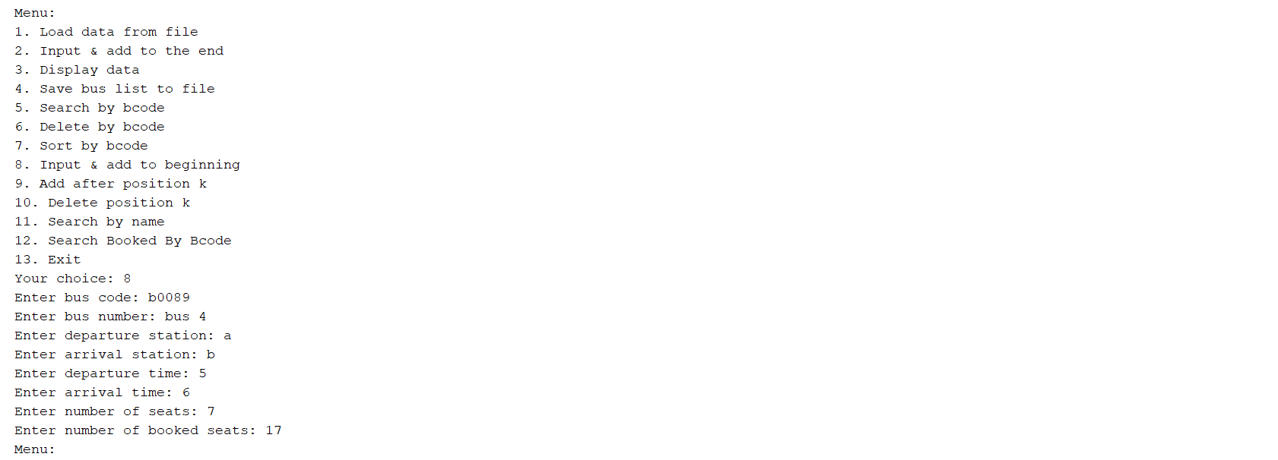

**1.9 Add after position k**

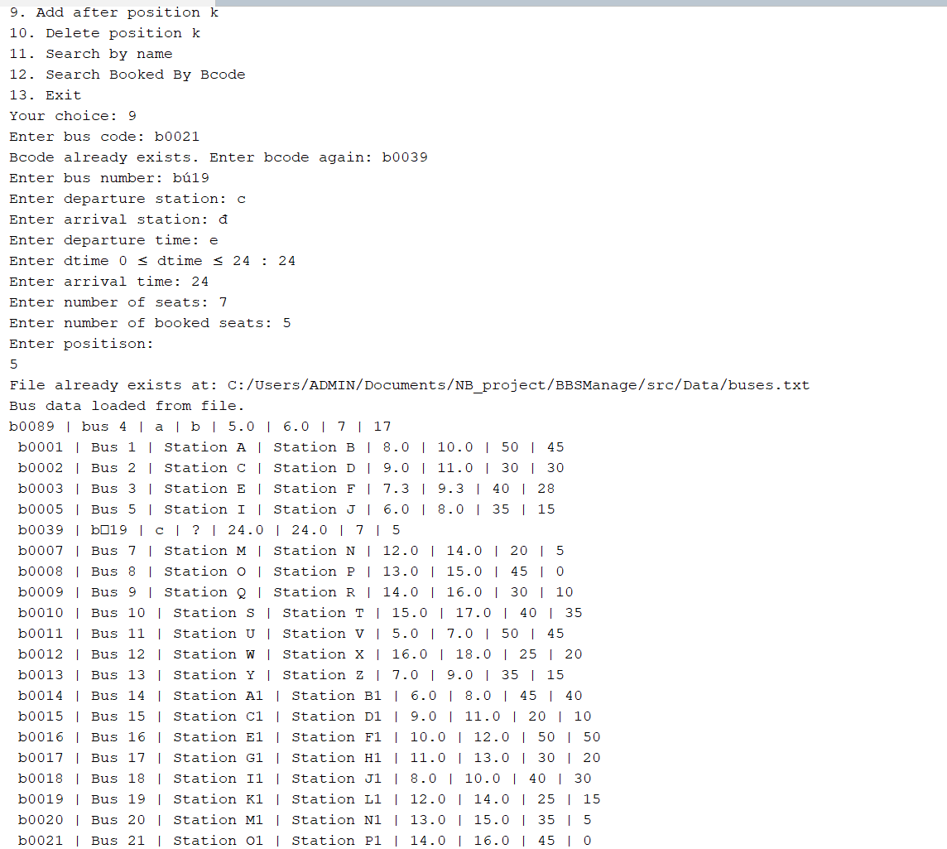

**1.10 Delete position k**

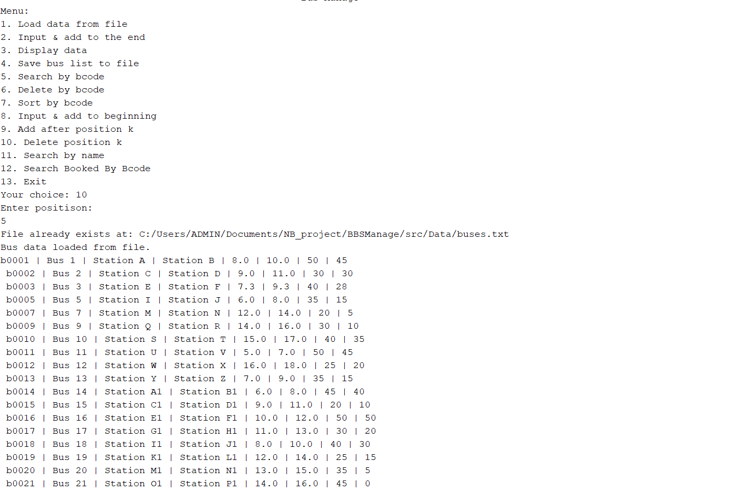

**1.11. Search by name**

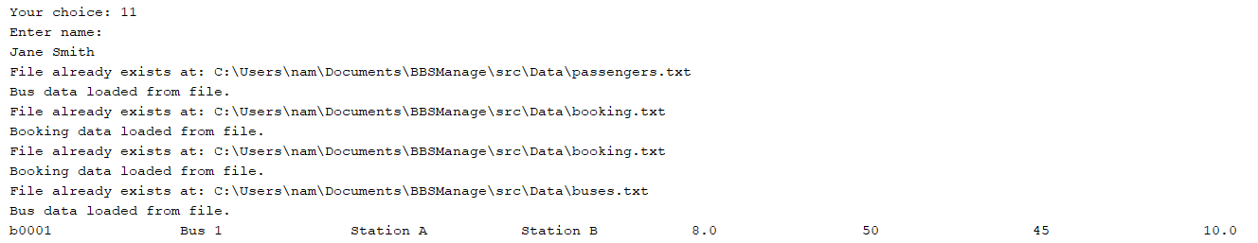

**1.12.Search booked by bcode**

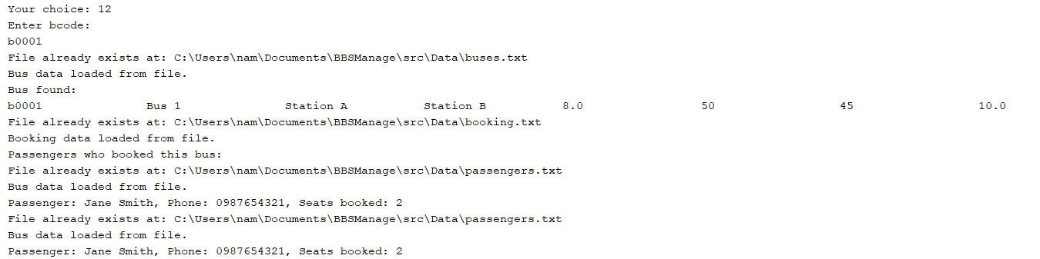

**2. Passenger List**

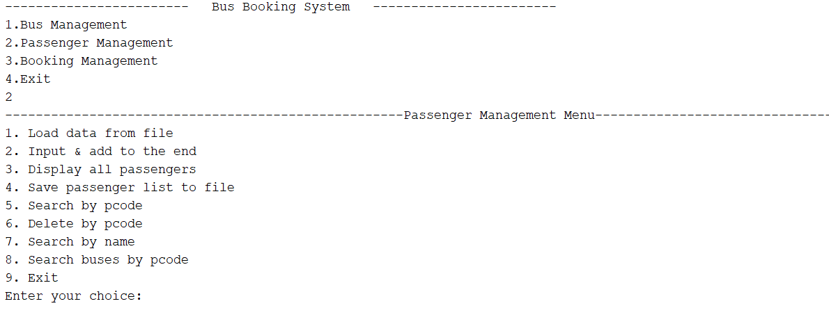

**2.1 Load data from file**



**2.2 Input & add to the end**

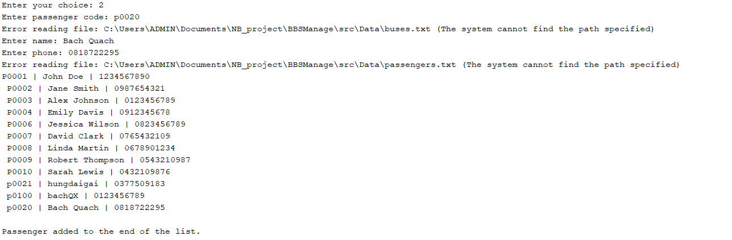

**2.3 Display data**

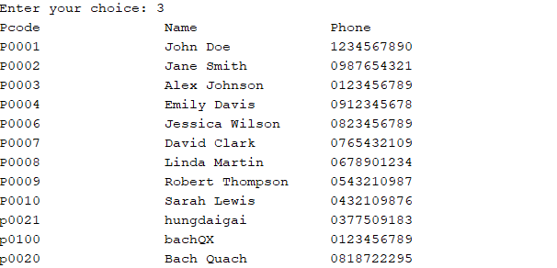

**2.4 Save passenger list to file**



**2.5 Search by pcode**

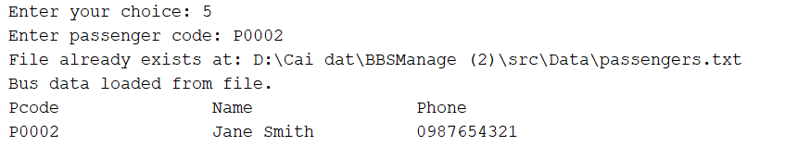

**2.6 Delete by pcode**

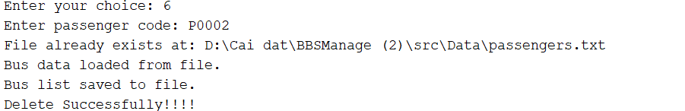

**2.7 Search by name**

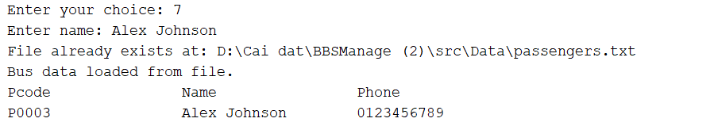

**2.8 Search buses by pcode**

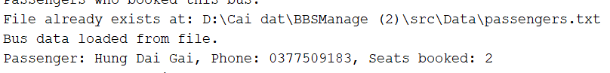

**3. Booking List**

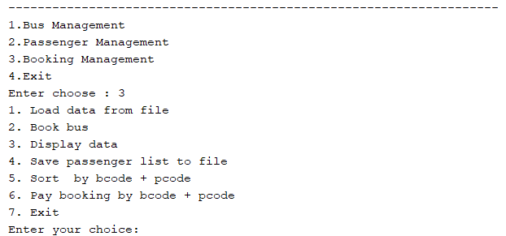

**3.1. Load data from file**



**3.2. Book Bus**

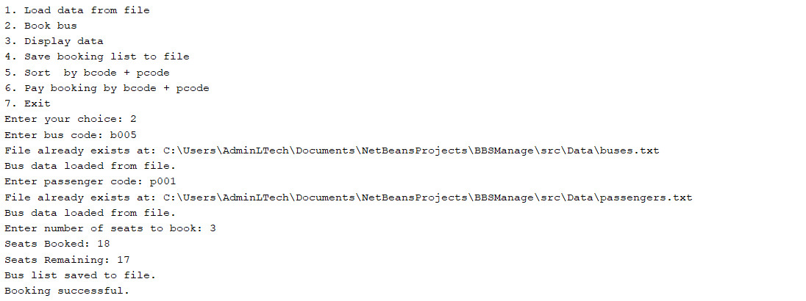

**3.3. Display Data**

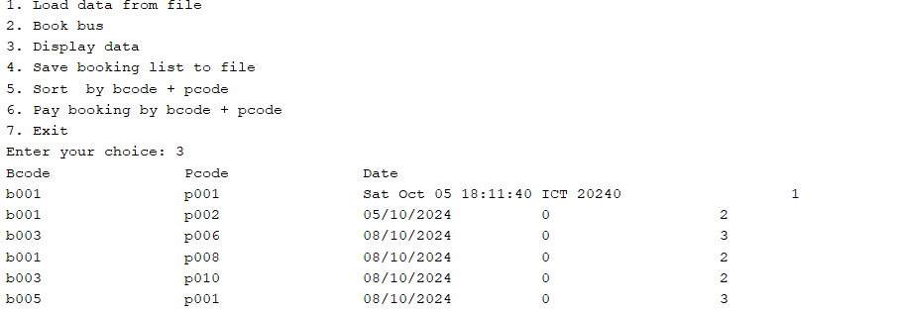

**3.4. Save booking list to file**

**3.5 Sort by bcode + pcode**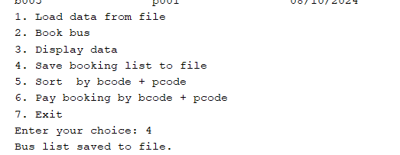

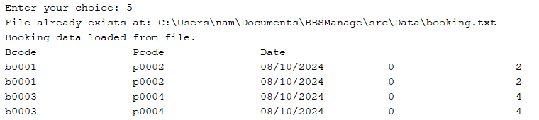

**3.6 Pay booking by bcode + pcode**

