Function

I save dates in database as YYYYMMDD int or bigint YYYYMMDDHHMM

public static List<TrainingDate> CreateTraining(int dateFrom, int dateTo, TrainingTeam trainingTeam = null)

* start clients to instructors assigning dateFrom until dateTo
* if trainingTeam is not null that mean we need to do assigning only to this trainingTeam else (trainingTeam not null) we need to do assigning to all active training teams
* data structure

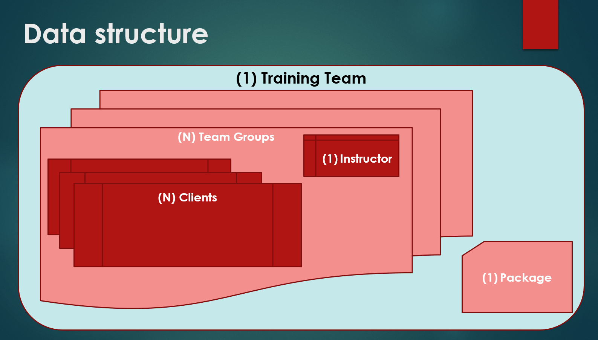

* algorithm:
  1. select all active instructors including records at table **InstrsAttendance** between date dateFrom – dateTo
  2. select all active trainingTeams that have active packages that between date dateFrom – dateTo including Clients data and teamGroup data (all related data)
  3. select all active assignments from database (tables: **DiaryTeams**, **DiaryClnts, DiaryInstrs)**
  4. here you have all data at application memory
  5. sort all list to improve performance
  6. assign all trainingteam clients (teamgroups if multiple) at the same hour [ concept for that they are coming together to the gym and they need to leave together)
  7. start looping at period dateFrom – dateTo check first trainingTeam check clients and teamgroup and reqirements are like

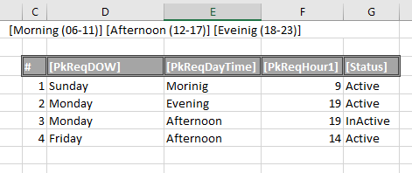

Loop at all clients at teamgroup and check if all client at teamgroup have same favorite instructor **FavIntrId** check if that instructor is available then do the assignment

But if the instructor is unavailable we have 2 options regarding value in filed MustFavIntrId (true/false)

** true – must assign the favorite instructor (if there is multiple groups in the team you must put all training team clients at the same hour) check field **PkReqDayTime** this will give you tolerance for assignment +- few hours such as

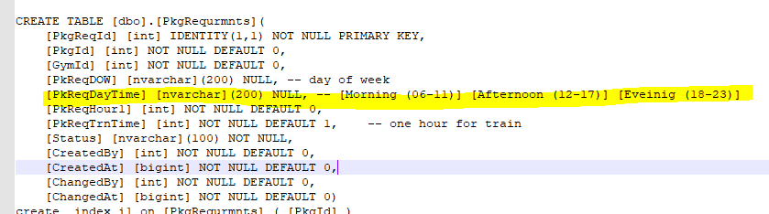

Maybe you need to postponed the training to the next day because of MustFavIntrId = true

** if MustFavIntrId is false you can assign the teamgroup members(clients) to another available instructor.

Check if record already in database (tables: **DiaryTeams**, **DiaryClnts, DiaryInstrs)** due to those table by fields ( marked in yellow )

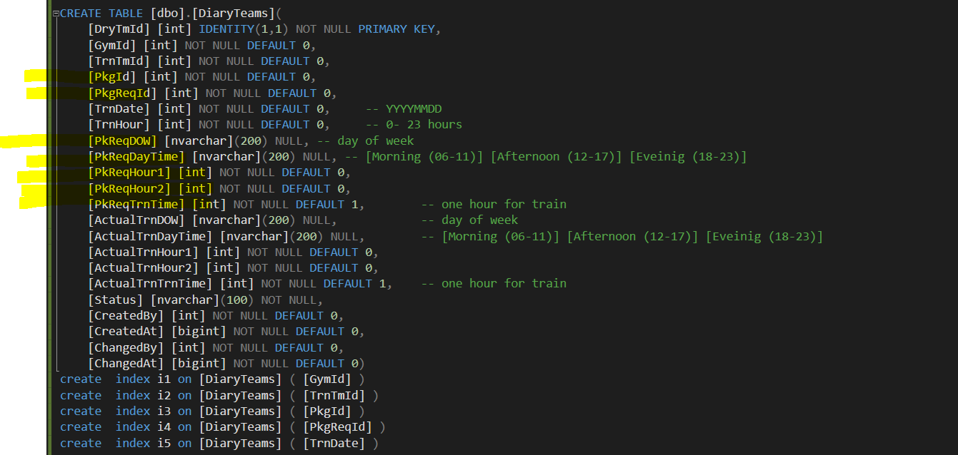

You know maybe I don’t need those fields in 3 tables, could be enough PkgId & PkgReqId

[PkgId] [int] NOT NULL DEFAULT 0,

[PkgReqId] [int] NOT NULL DEFAULT 0,

[TrnDate] [int] NOT NULL DEFAULT 0, -- YYYYMMDD

[TrnHour] [int] NOT NULL DEFAULT 0, -- 0- 23 hours

[PkReqDOW] [nvarchar](200) NULL, -- day of week

[PkReqDayTime] [nvarchar](200) NULL, -- [Morning (06-11)] [Afternoon (12-17)] [Eveinig (18-23)]

[PkReqHour1] [int] NOT NULL DEFAULT 0,

[PkReqHour2] [int] NOT NULL DEFAULT 0,

[PkReqTrnTime] [int] NOT NULL DEFAULT 1, -- one hour for train

[ActualTrnDOW] [nvarchar](200) NULL, -- day of week

[ActualTrnDayTime] [nvarchar](200) NULL, -- [Morning (06-11)] [Afternoon (12-17)] [Eveinig (18-23)]

[ActualTrnHour1] [int] NOT NULL DEFAULT 0,

[ActualTrnHour2] [int] NOT NULL DEFAULT 0,

[ActualTrnTrnTime] [int] NOT NULL DEFAULT 1, -- one hour for train