SYNCHRO STELLWERK
System for Yielding Networked CHannel Rail Operation
Interim Report — Milestone M4
System Integration & Report, Week 48–50
Author: Jonas Henz
Allgemeine Gewerbeschule Basel (AGS)
Cross-departmental Project (BÜP) — Autumn Semester 2026
21 September 2026

Table of Contents
1. Introduction 3
2. System Architecture Overview 4
3. Hardware Design 5
4. Software Design 8
5. Development History 9
6. Current Status 10
7. Key Decisions and Lessons Learned 11
8. Outlook / Next Steps 12
9. Conclusion 13

1. Introduction
SYNCHRO (System for Yielding Networked CHannel Rail Operation) is a modular, fault-tolerant DCC (Digital Command Control) model-railway control ecosystem, developed by Jonas Henz as a cross-departmental project (BÜP) at the Allgemeine Gewerbeschule Basel (AGS), running from Week 35 (24 August 2026) to Week 51 (December 2026) of the autumn semester.
The project separates timing- and network-logic from high-current track driving to avoid ground loops and electrical interference, using a three-tier hardware architecture:
- SYNCHRO_Zentrale: central control unit for signal generation, protocol handling and networking.
- SYNCHRO_Booster: isolated power stage for track voltage generation, signal amplification and short-circuit protection.
- SYNCHRO_Modul: an accessory/peripheral module for turnouts, signals and servos (concept not yet finalized).
This interim report corresponds to project milestone M4 (System Integration & Report, Week 48–50) of the official realization plan. It documents the system architecture, the hardware designed and built so far, the software developed, the project's development history, and the work remaining before the final presentation (M5, Week 51).

2. System Architecture Overview
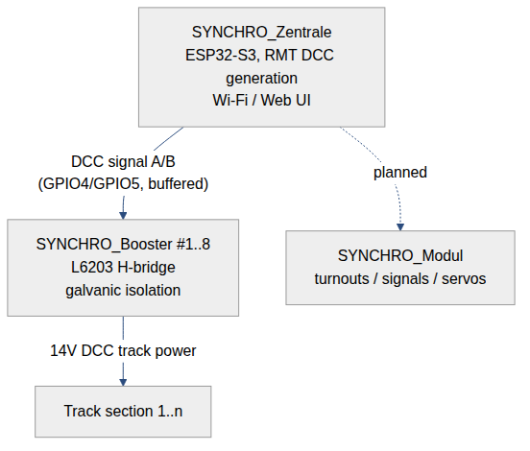
Figure 1 – SYNCHRO three-tier system architecture
The Zentrale generates the DCC bitstream in hardware (no firmware jitter) and fans it out, buffered, to up to eight Booster boards over point-to-point wiring; each Booster galvanically isolates the logic-side signal from the track-side power and drives its own track section with autonomous overcurrent shutdown. The Modul tier (accessory decoding) is planned but not yet designed; see Section 8.
Point-to-point single-ended signal distribution and RS-485/differential transmission were both evaluated for the Zentrale→Booster link; differential signaling was rejected as unnecessary complexity for the current cable lengths and booster count.

3. Hardware Design
All schematics and PCB layouts are designed in KiCad. Both boards below are the most recently committed revisions in the project repository.

3.1 SYNCHRO_Zentrale (control unit)
- Board: 84.5 × 90.22 mm, 2-layer, 56 components, 316 routed tracks, 41 vias; GND poured on F.Cu, +5V_Z poured on B.Cu.
- Core: ESP32-S3-WROOM-1-N8R8, DCC bitstream generated via the hardware RMT peripheral on GPIO4 (Signal A) and GPIO5 (Signal B) for jitter-free timing independent of firmware load.
- Signal fan-out: two MC74VHCT541ADWR2G octal bus buffers (IC1, IC2) distribute the DCC signal to eight booster connectors J2–J9 (point-to-point, single-ended).
- Power: dual-path 3.3 V supply: the AZ1117CH-3.3 LDO (IC3) fed from USB 5 V through a PMEG3010ER Schottky diode (D1) for flashing, and an R-78E3.3-0.5 DC/DC module (PS1) fed directly from the 12 V rail for normal operation; an R-78E5.0-1.0 module (PS2) generates +5V_Z to power the booster connectors.
- Connectors: USB-B (J1) for flashing/monitoring only; 12 V barrel jack (J10) for normal operation; J2–J9 to the boosters.
- User I/O: four push-buttons (SW1–SW4, active-low with 10 kΩ pull-ups) and status LEDs (D2–D5, 220 Ω series resistors); further GPIOs broken out on J11 for future use.
- Net-class trace widths: GND 1 mm, +5V_Z 0.8 mm, +3.3V 0.5 mm.
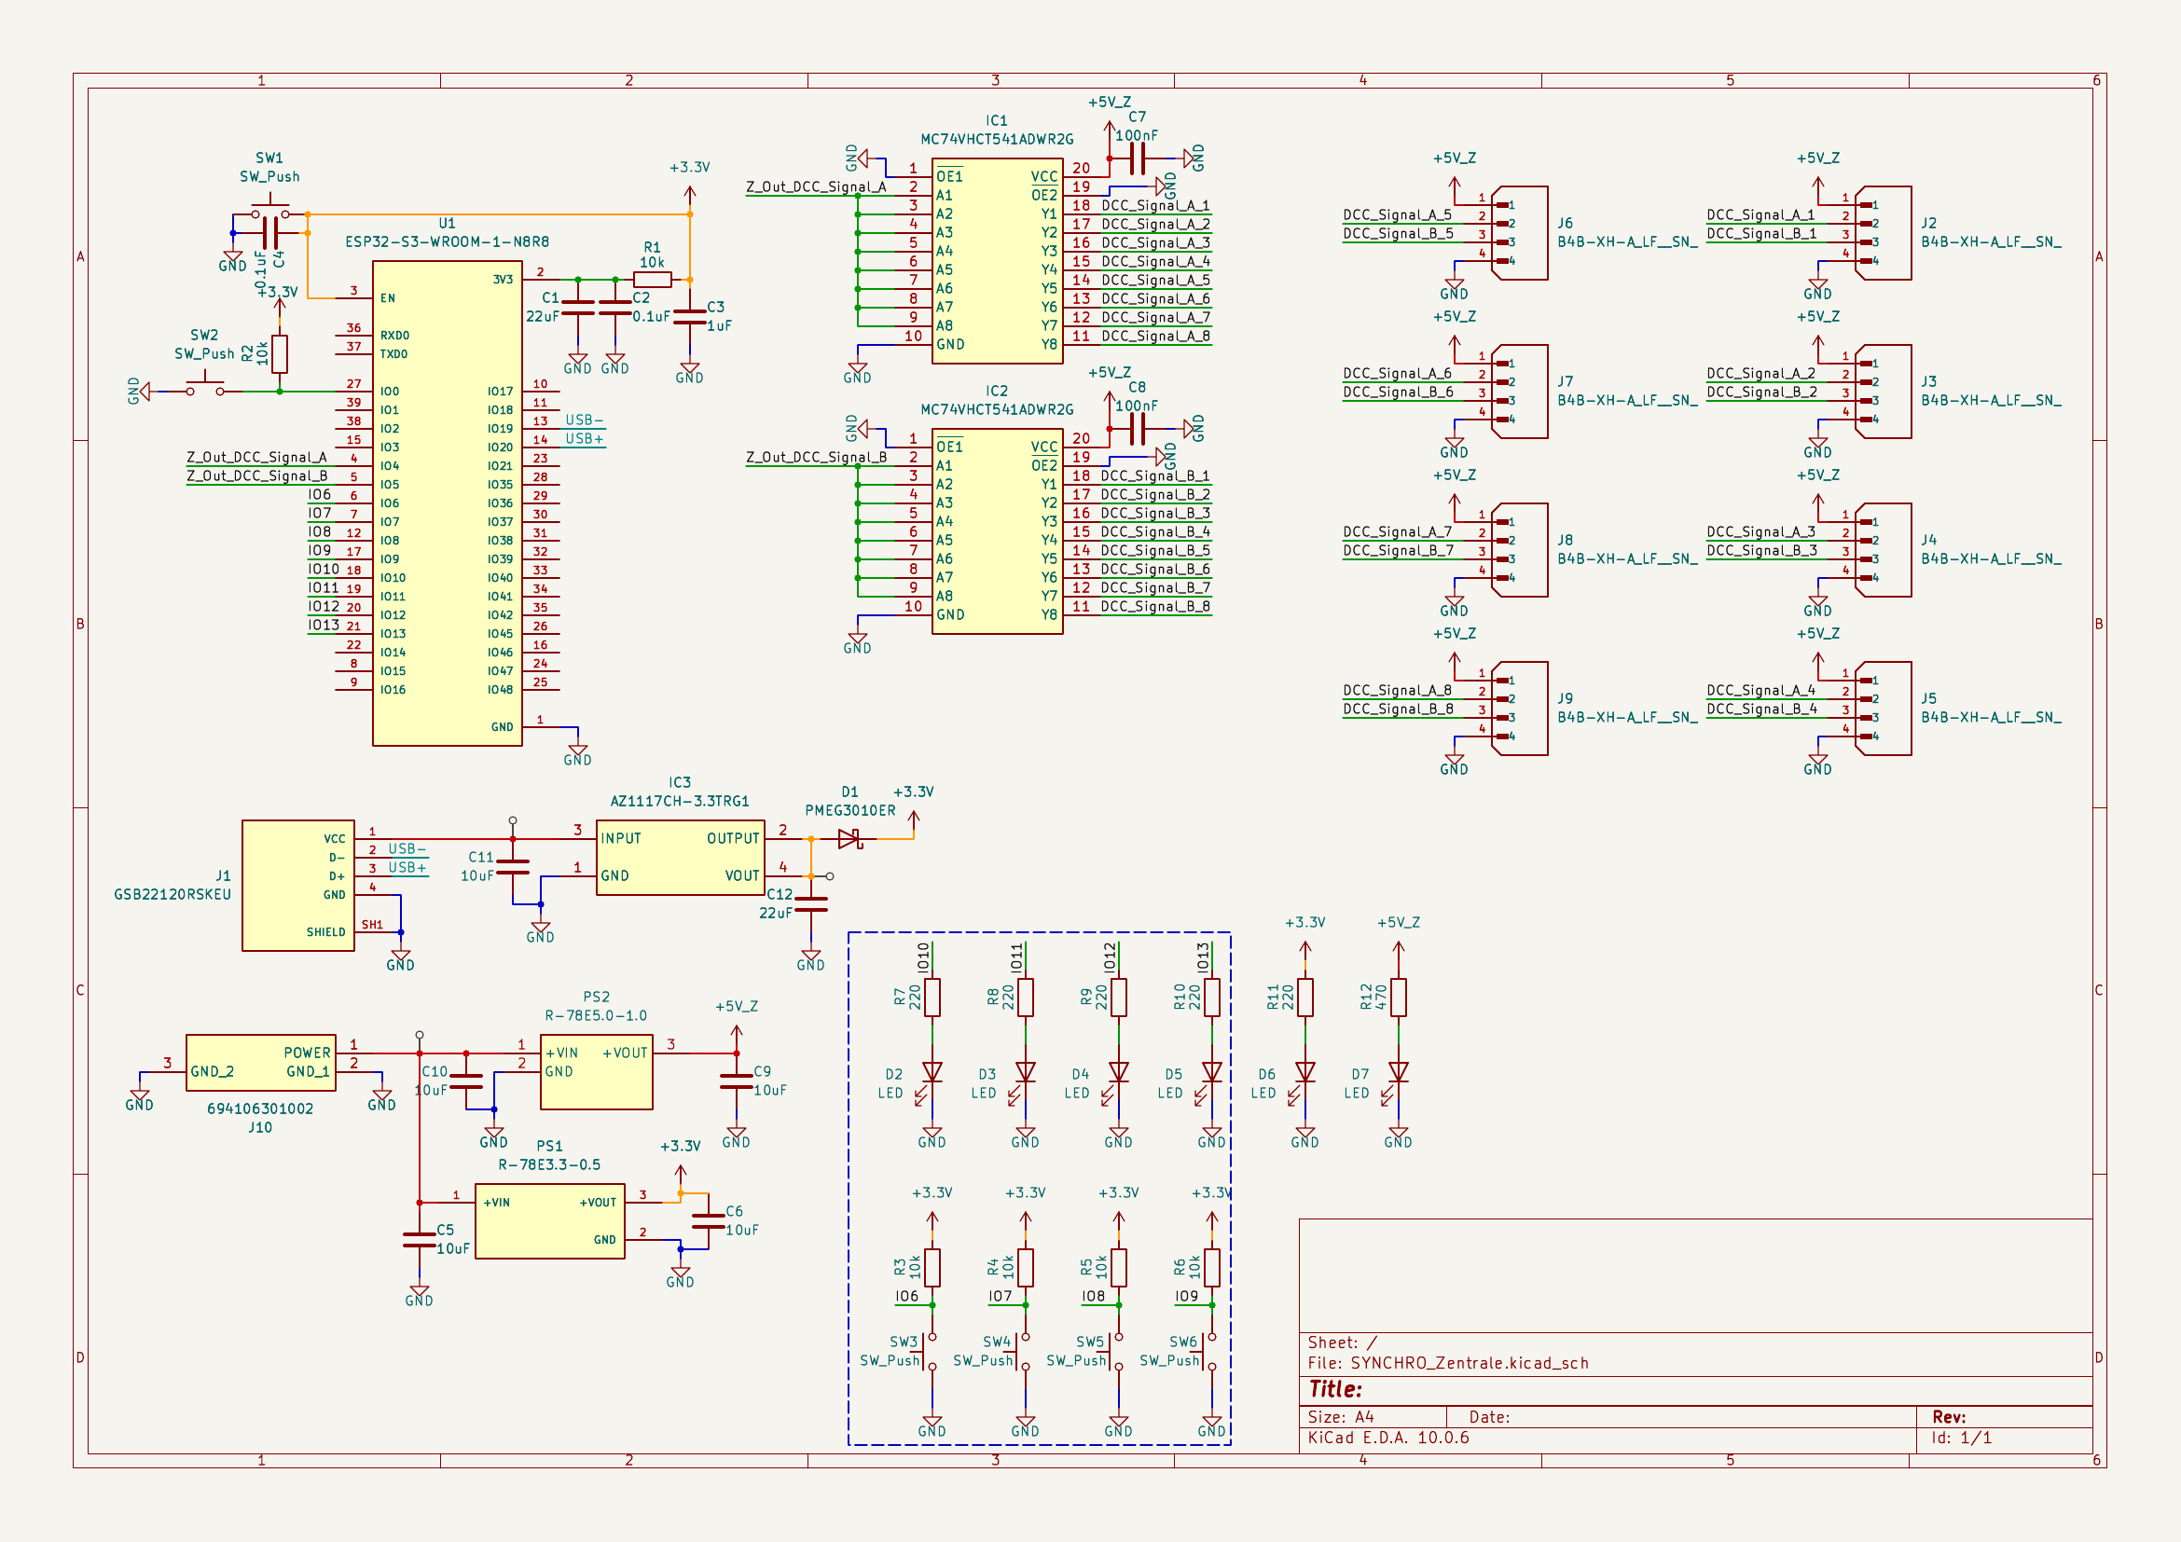
Figure 2 – SYNCHRO_Zentrale schematic (KiCad)
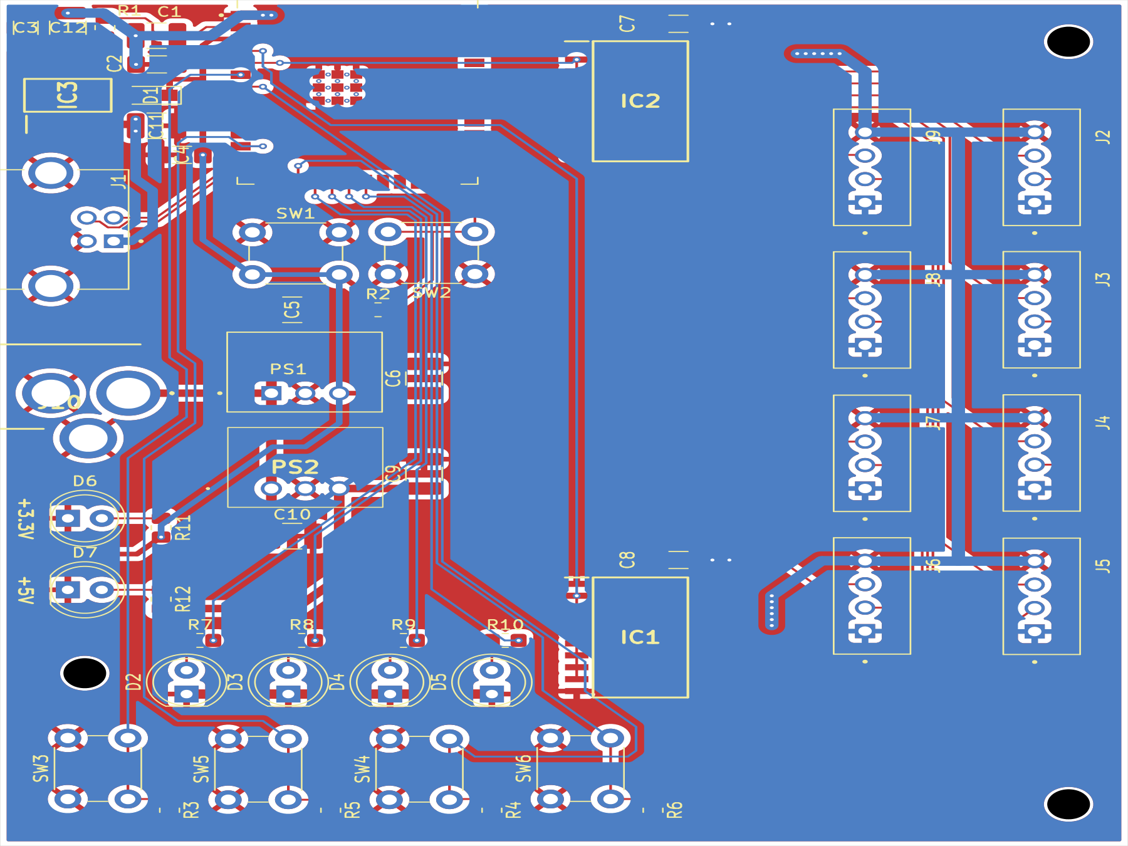
Figure 3 – SYNCHRO_Zentrale PCB layout, 84.5 × 90.22 mm, 2-layer (KiCad)

3.2 SYNCHRO_Booster (power stage, v2.0)
- Board: 71.17 × 67.36 mm, 2-layer, 45 components, 179 routed tracks; separate GND1/GND_Z copper pours on both layers.
- Power stage: L6203 full H-bridge driver (IC1) switching the 14–15 V track supply, buffered by 470 µF electrolytics (C2, C3) and an RC snubber (R6/C6, C7) to damp high-frequency ringing at the bridge output.
- Galvanic isolation: two 6N137 high-speed optocouplers (U2, U3) isolate the incoming DCC logic signal and the shutdown/status lines from the Zentrale's ground reference.
- Overcurrent protection: a 100 mΩ low-side shunt (R1) feeds an LM393 comparator (U1); its output is latched through a 74LVC2G02 NOR-gate RS latch (U4) for sub-millisecond, firmware-independent shutdown on a track short. This resolves the RS-latch design question raised during the June 2026 bench tests of the driver stage.
- Protection components: a resettable PTC fuse (F1, MF-R185-2-99) and a 16 V TVS diode (D3, SMAJ16CA) guard the track output against overload and voltage spikes; a manual reset/status LED pair (D4, D5) is provided.
- Local 5 V logic supply: R-78E5.0-0.5 DC/DC module (PS1).
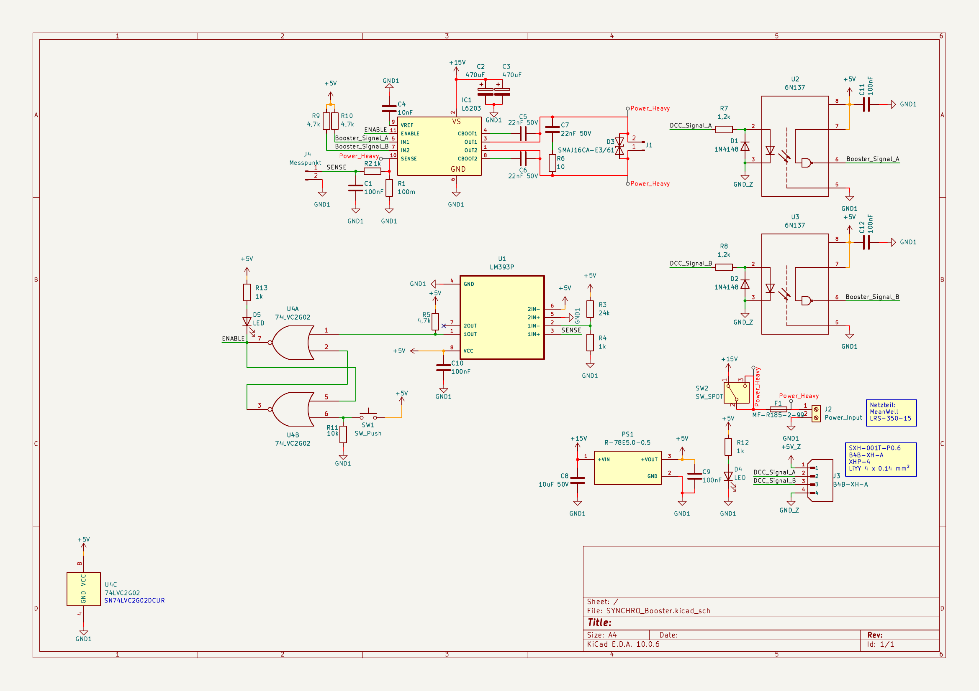
Figure 4 – SYNCHRO_Booster v2.0 schematic (KiCad)
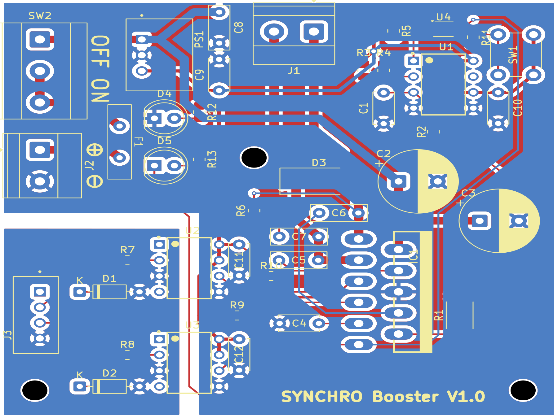
Figure 5 – SYNCHRO_Booster v2.0 PCB layout, 71.17 × 67.36 mm, 2-layer (KiCad)

4. Software Design
The operator-facing control software is a browser-based control panel (“Stellwerk”), located in the repository under Software/Modelleisenbahn-Steuerungssoftware/:
File | Role
index.html / Modelleisenbahn Controller.html | Application entry point
app.jsx | Main application shell and state
map.jsx | Track/layout map view
locos.jsx | Locomotive list and control
tweaks-panel.jsx | Settings/tuning panel

The software communicates with the Zentrale over the network (Wi-Fi) rather than a wired serial link, matching the Zentrale's role as the network/protocol endpoint of the system. Firmware for the ESP32-S3 itself (RMT-based DCC generation, Wi-Fi stack, command parsing) is the counterpart on the hardware side; it is developed alongside the hardware bring-up and is not yet in its own tracked source tree in the repository.

5. Development History
Reconstructed from the jonashenz/SYNCHRO GitHub repository's commit history (31 commits, 12 June – 15 September 2026):
Date | Milestone
12 Jun 2026 | Project structure migrated to a professional layout on OneDrive; initial KiCad library and Git workflow tooling (“git-manager”) set up
17 Jun 2026 | Booster schematic: RJ45 connection to booster added; general push/sync testing
21–26 Jun 2026 | Booster schematic updated with an RS-flip-flop for the overcurrent latch
11 Aug 2026 | Booster_Design_v1.0 committed
12 Aug 2026 | Zentrale hardware design started; first Zentrale schematic push; software push
13 Aug 2026 | Zentrale design backup
1 Sep 2026 | Zentrale layout v1.0 finalized; hardware update push; first push of the Pflichtenheft (.docx)
15 Sep 2026 | Booster v2.0 layout reworked and debugged (latest state, shown in Section 3.2)

This progression matches the realization plan's Phase 1–2 targets (specification, circuit simulation and PCB layout, Weeks 35–42): the Booster circuit was simulated and iterated first (LTSpice files in Hardware/LTSpice/), followed by the Zentrale schematic and layout, with the Booster subsequently revised to v2.0 to fix issues found during layout review.

6. Current Status
Against the realization plan's milestones:
Milestone | Plan (Week) | Status
M1 — Specification & circuit completion | 35–37 | Done: requirements defined, Booster circuit simulated in LTSpice
M2 — PCB layout & manufacturing release | 38–42 | Done for Zentrale and Booster v1.0/v2.0; Gerbers exported for Booster v1.0
M3 — Prototyping & partial commissioning | 43–47 | In progress: boards not yet assembled or bench-tested per repository state
M4 — System integration & report | 48–50 | In progress: this document
M5 — Completion & presentation | 51 | Not started

Against the mandatory/optional requirements:
Req. | Requirement | Status
M-01 | Zentrale receives commands via standardized interface | Web-based Stellwerk software implemented; Wi-Fi link to Zentrale
M-02 | Zentrale generates and transmits a control stream | Implemented in hardware (ESP32-S3 RMT on GPIO4/5, buffered to 8 booster outputs)
M-03 | Booster provides stable power and signal transmission | Implemented (L6203 H-bridge, v2.0 layout); not yet validated on hardware
M-04 | Peripheral modules decode signals and act autonomously | Not started: SYNCHRO_Modul concept undefined
O-01 | Autonomous short-circuit protection | Implemented: shunt, LM393 comparator and RS-latch (74LVC2G02)
O-02 | Galvanic isolation of logic and power | Implemented: 6N137 optocouplers on the Booster
O-03 | Spike protection | Implemented: TVS diode (D3) and PTC fuse (F1) on the Booster
O-04 | Status indicators & manual reset | Implemented: status LEDs and reset switch on the Booster
O-05 | Universal actuator output on the Modul | Not started

Outstanding open items carried from hardware bring-up: the SYNCHRO_Modul's purpose and BOM are still undefined, which also blocks completion of the overall cost-planning workbook (SYNCHRO_Stellwerk_Kostenplanung.xlsx).

7. Key Decisions and Lessons Learned
- Two alternatives were evaluated for the Zentrale-to-Booster link, an LTC4412 ideal-diode power path and RS-485 differential signaling, and both were dropped in favor of the simpler point-to-point single-ended wiring already in use.
- An early revision fed the R-78E3.3-0.5 module from the +5V_Z rail, which sits below its 6 V minimum input. The corrected design feeds it directly from the 12 V input instead.
- Bench tests of an L6203 H-bridge in isolation initially produced no output. Working through a checklist (ENABLE high, Vs present, IN2 not floating, bootstrap capacitor fitted, GND and thermal-tab continuity) found the fault. The RS-flip-flop latch added to the Booster schematic in June 2026, together with the LM393 comparator shutdown circuit, now provides the autonomous, firmware-independent shutdown required by O-01.
- Component choices are checked against datasheets before layout. The AZ1117CH-3.3's ceramic-capacitor compatibility, for instance, was confirmed against the manufacturer's reference design.
- Bills of material list every individual component, including major ICs, rather than grouped catch-all line items, so ordering and cost tracking stay accurate.

8. Outlook / Next Steps
To reach M5 (Week 51):
- Assemble and bench-test the Zentrale and Booster v2.0 prototypes (SMD/THT assembly, isolation testing, calibration of the overcurrent shutdown threshold) — Phase 3 of the plan.
- Run the full signal-path integration test: Zentrale → booster connector → Booster → track, under load.
- Define the purpose and bill of materials for SYNCHRO_Modul so the overall cost-planning workbook can be finalized.
- Push the ESP32-S3 firmware source to the repository alongside the existing web-based Stellwerk software.
- Perform the target/actual comparison and archive all schematics and code ahead of the final presentation at AGS.

9. Conclusion
By Week 38 of the autumn semester, SYNCHRO's specification and circuit design (M1) are complete, and both core boards, the SYNCHRO_Zentrale control unit and the SYNCHRO_Booster power stage, have a finished, routed PCB layout (M2), with the Booster already through a v1.0-to-v2.0 revision cycle that resolved its overcurrent-latch and layout issues. The system's mandatory signal-generation and -distribution requirements, and its optional isolation, spike-protection and overcurrent-protection requirements, are designed in and verifiable in the schematics. The main gaps ahead of the December presentation are physical assembly and bench validation (M3), the still-undefined SYNCHRO_Modul, and getting the ESP32-S3 firmware into version control alongside the existing web-based control software.

