**Introduction**

Vanilla kernel refers to Linux kernels which are not tied to any distributions. Integrating kernels provide ways to customize the operating system. The hands on guide to Linux kernel compilation can be found at:

<https://www.cyberciti.biz/tips/compiling-linux-kernel-26.html>

Other related web based sources and videos in Youtube can serve as you reference.

Note:

1. Take notice of all the tools required for kernel compilation.
2. An **average of 2 to 3 hrs** are required for **one** kernel compilation process to be completed. Allocate a minimum of 4GB RAM.
3. **Attempt this assignment over a Virtual Machine**, **not over your host system**  since newly installed kernels may not boot and may corrupt existing Windows or host OS in real time environment.

**Objective**

To expose students to the Linux kernel compilation process and gain skills needed for kernel deployment.

**Task**

Each ONE is required to upgrade the kernel of the Ubuntu 16.04 OS to the kernel versions as per indicated in Table 1 below. Kernel sources can be downloaded at:

<https://cdn.kernel.org/pub/linux/kernel/v5.x/>

Please note that each group is allocated the following kernel versions:

|  |  |
| --- | --- |
| **Group** | **Kernel Version** |
| 1 | 5.0.13 |
| 2 | 5.0.14 |
| 3 | 5.0.15 |
| 4 | 5.0.16 |
| 5 | 5.0.17 |
| 6 | 5.0.18 |
| 7 | 5.0.19 |
| 8 | 5.0.20 |
| 9 | 5.0.21 |
| 10 | 5.1 |
| 11 | 5.1.1 |
| 12 | 5.1.2 |
| 13 | 5.1.3 |
| 14 | 5.1.4 |
| 15 | 5.1.5 |
| 16 | 5.1.6 |
| 17 | 5.1.7 |
| 18 | 5.1.8 |
| 19 | 5.1.9 |

Please consult the Instructor if your kernel version is not listed above.

**Note:**

1. For grouping and kernel versions required to be compiled, refer and fill up:

https://xmueducn-my.sharepoint.com/:x:/g/personal/jiayew_teh_xmu_edu_my/ESEOViiAxVxAnt2vDwQJQ54BHJmtodREuUQBm0WzNfsctQ?e=ZZUHup

1. **No two or more groups shall compile identical kernel versions. Marks will be split between two groups presenting the same kernel version.**
2. **It is highly recommended that group members be formed from students of identical programs. Such facilitates Live Demo upon physical class resumption since live demo can be continued into Tues (CST) & Wed (AIT) lab groups. Otherwise, live demo can only be performed on Monday.**
3. **This documents shall be provided in both pdf & Word versions. Both versions are identical. If there are any discrepancies, the pdf version shall prevail.**

**Deliverables**

1. **Live Demo**
2. ***Live Demo*** of your newly installed kernel. Your Ubuntu OS must boot with the newly installed kernel. Appoint***one member*** from your group whom shall conduct the demo Kindly ***narrate*** the steps in your video (e.g. booting up machine). Each live demo shall be 5 min and followed by 5 min of Q&A by the course lecturer. The Q & A will assess your knowledge in the Linux kernel deployment process. Q&A can be answered by any group member.

**NOTE:** Live Demo shall be conducted on **9th May 2022, Monday during class time either over Teams (out of campus students) or face to face (in campus students). Demo shall be conducted by in campus students followed by out of campus students.**

1. **Lab Report Submission**

The following needs to be included in your lab report:

1. Apart from video mentioned above, print all pages of this assignment question and submit together with the attached marking rubric, duly signed by all members of your group, into Moodle by the due date mentioned above
2. **Screenshot** of your Terminal with these command outputs, ‘date’, ‘uname –a’ and ‘dpkg --list | grep linux-image’ to display the newly installed kernel. Paste your screenshot on the ‘Output’ section below.
3. **Screenshot** of your /boot folder, with date and time stamp of files. Apply a red circle or rectangle around your kernel image file, in which you used to install the new kernel.
4. Due date for submission is**: 9th May 2022 @ 11.59 pm Malaysian time (MYT)**.
5. No source code is required to be submitted since the kernel is a huge collection of 10k files with millions of lines of code (LOC).

**Output Section**

**Screenshot** of your Terminal with these command outputs, ‘date’, ‘uname –a’ and ‘dpkg --list | grep linux-image’ to display the newly installed kernel.

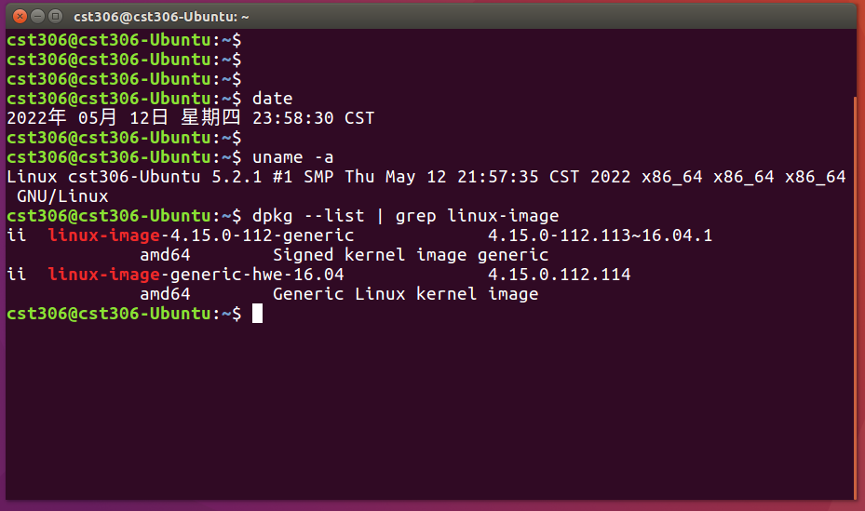

**Screenshot** of your /boot folder, with date and time stamp of files. Apply a red circle or rectangle around your kernel image file, in which you used to install the new kernel.

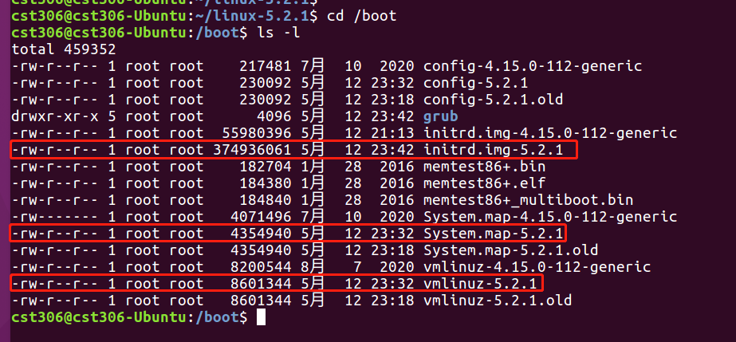

|  |  |  |  |  |  |  |  |  |
| --- | --- | --- | --- | --- | --- | --- | --- | --- |
| **Component Title** | **Assignment 1** | | | | | **Percentage (%)** |  | |
|  | | | | | **5.0** | |
| **Criteria** | **Score and Descriptors** | | | | | | **Weight (%)** | **Marks** |
| **Excellent**  **(5)** | **Good**  **(4)** | **Average**  **(3)** | **Need Improvement**  **(2)** | **Poor**  **(1)** | |
| **Delivery** | Completed 100% of  task requirements  Delivered on time,  and in correct format | Completed between  75-85% of the task  requirements  Delivered on time,  and in correct format | Completed between  60-75% of the task  requirements  Delivered on time,  and in correct format | Completed at least 60% of the task requirements.  Delivered not on time,  but with slight delays and in correct format. | Completed less than 50% of the requirements.  Not delivered on time or not in correct format (disk, email, printout etc.).  Does not comply with requirements (does something other than requirements).  . | | **1.67** | **5** |
| **Implement**  **ation** | 100 % use of visual aids (e.g. screenshots, arrows comment boxes) to demonstrate evidence of successful implementation | 85 % use of visual aids (e.g. screenshots, arrows comment boxes) to demonstrate evidence of successful implementation  . | 50 % use of visual aids (e.g. screenshots, arrows comment boxes) to demonstrate evidence of successful implementation | 25 % use of visual aids (e.g. screenshots, arrows comment boxes) to demonstrate evidence of successful implementation | 10 % use of visual aids (e.g. screenshots, arrows comment boxes) to demonstrate evidence of successful implementation | | **3.33** | **10** |
| **Q &A** | Able to answer questions *greatly* exceeding expectations and explanation delivered with high clarity | Able to answer questions exceeding expectations and explanation delivered with high clarity | Able to answer questions meeting expectations and explanation delivered with clarity | Able to answer questions satisfactorily and explanation delivered with clarity | Able to answer questions satisfactorily and explanation delivered with poor clarity | | **5.0** | **15** |
| **TOTAL** | | | | | | | **10** | **30** |

**APPENDIX 1**

**Marking Rubrics**