**Will You Match Me? UGRP! (Matching program for UGRP Team Members)**

고낙헌(201911101, skrgjsdl23@dgist.ac.kr), 김주형(201911031, kimmold@dgist.ac.kr),

이의정(201911131, dmlwjd317@dgist.ac.kr), 한현영(201911189, hyhan@dgist.ac.kr)

**1. What you plan to do, why & what is hard about it**

As a student of DGIST, UGRP(Undergraduate Group Research Program) is essential. It is important to find a team that fits well before starting a full-fledged study by the UGRP. However, it is not easy to team up with students who have similar interests. To solve these difficulties, we decided to design a UGRP matching program. Simply, after entering student information such as major field, student number, and interested research field, the program prints list of students who are suitable as team members by comparing various factors such as inputs, personality and professor. The key point of this project is that the weighting should be well set to rank students' data and quantity. We aim to help students form a well-matched team by considering not only the field of research or major, but also interpersonal factors.

**2. Describe the implementation design of your project**

We composed the class necessary for the project progress as below.

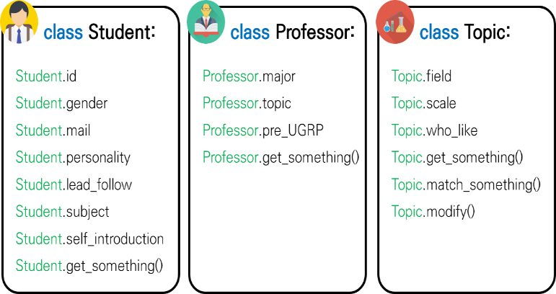The ‘Student’ class forms an object that stores information about individual students wishing to participate in the UGRP.

The ‘Professor’ class forms an object that stores information about professors who have taught an existing UGRP task or have the capacity to lead a new UGRP team.

The ‘Topic’ class forms an object that stores information about all UGRP assignments opened so far.

When the initial screen of the program is first turned on, individual students must write their student id, gender, e-mail address, personality, leader/follower status, interest field, and one line self-introduction on the registration screen. We enter the information of individual professors in advance.

After the login screen, other students who match the visitor’s student ID, gender, leader/follower trend, interest field, etc. are ranked and recommended and printed. Individual students can easily find team members through the email address written in the output.

The most important part of this project is matching system. To find most suitable UGRP group member, it is very import to design matching algorithm. Student Object has preferred object array, and ‘gender and personality’ array. Each array contain 0 or 1 value, and each index means subject.

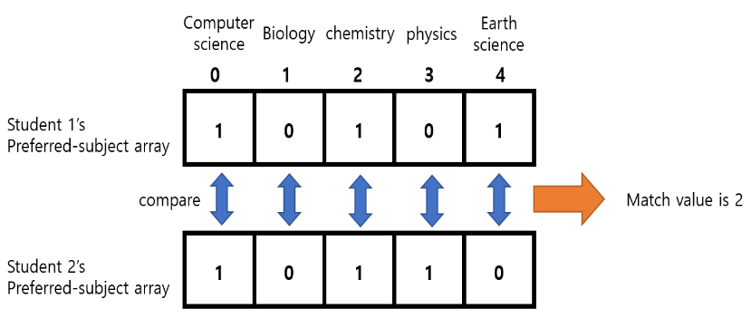For example, at preferred object array, Computer science correspond to 0 index, and Biology correspond to 1 index, chemistry to 2.., and if some student prefer Computer science and chemistry, this student’s preferred subject array contains 1 0 1… So, to find crew who has same preferred subject and similar personality, we will compare each array. Compare the arrays of two students, add 1 “match value” if both are “1” at one index. After finding all the match values of the other students against one student, sort match value in descending order to find best match student. Find match value at the gender-personality array in the same way. We will find final match value by balancing between preferred object’s match value and gender-personality’s match value.

And Topic class has field array which is same type of student class’s subject array. So we can use same matching algorithm that mentioned above. Professor is too. So we can find out most suitable topic and professor.

**3. Experiments you will run and the results you expect**

I. Sign up: The program requires users to enter their student number and password, as well as their interests, personalities, and self-introduction. It also provides a list of historical UGRPs and then allows them to choose topics of their interest.

II. Sign in: At the sign in section, users enter their student number and password. If the entered class matches the information stored in the database within the program, access the main screen.

III. Main: The program combines the characteristics, areas of interest, and topics of choice entered in the membership section. Subsequently, it reflects this and connects users who are entered similarly to users. The output that the user can see is the contact of a user similar to himself.

**4. Metrics of success in detail: it should be quantifiable (Tentative)**

|  |  |  |  |  |
| --- | --- | --- | --- | --- |
|  | **#(data) = 16** | **#(data) = 32** | **#(data) = 64** | **#(data) = 128** |
| Match Accuracy (whether it is matched as intended by the user) | **W %** | **X %** | **Y %** | **Z %** |

**5. Describe the final project demo plan & what you will report in the final project report**

First of all, what will be included in the report is user input and corresponding output using console-based programs. It will also include results on whether other users are normally matched to the desired area, as we intended. If time permits, it will evolve into a GUI format and provide services for students in DGIST to use.