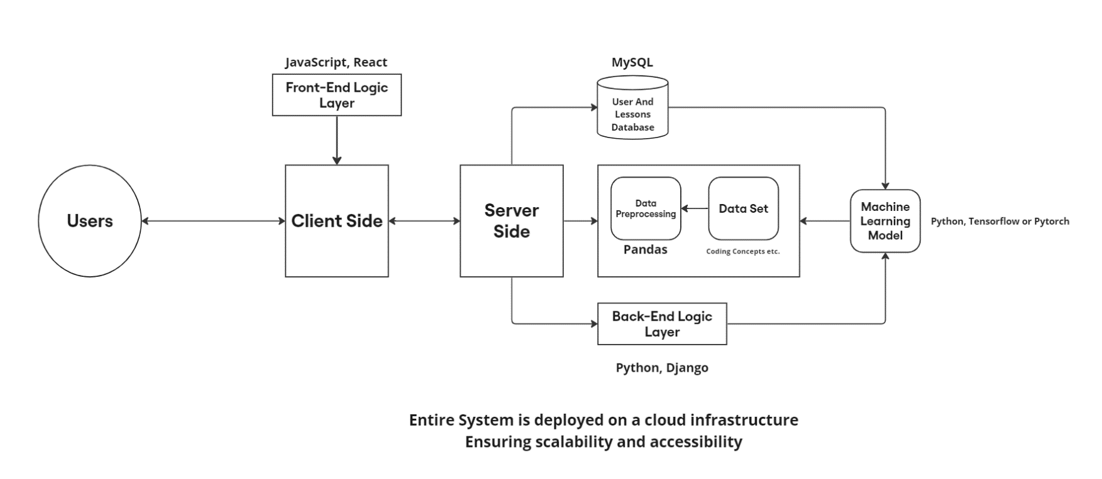Machine Learning Mentor

Abstract

In the era of digital education, programming skills stand as a critical asset, demanding innovative learning approaches. This project endeavors to craft an intelligent online tutoring platform, employing advanced machine learning to revolutionize personalized programming education.

The platform harnesses the power of machine learning models to meticulously evaluate users' programming proficiency. By analyzing curated datasets encompassing programming concepts, user interactions, and learning outcomes, it dynamically tailors lesson plans according to individual skill levels and existing knowledge.

At the core of this platform lies a sophisticated machine learning framework. This framework, trained on extensive datasets sourced from diverse programming resources, intelligently assesses user input, adapts to varying skill levels, and intricately structures personalized lesson pathways.

provides a user-centric interface, intuitively guiding learners through personalized lesson modules crafted by the machine learning model. This interface fosters interactive learning experiences, allowing users to grasp programming concepts at their own pace and skill level.

Through the fusion of state-of-the-art machine learning algorithms and an intuitive user interface, it aspires to redefine programming education. By dynamically tailoring lessons to individual learners, the platform aims to empower users of all proficiencies on their journey to mastering programming skills in a personalized and adaptive manner.