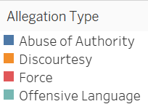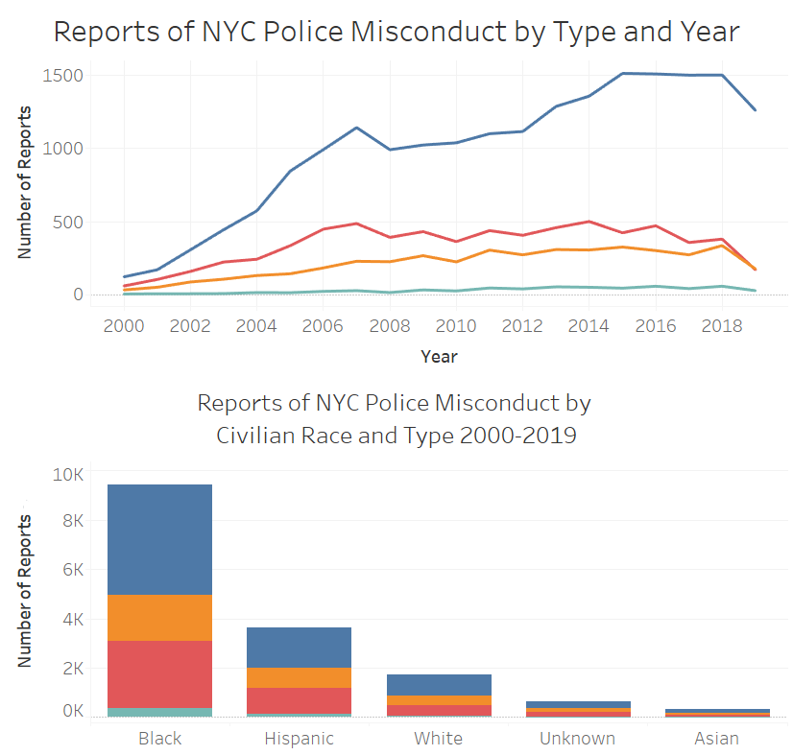

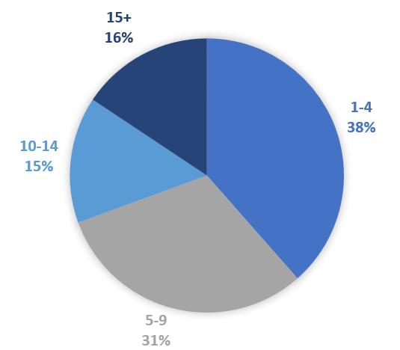

*shows only active officers named in at least one report.

Number of Reports per Officer*

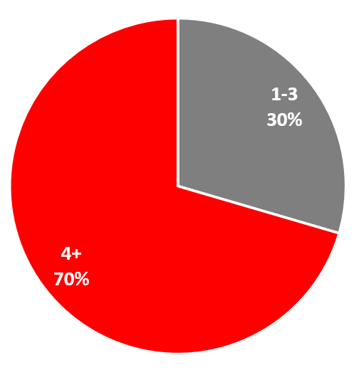

show that **70%** of officers named in the reports have had four or more allegations of misconduct.

**Reports of Repeated Misconduct…**

show that reports have rapidly increased over time. There were over 2,300 reports of misconduct in 2016 alone.

show that over 90% of civilians involved were people of color.

**Reports of Misuse of Force…**

Dataset includes the results of all civilian complaints filed against active New York City police officers from 1986-2020, results from recent years excluded due to incomplete data. Source: ProPublica

Outcomes of NYC Police Misconduct Investigations 2000-2018

Year

Outcome by Officer Race

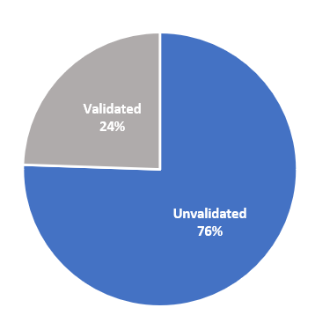

Overall Report Outcomes

There were over six times more false complaints in 2006 as there were in 2000. From 2006-2018, there were over 1300 false allegations made against police officers annually.

**False Civilian Complaints Against Police Officers in NYC 2000-2018**

**Misconduct Allegations by Outcome and Race**

**Police Complaints Involving Force**

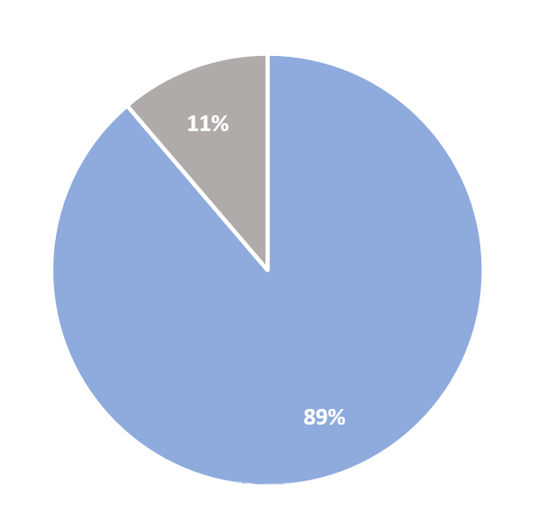

**Nearly 90% of allegations of excessive force were found to be unsubstantiated** by New York City’s Civilian Complaint Review Board.