Python lab #11

Title: The Sea-Wolf

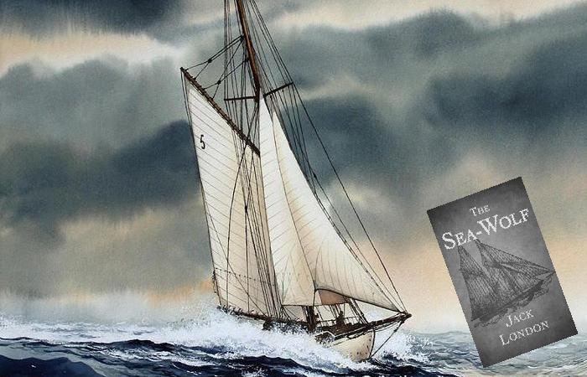

**Author: Jack London**

*Author of the report: Nykonchuk Illia*

Chart Page

Plot about distribution of words among paragraphs in Chapter I:

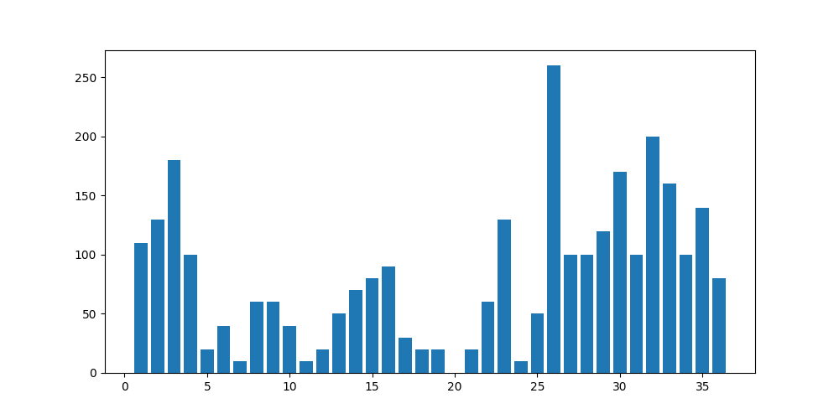

Chapter I Analysis

Number of paragraphs: 36

Count of words: 2847

Biggest amount of words in paragraph: 26

Average amount of words per paragraph: 86

Amount of paragraphs with the same amount of words: 24