哈市2026榜中榜（A）英语范文汇编
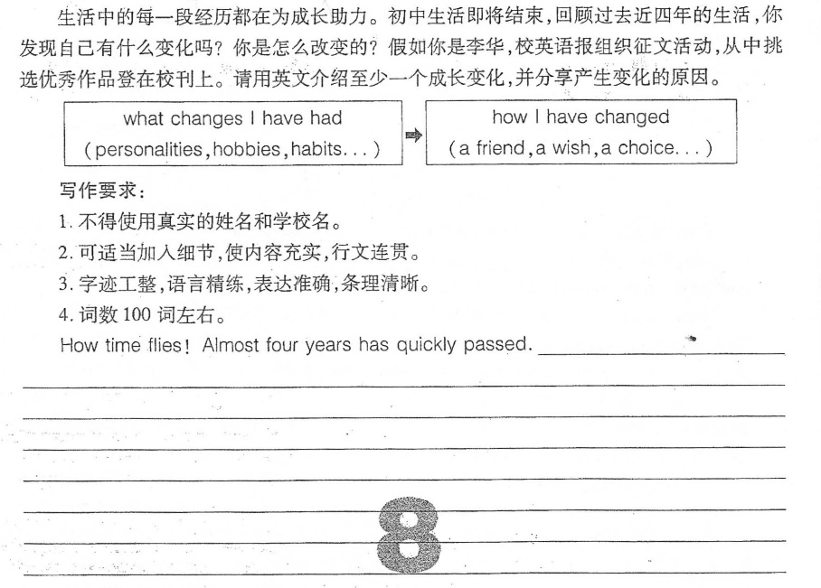
I.英语试卷（一）
One possible version:
How time flies! Almost four years has quickly passed. Looking back, my most noticeable (adj.明显的) change is becoming more confident.
In the past, I was too shy to answer questions in class. But last year,my English teacher encouraged me to join a speech contest. Though I felt very nervous at first, I practiced daily and finally won third prize. This experience taught me that courage grows through challenges. Now, I actively take part in class discussions and even lead group projects.
This change came because I realized: growth happens outside our comfort zone (舒适带). Every small step forward builds confidence. Junior high taught me that I should face challenges bravely.
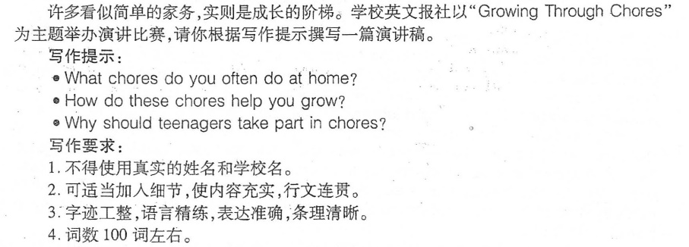
II.英语试卷（二）
One possible version:
Good morning,everyone!
I'm glad to share my ideas on "Growing Through Chores". At home, I often do chores like sweeping the floor, washing the dishes and folding my clothes. Sometimes I also help my parents water the plants or take out the rubbish.
These chores have helped me grow a lot. Doing them teaches me to be responsible—since I know my family needs my help. I've also learned to manage my time well, as I have to finish chores before doing my homework. What' s more, folding clothes or arranging (v.安排) things makes me more careful and patient.
Teenagers should take part in chores. First,it helps us understand how hard our parents work. Second, chores teach us useful life skills that we'll need in the future. Finally, working with family on chores can bring us closer together. Let' s start with small chores and grow into better people! Thank you!
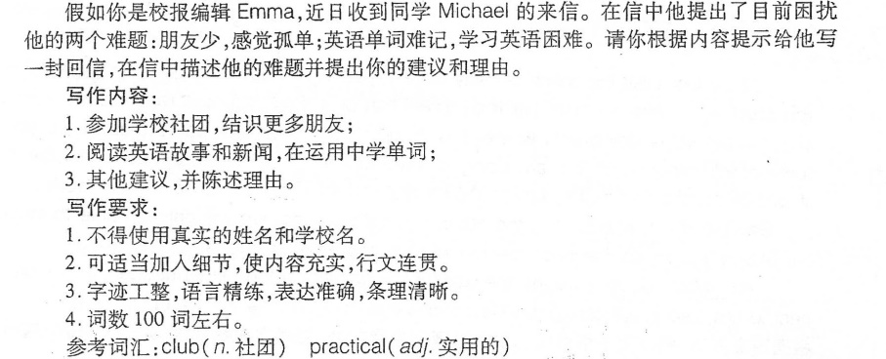
III.英语试卷（三）
One possible version:
Dear Michael,
I understand your concerns about (对…的担忧) feeling lonely and struggling with (与…努力应对) English vocabulary (n.词汇). Here are some suggestions that might help.
Firstly, joining school clubs is a great way to meet new people who share your interests, making it easier to form friendships. Secondly, try reading English stories and news. This not only exposes (v.接触，体验) you to practical (adj.实用的) vocabulary but also helps you learn words in context (n.语境), making them more memorable (adj.难忘的). Additionally, consider using flashcards (闪卡，单词卡) or apps for vocabulary practice, as they offer interactive (adj.交互式的) and fun ways to learn.
I hope you'll find my advice useful. Good luck with everything.
Yours,
Emma
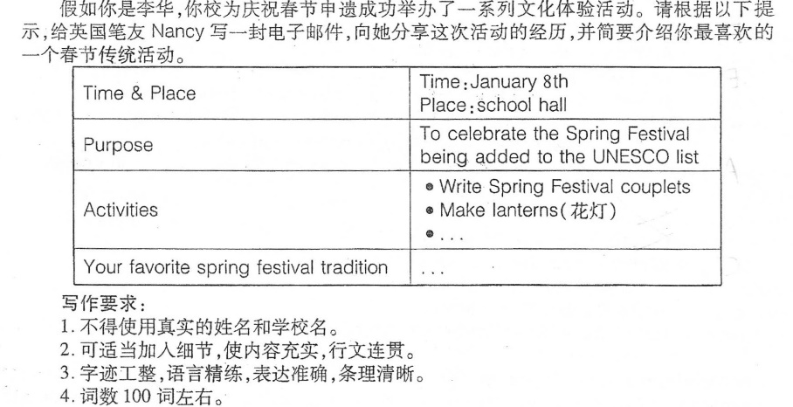
IV.英语试卷（四）
One possible version:
Dear Nancy,
I'm really excited to tell you about the activities our school held on January 8th in the school hall-we celebrated the Spring Festival being added to the UNESCO (abbr.联合国教科文组织) list!
We did lots of fun traditional things:writing Spring Festival couplets on red paper with good wishes,making colorful lanterns with glue and paint,and even learning paper-cutting.I tried hard and finally made a small rabbit shape. The hall was full of red and gold,and everyone was chatting and laughing!
My favorite Spring Festival tradition is the New Year's Eve dinner. All my relatives sit around a big table with dumplings,fish,and rice cakes. We talk about the past year and wish each other well. It's the warmest time of the year!
It was such a nice day. Do you want me to send you a photo of my handmade lantern?
Yours,
Li Hua
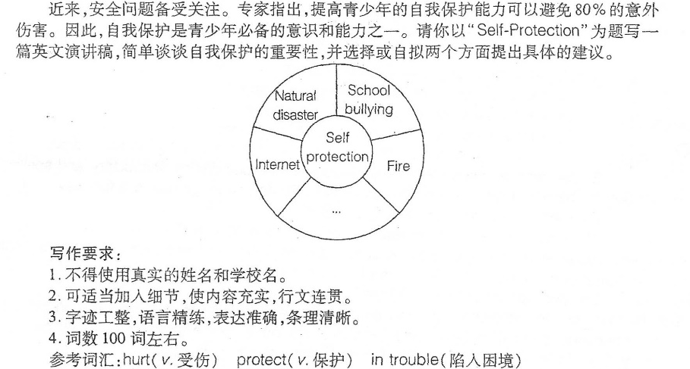
V.英语试卷（五）
One possible version:
Good afternoon,everyone!
Recently,safety has been paid much attention to.It is reported that 80% of the injuries (n.伤害) can be prevented by improving our self-protection abilities. Self-protection is one of the most important skills to us.
We can avoid or reduce the possibility of being hurt if we know what to do in different situations. Fire is one of the most terrible accidents around us. If our building is on fire,the most important is to calm down first. Then,cover the mouth and nose with a wet towel to protect ourselves from thick smoke and try to get out as soon as possible.
School bullying is another danger that may happen around us. If we meet with school bullying,we must tell our teachers or parents about it. They will help us deal with it well.What's more,it's necessary for us to help others if they are in trouble. In a word, we should have some self-protection skills to live a safe and happy life.
Thanks for your listening.
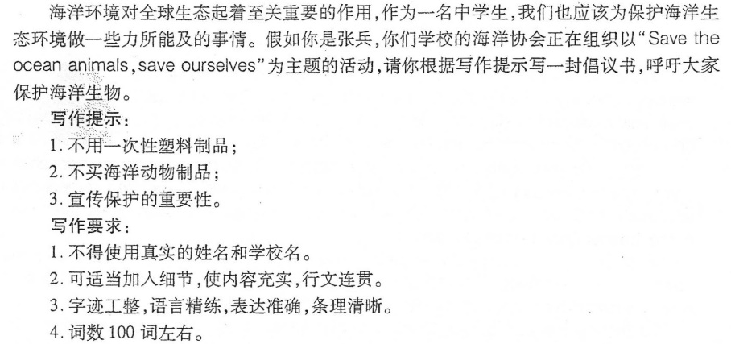
VI.英语试卷（六）
One possible version:
Dear schoolmates,
As we all know, the ocean is home to countless (adj.无数的) animals, and it plays a key role in our global ecosystem. But now, many ocean animals are in danger. As middle students, we should take action to protect them.
Here are three practical ways. First, stop using single-use plastics like plastic bags and bottles, as they often end up in the ocean and hurt animals. We can carry reusable bags when shopping instead. Second, don't buy products made of ocean animals, such as coral jewelry (珊瑚首饰), for this will stop the illegal hunting of these creatures. Third, spread the importance of ocean protection to our families and friends, so more people will join our protection team.
Saving ocean animals is saving ourselves. Let's start right now and make a difference!
Zhang Bing
The School Ocean Association (协会)


VII.英语试卷（七）
One possible version:
AI in My School Life
With the development of technology, Al has become a helpful friend in my school life. The AI tool I use most is an English listening and speaking app.
It helps me a lot with my English study. Every day, I practice listening to short passages on it. After that, when I repeat the sentences, it checks my pronunciation. It also tells me where I make mistakes. This way, my listening and speaking skills have improved quickly.
But we must use Al properly and not depend on it too much. After all, AI is just a study tool, not a replacement (n.代替) for our own efforts.

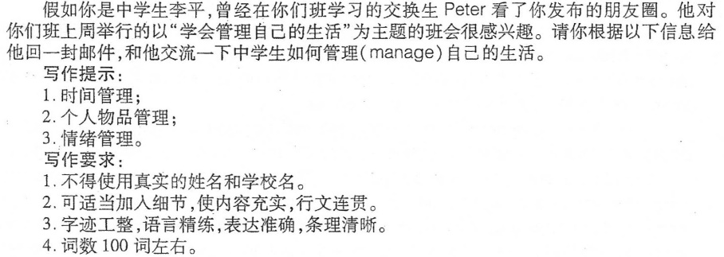
VIII.英语试卷（八）
One possible version:
Dear Peter,
I'm glad you're interested in our class meeting themed "Learn to Manage Our Lives" last week. Here are three key points we discussed.
First, time management is important. We should make a daily plan, like finishing homework before playing games or watching TV. For example, I set 7 to 8 p. m. as homework time every day, which helps me avoid putting things off. Second, manage personal items (n.项目，物品) well. Keeping our desks tidy and organizing schoolbags every night make it easy to find textbooks or notebooks in class. I even use small boxes to sort (v.整理，分类) things. Third, control emotions properly. When feeling upset about bad grades or arguments with classmates, talk to parents or friends. They always give useful advice instead of letting us stay sad alone.
These ways have helped us a lot. Do you have other good ideas about life management? Looking forward to your reply!
Yours,
Li Ping
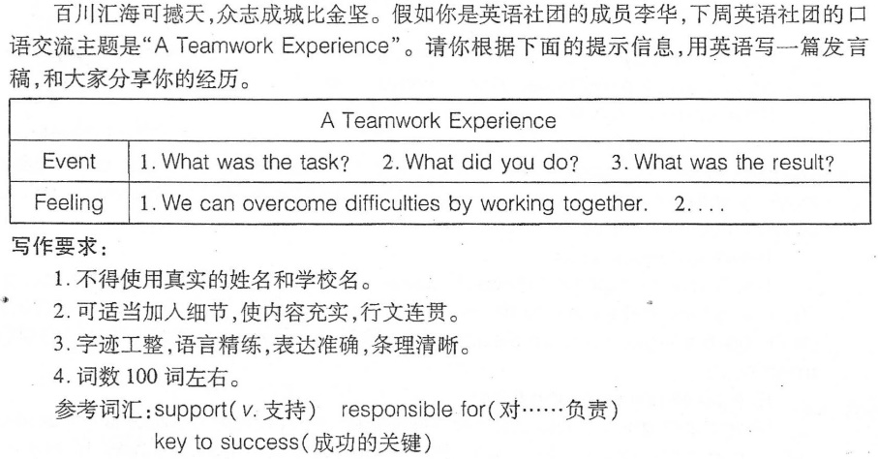
IX.英语试卷（九）
One possible version:
Hello, everyone! I'd like to share a teamwork experience of mine.
Last month, we were divided into groups for a project on global warming. My team worked together to collect information and prepare our report, with each member responsible for different parts. I focused on the influence of global warming, while the others explored (v.探寻) useful ways. Everyone worked so hard and we worked so well together that the project was completed perfectly.
This experience made me understand the power of teamwork. Working together, we could overcome difficulties. And we supported and encouraged one another, making us stronger as a whole. Working well as a team is the key to success. Let's value every chance to work together and grow as a team.
That's all. Thank you.

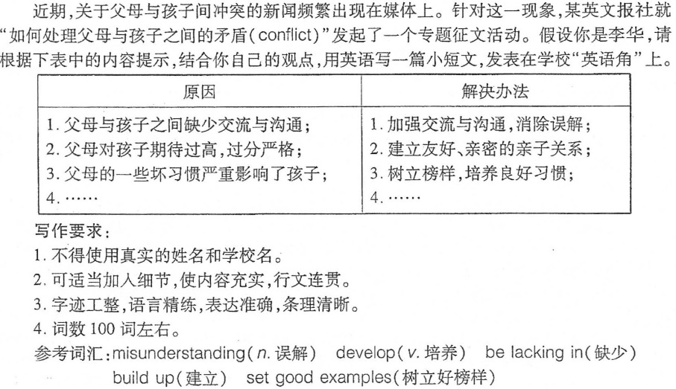
X.英语试卷（十）
One possible version:
Recently, news about the conflicts (n.矛盾，冲突) between parents and children frequently (adv.经常地，频繁地) appears in the media. Why are the relationships between parents and children becoming worse?
There are several reasons. First, parents and children are lacking in (缺乏) communication, which leads to misunderstandings. Second, some parents expect too much and are too strict with their children. Third, bad habits of parents may influence children negatively (adv.消极地).
To solve these problems, we should take action. Parents and children should communicate more to clear up misunderstandings. It is also important to build a close and friendly parent-child relationship. Parents should set good examples to help children develop good habits. If we understand and respect each other, our family life will be happier.

