感谢信模版
开头：点明写信目的
感谢谁(who) + 感谢什么事(what)
主体：具体感谢内容（2–3 点）
对方做了什么 + 带来什么帮助 + 你的感受
结尾：再次感谢 + 祝福 / 回报
表达感激 + 希望回报 / 保持联系
格式：书信规范
称呼、正文、结束语、署名
Dear ______（称呼，如 Teachers / Mom / Mr. Wang）,
1.开头（点明写信目的）
① How is your life / study / work recently? I’m writing this letter to express my sincere thanks for ______（原因，如 your endless /generous help and support /kindness and support over the past three years）.
2. 中间（困难+帮助+改变）
② Thanks to your help, I ______（成果，如 have made great progress and grown into a more confident person）. It’s because of your efforts that I could keep moving forward. (强调句）
First of all, you helped me ______（帮助一，如 with my English studies when I fell behind）. Whenever I met difficult grammar rules or couldn’t pronounce words correctly, you always spent extra time explaining them to me patiently, until I fully understood them.（让状）
Beyond that, you ______（帮助二，如 always encouraged me when I felt upset about my grades）. It’s just you that told me not to give up easily because mistakes are just chances to learn. Your words were like sunshine ,always giving me the courage to keep trying.(强调句）（比喻）
Most importantly, you ______（帮助三，如 taught me how to face challenges with a positive attitude）. You let me know that it’s okay to fail, as long as I keep working hard and never lose hope.
Without your help, I wouldn’t have ______（成果，如 become the confident student I am today or achieved such great progress）. All in all, I really appreciate your help.
3.结尾再次感谢+决心
③ Thank you again for what you have done. I hope to have the chance to express my thanks. I ______（感谢方式/决心，如 will keep your words in mind and strive for my dreams in the future）. I promise to work hard and never let you down. Looking forward to seeing you.
Yours,
______（署名，如 Li Hua / Li Ming）
一、开头表达感谢
1. I’m writing to show/ express / convey /extend my sincere/deepest thanks / gratitude/appreciation for your generous / kind / endless / selfless /generous help.
(support / encouragement / love/kindness / guidance)
我写这封信对你慷慨的/友善的/无尽的/无私的帮助/支持/鼓励/爱/指导，表达我的诚挚的感谢。
2. I’d like to take this opportunity to thank you for helping me with my English/ helping me in my school life.
我想借此机会感谢你在英语方面给予我的帮助/在我在校学期期间给予我的帮助。
3. I’d like to take this opportunity to express my great appreciation for your timely help.
我先给次机会表达你给与我的及时的帮助。
4. I’m extremely grateful for your great support/ for you selfless assistance during the four years/ during my stay here.
我非常感谢在四年的学习生活中给予我的支持/无私的帮助。
5. No words can describe my sincere thanks for you endless help.
言语难以表达我对你无尽的帮助的感谢。
- Words fail to express my thanks to you.
语言无法表达我对你的感谢。
7. On behalf of all the class, I would like to extend our deepest appreciation for your help.
我带表全班同学，对你的帮助表示深深的感谢。
- As a monitor,I’d like to take the opportunity/chance to thank all of you,my dear teachers.
作为班长，我想借此机会感谢各位亲爱的老师。
二、第二段提及对方的善举
1. Your generous support in...... has meant so much/a lot to me.
你在...方面的慷慨支持对我来说意义重大。
2. I truly appreciate the company and effort you put into my study life.
我非常感激你在我的学习生活中的付出的陪伴和努力。
3. Without your help, I would not have been able to get such success/ make great progress/ realize my dream.
若无你的帮助，我无法...
4. Many thanks for all the things you have done in helping us with/ do...
非常感谢你为了帮助我们.......中所做的一切。
5.Not only did you help me with…, but also you encouraged me to…
你不仅帮我……，还鼓励我……
- No matter when I felt stressed out,you always accompanied me in silence ,cheering me up gradually.
每当我倍感压力时，你总会默默陪伴，一点点使我振作起来。
- Whenever I had difficulty in studying,you were patient enough all the time to explain clearly until I understood completely.
每当我学习上遇到困难，你总是耐心地细致讲解，直到我完全弄懂为止。
- You’re like my mother to me,always caring for me.
于我而言，你就像妈妈一样，一直悉心照料着我。
- You’re like sunshine, bringing me warmth /warming me all the time.
您就像阳光，始终给予我温暖。
- Your encouraging words were like sunshine,cheering me up when I felt upset.
您鼓励的话语如同阳光，在我低落时让我重新振作。
- It is you who are like my mother to me,always caring for me.
正是您，待我如同母亲一般，一直悉心照料着我。
- It was your encouraging words that cheered me up when I felt upset.
在我心情低落时，正是您鼓励的话语让我重新振作。
13. It was your patience that helped me out of trouble.
正是您的耐心帮我走出困境。
14. It was your silent company that warmed my heart.
正是您默默的陪伴温暖了我的心。
- It was just your encouragement that helped me make greater progress in English.
正是您的鼓励，让我的英语取得了更大进步。
16. It's your patience that has improved my study a lot.
正是您的耐心，让我的学习进步很多。
17.You offered me plenty of useful advice, which was of great value to me.
您给了我许多有用的建议，这对我帮助极大。
18.It’s just your encouragement that has helped me make greater progress in English, which makes me more confident.
翻译：正是您的鼓励让我的英语取得长足进步，这也让我变得更加自信。
19.I cannot make greater progress without your patience and care.
我的进步也离不开您的耐心与关怀。
20.Without your help, I couldn’t have made such great progress.
没有您的帮助，我不会取得如此大的进步。
21.Without your encouragement and support,I can’t the person I am today/a better person.
没有您的鼓励与支持，就没有如今的我 / 我也无法成为更好的自己
三.结尾再次感谢+决心
- Once again, thank you so much for.......
I will be more than pleased if I have the opportunity to repay your kindness.
再次感谢你为我......。如果有机会报达你的好意,我会非常高兴。
2. Please accept my deepest / heartfelt gratitude/ thanks for doing me a favor.
请接受我对你的帮助的最深切的/ 真诚的感谢。
3. Thank you again for your generosity/ help / encouragement. I’m looking forward to staying in touch.
再次感谢你的慷慨/帮助/鼓励。希望我们多联系。
4. It was kind and generous of you to do this for me, and I appreciate it more than I can say.
你对我如此慷慨，我真是感激不尽。
5. In brief, I wish there were a better word than “thanks” to express my appreciation for your generous help.
总之，任何语言都无法表达我的真挚谢意。
- I’ll spare no effort to study ,making you proud of me/live up to your expectations.
My appreciation is beyond expression/description.
我定会全力以赴刻苦学习，不辜负您的期望。
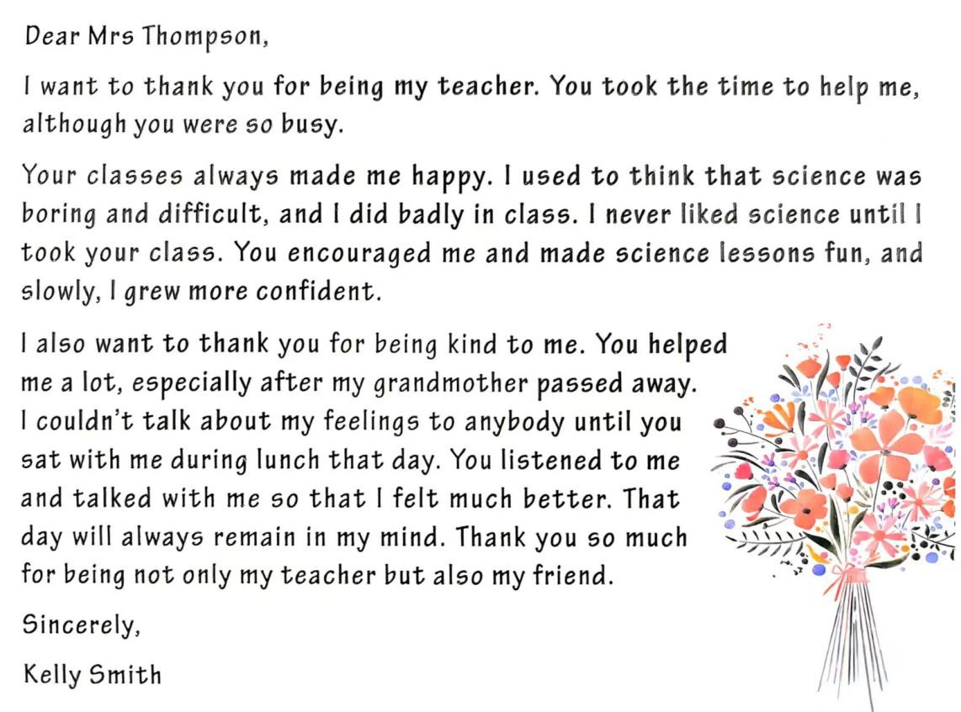
No words can hardly express how thankful I am.没有语言表达我多么感谢你。

假如你是李明。在学习生活中，你的英国笔友 Mike 在你的英语诸多方面给予你极大的帮助。根据提示用英文
写一封感谢信，表达你的感激之情。要点如下:
1. 考试失败有他的鼓励；
2. 练习口语有他的陪伴；
3. 英语写作有他的更正。
参考词汇: appreciation (n.感激), company (n.陪伴)
Dear Mike,
How is your life recently? I’m writing this letter to express my sincere gratitude for your endless help and support in my English study.
Thanks to your help, I have made great progress in English and become a more confident learner. It’s because of your constant support that I could keep moving forward on my English journey.First of all, you always encouraged me whenever I failed in English exams. I once felt upset and wanted to give up when I got bad grades. It was your warm words that cheered me up, which gave me great courage to face my mistakes bravely.Beyond that, you always stayed with me ,helping me practice my oral English. You kept talking with me patiently and corrected my pronunciation over and over again. Your quiet company made my practice less boring, which helped me speak English more fluently.Most importantly, you carefully corrected my mistakes in English writing. You pointed out my grammar problems and told me useful writing skills patiently. Without your careful correction, I couldn’t have improved my writing ability so quickly.
My gratitude is beyond words. Thank you again for what you have done for me. I will keep your kindness in mind and spare no effort to study English harder in the future. I promise I will never let you down. Looking forward to your reply.
Yours,
Li Ming

