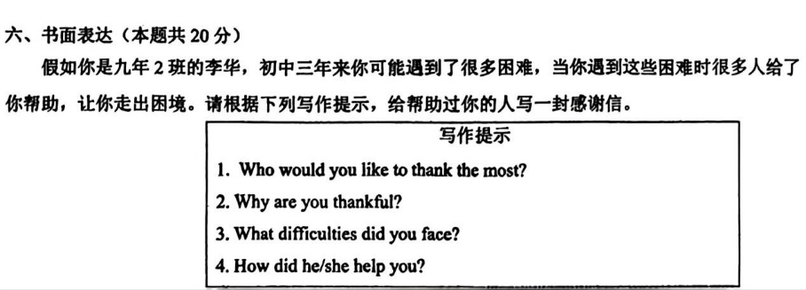
阿城区二模（2026.5.19）
优秀作文（感谢信）
Dear Li Nan,
I'm more than delighted to write this letter, expressing my sincere thanks for your help. During the last three years, you have been the person who helps most.
There are many unforgettable experiences between us, which I’ll keep in my mind. Whenever I think of the warmest moment, my mind will go back to those sweet days. Outgoing and warm-hearted, you were liked by all the classmates including me. I used to be a shy girl and had trouble communicating with others. It was you that reached out to me .You were always spending plenty of time accompanying me and sharing funny stories with me .At that time, you were like warm sunshine, making me no longer lonely. What touches me most is that I was absent from school because of a fever last year. Deeply worried about me, you came to my home with books right after school and devoted yourself to helping me keep up with my studies. Your cheerful smile left a lasting impression on me .Whenever hard times came, you were there all the time, bringing me endless warmth and courage.
My dear friend, thank you again for what you have done for me. No matter where we go in the future, you will be my best friend forever.
Best wishes!
Yours,
Li Hua
