**MLHW3 REPORT**

Team member:

0516061馬旭勃

0516047邱聖約

0516302[黃政鈺](https://www.facebook.com/rn100799)

0516057李晉廷

0516072洪立宇

*What Environments the members are using:

0516061: windows10 home ver : 17134.345

Python ver : 3.6.5 / C++:Dev-C++ 5.11 (gnu11)

Package : Pandas : 0.23.4

Scikit-learn : 0.20.0

Numpy : 1.14.6 + mk1

Matplotlib : 3.0.0

0516047:

System version : macOS 10.14(18A391)

Kernel version : Darwin 18.0.0

Python ver : 3.6.6 :: Anaconda custom (64-bit)

C++: gcc 5.4.0

Package : Scikit-learn : 0.19.1

Pandas : 0.23.3

Numpy : 1.14.5

Matplotlib : 3.0.0

0516057:

windows10 home ver :17134.345

Python ver : 3.5.4 / C++: Cygwin(gcc 6.4.0)

Package : Pandas : 0.23.4

Scikit-learn : 0.20.0

Numpy : 1.14.6 + mk1

Matplotlib :3.0.0

0516072:

System version : Ubuntu 18.04.1 LTS

Python ver : 3.6.6

Package : Pandas : 0.23.4

Scikit-learn : 0.0

Numpy : 1.15.2 + mk1

Matplotlib :3.0.0

0516302:

windows10 home ver :17134.345

Python ver : 3.6.5

Package : Pandas : 0.23.4

Scikit-learn : 0.20.0

Numpy : 1.15.2 + mk1

Matplotlib : 3.0.0

**every one uses MATLAB R2017b

*Visualization of all the features with the target

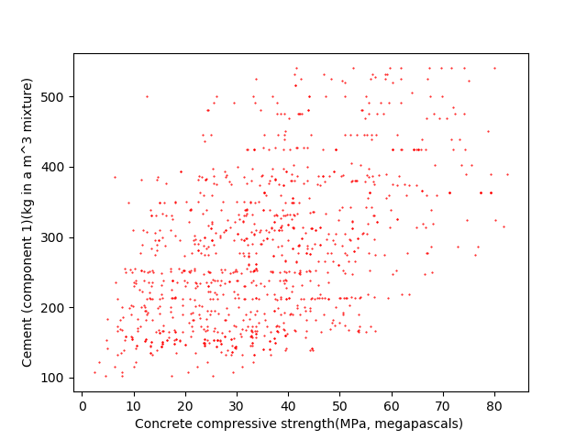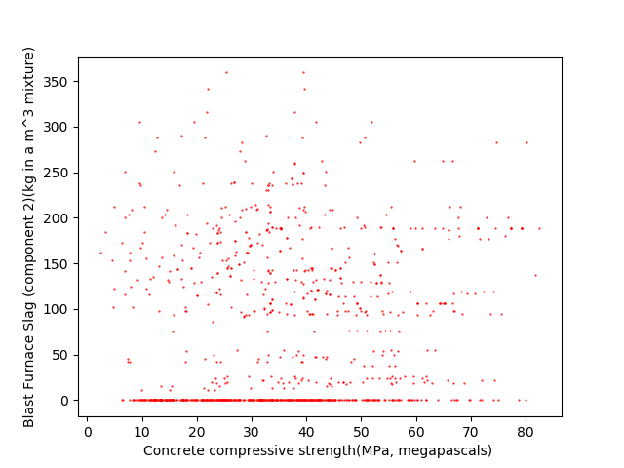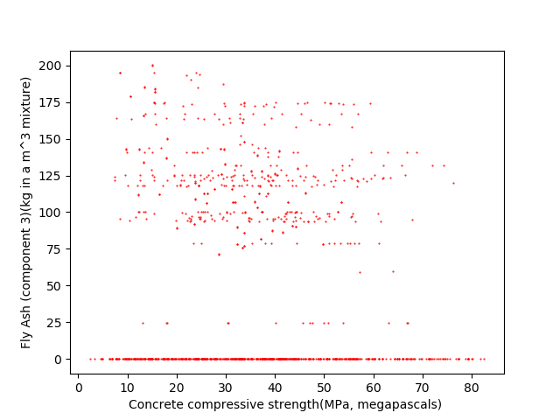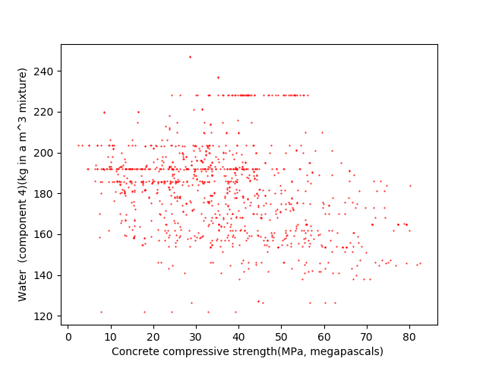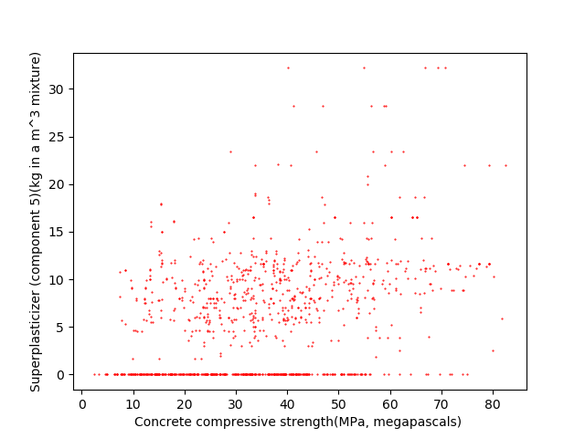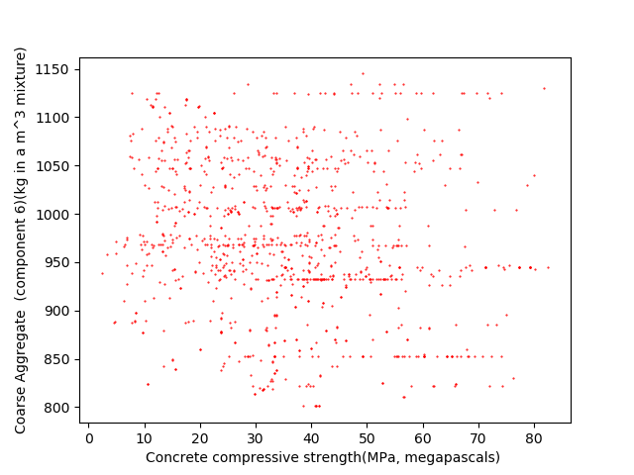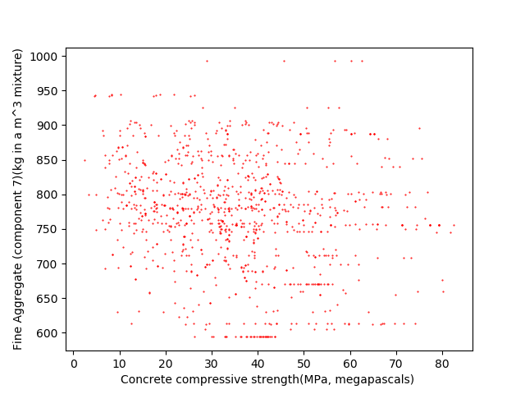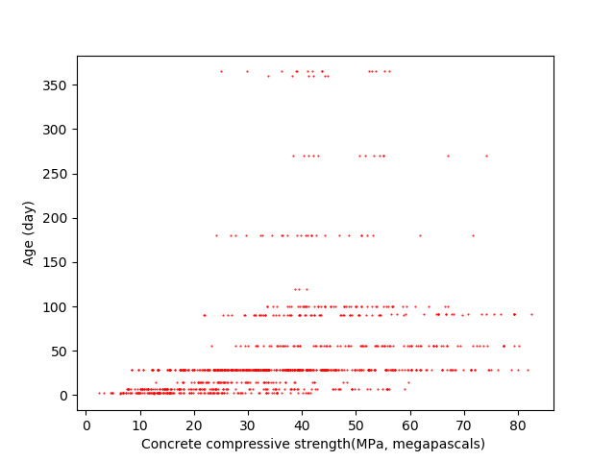

*The code, graph, r2_score, weight and bias for problem 1

