第六次实验报告

实验题目

要求采用三种不同的初始数据测试：1、基本无序。2、递增。3、递减。

测试比较各种排序算法。测试数据一般在5000-10000之间，以保证测试时间足够大，测试每种算法的执行时间并对结果进行分析。

实验过程

1. 使用生成器生成三种序列。
2. 应用各种算法，并使用clock进行时间分析。

效果截图

test size:6000

*random asc desc

bubble 165 92 116

insert 31 6 59

select 62 60 59

quick 1 2 1

rx 1 0 0

heap 1 1 1

test size:10000

*random asc desc

bubble 417 280 368

insert 86 11 154

select 168 161 156

quick 1 3 2

rx 0 0 0

heap 3 2 1

test size:14000

*random asc desc

bubble 812 468 625

insert 162 19 298

select 310 308 302

quick 2 5 3

rx 1 1 1

heap 3 3 3

test size:18000

*random asc desc

bubble 1324 768 1017

insert 262 33 489

select 530 516 510

quick 2 7 4

rx 1 2 1

heap 4 4 4

test size:22000

*random asc desc

bubble 1983 1136 1523

insert 390 48 728

select 774 766 767

quick 4 9 4

rx 1 1 2

heap 6 5 4

test size:26000

*random asc desc

bubble 2809 1593 2124

insert 543 69 1010

select 1096 1068 1069

quick 5 12 5

rx 2 2 1

heap 6 5 5

test size:30000

*random asc desc

bubble 3725 2116 2822

insert 720 90 1344

select 1437 1420 1451

quick 5 10 7

rx 1 2 2

heap 8 7 6

test size:34000

*random asc desc

bubble 5182 2777 3884

insert 966 118 1830

select 1912 1860 1888

quick 6 16 6

rx 2 2 2

heap 8 8 7

test size:38000

*random asc desc

bubble 6113 3425 4562

insert 1159 145 2169

select 2319 2275 2333

quick 7 17 8

rx 2 2 2

heap 10 9 8

test size:42000

*random asc desc

bubble 7328 4156 5575

insert 1417 179 2653

select 2827 2763 2795

quick 7 18 14

rx 3 3 3

heap 11 9 9

test size:46000

*random asc desc

bubble 8764 4986 6678

insert 1691 207 3184

select 3373 3307 3352

quick 8 17 9

rx 2 3 3

heap 12 10 10

test size:50000

*random asc desc

bubble 10441 5901 7899

insert 2017 253 3819

select 3994 3932 3991

quick 8 23 10

rx 3 3 3

heap 13 11 10

test size:54000

*random asc desc

bubble 12141 6882 9428

insert 2443 291 4383

select 4642 4580 4603

quick 9 23 15

rx 3 3 3

heap 14 12 11

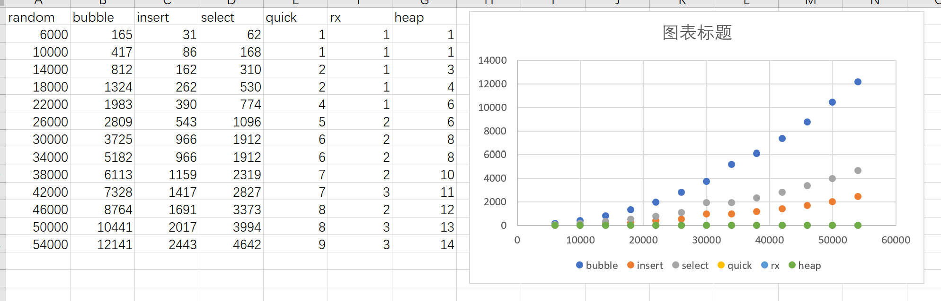

如图分析，冒牌排序，插入排序，选择排序都比较满，且呈现明显的*O*(*n*2)的指数上升的趋势。

代码

main.cpp

#include <iostream>

#include <ctime>

#include <sys/utime.h>

#include "sorthelper.h"

#include "msort.h"

using namespace std;

int main() {

for(int i = 6000; i < 55000; i+= 4000){

test_a_size(i);

cout << endl;

}

}

sorthelper.h

*//*

*// Created by cht on 2019/12/18.*

*//*

#pragma once

#include <random>

#include <ctime>

#include "msort.h"

#include <iostream>

#include <iomanip>

using namespace std;

enum class sort_type{

bubble,

insert,

select,

quick,

rx,

heap

};

using namespace std;

default_random_engine e;

int rand_int(int start, int end){

uniform_int_distribution<unsigned> u(start, end -1);

return u(e);

}

void build_data(int* a,int length, int way){

*//int length = 200;*

int max_n = 10000;

if(way == 0){ *//random generate*

for(int i = 0; i < length; ++i){

a[i] = rand_int(0,max_n);

}

} else {

double step = max_n / (double)length;

if(way == 1){

for(int i = 0; i < length; ++i){

a[i] = (int)( i * step);

}

} else {

for(int i = 0; i < length; ++i){

a[i] = (int)( (length - 1 - i) * step);

}

}

int swap_count = length / 20;

for(int i = 0; i< swap_count; ++i){

int swap_i = rand_int(0, length);

int swap_j = rand_int(0, length);

swap(a[swap_i], a[swap_j]);

}

}

}

long test_sort(int* a ,int length, sort_type type){

clock_t start = clock();

if(type == sort_type::bubble){

m_bubble_sort(a, a + length);

} else if(type == sort_type::select){

m_select_sort(a, a + length);

} else if(type == sort_type::insert){

m_insert_sort(a, a + length);

} else if(type == sort_type::quick){

m_quick_sort(a, a + length);

} else if(type == sort_type::rx){

m_rx_sort(a, a + length, 4);

} else {

m_heap_sort(a, a + length);

}

clock_t end = clock();

return end-start;

}

void test_a_size(int size){

int column_size = 6;

cout << "test size:" << size << endl;

cout << setw(column_size) << "*" << setw(column_size) << "random"

<< setw(column_size) << "asc" << setw(column_size) << "desc" << endl;

sort_type st[] = {sort_type::bubble, sort_type::insert, sort_type::select,

sort_type::quick, sort_type::rx, sort_type::heap};

string sn[] = {"bubble","insert","select","quick","rx","heap"};

for(int i = 0; i < 6; i++){

int* random_data = new int[size];

int* asc_data = new int[size];

int* des_data = new int[size];

build_data(random_data, size, 0);

build_data(asc_data, size, 1);

build_data(des_data, size, 2);

cout << setw(column_size) << sn[i];

cout << setw(column_size) << test_sort(random_data, size, st[i]);

cout << setw(column_size) << test_sort(asc_data, size, st[i]);

cout << setw(column_size) << test_sort(des_data, size, st[i]);

cout << endl;

delete[] random_data;

delete[] asc_data;

delete[] des_data;

}

}

msort.h

*//*

*// Created by cht on 2019/12/18.*

*//*

#pragma once

void m_swap(int* first, int* second){

int temp = *first;

*first = *second;

*second = temp;

}

bool compare(int first, int second, int direction = 0){

if(direction >= 0 && first > second)

return true;

if(direction < 0 && first < second)

return true;

return false;

}

void m_bubble_sort(int* start, int* end, int direction = 0){

for(int* pi = start; pi < end - 1 ; ++pi){

for(int* pj = end - 1; pj > pi; --pj){

if(compare(*(pj - 1),*pj, direction))

m_swap(pj - 1, pj);

}

}

}

void m_select_sort(int* start, int* end, int direction = 0){

for(int* pi = start; pi < end - 1; ++pi){

int* temp = pi;

for(int* pj = pi + 1; pj < end; ++pj){

if(compare(*temp, *pj))

temp = pj;

}

m_swap(pi, temp);

}

}

void m_insert_sort(int* start, int* end, int direction = 0){

for(int* pi = start + 1; pi < end; ++pi){

int temp = *pi;

int* pj = pi;

for(pj = pi; pj >= start; pj--){

if(compare (*(pj-1), temp) )

*pj = *(pj-1);

else

break;

}

*(pj) = temp;

}

}

int* quick_v(int* start, int* end, int direction = 0){

int temp = *start;

while(start < end){

while(start < end && !compare(temp,*end)){

end--;

}

*start = *end;

while(start < end && !compare(*start, temp)){

start++;

}

*end = *start;

}

*start = temp;

return start;

}

void _m_quick_sort(int* start, int* end, int direction = 0){

if(start < end){

int* middle = quick_v(start, end, direction);

_m_quick_sort(start, middle-1 ,direction);

_m_quick_sort(middle+1, end, direction);

}

}

void m_quick_sort(int* start, int* end, int direction = 0){

_m_quick_sort(start, end-1);

}

void adjust_heap(int* a, int node, int size){

int left = 2*node + 1;

int right = 2*node +2;

int max = node;

if(left < size && a[left] > a[max])

max = left;

if(right < size && a[right] > a[max])

max = right;

if(max != node){

m_swap(a+max,a+node);

adjust_heap(a, max, size);

}

}

void m_heap_sort(int* start, int* end, int direction = 0){

int len = end - start;

for(int i = len/2 - 1; i >= 0; --i)

adjust_heap(start, i, len);

for(int i = len-1; i >= 0; --i){

m_swap(start, start+i);

adjust_heap(start, 0, i);

}

}

void m_rx_sort(int* start, int* end, int d){

int k = 10;

int length = end - start;

int* counts = new int[k];

int* temp = new int[length];

int index;

int pval = 1;

for(int i = 0 ;i < d; i++){

for (int j = 0; j < k; ++j)

counts[j] = 0;

for(int*p = start; p < end; ++p){

index = (*p / pval) % k;

counts[index]++;

}

for(int j = 1; j < k;++j){

counts[j] += counts[j-1];

}

for(int*p = end-1; p >= start;--p){

index = (*p / pval) % k;

temp[counts[index] - 1] = *p;

counts[index]--;

}

for(int *p =start; p < end; ++p) {

*p = temp[p - start];

}

pval*= k;

}

delete[] counts;

delete[] temp;

}