# SOIL PRISM

***A Report submitted in partial fulfillment for***

**HACKATHON - 2021**

***By***

**SRILEKHA NAMPELLI (190330231)**

**AKULA SAI SINDHU SIVA MYTHILI (190330013)**

**MEDCHAL MOUNI (190330154)**

**RAGAM SAI PRASHANTH KARTIK (190330190)**

**V SAI KALYAN (190330297)**

pursued in

**Department of Computer Science and Engineering**



**Aziznagar, Moinabad Road, Near TS Police Academy,**

**Hyderabad, Telangana-500075, India.**

**APRIL, 2021**

# CERTIFICATE

This is to certify that the project report entitled **Soil Prism** submitted by ***SRILEKHA NAMPELLI (190330231), AKULA SAI SINDHU SIVA MYTHILI(190330013), MEDCHAL MOUNI (190330154), RAGAM SAI PRASHANTH KARTIK (190330190), V SAI KALYAN (190330297)*** to the KL University Hyderabad Campus, in partial fulfillment for the Course DATASCIENCE, of the degree of **B. Tech in Computer Science and Engineering** is a bonafiderecord of project work carried out by him/her under my/our supervision. The contents of this report, in full or in parts, have not been submitted to any other Institution or University for the award of any degree or diploma.

<Signature> <Signature>

<Name of the supervisor> <Name of the Course Co-Ordinator> Supervisor Course Co-Ordinator

Counter signature of HOD with seal

# DECLARATION

I declare that this project report titled **SOIL PRISM** submitted in partial fulfillment of the Course DATASCIENCE of **B. Tech in Computer Science and Engineering,** is a record of original work carried out by me under the supervision of <**Name(s) of the Supervisor(s)>**, and has not formed the basis for the award of any other degree or diploma, in this or any other Institution or University. In keeping with the ethical practice in reporting scientific information, due acknowledgements have been made wherever the findings of others have been cited.

#### 

#### <Signature>

SRILEKHA NAMPELLI (190330231)

A SAI SINDHU SIVA MYTHILI (190330013)

MEDCHAL MOUNI (190330154)

RAGAM SAI PRASHANTH KARTIK (190330190)

V SAI KALYAN (190330297)

*April 2021*

# ACKNOWLEDGMENTS

Before getting into the thickest of things, we would like to thank the personalities who were part of my project in numerous ways, those who gave me outstanding support from birth of the project.

We are extremely thankful to our beloved management providing necessary infrastructure and resources for the accomplishment of our project at **KLH, Hyderabad.**

We are highly indebted to Dr. L. Koteswara Rao, Principal **of KLH, Hyderabad,** for his support during the tenure of the project.

We are very much obliged to our beloved **Dr. E. Anupriya, Head of the Department of Computer Science & Engineering,** KLH, for providing the opportunity to undertake this project and encouragement in completion of this project.

We hereby wish to express our deep sense of gratitude to **<Supervisor Name>,** Department of Computer Science and Engineering, KLH, for the esteemed guidance, moral support and invaluable advice provided by him for the success of the project.

We are also thankful to all the staff members of Computer Science and Engineering department who have cooperated in making our project a success. We would like to thank all our parents and friends who extended their help, encouragement and moral support to complete our project work.

Thanks for Your Valuable Guidance and kind support.

SRILEKHA NAMPELLI (190330231)

AKULA SAI SINDHU SIVA MYTHILI (190330013)

MEDCHAL MOUNI (190330154)

RAGAM SAI PRASHANTH KARTIK (190330190)

V SAI KALYAN (190330297)

# ABSTRACT

Soil is a critical part of successful agriculture and is the original source of the nutrients that we use to grow crops. The nutrients move from the soil into plants that we eat.  In the end, we benefit from healthy soil. We developed our project to solve soil cultivation and yield increase per hectare for farmers using technology by implementing various modules:

* Soil
* Crops
* Show Data Info
* Book Help

Our main concept is to give best & quick result to user.

# CONTENTS

1. Cover Page
2. Certificate
3. Declaration
4. Acknowledgments
5. Abstract
6. Introduction

* Reasons for soil cultivation
* Methods of cultivation

1. Modules
2. Requirements
3. Literature Survey
4. UML Diagrams
   * + Use case Diagram
     + Class Diagram
5. Approaches to solve the problem
6. Datasets and Discussion
7. Implementation codes and outputs
8. Output on Web Application
9. Analysis
10. Conclusion
11. References

# INTRODUCTION

Soil cultivation is any process that re-arranges the soil by using some activity. For farmers, cultivation typically means running a tractor over their field with a plow or disc to break up the soil's surface. This is done prior to planting. In the landscape, garden or lawn, we do the same thing. For small gardens this is usually done by hand with a shovel or fork. A Good care also has to be taken not to over-cultivate the soil. Several bad things happen when we over-cultivate. Cultivation disrupts the soil natural structure. Extreme cultivation as is done with a roto-tiller, pulverizes the soil's structure in such a way that it may become even more compacted in a short period of time. Cultivation also brings weed seeds to the surface that may become a problem. Extreme cultivation also destroys earthworm

population.

**REASONS FOR SOIL CULTIVATION:**

* Soils under adverse conditions may become compacted, that is, the soil loses its structure. The little pockets of air beneath the surface are squeezed together. Water and nutrients no longer move through the soil. It becomes more difficult for roots to grow.
* Ideally, when we cultivate the soil, additional soil amendments should be added and incorporated into the cultivated soil. This will help keep the soil healthy and loose and less likely to become compacted as quickly if no additional amendments are added.

**METHODS OF CULTIVATION:**

* **Aerating:** When the soil underneath your lawn becomes compacted, it reduces root growth as well as the grasses' recuperative ability, thus increasing a lawn's relative susceptibility to diseases. Aeration improves shoot and root growth and recuperative ability, and decrease the likelihood of disease and insect damage.
* **Basic digging:** Basic digging is just lifting a shovel full of dirt, turning it over and chopping it up. Once the soil is turned over, soil amendments such as organic matter can be incorporated into the turned-over soil. One variation of digging is to use a fork. This is especially good for extremely rocky or mostly clay soils.
* **Single digging:** When using a shovel or fork, there are a couple of techniques to efficiently work through the task. Single digging is a process efficiently covering the area to a uniform standard. It's really very simple: mentally divide the area into strips. Dig a small trench (about 12" wide, and a spade’s depth). Place the soil to one side, leaving the trench empty. Next, move to the next strip adjoining the first dug out trench. Lift the same amount of soil from this strip, and drop it back into the original trench, breaking up the clumps as you go. Continue on with this lift and move process until the entire area has been worked. At the end, the final trench is filled with the soil that left from the first trench. As much as possible avoid walking on the newly turned soil. Once the entire area has been turned, add soil amendments evenly over the entire area and using a fork, work this organic matter into the soil.
* **Double digging:** This follows the same method as single digging, but after removing each trench, the soil below is turned before filling back up with soil from the next strip. This process cultivates the subsoil area as well as the topsoil, but without mixing the 2 different soil-types together. If organic matter is routinely added each year, you may want to mix the two soil types together creating an even deeper topsoil layer.
* **Surface cultivation:** For soils that are not compacted, without problem weeds, and which already have good organic matter, shallow cultivation may be enough. This is the ideal method to use and the ultimate goal you'll be trying to achieve after using any of the digging processes. Surface cultivation is using a tined-rake, or hoe and doesn't disturb the soil's structure below about 2 - 3" deep.
* **When not to dig:** Never dig when the soil is overly moist as this can damage the soil's structure. Roto-tilling the soil every year will create a smeared, impermeable hard pan just below the depth of the roto-tiller's tines. Deep roto-tilling annually, in the long term, ruins the soil's structure and should be avoided. It is better to do a one-time deep roto-tilling, incorporate organic matter, till that in and then plant. In following years, only do a surface tilling.
* **The ‘no-dig’ approach:** On soils with good soil structure and adequate organic matter already incorporated, digging is often not necessary. Mulching over the soil in layers of organic matter to a depth of 3" — 6" should be sufficient to maintain a healthy, organic-rich top-soil. The deeper the mulch, the better it will keep down weeds. At planting time, the mulch is raked away for planting and seed sowing. Slugs can be a problem in damp mulches.

# MODULES

* **Soil:** This module consists of various types of cultivation techniques suitable for different types of soils and allows a user to book an appointment for soil testing.
* **Crops:** This module contains details and suggestions to increase yield related to every individual crop type.
* **Location Based Reduction:** This module helps a user to simply enter their location (state) and get information on which crops are more preferable in that area based on previous crop production and crop cultivation from datasets.
* **Book Help:** This module is used to book an appointment from expert soil cultivation groups to help for specific crops.

# REQUIREMENTS

Software:

* + Python
  + PyCharm IDE with pandas, sqlite and django packages
  + Web browser (Chrome)

Hardware:

* + RAM (2-4 GB)
  + HARDISK (10GB)
  + PROCESSOR 2.0 GHz

# LITREATURE SURVEY

The goal of soil quality research is to learn to manage soil for long term productivity and environmental integrity. Soil scientists have extensively examined characteristics such as organic matter, erosion rates, and nutrient availability. Focusing on soil quality has added a focus on the dynamic and biological character of soil. This means assessing soil processes such as nutrient and water cycling for clues about short- and long-term soil function.

The current discussion of soil quality is distinguished from previous soil assessment efforts by its attention to the dynamic soil characteristics that are affected by management choices. It is distinguished by focusing not just on characteristics such as nitrogen, phosphorous, potassium, and total organic matter levels, but also focuses on overall soil biological activity, organic matter fractions, water infiltration, and structural aggregation. In addition to crop production, the current soil quality discussion has considered soil functions such as management of water flow and the filtering and buffering of environmentally active substances. This discussion does not define soil quality only by the absence of degradation such as erosion, but by its fitness or ability to perform desired functions. The characteristics that define a high quality soil depend on the inherent features of the soil, landscape, climate, and land use. But there are some general features that most authors imply are necessary for a soil to be described as healthy or of high quality.

Quality soil will produce healthy crops over the long-term without increasing levels of inputs. It will control water flow and will filter and degrade potential environmental contaminants. Healthy soil is buffered against wide swings in temperature, moisture and other environmental conditions. This buffering capacity will be reflected in low levels of pest outbreaks and relatively stable production levels.

The first rule in interpreting the measurements of soil quality is to recognize the complexity of the soil system. This means that no single characteristic of soil tells its story. Understanding the quality of soil requires several kinds of observations, at several places, at several points in time, in which particular observations, places, and times depend on the type of soil.

The second rule in interpreting soil observations is to recognize the scale of the measurement, the scale of the process related to that soil characteristic, and the scale at which solutions should be attempted. For example, a regional monitoring program needs to track long-term trends in overall soil function, while a farmer needs guidance for this season’s production decisions. The kind of measurements that give a picture of the region’s soil resources, do not necessarily inform local management.

# UML DIAGRAMS

**USE CASE DIAGRAM:**

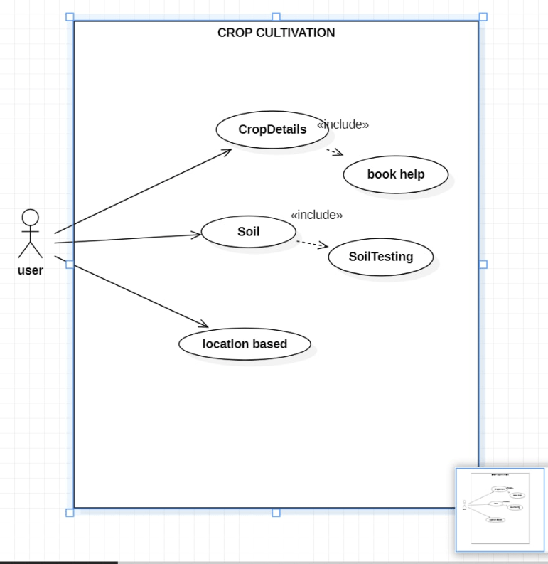

**CLASS DIAGRAM:**

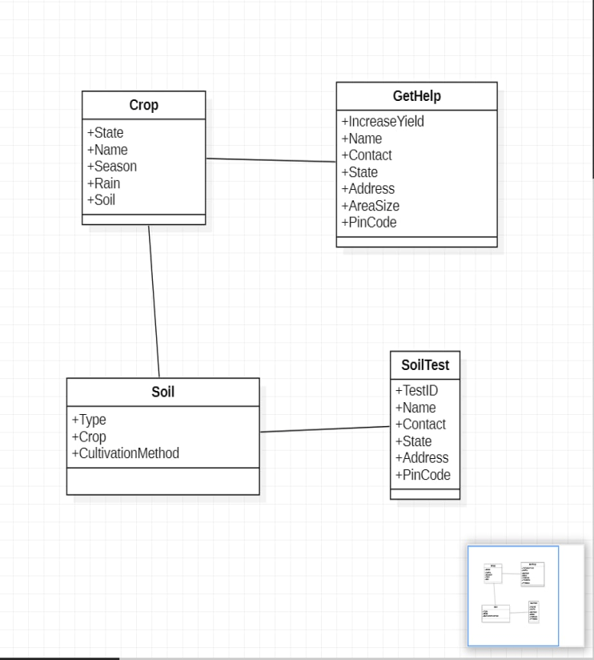

# APPROCHES TO SOLVE THE PROBLEM

* **Soil Testing:**

This is a way in which a user can book an appointment from the website without any login/signup complications by simply filling a form containing – name, contact, address, and state. The person, who is appointed, goes and takes a sample of the soil and returns back a simple suggestion report which consists of the soil type, nutrient content, and best suited crops and fertilizers for the soil.

All the reports will be lab tested and highly reliable as they are produced by considering various factors like nutrients which the tested soil is deficient or rich in, the average temperature of the region, humidity, average rainfall, soil fertility state, etc.

* **Book Help:**

A user, after doing his/her research about a particular crop has an option to book for more help for soil cultivation techniques from experts.

The user, by entering only the details – name, contact, state, address, pin code and area size, will be able to receive help from other end.

The professionals first investigate the soil of the land and apply soil cultivation techniques accordingly.

* **Showing Reduced Information Based on Selection:**

A user has the provision to check concise information of his particular selection. If he chooses a state, data based on crops best grown in that area is displayed. If he chooses a crop, data based on which location and season it grows best in is shown. If he chooses season, the data based on which crop grows best in that season is displayed. The other option is to check the soil, selecting a type of soil will give the user a list of crops which favor to the selected soil.

# DATASETS AND DISCUSSIONS

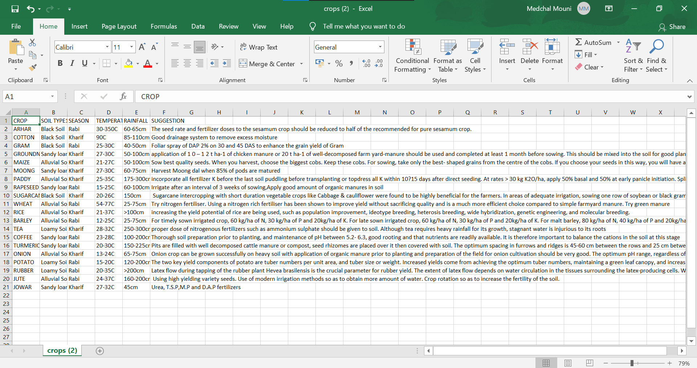

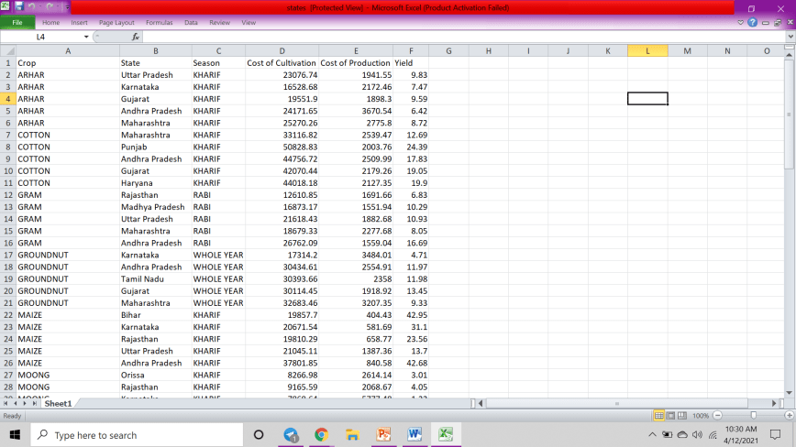

# IMPLEMENTATION CODES AND OUTPUTS



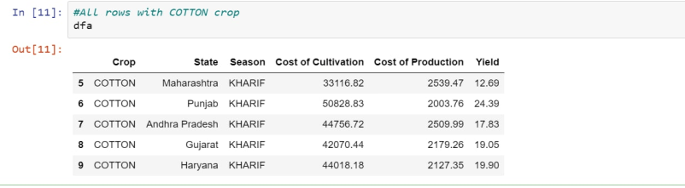

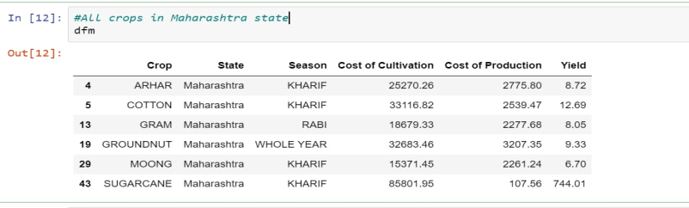

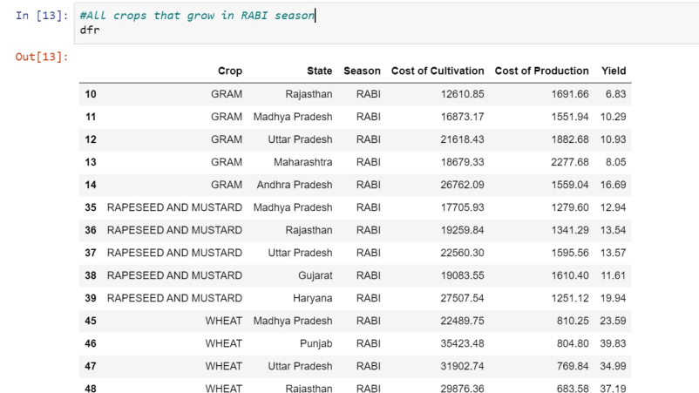

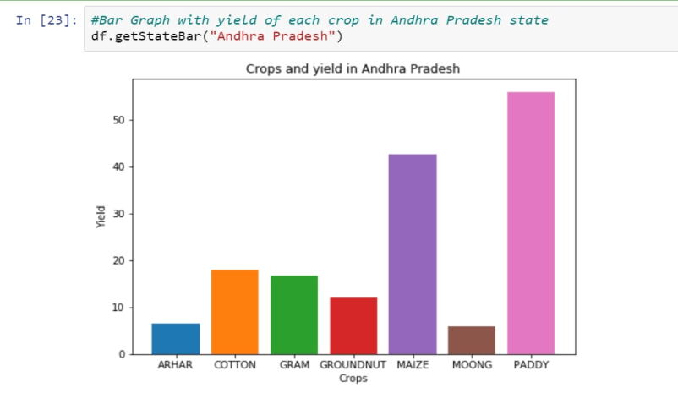

# OUTPUT ON THE WEB APPLICATION

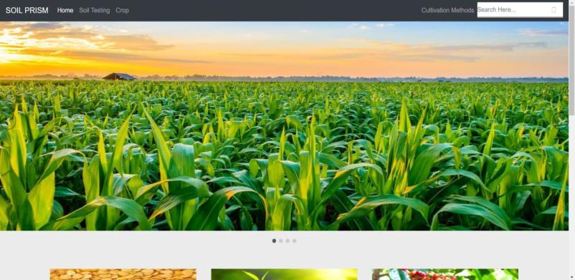

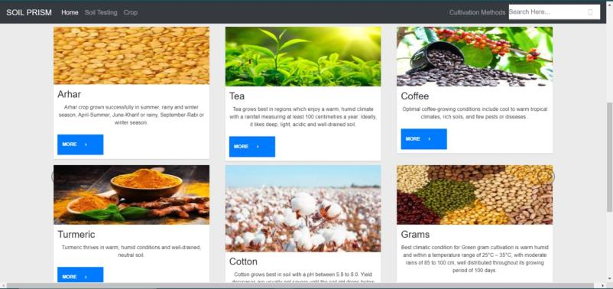

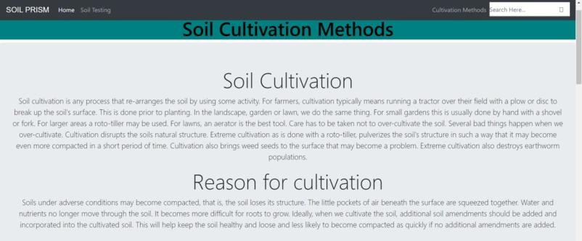



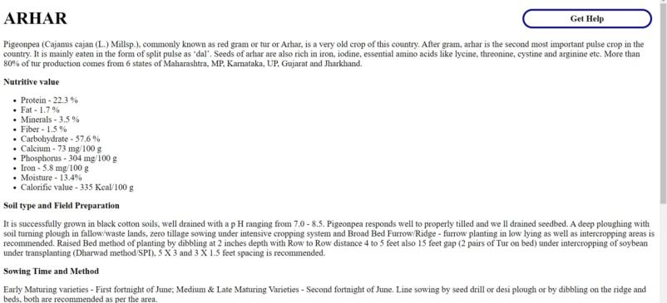

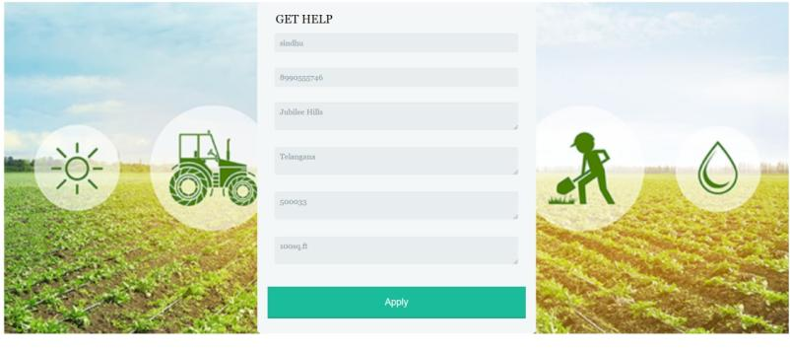



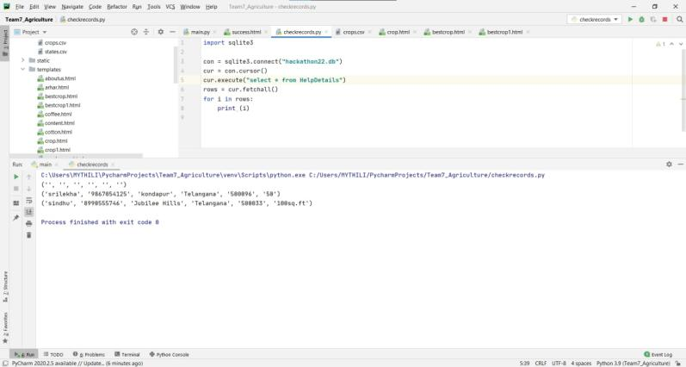

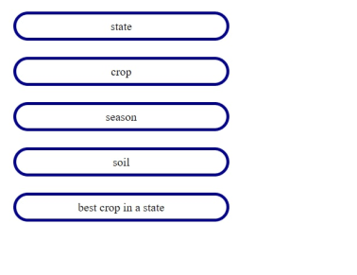



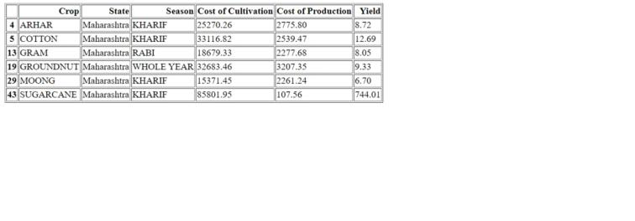

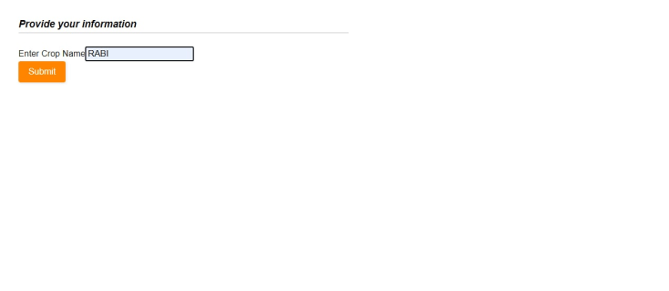

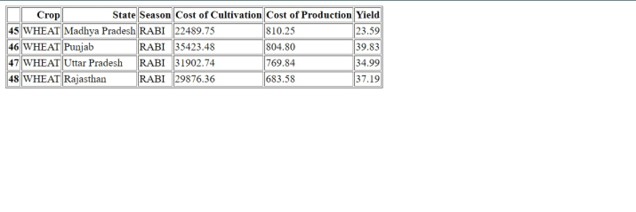

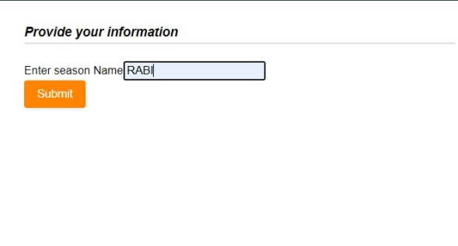

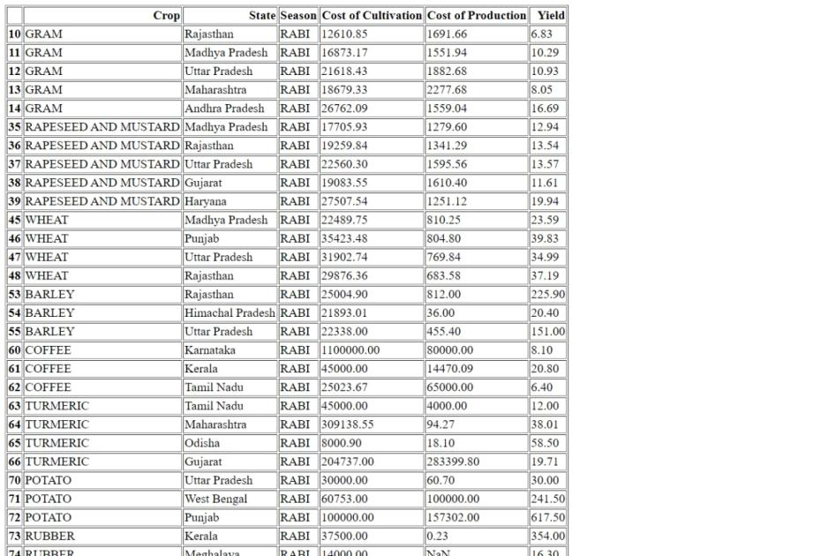

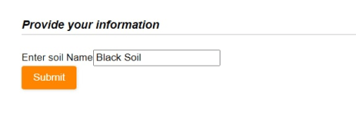

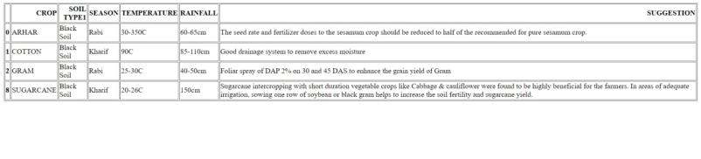



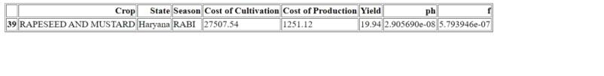



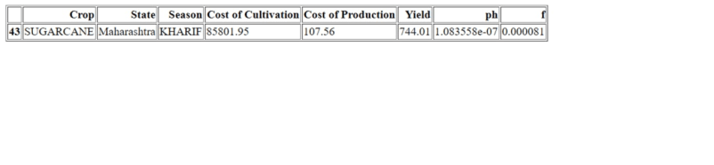

Git Upload



# ANALYSIS

Here, two datasets are used. One showing which states grows which crop, in which season, crop production and crop cultivation.

The second, containing the individual properties of different crops.

A user has the provision to check concise information of his particular selection.

If he chooses a state, data based on crops best grown in that area is displayed.

If he chooses a crop, data based on which location and season it grows best in is shown.

If he chooses season, the data based on which crop grows best in that season is displayed.

The other option is to check the soil, selecting a type of soil will give the user a list of crops which favor to the selected soil.

This is helping the user to advise which crop to grow based on location, soil, season etc. For any crop chosen, measures to ensure optimum yield is shown, as well as the best crop to grow in a state is also calculated.

Soil testing and expertized soil cultivation methods can be implemented with a simple appointment.

# CONCLUSION

With this web application, a user is able to conveniently get the fertility of their land’s soil tested and receive a response document consisting of the recommended crop, fertilizer, soil cultivation technique favorable for increase in yield production.

A user is also able to get the support of a team of experts in soil cultivation by just one appointment thereby keeping the fertility of the soil stable for increase in production.

# REFERENCES

<https://eos.com/blog/crop-yield-increase/>

<https://www.kaggle.com/srinivas1/agricuture-crops-production-in-india>

<https://vikaspedia.in/agriculture/crop-production/package-of-practices/pulses/pigeon-pea>

<https://vikaspedia.in/agriculture/crop-production/package-of-practices/plantation-crops/coffee>

<https://vikaspedia.in/agriculture/crop-production/package-of-practices/vegetables-1/onion-allium-cepa>

<https://vikaspedia.in/agriculture/crop-production/package-of-practices/commercial-crops/cotton>

<http://www.landscape-america.com/landscapes/soil/cultivation.html#:~:text=Soil%20cultivation%20is%20any%20process,we%20do%20the%20same%20thing>.

<https://vikaspedia.in/agriculture/crop-production/package-of-practices/spices/turmeric>

<https://vikaspedia.in/agriculture/crop-production/package-of-practices/vegetables-1/potato>