II-CSE-A



INTELLIGENT

HOSPITAL SYSTEM

DONE BY: SARVESH (190330218), R PRASHANTH (190330190), SRILEKHA N (190330231)

COURSE INSTRUCTORS: Dr. Jyothsna Datti, Dr. Yellaswamy K

II-CSE-A

EP-PROJECT

## PROBLEM STATEMENT:

It is very important for a hospital to maintain efficient software to handle information of a particular patient, nurse, doctor, etc. Patients visit the hospital many number of times and return without any progress in the cure of their problem. Too much paperwork makes it hard to keep track of patients past treatments/medicines. It is difficult to trace problems based on symptoms that keep changing from person to person, and hence takes time for the doctor to detect and confirm a disease.

The existing systems provide the basic functionalities needed to be handled in a hospital management environment. There is no intelligence of the software in such cases. In the existing system, all the patient details, doctor availability details, tests, prescriptions made by the doctor, all are maintained manually by the receptionist. There is also no proper technique to check the patient information and medical history.

**HARDWARE REQUIREMENT**

Client side:

RAM 2-4 GB

Hard disk 10 GB

Processor 2.0 GHz

Server Side:

RAM 2-4 GB

Hard disk 20 GB

Processor 2.0 GHz

**SOFTWARE REQUIREMENT**

Client side:

Web Browser Google, Mozilla Firefox etc.

Server side: Tomcat server

Web Server Database Server MySql

Other Softwares Eclipse, Mysql-Workbench , Java

## USER STORIES:

* Maintaining paperwork of previous medical history is difficult.
* Many visits to the doctor are wasted just to wait, and being unattended at the end.
* Prediction of a disease takes longer time and many tests.
* Mistakes are more likely to happen by entering in softcopies.
* Only receptionist taking care of multiple duties of registering the patient as well as entering patient test results leads to clumsiness.
* Frequency of visits to the doctor, or urgency of tests and results should be scheduled and planned based on seriousness of disease and not have delays.

## WHAT DOES THE INTELLIGENT HOSPITAL SYSTEM DO?

It is an application which is developed to retrieve a patient’s details easily. In this application, nurse directly collects all the information of the patient regarding the disease like patient name, age, gender, B.P, weight, blood test, urine test, and description/symptoms of the disease.

Doctor can easily analyze the disease of the patient easily with this information. He/she can study the symptoms and suggest the cure or medication to the disease easily. Depending on the study, required medicines or treatment is prescribed to the patient. When any new symptom is found common in a number of patients for a same disease, the symptom can be added to the disease module making it easier to detect the disease for any other next patient.

## WHY THIS SYSTEM?

* + Improved Processes**:** Automation is one of the main benefits here. It helps to optimize the user experience. Medical specialists, nurses, and hospital authorities can interact online.
  + Digital medical records: The hospital database includes all the necessary patient data. The disease history, test results, prescribed treatment can be accessed by doctors without much delay in order to make an accurate diagnosis and monitor the patient’s health. It enables lower risks of mistakes.
  + Staff interaction**:** They do not need to make special requests and wait for a long time for an answer. Each specialist will be in charge of certain process stage and can share outcomes with colleagues just in one click.
  + Facility management**:** Hospitals authorities are able to manage their available resources, analyze staff work, reduce the equipment downtime, optimize the supply chain, etc. Another fact to mention is that hospital staff deal with the digital data instead of endless paperwork.
  + Less time consuming**:** As the services and interactions are improved in all possible ways, everything is being planned with greater precision. It

saves the time of all the system users and provides them with up-to- date information.

## MODULES:

* + Doctor Module: Doctor can register by entering the information. He/she can login by entering the unique username and password. Doctor can view patient details, search the disease by selecting the symptoms and update any symptoms to the disease module if necessary.
  + Nurse Module: Nurse can register by entering the information. He/she can login by entering the unique username and password. The nurses enter a patient’s test results and reports to carry forward to the doctor for examination.
  + Staff Management/Receptionist Module**:** This module provides the human resources administration. It updates the job description of employees, updates the hospital structure, tracks the recruiting records of patients, their medical history, nurses and doctors.
  + Patient Module:-This module gives the detail of patient by receptionist. This module contains id, appointment, symptoms of the patient with can be viewed by doctor and nurse
  + Disease Module: This module contains the list of drugs that is usually used for the specific treatment. It keeps records of diseases and it’s symptoms for the doctor to easily identify the problem and provide according prescriptions.

.

# CLASS DIAGRAM:

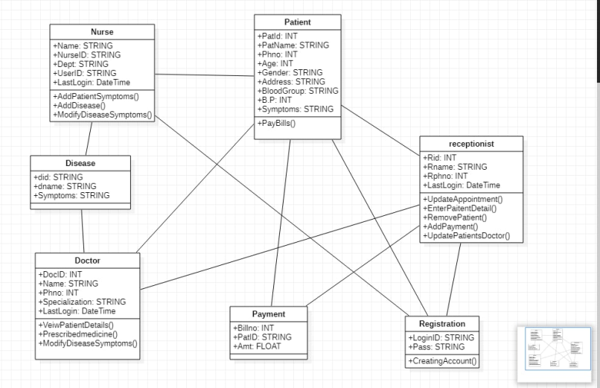

**USE CASE DIAGRAM:**

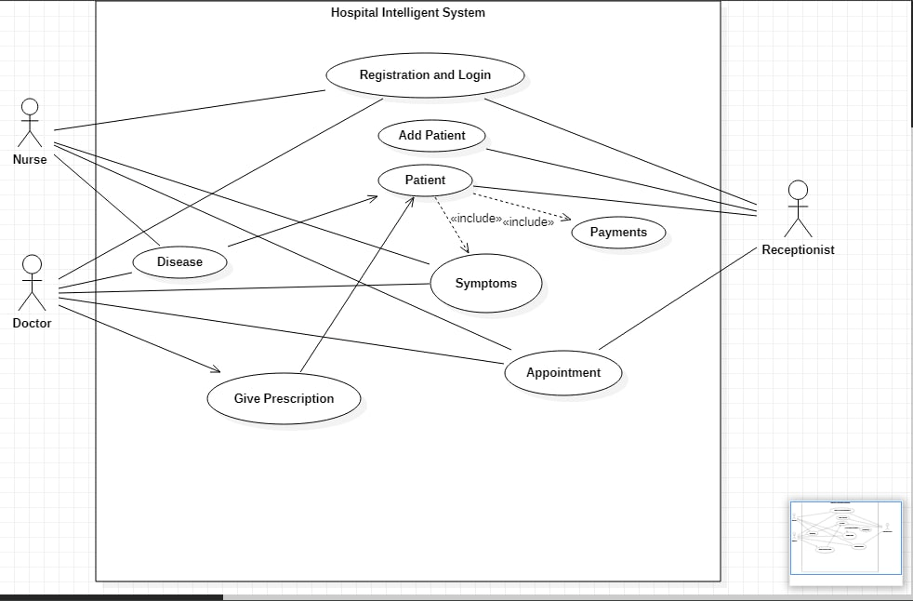

# FLOW CHART:

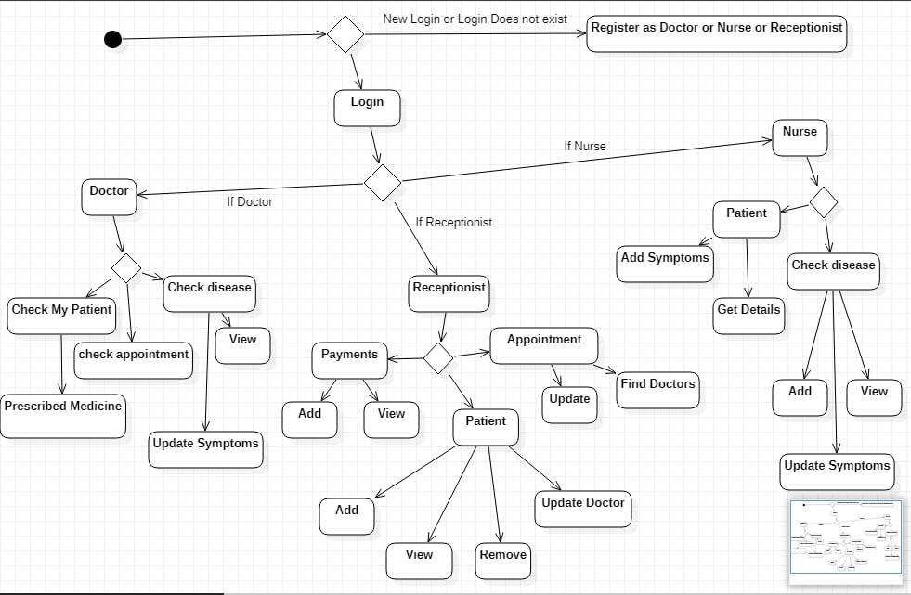

Data Dictionary:

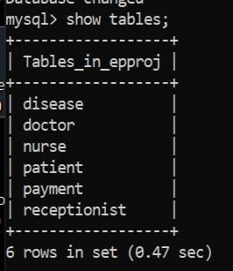

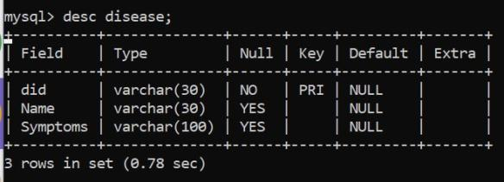

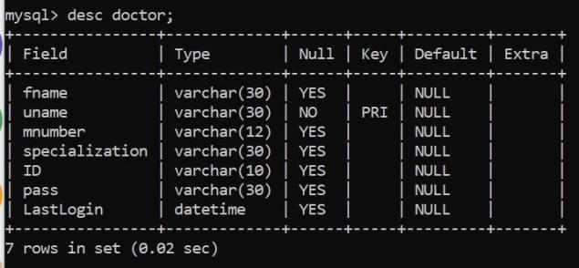

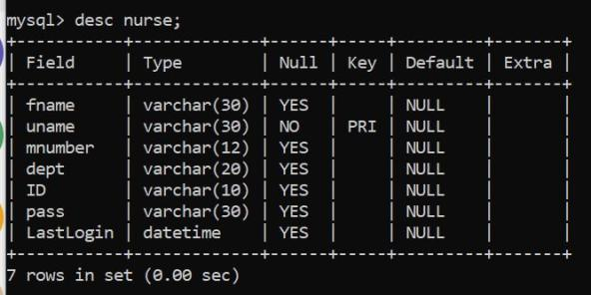

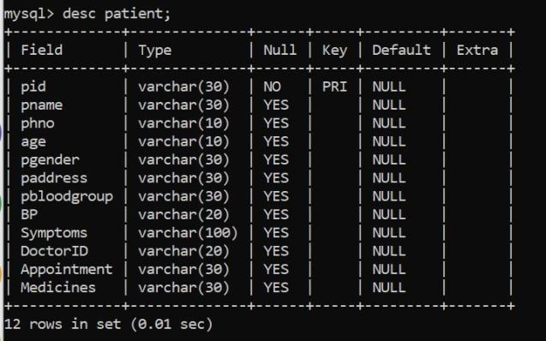

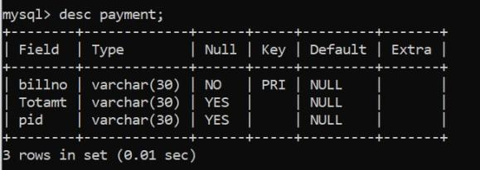

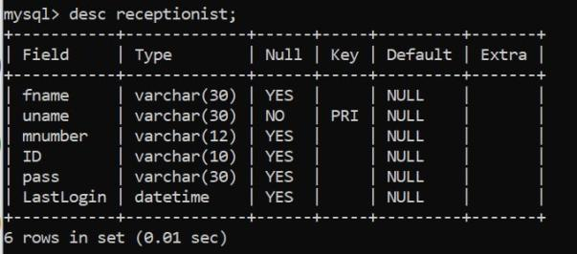

EXECUTION FLOW:

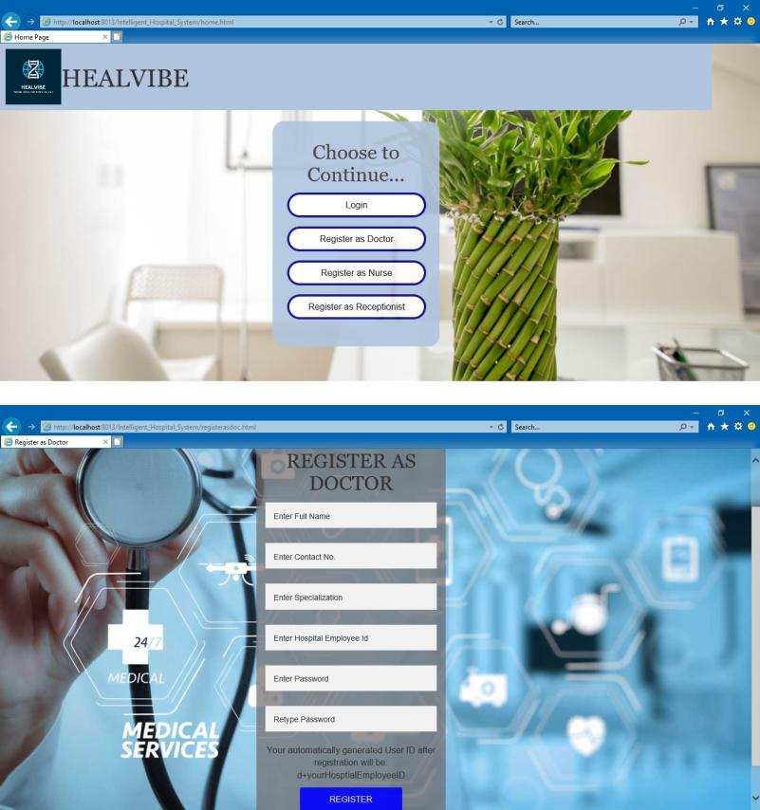

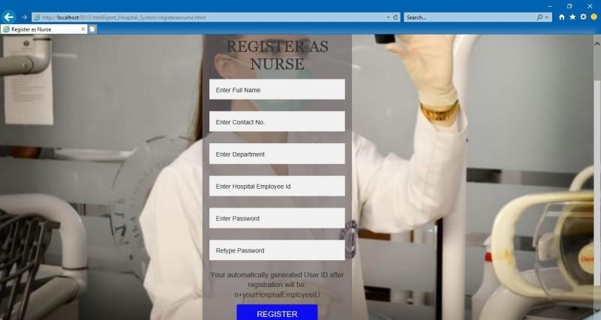

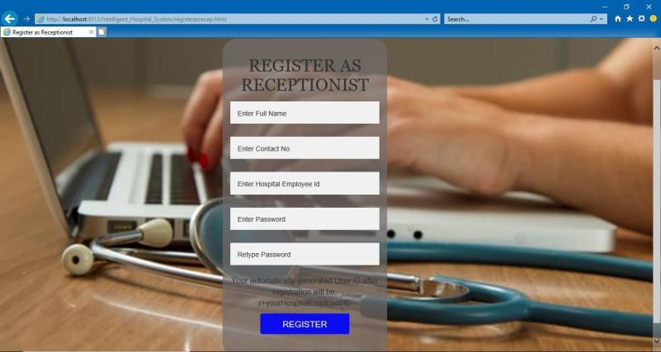

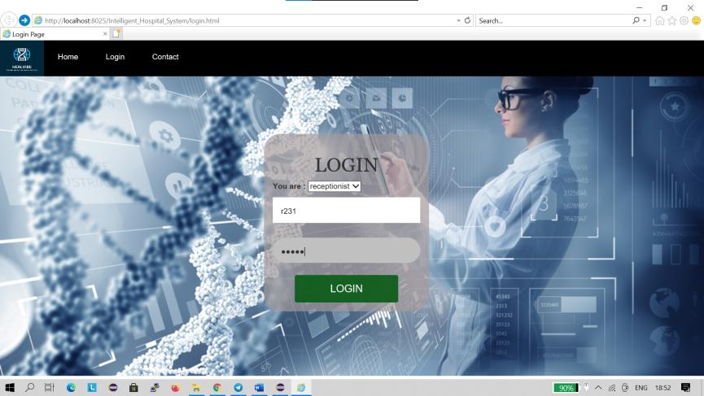

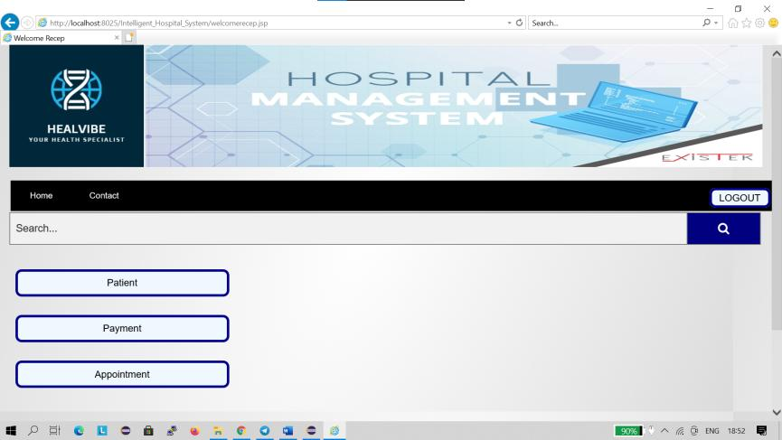

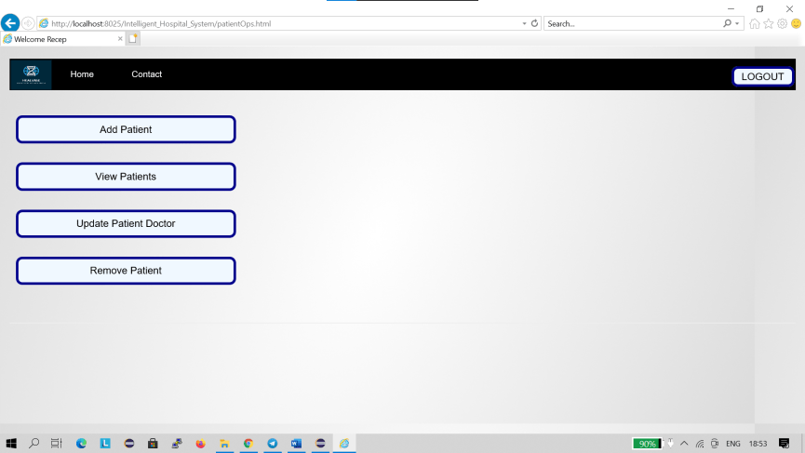

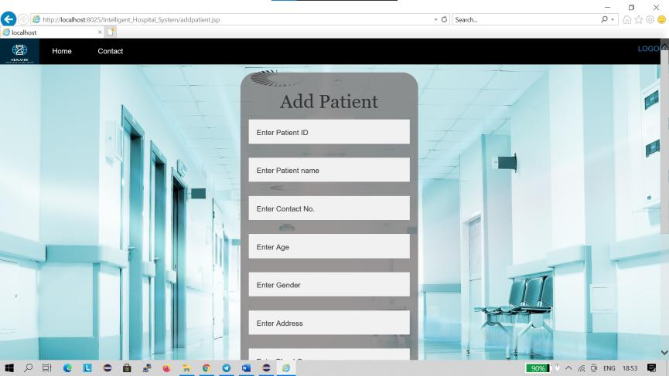

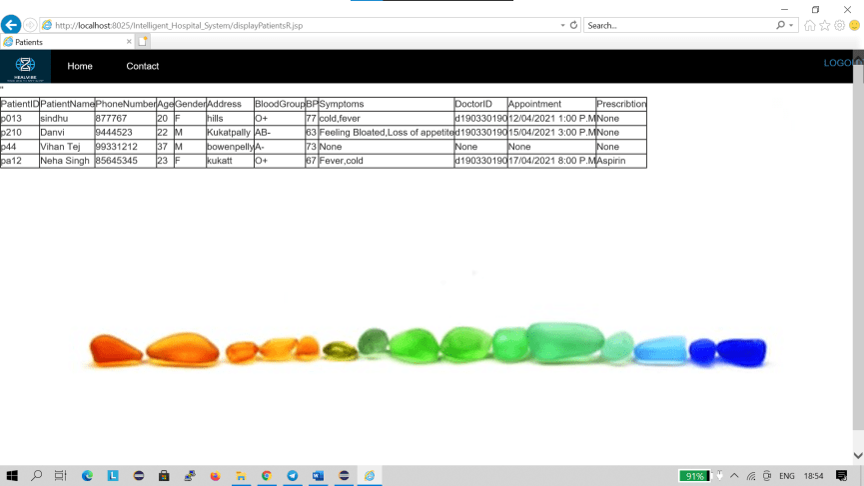

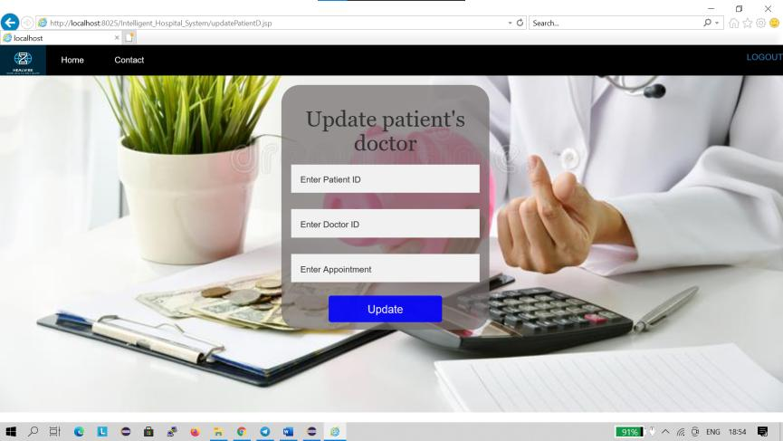

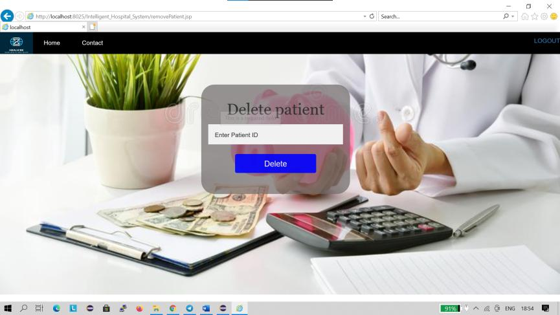

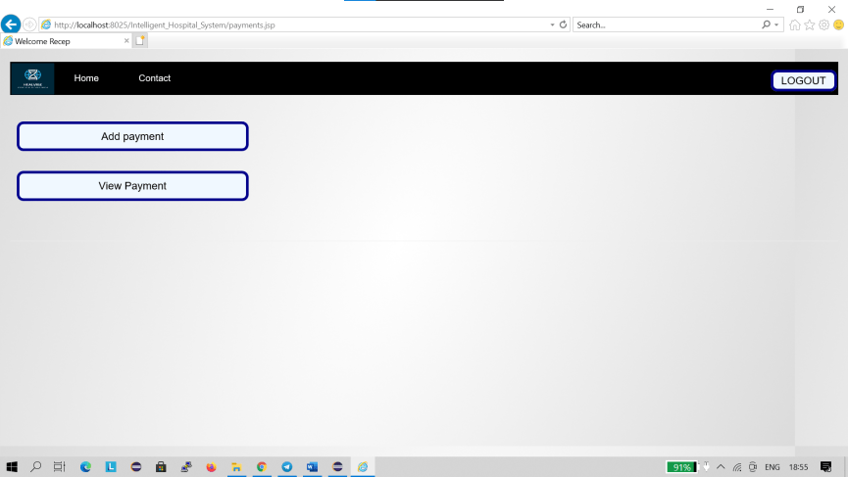

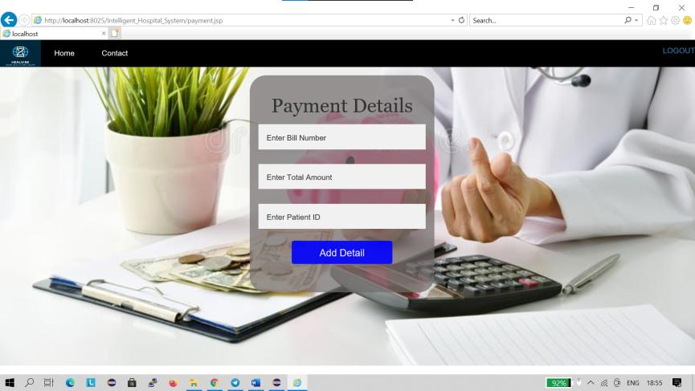

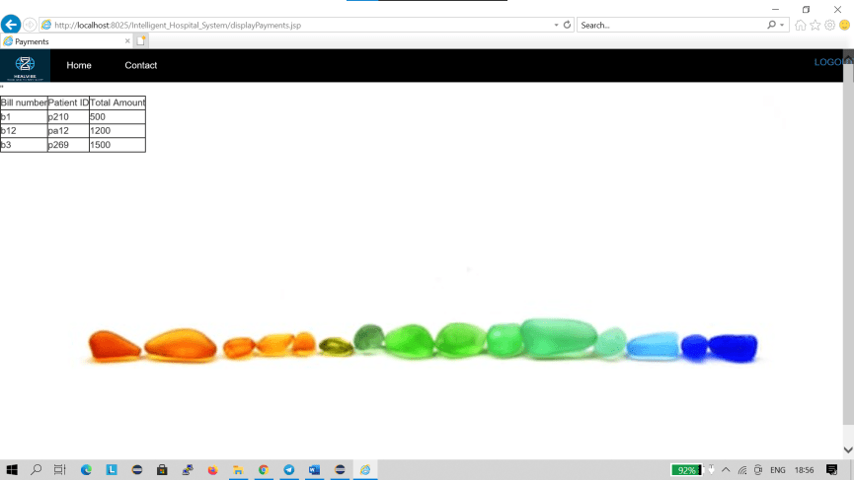

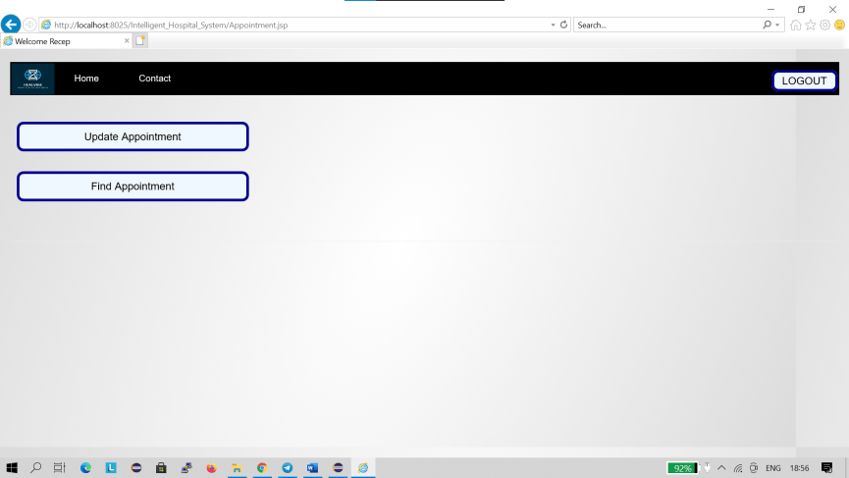

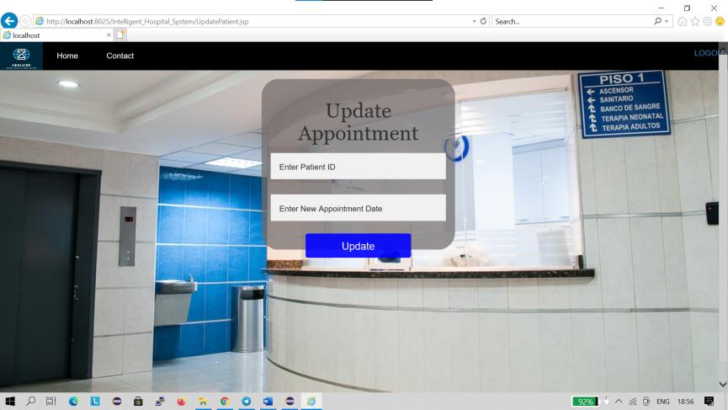

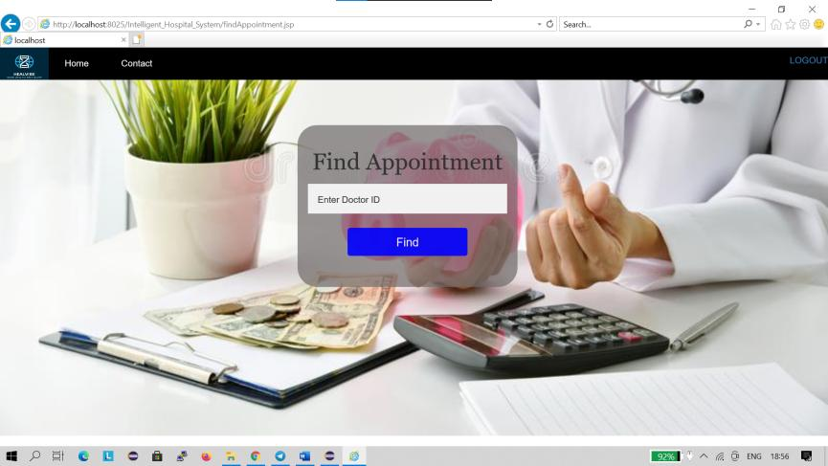

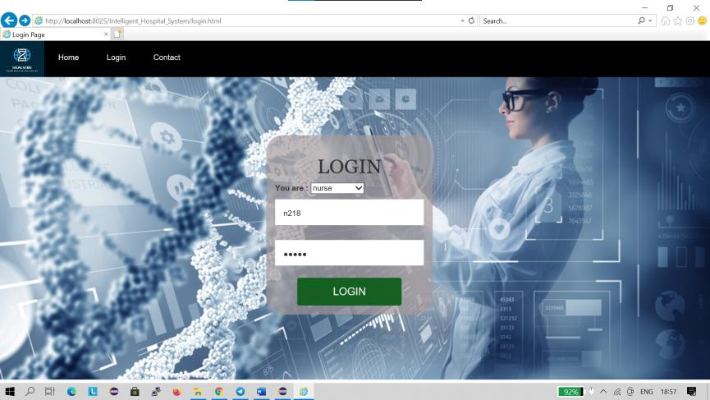

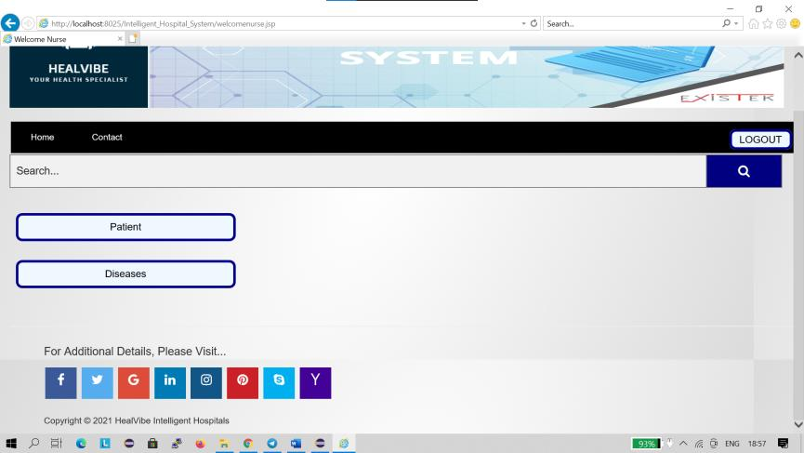

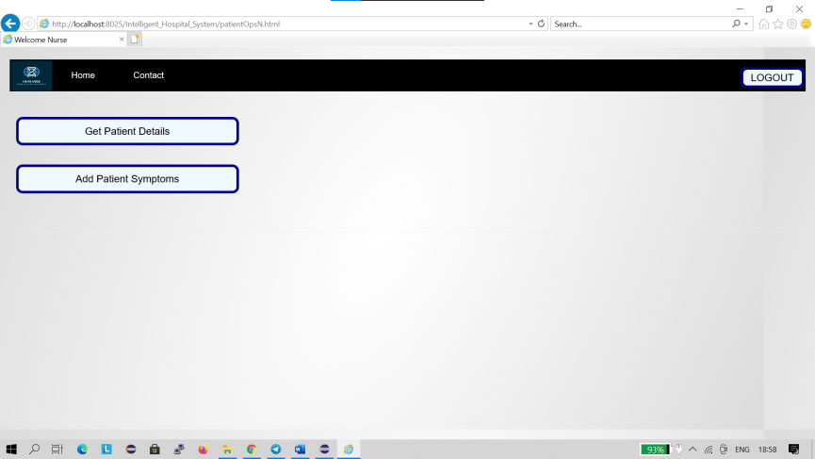

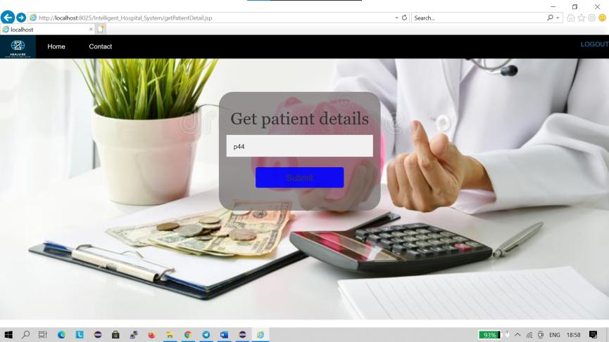

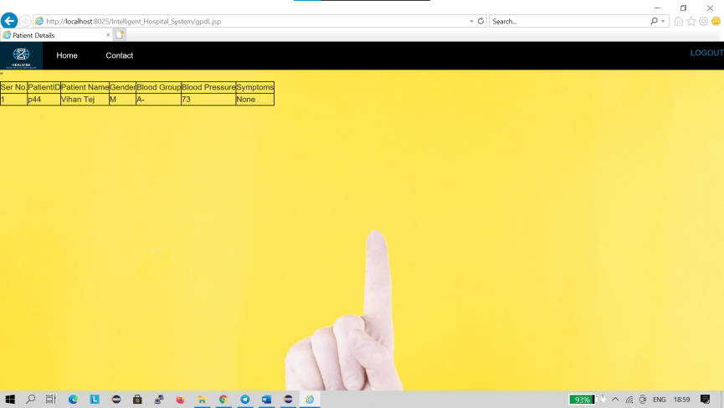

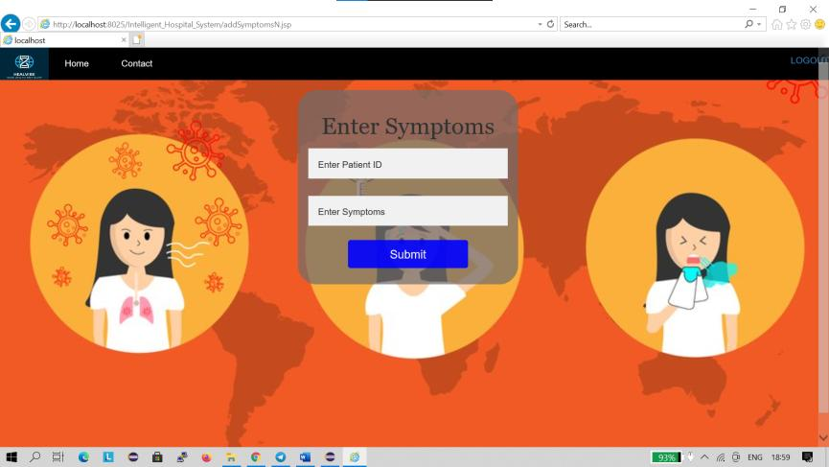

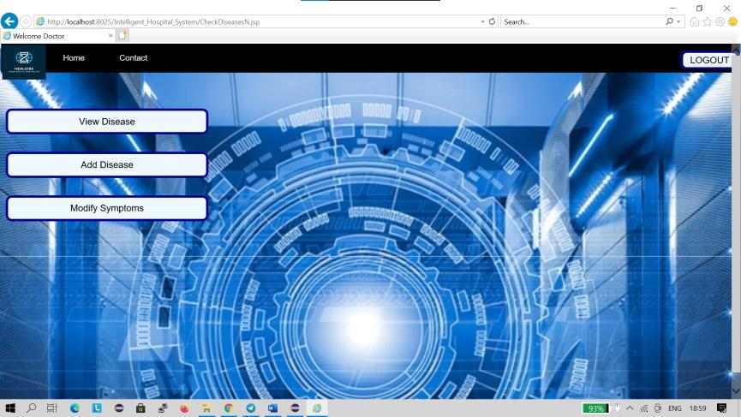

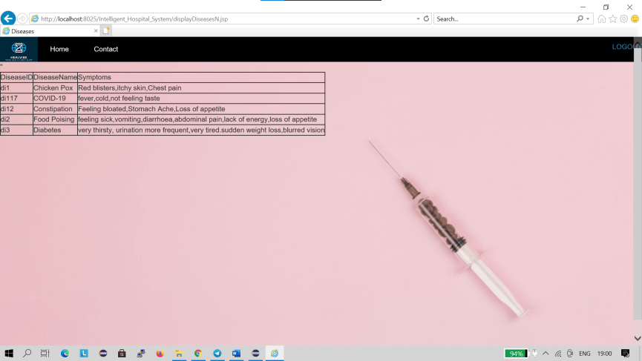

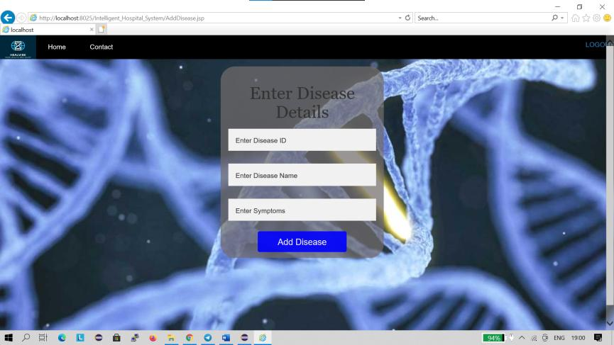

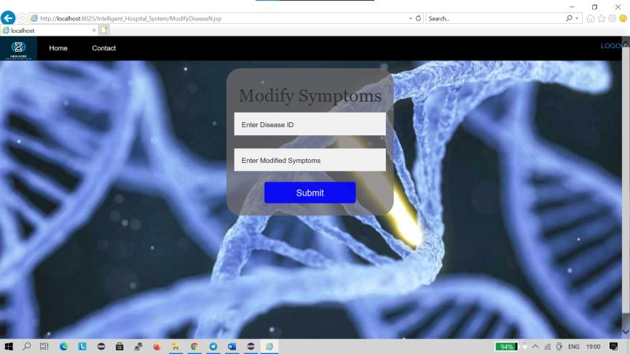

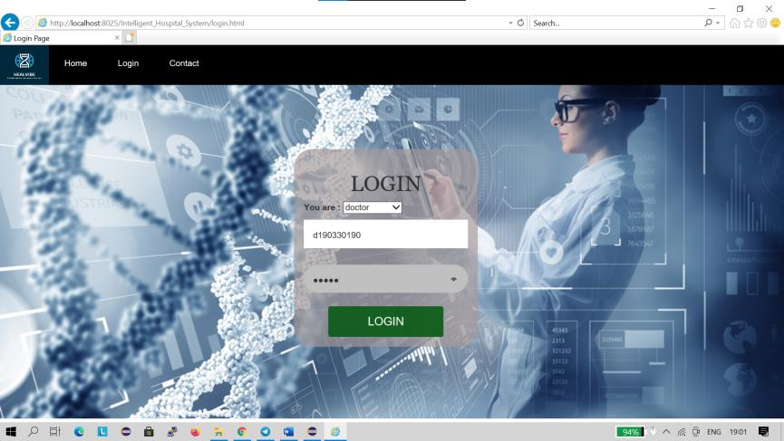

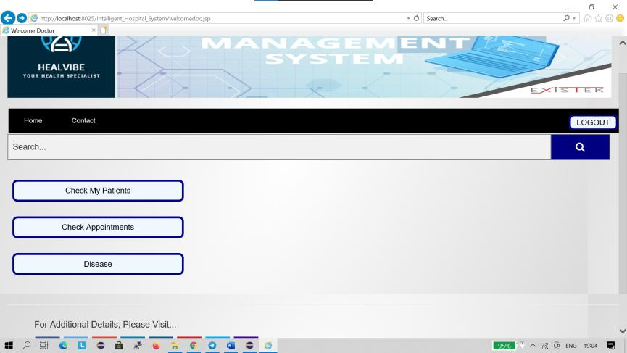

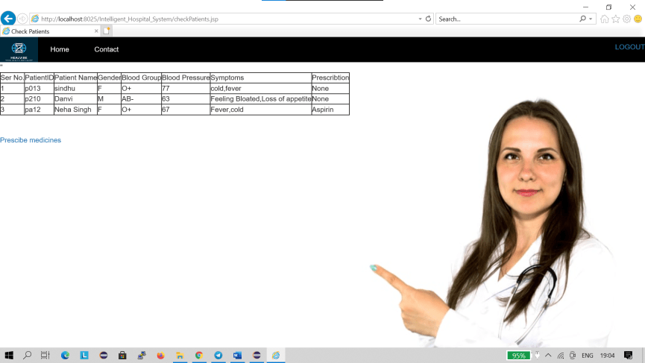

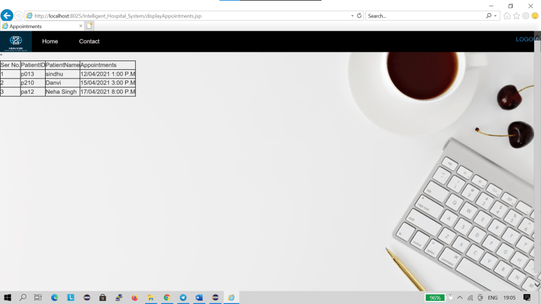

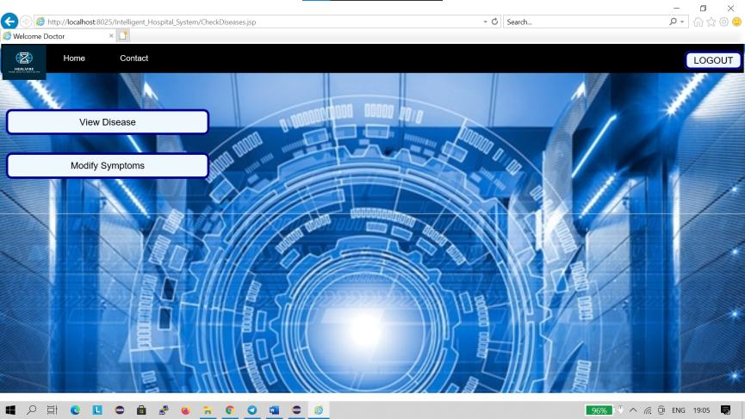

Data stored in dbms:

