Privacy-Preserving Computing Project
Final Report: Data Generation, Syntactic Anonymization, Non-Private PrivBayes, and Private PrivBayes
Includes Phase 1 dataset generation, Phase 2 k-anonymity/l-diversity/t-closeness experiments, Phase 3 non-private PrivBayes synthetic-data generation, Phase 4 simplified private PrivBayes synthetic-data generation, and final cross-method analysis.

1. Executive Summary
This project evaluates privacy-preserving data publishing methods on a controlled Adult-like simulated dataset. Phase 1 generated three correlated datasets with 3 numeric quasi-identifiers (QIs) and 1 sensitive attribute (SA). Phase 2 implemented k-anonymity, l-diversity, and t-closeness using global recoding plus bounded record suppression. Phase 3 implemented a non-private simplified PrivBayes baseline: it learns a Bayesian network using empirical mutual information, fits exact conditional probability tables, and samples synthetic datasets. Phase 4 implemented a simplified private PrivBayes-style mechanism: it privately learns network structure with the exponential mechanism, privately learns noisy CPTs with the Laplace mechanism, and samples synthetic datasets from the resulting private model. The Phase 3 results are used only as a non-private utility upper baseline; the Phase 4 method is the differential-privacy-style synthetic-data release evaluated in this report.
- Datasets: n = 3000, 5000, and 10000 records.
- QIs: age, education_num, and hours_per_week.
- SA: income_class, a six-level skewed categorical attribute with rare Extreme cases.
- Phase 2 parameters: k in {5, 10, 20}, l in {2, 3, 4} with k fixed at 10, and t in {0.2, 0.3, 0.4} with k fixed at 10.
- Suppression budget: at most 5% of records may be removed to avoid full-column suppression when balanced generalization is otherwise impossible.
- Validation result: all 27 Phase 2 anonymized outputs passed independent validation.
- Phase 3 parameters: Bayesian-network parent degree r in {0, 1, 2}, seeds in {0, 1, 2, 3, 4}, and dataset sizes n = 3000, 5000, 10000.
- Phase 3 validation result: all 45 non-private PrivBayes synthetic outputs passed independent network, CPT, and synthetic-data validation.
- Best aggregate private setting in the tested grid: r = 1, epsilon = 2.0, with mean 2-way TVD 0.159009 and mean 3-way TVD 0.241821.
- Phase 4 validation result: all 180 private PrivBayes synthetic outputs passed independent validation; raw MI scores are not persisted in private-release artifacts.
- Phase 4 parameters: epsilon in {0.1, 0.5, 1.0, 2.0}, r in {0, 1, 2}, seeds in {0, 1, 2, 3, 4}, and dataset sizes n = 3000, 5000, 10000.

2. Phase 1: Simulated Dataset Generation

2.1 Objective and Schema
The Phase 1 objective was to construct a controlled Adult-like tabular dataset suitable for evaluating syntactic anonymization and PrivBayes-style synthetic data generation. The dataset intentionally contains exactly four attributes: three numeric QIs and one categorical SA. Numeric QIs were selected because they support interval-based generalization and numeric utility metrics. The SA was kept categorical because l-diversity and t-closeness are naturally defined over sensitive-value distributions.
Table 1. Final simulated schema
Attribute | Role | Type | Domain / Values | Purpose
age | QI | integer | 18-80 | Adult-like demographic quasi-identifier
education_num | QI | integer | 6-16 | Numeric education level used as QI and dependency driver
hours_per_week | QI | integer | 1-70 | Employment-related numeric QI
income_class | SA | categorical ordinal | Low, LowerMiddle, UpperMiddle, High, VeryHigh, Extreme | Sensitive income class with skew and rare cases

2.2 Adult Reference and Controlled Simulation
The UCI Adult/Census Income dataset was used as a statistical reference for plausible ranges, means, class skew, and dependency direction. The project does not release Adult records as the main experimental data. Instead, Adult informed the construction of synthetic Adult-like records, allowing the rare sensitive cases and attribute dependencies to be controlled explicitly.
The generator follows the dependency order age -> education_num -> hours_per_week -> income_class. Education is generated as a noisy nonlinear function of age; hours worked depend on education and nonlinear age-band effects; and income_class is generated from a latent income score depending on all three QIs. This avoids independent attribute sampling and creates meaningful pairwise dependence for the later privacy and utility evaluation.
Table 2. Implemented dependency structure
Dependency | Generation role
age -> education_num | Education is a noisy nonlinear function of age.
age -> hours_per_week | Age-band effects create a nonlinear work-life pattern.
education_num -> hours_per_week | Education contributes positively to work hours.
age -> income_class | Age contributes to the latent income score.
education_num -> income_class | Education is the strongest contributor to latent income score.
hours_per_week -> income_class | Hours worked contribute to latent income score.

2.3 Sensitive Attribute Skew and Rare Cases
The sensitive attribute is deliberately non-uniform. The rare value Extreme has target probability 0.003. This produces 9, 15, and 30 Extreme records for n = 3000, 5000, and 10000 respectively. These counts are small enough that not every equivalence class can contain rare sensitive cases, which makes l-diversity and t-closeness meaningful rather than trivial.
Table 3. Target sensitive attribute distribution
income_class | Target probability
Low | 0.280
LowerMiddle | 0.340
UpperMiddle | 0.240
High | 0.100
VeryHigh | 0.037
Extreme | 0.003

Table 4. Generated dataset summaries
n | Mean age | Mean education_num | Mean hours_per_week | Extreme rows
3000 | 41.72 | 10.47 | 40.14 | 9
5000 | 41.83 | 10.49 | 40.00 | 15
10000 | 41.91 | 10.46 | 40.02 | 30

2.4 Phase 1 Validation
An independent Phase 1 validator checked the row count, exact columns, missing values, integer-valued numeric fields, numeric domain bounds, allowed sensitive values, non-uniform sensitive distribution, presence and proportion of Extreme cases, nonzero pairwise mutual information, and mixed dependency strengths. All three generated datasets passed all 11 validation checks.
Table 5. Phase 1 validation summary
n | Validation result | Checks passed
3000 | PASS | 11/11
5000 | PASS | 11/11
10000 | PASS | 11/11

Table 6. Pairwise dependency validation by mutual information
Pair, n = 10000 | MI (nats) | Strength
education_num <-> income_class | 0.2642 | strong
age <-> hours_per_week | 0.1542 | strong
age <-> income_class | 0.1488 | medium
age <-> education_num | 0.0473 | weak
hours_per_week <-> income_class | 0.0390 | weak
education_num <-> hours_per_week | 0.0253 | weak

3. Phase 2: k-anonymity, l-diversity, and t-closeness

3.1 Privacy Criteria
Phase 2 implements three syntactic privacy models. k-anonymity requires every released equivalence class over the QIs to contain at least k records. l-diversity additionally requires every equivalence class to contain at least l distinct sensitive values. t-closeness additionally requires the sensitive-attribute distribution within each equivalence class to be close to the global sensitive-attribute distribution. This implementation uses total variation distance for the t-closeness distance measure.
Table 7. Phase 2 privacy checks
Method | Verified condition
k-anonymity | For every QI equivalence class E: |E| >= k.
l-diversity | For every QI equivalence class E: |E| >= k and distinct income_class values in E >= l.
t-closeness | For every QI equivalence class E: |E| >= k and TVD(P(income_class | E), P(income_class in raw data)) <= t.

3.2 Generalization and Suppression Settings
The anonymization algorithm uses global recoding: a selected generalization level is applied consistently to each QI across the whole dataset. The search space is all 5^3 combinations of levels for age, education_num, and hours_per_week. The sensitive attribute income_class is never modified.
Table 8. QI generalization hierarchy
QI | Level 0 | Level 1 | Level 2 | Level 3 | Level 4
age | exact integer | 5-year interval | 10-year interval | 20-year interval | *
education_num | exact integer | 2-level interval | 4-level interval | LowEdu/MidEdu/HighEdu | *
hours_per_week | exact integer | 5-hour interval | 10-hour interval | 20-hour interval | *

Pure global recoding produced excessive full-column suppression on this sparse QI space. Therefore, the final implementation uses global recoding plus bounded record suppression. After a candidate global recoding is applied, equivalence classes that still violate the target privacy condition are suppressed by dropping their records. A candidate is feasible only if the number of dropped records is at most 5% of the input dataset. This is controlled by MAX_SUPPRESSION_FRAC = 0.05. Setting this constant to 0.0 restores pure global recoding.
The selection objective ranks feasible candidates by combined information loss. Kept records contribute their generalized-cell normalized certainty penalty (NCP), while suppressed records count as full loss. Ties prefer fewer fully suppressed QIs, lower maximum generalization level, lower total level sum, fewer suppressed rows, and more equivalence classes. This prevents the algorithm from choosing outputs with two or three QI columns replaced by * when balanced interval generalization plus limited suppression is available.

3.3 Experimental Parameter Grid
The assignment requested 2-3 different parameters for each method. This experiment uses three settings for each method and runs every setting on all three dataset sizes, producing 27 anonymized outputs.
Table 9. Phase 2 parameter grid
Method | Dataset sizes | Parameter settings | Fixed settings | Number of outputs
k-anonymity | 3000, 5000, 10000 | k = 5, 10, 20 | None | 9
l-diversity | 3000, 5000, 10000 | l = 2, 3, 4 | k = 10 | 9
t-closeness | 3000, 5000, 10000 | t = 0.2, 0.3, 0.4 | k = 10; TVD distance over income_class | 9

3.4 Validation: How Correctness Was Verified
The validation script is independent from the anonymizer. It re-reads runtime_summary.csv and each released anonymized CSV, then recomputes all required properties rather than trusting statistics generated during anonymization. This is important for t-closeness: the validator recomputes the global raw income_class distribution, recomputes the sensitive distribution in every released equivalence class, calculates TVD for each class, and verifies that the maximum class TVD is no larger than the target t. Therefore the t-closeness result is directly verified by the validation code, not assumed from the construction algorithm.
Table 10. Independent validation checks
Validation check | Purpose
schema_exact | Confirms the released table has exactly age, education_num, hours_per_week, income_class.
no_missing_values | Ensures no empty or missing values are introduced.
row_count_preserved_or_reported | Allows reduced row count only when row_suppression_used is reported and rows_suppressed matches.
suppressed_qi_values_valid | Checks exact values, intervals, broad education labels, and * are well-formed.
income_domain_unchanged | Confirms income_class values remain legal and are not generalized.
k_anonymity | Recomputes equivalence classes and minimum class size.
l_diversity | Recomputes distinct sensitive values per equivalence class.
t_closeness | Recomputes per-class TVD against the raw global sensitive distribution.

Final validation result: all 27 feasible Phase 2 outputs passed all applicable checks, and the validation script ended with OVERALL: PASS.
Table 11. Direct t-closeness verification results
n | Target | Chosen levels | Max class TVD | Threshold | Suppressed rows | Suppression rate
3000 | t=0.2 | (4,4,2) | 0.1781 | 0.2 | 24 | 0.80%
3000 | t=0.3 | (4,4,1) | 0.2897 | 0.3 | 11 | 0.37%
3000 | t=0.4 | (2,4,3) | 0.3466 | 0.4 | 148 | 4.93%
5000 | t=0.2 | (4,4,3) | 0.0898 | 0.2 | 108 | 2.16%
5000 | t=0.3 | (4,4,0) | 0.2830 | 0.3 | 200 | 4.00%
5000 | t=0.4 | (1,4,3) | 0.3769 | 0.4 | 228 | 4.56%
10000 | t=0.2 | (4,4,1) | 0.1971 | 0.2 | 402 | 4.02%
10000 | t=0.3 | (4,4,0) | 0.2840 | 0.3 | 74 | 0.74%
10000 | t=0.4 | (1,4,3) | 0.3804 | 0.4 | 451 | 4.51%

3.5 Utility and Runtime Metrics
Utility is evaluated in two ways. First, information loss is measured using level-based loss and numeric NCP. Numeric NCP parses exact values, intervals, broad education categories, and * as numeric spans, and suppressed rows are counted as full loss in the anonymizer selection score. Second, marginal fidelity is measured using total variation distance on all 2-way and 3-way marginals over the four attributes.
Two TVD variants are reported. strict_symbolic_tvd treats generalized intervals and * as explicit categories distinct from raw exact values. This metric is intentionally harsh and often equals 1.0 when intervals are present. midpoint_binned_tvd converts generalized numeric QIs to interval midpoints, bins raw and anonymized numeric values into common bins, and then computes TVD. The midpoint-binned metric is the main interpretable utility metric for report comparison.
Table 12. Aggregate information loss by method
Method | Mean level loss | Mean numeric NCP
k-anonymity | 0.5000 | 0.1716
l-diversity | 0.6111 | 0.2814
t-closeness | 0.7407 | 0.6155

Table 13. Aggregate marginal TVD by method
Method | Metric type | Mean 2-way TVD | Mean 3-way TVD
k-anonymity | midpoint_binned_tvd | 0.1668 | 0.2431
k-anonymity | strict_symbolic_tvd | 0.9817 | 1.0000
l-diversity | midpoint_binned_tvd | 0.1999 | 0.2857
l-diversity | strict_symbolic_tvd | 1.0000 | 1.0000
t-closeness | midpoint_binned_tvd | 0.4466 | 0.5999
t-closeness | strict_symbolic_tvd | 0.9638 | 1.0000

Table 14. Execution time by method
Method | Mean runtime (s) | Min runtime (s) | Max runtime (s)
k-anonymity | 0.6472 | 0.5135 | 0.8617
l-diversity | 0.7072 | 0.5238 | 1.0487
t-closeness | 1.2236 | 1.0202 | 1.4974

Table 15. Runtime sensitivity by parameter
Method | Parameter setting | Mean runtime across n (s)
k-anonymity | k=5 | 0.6494
k-anonymity | k=10 | 0.6490
k-anonymity | k=20 | 0.6432
l-diversity | l=2 | 0.7084
l-diversity | l=3 | 0.7335
l-diversity | l=4 | 0.6796
t-closeness | t=0.2 | 1.2276
t-closeness | t=0.3 | 1.2205
t-closeness | t=0.4 | 1.2227

Table 16. Suppression and full-QI suppression summary
Method | Mean suppression rate | Min | Max | Mean suppressed rows | Mean fully suppressed QIs
k-anonymity | 3.69% | 2.70% | 4.80% | 214.8 | 0.00
l-diversity | 3.70% | 2.27% | 4.40% | 227.3 | 0.33
t-closeness | 2.90% | 0.37% | 4.93% | 182.9 | 1.67

3.6 Interpretation of Phase 2 Results
The bounded-suppression version is substantially more useful than the pure-generalization version. k-anonymity no longer requires any fully suppressed QI columns on average, and l-diversity averages only 0.33 fully suppressed QIs. In contrast, strict t-closeness still frequently requires coarse generalization because each equivalence class must have a sensitive-value distribution close to the raw global distribution, which is difficult under rare Extreme cases and sparse QI combinations.
The aggregate numeric NCP follows the expected privacy-utility ordering: k-anonymity has the lowest mean loss (0.1716), l-diversity is higher (0.2814), and t-closeness is highest (0.6155). The midpoint-binned TVD results show the same pattern: k-anonymity has the best marginal fidelity, l-diversity is moderately worse, and t-closeness has the largest distortion. This is consistent with the fact that t-closeness constrains the full sensitive-attribute distribution inside every equivalence class, not only class size or distinct sensitive values.
Strict symbolic TVD remains high because generalized intervals are symbolically different from raw exact values. This should be reported as a conservative output-symbol distortion metric, but the midpoint-binned TVD should be used as the main interpretable numeric utility measure. The midpoint-binned metric reflects the fact that an interval such as [30-39] is still numerically close to raw ages inside that range, whereas strict symbolic TVD treats it as a completely different category.

3.7 Phase 2 Output Files
- src/anonymize.py: implements global recoding plus bounded record suppression.
- src/validate_anonymization.py: independently validates all anonymized outputs.
- src/evaluate_anonymization.py: computes information loss and marginal TVD.
- data/anonymized/: contains 27 anonymized CSV outputs.
- outputs/phase2/runtime_summary.csv: records runtime, chosen levels, class statistics, and suppression counts.
- outputs/phase2/validation_report.txt and validation_summary.csv: contain independent validation results.
- outputs/phase2/information_loss_summary.csv and marginal_tvd_summary.csv: contain utility metrics.
- outputs/phase2/phase2_summary.txt: summarizes per-run and aggregate utility results.

4. Phase 3: Non-Private Simplified PrivBayes

4.1 Objective and Privacy Interpretation
Phase 3 implements a simplified non-private PrivBayes-style synthetic-data generator. The purpose of this phase is to establish a utility upper baseline for the later private version. The model is non-private because both the Bayesian-network structure and the conditional probability tables are learned exactly from the raw data without adding noise. Therefore, Phase 3 should not be interpreted as a privacy mechanism. Its role is to show how much 2-way and 3-way marginal structure can be preserved when there is no differential-privacy cost.
Table 17. Phase 3 implementation files
File | Purpose
src/privbayes_utils.py | Shared constants, discretization, midpoint decoding, empirical MI in nats, and TVD utilities.
src/privbayes_nonprivate.py | GreedyBayes structure learning, exact CPT fitting, marginal fallback, ancestral sampling, and CSV output.
src/validate_privbayes_nonprivate.py | Independent validation of learned networks, CPT validity, and synthetic-data correctness.
src/evaluate_privbayes_nonprivate.py | Utility evaluation using 2-way/3-way marginal TVD, pairwise MI preservation, and runtime aggregation.

4.2 Discretization and Decoding
PrivBayes requires discrete attributes. The three numeric QIs are therefore discretized before Bayesian-network learning. The sensitive attribute is already categorical and is passed through unchanged. After sampling, the synthetic records are decoded back to the original four-column schema. Numeric bins are decoded using round-half-up midpoint values, so the documented examples age 30-39 -> 35 and hours_per_week 40-49 -> 45 are exact.
Table 18. PrivBayes discretization and decoding settings
Attribute | Learning representation | Synthetic output representation
age | 10-year bins: 18-29, 30-39, 40-49, 50-59, 60-69, 70-80 | Rounded midpoint: 24, 35, 45, 55, 65, 75
education_num | Exact integer categories 6-16 | Exact integer 6-16
hours_per_week | 10-hour bins: 1-9, 10-19, 20-29, 30-39, 40-49, 50-59, 60-70 | Rounded midpoint: 5, 15, 25, 35, 45, 55, 65
income_class | Original categories | Original categories

4.3 GreedyBayes Structure Learning
The implementation follows the simplified GreedyBayes strategy from the course requirement. For each dataset size, parent-degree setting, and seed, the algorithm first selects one root attribute uniformly at random using the seed. It then repeatedly considers every unselected attribute X and every parent set Pi drawn from the already selected variables V, where |Pi| = min(r, |V|). For each candidate pair (X, Pi), it computes the empirical mutual information I(X; Pi) on the discretized raw data and selects the candidate with maximum MI. Parent sets with two variables are encoded as one composite categorical variable, which implements MI between X and the joint parent configuration.
MI is computed in nats using the natural logarithm. The log base does not affect candidate ranking, but using nats keeps the convention consistent with the Phase 1 mutual-information validation. Ties are resolved deterministically by attribute name and then parent tuple, after sorting by decreasing MI. This makes r = 0 deterministic after the random root and keeps the generated network reproducible.
Table 19. Phase 3 experimental parameter grid
Parameter | Values | Meaning
n | 3000, 5000, 10000 | Raw dataset size.
r | 0, 1, 2 | Maximum Bayesian-network parent degree. This is separate from k-anonymity k.
seed | 0, 1, 2, 3, 4 | Controls the random root and ancestral sampling.
Outputs | 45 synthetic CSVs | 3 dataset sizes x 3 r values x 5 seeds.

4.4 CPT Estimation and Synthetic Sampling
After learning the network, Phase 3 fits exact empirical conditional probability tables from the same discretized raw dataset. If a node has no parents, the CPT is the marginal distribution P(X). Otherwise, each row stores P(X | Parents) for one observed parent configuration. The implementation also stores a marginal fallback distribution P(X) for every attribute. During ancestral sampling, if a parent configuration is unseen or has an invalid zero-sum row, the sampler falls back to the attribute marginal rather than crashing. The sampled discrete table is then decoded to the canonical output schema: age, education_num, hours_per_week, income_class.

4.5 Verification Method
Phase 3 uses an independent validation script. The validator re-reads learned_networks.json and all synthetic CSV files. It does not import the generator script and it re-fits CPTs from the raw data before checking CPT validity. This prevents the validation result from merely repeating statistics produced by the generation code.
Table 20. Phase 3 independent validation checks
Component | Checks performed
Network structure | Every attribute appears exactly once; parent degree <= r; every parent appears earlier in the network order; no cycles; no duplicate attribute-parent pairs.
CPT validity | Every probability is finite; no probability is negative; every CPT row sums to 1 within tolerance; marginal fallback distributions are valid.
Synthetic outputs | All 45 files exist; row count equals raw n; exact schema is preserved; no missing values; numeric domains are valid; income_class values are legal.
Evaluation consistency | Raw and synthetic tables are mapped to the shared Phase 2 evaluation bin space for 2-way/3-way marginal TVD; MI preservation is computed on the PrivBayes discretization.

Final validation result: all 45 Phase 3 synthetic outputs passed. The CPT validation table contains 180 PASS rows, and the synthetic-output validation table contains 360 PASS rows. No validation failures were observed.

4.6 Utility Results: Marginal TVD
The required utility metric is marginal distance on 2-way and 3-way marginals. Phase 3 computes total variation distance between the raw data and each synthetic output, then averages over all 2-way marginals and all 3-way marginals. For comparability with Phase 2, both raw exact values and decoded synthetic midpoint values are mapped into the same Phase 2 evaluation bin space before TVD is computed. This makes cross-phase comparison possible, but it also means the absolute TVD values include some bin-edge effects from comparing PrivBayes 10-year learning bins with the Phase 2 evaluation bins. The main interpretation is therefore the trend across r.
Table 21. Phase 3 marginal TVD by dataset size and parent degree
n | r | Mean 2-way TVD | Mean 3-way TVD
3000 | 0 | 0.210289 | 0.348817
3000 | 1 | 0.156189 | 0.244000
3000 | 2 | 0.150133 | 0.229800
5000 | 0 | 0.208080 | 0.346000
5000 | 1 | 0.151893 | 0.231420
5000 | 2 | 0.145820 | 0.220410
10000 | 0 | 0.206390 | 0.347410
10000 | 1 | 0.152053 | 0.230165
10000 | 2 | 0.142487 | 0.215190

Table 22. Phase 3 aggregate marginal TVD by parent degree
r | Mean 2-way TVD | Mean 3-way TVD | Interpretation
0 | 0.208253 | 0.347409 | Independent baseline
1 | 0.153378 | 0.235195 | Dependency-preserving model
2 | 0.146147 | 0.221800 | Dependency-preserving model

4.7 Pairwise MI Preservation
Pairwise mutual information is not the primary assignment metric, but it is a useful diagnostic for checking whether the learned network preserves dependencies. As expected, r = 0 collapses most pairwise MI because it samples attributes independently. Increasing r reduces the average absolute MI error substantially.
Table 23. Pairwise MI preservation by dataset size and parent degree
n | r | Raw MI (nats) | Synthetic MI (nats) | Abs. MI error
3000 | 0 | 0.111801 | 0.006130 | 0.105671
3000 | 1 | 0.111801 | 0.110264 | 0.020149
3000 | 2 | 0.111801 | 0.119208 | 0.009405
5000 | 0 | 0.107077 | 0.003871 | 0.103206
5000 | 1 | 0.107077 | 0.103622 | 0.016477
5000 | 2 | 0.107077 | 0.110427 | 0.005035
10000 | 0 | 0.106590 | 0.002054 | 0.104535
10000 | 1 | 0.106590 | 0.102457 | 0.012970
10000 | 2 | 0.106590 | 0.109567 | 0.004085

4.8 Runtime Results
Runtime is recorded separately for discretization, structure learning, CPT fitting, sampling, and total runtime. The expected pattern is visible: r = 0 has nearly zero structure-learning cost, while r = 2 is slower because more candidate parent sets must be evaluated.
Table 24. Phase 3 runtime by dataset size and parent degree
n | r | Structure learning (s) | Sampling (s) | Total runtime (s)
3000 | 0 | 0.0001 | 0.5874 | 0.6277
3000 | 1 | 0.1675 | 0.6257 | 0.8312
3000 | 2 | 0.3532 | 0.5748 | 0.9715
5000 | 0 | 0.0001 | 0.9403 | 0.9764
5000 | 1 | 0.1919 | 0.9989 | 1.2471
5000 | 2 | 0.4293 | 0.9443 | 1.4245
10000 | 0 | 0.0001 | 1.9146 | 1.9743
10000 | 1 | 0.2227 | 1.9505 | 2.2502
10000 | 2 | 0.6927 | 2.2376 | 3.0118

4.9 Learned Dependency Structure
The learned networks recover the major dependencies that were intentionally built into the Phase 1 generator. The most frequent learned edge is education_num <- income_class, reflecting the strong education-income relationship. The edge hours_per_week <- age is also frequently selected, matching the designed age-hours relationship. This supports the correctness of the MI-based structure-learning step.
Table 25. Most frequent learned edges across Phase 3 runs
Learned edge | Frequency
education_num <- income_class | 21
age <- income_class | 12
hours_per_week <- age | 12
age <- education_num + income_class | 12
hours_per_week <- age + income_class | 12
income_class <- education_num | 6
age <- hours_per_week | 6
income_class <- age | 3

4.10 Interpretation of Phase 3 Results
The Phase 3 results show the expected behavior for a non-private Bayesian-network synthetic-data baseline. With r = 0, the generator preserves mostly one-way distributions and loses most attribute dependence, producing the highest 2-way and 3-way TVD. With r = 1, the model captures one-parent dependencies and substantially improves both marginal TVD and MI preservation. With r = 2, the model captures additional joint parent effects and gives the best utility across all dataset sizes.
Because no privacy noise is added, these Phase 3 results should be interpreted as an upper bound on the utility that the private version can try to approach. The private Phase 4 implementation should have lower utility than this baseline at small epsilon, especially for r = 2 where higher-dimensional CPTs require more noisy cells.

4.11 Phase 3 Output Files
- src/privbayes_utils.py: shared discretization, decoding, MI, and marginal TVD utilities.
- src/privbayes_nonprivate.py: generates 45 non-private PrivBayes synthetic datasets.
- src/validate_privbayes_nonprivate.py: independently validates network, CPT, and synthetic-output correctness.
- src/evaluate_privbayes_nonprivate.py: computes marginal TVD, MI preservation, and runtime summaries.
- data/synthetic/nonprivate/: contains 45 synthetic CSV outputs.
- outputs/phase3/runtime_summary.csv: records per-run timing and output paths.
- outputs/phase3/network_summary.csv and learned_networks.json: record learned network structure.
- outputs/phase3/cpt_validation_summary.csv and synthetic_validation_summary.csv: record independent validation results.
- outputs/phase3/marginal_tvd_summary.csv and pairwise_mi_summary.csv: record utility metrics.
- outputs/phase3/phase3_summary.txt: summarizes generation and evaluation results.

5. Phase 4: Simplified Private PrivBayes

5.1 Objective and Privacy Interpretation
Phase 4 implements a simplified private PrivBayes-style synthetic-data generator. The goal is to release synthetic data while accounting for privacy loss during both Bayesian-network structure learning and parameter learning. The implementation follows the same discretization, decoding, and evaluation space as Phase 3, so the Phase 3 non-private results serve as a direct utility upper baseline.
The implementation is intentionally described as simplified private PrivBayes, not as the full PrivBayes algorithm from Zhang et al. The structure-learning score is direct empirical mutual information in nats, used inside the exponential mechanism. The full paper proposes a lower-sensitivity surrogate score F for improved utility, but that surrogate is not implemented here. Privacy accounting uses basic sequential composition under a replace-one-tuple neighboring relation.
Table 26. Phase 4 implementation files
File | Purpose
src/privbayes_private.py | Private GreedyBayes structure learning with the exponential mechanism, Laplace-noisy CPT construction, ancestral sampling, and private CSV output.
src/validate_privbayes_private.py | Independent validation of private-source tags, budget accounting, noisy CPT validity, and synthetic-output correctness.
src/evaluate_privbayes_private.py | Utility evaluation using 2-way/3-way marginal TVD, sensitive-attribute TVD, rare Extreme error, pairwise MI preservation, and runtime aggregation.
src/privbayes_utils.py | Shared discretization, decoding, fixed public domains, empirical MI, and TVD utilities.

5.2 Privacy Mechanism and Budget Accounting
The private mechanism has three stages. First, the root attribute is chosen uniformly at random, which is data-independent and consumes no privacy budget. For r > 0, the remaining d - 1 structure-learning steps use the exponential mechanism over all candidate attribute-parent pairs. The quality score is empirical MI I(X; Pi), and the sensitivity bound is computed as Delta_I(n) in nats. Second, the parameter-learning stage materializes one full-domain joint count table per attribute, adds Laplace noise to every cell, clips negative noisy counts to zero, and normalizes the result into conditional probability rows. Third, synthetic records are sampled using only the private network structure, noisy CPTs, fallback distributions, and fixed public domains.
For r = 0, the network structure is data-independent because every parent set is empty, so the full epsilon budget is assigned to parameter learning. For r = 1 and r = 2, epsilon is split evenly: epsilon/2 for structure and epsilon/2 for parameters. With d = 4 attributes, the structure budget is divided over 3 exponential-mechanism steps, and the parameter budget is divided over 4 noisy CPTs. The count-histogram sensitivity is 2 under replace-one-tuple neighbors, so the Laplace scale is 2 / epsilon_cpt.
Table 27. Phase 4 privacy accounting by r and epsilon
r | epsilon | epsilon_structure | epsilon_parameters | EM steps | epsilon_step | epsilon_cpt | Laplace scale
0 | 0.1 | 0.0000 | 0.1000 | 0 | 0.000000 | 0.025000 | 80.00
0 | 0.5 | 0.0000 | 0.5000 | 0 | 0.000000 | 0.125000 | 16.00
0 | 1.0 | 0.0000 | 1.0000 | 0 | 0.000000 | 0.250000 | 8.00
0 | 2.0 | 0.0000 | 2.0000 | 0 | 0.000000 | 0.500000 | 4.00
1 | 0.1 | 0.0500 | 0.0500 | 3 | 0.016667 | 0.012500 | 160.00
1 | 0.5 | 0.2500 | 0.2500 | 3 | 0.083333 | 0.062500 | 32.00
1 | 1.0 | 0.5000 | 0.5000 | 3 | 0.166667 | 0.125000 | 16.00
1 | 2.0 | 1.0000 | 1.0000 | 3 | 0.333333 | 0.250000 | 8.00
2 | 0.1 | 0.0500 | 0.0500 | 3 | 0.016667 | 0.012500 | 160.00
2 | 0.5 | 0.2500 | 0.2500 | 3 | 0.083333 | 0.062500 | 32.00
2 | 1.0 | 0.5000 | 0.5000 | 3 | 0.166667 | 0.125000 | 16.00
2 | 2.0 | 1.0000 | 1.0000 | 3 | 0.333333 | 0.250000 | 8.00

5.3 Experimental Parameter Grid
Phase 4 evaluates the same dataset sizes and parent-degree values as Phase 3, but adds an epsilon grid and repeats each private setting over five seeds. This produces 3 dataset sizes x 3 parent degrees x 4 epsilon values x 5 seeds = 180 private synthetic datasets.
Table 28. Phase 4 experimental parameter grid
Parameter | Values | Meaning
n | 3000, 5000, 10000 | Raw dataset size.
r | 0, 1, 2 | Maximum Bayesian-network parent degree; separate from k-anonymity k.
epsilon | 0.1, 0.5, 1.0, 2.0 | Total privacy budget for the simplified private PrivBayes mechanism.
seed | 0, 1, 2, 3, 4 | Controls randomized structure selection and synthetic sampling.
Outputs | 180 synthetic CSVs | 3 x 3 x 4 x 5 private synthetic datasets.

5.4 Verification Method
The Phase 4 validator is independent from the generator. It re-reads the learned private networks, privacy-accounting summaries, noisy CPT summaries, and private synthetic CSV outputs. The validation checks implementation consistency and privacy-budget accounting; it is not a formal proof of differential privacy. The proof obligation is addressed by the mechanism design and documented composition calculation.
A specific leakage fix was applied before finalizing Phase 4. The generator originally persisted the selected candidate raw MI score in the private trace. That field was removed because the exponential mechanism privatizes the selected candidate, not the exact raw score. The final private trace keeps only mechanism metadata, epsilon_step, Delta_I(n), and whether a uniform fallback was used. A grep check confirmed that score_mi_nats and raw_mi are absent from private-release paths. Raw MI now appears only in curator-side evaluation output, not in the private release.
Table 29. Phase 4 independent validation summary
Validation area | Result | Details
Private-source guard | PASS | All private networks use source tag phase4_private_exponential_mechanism; outputs are in data/synthetic/private/.
Network not reused from Phase 3 | PASS | 69/180 structures matched Phase 3 by chance or convergence, but the validator confirmed Phase 4 did not copy Phase 3 artifacts.
Noisy CPT checks | PASS | 720 PASS rows: finite probabilities, no negatives, rows sum to 1, and fallbacks valid.
Synthetic-output checks | PASS | 1440 PASS rows: files exist, row counts match n, schema is exact, no missing values, domains are valid.
Overall combinations | PASS | 180/180 private settings fully passed.
Raw-score leakage check | PASS | score_mi_nats and raw_mi absent from private-release paths after the fix.

5.5 Utility Results: Marginal TVD
The required utility metric is total variation distance on 2-way and 3-way marginals. The evaluator computes the empirical marginal distribution for every attribute pair and triple in the raw data and in each private synthetic dataset, maps both to the shared Phase 2 evaluation bin space, and averages TVD across all 2-way and 3-way marginals. Lower values indicate better fidelity.
The expected privacy-utility trend is observed. For every fixed n and r, average 2-way TVD decreases monotonically as epsilon increases from 0.1 to 2.0. At low epsilon, r = 1 and r = 2 can perform worse than r = 0 because the privacy budget must be split between structure and many higher-dimensional CPT cells. At higher epsilon, dependency modeling becomes useful: r = 1 is usually the best aggregate private setting, while r = 2 becomes competitive for the largest dataset size.
Table 30. Phase 4 marginal TVD by dataset size, parent degree, and epsilon
n | r | epsilon | Mean 2-way TVD | Mean 3-way TVD | Std 2-way | Std 3-way
3000 | 0 | 0.1 | 0.256422 | 0.386650 | 0.016381 | 0.015121
3000 | 0 | 0.5 | 0.214400 | 0.354450 | 0.006381 | 0.007249
3000 | 0 | 1.0 | 0.212222 | 0.352500 | 0.005138 | 0.006255
3000 | 0 | 2.0 | 0.211711 | 0.352017 | 0.004262 | 0.005988
3000 | 1 | 0.1 | 0.404878 | 0.551017 | 0.028343 | 0.034111
3000 | 1 | 0.5 | 0.219622 | 0.330350 | 0.030243 | 0.030338
3000 | 1 | 1.0 | 0.181678 | 0.277017 | 0.011640 | 0.012616
3000 | 1 | 2.0 | 0.167167 | 0.257183 | 0.004514 | 0.007600
3000 | 2 | 0.1 | 0.430522 | 0.584067 | 0.036969 | 0.036358
3000 | 2 | 0.5 | 0.264634 | 0.385117 | 0.013862 | 0.018775
3000 | 2 | 1.0 | 0.220489 | 0.324633 | 0.010248 | 0.014788
3000 | 2 | 2.0 | 0.192700 | 0.288000 | 0.012845 | 0.016937
5000 | 0 | 0.1 | 0.230100 | 0.363910 | 0.005927 | 0.007731
5000 | 0 | 0.5 | 0.210947 | 0.349260 | 0.001710 | 0.002629
5000 | 0 | 1.0 | 0.209940 | 0.348340 | 0.001377 | 0.002320
5000 | 0 | 2.0 | 0.209553 | 0.348130 | 0.001427 | 0.001533
5000 | 1 | 0.1 | 0.327800 | 0.456740 | 0.013749 | 0.017964
5000 | 1 | 0.5 | 0.188300 | 0.284350 | 0.018855 | 0.019511
5000 | 1 | 1.0 | 0.164673 | 0.252760 | 0.005664 | 0.017399
5000 | 1 | 2.0 | 0.156260 | 0.236760 | 0.002995 | 0.005088
5000 | 2 | 0.1 | 0.375447 | 0.523540 | 0.036943 | 0.038959
5000 | 2 | 0.5 | 0.227973 | 0.333320 | 0.007859 | 0.015163
5000 | 2 | 1.0 | 0.197633 | 0.289450 | 0.012543 | 0.015818
5000 | 2 | 2.0 | 0.169633 | 0.253110 | 0.009734 | 0.011441
10000 | 0 | 0.1 | 0.213880 | 0.357375 | 0.006837 | 0.009428
10000 | 0 | 0.5 | 0.207983 | 0.351675 | 0.003576 | 0.005539
10000 | 0 | 1.0 | 0.207407 | 0.351150 | 0.002981 | 0.004721
10000 | 0 | 2.0 | 0.207220 | 0.351035 | 0.002905 | 0.004658
10000 | 1 | 0.1 | 0.258263 | 0.369930 | 0.024190 | 0.032230
10000 | 1 | 0.5 | 0.165804 | 0.253010 | 0.007096 | 0.017721
10000 | 1 | 1.0 | 0.156037 | 0.233855 | 0.001134 | 0.001271
10000 | 1 | 2.0 | 0.153600 | 0.231520 | 0.001322 | 0.001596
10000 | 2 | 0.1 | 0.310147 | 0.436135 | 0.032044 | 0.036479
10000 | 2 | 0.5 | 0.189507 | 0.277775 | 0.008409 | 0.011309
10000 | 2 | 1.0 | 0.162117 | 0.243475 | 0.004804 | 0.005720
10000 | 2 | 2.0 | 0.150463 | 0.227535 | 0.003367 | 0.002741

Table 31. Phase 4 aggregate marginal TVD and sensitive-attribute fidelity by r and epsilon
r | epsilon | Mean 2-way TVD | Mean 3-way TVD | SA TVD | Extreme abs. error
0 | 0.1 | 0.233467 | 0.369312 | 0.061616 | 0.015642
0 | 0.5 | 0.211110 | 0.351795 | 0.017869 | 0.004051
0 | 1.0 | 0.209856 | 0.350663 | 0.013969 | 0.002364
0 | 2.0 | 0.209495 | 0.350394 | 0.012309 | 0.001476
1 | 0.1 | 0.330314 | 0.459229 | 0.115349 | 0.042687
1 | 0.5 | 0.191242 | 0.289237 | 0.032602 | 0.013153
1 | 1.0 | 0.167463 | 0.254544 | 0.021002 | 0.006922
1 | 2.0 | 0.159009 | 0.241821 | 0.014924 | 0.003402
2 | 0.1 | 0.372039 | 0.514581 | 0.149264 | 0.057718
2 | 0.5 | 0.227371 | 0.332071 | 0.046444 | 0.021873
2 | 1.0 | 0.193413 | 0.285853 | 0.026896 | 0.013789
2 | 2.0 | 0.170932 | 0.256215 | 0.018869 | 0.008331

5.6 Pairwise MI Preservation
Pairwise MI preservation is a diagnostic rather than the primary assignment metric. It checks whether the private synthetic data retains the designed dependencies from Phase 1. For r = 0, MI error is almost insensitive to epsilon because attributes are sampled independently except for noisy one-way marginals. For r = 1 and r = 2, MI error decreases sharply as epsilon increases, showing that private dependency modeling becomes useful when the noise scale is not too large.
Table 32. Phase 4 aggregate pairwise MI absolute error by r and epsilon
r | epsilon | Mean abs. MI error (nats)
0 | 0.1 | 0.104720
0 | 0.5 | 0.104477
0 | 1.0 | 0.104408
0 | 2.0 | 0.104360
1 | 0.1 | 0.156729
1 | 0.5 | 0.057411
1 | 1.0 | 0.031592
1 | 2.0 | 0.020470
2 | 0.1 | 0.129612
2 | 0.5 | 0.055097
2 | 1.0 | 0.033096
2 | 2.0 | 0.019659

5.7 Runtime Results
Runtime was recorded separately for structure learning, noisy CPT fitting, sampling, and total time. Phase 4 is faster than the Phase 3 implementation in this run because the private generator uses vectorized ancestral sampling. The expected structure-learning trend remains visible: r = 0 has nearly zero structure cost, r = 1 is moderate, and r = 2 is the slowest because it evaluates more candidate parent sets.
Table 33. Phase 4 runtime by dataset size and parent degree
n | r | Structure learning (s) | Noisy CPT fitting (s) | Sampling (s) | Total runtime (s)
3000 | 0 | 0.0001 | 0.0046 | 0.0029 | 0.0077
3000 | 1 | 0.1331 | 0.0140 | 0.0288 | 0.1759
3000 | 2 | 0.2712 | 0.0170 | 0.0371 | 0.3253
5000 | 0 | 0.0001 | 0.0073 | 0.0042 | 0.0117
5000 | 1 | 0.1595 | 0.0152 | 0.0462 | 0.2208
5000 | 2 | 0.3410 | 0.0184 | 0.0563 | 0.4157
10000 | 0 | 0.0001 | 0.0079 | 0.0055 | 0.0136
10000 | 1 | 0.1645 | 0.0163 | 0.0842 | 0.2650
10000 | 2 | 0.4704 | 0.0192 | 0.0921 | 0.5817

5.8 Artifact Classification and Release Boundary
Phase 4 separates private-release artifacts from trusted curator-side evaluation artifacts. This distinction matters because utility evaluation necessarily compares raw data to synthetic data and therefore uses full raw-data access. These evaluation files support the report but should not be represented as differentially private public outputs.
Table 34. Phase 4 artifact classification
Artifact class | Files / outputs | Release interpretation
Private release | data/synthetic/private/*.csv | Synthetic datasets generated from the private network and noisy CPTs.
Private release | outputs/phase4/learned_networks_private.json | Exponential-mechanism selected network structure and mechanism metadata; raw candidate scores are deliberately not persisted.
Privacy accounting | outputs/phase4/privacy_accounting_summary.csv | Documents epsilon split, epsilon_step, epsilon_cpt, Laplace scale, MI sensitivity bound, and neighbor model.
Trusted curator-side evaluation | outputs/phase4/marginal_tvd_summary.csv | Raw-vs-synthetic marginal TVD and sensitive-attribute fidelity; computed with raw access for analysis only.
Trusted curator-side evaluation | outputs/phase4/pairwise_mi_summary.csv | Contains raw MI and synthetic MI diagnostics; not part of the private release.

5.9 Interpretation of Phase 4 Results
Phase 4 behaves as expected for a simplified private PrivBayes mechanism. Low epsilon values inject large Laplace noise and make the exponential-mechanism structure choices less reliable. This is especially damaging for r = 1 and r = 2 because the privacy budget is split between structure and parameters, and higher-degree CPTs have more cells. As epsilon increases, the private synthetic data approaches the Phase 3 non-private utility baseline but remains worse than Phase 3 because privacy noise is unavoidable.
The best aggregate Phase 4 setting is r = 1, epsilon = 2.0, with mean 2-way TVD 0.159009 and mean 3-way TVD 0.241821. This is close to the Phase 3 r = 1 baseline (0.153378 and 0.235195) and comparable to the Phase 2 k-anonymity midpoint-binned TVD (0.1668 and 0.2431), but the privacy semantics differ. k-anonymity gives equivalence-class indistinguishability over QIs; Phase 4 gives a differential-privacy-style synthetic-data mechanism under the documented simplified accounting.
The r = 2 setting is not uniformly best. Although r = 2 gives the strongest non-private utility in Phase 3, in Phase 4 it only becomes competitive when n and epsilon are large enough. For example, at n = 10000 and epsilon = 2.0, r = 2 reaches 0.150463 2-way TVD and 0.227535 3-way TVD, close to the Phase 3 r = 2 baseline. For smaller n or epsilon, the higher-dimensional noisy CPTs dominate the dependency benefit.

5.10 Phase 4 Output Files
- src/privbayes_private.py: generates 180 simplified private PrivBayes synthetic datasets.
- src/validate_privbayes_private.py: independently validates private-source tags, privacy accounting, noisy CPTs, and synthetic outputs.
- src/evaluate_privbayes_private.py: computes marginal TVD, sensitive-attribute fidelity, rare Extreme error, MI preservation, and runtime summaries.
- data/synthetic/private/: contains 180 private synthetic CSV outputs.
- outputs/phase4/runtime_summary.csv: records per-run timing and output paths.
- outputs/phase4/network_summary.csv and learned_networks_private.json: record private network structure and mechanism metadata, without raw MI scores.
- outputs/phase4/privacy_accounting_summary.csv: records epsilon splits, per-step budgets, histogram sensitivity, Laplace scale, and neighbor model.
- outputs/phase4/noisy_cpt_validation_summary.csv and synthetic_validation_summary.csv: record independent validation results.
- outputs/phase4/marginal_tvd_summary.csv and pairwise_mi_summary.csv: record curator-side utility metrics.
- outputs/phase4/phase4_summary.txt and phase4_validation_report.txt: summarize generation, evaluation, and validation results.

6. Final Cross-Phase Comparison
All phases are evaluated on the same controlled generated data, but their privacy semantics differ. Phase 2 methods transform the original table through syntactic privacy constraints. Phase 3 is non-private and exists only as a synthetic-data utility upper baseline. Phase 4 is the private synthetic-data mechanism, with privacy cost controlled by epsilon and with utility measured against the Phase 3 upper baseline and Phase 2 anonymized outputs.
Table 35. Cross-method utility and privacy comparison
Phase | Method | Representative setting | Privacy interpretation | Mean 2-way TVD | Mean 3-way TVD
Phase 2 | k-anonymity | k in {5,10,20} | syntactic QI indistinguishability | 0.1668 | 0.2431
Phase 2 | l-diversity | k=10, l in {2,3,4} | syntactic SA diversity within QI classes | 0.1999 | 0.2857
Phase 2 | t-closeness | k=10, t in {0.2,0.3,0.4} | syntactic SA distribution closeness | 0.4466 | 0.5999
Phase 3 | Non-private PrivBayes r=0 | seeded synthetic baseline | none; utility upper baseline only | 0.208253 | 0.347409
Phase 3 | Non-private PrivBayes r=1 | seeded synthetic baseline | none; utility upper baseline only | 0.153378 | 0.235195
Phase 3 | Non-private PrivBayes r=2 | seeded synthetic baseline | none; utility upper baseline only | 0.146147 | 0.221800
Phase 4 | Private PrivBayes r=0, epsilon=2.0 | best tested epsilon | simplified DP-style synthetic release | 0.209495 | 0.350394
Phase 4 | Private PrivBayes r=1, epsilon=2.0 | best tested epsilon | simplified DP-style synthetic release | 0.159009 | 0.241821
Phase 4 | Private PrivBayes r=2, epsilon=2.0 | best tested epsilon | simplified DP-style synthetic release | 0.170932 | 0.256215

The comparison shows three main patterns. First, the non-private PrivBayes baseline gives the best synthetic-data utility because it has no privacy noise. Second, private PrivBayes can approach this utility when epsilon is large enough, especially at r = 1. Third, syntactic anonymization and private synthetic data should not be ranked by TVD alone because their privacy meanings are not equivalent. Phase 2 protects against small QI equivalence classes and sensitive-value homogeneity; Phase 4 protects through randomized mechanisms with explicit epsilon accounting.
Table 36. Main empirical findings
Finding | Evidence
Bounded suppression improved Phase 2 utility. | It avoided excessive full-column suppression; k-anonymity reached mean midpoint-binned TVD 0.1668 / 0.2431.
PrivBayes needs dependencies to help. | Phase 3 r = 0 had 0.208253 / 0.347409 TVD, while r = 2 improved to 0.146147 / 0.221800.
Privacy noise creates the expected utility gap. | Phase 4 r = 1, epsilon = 2.0 reached 0.159009 / 0.241821, close but worse than Phase 3 r = 1.
Low epsilon penalizes higher-degree networks. | At epsilon = 0.1, Phase 4 r = 2 aggregate TVD was 0.372039 / 0.514581, worse than r = 0.
Larger n improves private utility. | At r = 2 and epsilon = 2.0, 3-way TVD improved from 0.288000 at n = 3000 to 0.227535 at n = 10000.

6.1 Visualization Summary
The following figures summarize the main cross-phase analysis. They use the shared Phase 2/common-bin TVD evaluation space so the syntactic anonymization outputs, non-private PrivBayes outputs, and private PrivBayes outputs are compared on the same utility scale. Lower TVD indicates better marginal fidelity.
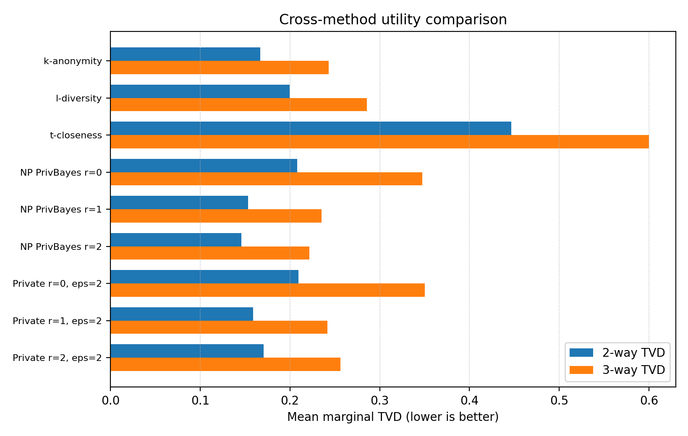
Figure 1. Cross-method 2-way and 3-way marginal TVD. Non-private PrivBayes gives the best utility upper baseline, while the best private setting in the tested grid (r = 1, epsilon = 2.0) is close to k-anonymity under the shared utility metric but has different privacy semantics.
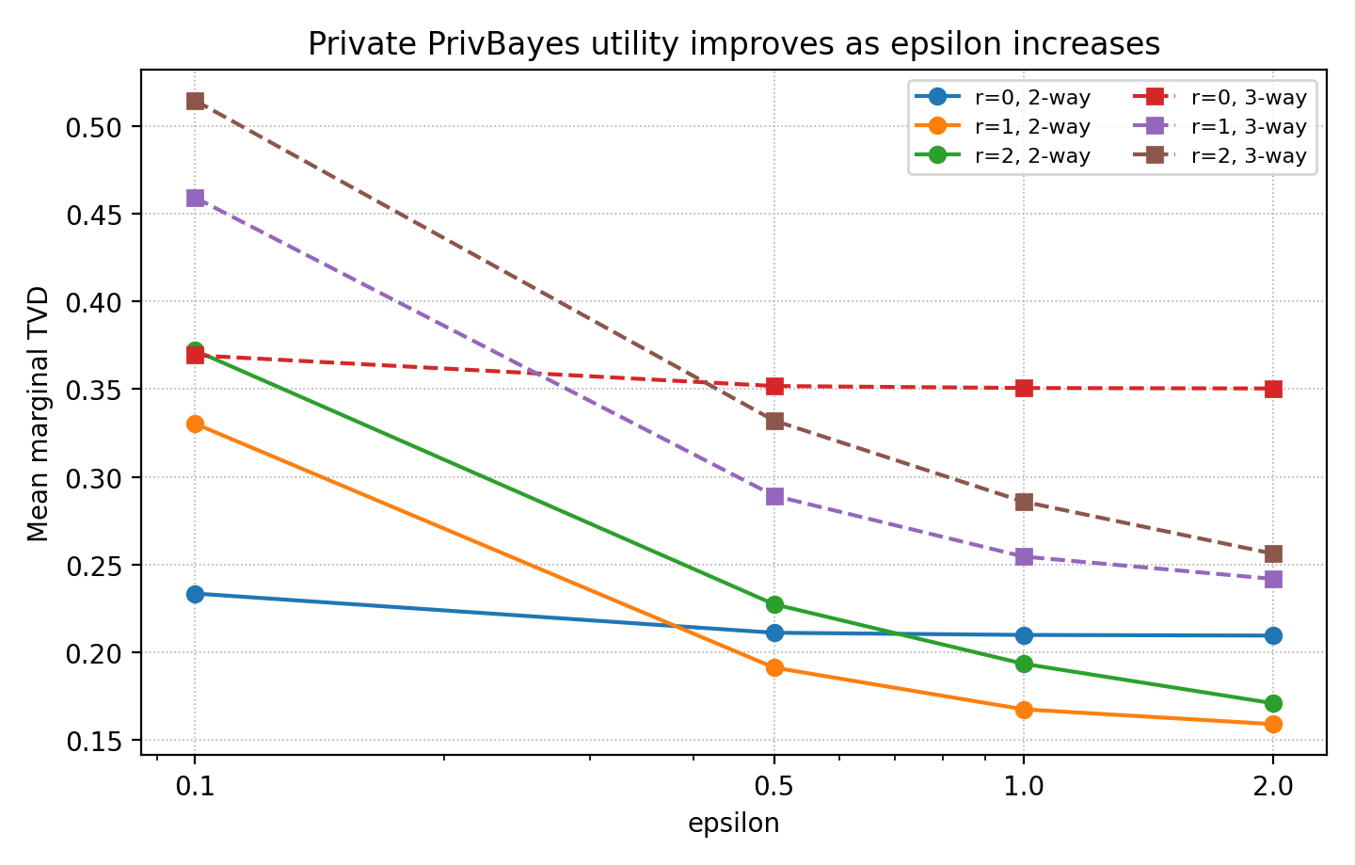
Figure 2. Private PrivBayes marginal TVD by epsilon and parent degree. Utility generally improves as epsilon increases. At low epsilon, r = 0 is more stable because it avoids spending budget on structure learning and higher-dimensional CPTs; at higher epsilon, r = 1 and r = 2 recover more dependency information.
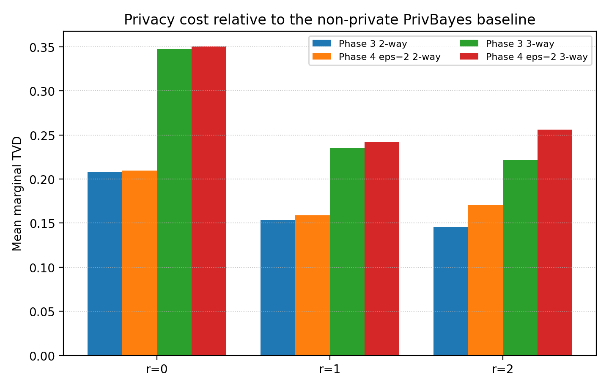
Figure 3. Phase 3 non-private PrivBayes versus Phase 4 private PrivBayes at epsilon = 2.0. The difference is the empirical utility cost of privacy noise in the simplified mechanism. The r = 1 setting has the smallest aggregate gap in this experiment.

7. Discussion and Limitations
The project compares methods with different privacy semantics. k-anonymity, l-diversity, and t-closeness are syntactic privacy models defined over equivalence classes in the released table. They are intuitive and directly checkable, but they do not provide the adversary-independent guarantee of differential privacy. The private PrivBayes implementation instead uses randomized mechanisms and epsilon accounting, but it releases synthetic data whose utility depends heavily on epsilon, parent degree, data size, and discretization.
The most important limitation is that Phase 4 is not the full PrivBayes algorithm. It uses direct MI in the exponential mechanism rather than the lower-sensitivity surrogate F from the paper, uses basic sequential composition rather than advanced composition, and uses a fixed parent-degree grid rather than an automatic theta-usefulness selection rule. The result is appropriate for the simplified course-project requirement, but the report should not claim the same privacy/utility performance as the full PrivBayes paper.
The second limitation is evaluation release. Raw-vs-synthetic TVD and raw MI summaries require raw-data access and are therefore trusted curator-side evaluation outputs. They are valid for the report, but they should not be treated as public differentially private artifacts. The final private-release boundary is the private synthetic datasets and the exponential-mechanism-selected network structure with raw candidate scores removed.

7.1 Final Reporting Checks
The final report should distinguish public/private-release artifacts from curator-side evaluation files. The private synthetic CSVs, private network metadata without raw scores, and privacy-accounting summaries are the intended private-release artifacts. Raw-vs-synthetic TVD and raw MI diagnostics require raw-data access and are report-only evaluation outputs.
The report should also avoid ranking k-anonymity, l-diversity, t-closeness, and differential privacy as if they used the same privacy definition. The numeric comparisons in this report are utility and runtime comparisons under different privacy semantics.

8. Conclusion
The completed project implements and evaluates four privacy-preserving data publishing components on the same correlated Adult-like simulated data: controlled data generation, syntactic anonymization, non-private PrivBayes, and simplified private PrivBayes. Phase 1 confirmed the data generator produced valid schema, rare sensitive cases, and nonzero dependencies. Phase 2 showed that global recoding plus bounded suppression can satisfy k-anonymity, l-diversity, and t-closeness while preserving more utility than pure overgeneralization. Phase 3 showed that a non-private Bayesian network can preserve 2-way and 3-way marginals well when parent degree is greater than zero. Phase 4 showed the expected privacy-utility tradeoff: larger epsilon improves utility, while larger parent degree helps only when the data size and privacy budget are sufficient to overcome noisy CPTs.
The strongest final private setting in the tested grid is r = 1, epsilon = 2.0 by aggregate TVD, while r = 2 becomes competitive for n = 10000. These results support the main conclusion: dependency-aware synthetic data can preserve useful marginal structure, but formal privacy requires noise, careful artifact separation, and conservative reporting of what the simplified mechanism does and does not guarantee.

References
- UCI Machine Learning Repository. Adult dataset / Census Income.
- Zhang, J., Cormode, G., Procopiuc, C. M., Srivastava, D., and Xiao, X. PrivBayes: Private Data Release via Bayesian Networks. SIGMOD 2014.
- Project files: src/generate_simulated_data.py, src/validate_phase1.py, src/anonymize.py, src/validate_anonymization.py, src/evaluate_anonymization.py, src/privbayes_utils.py, src/privbayes_nonprivate.py, src/validate_privbayes_nonprivate.py, src/evaluate_privbayes_nonprivate.py, src/privbayes_private.py, src/validate_privbayes_private.py, src/evaluate_privbayes_private.py.
- Project outputs: outputs/phase1/*, outputs/phase2/*, outputs/phase3/*, outputs/phase4/*, data/anonymized/*, data/synthetic/nonprivate/*, and data/synthetic/private/*.

