Linux Device Driver for interfacing accelerometer using Raspberry Pi

Introduction -
The ADXL345 is a small, thin, low power, 3-axis accelerometer with high resolution (13-bit) measurement at up to ±16 g. Digital output data is formatted as 16-bit twos complement and is accessible through either a SPI (3- or 4-wire) or I2 C digital interface. The ADXL345 is well suited for mobile device applications. It measures the static acceleration of gravity in tilt-sensing applications, as well as dynamic acceleration resulting from motion or shock. Its high resolution (4 mg/LSB) enables measurement of inclination changes less than 1.0°. Several special sensing functions are provided.
Activity and inactivity sensing detect the presence or lack of motion and if the acceleration on any axis exceeds a user-set level. Tap sensing detects single and double taps. Free-fall sensing detects if the device is falling. These functions can be mapped to one of two interrupt output pins. An integrated, patent pending 32-level first in, first out (FIFO) buffer can be used to store data to minimize host processor intervention.

Block Diagram -

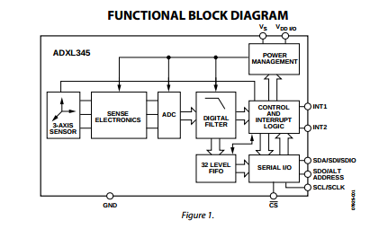
ADXL345
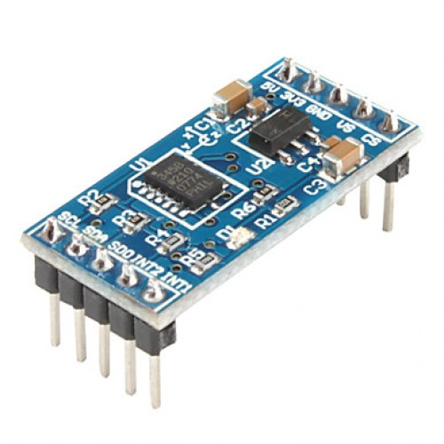

Purpose of Code
Code adxl.c specifies linux device driver for interfacing ADXL345 digital accelerometer module with raspberry pi board.
Actually, we were on a mobile phone project and accelerometer sensor is one part of that. The role of this sensor is to provide the auto rotate feature present in our mobile phone. So, as we tilt the accelerometer module it gives the corresponding axis readings and as soon as the tilt reading ( of respective axis) crosses a certain thresold, screen is rotated. Thus, via this code I have demonstrated that how the readings are changing as we are providing tilt to our accelerometer.

How to use code

In order to use code following steps are to be performed -
- first of all make sure that i2c drivers are installed in your system.

Now steps to execute -
1. Get whole project into a folder and point your directory path towards it.
2. run >> make all
3 Insert the module using >> sudo insmod adxl.ko
4 To check whether i2c device (here accelerometer) is been detected or not run
>> sudo i2cdetect -y 1 // This wil point out the address of the i2c device (0x53 in case of accelerometer ) if it is detected.
4. Finally, for demo of driver run the python script using
>> sudo python script.py

Result – Tilting of the accelerometer will give varying reading of x- , y- . and z- axis .

Applications of ADXL345
Mobile Handsets,
Medical instrumentation Gaming and pointing devices,
Industrial instrumentation,
Personal navigation devices,
Hard disk drive (HDD) protection,
Fitness equipment

Problems occured while building code -
Linux headers not installed - We faced this issue while building our code, to ovecome this a set of command need to be run, these may solve the problem -
Command are -
>> sudo apt-get update
>> sudo apt-get upgrade
(now reboot the system)
>> sudo apt-get install build-essentials linux-headers-$(uname -r)

Enabling i2c - The new Raspbian may have the I2C driver installed but they are disabled by default. To enable it all you need to do is comment out a line by putting # in front. At the prompt type.
>> sudo nano /etc/modprobe.d/raspi-blacklist.conf
Then add # to start of third line

Now install the i2c-tools package by:
>> sudo apt-get install i2c tools
( for more detailed information , you care refer to this - http://skpang.co.uk/blog/archives/575 )

