**A REPORT ON**

**DRIVER FOR BME280**

BY

**JEEVARAAM K 2020H1400216H**

**RISHI S PHAYE 2020H1400230H**

**M.E. EMBEDDED SYSTEMS**

Prepared in partial fulfilment of the

**(G547)**

**DEVICE DRIVERS**



**BIRLA INSTITUTE OF TECHNOLOGY & SCIENCE, PILANI**

**(DECEMBER 2021)**

**LIST OF FIGURES:**

Figure 1: BME280 sensor…………………………………………………………..4

Figure 2: Memory map for BME280……………………………………………………..5

Figure 3: Compensation parameter storage,naming and data type……………………….6

Figure 4: Connection with BME280 with raspberry pi 4…………………………………7

Figure 5: Pin diagram of raspberry pi …………………………………………………….7

Figure 6: Actual connection with BME280……………………………………………….8

**CONTENTS**

1. Summary……………………………………………….………………....4

2. Hardware design……………………………………………………...…..7

3. Kernel Space Driver and its build process………………………………..9

4. User space application build process and usage…………………………17

5. IOCTL Header file……………………………………………………….20

6. Makefile……………………………………………………………….…21

7. Makefile commands……………………………………………………...23

**SUMMARY:**

* This project collects the data(temperature, humidity and pressure) from the sensor BME280 and stores it in a log file in given intervals.
* The user space application is capable of receiving data from the kernel using IOCTL call
* The received data is logged into a log file in the same directory.
* In kernel, once the IOCTL call is received the kernel initiates the I2C read from the sensor applies compensation algorithm to the raw values and transfers them to the user space request; the process is same for all the three parameters.

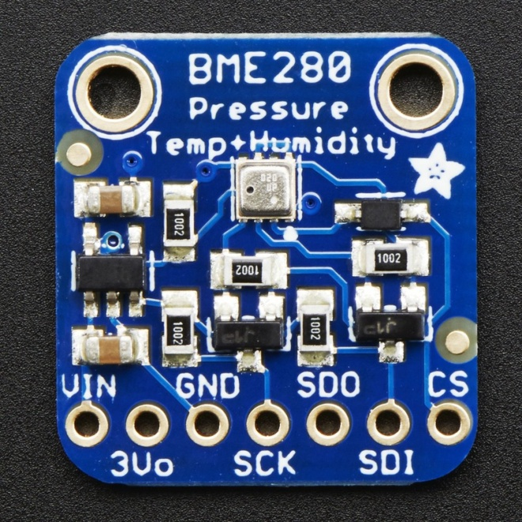

Figure 1: BME280 sensor

**Register description:**

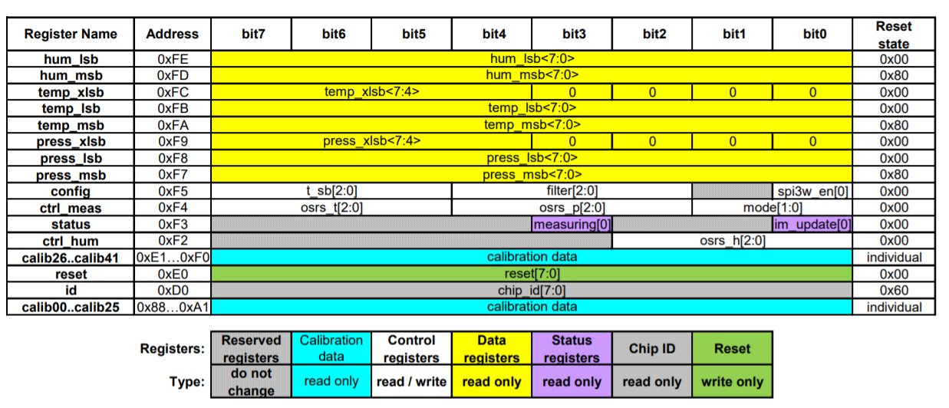

Figure 2 :Memory map for BME280

* The entire communication with the device is performed by reading from and writing to registers, the above memory map is used for all those purposes.
* The Following points must be noted:
* For humidity the register address 0xFE and 0xFD are being used to get the raw data value.
* For temperature the register address 0xFC, 0xFB and 0xFA are being used to get the raw data.
* For pressure the register address starting 0xF9, 0xF8 and 0xF7 are being used to get the raw data.
* Config(0xF5) and ctrl_meas(0xF4) are configured with respective parameters for proper sensing and operation of sensor.

**READING PARAMETERS:**

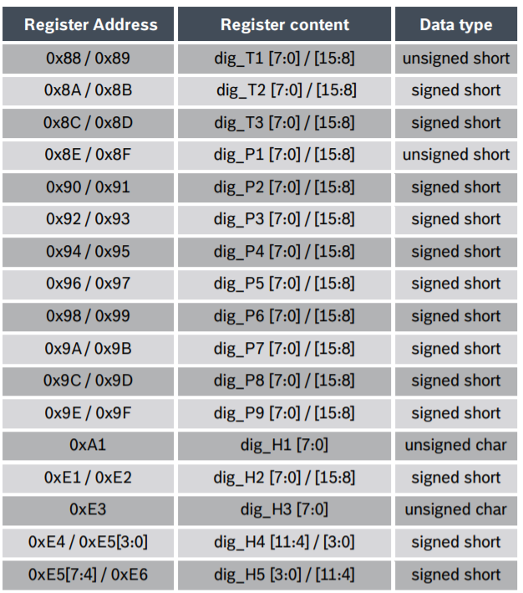



Figure 3: Compensation parameter storage,naming and data type

* The parameter are programmed inside the non-volatile memory during production and we can’t alter it.
* Each compensation word is a 16-bit signed or unsigned integer value stored in 2’s complement form.
* 2 words must always be combined in order to represent the compensation word, as the memory is organized into 8-bit words.
* These compensation parameters are read by the kernel during initialization and kept in global space of kernel module for further calculations during runtime.

**HARDWARE SCHEMATIC:**

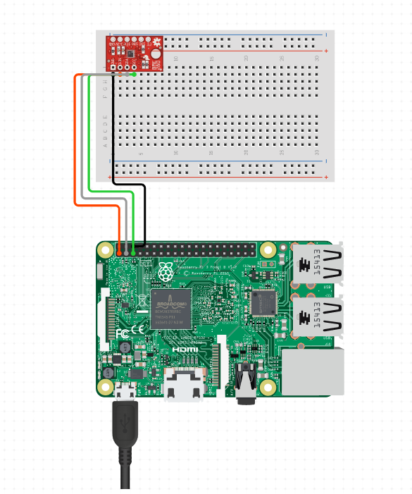

Figure 4: Connection with BME280 with raspberry pi 4

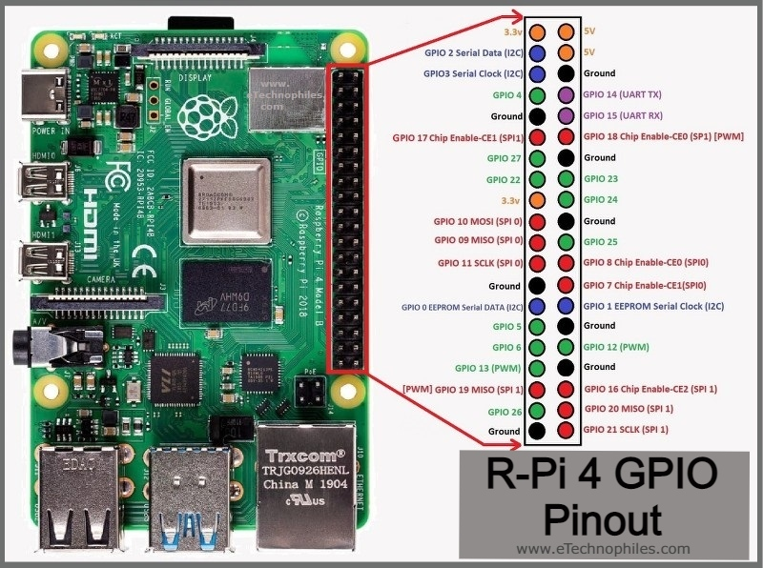

Figure 5: Pin diagram of raspberry pi

The connections for our code will be as explained below:

* 3.3V is given to pin 1 of Raspberry pi and the Vdd pin of BME280
* Pin number 3 of Raspberry Pi is connected to the SDA pin of BME280.
* Pin number 5 of Raspberry Pi is connected to the SCL pin of BME280.
* Pin number 6 of Raspberry Pi and GND pin of BME280 are connected to ground.

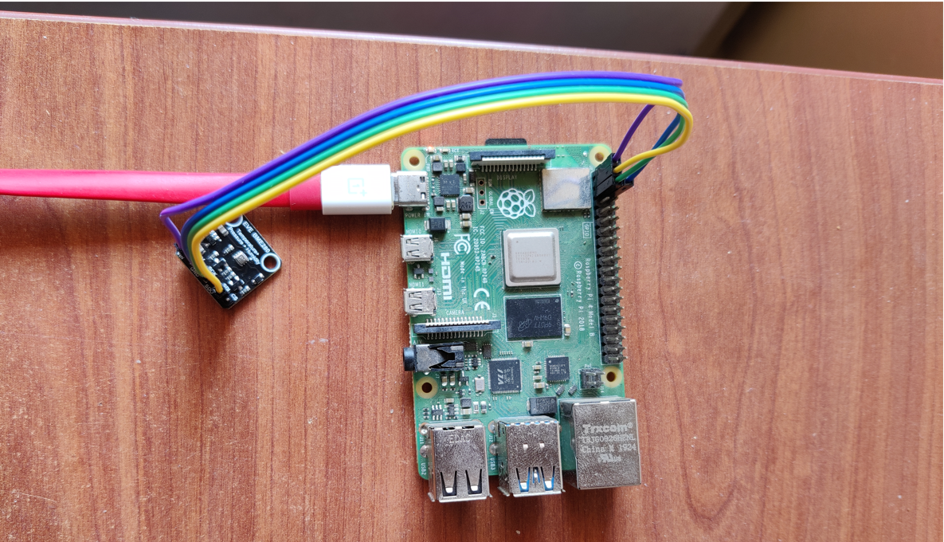

Figure 6: Actual connection with BME280.

**Kernel Space Driver and it’s build process:**

/* General Includes for Kernel Compilation */

#include <linux/module.h>

#include <linux/init.h>

#include <linux/fs.h>

#include <linux/version.h>

#include <linux/cdev.h>

#include <linux/uaccess.h>

#include <linux/slab.h>

#include <linux/i2c.h>

#include <linux/kernel.h>

/* IOCTL Call Definition Header */

#include "config.h"

#define DRIVER_NAME "bme280" //Name of the driver to be created

#define DRIVER_CLASS "bme280Class" //Name of the class to be used for driver

/* User-defined data types for Pressure compensation algorithm */

typedef uint32_t BME280_U32_t;

typedef int32_t BME280_S32_t;

static struct i2c_adapter * bme_i2c_adapter = NULL; //I2C Adapter

static struct i2c_client * bme280_i2c_client = NULL; //I2C Client

/* Variables for holding Trim parameters from the sensor */

int32_t calib_T1,calib_T2,calib_T3,calib_Tfine;

int32_t calib_P1,calib_P2,calib_P3,calib_P4,calib_P5,calib_P6,calib_P7,calib_P8,calib_P9;;

int32_t calib_H1,calib_H2,calib_H3,calib_H4,calib_H5,calib_H6;

/* Driver Metadata */

MODULE_AUTHOR("Jeevaraam K, Rishi S Phaye");

MODULE_LICENSE("GPL");

MODULE_DESCRIPTION("BME280 Sensor Kernel Driver");

#define I2C_BUS_USED       1 //I2C Bus used for Communication

#define BME280_SENSOR_NAME       "BME280" //Sensor name for Metadata

#define BME280_SLAVE_ADDRESS    0x77 //I2C Address of Sensor used

/* Device ID Structure Initialization */

static const struct i2c_device_id bme280_dev_id[]={

{ BME280_SENSOR_NAME, 0},

{ }

};

/* I2C Driver Structure Initialization */

static struct i2c_driver bme280_driver = {

 .driver = {

   .name = BME280_SENSOR_NAME,

   .owner = THIS_MODULE

  }

};

/* Board and Device Mapping Structure */

static struct i2c_board_info bme280_i2c_board_info = {

 I2C_BOARD_INFO(BME280_SENSOR_NAME, BME280_SLAVE_ADDRESS)

};

static dev_t bme280_device_number; //Major and Minor Number holding variable

static struct class *bme280_class; //Sensor class variable

static struct cdev bme280_device; //Char device for Sensor

/*BME280 Compensation Routines */

/* Compensation Routine for reading and Converting Raw Sensor value to Humidity Values */

static uint32_t read_humidity(void)

{

    int32_t var1;

    int32_t var2;

    int32_t var3;

    int32_t var4;

    int32_t var5;

    uint32_t humidity;

    uint32_t humidity_max = 102400;

    uint8_t lsb,msb;

    uint32_t current_humidity;

    /*Read Raw values from sensor */

    lsb = i2c_smbus_read_byte_data(bme280_i2c_client, 0xFE);

    msb = i2c_smbus_read_byte_data(bme280_i2c_client, 0xFD);

    current_humidity = ((uint32_t)msb<<8) | ((uint32_t)lsb);

    /* Compensation Algorithm */

    var1 = calib_Tfine - ((int32_t)76800);

    var2 = (int32_t)(current_humidity * 16384);

    var3 = (int32_t)(((int32_t)calib_H4) * 1048576);

    var4 = ((int32_t)calib_H5) * var1;

    var5 = (((var2 - var3) - var4) + (int32_t)16384) / 32768;

    var2 = (var1 * ((int32_t)calib_H6)) / 1024;

    var3 = (var1 * ((int32_t)calib_H3)) / 2048;

    var4 = ((var2 * (var3 + (int32_t)32768)) / 1024) + (int32_t)2097152;

    var2 = ((var4 * ((int32_t)calib_H2)) + 8192) / 16384;

    var3 = var5 * var2;

    var4 = ((var3 / 32768) * (var3 / 32768)) / 128;

    var5 = var3 - ((var4 * ((int32_t)calib_H1)) / 16);

    var5 = (var5 < 0 ? 0 : var5);

    var5 = (var5 > 419430400 ? 419430400 : var5);

    humidity = (uint32_t)(var5 / 4096);

    if (humidity > humidity_max)

    {

        humidity = humidity_max;

    }

    return humidity;

}

/* Compensation Routine for reading and Converting Raw Sensor value to Pressure Values */

static uint32_t read_pressure(void)

{

 /*int32_t var1;

 int32_t var2;

 int32_t var3;

 int32_t var4;

 uint32_t var5;*/

 uint32_t current_pressure;

 uint8_t lsb,msb,xlsb;

 BME280_S32_t var1, var2;

 BME280_U32_t p;

 /* Read raw values from Sensor */

 lsb = i2c_smbus_read_byte_data(bme280_i2c_client,0xF8);

 msb = i2c_smbus_read_byte_data(bme280_i2c_client,0xF7);

 xlsb = i2c_smbus_read_byte_data(bme280_i2c_client, 0xF9);

 current_pressure = (((uint32_t)msb)<<12) | ((uint32_t)lsb<<4) | ((uint32_t)xlsb>>4);

// current_pressure = ( (current_pressure<<4) | ( (uint32_t) (xlsb&0xF0) >>4 ) );

 printk("Pressure:%x\n",current_pressure);

 /* Compensation Algorithm */

 var1 = (((BME280_S32_t)calib_Tfine)>>1) - (BME280_S32_t)64000;

 var2 = (((var1>>2) * (var1>>2)) >> 11 ) * ((BME280_S32_t)calib_P6);

 var2 = var2 + ((var1*((BME280_S32_t)calib_P5))<<1);

 var2 = (var2>>2)+(((BME280_S32_t)calib_P4)<<16);

 var1 = (((calib_P3 * (((var1>>2) * (var1>>2)) >> 13 )) >> 3) + ((((BME280_S32_t)calib_P2) * var1)>>1))>>18;

 var1 =((((32768+var1))*((BME280_S32_t)calib_P1))>>15);

 if (var1 == 0)

 {

  return 0; // avoid exception caused by division by zero

 }

 p = (((BME280_U32_t)(((BME280_S32_t)1048576)-current_pressure)-(var2>>12)))*3125;

 if (p < 0x80000000)

 {

  p = (p << 1) / ((BME280_U32_t)var1);

 }

 else

 {

  p = (p / (BME280_U32_t)var1) * 2;

 }

 var1 = (((BME280_S32_t)calib_P9) * ((BME280_S32_t)(((p>>3) * (p>>3))>>13)))>>12;

 var2 = (((BME280_S32_t)(p>>2)) * ((BME280_S32_t)calib_P8))>>13;

 p = (BME280_U32_t)((BME280_S32_t)p + ((var1 + var2 + calib_P7) >> 4));

 return p;

static int32_t read_temperature(void)

{

 int32_t var1,var2;

 uint8_t aTemp,bTemp,cTemp;

 int32_t temperature;

 int32_t finalTemp;

 /* Read raw values from Sensor */

 aTemp = i2c_smbus_read_byte_data(bme280_i2c_client, 0xFA);

 bTemp = i2c_smbus_read_byte_data(bme280_i2c_client, 0xFB);

 cTemp = i2c_smbus_read_byte_data(bme280_i2c_client, 0xFC);

 /* Compensation Algorithm */

 temperature = (((int32_t)aTemp) << 12) | (((int32_t)bTemp) << 4) | (((int32_t)cTemp) >> 4);

 var1 = (int32_t)((temperature / 8) - ((int32_t)calib_T1 * 2));

 var1 = (var1 * ((int32_t)calib_T2)) / 2048;

 var2 = (int32_t)((temperature / 16) - ((int32_t)calib_T1));

 var2 = (((var2 * var2) / 4096) * ((int32_t)calib_T3)) / 16384;

 calib_Tfine = var1 + var2;

 finalTemp = ((var1 + var2) * 5 + 128) / 256;

 printk("Temp:%d\n",finalTemp);

 printk("Tfine:%d\n",calib_Tfine);

 return finalTemp;

}

/* Direct Call Read routine for I2C device */

static ssize_t bme280_driver_read(struct file *File, char __user *user_buffer, size_t count, loff_t *offs)

{

 int to_copy, not_copied, delta;

 char out_string[30];

 int32_t temperature;

 int32_t pressure;

 int32_t humidity;

 to_copy = min(sizeof(out_string), count);

 /* Read all 3 values */

 temperature = read_temperature();

 pressure = read_pressure();

 humidity = read_humidity();

 /* Transfer the read values */

 snprintf(out_string, sizeof(out_string), "T:%d,P:%d,H:%d\n",temperature,pressure,humidity);

 not_copied = copy_to_user(user_buffer, out_string, to_copy);

 delta = to_copy - not_copied;

 return delta;

}

/* IOCTL Call routine */

long ioctl_dev(struct file *file, unsigned int ioctl_num, unsigned long ioctl_param)

{

 switch(ioctl_num)

 {

  /* IOCTL Call for Temperature */

  case IOCTL_TEMPERATURE:

  put_user(read_temperature(),(int32_t*)ioctl_param);

  break;

  /* IOCTL Call for Pressure */

  case IOCTL_PRESSURE:

  put_user(read_pressure(),(int32_t*)ioctl_param);

  break;

  /* IOCTL Call for Humidity */

  case IOCTL_HUMIDITY:

  put_user(read_humidity(),(int32_t*)ioctl_param);

  break;

 }

return 0;

}

/* Driver open routine */

static int bme280_driver_open(struct inode *deviceFile, struct file *instance)

{

 printk("Driver Open\n");

 return 0;

}

/* Driver close routine */

static int bme280_driver_close(struct inode *deviceFile, struct file *instance)

{

 printk("Driver Close\n");

 return 0;

}

/* File Operations structure for Open, Close, Read and IOCTL routines linkage */

static struct file_operations fops  = {

 .owner = THIS_MODULE,

 .open = bme280_driver_open,

 .release = bme280_driver_close,

 .unlocked_ioctl = ioctl_dev,

 .read = bme280_driver_read,

};

/* Driver Initialization Routine */

static int __init bme280Init(void)

{

 int ret =-1;

 int32_t tempH4a,tempH4b,tempH5a;

 u8 id;

 printk("Driver Init\n");

 /* Allocating Random Major number from Linux with one device */

 if ( alloc_chrdev_region(&bme280_device_number, 0, 1, DRIVER_NAME) < 0)

 {

  printk("Device Number could not be allocated!\n");

 }

 printk("Device Number %d was registered\n", bme280_device_number);

 /* Create Device Class */

 if ((bme280_class = class_create(THIS_MODULE, DRIVER_CLASS)) == NULL)

 {

  printk("Device Class can not be created!\n");

  goto ClassError;

 }

 /* Create Device file */

 if (device_create(bme280_class, NULL, bme280_device_number, NULL, DRIVER_NAME) == NULL)

 {

  printk("Can not create device file!\n");

  goto FileError;

 }

 /* Initialize Device file */

 cdev_init(&bme280_device, &fops);

 /* register device to kernel */

 if (cdev_add(&bme280_device, bme280_device_number, 1) == -1)

 {

  printk("Registering of device to kernel failed!\n");

  goto KernelError;

 }

 /* Locking I2C Bus Adapter */

 bme_i2c_adapter = i2c_get_adapter(I2C_BUS_USED);

 if(bme_i2c_adapter != NULL)

 {

  /* I2C Client Static Link */

  bme280_i2c_client = i2c_new_client_device(bme_i2c_adapter, &bme280_i2c_board_info);

  if(bme280_i2c_client != NULL)

  {

   /* Add I2C Driver */

   if(i2c_add_driver(&bme280_driver) != -1)

   {

    ret = 0;

   }

   else

    printk("Can't add driver...\n");

  }

  /* Releasing I2C Bus Adapter */

  i2c_put_adapter(bme_i2c_adapter);

 }

 printk("BME280 Driver Init\n");

 /* Read Device ID for Communication Verification */

 id = i2c_smbus_read_byte_data(bme280_i2c_client, 0xD0);

 printk("ID: 0x%x\n",id);

 /* Read Trim Values from the Sensor and store in Global Kernel Variables */

 calib_T1 = i2c_smbus_read_word_data(bme280_i2c_client,0x88);

 calib_T2 = i2c_smbus_read_word_data(bme280_i2c_client,0x8A);

 calib_T3 = i2c_smbus_read_word_data(bme280_i2c_client,0x8C);

 calib_P1 = i2c_smbus_read_word_data(bme280_i2c_client,0x8E);

 calib_P2 = i2c_smbus_read_word_data(bme280_i2c_client,0x90);

 calib_P3 = i2c_smbus_read_word_data(bme280_i2c_client,0x92);

 calib_P4 = i2c_smbus_read_word_data(bme280_i2c_client,0x94);

 calib_P5 = i2c_smbus_read_word_data(bme280_i2c_client,0x96);

 calib_P6 = i2c_smbus_read_word_data(bme280_i2c_client,0x98);

 calib_P7 = i2c_smbus_read_word_data(bme280_i2c_client,0x9A);

 calib_P8 = i2c_smbus_read_word_data(bme280_i2c_client,0x9C);

 calib_P9 = i2c_smbus_read_word_data(bme280_i2c_client,0x9E);

 calib_H1 = i2c_smbus_read_byte_data(bme280_i2c_client,0xA1);

 calib_H2 = i2c_smbus_read_word_data(bme280_i2c_client,0xE1);

 calib_H3 = i2c_smbus_read_byte_data(bme280_i2c_client,0xE3);

 tempH4a = i2c_smbus_read_byte_data(bme280_i2c_client,0xE4);

 tempH4b = i2c_smbus_read_byte_data(bme280_i2c_client,0xE5);

 tempH5a = i2c_smbus_read_byte_data(bme280_i2c_client,0xE6);

 calib_H6 = i2c_smbus_read_byte_data(bme280_i2c_client,0xE7);

 calib_H4 = (tempH4a<<4) | (tempH4b&0x0F);

 calib_H5 = (tempH5a<<4) | ((tempH4b&0xF0)>>4);

 if(calib_T2 > 32767)

 {

  calib_T2 -= 65536;

 }

 if(calib_T3 > 32767)

 {

  calib_T3 -= 65536;

 }

 printk("BME280 Calib Values\n");

 printk("T1:%d\nT2:%d\nT3:%d\nP1:%d\nP2:%d\nP3:%d\nP4:%d\nP5:%d\nP6:%d\nP7:%d\nP8:%d\nP9:%d\n",calib_T1,calib_T2,calib_T3,calib_P1,calib_P2,calib_P3,calib_P4,calib_P5,calib_P6,calib_P7,calib_P8,calib_P9);

 /* Sensor Initilatization Sequence */

 i2c_smbus_write_byte_data(bme280_i2c_client, 0xf5, 5<<5);

 i2c_smbus_write_byte_data(bme280_i2c_client, 0xf4, ((5<<5) | (5<<2) | (3<<0)));

 return ret;

 /* Error Handling on Failure */

KernelError:

        device_destroy(bme280_class, bme280_device_number);

FileError:

        class_destroy(bme280_class);

ClassError:

        unregister_chrdev(bme280_device_number, DRIVER_NAME);

        return (-1);

}

/* Driver Uninitialization routine */

static void __exit bme280Exit(void)

{

 printk("bme280_deviceDriver - Goodbye, Kernel!\n");

 i2c_unregister_device(bme280_i2c_client);

 i2c_del_driver(&bme280_driver);

 cdev_del(&bme280_device);

 device_destroy(bme280_class, bme280_device_number);

 class_destroy(bme280_class);

 unregister_chrdev_region(bme280_device_number, 1);

}

/*Linking Init and Exit Functions to Driver Structure */

module_init(bme280Init);

module_exit(bme280Exit);

**User space application build process and usage**

/* General Includes */

#include<stdio.h>

#include<stdlib.h>

#include<fcntl.h>

#include<unistd.h>

#include<sys/ioctl.h>

#include<signal.h>

#include<unistd.h>

#include<time.h>

/* IOCTL Interface Definition */

#include "config.h"

/* Char Device Variable */

int file_desc;

/* Log File */

FILE *fptr;

/* SIGINT Signal Handler */

void exitHandler(int sig_num)

{

 signal(SIGINT, exitHandler);

 printf("\nExit Initiated");

 close(file_desc);

 fprintf(fptr,"\n");

 fclose(fptr);

 printf("\nShutdown Procedures Complete.Bye\n");

 exit(0);

}

/* IOCTL Userspace Call for Pressure */

int ioctl_pressure(int file_desc, int32_t *msg)

{

 int ret_val;

 ret_val = ioctl(file_desc, IOCTL_PRESSURE,msg);

 return ret_val;

}

/* IOCTL Userspace Call for Temperature */

int ioctl_temperature(int file_desc, int32_t *msg)

{

 int ret_val;

 ret_val = ioctl(file_desc, IOCTL_TEMPERATURE,msg);

 return 0;

}

/* IOCTL Userspace Call for Humidity */

int ioctl_humidity(int file_desc, int32_t *msg)

{

 int ret_val;

 ret_val = ioctl(file_desc, IOCTL_HUMIDITY,msg);

 return 0;

}

/* Main Routine */

int main(void)

{

 int ret_val,i;

 int32_t recv_msg;

 time_t ltime;

 struct tm result;

 char time_string[32];

 float temperature,pressure,humidity;

 /* Register SIGINT Handler */

 signal(SIGINT, exitHandler);

 /* Open Char Device */

 file_desc = open(DEVICE_FILE_NAME,0);

 /* Log File Open */

 fptr = fopen("data.log","a");

 if(file_desc<0)

 {

  printf("Device Open Failed for %s\n",DEVICE_FILE_NAME);

  exit(-1);

 }

 printf("Logging started...\n");

 /* Infinite Execution Block */

 while(1)

 {

  /* Current Timestame Retrieval */

  ltime = time(NULL);

  localtime_r(&ltime, &result);

  asctime_r(&result, time_string);

  i=0;

  /* Format Timestamp for Log Print */

  while(time_string[i]!='\0')

  {

   if(time_string[i]=='\n')

    time_string[i]=0;

   i++;

  }

  /* Print Timestamp to Log File */

  fprintf(fptr, "%s : ",time_string);

  /* Retrieve Temperature and Print to Log File */

  ioctl_temperature(file_desc,&recv_msg);

  temperature = (float)recv_msg/100.0;

  fprintf(fptr, "Temperature:%f ",temperature);

  /* Retrieve Pressure and Print to Log File */

  ioctl_pressure(file_desc,&recv_msg);

  pressure = (float)recv_msg/100.0;

  fprintf(fptr, "Pressure:%f ",pressure);

  /* Retrieve Humidity and Print to Log File */

  ioctl_humidity(file_desc,&recv_msg);

  humidity = (float)recv_msg/1024.0;

  fprintf(fptr, "Humidity:%f\n", humidity);

  /* Delay for 5 Seconds */

  sleep(5);

 }

}

**IOCTL Header file:**

#ifndef CHAR_CONFIG_H

#define CHAR_CONFIG_H

#include <linux/ioctl.h>

#define MAGIC_NUM 225

//IOCTL interface prototypes

#define IOCTL_TEMPERATURE _IOWR(MAGIC_NUM, 0, int32_t *)

#define IOCTL_HUMIDITY _IOWR(MAGIC_NUM, 1, int32_t *)

#define IOCTL_PRESSURE _IOWR(MAGIC_NUM, 2, int32_t *)

//Device file interface

#define DEVICE_FILE_NAME "/dev/bme280"

#endif

**Makefile:**

# All the Parameters can be over-ridden while Make call from the Terminal. Default values are assigned to match with the currnet project files.

# Note: The make recepies are designed in such a way assuming the make invoke is done from superuser(root)

# Name of the Userapp file.

USERFILE ?= userapp

# Name of the Kernel File

KERN_NAME ?= bme280

# Name of the Data Log file used for storing sensor values

DATAFILE ?= data.log

# Default Text Editor for displaying the log file

TEXT_EDITOR ?= nano

# Kernel Module Name Definition

obj-m := $(KERN_NAME).o

# Compiles the Kernel and Userapp files

all:

    make -C /lib/modules/$(shell uname -r)/build M=$(shell pwd) modules

    gcc -o $(USERFILE) $(USERFILE).c

# Compiles the Kernel code alone

kern:

    make -C /lib/modules/$(shell uname -r)/build M=$(shell pwd) modules

# Compiles the Userapp alone

user:

    gcc -o $(USERFILE) $(USERFILE).c

# Cleans the directory (Won't remove the log file)

clean:

    make -C /lib/modules/$(shell uname -r)/build M=$(shell pwd) clean

    rm userapp

# Installs the Compiled Kernel Module into Kernel Space

install:

    sudo insmod $(KERN_NAME).ko

# Removes the loaded module from the Kernel Space

remove:

    sudo rmmod $(KERN_NAME).ko

# Runs the Userapp Application

run:

    sudo ./$(USERFILE)

# Deletes the Sensor Log generated by Userapp application

log_clean:

    rm $(DATAFILE)

# Displays the Log generated by the Userapp application

log_display:

    nano $(DATAFILE)

**MAKE COMMANDS:**

All the Operations are defined as Makefile recepies to make it easier for the execution

Following are the various recepies defined for compilation and execution

1. all - Compiles Kernel and User Space Code
2. kern - Compiles Kernel Space Code
3. user - Compiles User Space Code
4. install - Installs Kernel Module into Kernel Space
5. remove - Removes Kernel Module from Kernel Space
6. log_display - Displays the Log generated by User Space application
7. log_delete - Deletes the Log generated by the User Space application
8. log_clean – will delete the data log file
9. clean – erases the all the executables and compiled files
10. run - Runs the User Space Application