Project Title – Implementing the functionality of the sensor LM75 using IIO

# Summary :-

IIO provides standard interface to user space applications LM75.This project aims to develop a driver for a temperature sensor to interface it with any device running on linux which has i2c functionality. For testing we are using a Raspberry pi as the host running the Raspbian OS on top. It is based on Debian which is a popular version of Linux.

# Hardware Design :-

* Raspberry Pi 4 Model B
* LM75 sensor

Datasheet : <https://www.nxp.com/docs/en/data-sheet/LM75B.pdf>

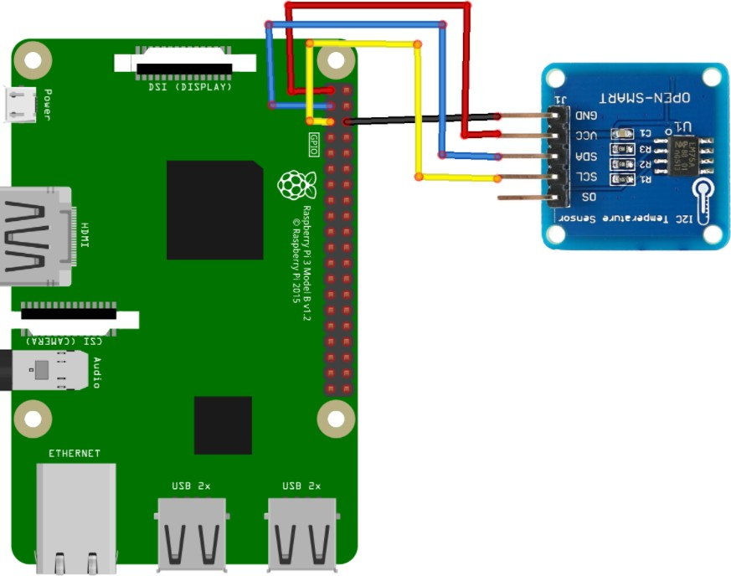

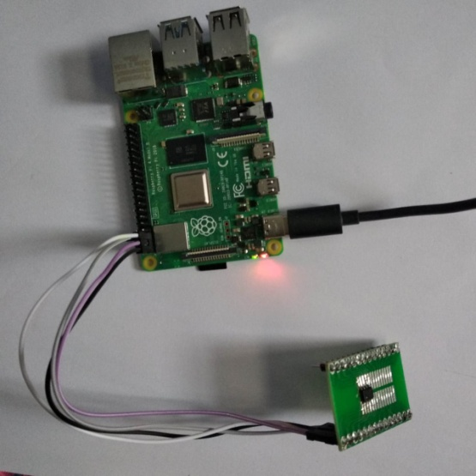

LM-75 Address Mapping :-

## Pin Configuration:-

Sensor - Raspberry Pi VCC - Pin 1 (3.3V) GND - Pin 6

SDA - Pin3 SCL - Pin 5

|  |  |
| --- | --- |
| **Address** | **Function** |
| 0x00h | Temperature register |
| 0x01h | Configuration register |
| 0x02h | Hysteresis register |
| 0x03h | Over temperature shutdown threshold register |

The driver is meant to be used with the Linux kernel. It creates a simple interface for the host to communicate with the sensor. The sensor and the host use I2C communication protocol to transfer information.

Commands to be executed for driver insertion into the kernel:

(Note : To be executed from the directory where the make file and kernel are present.)

* make
* sudo insmod temp.ko

(Temp is the name of kernel file)

To remove the driver the following command can be executed:

* sudo rmmod temp.ko

Commands to be executed after driver insertion:-

* ./user : To run the userapp