Titile : OTT PLATFORM

Contributed by

22CSB0C13 CHINTHAREDDY HRUSHIK REDDY (Section A)

DESCRIPTION

The OTT database serves as the foundation for organizing and managing all data related to an online streaming platform. It acts as a centralized repository, storing crucial information such as user details, content metadata, payment transactions, viewing statistics, subscription information, ratings, subtitle options, and awards received by content.

Through its interconnected structure and robust relational architecture, the OTT database facilitates seamless communication between different components of the streaming platform, ensuring smooth user interactions and content delivery. Overall, it plays a pivotal role in driving engagement, fostering content discovery, and maximizing the platform's overall success.

Entities and Relations

Entities

**Users:** Representing individuals registered on the platform. It consists of attributes UserID as “Primary key” , UserName ,

Email ,EndDate and Password.

NOTE: The attribute EndDate describes the Last active day of the subscription.

Payments: Recording financial transactions made by Users. It

Consists of attributes PayID as “Primary key” ,Amount

PaymentDate.

Subscriptions: Managing user Subscription Data. It

Consists of attributes SubscribeID as “Primary key” , EndDate,

StartDate,Type .

Contents: Cataloging diverse range of media available for streaming . It Consists of attributes ContentID as “Primary key”,

ReleaseDate, Type, Genere, Title.

Ratings: Capturing User provided rating for the content. It consists

Of attributes RatingID, Rating, Timestamp.

Subtitles : Storing information about available subtitle options for the respective content.It consists of attributes

SubtitleID as “primary key” , NoOfLanguages , English,Tamil,Telugu,Hindi.

NOTE: The attributes English,Hindi,Tamil,Telugu contains Boolean values i.e The respective language subtitle is present or not.

Awards: Recording the accolades and recognition received by content hosted on the platform, showcasing noteworthy achievements. It consists of attributes AwardID as “primary key”,AwardYear,AwardName.

Relations

**HasViewed (Users to Views)**

This relationship signifies the connection between users and the views they've made. It allows tracking of the views made by each user individually

The cardinality is 1:n because one user can have multiple views (for example, watching multiple movies or TV shows over time). However, each view is associated with only one user. Therefore, for each user, there can be multiple related views, but each view is tied to only one user.

**MadePayment (Users to Payments):**

This relationship represents the link between users and their payment transactions. It enables the tracking of financial transactions made by users.

The cardinality is 1:n because one user can make multiple payments (e.g., subscribing to different services or making periodic payments for subscriptions). However, each payment is associated with only one user. Therefore, for each user, there can be multiple related payments, but each payment is tied to only one user.

**ForContent (Payments to Contents):**

This relationship indicates the association between payments and the content they are related to. It reflects which content items users have paid for.

The cardinality is m:n because multiple payments can be associated with multiple contents. Users can make payments for various content items, and each content item can receive payments from multiple users. Therefore, the relationship between payments and contents is many-to-many.

**Viewed (Views to Contents):**

This relationship signifies the connection between views and the content being watched. It allows tracking which content items users have viewed.

The cardinality is n:1 because multiple views can be associated with one content. Users can watch the same content item multiple times. However, each view is tied to only one content item. Therefore, for each content item, there can be multiple related views, but each view is associated with only one content item.

**HasSubtitles (Contents to Subtitles):**

This relationship indicates which subtitles are available for each content item. It ensures that various language options for subtitles are associated with each content.

The cardinality is 1:n because one content item can have multiple subtitle options available. Different language options for subtitles can be provided for a single content item. However, each subtitle option is associated with only one content item. Therefore, for each content item, there can be multiple related subtitle options, but each subtitle option is tied to only one content item.

**Rated (Ratings to Contents):**

This relationship indicates the user-provided ratings for each content item. It allows tracking the ratings given by users to different content items.

The cardinality is n:1 because multiple ratings can be given for one content item. Different users can rate the same content item. However, each rating is tied to only one content item. Therefore, for each content item, there can be multiple related ratings, but each rating is associated with only one content item.

**WonAwards (Contents to Awards):**

This relationship signifies the recognition and accolades received by each content item. It allows tracking which awards have been won by which content items.

The cardinality is 1:n because one content item can win multiple awards. Different awards can be received by a single content item. However, each award is associated with only one content item. Therefore, for each content item, there can be multiple related awards, but each award is tied to only one content item.

ER DIAGRAM

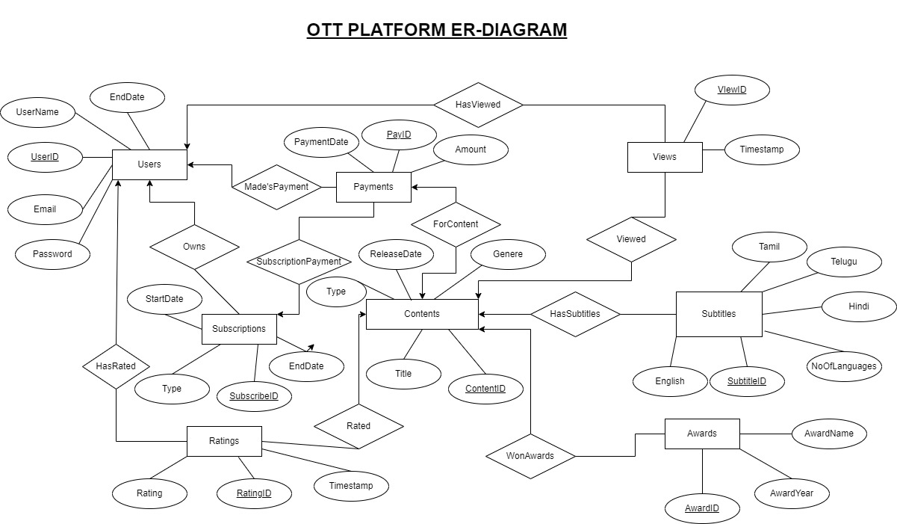

RELATIONAL DIAGRAM

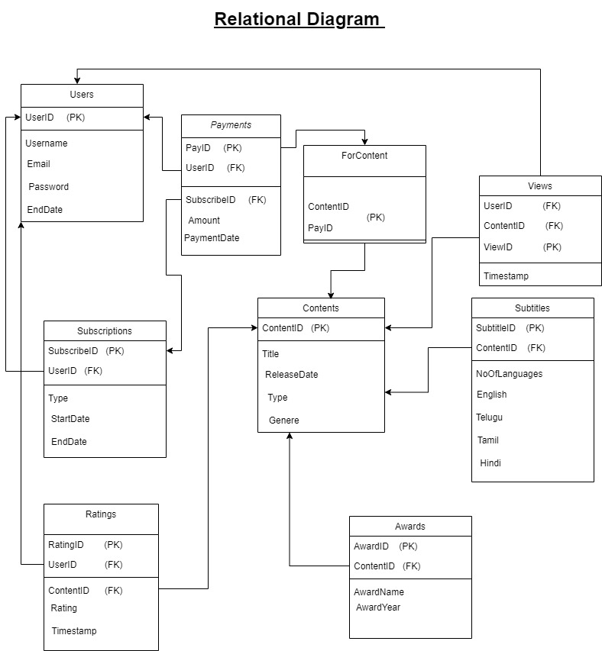

Normalization

STEP 1:

In above relational diagram we can notice all the attributes have monoatomic Values . So it is in 1NF.

STEP 2:

The primary key of all the tables is a single attribute not union of two or more attributes . Therefore there is no chance of partial dependency .

Hence we can say that above relational schema is in 2NF.

STEP 3:

There are no functional dependencies like non_prime determining non_prime.

Hence we can say the above relational schema is in 3NF

STEP 4:

In all functional dependencies the only primary is determining all other attributes.

Hence we can say the above relational schema is in BCNF.

**CREATING TABLES**

create database ott;

use ott;

-- Users table

CREATE TABLE Users (

UserID INT PRIMARY KEY,

Username VARCHAR(255),

Email VARCHAR(255),

Password VARCHAR(255),

EndDate DATE

);

-- Subscriptions table

CREATE TABLE Subscriptions (

SubscribeID INT PRIMARY KEY,

UserID INT,

Type VARCHAR(50),

StartDate DATE,

EndDate DATE,

FOREIGN KEY (UserID) REFERENCES Users(UserID)

);

-- Payments table

CREATE TABLE Payments (

PayID INT PRIMARY KEY,

UserID INT,

Amount DECIMAL(10, 2),

PaymentDate DATE,

SubscribeID INT,

FOREIGN KEY (UserID) REFERENCES Users(UserID),

FOREIGN KEY (SubscribeID) REFERENCES Subscriptions(SubscribeID)

);

-- Contents table

CREATE TABLE Contents (

ContentID INT PRIMARY KEY,

Title VARCHAR(255),

ReleaseDate DATE,

Type VARCHAR(50),

Genre VARCHAR(100)

);

-- Views table

CREATE TABLE Views (

ViewID INT PRIMARY KEY,

UserID INT,

ContentID INT,

Timestamp TIMESTAMP,

FOREIGN KEY (UserID) REFERENCES Users(UserID),

FOREIGN KEY (ContentID) REFERENCES Contents(ContentID)

);

-- Ratings table

CREATE TABLE Ratings (

RatingID INT PRIMARY KEY,

UserID INT,

ContentID INT,

Rating INT,

Timestamp TIMESTAMP,

FOREIGN KEY (UserID) REFERENCES Users(UserID),

FOREIGN KEY (ContentID) REFERENCES Contents(ContentID)

);

-- Awards table

CREATE TABLE Awards (

AwardID INT PRIMARY KEY,

ContentID INT,

AwardName VARCHAR(255),

Year INT,

FOREIGN KEY (ContentID) REFERENCES Contents(ContentID)

);

-- Subtitles table

CREATE TABLE Subtitles (

SubtitleID INT PRIMARY KEY,

ContentID INT,

NoOfLanguages INT,

English BOOL,

Hindi BOOL,

Tamil BOOL,

Telugu BOOL,

FOREIGN KEY (ContentID) REFERENCES Contents(ContentID)

);

-- For_Content table

CREATE TABLE ForContent (

PayID INT,

ContentID INT,

PRIMARY KEY (PayID, ContentID),

FOREIGN KEY (PayID) REFERENCES Payments(PayID),

FOREIGN KEY (ContentID) REFERENCES Contents(ContentID)

);

**INSERTING VALUES**

1. **Users**

INSERT INTO Users (UserID, Username, Email, Password, EndDate)

VALUES

(10045, 'Rayudu', 'Rayudu@gmail.com', 'password123', '2021-12-31'),

(12342, 'Hrushik', 'hru@gmail.com', 'password456', '2022-06-30'),

(10123, 'Alekhya', 'Alu_1@gmail.com', 'password789', '2022-10-15'),

(77777, 'Krishna', 'Krish@gmail.com', 'password321', '2021-08-20'),

(54321, 'Aishwarya', 'Aish@gmail.com', 'password654', '2022-09-25'),

(98765, 'Shreya', 'Shrey@gmail.com', 'password987', '2021-01-10'),

(24680, 'Vaishnavi', 'Vaish@gmail.com', 'password126', '2022-12-05'),

(11111, 'Karthik', 'Karti@gmail.com', 'password789', '2022-04-30'),

(88888, 'Deekshith', 'dee@gmail.com', 'password956', '2021-03-15'),

(55555, 'Virat', 'viru@gmail.com', 'password763', '2022-11-20'),

(22222, 'sakshi', 'sa1234@gmail.com', 'password906', '2021-02-25'),

(99999, 'Rithika', 'Rith@gmail.com', 'password999', '2022-07-10'),

(44444, 'vikram', 'viky@gmail.com', 'password543', '2022-08-15'),

(77799, 'kaushal', 'kau@gmail.com', 'password232', '2021-05-30'),

(33333, 'vedika', 'vedh@gmail.com', 'password781', '2021-09-05');

1. **Subscriptions**

INSERT INTO Subscriptions (SubscribeID, UserID, Type, StartDate, EndDate)

VALUES

(12258, 10045, 'Premium', '2020-01-01', '2021-12-31'),

(138492, 12342, 'Basic', '2022-01-30', '2022-06-30'),

(980124, 10123, 'Super', '2022-01-15', '2022-10-15'),

(25081, 77777, 'Premium', '2020-08-20', '2021-08-20'),

(14582, 54321, 'Basic', '2022-03-15', '2022-09-25'),

(98632, 98765, 'Premium', '2020-01-10', '2021-01-10'),

(36512, 24680, 'Super', '2022-06-05', '2022-12-05'),

(75492, 11111, 'Basic', '2021-10-30', '2022-04-30'),

(25417, 88888, 'Premium', '2020-03-15', '2021-03-15'),

(12039, 55555, 'Basic', '2022-05-20', '2022-11-20'),

(93621, 22222, 'Premium', '2020-02-25', '2021-02-25'),

(75432, 99999, 'Super', '2022-01-10', '2022-07-10'),

(15874, 44444, 'Basic', '2022-02-15', '2022-08-15'),

(33659, 77799, 'Premium', '2020-05-30', '2021-05-30'),

(57234, 33333, 'Super', '2021-03-05', '2021-09-05');

1. **Payments**

INSERT INTO Payments (PayID, UserID, Amount, PaymentDate, SubscribeID)

VALUES

(122, 10045, 1725.00, '2020-01-01', 12258),

(123, 12342, 999.00, '2022-01-30', 138492),

(124, 10123, 1250.00, '2022-01-15', 980124),

(125, 77777, 1725.00, '2020-08-20', 25081),

(126, 54321, 999.00, '2022-03-15', 14582),

(127, 98765, 1725.00, '2020-01-10', 98632),

(128, 24680, 1250.00, '2022-06-05', 36512),

(129, 11111, 999.00, '2021-10-30', 75492),

(130, 88888, 1725.00, '2020-03-15', 25417),

(131, 55555, 999.00, '2022-05-20', 12039),

(132, 22222, 1725.00, '2020-02-25', 93621),

(133, 99999, 1250.00, '2022-01-10', 75432),

(134, 44444, 999.00, '2022-02-15', 15874),

(135, 77799, 1725.00, '2020-05-30', 33659),

(136, 33333, 1250.00, '2021-03-05', 57234);

1. **Contents**

INSERT INTO Contents (ContentID, Title, ReleaseDate, Type, Genre)

VALUES

(13910, 'The Matrix', '1999-03-31', 'Movie', 'Sci-Fi'),

(13911, 'Breaking Bad', '2008-01-20', 'TV Show', 'Drama'),

(13912, 'The Shawshank Redemption', '1994-09-23', 'Movie', 'Drama'),

(13913, 'Friends', '1994-09-22', 'TV Show', 'Comedy'),

(13914, 'The Godfather', '1972-03-24', 'Movie', 'Crime'),

(13915, 'Stranger Things', '2016-07-15', 'TV Show', 'Sci-Fi'),

(13916, 'Inception', '2010-07-16', 'Movie', 'Action'),

(13917, 'Game of Thrones', '2011-04-17', 'TV Show', 'Fantasy'),

(13918, 'Pulp Fiction', '1994-10-14', 'Movie', 'Crime'),

(13919, 'The Office', '2005-03-24', 'TV Show', 'Comedy'),

(13920, 'The Dark Knight', '2008-07-18', 'Movie', 'Action'),

(13921, 'Breaking Bad', '2008-01-20', 'TV Show', 'Drama'),

(13922, 'The Lord of the Rings: The Fellowship of the Ring', '2001-12-19', 'Movie', 'Adventure'),

(13923, 'The Crown', '2016-11-04', 'TV Show', 'Drama'),

(13924, 'Forrest Gump', '1994-07-06', 'Movie', 'Drama');

1. **Awards**

INSERT INTO Awards (AwardID, ContentID, AwardName, Year)

VALUES

(1001, 13910, 'Best Visual Effects', 2000),

(1002, 13914, 'Best Picture', 1973),

(1003, 13916, 'Best Cinematography', 2011),

(1004, 13917, 'Best Drama Series', 2015),

(1005, 13920, 'Best Supporting Actor', 2009),

(1006, 13922, 'Best Visual Effects', 2002),

(1007, 13924, 'Best Actor', 1995),

(1008, 13911, 'Best Drama Series', 2013),

(1009, 13913, 'Best Comedy Series', 2002),

(1010, 13915, 'Best Ensemble Cast', 2017),

(1011, 13919, 'Best Comedy Series', 2006),

(1012, 13921, 'Best Actor', 2010),

(1013, 13923, 'Best Drama Series', 2018),

(1014, 13912, 'Best Picture', 1995),

(1015, 13918, 'Best Original Screenplay', 1995);

1. **Views**

INSERT INTO Views (ViewID, UserID, ContentID, Timestamp)

VALUES

(1001, 10045, 13910, '2021-05-01 08:30:00'),

(1002, 12342, 13914, '2022-04-15 12:45:00'),

(1003, 10123, 13913, '2022-07-20 17:20:00'),

(1004, 77777, 13920, '2020-10-09 19:10:00'),

(1005, 54321, 13912, '2022-07-15 22:55:00'),

(1006, 98765, 13921, '2020-02-01 14:30:00'),

(1007, 24680, 13916, '2022-08-20 09:40:00'),

(1008, 11111, 13923, '2022-03-30 16:25:00'),

(1009, 88888, 13915, '2020-04-15 11:15:00'),

(1010, 55555, 13919, '2022-09-09 20:05:00'),

(1011, 22222, 13922, '2020-03-14 18:00:00'),

(1012, 99999, 13911, '2022-01-27 13:10:00'),

(1013, 44444, 13918, '2022-08-03 10:20:00'),

(1014, 77799, 13917, '2020-06-01 14:50:00'),

(1015, 33333, 13924, '2021-09-05 16:35:00');

1. **Subtitles**

INSERT INTO Subtitles (SubtitleID, ContentID, NoOfLanguages, English, Hindi, Tamil, Telugu)

VALUES

(1, 13910, 3, TRUE,TRUE, FALSE, TRUE),

(2, 13911, 2, TRUE, TRUE, FALSE, FALSE),

(3, 13912, 1, TRUE, FALSE, FALSE, FALSE),

(4, 13913, 3, TRUE, TRUE, FALSE, TRUE),

(5, 13914, 3, TRUE, TRUE, TRUE, FALSE),

(6, 13915, 4, TRUE, TRUE, TRUE, TRUE),

(7, 13916, 2, TRUE, FALSE, TRUE, FALSE),

(8, 13917, 3, TRUE, TRUE, TRUE, FALSE),

(9, 13918 , 4, TRUE, TRUE, TRUE, TRUE),

(10, 13919, 3, TRUE, FALSE, TRUE, TRUE),

(11, 13920, 2, TRUE, FALSE, FALSE, TRUE),

(12, 13921, 2, TRUE, FALSE, TRUE, FALSE),

(13, 13922, 4, TRUE, TRUE, TRUE, TRUE),

(14, 13923, 3, TRUE, TRUE, TRUE, FALSE),

(15, 13924, 2, TRUE, TRUE, FALSE, FALSE);

1. **Ratings**

INSERT INTO Ratings (RatingID, UserID, ContentID, Rating, Timestamp)

VALUES

(1, 10045, 13910, 4, '2020-01-25 12:45:00'),

(2, 12342,13911 , 5, '2022-06-21 09:30:00'),

(3, 10123,13912 , 5, '2022-09-26 14:20:00'),

(4, 77777,13913 , 3, '2021-02-10 10:00:00'),

(5, 54321,13914 , 4, '2022-07-25 16:30:00'),

(6, 98765,13915 , 5, '2020-07-15 11:45:00'),

(7, 24680, 13916, 4, '2022-12-01 08:15:00'),

(8, 11111,13917 , 3, '2021-10-30 14:00:00'),

(9, 88888, 13918, 5, '2020-03-25 17:00:00'),

(10, 55555, 13919, 4, '2023-11-01 20:30:00'),

(11, 22222, 13920, 2,'2020-09-25 13:45:00'),

(12, 99999, 13921, 3, '2022-07-06 09:00:00'),

(13, 44444,13922 , 4, '2022-06-30 11:20:00'),

(14, 77799,13923 , 5, '2021-04-15 18:45:00'),

(15, 33333,13924 , 5, '2021-03-25 12:00:00');

1. **ForContent**

INSERT INTO ForContent (PayID, ContentID)

VALUES

(122, 13910),

(123, 13914),

(124, 13913),

(125, 13920),

(126, 13912),

(127, 13921),

(128, 13916),

(129, 13923),

(130, 13915),

(131, 13919),

(132, 13922),

(133, 13911),

(134, 13918),

(135, 13917),

   (136, 13924);

**DISPLAYING THE TABLES**

## Users

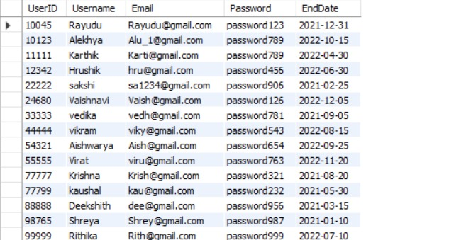

## Payments

## 

## Subscriptions

## 

## Contents

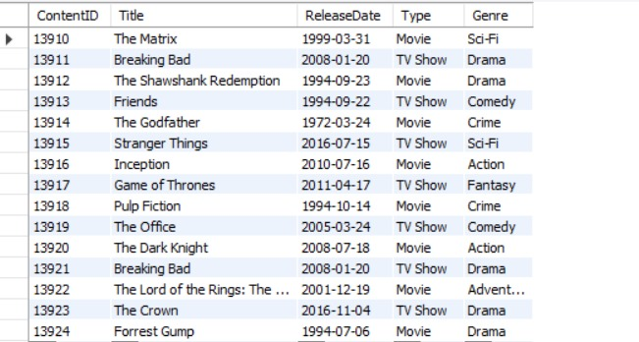

## Ratings

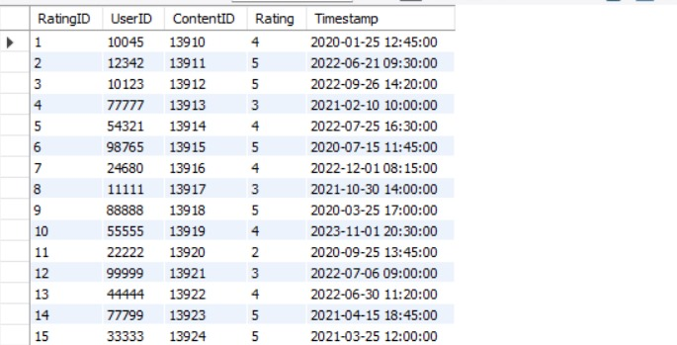

## Views

## 

## Awards

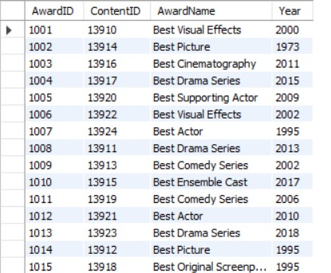

## Subtitles

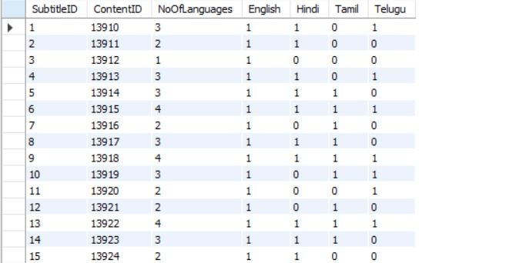

## ForContent

