

Hello,
Thank you for purchasing Photopro wordpress theme. This is the readme file or also known as guide that may help you.
About the theme:
Photopro is a wordpress theme which you can use for:
- a personal gallery.
- a photoblog site.

Browser compatibility:
Firefox2, Firefox 3, IE 6, Safari

Features:
- Widget ready
- Gravatar ready
- Trackbacks and comments separated
- Specialize for photoblog (custom filed)
- Easy navigation
- Ajax (tooltip, slider)
- Custom user detail (edit in admin panel)
- & More..

F.A.Q
Q. Where is the advertisement section?
A. You are wrong. This theme isn’t for showing ads. But you can use widget to put anything you like in the sidebar. Max width of sidebar is 220 pixels.

Q. Can i add more stuff in the sidebar?
A. Yes you can, this theme is widgetize.

Q. Why someone has picture in the comment list?
A. That is Gravatar. You can create one. Just visit http://en.gravatar.com/ and signup. Easy.

Installing the theme:
- Unzipped the template file you’ve downloaded.
- Upload the whole directory (photopro) to your wp-content/themes/ folder
- Log in to your WordPress admin.
- Go to Design panel.
- Click on the photopro theme to activate it.
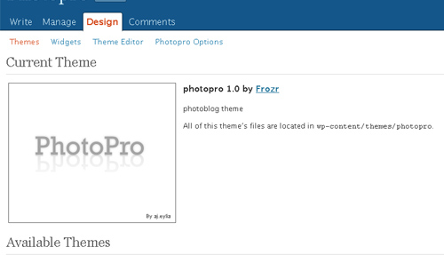
Custom field:
WordPress has the ability to allow post authors to assign custom fields to a post. This arbitrary extra information is known as meta-data.
More info about custom field: http://codex.wordpress.org/Using_Custom_Fields
The theme uses about 7 meta-data. 5 is optional, the other 2 required.
The main custom field (must) :
- image (max width 700 pixels)
- thumbnail (image 100 x 70 pixels)
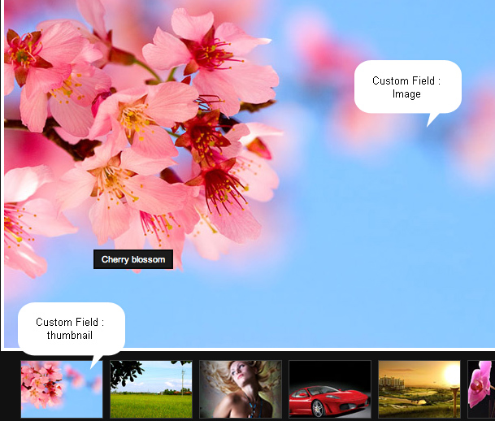
The key :
- Image
- thumbnail.
Extra section aka image detail (optional) :
- Camera model
- Shutter speed
- Focal length
- Aperture value
- ISO sensitivity
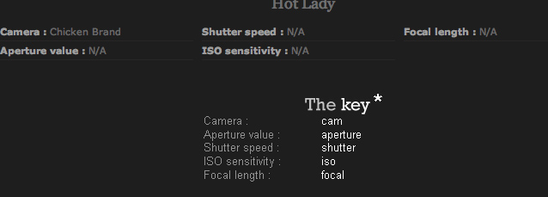
If the extra section is blank (no value) it will show N/A
So where to put these key?
Here:
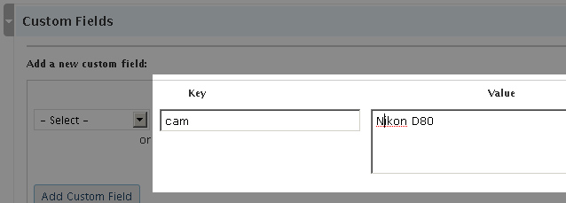
It is in the custom field section where you can find it in “write a post” page. It’s located in the bottom.

Writing a post:
Writing a post is easy. What do you need is two pictures. One is for normal view (image) and the other one is for thumbnail. Image maximum width 700 pixels, so don’t break the width. Height doesn’t really matter. For the thumbnail the size is 100 x 70 pixels.

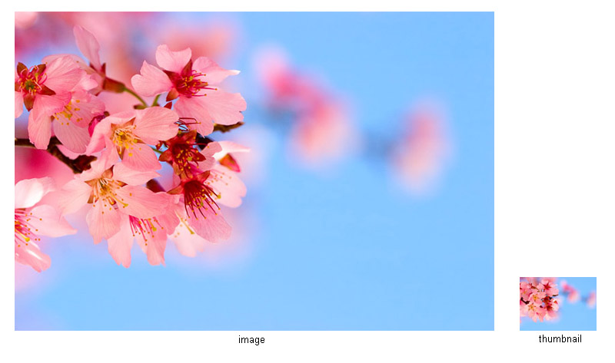
- Upload the image and thumbnail in the wordpress or somewhere else.

- Get the links.

- Paste the links in the custom field section under value for key image and thumbnail.
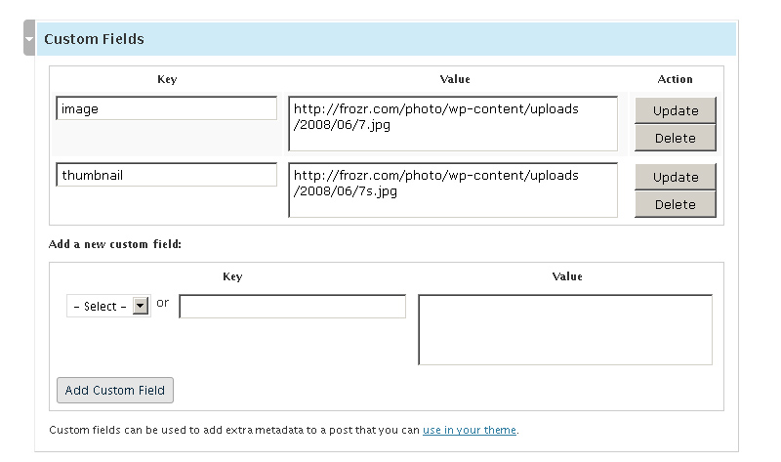

And fill in the all key for cam, iso, aperture, focal and shutter. (Optional)

Example:

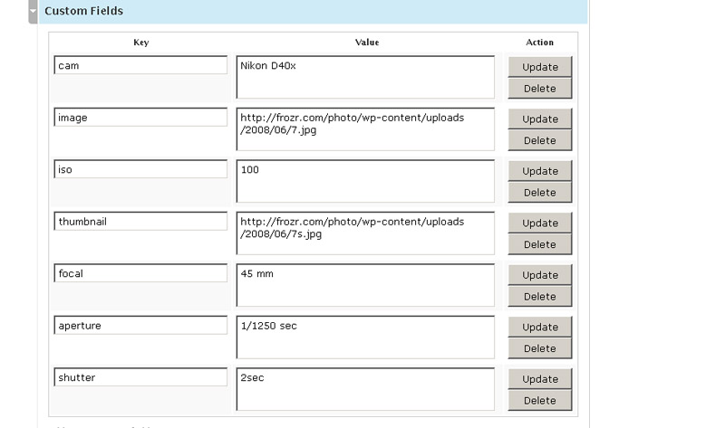
At this stage, you can just hit publish button.

Support:

Go to http://frozr.com/support/

Thank you!

Ajmal Eylia

