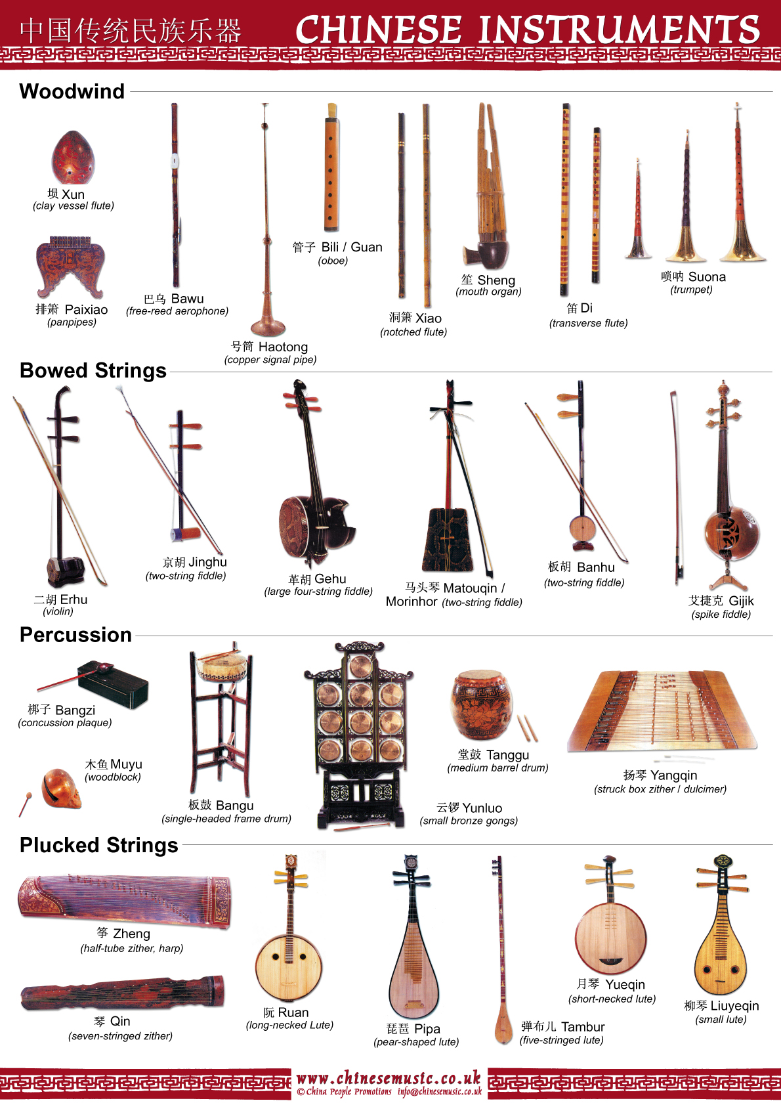

Yunluo

The *yunluo* is a set of usually ten small tuned gongs mounted in a wooden frame, with each gong being about 9-12 cm in diameter, and the height of the frame being about 52 cm. The *yunluo'*s gongs are generally of equal diameter but different thicknesses; the thicker gongs produce a higher pitch. It is often used in wind and percussion ensembles in [northern China](http://en.wikipedia.org/wiki/North_China). Old drawings also depict a smaller *yunluo* with just five gongs, which was held by a handle by one hand and played with the other.

Ruan

The ***ruan*** ([阮](http://en.wiktionary.org/wiki/%E9%98%AE), [pinyin](http://en.wikipedia.org/wiki/Pinyin): *ruǎn*) is a [Chinese](http://en.wikipedia.org/wiki/Traditional_Chinese_musical_instruments) plucked [string instrument](http://en.wikipedia.org/wiki/String_instrument). It is a [lute](http://en.wikipedia.org/wiki/Lute) with a [fretted](http://en.wikipedia.org/wiki/Fret) neck, a circular body, and four strings. Its strings were formerly made of [silk](http://en.wikipedia.org/wiki/Silk) but since the 20th century they have been made of steel (flatwound for the lower strings). The modern *ruan* has 24 frets with 12 semitones on each string, which has greatly expanded its range from a previous 13 frets. The frets are commonly made of ivory. Or in recent times, metal mounted on wood. The metal frets produce a brighter tone as compared to the ivory frets. It is sometimes called *ruanqin* (阮琴), particularly in [Taiwan](http://en.wikipedia.org/wiki/Taiwan).

Ehru

The ***erhu*** ([Chinese](http://en.wikipedia.org/wiki/Chinese_language): [二胡](http://en.wiktionary.org/wiki/%E4%BA%8C%E8%83%A1); [pinyin](http://en.wikipedia.org/wiki/Pinyin): èrhú), also called ***nanhu*** ([南胡](http://en.wiktionary.org/wiki/%E5%8D%97%E8%83%A1" \o "wikt:南胡), "southern fiddle"), and sometimes known in the [West](http://en.wikipedia.org/wiki/Western_world) as the "Chinese [violin](http://en.wikipedia.org/wiki/Violin)" or "[Chinese](http://en.wikipedia.org/wiki/China) two-string fiddle," is a two-stringed [bowed](http://en.wikipedia.org/wiki/Bow_%28music%29) [musical instrument](http://en.wikipedia.org/wiki/List_of_traditional_Chinese_musical_instruments), used as a solo instrument as well as in small ensembles and large orchestras. It is the most popular instrument in the [*huqin*](http://en.wikipedia.org/wiki/Huqin) family of Chinese bowed string instruments, together with the [*zhonghu*](http://en.wikipedia.org/wiki/Zhonghu), [*gaohu*](http://en.wikipedia.org/wiki/Gaohu), [*banhu*](http://en.wikipedia.org/wiki/Banhu), [*jinghu*](http://en.wikipedia.org/wiki/Jinghu_%28instrument%29), [*sihu*](http://en.wikipedia.org/wiki/Sihu_%28instrument%29), and numerous others. Used in both traditional and contemporary pieces, it is a versatile instrument.

Xiao

The *xiāo* is a very ancient Chinese instrument usually thought to have developed from a simple end-blown flute used by the [Qiang people](http://en.wikipedia.org/wiki/Qiang_people) of [Southwest China](http://en.wikipedia.org/wiki/Southwest_China). The modern six-hole form of the instrument goes back to the [Ming Dynasty](http://en.wikipedia.org/wiki/Ming_Dynasty).

Bangu

**bangu,** Wade-Giles romanization pan-ku, also called danpi, Chinese frame [drum](http://www.britannica.com/EBchecked/topic/172045/drum) that, when struck by one or two small bamboo sticks, creates a sharp dry sound essential to the aesthetics of [Chinese opera](http://www.britannica.com/EBchecked/topic/112672/Chinese-opera). It is also used in many Chinese [chamber music](http://www.britannica.com/EBchecked/topic/104861/chamber-music) ensembles. The drum, which is about 25 cm (10 inches) in diameter and 10 cm (4 inches) deep, consists of an animal skin stretched over wooden wedges; the skin and wedges are wrapped by a metal band. The wedges do not reach the small area in the centre (the drum’s “heart,” guxin) where the drum is struck. The bangu is held in its own stand; its player leads the ensemble.

Yuequin

The ***yueqin*** ([Chinese](http://en.wikipedia.org/w/index.php?title=Chineuise_language&action=edit&redlink=1): [月琴](http://en.wiktionary.org/wiki/%E6%9C%88%E7%90%B4), [pinyin](http://en.wikipedia.org/wiki/Pinyin): yuèqín; also spelled ***yue qin***, or ***yueh-ch'in***; and also called **moon guitar**, **moon-zither**, ***gekkin***, ***la ch'in***, or ***laqin***) is a [traditional Chinese](http://en.wikipedia.org/wiki/Traditional_Chinese_musical_instruments) [string instrument](http://en.wikipedia.org/wiki/String_instrument). It is a [lute](http://en.wikipedia.org/wiki/Lute) with a round, hollow wooden body which gives it the nickname *moon guitar*. It has a short fretted neck and four strings tuned in courses of two (each pair of strings is tuned to a single pitch), generally tuned to the interval of a perfect fifth. Occasionally, the body of the yueqin may be octagonal in shape.[photo](http://www.yuemi.net/images3/MZ_boxian/yueqin%28yizu%29.jpg)

Banhu

The ***banhu*** ([板胡](http://en.wiktionary.org/wiki/%E6%9D%BF%E8%83%A1" \o "wikt:板胡), [pinyin](http://en.wikipedia.org/wiki/Pinyin): bǎnhú) is a Chinese traditional bowed [string instrument](http://en.wikipedia.org/wiki/String_instrument) in the [huqin](http://en.wikipedia.org/wiki/Huqin) family of instruments. It is used primarily in northern China. *Ban* means a piece of wood and *hu* is short for *huqin*.

Like the more familiar [*erhu*](http://en.wikipedia.org/wiki/Erhu) and [*gaohu*](http://en.wikipedia.org/wiki/Gaohu), the *banhu* has two strings, is held vertically, and the bow hair passes in between the two strings. The *banhu* differs in construction from the [erhu](http://en.wikipedia.org/wiki/Erhu) in that its soundbox is generally made from a [coconut](http://en.wikipedia.org/wiki/Coconut) shell rather than wood, and instead of a [snakeskin](http://en.wikipedia.org/wiki/Snakeskin) that is commonly used to cover the faces of *huqin* instruments, the *banhu* uses a thin wooden board.

Tanggu

The ***tanggu*** ([堂鼓](http://en.wiktionary.org/wiki/%E5%A0%82%E9%BC%93" \o "wikt:堂鼓); pinyin: tánggǔ; literally "ceremonial hall drum"; sometimes spelled ***tang gu***) is a traditional Chinese drum from the 19th century. It is medium in size and barrel-shaped, with two heads made of animal skin, and is played with two sticks.

The *tanggu* is usually suspended by four rings in a wooden stand.[photo](http://www.ccnt.gov.cn/fwzwh/zlsc/t20060210_23707.htm)

Sheng

The [Chinese](http://en.wikipedia.org/wiki/China) **sheng** ([Chinese](http://en.wikipedia.org/wiki/Chinese_language): [笙](http://en.wiktionary.org/wiki/%E7%AC%99); [Pinyin](http://en.wikipedia.org/wiki/Pinyin) *shēng*) is a [mouth](http://en.wikipedia.org/wiki/Mouth)-blown [free reed instrument](http://en.wikipedia.org/wiki/Free_reed_instrument) consisting essentially of vertical pipes.

Traditionally, the *sheng* has been used as an [accompaniment](http://en.wikipedia.org/wiki/Accompaniment) instrument for solo [*suona*](http://en.wikipedia.org/wiki/Suona) or [*dizi*](http://en.wikipedia.org/wiki/Dizi_%28musical_instrument%29) performances. It is one of the main instruments in [*kunqu*](http://en.wikipedia.org/wiki/Kunqu) and some other forms of [Chinese opera](http://en.wikipedia.org/wiki/Chinese_opera). Traditional small ensembles also make use of the sheng, such as the wind and percussion ensembles in northern China. In the modern large [Chinese orchestra](http://en.wikipedia.org/wiki/Chinese_orchestra), it is used for both melody and accompaniment

Bili/Guan

The ***guan*** ([管](http://en.wiktionary.org/wiki/%E7%AE%A1); [pinyin](http://en.wikipedia.org/wiki/Pinyin): guǎn; literally "pipe" or "tube") is a Chinese [double reed](http://en.wikipedia.org/wiki/Double_reed) wind instrument. The [northern Chinese](http://en.wikipedia.org/wiki/North_China) version is called ***guanzi*** ([管子](http://en.wiktionary.org/wiki/%E7%AE%A1%E5%AD%90" \o "wikt:管子)) or ***bili*** (traditional: [篳篥](http://en.wiktionary.org/wiki/%E7%AF%B3%E7%AF%A5); simplified: [筚篥](http://en.wiktionary.org/wiki/%E7%AD%9A%E7%AF%A5)) and the Cantonese version is called ***houguan*** ([喉管](http://en.wiktionary.org/wiki/%E5%96%89%E7%AE%A1" \o "wikt:喉管)). It is classified as a [bamboo](http://en.wikipedia.org/wiki/Bamboo) instrument in the Ba Yin (ancient Chinese instrument classification) system. Unlike instruments in the [shawm](http://en.wikipedia.org/wiki/Shawm) family, such as the Western [oboe](http://en.wikipedia.org/wiki/Oboe) or Chinese [*suona*](http://en.wikipedia.org/wiki/Suona), the *guan* has a cylindrical [bore](http://en.wikipedia.org/wiki/Bore_%28wind_instruments%29), giving it a [clarinet](http://en.wikipedia.org/wiki/Clarinet)-like tone.