**Cryptocurrency Prediction Model**

Atman Patel, Yeshwanth Myla

University of Maryland Baltimore, County

Data 606: Capstone in Data Science

Dr. Muhammad Ali Yousuf

**Abstract**

Cryptocurrencies have gained recognition as Virtual currencies and become a popular investment option due to their potential for high profitability. Investors have been drawn to cryptocurrency trades due to their lucrative nature. Due to its dynamic characteristics and unpredictable nature worries the investors and makes their investment at high risk. In this project, we explored the use of time series analysis for predicting the performance of three different stocks. We used time series models, ARIMA and Double Exponential Smoothing, and LSTM to predict the stock prices, and evaluated their accuracy using mean squared error. It will be possible to analyze the price changes of the cryptocurrencies using historical data stored and controlled by Blockchain technology using ML techniques like Bayesian neural networks, supervised learning, random forest, and unsupervised learning.

# Introduction

Cryptocurrencies have emerged as a significant and transformative force in the financial markets in recent years. A cryptocurrency is a type of digital or virtual currency that uses cryptography for security and operates independently of a central authority. Bitcoin, Ethereum, and Litecoin are some of the most well-known cryptocurrencies, and they have gained significant attention from investors, traders, and businesses alike. The importance of cryptocurrencies lies in their potential to disrupt traditional financial systems and offer new opportunities for investment, transactional efficiency, and decentralization. Cryptocurrencies provide an alternative to traditional financial instruments and payment systems, allowing for faster and cheaper cross-border transactions, reduced transaction fees, and increased financial inclusivity for unbanked or underbanked populations. At the heart of cryptocurrencies is blockchain, a decentralized and distributed digital ledger that records all transactions across a network of computers. Blockchain technology ensures transparency, security, and immutability of transactions, making cryptocurrencies a viable option for various use cases beyond financial transactions, such as supply chain management, digital identity verification, and more. Given the volatility and potential for high returns in the cryptocurrency markets, many investors are interested in predicting the performance of cryptocurrencies to make informed investment decisions. Time series analysis and neural networks are popular methods used for cryptocurrency price prediction due to their ability to capture patterns and trends in historical data and make predictions based on past performance. In this report, we will apply time series analysis to predict the performance of three selected cryptocurrencies: Bitcoin, and Ethereum. Finally, based on our findings, we will provide recommendations for potential investment opportunities in these cryptocurrencies.

Dataset Description

This section shows the data sets which are used in the study. To conduct, the experiment datasets have been collected form Yahoo Finance (https://finance.yahoo.com/crypto/) which is an official website for the data with the tickers which helps to locate any stock easily. The dataset includes cryptocurrency like Bitcoin and Ethereum which has size of 1461 respectively. Also, there is no missing values in both the dataset.

**Methodology**

Here, the process is divided into some phases including missing value, feature scaling, building test and train model and evaluation of the results. The image shows the whole process.



1. **Data Collection:**

We have gathered the historical cryptocurrency of Bitcoin and Ethereum from Yahoo finance package.

1. **Data Pre-processing:**

Data Pre-processing is an important task to train model. It includes the missing value imputation and feature scaling. Missing value imputation is an important task in machine.

learning when the data is too small to train the model. Mean and mode are one of the

famous types for missing value imputation. Unfortunately, this dataset doesn’t have any missing values, so this dataset doesn’t need data pre-processing.

1. **Feature Selection:**

Identify the most relevant features for forecasting, such as adj close, volume, open, high, low, and close. In this case, we have chosen close as it is very important feature because rest all the data keeps changing during the market open hours, so it makes more easier to choose the “close” as feature which gives the perfect numbers when the market is closed.

1. **Model Selection:**

We have used both supervised and un-supervised models to predict the price of cryptocurrency. We have used Arima Model, Double Exponential Smoothing Model and, Long Short-Term Memory Model for predicting the price of cryptocurrency.

1. **Training and Testing:**

Train and test sets were created from the data sets. 20% of the real data set is included in

the test, while the remaining 80% is included in the train set.

1. **Model Evaluation:**

In this experiment, we have use metrics like Mean Squared Error (MSE), Root Mean Squared Error (RMSE) to compare the accuracy of the models.

**Experimental Results**

This section shows the analysis of the data that we worked and get some outputs from trained models. After conducting the experiment for supervised and unsupervised model, we have obtained the results. The RMSE and MSE scores are available after training models through the selected algorithms.

**Supervised Model:**

We have used two models which is Arima and Double Exponential Smoothing for prediction and based on that we have found the results which is shown below:

|  |  |  |  |
| --- | --- | --- | --- |
| **BITCOIN** |  | **MSE** | **RMSE** |
| **ARIMA** | 722071.679364 | 849.748009 |
| **DES** | 2.115104e+07 | 4599.025962 |
| **ETHEREUM** |
| **ARIMA** | 6043.980875 | 77.743044 |
| **DES** | 1.279844e+06 | 1131.30188 |

**Bitcoin Forecasting:**

The pictures shown below is for Bitcoin price forecasting using two models.

**Ethereum Forecasting:**

The pictures shown below is for Ethereum price forecasting using two models.

**Unsupervised Model:**

We have used LSTM model for the cryptocurrency prediction and depending on that we have found the results which are shown below:

|  |  |  |  |
| --- | --- | --- | --- |
|  |  | **MSE** | **RMSE** |
| **BITCOIN** | **LSTM** | 0.012 | 3756.3172068627173 |
| **ETHEREUM** | 0.009 | 209.39323743559692 |

**Bitcoin Forecasting:**

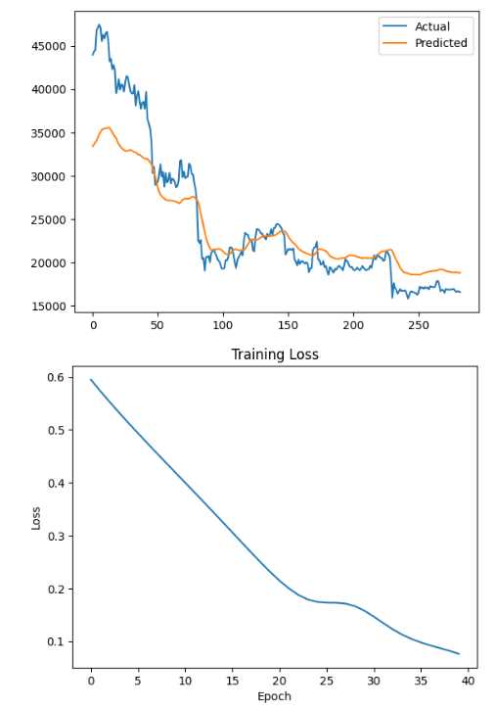

**Ethereum Forecasting:**

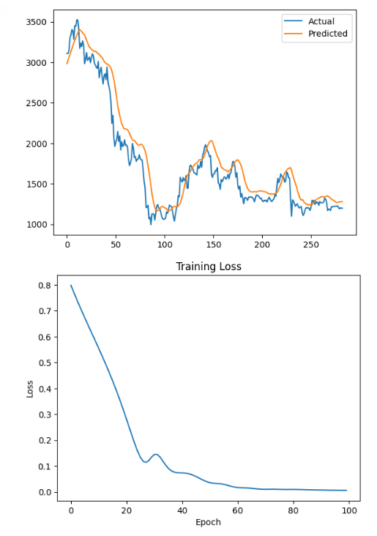

We can see that in the graph that the loss in the LSTM model decreases as we increase the epoch. We have trained it for both Bitcoin and Ethereum but the model suits better for the Ethereum, this may be because Ethereum is more stable in the market than Bitcoin.

**Conclusion**

We have used supervised and unsupervised models for predicting the price of cryptocurrency in the future. According to the results of supervised model, we can easily identify that Arima model works best compared to Des model. Also, Ethereum is good option to invest as it is more stable compared to Bitcoin. Moreover, based on our experiments and analysis, the LSTM model outperformed the other models, providing the lowest MSE, RMSE values. This indicates that LSTM is the most suitable model for forecasting cryptocurrency prices in the  
given dataset. However, it is important to note that cryptocurrency markets are highly volatile, and accurate predictions are challenging due to numerous factors influencing their prices.

Further research and experimentation are necessary to validate these findings and explore other advanced forecasting techniques. Nonetheless, the results highlight the potential of leveraging blockchain technology and cryptocurrency data to make informed investment decisions and understand market trends.

**References**

1. <https://worldcoin.org/articles/why-is-cryptocurrency-important>
2. <https://finance.yahoo.com/crypto/>
3. Nakamoto, S. (2008). Bitcoin: A Peer-to-Peer Electronic Cash System. <https://bitcoin.org/bitcoin.pdf>
4. Tapscott, D., & Tapscott, A. (2016). Blockchain revolution: how the technology behind bitcoin is changing money, business, and the world. Penguin.
5. PyTorch Documentation. (n.d.). nn.Module. <https://pytorch.org/docs/stable/generated/torch.nn.Module.html>
6. PyTorch Documentation. (n.d.). nn.LSTM. <https://pytorch.org/docs/stable/generated/torch.nn.LSTM.html>
7. PyTorch Documentation. (n.d.). nn.Linear.   
   <https://pytorch.org/docs/stable/generated/torch.nn.Linear.html>
8. PyTorch Tutorials. (n.d.). Sequence Models and Long-Short Term Memory Networks.   
   <https://pytorch.org/tutorials/beginner/nlp/sequence_models_tutorial.ht>