Experiment report

Notice: SRA -> Simple Randomized Algorithm, SON -> SON Algorithm

1. Comparison
   1. T10I4D100K
      1. Sample size = 1 %

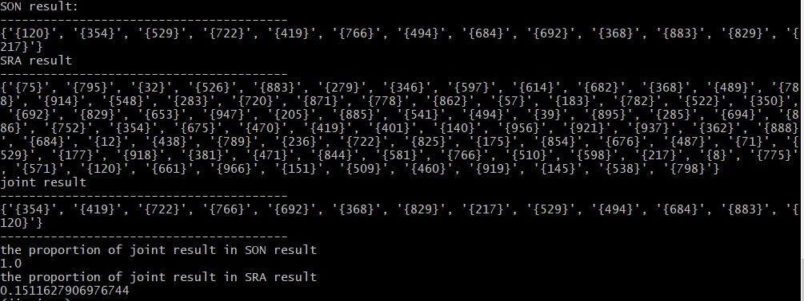

* + 1. Sample size = 2 %

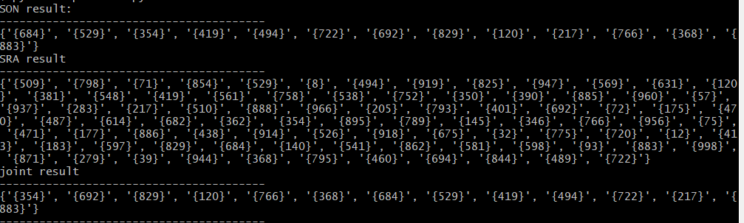

* + 1. Sample size = 5 %

SON

{'{883}', '{120}', '{722}', '{829}', '{494}', '{368}', '{529}', '{692}', '{766}', '{217}', '{684}', '{419}', '{354}'}

SRA

{'{885}', '{795}', '{350}', '{72}', '{509}', '{494}', '{368}', '{888}', '{32}', '{944}', '{541}', '{283}', '{470}', '{12}', '{862}', '{460}', '{798}', '{775}', '{487}', '{354}', '{510}', '{538}', '{895}', '{120}', '{522}', '{722}', '{561}', '{529}', '{548}', '{675}', '{381}', '{919}', '{39}', '{676}', '{998}', '{175}', '{205}', '{401}', '{883}', '{918}', '{782}', '{57}', '{581}', '{631}', '{145}', '{956}', '{829}', '{682}', '{793}', '{692}', '{471}', '{694}', '{346}', '{766}', '{419}', '{438}', '{183}', '{571}', '{71}', '{720}', '{177}', '{93}', '{914}', '{674}', '{614}', '{598}', '{362}', '{8}', '{279}', '{569}', '{684}', '{947}', '{140}', '{825}', '{966}', '{390}', '{886}', '{844}', '{489}', '{661}', '{854}', '{937}', '{789}', '{871}', '{217}', '{75}'}

Joint

{'{883}', '{494}', '{368}', '{120}', '{722}', '{829}', '{529}', '{692}', '{766}', '{217}', '{684}', '{419}', 354}'}

* + 1. Sample size = 10 %

SON

* 1. T40I10D100K
     1. Sample size = 1 %
     2. Sample size = 2 %
     3. Sample size = 5 %
     4. Sample size = 10 %
  2. Chess
     1. Sample size = 1 %
     2. Sample size = 2 %
     3. Sample size = 5 %
     4. Sample size = 10 %
  3. Connect
     1. Sample size = 1 %
     2. Sample size = 2 %
     3. Sample size = 5 %
     4. Sample size = 10 %
  4. Mushroom
     1. Sample size = 1 %
     2. Sample size = 2 %
     3. Sample size = 5 %
     4. Sample size = 10 %
  5. Pumsb
     1. Sample size = 1 %
     2. Sample size = 2 %
     3. Sample size = 5 %
     4. Sample size = 10 %
  6. pumsb star
     1. Sample size = 1 %
     2. Sample size = 2 %
     3. Sample size = 5 %
     4. Sample size = 10 %