

NAME : HILLARY HARUZIVI

REG NUMBER : H250167A

DEPARTMENT : SOFTWARE ENGINEERING

OOP JAVA LAB RECORD

Lab 1: Classes and Objects
Objectives
- Define a class with fields and methods.
- Create objects with new and use the dot operator.
- Understand references, aliasing and null.

Exercise 1 (Basic): Car class with display()
Explanation
A Car has brand, year and mileage fields and a display() method. Three Car objects are created and printed by looping over an array.
Code: Car.java
/** Lab 1, Exercises 1 & 2: Car class with display() and isAntique(). */
public class Car {
// State of every Car object
String brand;
int year;
double mileage;
Car(String brand, int year, double mileage) {
this.brand = brand;
this.year = year;
this.mileage = mileage;
}
void display() {
System.out.println("Brand: " + brand + ", Year: " + year + ", Mileage: " + mileage + " km");
}
// Exercise 2: a car is antique when it is more than 25 years old
boolean isAntique() {
int currentYear = java.time.Year.now().getValue();
return (currentYear - year) > 25;
}
public static void main(String[] args) {
Car c1 = new Car("Toyota", 1995, 250000);
Car c2 = new Car("Honda", 2015, 98000.5);
Car c3 = new Car("Mazda", 2022, 15000);
Car[] cars = {c1, c2, c3};
for (Car c : cars) {
c.display();
System.out.println(" Antique? " + c.isAntique());
}
}
}
Output: java Car
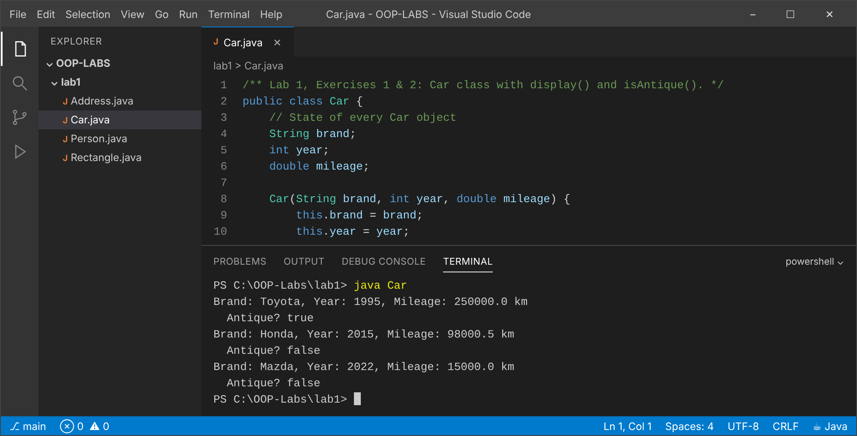

Exercise 2 (Basic): isAntique()
Explanation
isAntique() compares the current year (from java.time.Year) with the car's year and returns true when the difference is more than 25. The 1995 Toyota is antique; the others are not. (Same file as Exercise 1.)
Code: Car.java (listed under Exercise 1 above).

Exercise 3 (Intermediate): Rectangle: area, perimeter, largest of five
Explanation
area() and perimeter() are instance methods. A simple loop tracks the Rectangle with the largest area in an array of five.
Code: Rectangle.java
/** Lab 1, Exercises 3 & 4: Rectangle, largest area, and aliasing. */
public class Rectangle {
double width;
double height;
Rectangle(double width, double height) {
this.width = width;
this.height = height;
}
double area() { return width * height; }
double perimeter() { return 2 * (width + height); }
@Override
public String toString() {
return "Rectangle[" + width + " x " + height + ", area=" + area() + ", perimeter=" + perimeter() + "]";
}
public static void main(String[] args) {
// Exercise 3: array of 5 rectangles, print the one with the largest area
Rectangle[] rects = {
new Rectangle(2, 3), new Rectangle(5, 4), new Rectangle(1.5, 10),
new Rectangle(6, 6), new Rectangle(3, 2)
};
Rectangle largest = rects[0];
for (Rectangle r : rects) {
if (r.area() > largest.area()) largest = r;
}
System.out.println("Largest: " + largest);
// Exercise 4: aliasing. PREDICTION: r1.width prints 99.0 because r2 and r1
// hold the SAME reference, so changing r2.width changes the one shared object.
Rectangle r1 = new Rectangle(4, 5);
Rectangle r2 = r1;
r2.width = 99;
System.out.println("r1.width after r2.width = 99 : " + r1.width);
System.out.println("r1 == r2 ? " + (r1 == r2));
}
}
Output: java Rectangle
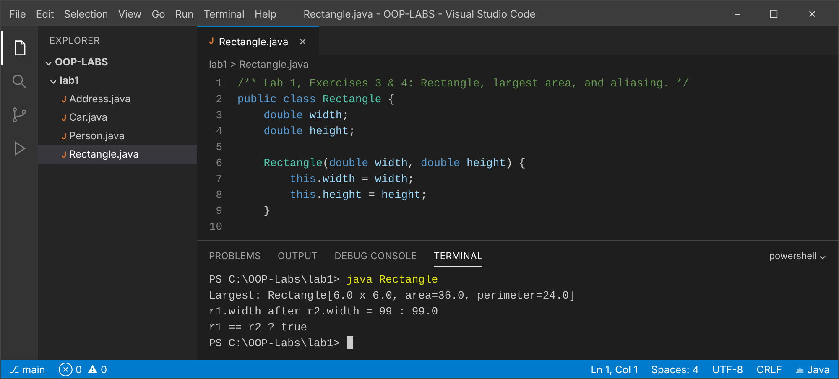

Exercise 4 (Intermediate): Aliasing: Rectangle r2 = r1
Explanation
Prediction: r1.width prints 99.0. Explanation: r2 = r1 copies the reference, not the object, so r1 and r2 are aliases of ONE object on the heap. Changing r2.width changes the shared object, which r1 also sees. (Output shown above, from the same program.)
Code: Rectangle.java (listed under Exercise 3 above).

Exercise 5 (Challenge): Person has an Address; chained dot and null
Explanation
p.address.city navigates person -> address -> city. When address is null, the chained expression throws NullPointerException, which is shown and then avoided with a null check.
Code: Address.java
/** Lab 1, Exercise 5 (part): Address class. */
public class Address {
String street;
String city;
}
Code: Person.java
/** Lab 1, Exercise 5: a Person HAS-AN Address; chained dot and null handling. */
public class Person {
String name;
Address address; // reference to another object (may be null)
public static void main(String[] args) {
Address a = new Address();
a.street = "12 Samora Machel Avenue";
a.city = "Harare";
Person p = new Person();
p.name = "Munya";
p.address = a;
// chained dot expression: person -> address -> city
System.out.println(p.name + " lives in " + p.address.city);
// Now a person with NO address
Person q = new Person();
q.name = "Tatenda";
try {
System.out.println(q.address.city); // address is null -> NullPointerException
} catch (NullPointerException e) {
System.out.println("NullPointerException: " + q.name + " has no address (address == null)");
}
// Safe version: test for null before using the reference
String city = (q.address != null) ? q.address.city : "unknown";
System.out.println(q.name + "'s city (null-safe): " + city);
}
}
Output: java Person
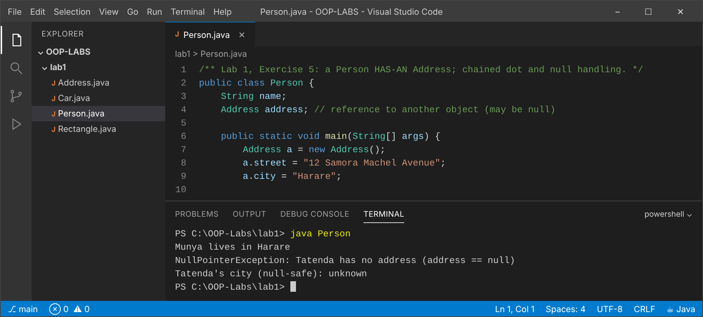

Conclusion
Objects hold state in fields and behaviour in methods; variables hold references, so assignment aliases rather than copies, and every chained dot expression needs a non-null reference.

Lab 2: Constructors, this and static
Objectives
- Initialise objects with constructors, overloading and chaining.
- Use this and static members.
- Understand initialiser block order.

Exercise 1 (Basic): Circle with constructors
Explanation
One constructor takes the radius; the no-argument constructor chains to it with this(1.0).
Code: Circle.java
/** Lab 2, Exercises 1 & 2: constructors and a static instance counter. */
public class Circle {
private static int count = 0; // one copy shared by all circles
private double radius;
public Circle(double radius) {
this.radius = radius;
count++;
}
public Circle() {
this(1.0); // constructor chaining: default radius 1.0
}
public double area() { return Math.PI * radius * radius; }
public static int getCount() { return count; }
@Override
public String toString() { return String.format("Circle[r=%.1f, area=%.2f]", radius, area()); }
public static void main(String[] args) {
System.out.println("Circles before: " + Circle.getCount());
Circle c1 = new Circle(2.5);
Circle c2 = new Circle();
Circle c3 = new Circle(4);
System.out.println(c1);
System.out.println(c2);
System.out.println(c3);
System.out.println("Circles created: " + Circle.getCount());
}
}
Output: java Circle
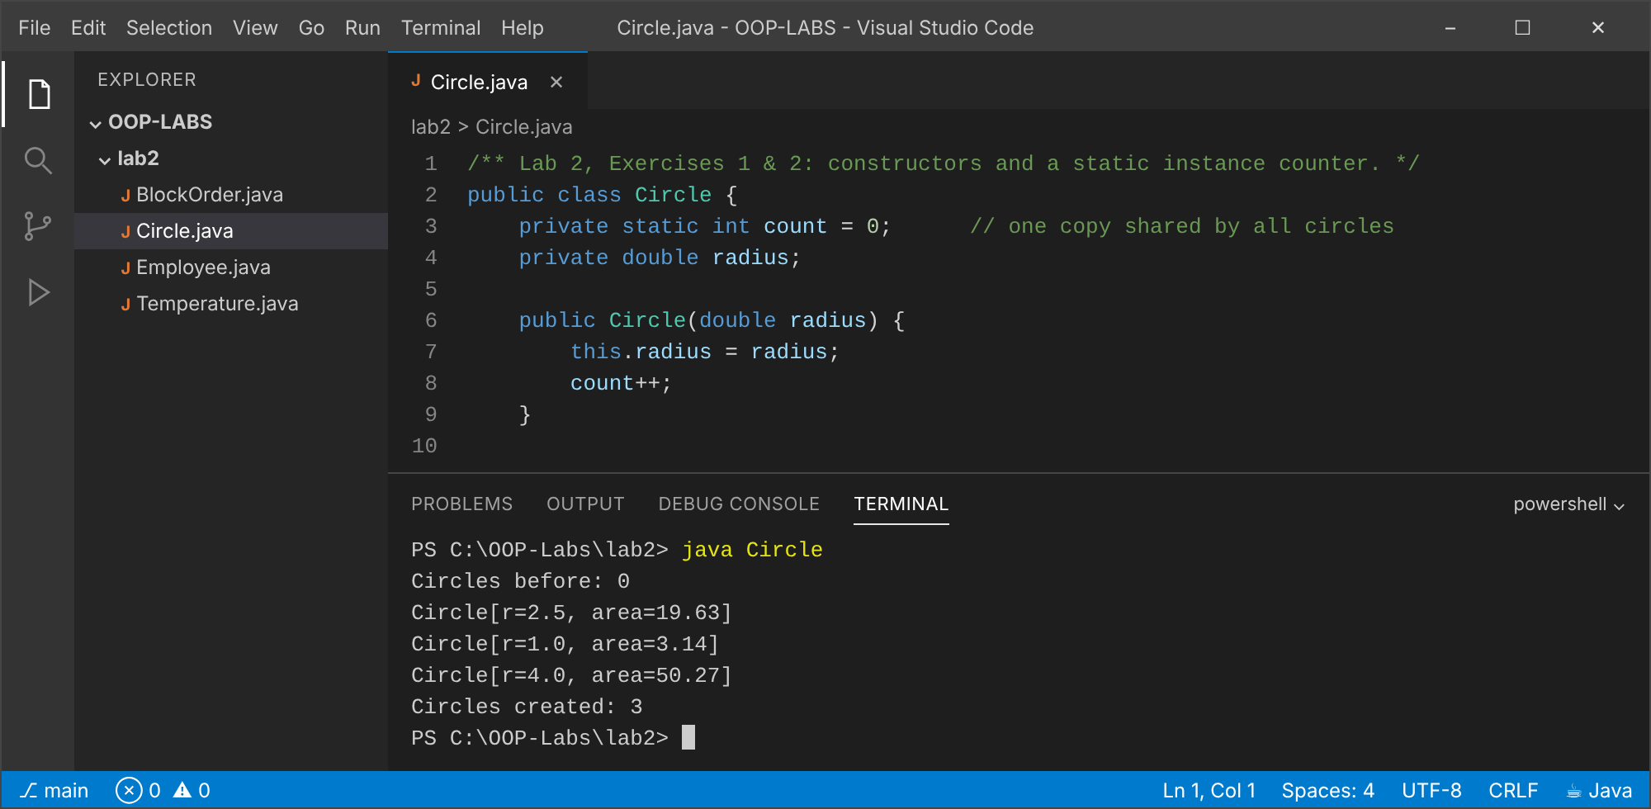

Exercise 2 (Basic): Static counter in Circle
Explanation
A private static int count is incremented in the constructor; the static getCount() returns it. The count is shared by all circles. (Same file and output as Exercise 1.)
Code: Circle.java (listed under Exercise 1 above).

Exercise 3 (Intermediate): Employee: static id, overloaded and copy constructors
Explanation
A static counter gives every new employee a unique employeeId. Three overloaded constructors chain to the full one, and the copy constructor makes an independent object (new id, same details).
Code: Employee.java
/** Lab 2, Exercise 3: auto-incrementing id, overloaded and copy constructors. */
public class Employee {
private static int nextId = 1000; // static counter shared by all employees
private final int employeeId;
private String name;
private String department;
private double salary;
public Employee(String name, String department, double salary) {
this.employeeId = nextId++;
this.name = name;
this.department = department;
this.salary = salary;
}
public Employee(String name, String department) {
this(name, department, 0.0);
}
public Employee(String name) {
this(name, "Unassigned");
}
// Copy constructor: new id (a different employee record) but same details
public Employee(Employee other) {
this(other.name, other.department, other.salary);
}
@Override
public String toString() {
return String.format("Employee #%d %s, %s, $%.2f", employeeId, name, department, salary);
}
public static void main(String[] args) {
Employee e1 = new Employee("Larry", "IT", 3500);
Employee e2 = new Employee("Hillary", "HR");
Employee e3 = new Employee("Tinevimbo");
Employee e4 = new Employee(e1); // copy of e1
System.out.println(e1);
System.out.println(e2);
System.out.println(e3);
System.out.println(e4 + " (copy of e1, new id)");
System.out.println("e1 == e4 ? " + (e1 == e4));
}
}
Output: java Employee
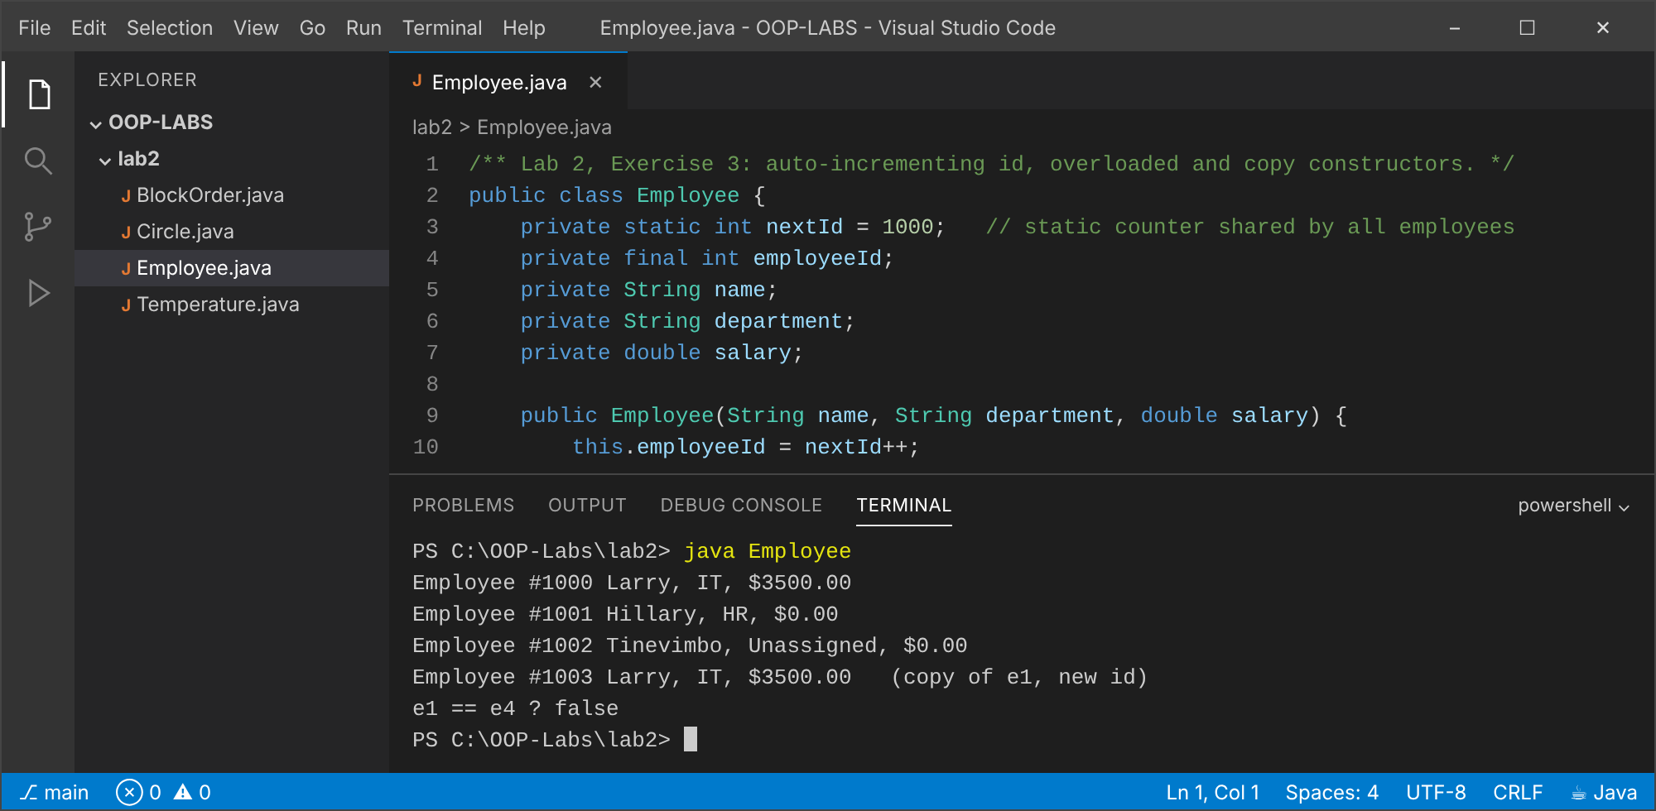

Exercise 4 (Intermediate): Order of static and instance blocks
Explanation
The prediction is written in the file's comment and the run matches it: static blocks run once when the class loads, in textual order; instance blocks run before each constructor body.
Code: BlockOrder.java
/**
* Lab 2, Exercise 4: two static blocks and two instance blocks.
* PREDICTION (static parts run once at class load, in textual order;
* instance parts run per object, in textual order, BEFORE the constructor body):
* static block 1
* static block 2
* --- main starts ---
* instance block 1
* instance block 2
* constructor
* instance block 1
* instance block 2
* constructor
*/
public class BlockOrder {
static { System.out.println("static block 1"); }
{ System.out.println("instance block 1"); }
static { System.out.println("static block 2"); }
{ System.out.println("instance block 2"); }
BlockOrder() { System.out.println("constructor"); }
public static void main(String[] args) {
System.out.println("--- main starts ---");
new BlockOrder();
new BlockOrder();
}
}
Output: java BlockOrder
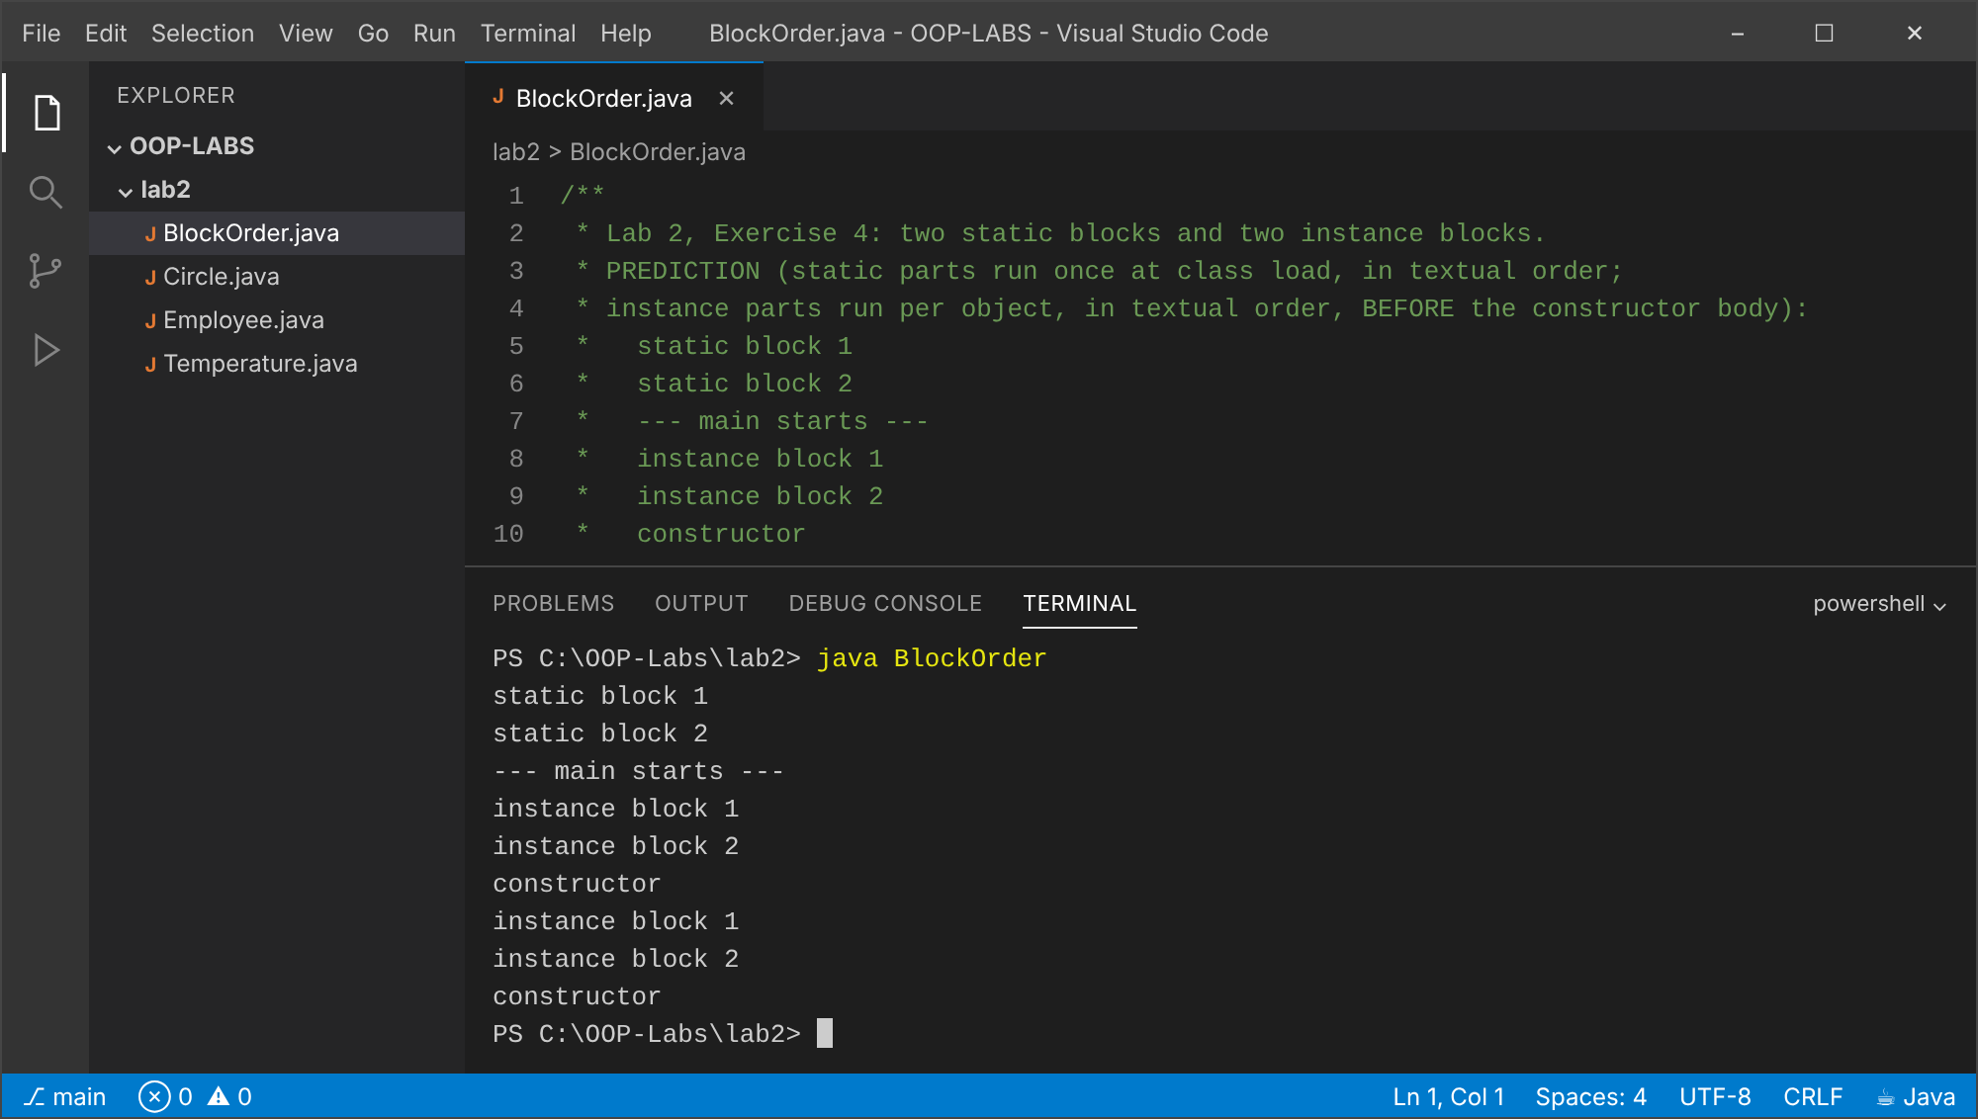

Exercise 5 (Challenge): Temperature with static factory methods
Explanation
The constructor is private; fromCelsius and fromFahrenheit are descriptive named factories. Overloaded constructors cannot distinguish two double units (same signature) and give no clue at the call site, so factories are clearer.
Code: Temperature.java
/**
* Lab 2, Exercise 5: static factory methods with a private constructor.
*
* Why static factories can be clearer than overloaded constructors:
* new Temperature(25.0) cannot say whether 25.0 is Celsius or Fahrenheit, and two
* constructors taking a double would have the same signature (illegal). Factories have
* descriptive names (fromCelsius / fromFahrenheit), can validate or cache, and can
* return a subtype, while the private constructor keeps one canonical representation.
*/
public class Temperature {
private final double celsius;
private Temperature(double celsius) { this.celsius = celsius; }
public static Temperature fromCelsius(double c) { return new Temperature(c); }
public static Temperature fromFahrenheit(double f) { return new Temperature((f - 32) * 5 / 9); }
public double toCelsius() { return celsius; }
public double toFahrenheit() { return celsius * 9 / 5 + 32; }
@Override
public String toString() { return String.format("%.1f°C / %.1f°F", toCelsius(), toFahrenheit()); }
public static void main(String[] args) {
Temperature t1 = Temperature.fromCelsius(100);
Temperature t2 = Temperature.fromFahrenheit(98.6);
System.out.println("Boiling water : " + t1);
System.out.println("Body temp : " + t2);
// new Temperature(5); // would not compile: constructor is private
}
}
Output: java Temperature
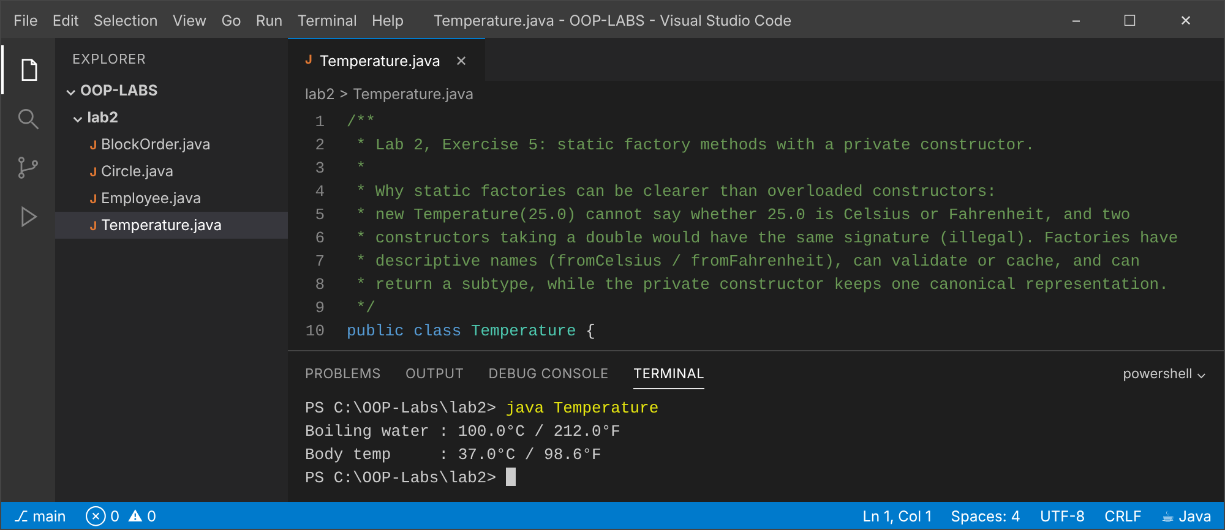

Conclusion
Constructors guarantee safe initialisation; chaining with this(...) removes duplication; static members belong to the class and initialiser blocks run in a fixed, predictable order.

Lab 3: Encapsulation and Access Modifiers
Objectives
- Hide data with private fields.
- Validate in setters and constructors.
- Design classes that cannot enter an invalid state.

Exercise 1 (Basic): Student with validated marks
Explanation
The setter rejects marks outside 0 to 100 with IllegalArgumentException, and the constructor reuses the setter so the same rule applies everywhere.
Code: Student.java
/** Lab 3, Exercises 1 & 2: validated marks and a computed grade. */
public class Student {
private String name;
private int marks;
public Student(String name, int marks) {
setName(name);
setMarks(marks);
}
public String getName() { return name; }
public int getMarks() { return marks; }
public void setName(String name) {
if (name == null || name.isBlank()) throw new IllegalArgumentException("Name required");
this.name = name.trim();
}
// Exercise 1: reject marks outside 0..100
public void setMarks(int marks) {
if (marks < 0 || marks > 100) {
throw new IllegalArgumentException("Marks must be between 0 and 100 but was " + marks);
}
this.marks = marks;
}
// Exercise 2: grade is DERIVED from marks, never stored, so it cannot go out of sync
public String getGrade() {
if (marks >= 70) return "A";
if (marks >= 60) return "B";
if (marks >= 50) return "C";
return "F";
}
public static void main(String[] args) {
Student s = new Student("Larry", 78);
System.out.println(s.getName() + ": " + s.getMarks() + " -> " + s.getGrade());
s.setMarks(55);
System.out.println(s.getName() + ": " + s.getMarks() + " -> " + s.getGrade());
try {
s.setMarks(120);
} catch (IllegalArgumentException e) {
System.out.println("Rejected: " + e.getMessage());
}
System.out.println("Marks still: " + s.getMarks());
}
}
Output: java Student
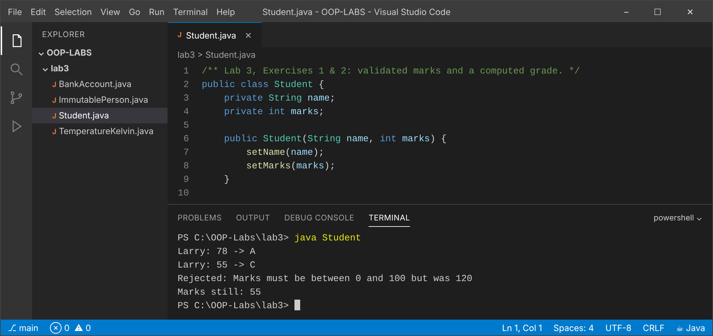

Exercise 2 (Basic): getGrade() computed, not stored
Explanation
The grade is derived from marks each time it is asked for, so it can never disagree with the marks. (Same file and output as Exercise 1.)
Code: Student.java (listed under Exercise 1 above).

Exercise 3 (Intermediate): BankAccount transaction history
Explanation
Every operation appends a line to a private list. The getter returns Collections.unmodifiableList(new ArrayList<>(history)): an unmodifiable COPY, so callers can neither modify the history nor expose the private list.
Code: BankAccount.java
import java.util.ArrayList;
import java.util.Collections;
import java.util.List;
/** Lab 3, Exercise 3: BankAccount with a transaction history. */
public class BankAccount {
private final String accountNumber;
private String ownerName;
private double balance;
private final List<String> history = new ArrayList<>();
public BankAccount(String accountNumber, String ownerName, double openingBalance) {
if (openingBalance < 0) throw new IllegalArgumentException("Opening balance cannot be negative");
this.accountNumber = accountNumber;
this.ownerName = ownerName;
this.balance = openingBalance;
history.add(String.format("OPEN %.2f -> balance %.2f", openingBalance, balance));
}
public String getAccountNumber() { return accountNumber; }
public String getOwnerName() { return ownerName; }
public double getBalance() { return balance; }
public void deposit(double amount) {
if (amount <= 0) throw new IllegalArgumentException("Deposit must be positive");
balance += amount;
history.add(String.format("DEPOSIT %.2f -> balance %.2f", amount, balance));
}
public boolean withdraw(double amount) {
if (amount <= 0) throw new IllegalArgumentException("Withdrawal must be positive");
if (amount > balance) {
history.add(String.format("FAILED withdraw %.2f (insufficient funds)", amount));
return false;
}
balance -= amount;
history.add(String.format("WITHDRAW %.2f -> balance %.2f", amount, balance));
return true;
}
/** Returns an UNMODIFIABLE COPY, so callers can neither change nor see later changes to the internal list. */
public List<String> getHistory() {
return Collections.unmodifiableList(new ArrayList<>(history));
}
public static void main(String[] args) {
BankAccount acc = new BankAccount("ACC-001", "Munya", 500);
acc.deposit(250);
acc.withdraw(100);
acc.withdraw(5000);
List<String> h = acc.getHistory();
h.forEach(System.out::println);
try {
h.add("HACK: +1000000"); // attempt to tamper
} catch (UnsupportedOperationException e) {
System.out.println("Tamper attempt blocked: history is unmodifiable");
}
System.out.println("Entries recorded: " + acc.getHistory().size());
}
}
Output: java BankAccount
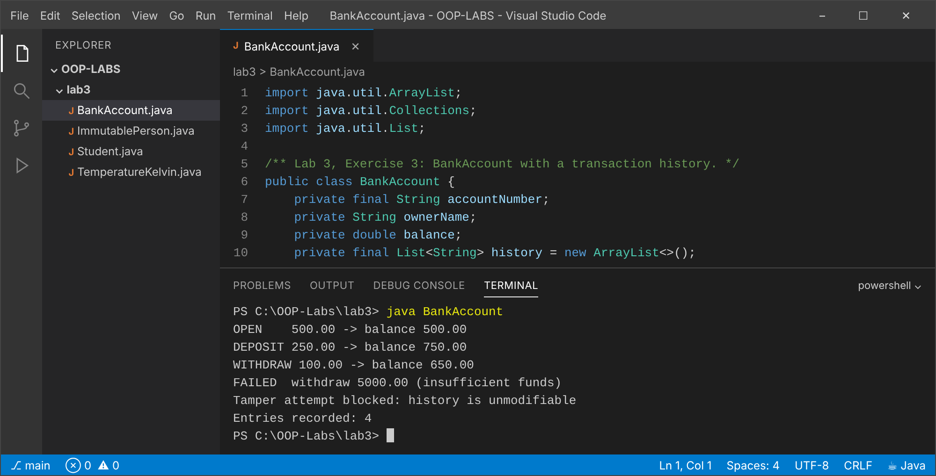

Exercise 4 (Intermediate): ImmutablePerson
Explanation
Design choices (also in the file's comment): final class, private final fields, no setters, validation in the constructor, and a withName() method that returns a new object instead of changing the old one.
Code: ImmutablePerson.java
import java.time.LocalDate;
/**
* Lab 3, Exercise 4: an immutable class.
* Design choices:
* - final class : no subclass can add mutable state or override getters to cheat.
* - private final fields : each field is assigned once, in the constructor, and is never exposed.
* - no setters : state cannot change after construction, so the object is thread-safe
* and safe to share or use as a map key.
* - validation in constructor : an invalid object can never exist.
* - mutable components (LocalDate here is itself immutable) would have to be defensively
* copied on the way in and out. "Changes" are expressed by returning a NEW object (withName).
*/
public final class ImmutablePerson {
private final String name;
private final LocalDate dateOfBirth;
public ImmutablePerson(String name, LocalDate dateOfBirth) {
if (name == null || name.isBlank()) throw new IllegalArgumentException("Name required");
if (dateOfBirth == null || dateOfBirth.isAfter(LocalDate.now()))
throw new IllegalArgumentException("Invalid date of birth");
this.name = name.trim();
this.dateOfBirth = dateOfBirth;
}
public String getName() { return name; }
public LocalDate getDateOfBirth() { return dateOfBirth; }
public ImmutablePerson withName(String newName) {
return new ImmutablePerson(newName, dateOfBirth);
}
@Override
public String toString() { return name + " (born " + dateOfBirth + ")"; }
public static void main(String[] args) {
ImmutablePerson p = new ImmutablePerson("Tinevimbo", LocalDate.of(2001, 5, 17));
ImmutablePerson q = p.withName("Tinevimbo Haruzivi");
System.out.println("Original : " + p);
System.out.println("Modified : " + q + " (a new object; original unchanged)");
}
}
Output: java ImmutablePerson
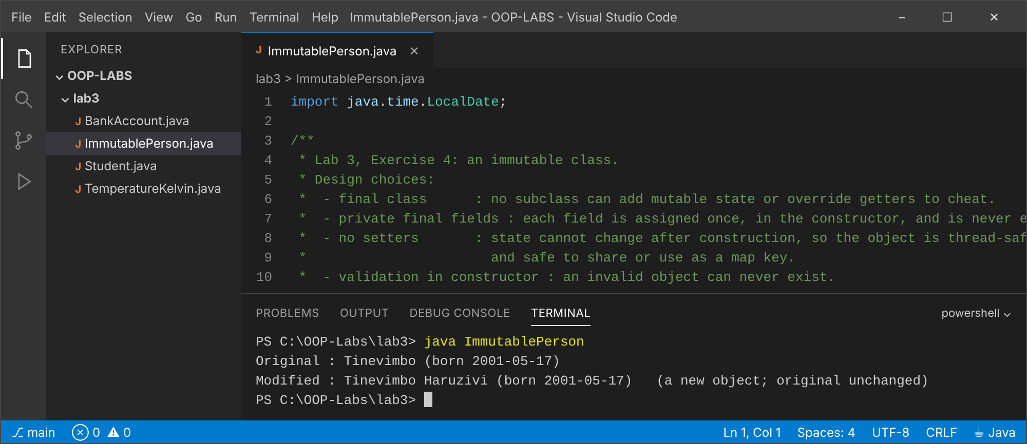

Exercise 5 (Challenge): Temperature stored in kelvin
Explanation
Kelvin is a private detail. Callers use getCelsius/getFahrenheit/setCelsius, so changing the internal unit would only change these method bodies. Values below absolute zero are rejected and the old value is kept.
Code: TemperatureKelvin.java
/**
* Lab 3, Exercise 5: Temperature stored internally in KELVIN.
* Callers only use getCelsius()/getFahrenheit(), so the internal unit is a hidden detail:
* we could switch the field to Celsius and re-write two method bodies without breaking callers.
*/
public class TemperatureKelvin {
private double kelvin; // private: the representation is hidden
public TemperatureKelvin(double celsius) { setCelsius(celsius); }
public double getCelsius() { return kelvin - 273.15; }
public double getFahrenheit() { return getCelsius() * 9 / 5 + 32; }
public void setCelsius(double c) {
double k = c + 273.15;
if (k < 0) throw new IllegalArgumentException("Below absolute zero (-273.15 C): " + c);
this.kelvin = k;
}
public static void main(String[] args) {
TemperatureKelvin t = new TemperatureKelvin(25);
System.out.printf("25 C -> %.2f F%n", t.getFahrenheit());
t.setCelsius(-40);
System.out.printf("-40 C -> %.2f F%n", t.getFahrenheit());
t.setCelsius(-273.15);
System.out.printf("Absolute zero accepted: %.2f C%n", t.getCelsius());
try {
t.setCelsius(-300);
} catch (IllegalArgumentException e) {
System.out.println("Rejected: " + e.getMessage());
}
System.out.printf("Value unchanged after rejection: %.2f C%n", t.getCelsius());
}
}
Output: java TemperatureKelvin
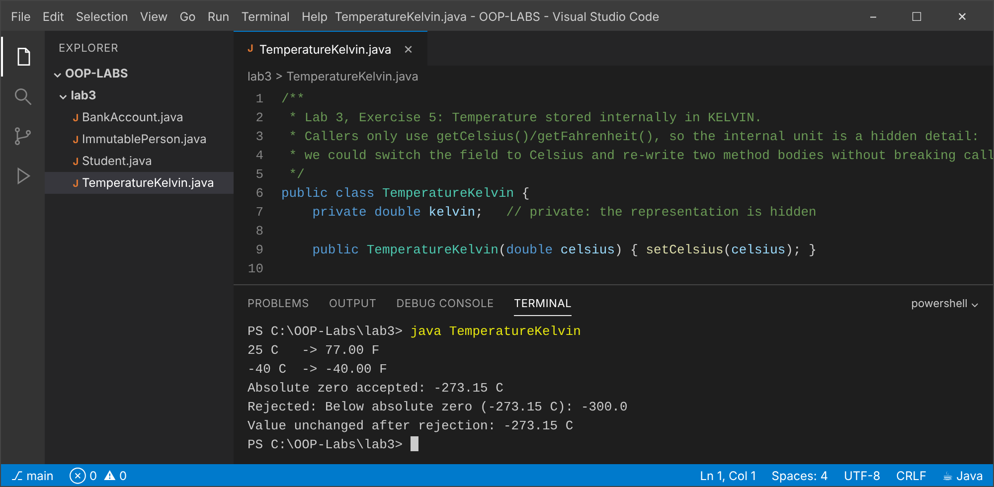

Conclusion
Private fields plus validated public methods keep objects consistent; returning copies and using immutability prevent outside code from breaking invariants.

Lab 4: Inheritance
Objectives
- Use extends and super.
- Understand constructor chaining across a hierarchy.
- Prefer composition when the relationship is not 'is-a'.

Exercise 1 (Basic): Person and Student
Explanation
Student extends Person and calls super(name, age) first. The inherited display() prints the Person part.
Code: Person.java
/** Lab 4, Exercise 1: superclass Person. */
public class Person {
protected String name;
protected int age;
public Person(String name, int age) {
this.name = name;
this.age = age;
}
public void display() {
System.out.println("Name: " + name + ", Age: " + age);
}
}
Code: Student.java
/** Lab 4, Exercise 1: Student extends Person (adds course). */
public class Student extends Person {
private String course;
public Student(String name, int age, String course) {
super(name, age); // must call the Person constructor first
this.course = course;
}
public String getCourse() { return course; }
public static void main(String[] args) {
Person p = new Person("Munya", 40);
Student s = new Student("Larry", 20, "Software Engineering");
p.display();
s.display(); // inherited display(): prints only the Person part
System.out.println("Course: " + s.getCourse());
}
}
Output: java Student
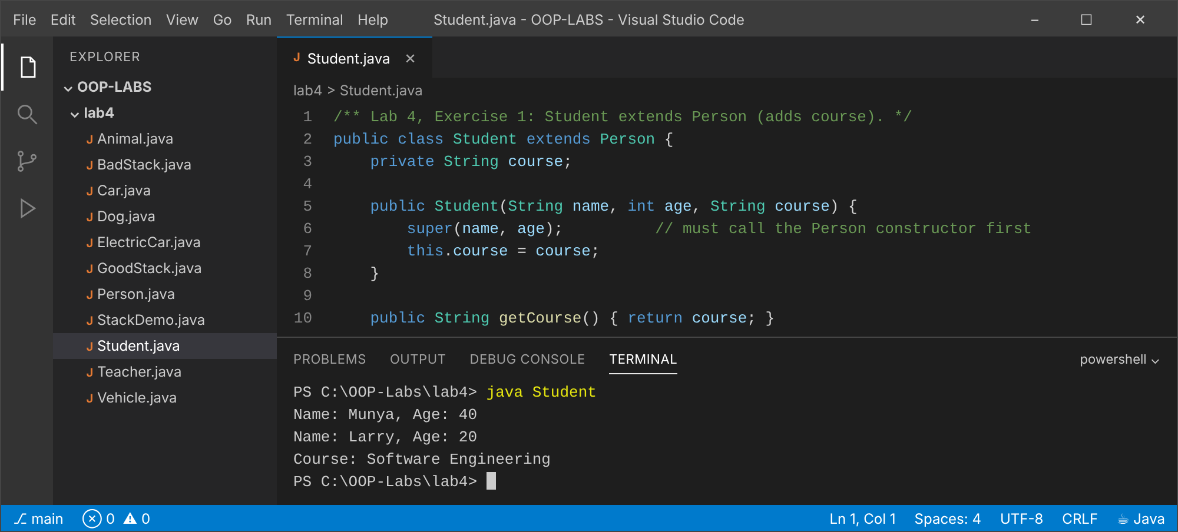

Exercise 2 (Basic): Add Teacher
Explanation
Teacher also extends Person; display() is written once in Person and reused by both subclasses.
Code: Teacher.java
/** Lab 4, Exercise 2: Teacher also extends Person, so Student and Teacher share Person code. */
public class Teacher extends Person {
private String subject;
public Teacher(String name, int age, String subject) {
super(name, age);
this.subject = subject;
}
public String getSubject() { return subject; }
public static void main(String[] args) {
Student s = new Student("Hillary", 21, "Networks");
Teacher t = new Teacher("Mr Mujawo", 45, "Java");
// display() is written ONCE in Person and reused by both subclasses
s.display();
t.display();
System.out.println("Teacher subject: " + t.getSubject());
System.out.println("Both are Persons? " + (s instanceof Person) + " " + (t instanceof Person));
}
}
Output: java Teacher
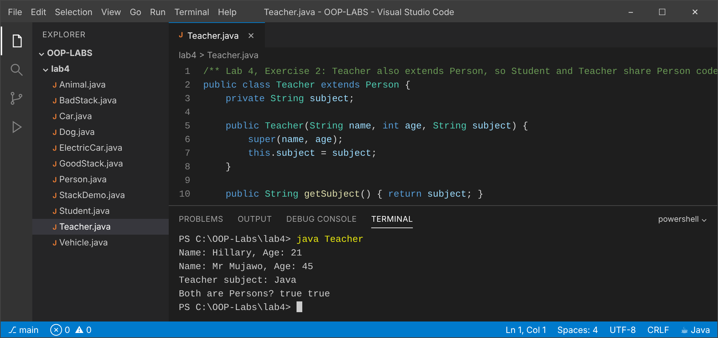

Exercise 3 (Intermediate): Vehicle -> Car -> ElectricCar
Explanation
Constructors run from the top of the hierarchy down: the numbered messages show Vehicle, then Car, then ElectricCar.
Code: Vehicle.java
/** Lab 4, Exercise 3: top of the multilevel chain Vehicle -> Car -> ElectricCar. */
public class Vehicle {
protected String make;
public Vehicle(String make) {
this.make = make;
System.out.println("1. Vehicle constructor: " + make);
}
}
Code: Car.java
public class Car extends Vehicle {
protected int doors;
public Car(String make, int doors) {
super(make);
this.doors = doors;
System.out.println("2. Car constructor: " + doors + " doors");
}
}
Code: ElectricCar.java
public class ElectricCar extends Car {
private int batteryKwh;
public ElectricCar(String make, int doors, int batteryKwh) {
super(make, doors);
this.batteryKwh = batteryKwh;
System.out.println("3. ElectricCar constructor: " + batteryKwh + " kWh");
}
public static void main(String[] args) {
// Constructors run from the TOP of the hierarchy down: Vehicle, Car, ElectricCar
new ElectricCar("Nissan Leaf", 5, 40);
}
}
Output: java ElectricCar
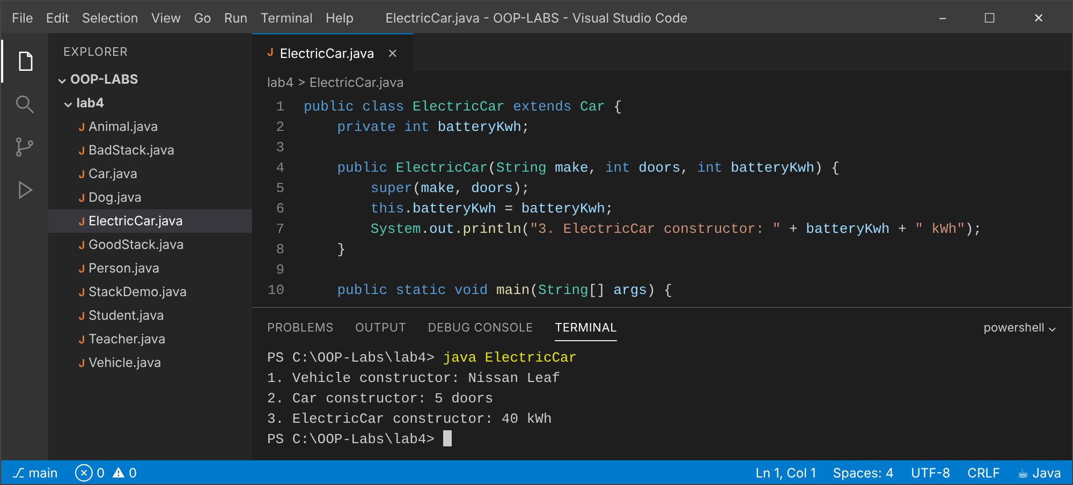

Exercise 4 (Intermediate): Why 'class Dog extends Animal' fails
Explanation
Animal only defines Animal(String), so the compiler does not supply a no-argument constructor. A Dog without its own constructor gets an implicit super(), which cannot find Animal(), and compilation fails (DogBroken.java.txt). The fix is Dog(String name) { super(name); }.
Code: Animal.java
/**
* Lab 4, Exercise 4: Animal has ONLY Animal(String name). Because a constructor is
* defined, Java no longer supplies the hidden no-argument constructor.
*/
public class Animal {
protected String name;
public Animal(String name) { this.name = name; }
}
Code: DogBroken.java.txt
// WON'T COMPILE:
class Dog extends Animal {
// no constructor written -> Java inserts Dog() { super(); }
// but Animal has no Animal() -> error:
// constructor Animal in class Animal cannot be applied to given types
}
Code: Dog.java
/**
* Exercise 4 explanation: if Dog declares no constructor, the compiler adds
* Dog() { super(); }. super() looks for Animal(), which does not exist because Animal
* defines Animal(String). Compilation fails ("constructor Animal in class Animal cannot be
* applied to given types"). See DogBroken.java.txt. FIX: call super(name) explicitly.
*/
public class Dog extends Animal {
public Dog(String name) {
super(name); // the fix
}
public static void main(String[] args) {
Dog d = new Dog("Rex");
System.out.println("Dog created: " + d.name);
}
}
Output: java Dog
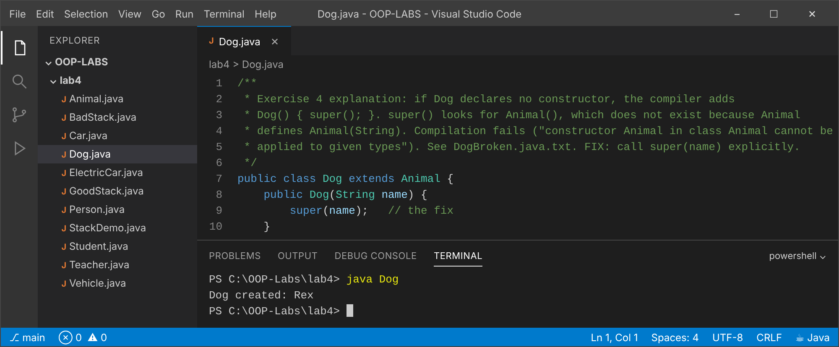

Exercise 5 (Challenge): Stack: inheritance vs composition
Explanation
BadStack extends ArrayList and wrongly exposes add(index), remove(index), get, set and so on, so the LIFO rule can be broken (shown in the output). GoodStack HAS-A list and exposes only push, pop, peek, isEmpty and size.
Code: BadStack.java
import java.util.ArrayList;
/**
* Lab 4, Exercise 5 (BAD design): Stack extends ArrayList.
* It WRONGLY exposes every ArrayList method: add(index, x), remove(index), get(i), set...
* so a caller can break the LIFO rule.
*/
public class BadStack<T> extends ArrayList<T> {
public void push(T x) { add(x); }
public T pop() { return remove(size() - 1); }
}
Code: GoodStack.java
import java.util.ArrayList;
import java.util.List;
/** Lab 4, Exercise 5 (GOOD design): composition. A Stack HAS-A list and exposes only stack operations. */
public class GoodStack<T> {
private final List<T> items = new ArrayList<>(); // hidden implementation detail
public void push(T x) { items.add(x); }
public T pop() {
if (items.isEmpty()) throw new IllegalStateException("Stack is empty");
return items.remove(items.size() - 1);
}
public T peek() { return items.get(items.size() - 1); }
public boolean isEmpty() { return items.isEmpty(); }
public int size() { return items.size(); }
}
Code: StackDemo.java
public class StackDemo {
public static void main(String[] args) {
BadStack<String> bad = new BadStack<>();
bad.push("A"); bad.push("B"); bad.push("C");
bad.add(0, "SNEAKY"); // inserts at the BOTTOM: violates LIFO, allowed by inheritance
bad.remove(1); // removes from the middle: also allowed
System.out.println("BadStack contents (LIFO broken): " + bad);
GoodStack<String> good = new GoodStack<>();
good.push("A"); good.push("B"); good.push("C");
// good.add(0, "SNEAKY"); // does not compile: no such method
System.out.println("GoodStack pop order: " + good.pop() + good.pop() + good.pop());
System.out.println(
"Inheritance wrongly exposes add(index), remove(index), get, set, clear, sort ... "
+ "and makes Stack-is-a-List, which is false. Composition exposes only push/pop/peek.");
}
}
Output: java StackDemo
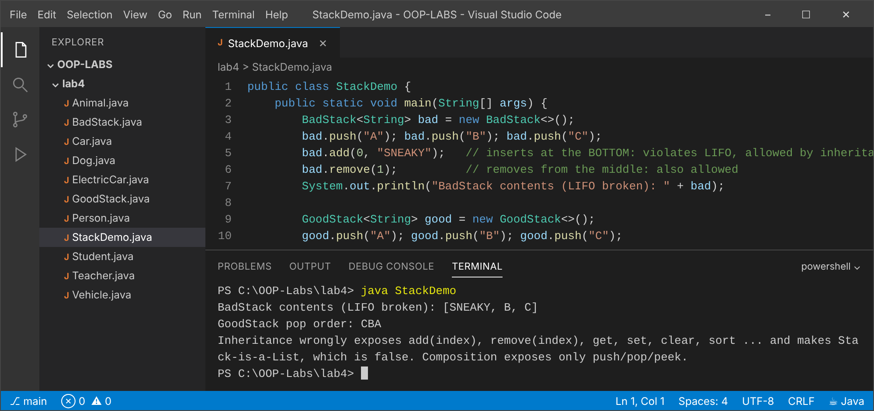

Conclusion
Inheritance reuses and specialises code for true is-a relationships; constructors chain from the top down; composition is safer when only part of a parent's interface should be exposed.

Lab 5: Polymorphism
Objectives
- Distinguish overloading from overriding.
- Use dynamic dispatch through superclass references.
- Compare instanceof chains with polymorphic design.

Exercise 1 (Basic): Overloaded print()
Explanation
The compiler chooses the overload from the argument types. The char 'A' widens to int, so print(int) is used and prints 65.
Code: PrintDemo.java
import java.util.Arrays;
/** Lab 5, Exercise 1: method overloading (resolved at COMPILE time by parameter types). */
public class PrintDemo {
static void print(int x) { System.out.println("int: " + x); }
static void print(double x) { System.out.println("double: " + x); }
static void print(String s) { System.out.println("String: " + s); }
static void print(int[] a) { System.out.println("int[]: " + Arrays.toString(a)); }
public static void main(String[] args) {
print(42);
print(3.14);
print("hello");
print(new int[]{1, 2, 3});
print('A'); // char widens to int -> print(int) chosen
}
}
Output: java PrintDemo
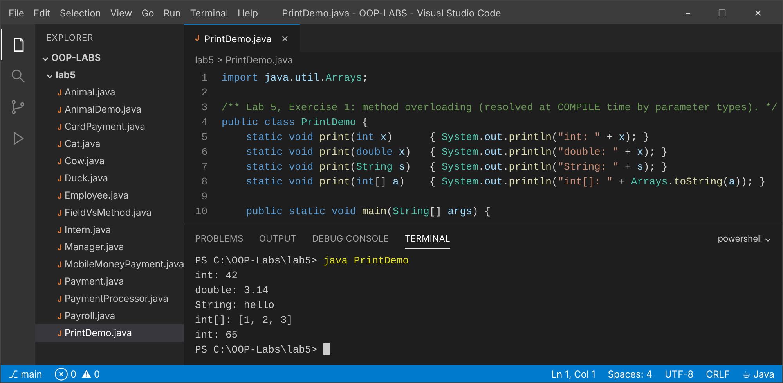

Exercise 2 (Basic): Animal[] with Cat, Cow, Duck
Explanation
One loop calls sound() through Animal references; the real object's override runs (dynamic dispatch).
Code: Animal.java
public class Animal {
public String sound() { return "..."; }
}
Code: Cat.java
public class Cat extends Animal { @Override public String sound() { return "Meow"; } }
Code: Cow.java
public class Cow extends Animal { @Override public String sound() { return "Moo"; } }
Code: Duck.java
public class Duck extends Animal { @Override public String sound() { return "Quack"; } }
Code: AnimalDemo.java
/** Lab 5, Exercise 2: Animal[] holding subclasses; each call dispatches to the real object's method. */
public class AnimalDemo {
public static void main(String[] args) {
Animal[] zoo = { new Cat(), new Cow(), new Duck(), new Animal() };
for (Animal a : zoo) {
System.out.println(a.getClass().getSimpleName() + " says " + a.sound());
}
}
}
Output: java AnimalDemo
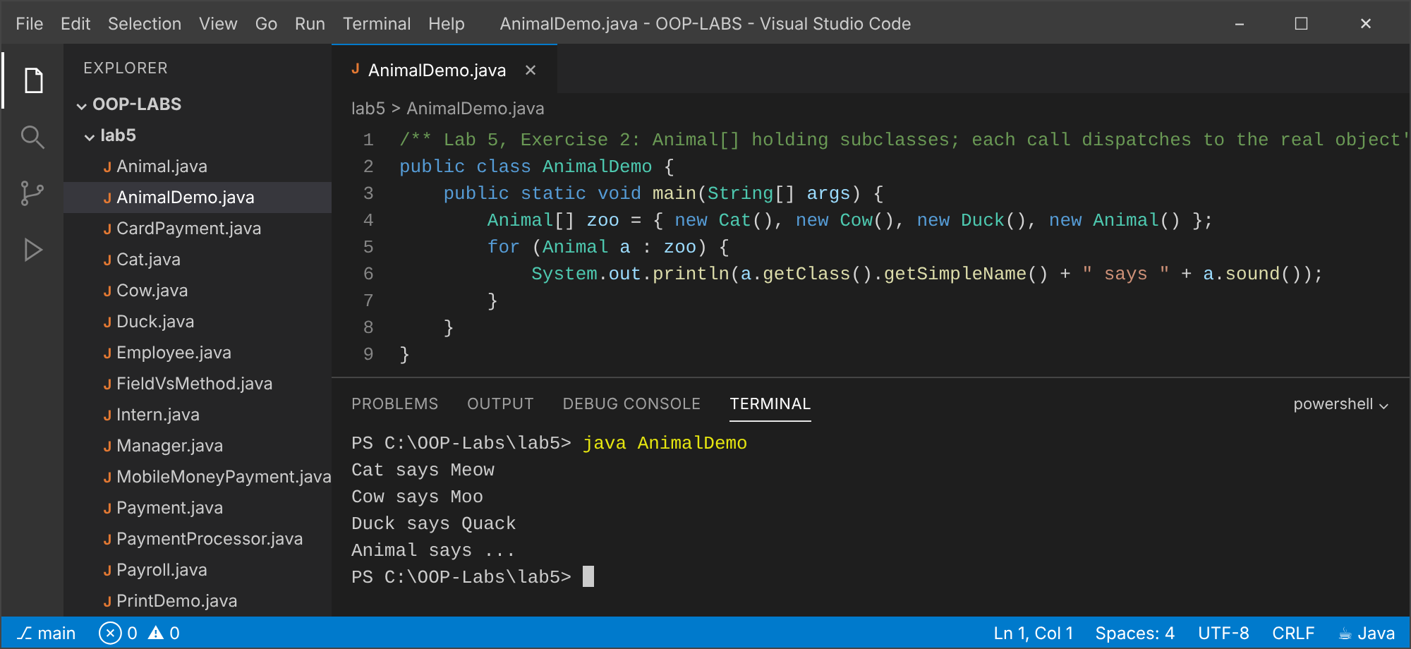

Exercise 3 (Intermediate): Payroll with Intern
Explanation
Adding Intern needs no change to the payroll loop, which only calls calculatePay() on Employee references.
Code: Employee.java
public class Employee {
private final String name;
protected double baseSalary;
public Employee(String name, double baseSalary) {
this.name = name;
this.baseSalary = baseSalary;
}
public String getName() { return name; }
public double calculatePay() { return baseSalary; }
}
Code: Manager.java
public class Manager extends Employee {
private final double bonus;
public Manager(String name, double baseSalary, double bonus) { super(name, baseSalary); this.bonus = bonus; }
@Override public double calculatePay() { return baseSalary + bonus; }
}
Code: Intern.java
/** Intern receives a fixed stipend: 60% of base salary. */
public class Intern extends Employee {
public Intern(String name, double baseSalary) { super(name, baseSalary); }
@Override public double calculatePay() { return baseSalary * 0.6; }
}
Code: Payroll.java
/** Lab 5, Exercise 3: the payroll loop never changes when new Employee types (Intern) are added. */
public class Payroll {
public static void main(String[] args) {
Employee[] staff = {
new Employee("Tatenda", 3000),
new Manager("Hillary", 3500, 800),
new Intern("Larry", 1500),
new Intern("Tinevimbo", 1800)
};
double total = 0;
for (Employee e : staff) { // <- this loop is unchanged by Intern
double pay = e.calculatePay(); // dynamic dispatch
System.out.printf("%-10s %-9s %8.2f%n", e.getName(), e.getClass().getSimpleName(), pay);
total += pay;
}
System.out.printf("Total payroll: %.2f%n", total);
}
}
Output: java Payroll
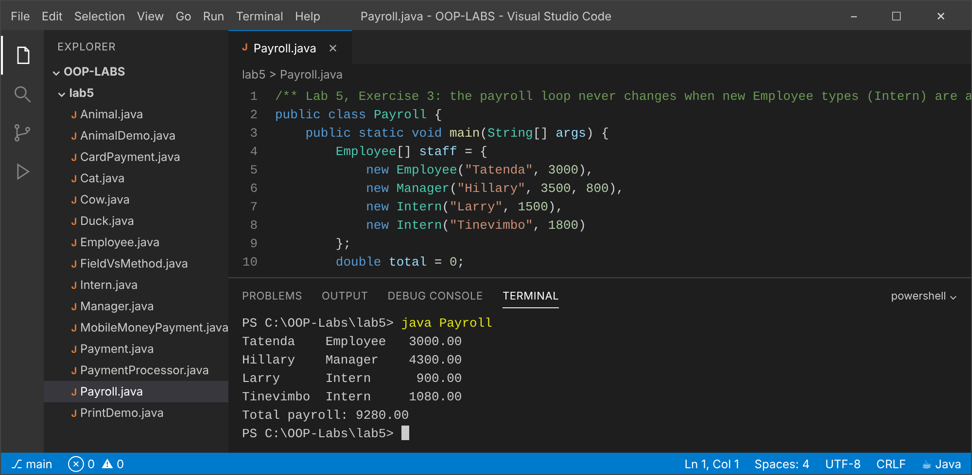

Exercise 4 (Intermediate): Method vs field through a superclass reference
Explanation
Methods are bound at run time to the real object (Child method). Fields and static methods are bound at compile time to the declared type, so p.label reads Parent's field even though the object is a Child.
Code: FieldVsMethod.java
/**
* Lab 5, Exercise 4: methods are polymorphic, fields (and static methods) are NOT.
* Methods are bound at RUN time to the real object's class (dynamic dispatch).
* Fields are bound at COMPILE time to the declared (reference) type, so a superclass
* reference reads the superclass's field even if the object is a subclass (field hiding).
*/
public class FieldVsMethod {
static class Parent {
String label = "Parent field";
String who() { return "Parent method"; }
static String stat() { return "Parent static"; }
}
static class Child extends Parent {
String label = "Child field"; // hides, does not override
@Override String who() { return "Child method"; }
static String stat() { return "Child static"; } // hides, does not override
}
public static void main(String[] args) {
Parent p = new Child();
System.out.println("p.who() -> " + p.who()); // Child method (dynamic)
System.out.println("p.label -> " + p.label); // Parent field (static binding)
System.out.println("((Child) p).label -> " + ((Child) p).label); // Child field
System.out.println("p.stat() -> " + Parent.stat() + " (static methods bind to the declared type)");
}
}
Output: java FieldVsMethod
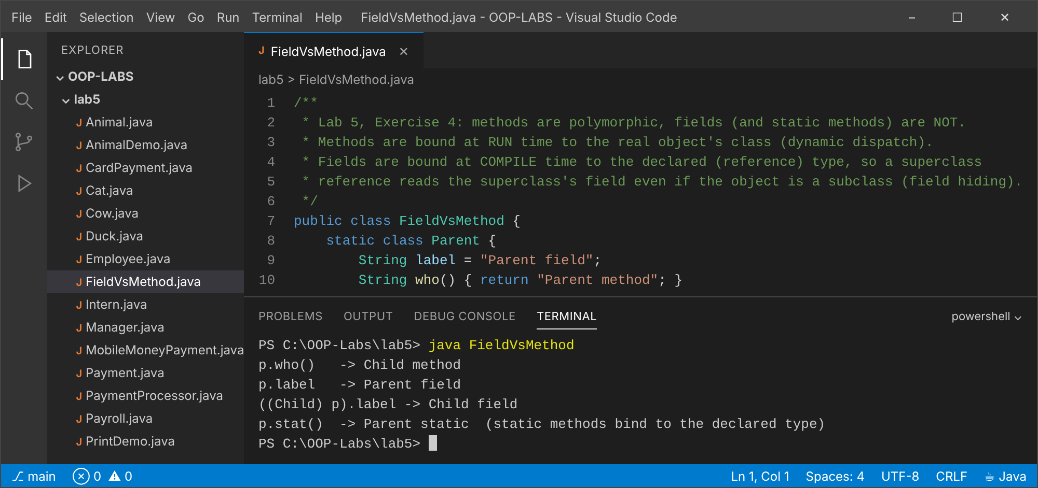

Exercise 5 (Challenge): PaymentProcessor: instanceof vs polymorphism
Explanation
Design 1 (pay) uses instanceof patterns, so each new payment type forces an edit of the processor. Design 2 (payPolymorphic) calls p.process(); a new payment type is just a new class. Both give the same output, but design 2 follows the Open/Closed Principle.
Code: Payment.java
public abstract class Payment {
protected final double amount;
protected Payment(double amount) { this.amount = amount; }
public double getAmount() { return amount; }
/** Polymorphic design (version 2): each subclass knows how to process itself. */
public abstract void process();
}
Code: CardPayment.java
public class CardPayment extends Payment {
private final String cardNumber;
public CardPayment(double amount, String cardNumber) { super(amount); this.cardNumber = cardNumber; }
public String last4() { return cardNumber.substring(cardNumber.length() - 4); }
@Override public void process() { System.out.printf("Charging card ****%s for $%.2f%n", last4(), amount); }
}
Code: MobileMoneyPayment.java
public class MobileMoneyPayment extends Payment {
private final String phone;
public MobileMoneyPayment(double amount, String phone) { super(amount); this.phone = phone; }
public String getPhone() { return phone; }
@Override public void process() { System.out.printf("Requesting mobile money from %s for $%.2f%n", phone, amount); }
}
Code: PaymentProcessor.java
/**
* Lab 5, Exercise 5: two designs.
* Version 1 : pay() uses instanceof pattern matching. Every new payment type forces an edit
* here (open for modification, closed for extension); a forgotten branch fails silently.
* Version 2 : payPolymorphic() just calls p.process(). A new type (e.g. BankTransfer) only needs
* a new class; PaymentProcessor never changes (Open/Closed Principle).
*/
public class PaymentProcessor {
// Design 1: type switching with instanceof patterns
public void pay(Payment p) {
if (p instanceof CardPayment c) {
System.out.printf("[v1] Charging card ****%s for $%.2f%n", c.last4(), c.getAmount());
} else if (p instanceof MobileMoneyPayment m) {
System.out.printf("[v1] Requesting mobile money from %s for $%.2f%n", m.getPhone(), m.getAmount());
} else {
throw new IllegalArgumentException("Unsupported payment type: " + p.getClass().getSimpleName());
}
}
// Design 2: polymorphism
public void payPolymorphic(Payment p) {
System.out.print("[v2] ");
p.process();
}
public static void main(String[] args) {
PaymentProcessor proc = new PaymentProcessor();
Payment[] payments = {
new CardPayment(120.50, "4111111111111234"),
new MobileMoneyPayment(35, "+263772418365")
};
for (Payment p : payments) proc.pay(p);
for (Payment p : payments) proc.payPolymorphic(p);
}
}
Output: java PaymentProcessor
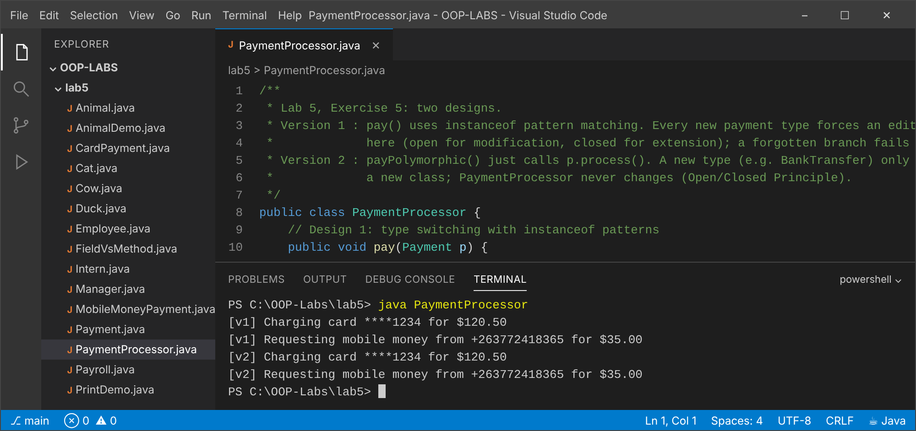

Conclusion
Overloading is resolved by the compiler, overriding by the JVM at run time; code written against a superclass works unchanged with new subclasses.

Lab 6: Abstraction, Abstract Classes and Interfaces
Objectives
- Declare abstract classes and methods.
- Define and implement interfaces.
- Use Comparable, Comparator and default methods.

Exercise 1 (Basic): Abstract Shape
Explanation
Shape declares abstract area() and perimeter() and a concrete describe(). Square reuses Rectangle.
Code: Shape.java
/** Lab 6, Exercise 1: abstract Shape. */
public abstract class Shape {
public abstract double area();
public abstract double perimeter();
// concrete method shared by all shapes
public void describe() {
System.out.printf("%-9s area=%8.2f perimeter=%7.2f%n", getClass().getSimpleName(), area(), perimeter());
}
}
Code: Circle.java
public class Circle extends Shape {
private final double radius;
public Circle(double radius) { this.radius = radius; }
@Override public double area() { return Math.PI * radius * radius; }
@Override public double perimeter() { return 2 * Math.PI * radius; }
}
Code: Rectangle.java
public class Rectangle extends Shape {
protected final double width, height;
public Rectangle(double width, double height) { this.width = width; this.height = height; }
@Override public double area() { return width * height; }
@Override public double perimeter() { return 2 * (width + height); }
}
Code: Square.java
public class Square extends Rectangle {
public Square(double side) { super(side, side); }
}
Code: ShapeDemo.java
public class ShapeDemo {
public static void main(String[] args) {
// Shape s = new Shape(); // compile error: Shape is abstract
Shape[] shapes = { new Circle(3), new Rectangle(4, 5), new Square(6) };
for (Shape s : shapes) s.describe();
}
}
Output: java ShapeDemo
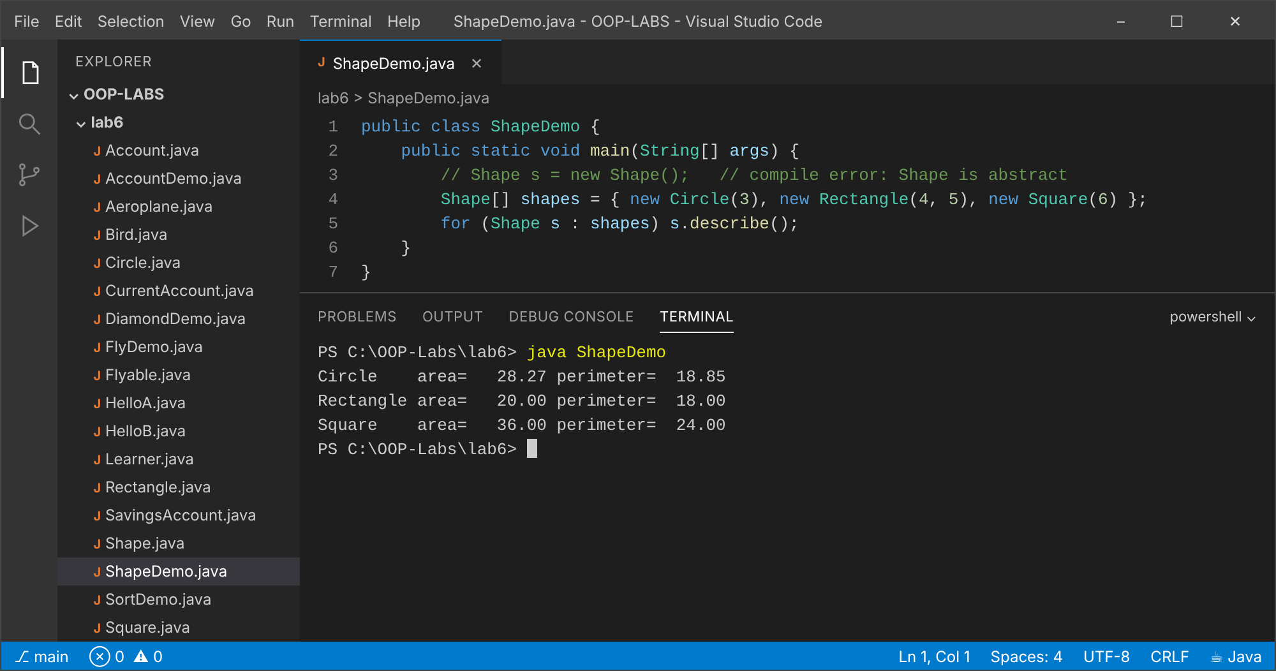

Exercise 2 (Basic): Flyable for Bird and Aeroplane
Explanation
An interface gives unrelated classes a common capability, so both can be stored in one Flyable[].
Code: Flyable.java
/** Lab 6, Exercise 2: an interface gives a capability to otherwise unrelated classes. */
public interface Flyable {
void fly();
}
Code: Bird.java
public class Bird implements Flyable {
@Override public void fly() { System.out.println("Bird flaps its wings and flies"); }
}
Code: Aeroplane.java
public class Aeroplane implements Flyable {
@Override public void fly() { System.out.println("Aeroplane accelerates down the runway and takes off"); }
}
Code: FlyDemo.java
public class FlyDemo {
public static void main(String[] args) {
// Bird and Aeroplane share NO superclass but can be used through one interface type
Flyable[] things = { new Bird(), new Aeroplane() };
for (Flyable f : things) f.fly();
}
}
Output: java FlyDemo
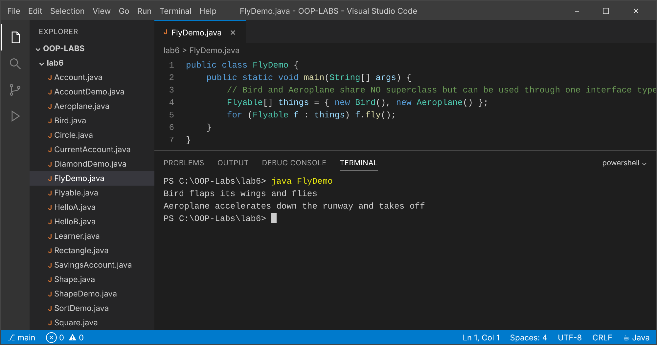

Exercise 3 (Intermediate): Abstract Account
Explanation
deposit() is concrete and shared; monthlyFee() is abstract and implemented differently: a flat fee for savings, a base fee plus 0.1% of the balance for current accounts.
Code: Account.java
/** Lab 6, Exercise 3: abstract Account with concrete deposit() and abstract monthlyFee(). */
public abstract class Account {
private final String number;
protected double balance;
protected Account(String number, double opening) { this.number = number; this.balance = opening; }
public void deposit(double amount) { // concrete: same for every account type
if (amount <= 0) throw new IllegalArgumentException("Deposit must be positive");
balance += amount;
}
public abstract double monthlyFee(); // each account type decides its own fee
public void applyMonthEnd() { balance -= monthlyFee(); }
public String getNumber() { return number; }
public double getBalance() { return balance; }
@Override public String toString() {
return String.format("%s %s balance=%.2f fee=%.2f", getClass().getSimpleName(), number, balance, monthlyFee());
}
}
Code: SavingsAccount.java
public class SavingsAccount extends Account {
public SavingsAccount(String number, double opening) { super(number, opening); }
@Override public double monthlyFee() { return 2.00; } // flat fee
}
Code: CurrentAccount.java
public class CurrentAccount extends Account {
public CurrentAccount(String number, double opening) { super(number, opening); }
@Override public double monthlyFee() { return 5.00 + balance * 0.001; } // base + 0.1% of balance
}
Code: AccountDemo.java
public class AccountDemo {
public static void main(String[] args) {
Account[] accounts = { new SavingsAccount("SAV-1", 1000), new CurrentAccount("CUR-1", 2000) };
for (Account a : accounts) {
a.deposit(500);
System.out.println("Before: " + a);
a.applyMonthEnd();
System.out.println("After : " + a);
}
}
}
Output: java AccountDemo
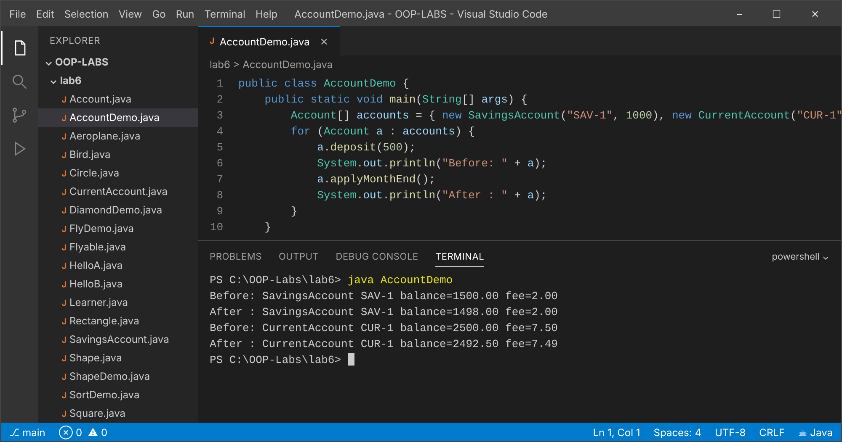

Exercise 4 (Intermediate): Comparable and Comparator
Explanation
The natural order (compareTo) is by name; a Comparator sorts by marks, highest first. (The manual calls the class Student; it is named Learner here to avoid clashing with other labs.)
Code: Learner.java
/** Lab 6, Exercise 4: Comparable (natural order by name) + Comparator (by marks). */
public class Learner implements Comparable<Learner> {
private final String name;
private final int marks;
public Learner(String name, int marks) { this.name = name; this.marks = marks; }
public String getName() { return name; }
public int getMarks() { return marks; }
@Override public int compareTo(Learner other) { return this.name.compareToIgnoreCase(other.name); }
@Override public String toString() { return name + "(" + marks + ")"; }
}
Code: SortDemo.java
import java.util.*;
public class SortDemo {
public static void main(String[] args) {
List<Learner> list = new ArrayList<>(List.of(
new Learner("Larry", 78), new Learner("Hillary", 64),
new Learner("Tatenda", 91), new Learner("Munya", 55)));
Collections.sort(list); // uses compareTo -> by name
System.out.println("By name (Comparable) : " + list);
Comparator<Learner> byMarks = Comparator.comparingInt(Learner::getMarks).reversed();
list.sort(byMarks); // highest marks first
System.out.println("By marks desc (Comparator): " + list);
}
}
Output: java SortDemo
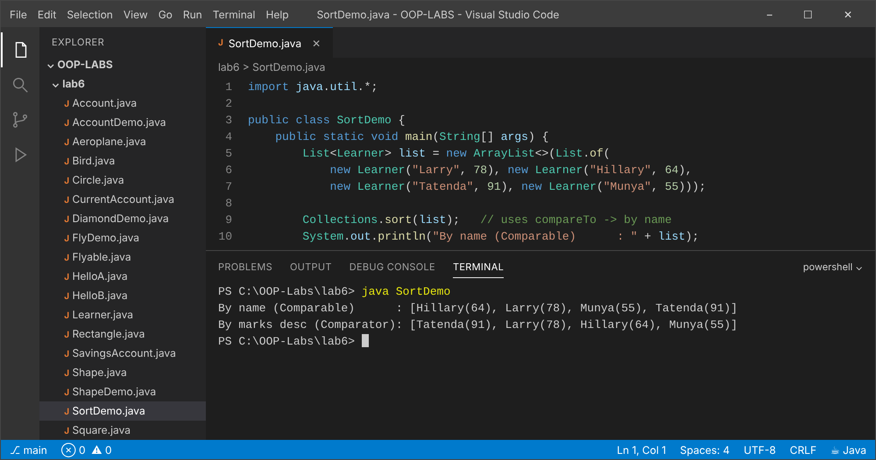

Exercise 5 (Challenge): Two default methods: InterfaceName.super
Explanation
Two inherited defaults with the same signature are ambiguous, so the class MUST override hello(). Inside it, HelloA.super.hello() and HelloB.super.hello() pick a specific default. Rules: class methods win; the more specific interface wins; otherwise the class resolves it explicitly.
Code: HelloA.java
public interface HelloA { default void hello() { System.out.println("Hello from A"); } }
Code: HelloB.java
public interface HelloB { default void hello() { System.out.println("Hello from B"); } }
Code: DiamondDemo.java
/**
* Lab 6, Exercise 5. If a class inherits two default methods with the same signature the
* compiler cannot choose, so it reports an error unless the class OVERRIDES hello().
* Inside the override, InterfaceName.super.hello() selects which default to call.
* Rule: (1) a class method always wins over an interface default; (2) a more specific
* interface wins over a less specific one; (3) otherwise the class must resolve it explicitly.
*/
public class DiamondDemo implements HelloA, HelloB {
@Override
public void hello() {
HelloA.super.hello();
HelloB.super.hello();
System.out.println("Hello from DiamondDemo (conflict resolved)");
}
public static void main(String[] args) { new DiamondDemo().hello(); }
}
Output: java DiamondDemo
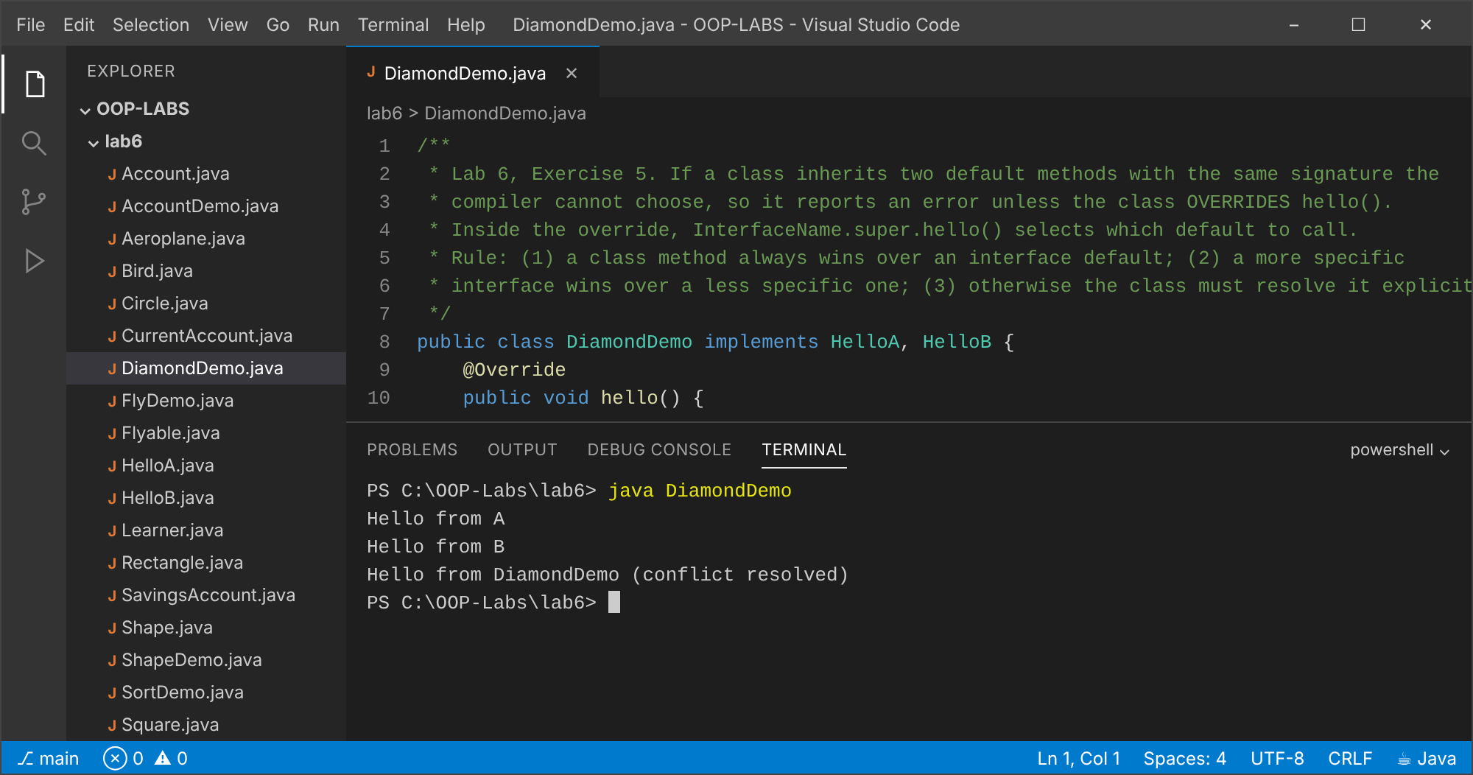

Conclusion
Abstract classes share code and force subclasses to complete the design; interfaces describe capabilities and allow a class to have many types.

Lab 7: Exception Handling
Objectives
- Use try/catch/finally.
- Create checked custom exceptions.
- Decide between exceptions and return values.

Exercise 1 (Basic): Safe division with Scanner
Explanation
Non-numeric input throws InputMismatchException; dividing by zero throws ArithmeticException. Both are caught and give friendly messages. The program is shown with three inputs: 12 and 4, abc, and 5 and 0.
Code: SafeDivide.java
import java.util.InputMismatchException;
import java.util.Scanner;
/** Lab 7, Exercise 1: read two ints and divide, handling bad input and divide-by-zero. */
public class SafeDivide {
static String divide(Scanner in) {
try {
System.out.print("Enter numerator: ");
int a = in.nextInt();
System.out.print("Enter denominator: ");
int b = in.nextInt();
return a + " / " + b + " = " + (a / b);
} catch (InputMismatchException e) {
in.nextLine(); // discard the bad token
return "Error: please enter whole numbers only";
} catch (ArithmeticException e) {
return "Error: cannot divide by zero";
}
}
public static void main(String[] args) {
Scanner in = new Scanner(System.in);
System.out.println(divide(in));
}
}
Output: java SafeDivide (input: 12, 4)
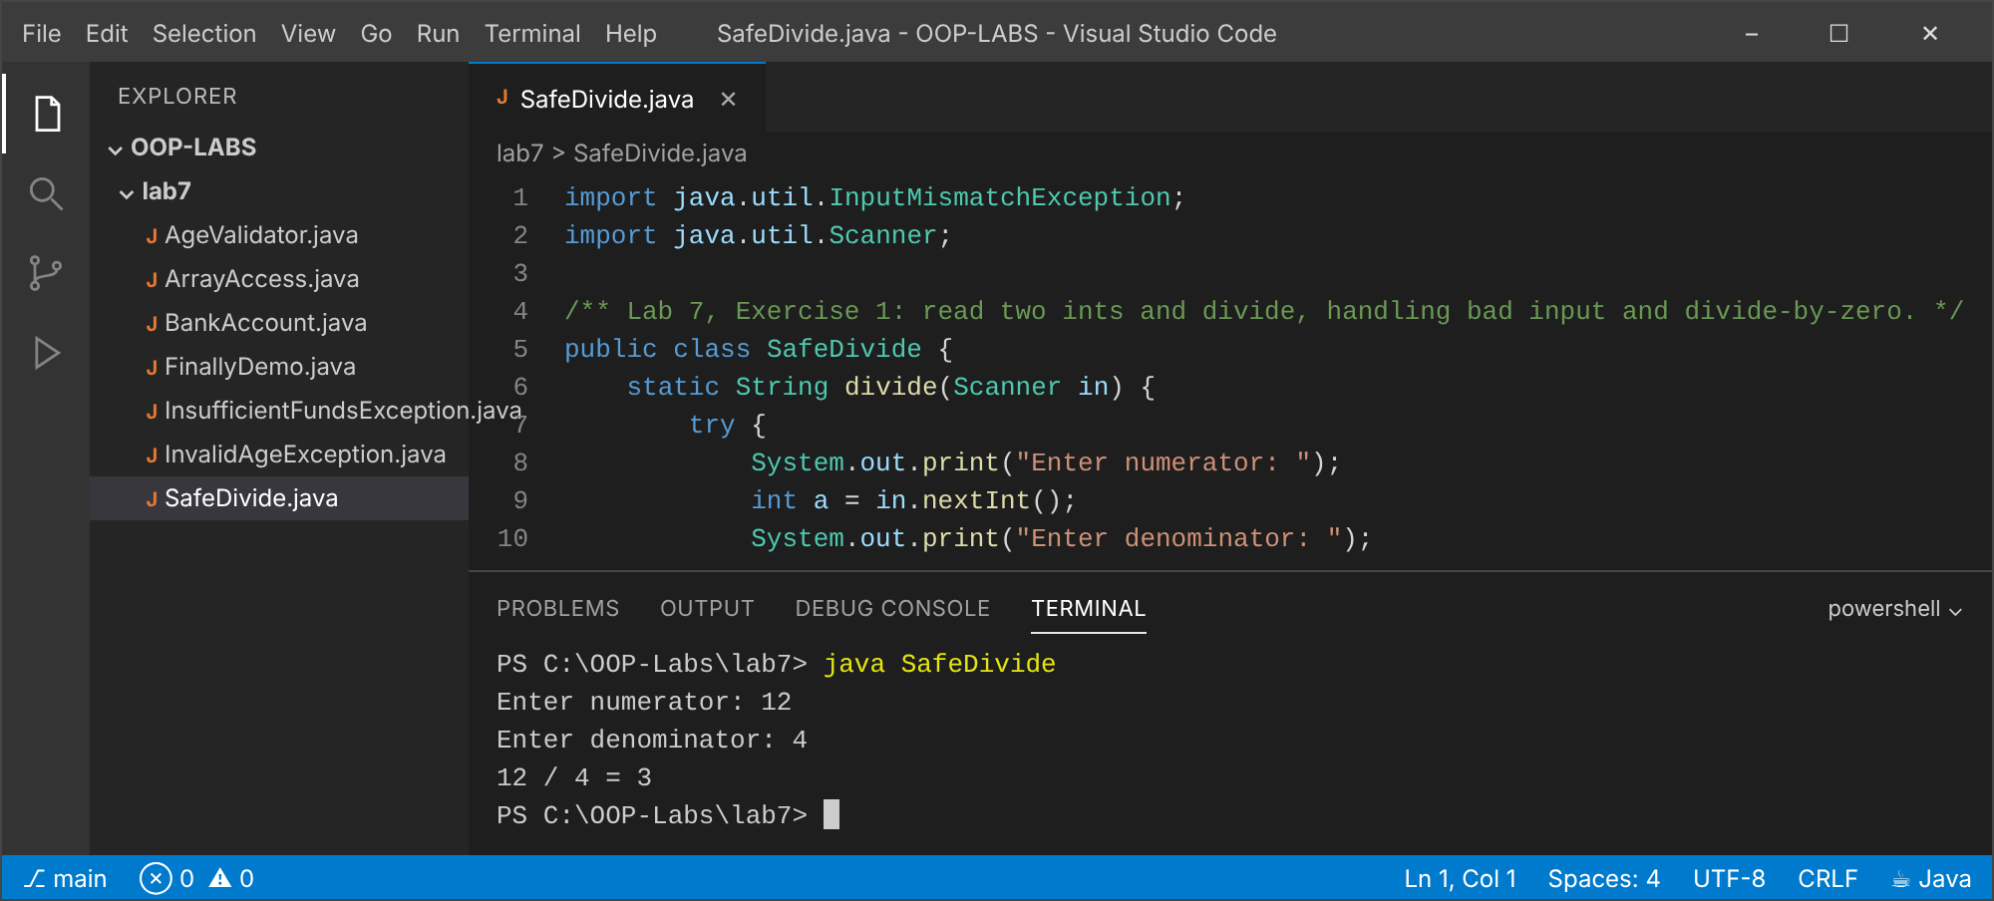
Output: java SafeDivide (input: abc)
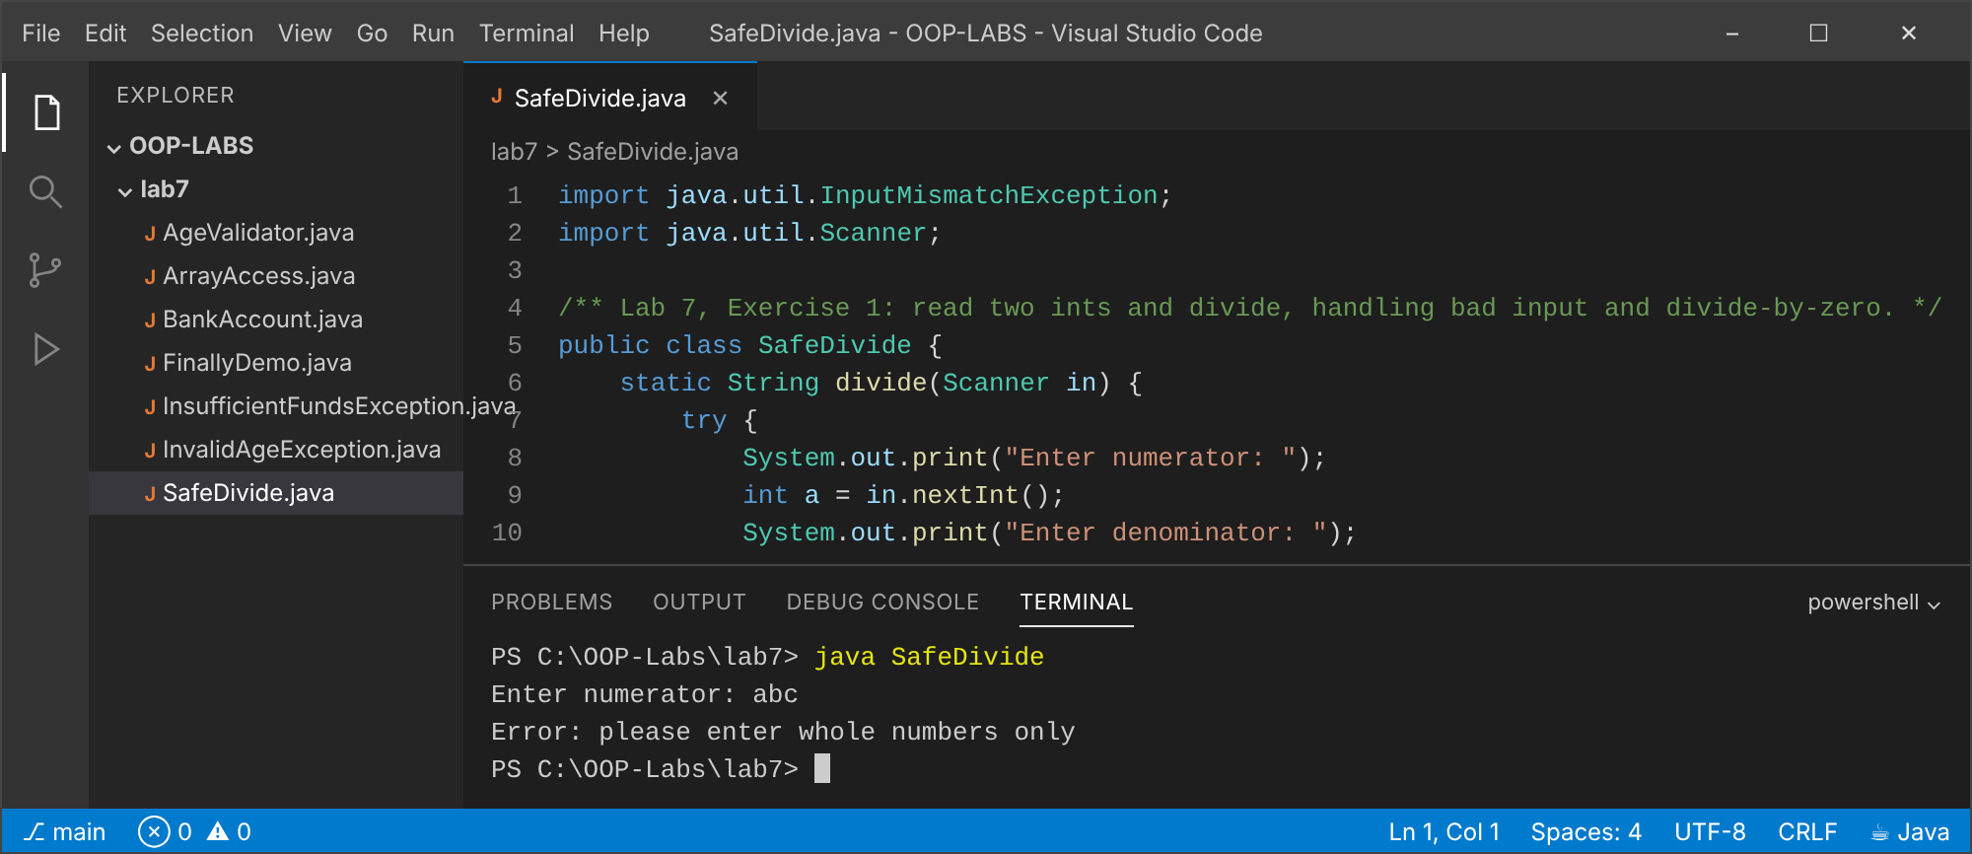
Output: java SafeDivide (input: 5, 0)
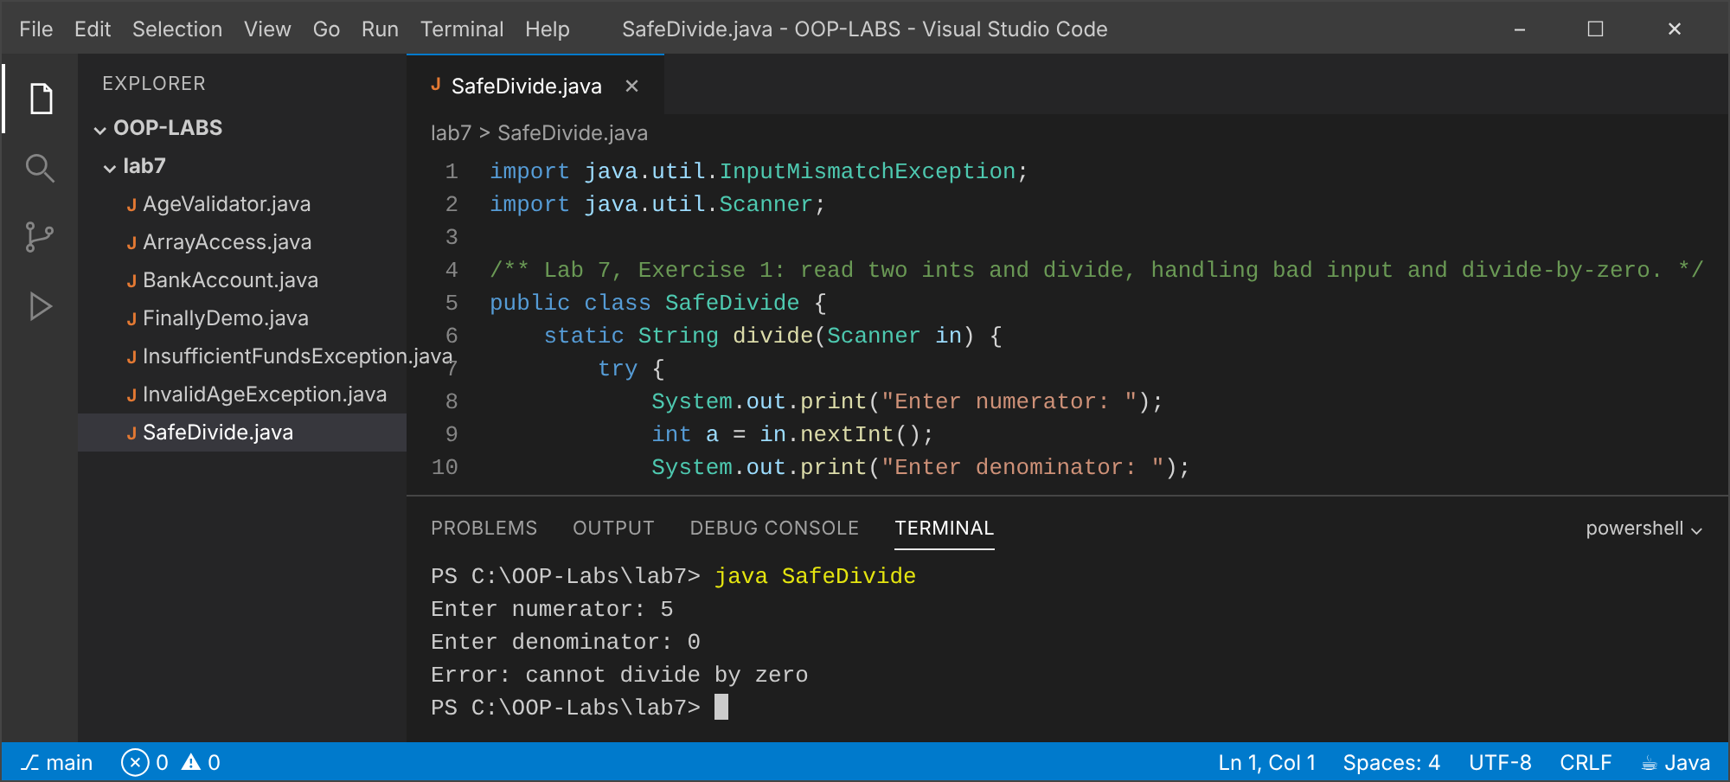

Exercise 2 (Basic): ArrayIndexOutOfBoundsException
Explanation
safeGet catches the exception, prints its message and returns -1.
Code: ArrayAccess.java
/** Lab 7, Exercise 2. */
public class ArrayAccess {
static int safeGet(int[] arr, int index) {
try {
return arr[index];
} catch (ArrayIndexOutOfBoundsException e) {
System.out.println("Caught: " + e.getMessage());
return -1;
}
}
public static void main(String[] args) {
int[] data = {10, 20, 30};
System.out.println("data[1] = " + safeGet(data, 1));
System.out.println("data[5] = " + safeGet(data, 5));
}
}
Output: java ArrayAccess
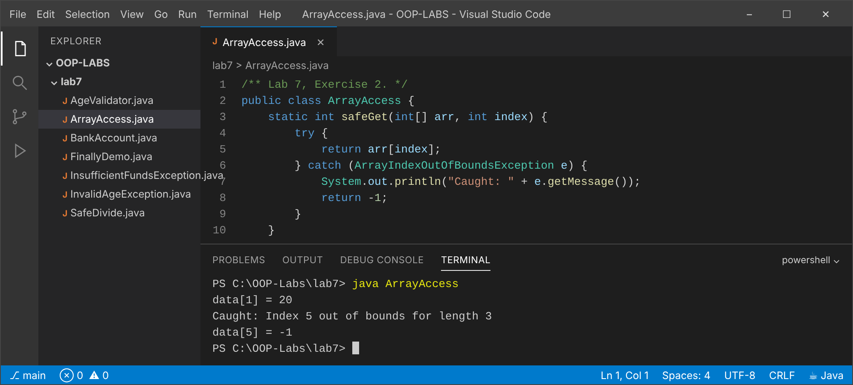

Exercise 3 (Intermediate): InvalidAgeException (checked)
Explanation
The class extends Exception, so callers must catch it or declare throws. Ages outside 0 to 120 are rejected.
Code: InvalidAgeException.java
/** Lab 7, Exercise 3: a CHECKED custom exception (extends Exception). */
public class InvalidAgeException extends Exception {
private final int age;
public InvalidAgeException(int age) {
super("Invalid age: " + age + " (must be 0 to 120)");
this.age = age;
}
public int getAge() { return age; }
}
Code: AgeValidator.java
public class AgeValidator {
static void validateAge(int age) throws InvalidAgeException { // callers MUST handle or declare it
if (age < 0 || age > 120) throw new InvalidAgeException(age);
}
public static void main(String[] args) {
int[] tests = {25, 0, 120, -5, 200};
for (int age : tests) {
try {
validateAge(age);
System.out.println(age + " is valid");
} catch (InvalidAgeException e) {
System.out.println("Rejected -> " + e.getMessage());
}
}
}
}
Output: java AgeValidator
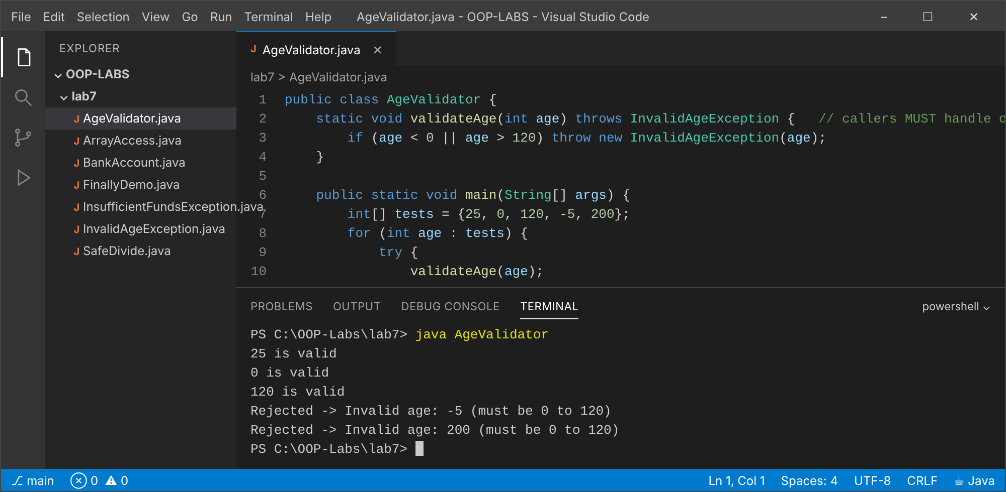

Exercise 4 (Intermediate): withdraw throws InsufficientFundsException
Explanation
withdraw now throws instead of returning false. Trade-offs are in the file's comment: the failure cannot be ignored and carries data, but callers need try/catch and an insufficient balance is arguably an expected event.
Code: InsufficientFundsException.java
public class InsufficientFundsException extends Exception {
private final double shortfall;
public InsufficientFundsException(double balance, double requested) {
super(String.format("Insufficient funds: balance %.2f, requested %.2f", balance, requested));
this.shortfall = requested - balance;
}
public double getShortfall() { return shortfall; }
}
Code: BankAccount.java
/**
* Lab 7, Exercise 4: withdraw now throws InsufficientFundsException.
* Trade-offs vs returning boolean:
* + The failure cannot be silently ignored (checked exception forces handling) and carries
* information (shortfall, message). Normal code path stays clean.
* + A boolean return conflates 'failed' with other reasons and is easy to forget to test.
* - Callers need try/catch boilerplate; exceptions are slower than a return value;
* - An insufficient balance is a fairly EXPECTED event, and some argue expected outcomes
* are better modelled by return values/Optional; exceptions suit exceptional conditions.
*/
public class BankAccount {
private final String accountNumber;
private double balance;
public BankAccount(String accountNumber, double opening) {
if (opening < 0) throw new IllegalArgumentException("Opening balance cannot be negative");
this.accountNumber = accountNumber;
this.balance = opening;
}
public double getBalance() { return balance; }
public void deposit(double amount) {
if (amount <= 0) throw new IllegalArgumentException("Deposit must be positive");
balance += amount;
}
public void withdraw(double amount) throws InsufficientFundsException {
if (amount <= 0) throw new IllegalArgumentException("Withdrawal must be positive");
if (amount > balance) throw new InsufficientFundsException(balance, amount);
balance -= amount;
}
public static void main(String[] args) {
BankAccount acc = new BankAccount("ACC-001", 500);
try {
acc.withdraw(200);
System.out.println("Withdrew 200, balance " + acc.getBalance());
acc.withdraw(1000);
System.out.println("not reached");
} catch (InsufficientFundsException e) {
System.out.println(e.getMessage() + " | short by " + e.getShortfall());
}
System.out.println("Balance unchanged by failed withdrawal: " + acc.getBalance());
}
}
Output: java BankAccount
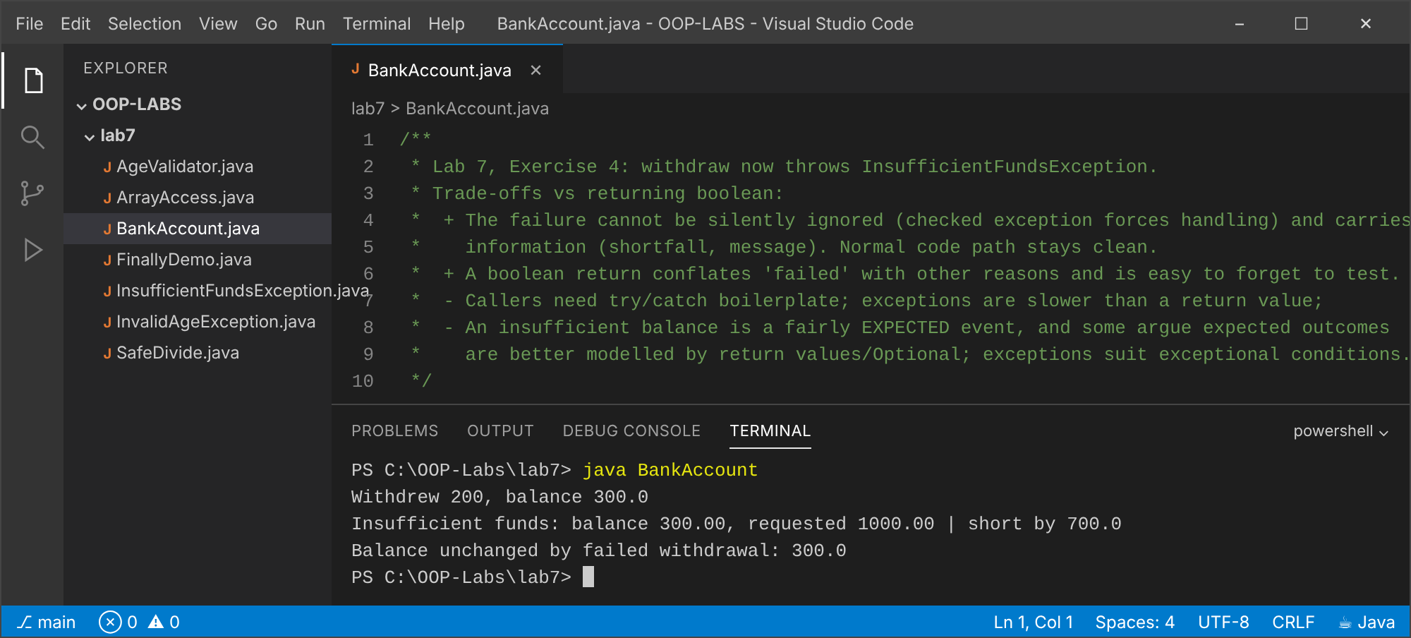

Exercise 5 (Challenge): return inside try with finally
Explanation
Prediction: in try, in finally, result = 1. finally always runs after the return value has been computed, which makes it the right place for cleanup. A return inside finally overrides the earlier value (override() returns 2), so it should be avoided.
Code: FinallyDemo.java
/**
* Lab 7, Exercise 5. PREDICTION: "in try", then "in finally", then "result = 1".
* The try block evaluates the return value (1), finally runs and prints,
* and only then does the method return 1.
* finally ALWAYS executes (return, exception or normal end) so it is used for cleanup;
* the only ways to skip it are System.exit() or the JVM dying.
* Note: a return inside finally would OVERRIDE the try's return value (bad practice).
*/
public class FinallyDemo {
static int test() {
try {
System.out.println("in try");
return 1;
} finally {
System.out.println("in finally");
}
}
@SuppressWarnings("finally")
static int override() {
try {
return 1;
} finally {
return 2; // overrides the try's return: avoid!
}
}
public static void main(String[] args) {
int r = test();
System.out.println("result = " + r);
System.out.println("override() = " + override());
}
}
Output: java FinallyDemo
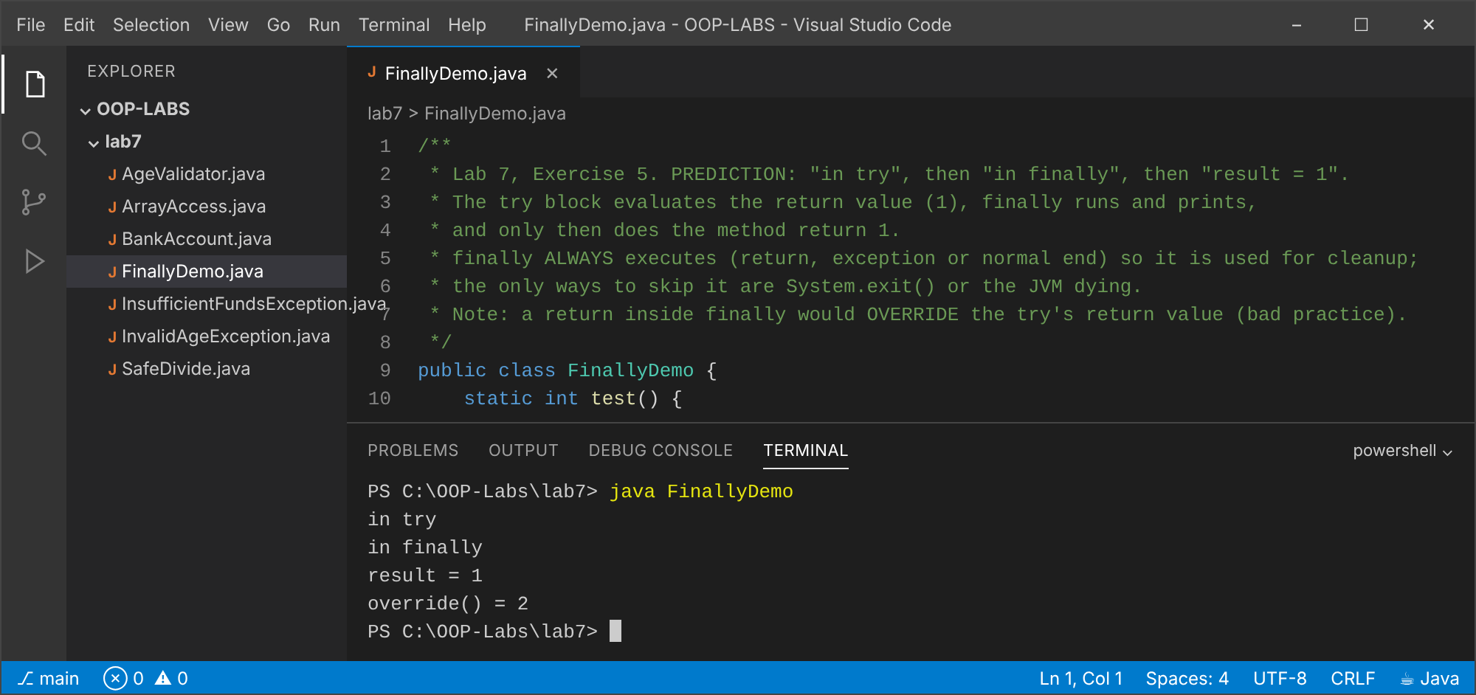

Conclusion
Exceptions separate error handling from normal logic; checked exceptions force the caller to deal with recoverable problems; finally guarantees cleanup.

Lab 8: Generics and the Collections Framework
Objectives
- Use List, Set and Map.
- Write generic classes and methods.
- Sort with Comparable and Comparator.

Exercise 1 (Basic): ArrayList: sum, max, reverse
Explanation
Ten integers are summed, the maximum is found with Collections.max and a reversed copy is made with Collections.reverse.
Code: ListStats.java
import java.util.*;
/** Lab 8, Exercises 1 & 2. */
public class ListStats {
public static void main(String[] args) {
// Exercise 1: sum, max, reverse
List<Integer> nums = new ArrayList<>(List.of(14, 3, 27, 9, 41, 8, 22, 35, 6, 19));
int sum = 0;
for (int n : nums) sum += n;
System.out.println("List : " + nums);
System.out.println("Sum : " + sum);
System.out.println("Max : " + Collections.max(nums));
List<Integer> reversed = new ArrayList<>(nums);
Collections.reverse(reversed);
System.out.println("Reverse: " + reversed);
// Exercise 2: remove duplicates with a Set (LinkedHashSet keeps the first-seen order)
List<String> names = List.of("Larry", "Hillary", "Larry", "Tinevimbo", "Hillary", "Tatenda", "Tinevimbo");
Set<String> unique = new LinkedHashSet<>(names);
System.out.println("Names : " + names);
System.out.println("Unique : " + unique);
}
}
Output: java ListStats
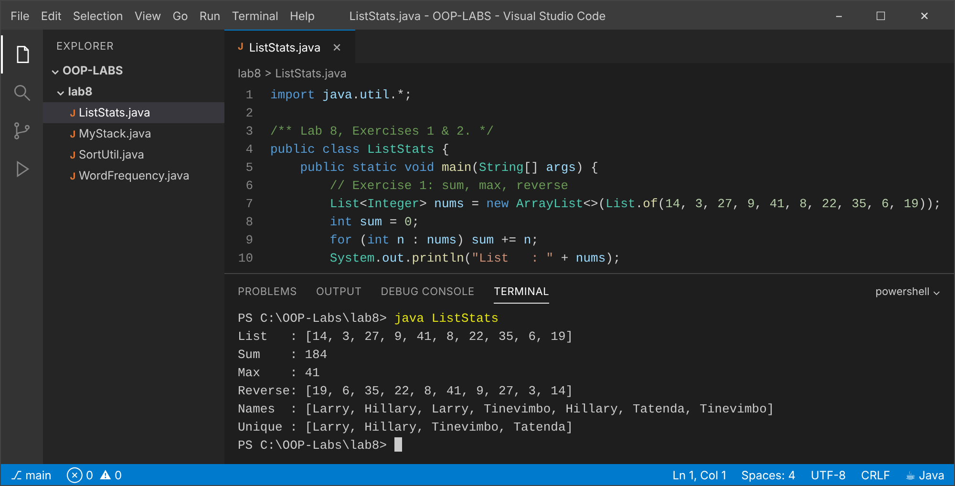

Exercise 2 (Basic): Remove duplicates with a Set
Explanation
A LinkedHashSet created from the list removes duplicates and keeps the first-seen order. (Same file and output as Exercise 1.)
Code: ListStats.java (listed under Exercise 1 above).

Exercise 3 (Intermediate): Generic Stack<T>
Explanation
MyStack<T> wraps an ArrayList<T>. The compiler rejects pushing the wrong type; pop and peek on an empty stack throw IllegalStateException.
Code: MyStack.java
import java.util.ArrayList;
import java.util.List;
/** Lab 8, Exercise 3: generic Stack<T> backed by an ArrayList<T>. */
public class MyStack<T> {
private final List<T> items = new ArrayList<>();
public void push(T item) { items.add(item); }
public T pop() {
if (isEmpty()) throw new IllegalStateException("Stack is empty");
return items.remove(items.size() - 1);
}
public T peek() {
if (isEmpty()) throw new IllegalStateException("Stack is empty");
return items.get(items.size() - 1);
}
public boolean isEmpty() { return items.isEmpty(); }
public int size() { return items.size(); }
public static void main(String[] args) {
MyStack<Integer> ints = new MyStack<>();
ints.push(1); ints.push(2); ints.push(3);
System.out.println("peek = " + ints.peek() + ", size = " + ints.size());
while (!ints.isEmpty()) System.out.print(ints.pop() + " ");
System.out.println();
MyStack<String> words = new MyStack<>();
words.push("alpha"); words.push("beta");
System.out.println("String stack pop: " + words.pop());
// words.push(5); // compile error: type safety from generics
try { new MyStack<Double>().pop(); }
catch (IllegalStateException e) { System.out.println("Empty pop -> " + e.getMessage()); }
}
}
Output: java MyStack
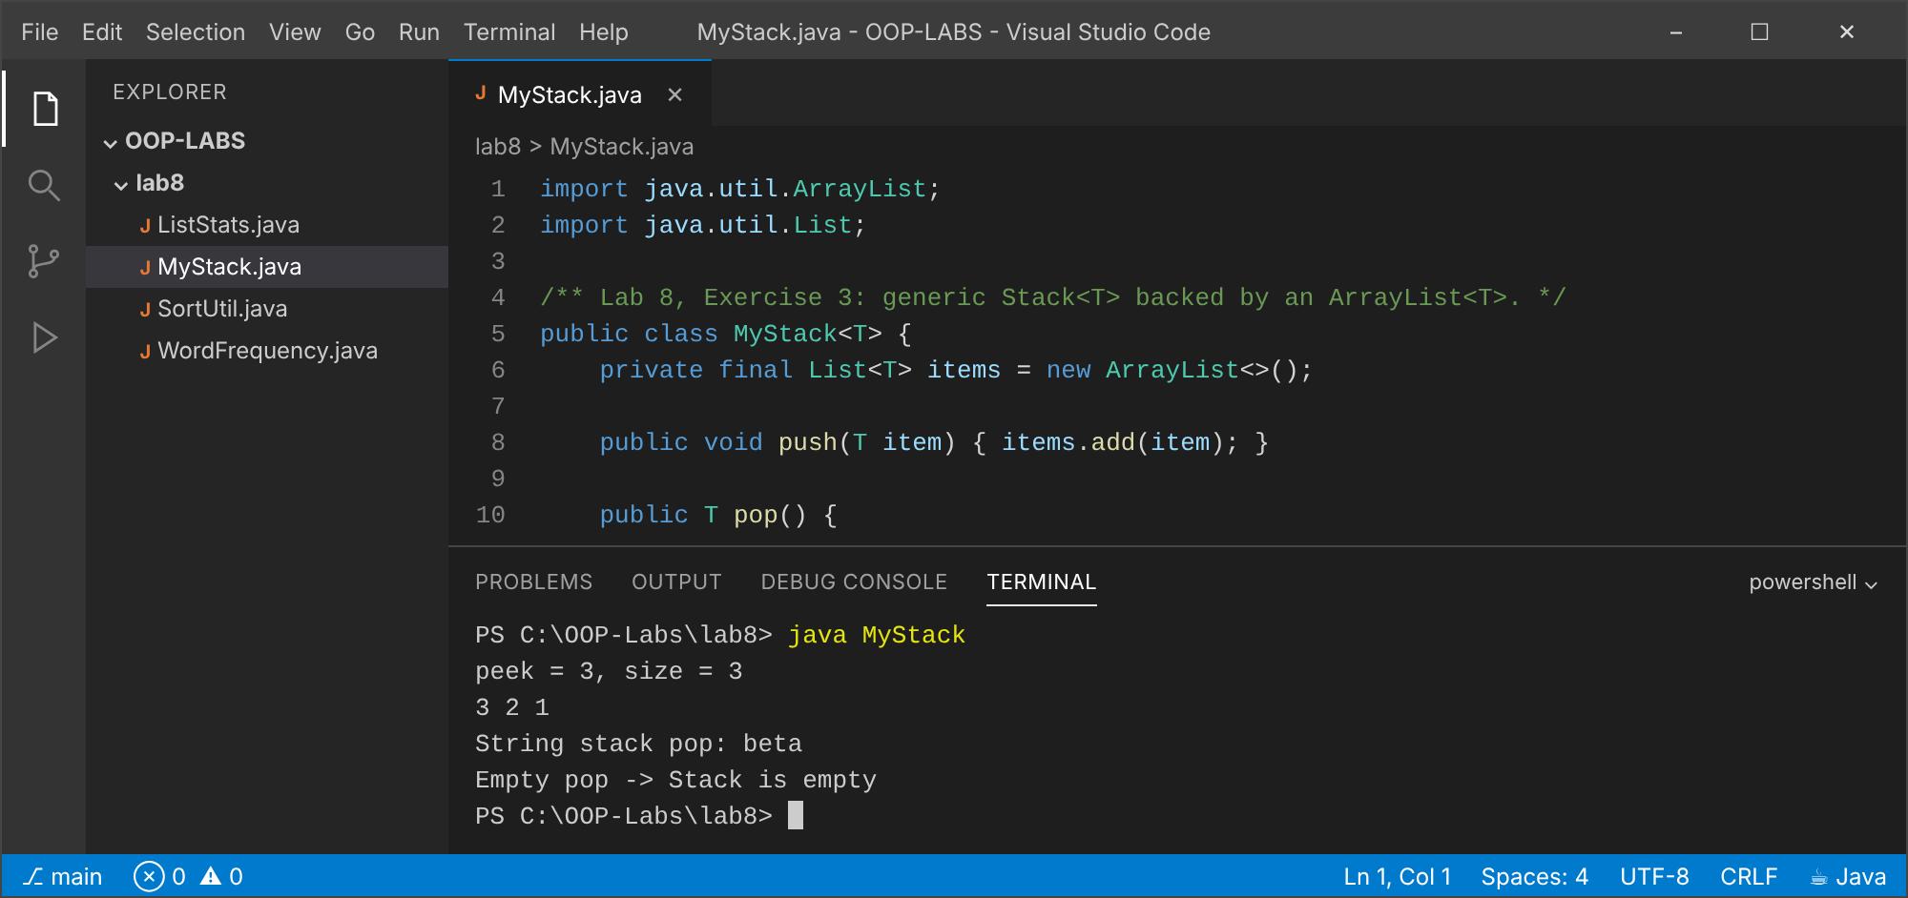

Exercise 4 (Intermediate): Word frequency, sorted by count
Explanation
A HashMap with merge(word, 1, Integer::sum) counts words. The entries are sorted by value descending, then alphabetically, and the top ten are printed.
Code: WordFrequency.java
import java.util.*;
import java.util.stream.Collectors;
/** Lab 8, Exercise 4: word frequency, sorted by count descending (ties alphabetical). */
public class WordFrequency {
public static void main(String[] args) {
String paragraph = """
Object oriented programming organises software around objects. An object bundles data
and behaviour. Classes describe objects, and objects interact through methods. The four
pillars of object oriented programming are encapsulation, inheritance, polymorphism and
abstraction. The pillars make programs easier to change.
""";
Map<String, Integer> freq = new HashMap<>();
for (String w : paragraph.toLowerCase().split("[^a-z]+")) {
if (!w.isEmpty()) freq.merge(w, 1, Integer::sum);
}
List<Map.Entry<String, Integer>> entries = new ArrayList<>(freq.entrySet());
entries.sort(Map.Entry.<String, Integer>comparingByValue().reversed()
.thenComparing(Map.Entry.comparingByKey()));
for (Map.Entry<String, Integer> e : entries.subList(0, 10)) {
System.out.printf("%-14s %d%n", e.getKey(), e.getValue());
}
System.out.println("(" + freq.size() + " distinct words; top 10 shown)");
}
}
Output: java WordFrequency
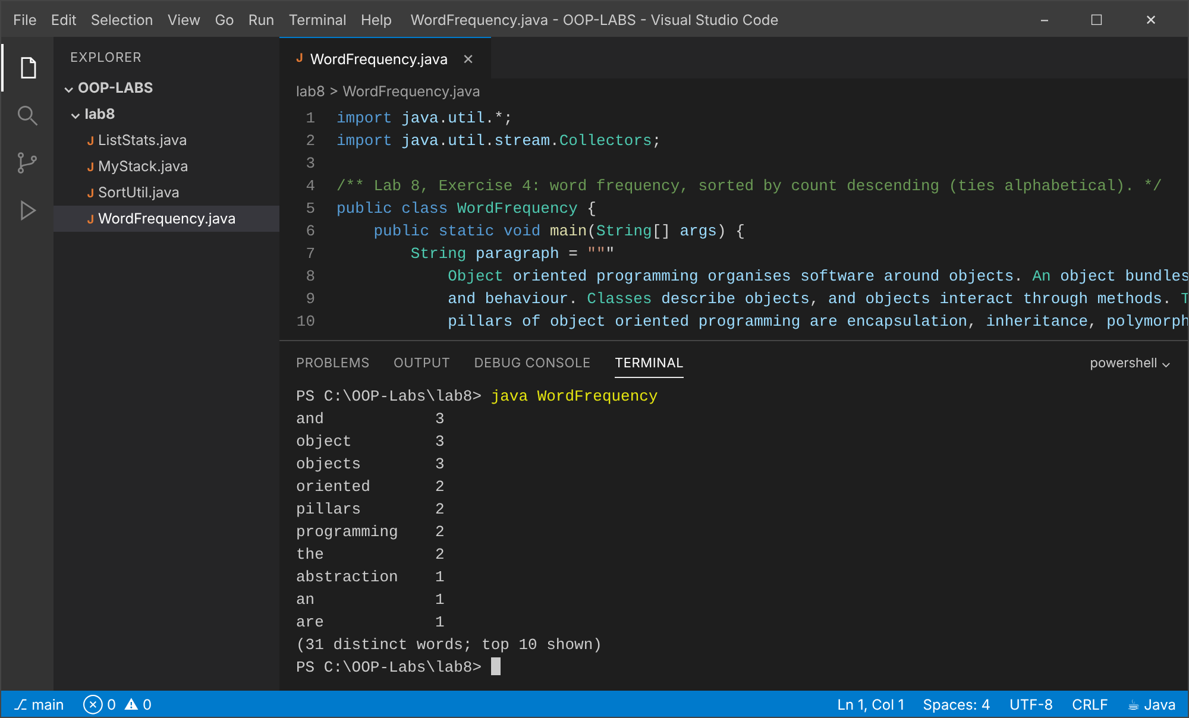

Exercise 5 (Challenge): Generic bubbleSort
Explanation
<T extends Comparable<T>> allows any comparable type. int[] does not work because generics need reference types (type erasure replaces T by Comparable), and int[] is not a T[]; Integer[] is used instead.
Code: SortUtil.java
import java.util.Arrays;
/**
* Lab 8, Exercise 5: generic bubble sort.
* int[] will not work because generics work only with REFERENCE types. T must be an object type
* (type erasure replaces T by Comparable at run time), and int[] is not a T[]: primitives are not
* objects, int[] is not an Object[], and int has no compareTo. Use Integer[] (boxing) instead.
*/
public class SortUtil {
public static <T extends Comparable<T>> void bubbleSort(T[] arr) {
for (int i = 0; i < arr.length - 1; i++) {
boolean swapped = false;
for (int j = 0; j < arr.length - 1 - i; j++) {
if (arr[j].compareTo(arr[j + 1]) > 0) {
T tmp = arr[j]; arr[j] = arr[j + 1]; arr[j + 1] = tmp;
swapped = true;
}
}
if (!swapped) break;
}
}
public static void main(String[] args) {
Integer[] nums = {5, 2, 9, 1, 7, 3};
String[] words = {"pear", "apple", "mango", "banana"};
bubbleSort(nums);
bubbleSort(words);
System.out.println(Arrays.toString(nums));
System.out.println(Arrays.toString(words));
int[] prim = {3, 1, 2};
// bubbleSort(prim); // compile error: inference variable T has incompatible bounds (int[] is not T[])
System.out.println("int[] cannot be passed: " + Arrays.toString(prim) + " (use Integer[] instead)");
}
}
Output: java SortUtil
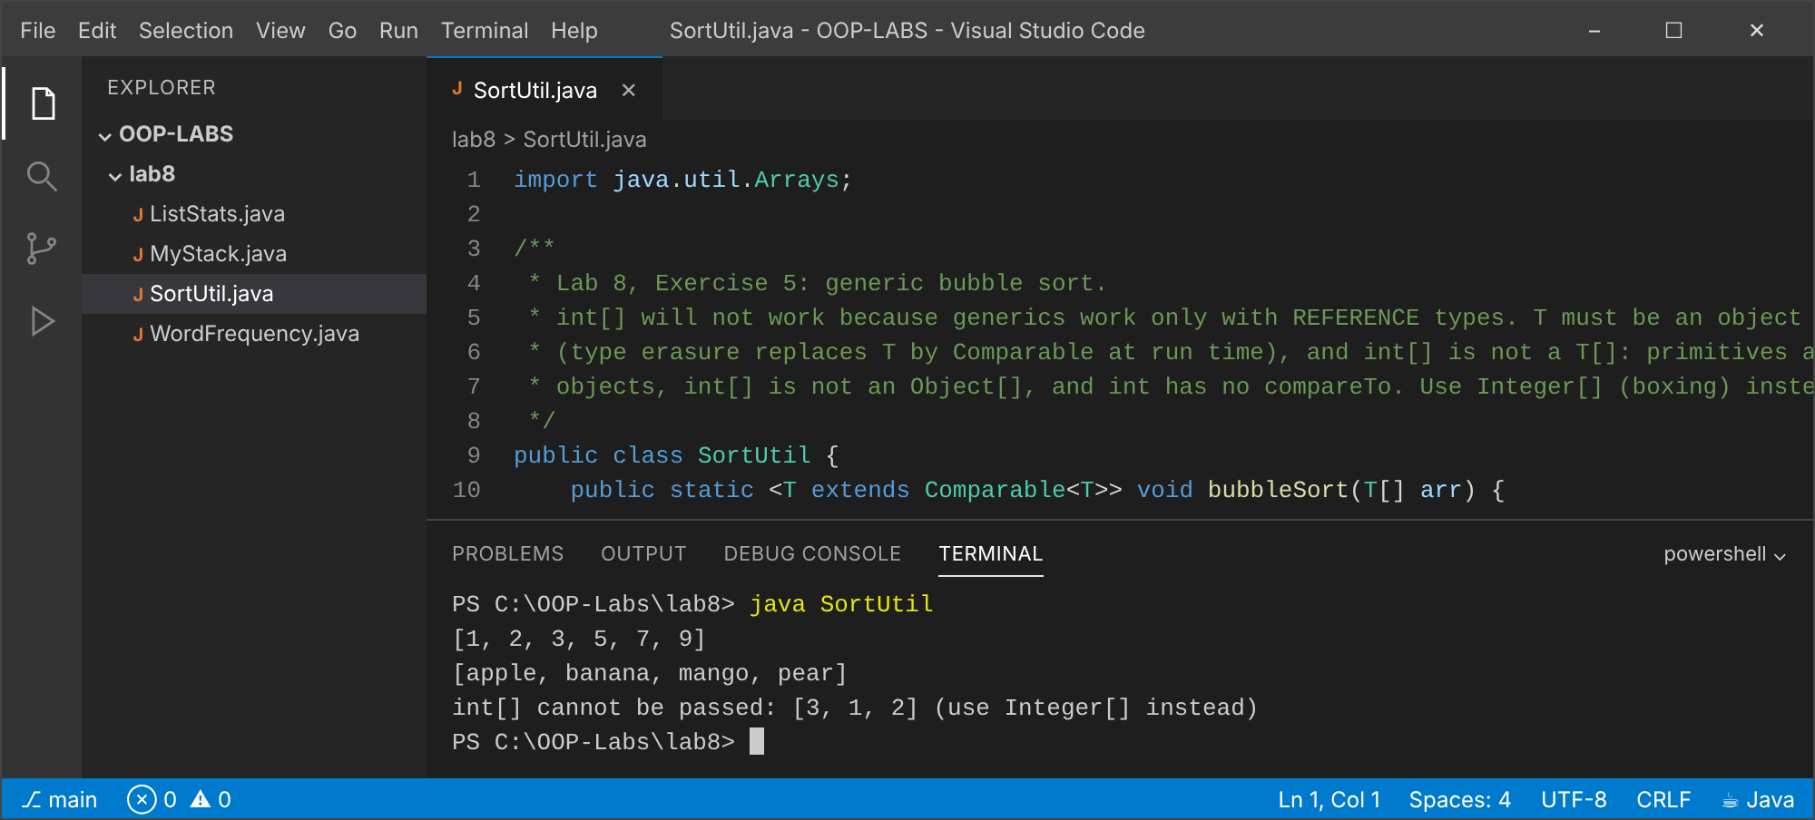

Conclusion
Generics give compile-time type safety; the collections framework supplies ready-made lists, sets and maps; sorting uses Comparable or Comparator.

Lab 9: Nested Types, Enums, Records and the Object Contract
Objectives
- Use enums with fields and switch.
- Use records.
- Override equals/hashCode/toString consistently and write nested/inner classes.

Exercise 1 (Basic): enum Level with switch
Explanation
A switch expression gives advice for each constant; there is no default because the compiler checks all constants are covered.
Code: LevelDemo.java
/** Lab 9, Exercise 1: enum + switch. */
public class LevelDemo {
enum Level { LOW, MEDIUM, HIGH }
static String advice(Level level) {
return switch (level) {
case LOW -> "Relax, but keep an eye on it.";
case MEDIUM -> "Plan ahead and monitor closely.";
case HIGH -> "Act now!";
};
}
public static void main(String[] args) {
for (Level l : Level.values()) System.out.println(l + " (ordinal " + l.ordinal() + "): " + advice(l));
System.out.println("valueOf(\"HIGH\") == Level.HIGH ? " + (Level.valueOf("HIGH") == Level.HIGH));
}
}
Output: java LevelDemo
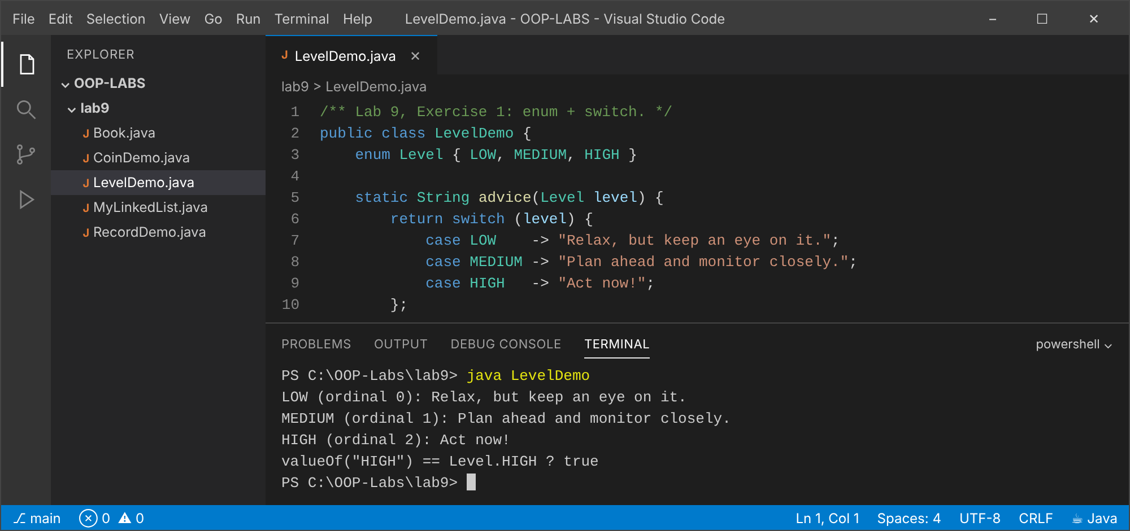

Exercise 2 (Basic): record Student
Explanation
The record generates a constructor, accessors, equals, hashCode and toString. Two records with equal components are equal even though they are different objects.
Code: RecordDemo.java
/** Lab 9, Exercise 2: records give constructor, accessors, equals, hashCode, toString for free. */
public class RecordDemo {
record Student(String name, int age) {
Student { // compact constructor for validation
if (age < 0) throw new IllegalArgumentException("age < 0");
}
}
public static void main(String[] args) {
Student a = new Student("Larry", 20);
Student b = new Student("Larry", 20);
Student c = new Student("Hillary", 22);
System.out.println(a); // Student[name=Larry, age=20]
System.out.println("a.equals(b): " + a.equals(b) + ", a == b: " + (a == b));
System.out.println("a.equals(c): " + a.equals(c));
System.out.println("same hashCode for equal records: " + (a.hashCode() == b.hashCode()));
System.out.println("component name() = " + a.name() + ", age() = " + a.age());
}
}
Output: java RecordDemo
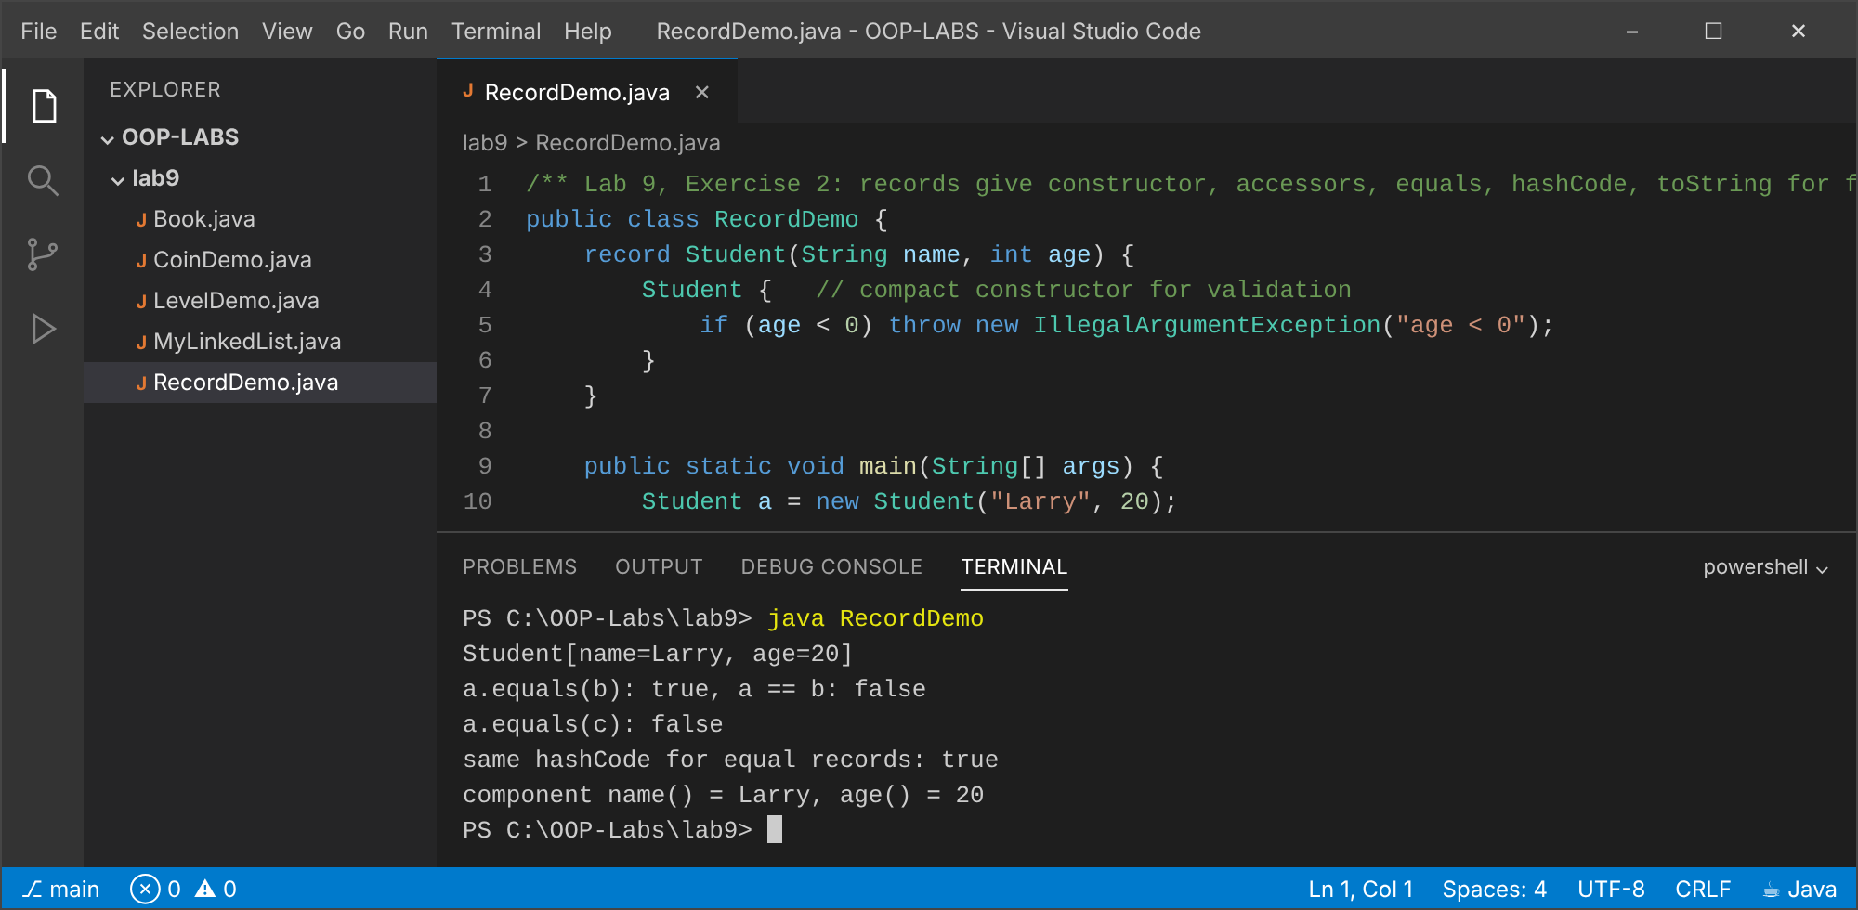

Exercise 3 (Intermediate): Book equals/hashCode in a HashSet
Explanation
Equality is by ISBN and hashCode uses the same field. add() returns false for the second copy, so the HashSet holds two books, not three.
Code: Book.java
import java.util.HashSet;
import java.util.Objects;
import java.util.Set;
/** Lab 9, Exercise 3: equality by ISBN; a HashSet then rejects duplicates. */
public class Book {
private final String isbn;
private final String title;
public Book(String isbn, String title) { this.isbn = isbn; this.title = title; }
@Override public boolean equals(Object o) {
if (this == o) return true;
if (!(o instanceof Book other)) return false;
return isbn.equals(other.isbn);
}
// equal objects MUST have equal hash codes, otherwise HashSet looks in the wrong bucket
@Override public int hashCode() { return Objects.hash(isbn); }
@Override public String toString() { return title + " [" + isbn + "]"; }
public static void main(String[] args) {
Set<Book> set = new HashSet<>();
System.out.println("add Clean Code -> " + set.add(new Book("978-0132350884", "Clean Code")));
System.out.println("add Effective Java -> " + set.add(new Book("978-0134685991", "Effective Java")));
System.out.println("add Clean Code (same ISBN)-> " + set.add(new Book("978-0132350884", "Clean Code (2nd copy)")));
System.out.println("Set size = " + set.size() + " -> " + set);
}
}
Output: java Book
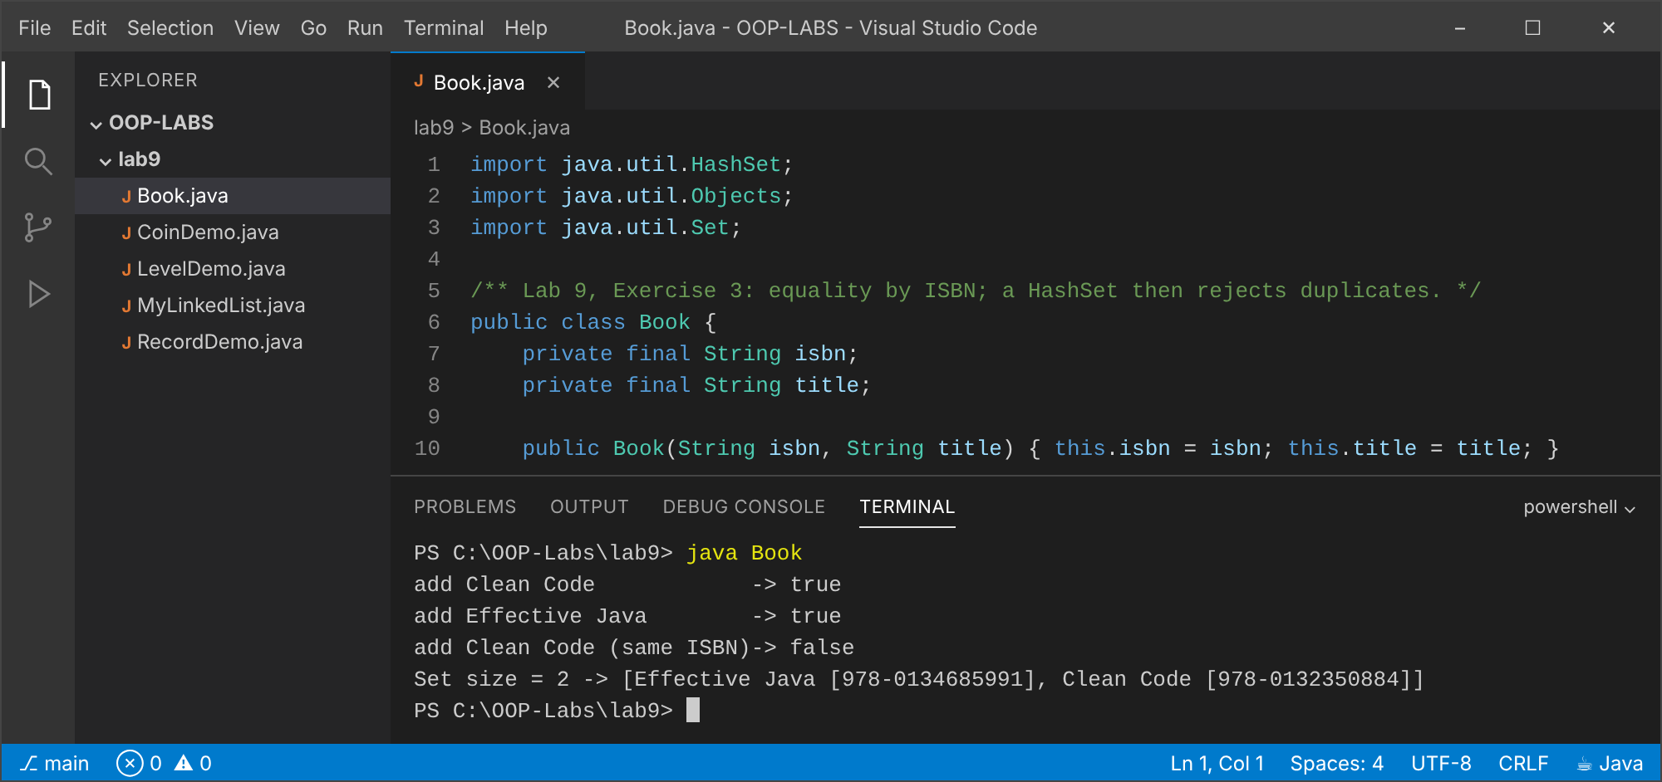

Exercise 4 (Intermediate): LinkedList with nested Node and inner Iterator
Explanation
Node is a private static nested class (it needs no list). The iterator is an inner class that uses the list's head. Implementing Iterable lets for-each work.
Code: MyLinkedList.java
import java.util.Iterator;
import java.util.NoSuchElementException;
/** Lab 9, Exercise 4: singly linked list with a private static nested Node and an inner Iterator. */
public class MyLinkedList<T> implements Iterable<T> {
// static nested: a Node needs no reference to the list that owns it
private static class Node<T> {
T data;
Node<T> next;
Node(T data) { this.data = data; }
}
private Node<T> head, tail;
private int size;
public void add(T item) {
Node<T> n = new Node<>(item);
if (head == null) head = tail = n;
else { tail.next = n; tail = n; }
size++;
}
public int size() { return size; }
// inner (non-static) class: it uses the enclosing list's 'head'
private class ListIterator implements Iterator<T> {
private Node<T> current = head;
@Override public boolean hasNext() { return current != null; }
@Override public T next() {
if (current == null) throw new NoSuchElementException();
T value = current.data;
current = current.next;
return value;
}
}
@Override public Iterator<T> iterator() { return new ListIterator(); }
public static void main(String[] args) {
MyLinkedList<String> list = new MyLinkedList<>();
list.add("one"); list.add("two"); list.add("three");
for (String s : list) System.out.println(s); // works because we implement Iterable
System.out.println("size = " + list.size());
}
}
Output: java MyLinkedList
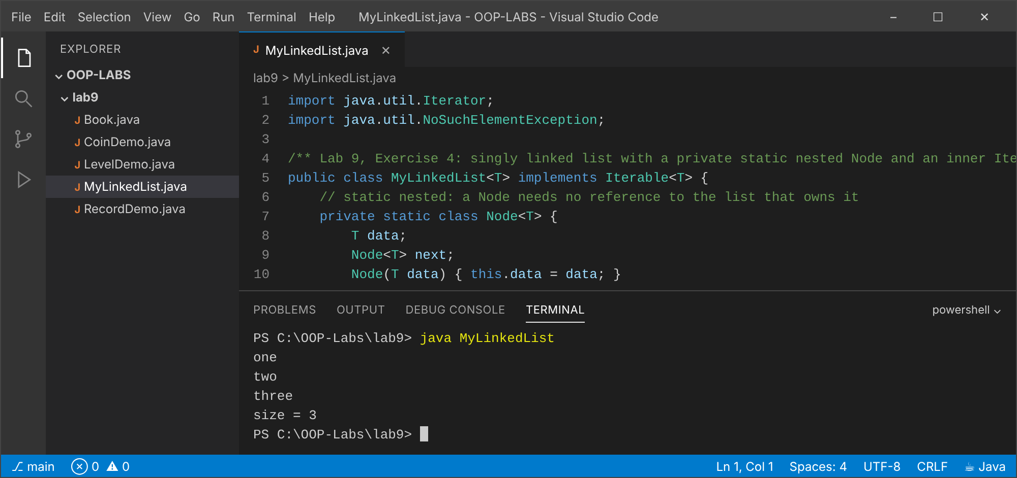

Exercise 5 (Challenge): enum Coin: fewest coins
Explanation
Each constant stores its value in cents. A greedy algorithm over the coins in descending order gives the fewest coins (greedy is optimal for this coin set).
Code: CoinDemo.java
import java.util.*;
/** Lab 9, Exercise 5: enum with fields and a greedy fewest-coins method. */
public class CoinDemo {
enum Coin {
PENNY(1), NICKEL(5), DIME(10), QUARTER(25);
private final int cents;
Coin(int cents) { this.cents = cents; }
int cents() { return cents; }
/** Greedy is optimal for this coin system. */
static Map<Coin, Integer> fewestCoins(int amount) {
if (amount < 0) throw new IllegalArgumentException("amount < 0");
Map<Coin, Integer> result = new EnumMap<>(Coin.class);
Coin[] desc = values().clone();
Arrays.sort(desc, Comparator.comparingInt(Coin::cents).reversed());
for (Coin c : desc) {
int n = amount / c.cents;
if (n > 0) { result.put(c, n); amount -= n * c.cents; }
}
return result;
}
}
public static void main(String[] args) {
for (int amt : new int[]{67, 99, 30, 4, 0}) {
Map<Coin, Integer> m = Coin.fewestCoins(amt);
int total = m.values().stream().mapToInt(Integer::intValue).sum();
System.out.println(amt + " cents -> " + m + " (" + total + " coins)");
}
}
}
Output: java CoinDemo
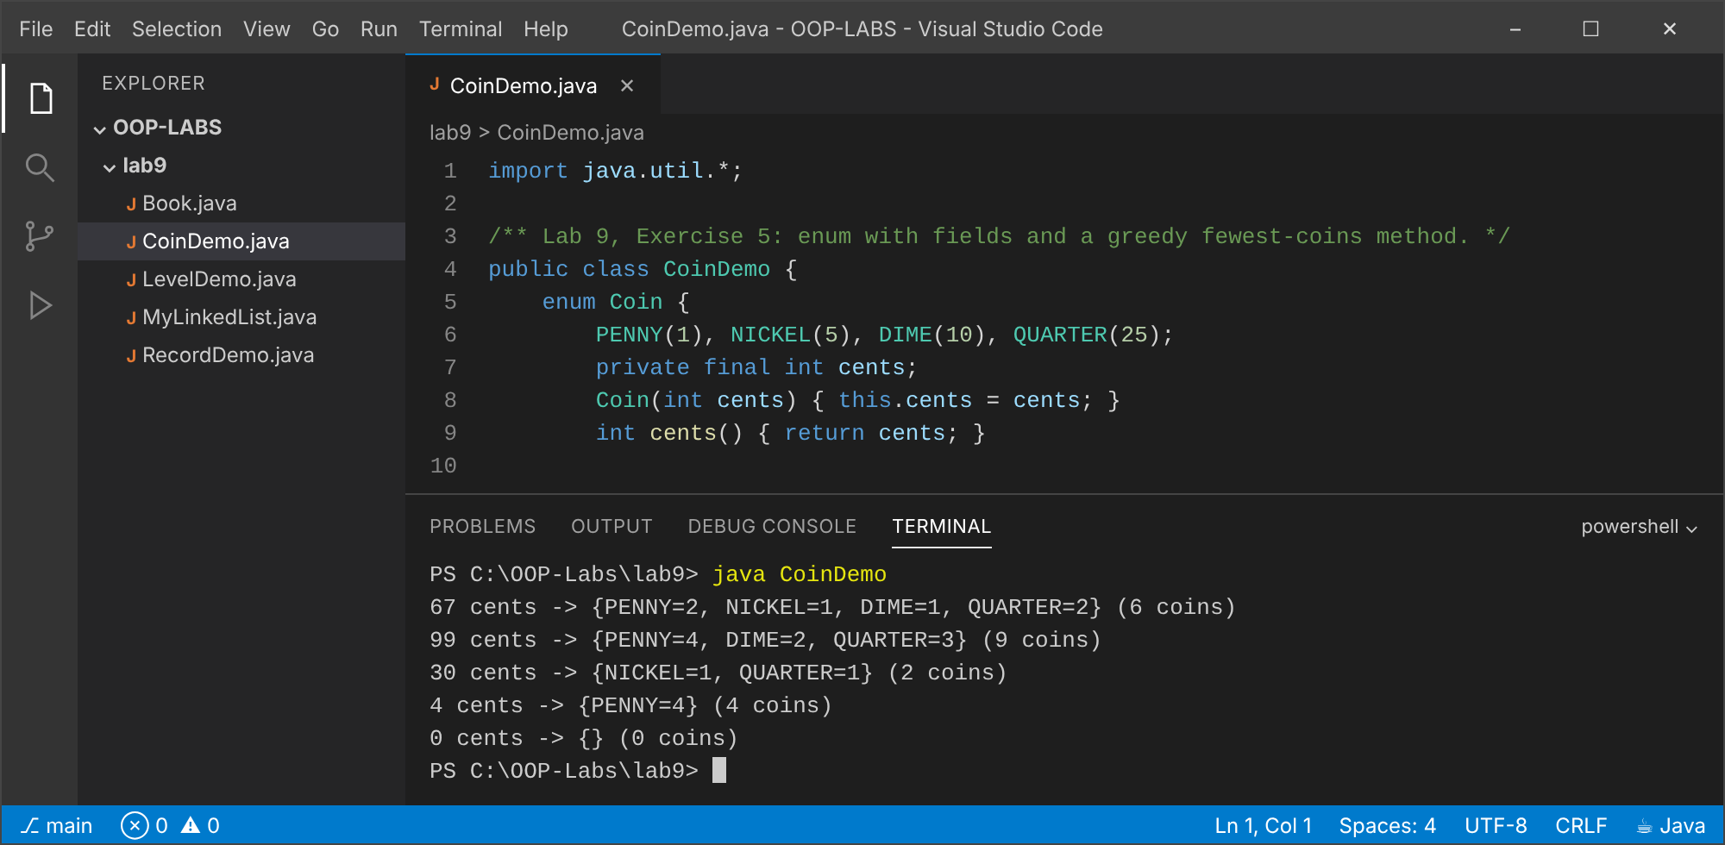

Conclusion
Enums and records express fixed sets and value types concisely; equals and hashCode must be overridden together; nested classes group helper types with their owner.

Lab 10: File I/O, Lambdas and Streams
Objectives
- Read and write files with java.nio.file.
- Use functional interfaces and lambdas.
- Process data with the Stream API.

Exercise 1 (Basic): Save five lines and read them back
Explanation
Five lines typed by the user are written with Files.write and read back with Files.readAllLines. (Input was supplied from a file here so the run is repeatable.)
Code: SaveLines.java
import java.io.IOException;
import java.nio.file.*;
import java.util.*;
/** Lab 10, Exercise 1: save five typed lines to a file, then read them back. */
public class SaveLines {
public static void main(String[] args) throws IOException {
Scanner in = new Scanner(System.in);
List<String> lines = new ArrayList<>();
for (int i = 1; i <= 5; i++) {
System.out.print("Line " + i + ": ");
lines.add(in.hasNextLine() ? in.nextLine() : "");
}
Path file = Path.of("notes.txt");
Files.write(file, lines); // writes and closes the file
System.out.println("\nSaved " + lines.size() + " lines to " + file);
System.out.println("--- reading back ---");
for (String s : Files.readAllLines(file)) System.out.println(s);
}
}
Output: java SaveLines (input: First line of my notes, Second line, Third line, Fourth line, Fifth line)
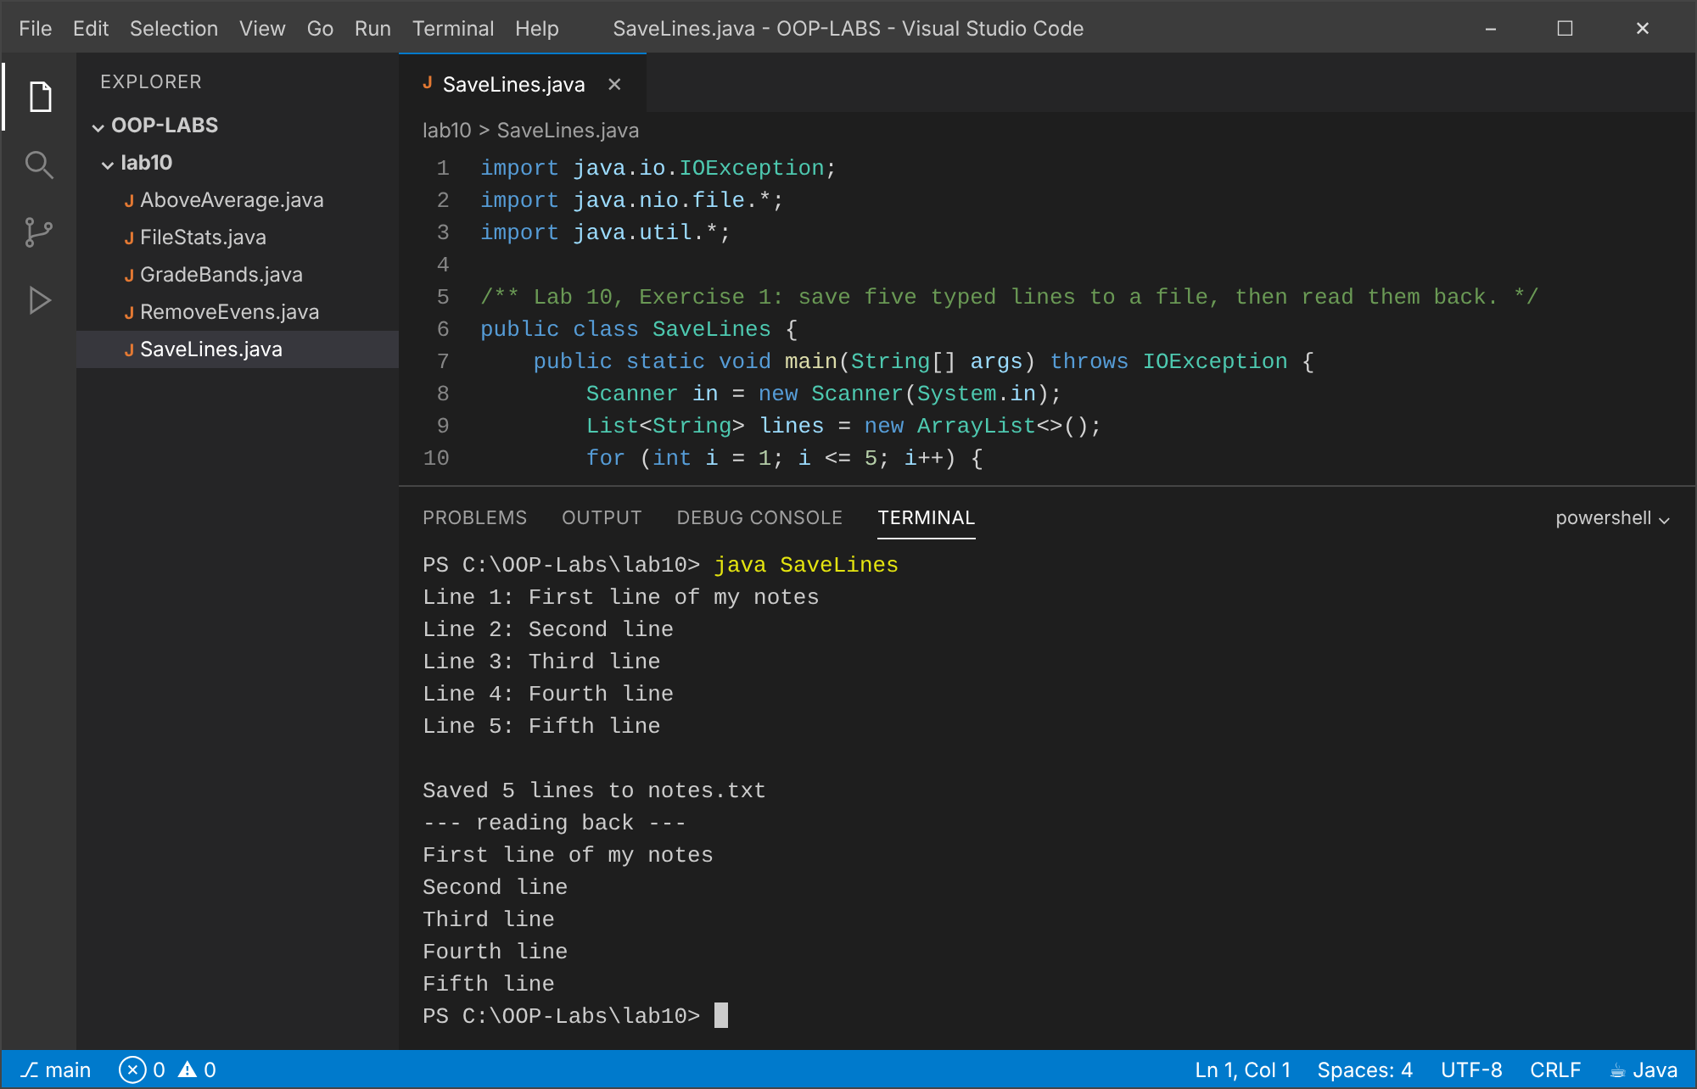

Exercise 2 (Basic): Predicate and removeIf
Explanation
A Predicate<Integer> that tests for even numbers is passed to removeIf.
Code: RemoveEvens.java
import java.util.*;
import java.util.function.Predicate;
/** Lab 10, Exercise 2: Predicate + removeIf. */
public class RemoveEvens {
public static void main(String[] args) {
List<Integer> nums = new ArrayList<>(List.of(1, 2, 3, 4, 5, 6, 7, 8, 9, 10));
Predicate<Integer> isEven = n -> n % 2 == 0;
nums.removeIf(isEven);
System.out.println("After removing evens: " + nums);
}
}
Output: java RemoveEvens
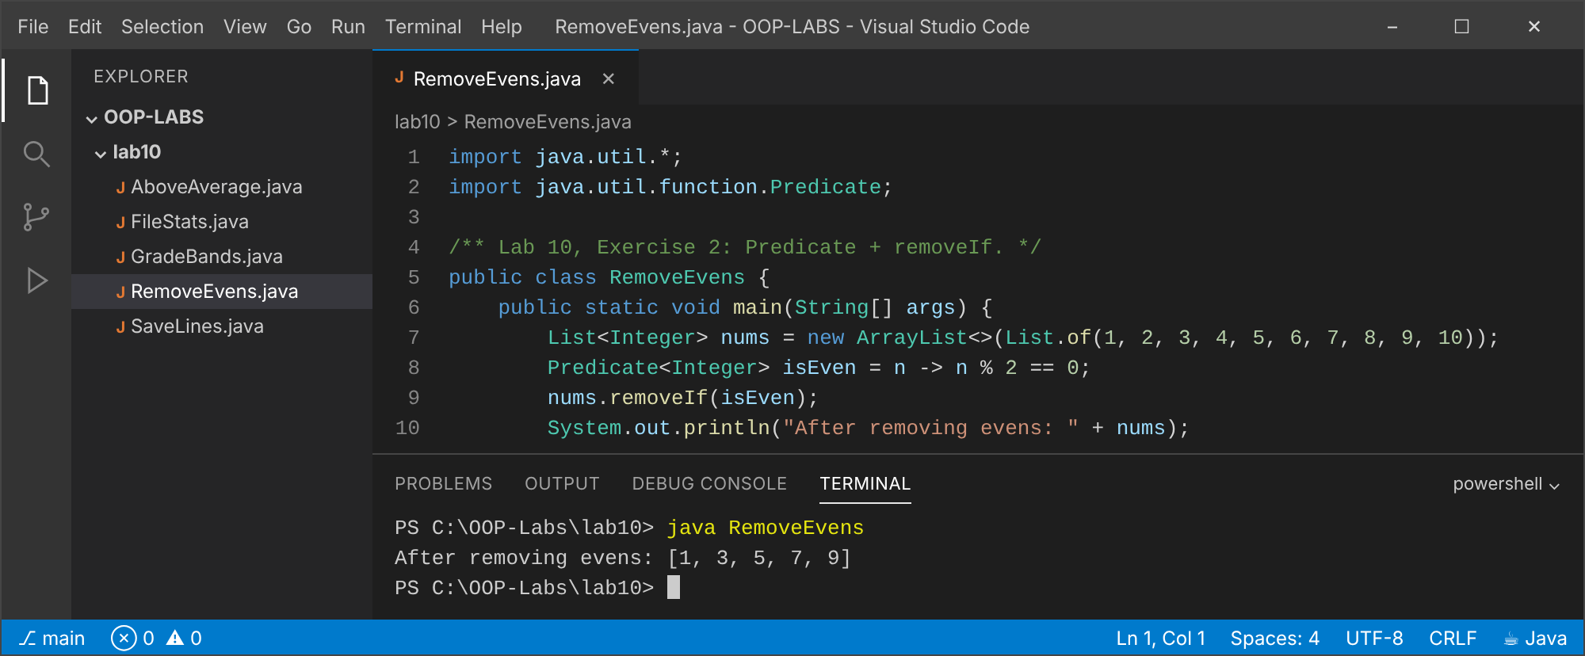

Exercise 3 (Intermediate): Count lines, words and characters
Explanation
The file sample.txt is read line by line; words are counted by splitting on whitespace.
Code: FileStats.java
import java.io.IOException;
import java.nio.file.*;
import java.util.List;
/** Lab 10, Exercise 3: count lines, words and characters (like the Unix wc command). */
public class FileStats {
public static void main(String[] args) throws IOException {
Path file = Path.of(args.length > 0 ? args[0] : "sample.txt");
List<String> lines = Files.readAllLines(file);
long words = 0, chars = 0;
for (String line : lines) {
String t = line.trim();
if (!t.isEmpty()) words += t.split("\\s+").length;
chars += line.length() + 1; // +1 for the newline
}
System.out.println("File : " + file);
System.out.println("Lines : " + lines.size());
System.out.println("Words : " + words);
System.out.println("Characters: " + chars + " (including newlines)");
}
}
Output: java FileStats
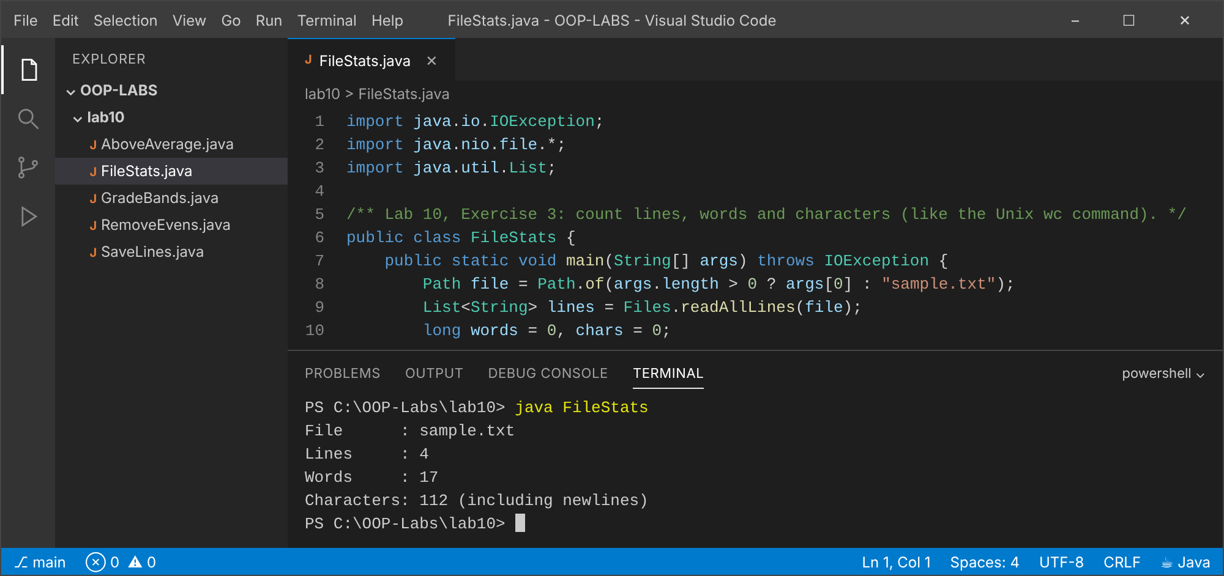

Exercise 4 (Intermediate): Streams: above-average students
Explanation
The average is computed with mapToDouble().average(); a second stream filters, maps to names and sorts them.
Code: AboveAverage.java
import java.util.*;
import java.util.stream.*;
/** Lab 10, Exercise 4: names of students above the class average, sorted alphabetically. */
public class AboveAverage {
record Student(String name, double mark) {}
public static void main(String[] args) {
List<Student> students = List.of(
new Student("Larry", 78), new Student("Hillary", 64), new Student("Tatenda", 91),
new Student("Munya", 55), new Student("Tinevimbo", 82), new Student("Larry", 47));
double avg = students.stream().mapToDouble(Student::mark).average().orElse(0);
System.out.printf("Class average: %.2f%n", avg);
List<String> above = students.stream()
.filter(s -> s.mark() > avg)
.map(Student::name)
.sorted()
.collect(Collectors.toList());
System.out.println("Above average: " + above);
}
}
Output: java AboveAverage
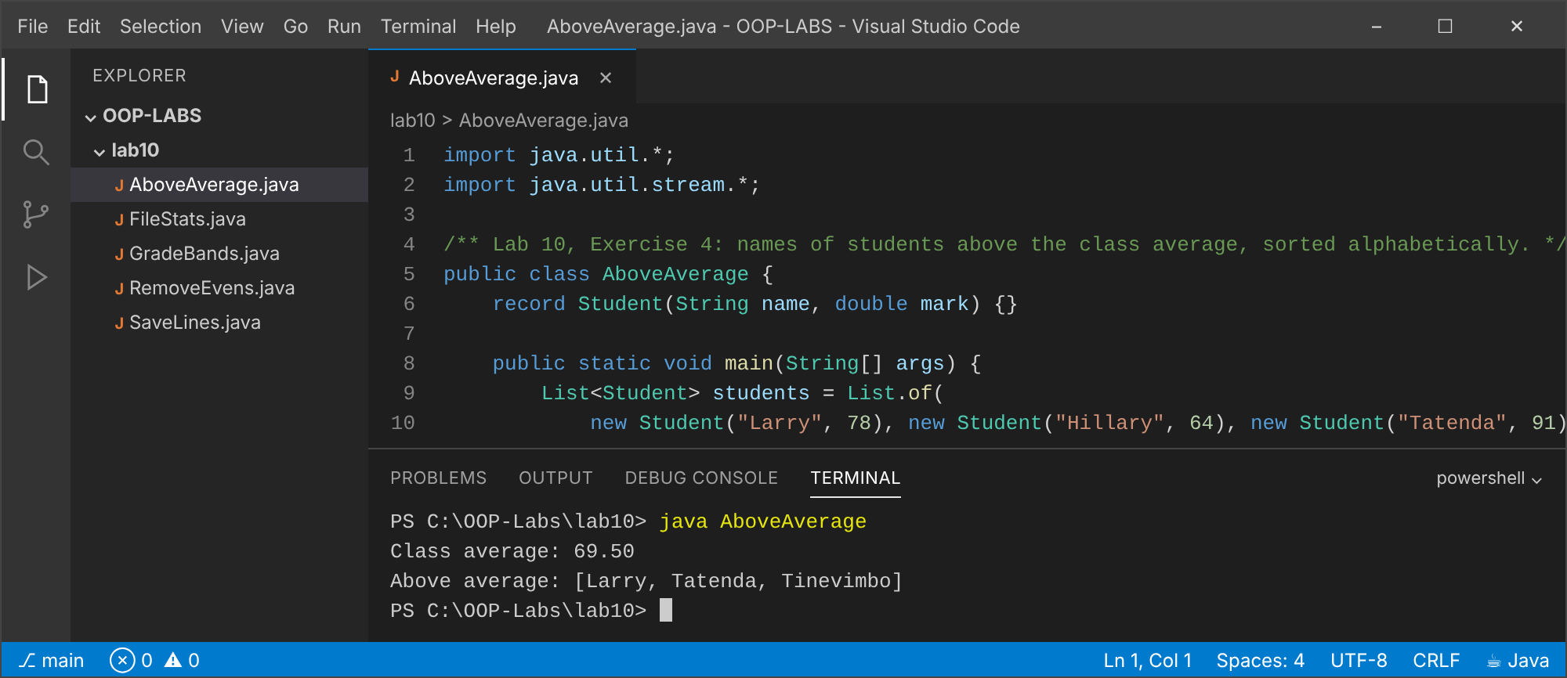

Exercise 5 (Challenge): learners.csv grouped by band, one report per band
Explanation
The CSV is read with Files.lines (in try-with-resources), grouped with Collectors.groupingBy into bands A (70+), B (60-69) and C (below 60), and one report file per band is written (report_A.txt, report_B.txt, report_C.txt).
Code: learners.csv
name,marks
Larry,78
Hillary,64
Tatenda,91
Munya,55
Tinevimbo,82
Larry,47
Hillary,70
Munya,58
Tinevimbo,66
Tatenda,73
Code: GradeBands.java
import java.io.IOException;
import java.nio.file.*;
import java.util.*;
import java.util.stream.*;
/**
* Lab 10, Exercise 5: load learners.csv, group by grade band with Collectors.groupingBy,
* and write one report file per band. Bands: A >= 70, B 60-69, C < 60.
*/
public class GradeBands {
record Learner(String name, int marks) {
String band() { return marks >= 70 ? "A" : marks >= 60 ? "B" : "C"; }
}
public static void main(String[] args) throws IOException {
List<Learner> learners;
try (Stream<String> lines = Files.lines(Path.of("learners.csv"))) {
learners = lines.skip(1) // skip the header
.filter(l -> !l.isBlank())
.map(l -> l.split(","))
.map(p -> new Learner(p[0].trim(), Integer.parseInt(p[1].trim())))
.toList();
}
Map<String, List<Learner>> byBand =
learners.stream().collect(Collectors.groupingBy(Learner::band, TreeMap::new, Collectors.toList()));
for (Map.Entry<String, List<Learner>> e : byBand.entrySet()) {
String band = e.getKey();
List<String> report = new ArrayList<>();
report.add("Band " + band + " report (" + e.getValue().size() + " learners)");
e.getValue().stream()
.sorted(Comparator.comparingInt(Learner::marks).reversed())
.forEach(l -> report.add(String.format("%-10s %3d", l.name(), l.marks())));
Path out = Path.of("report_" + band + ".txt");
Files.write(out, report);
System.out.println("Wrote " + out + ":");
report.forEach(r -> System.out.println(" " + r));
}
}
}
Output: java GradeBands
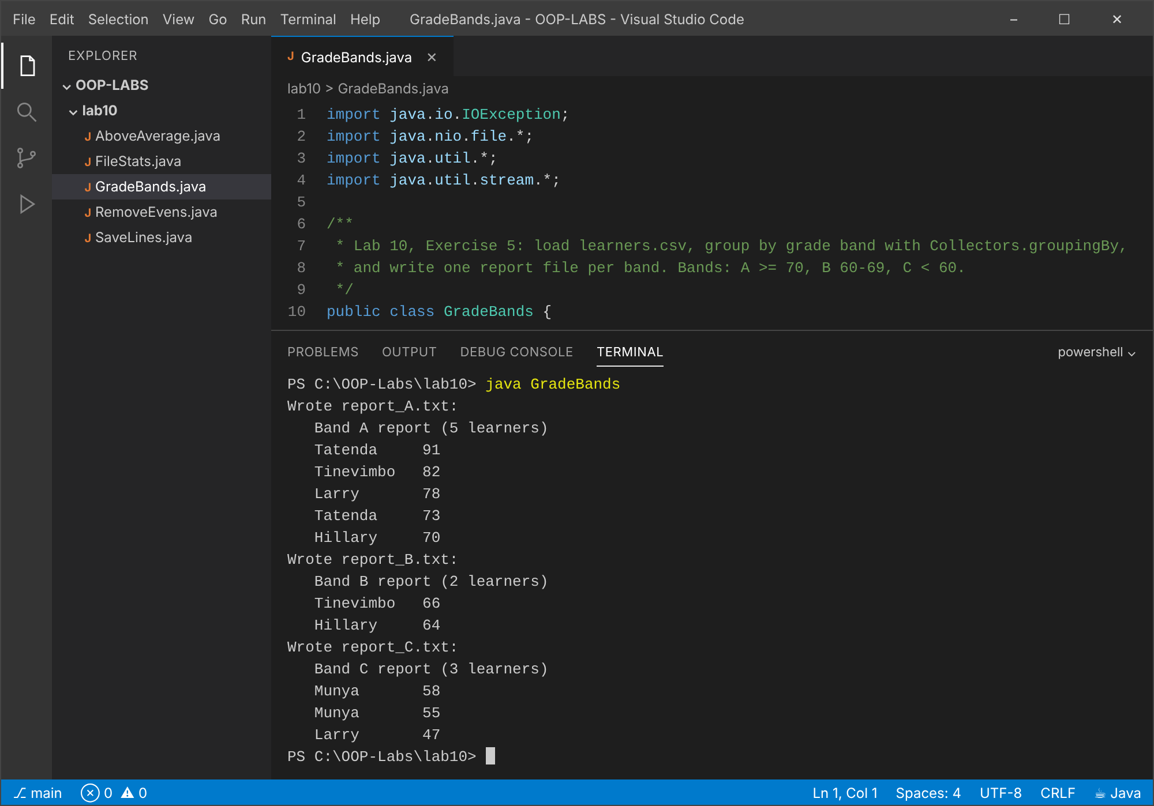

Conclusion
java.nio.file makes file work short and safe; lambdas and streams express filtering, mapping and grouping declaratively.

Mini-Project: Library Management System
A console application in which a library lends books and DVDs to members. It combines every concept from Labs 1 to 10 and saves all data to CSV files so it survives between runs.

1. Requirements and how each is met
# | Requirement | Where / how it is met
1 | Book, Member, Loan with private fields, validation, toString | Book.java, Member.java, Loan.java: private fields, constructors reject blank ids/names, toString on each.
2 | Abstract LibraryItem; Book and Dvd with own loanPeriodDays() | LibraryItem is abstract; Book returns 14 days, Dvd returns 7 days.
3 | Borrowable interface: borrow(Member), giveBack() | Borrowable.java, implemented once in LibraryItem.
4 | ItemNotAvailableException, MemberLimitExceededException (max 3 loans) | Two checked exceptions; Member.MAX_LOANS = 3; Library.borrow checks both BEFORE changing state, so a failure leaves nothing half-done.
5 | Map<String, ...> keyed by id | Library holds Map<String, LibraryItem> and Map<String, Member> (LinkedHashMap keeps insertion order).
6 | Persist to CSV on exit, reload on start | Library.save/load write and read items.csv, members.csv and loans.csv (Files + try-with-resources). Csv.java quotes commas and quotes in titles.
7 | Menu: add item, register member, borrow, return, list overdue, search (streams) | LibraryApp.java menu; overdueLoans() and searchByTitle() use streams (filter, sorted, toList).

2. Class diagram
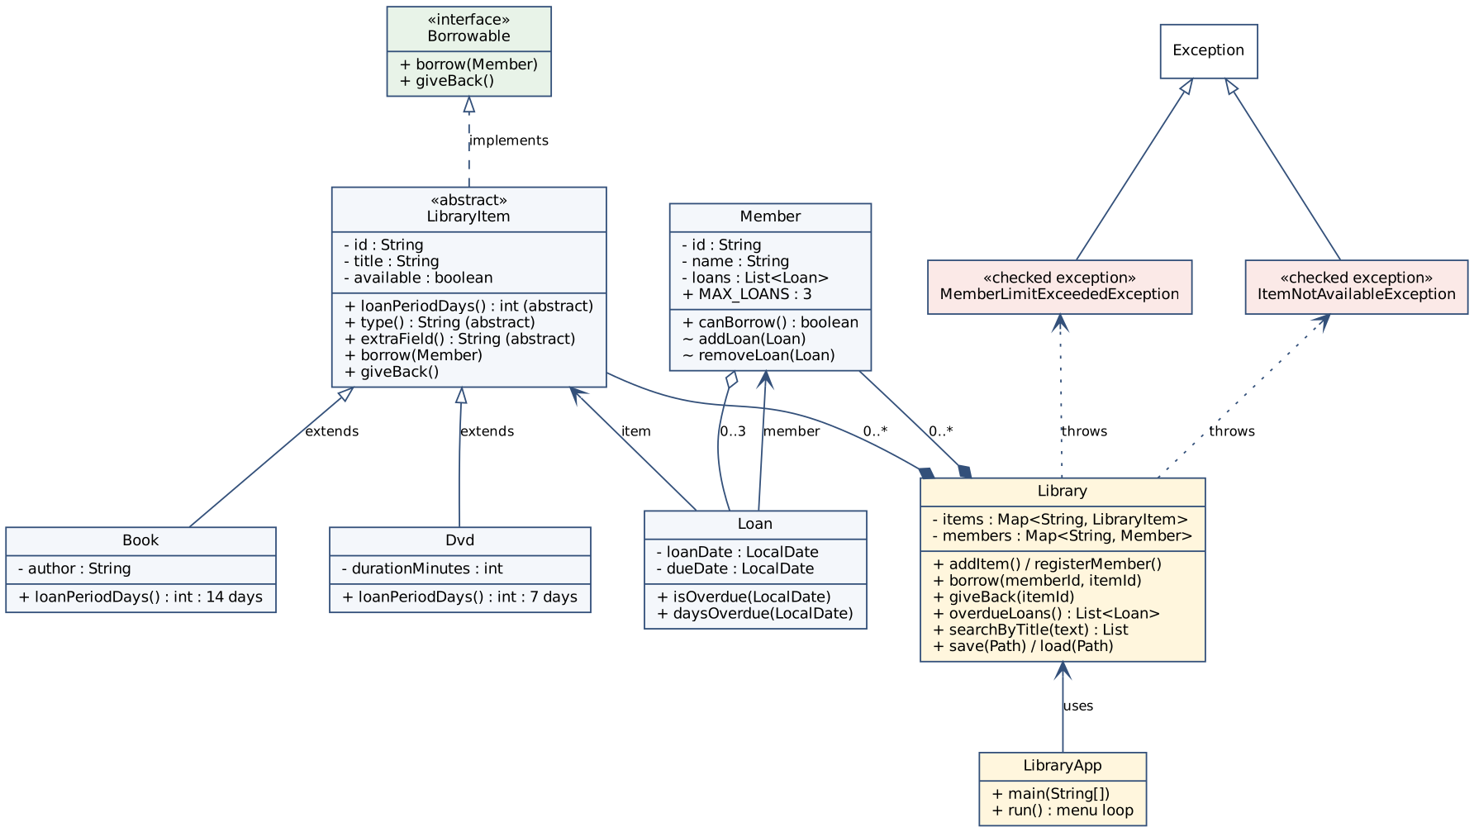
Figure 1: Class diagram. Book and Dvd extend the abstract LibraryItem, which implements Borrowable; Library owns the two maps and throws the two checked exceptions.

3. Design decisions
- Encapsulation: all fields are private. Member.getLoans() returns an unmodifiable view, and addLoan/removeLoan are package-private, so the 3-loan limit cannot be bypassed.
- Inheritance and abstraction: shared state and behaviour (id, title, availability, borrow, giveBack) live in LibraryItem; only what differs (loan period, type label, extra CSV field) is abstract.
- Polymorphism: Loan computes its due date with item.loanPeriodDays(); the same Loan code gives 14 days for a Book and 7 for a Dvd. Library, Loan and the menu never ask what type an item is.
- Error handling: expected business failures (item on loan, limit reached) are checked exceptions that the menu catches and reports; programmer errors (unknown id, blank name) are IllegalArgumentException.
- Atomic borrow: availability and limit are checked before anything is modified.
- Persistence: availability is not stored; it is rebuilt from loans.csv on load, so the files can never disagree. Dates are stored as ISO text (2026-10-13).
- Testability: Library takes a java.time.Clock, so tests can fix 'today' and prove overdue behaviour without waiting.

4. Testing
LibraryTest.java is a dependency-free test runner (no JUnit needed). It exercises polymorphism, both exceptions, rollback on failure, returns, validation, search, persistence, overdue dates and CSV escaping.
Output: java LibraryTest
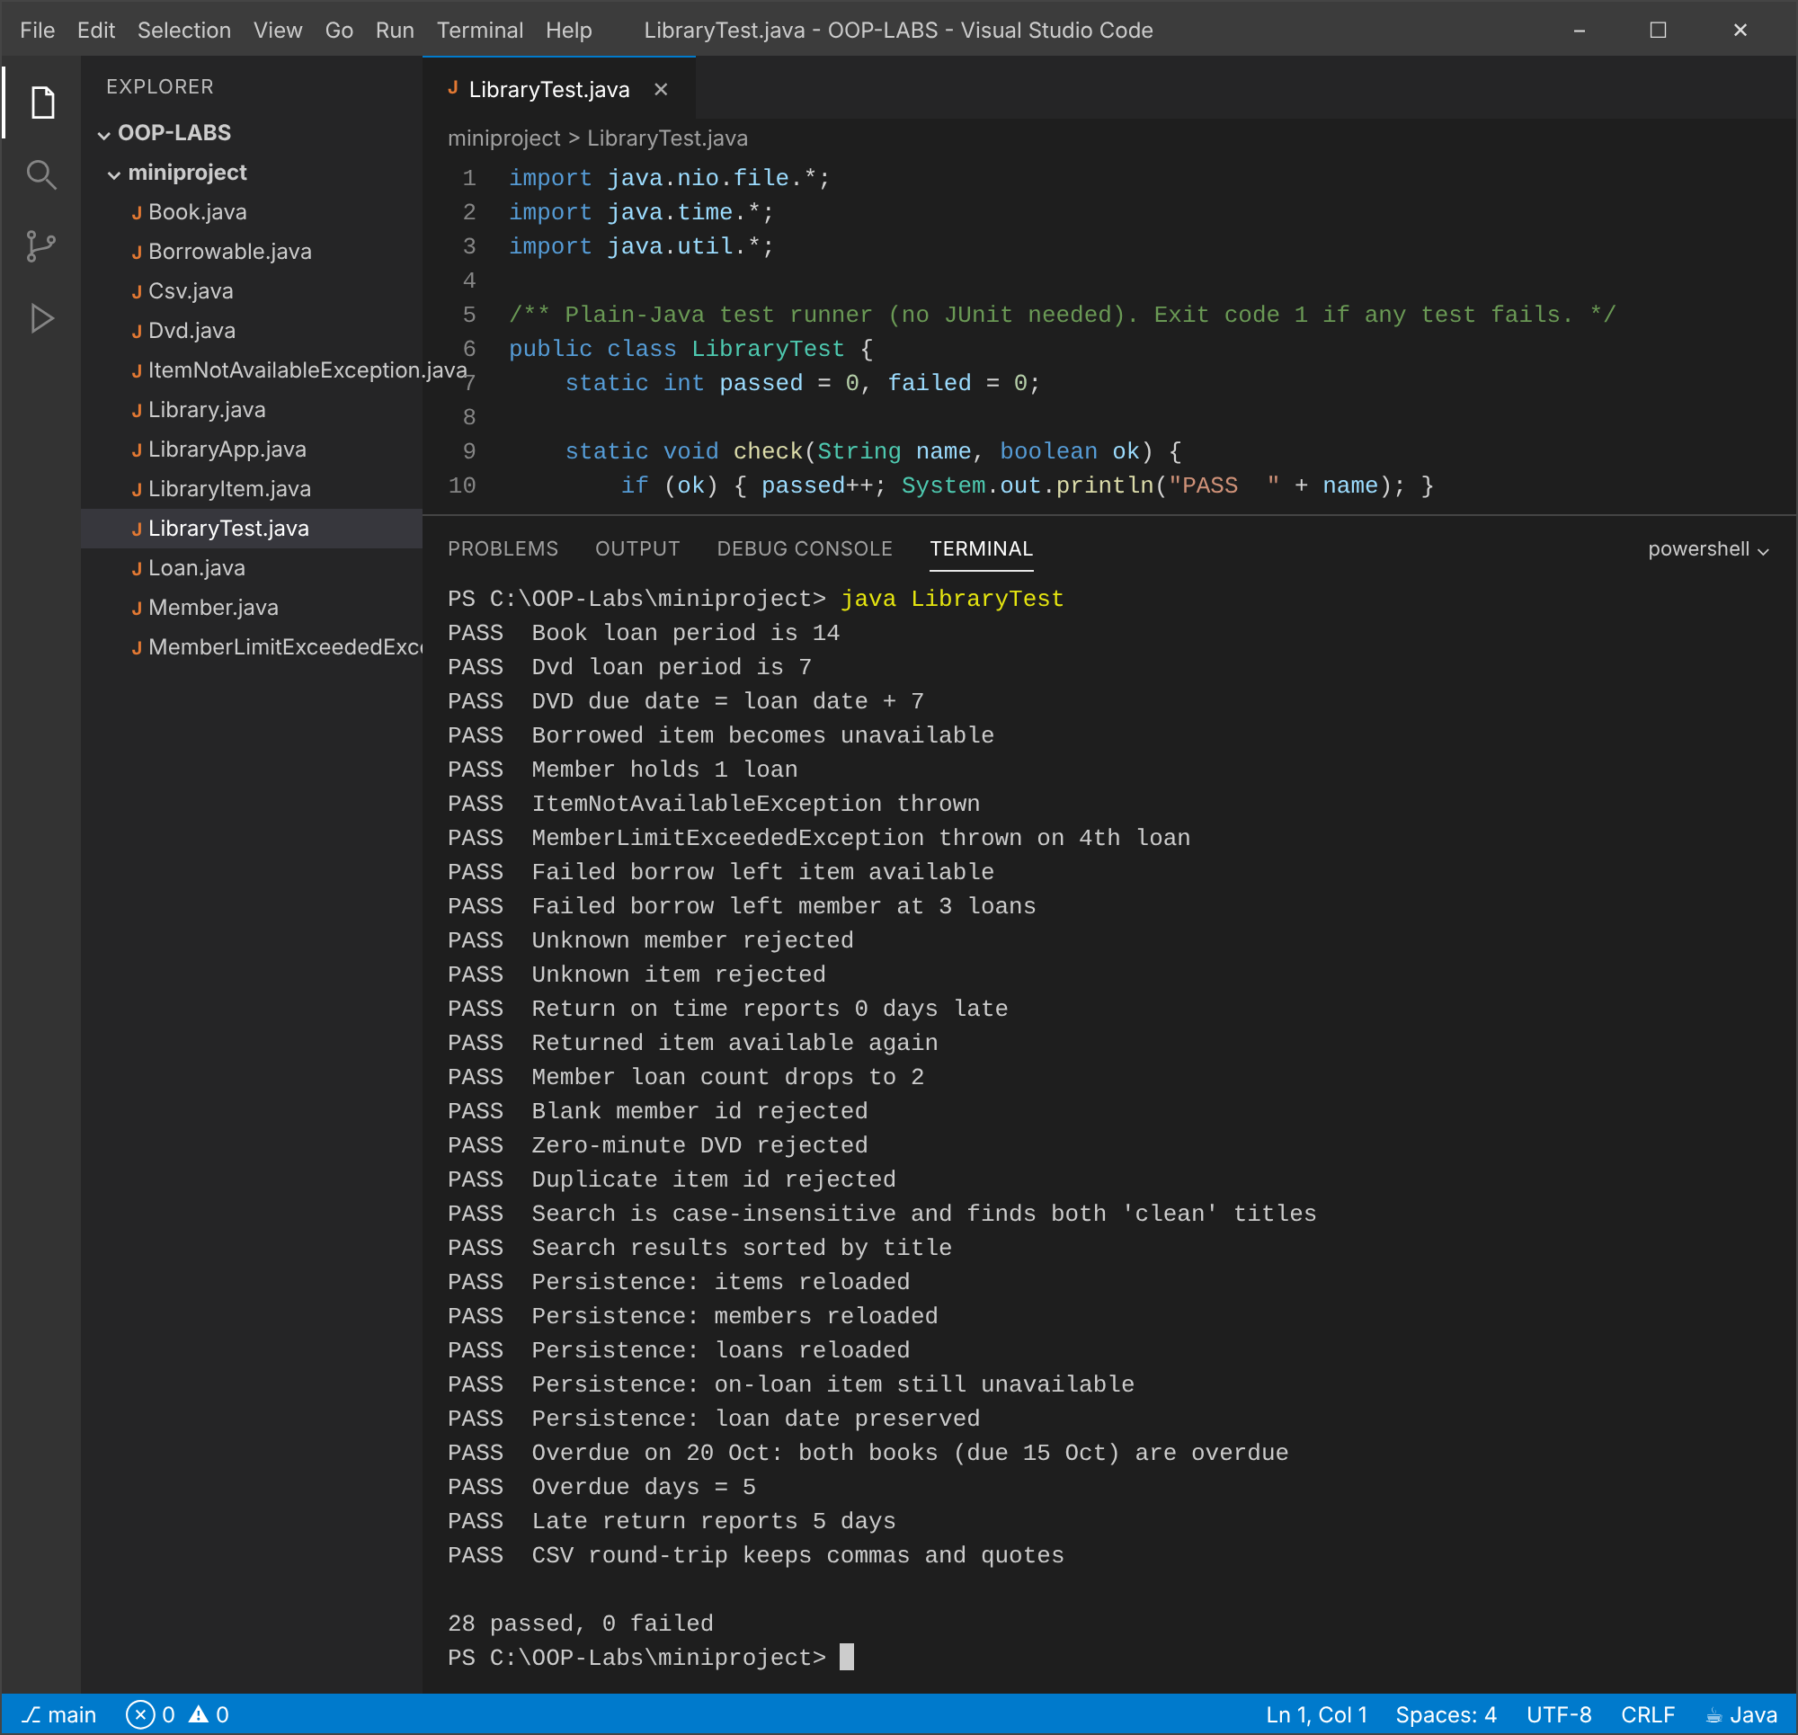

5. Sample sessions (real runs in the VS Code terminal)
Run 1: empty library: add items, register a member, borrow until the limit, search, list
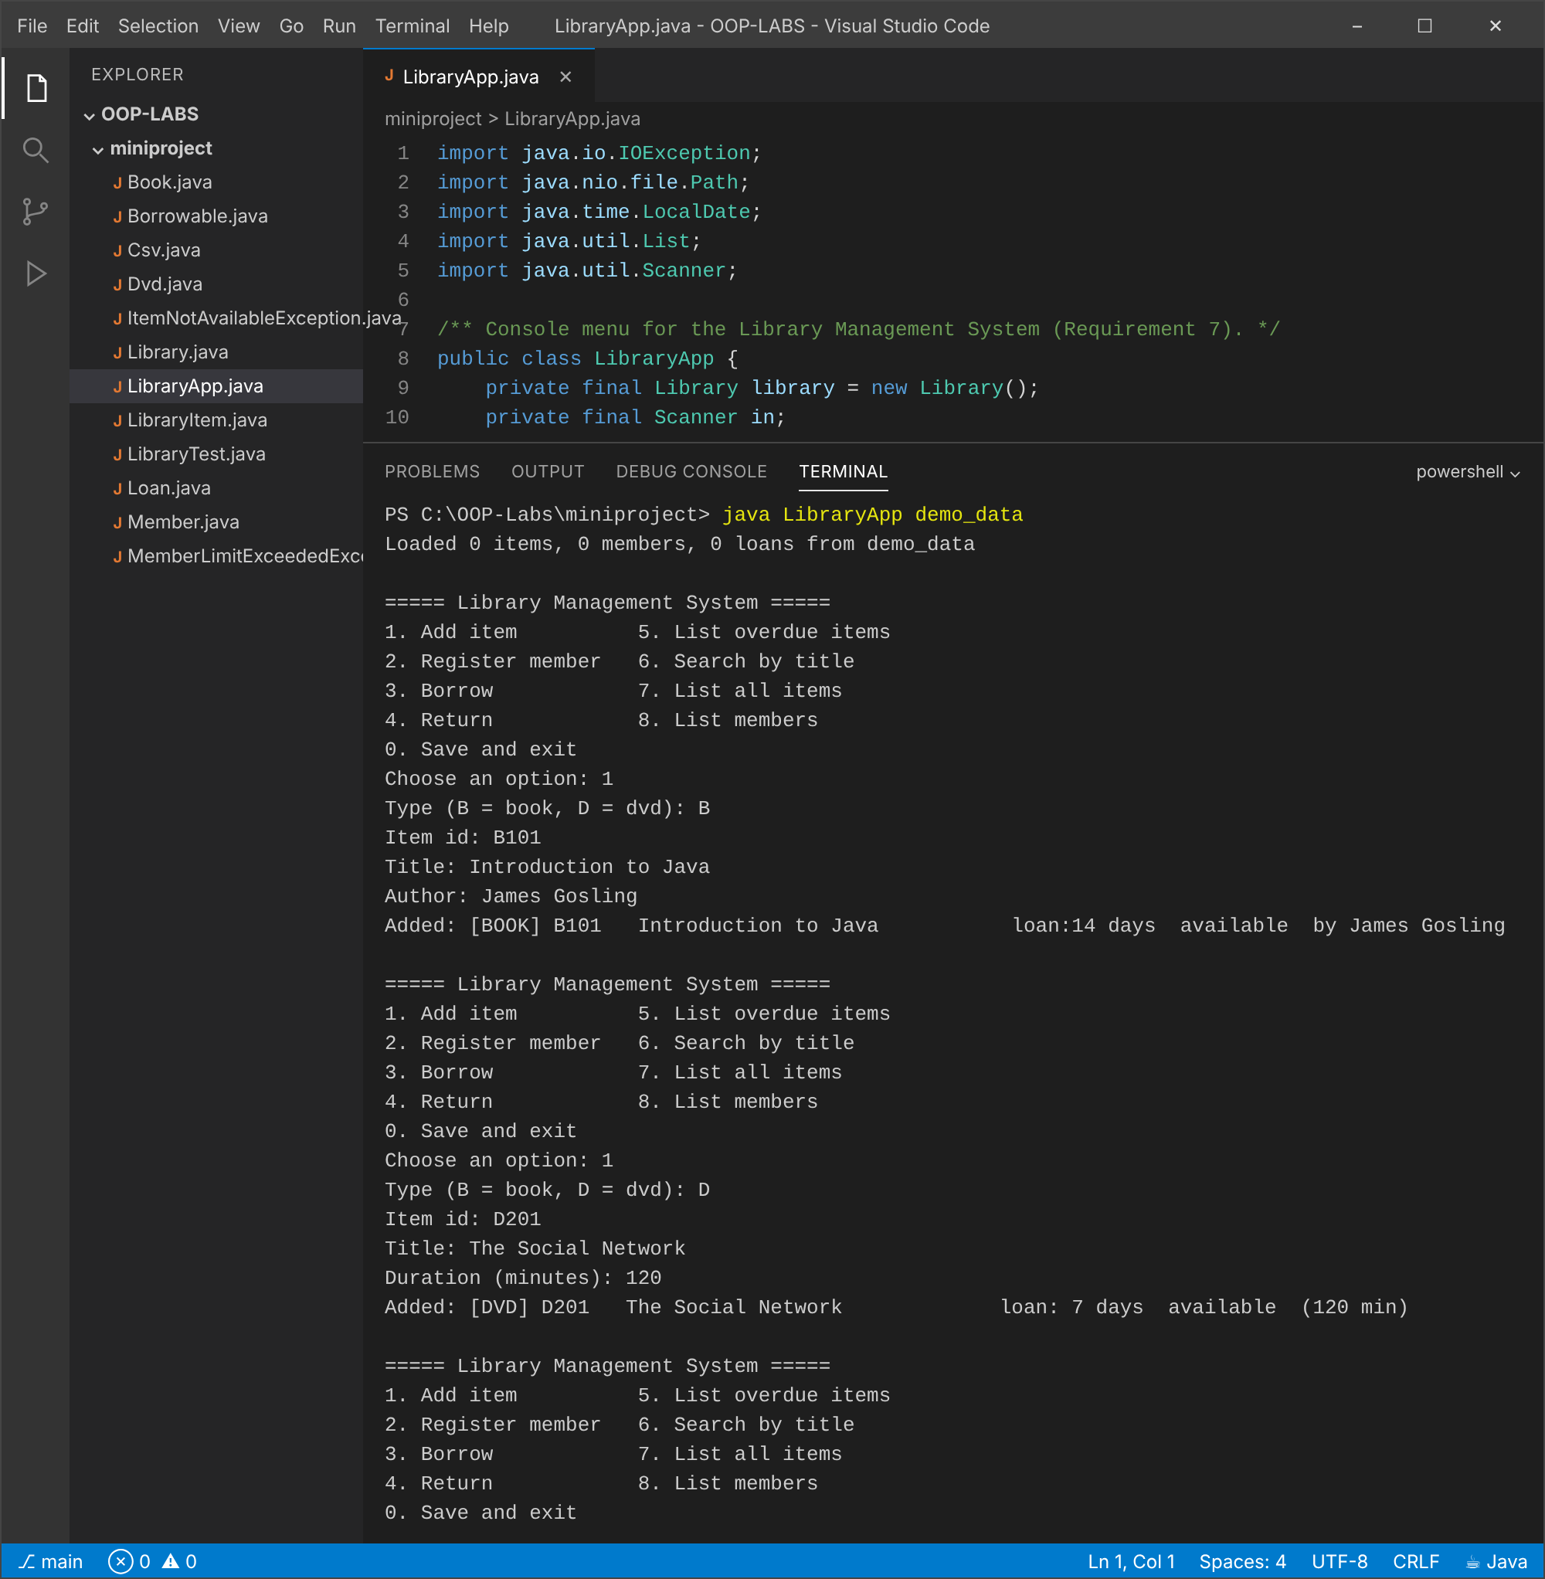
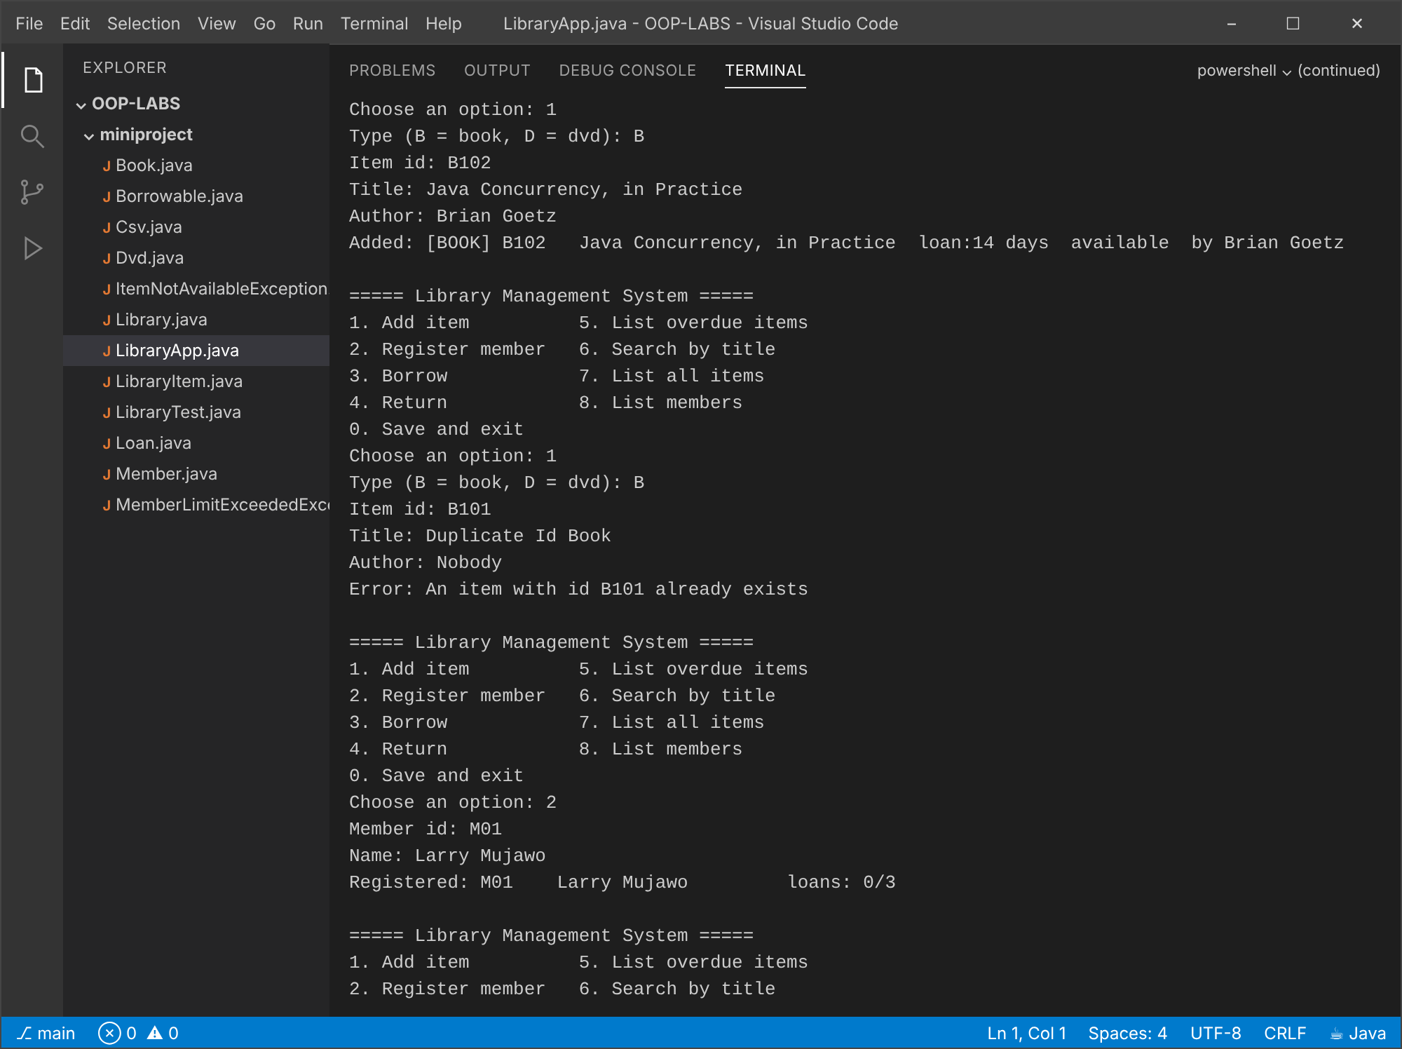
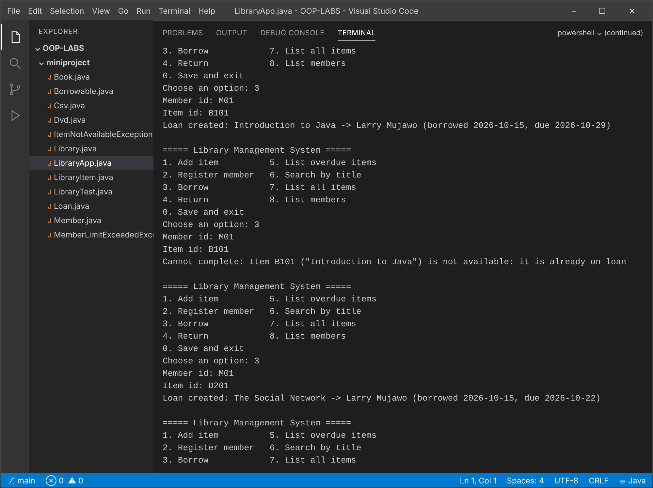
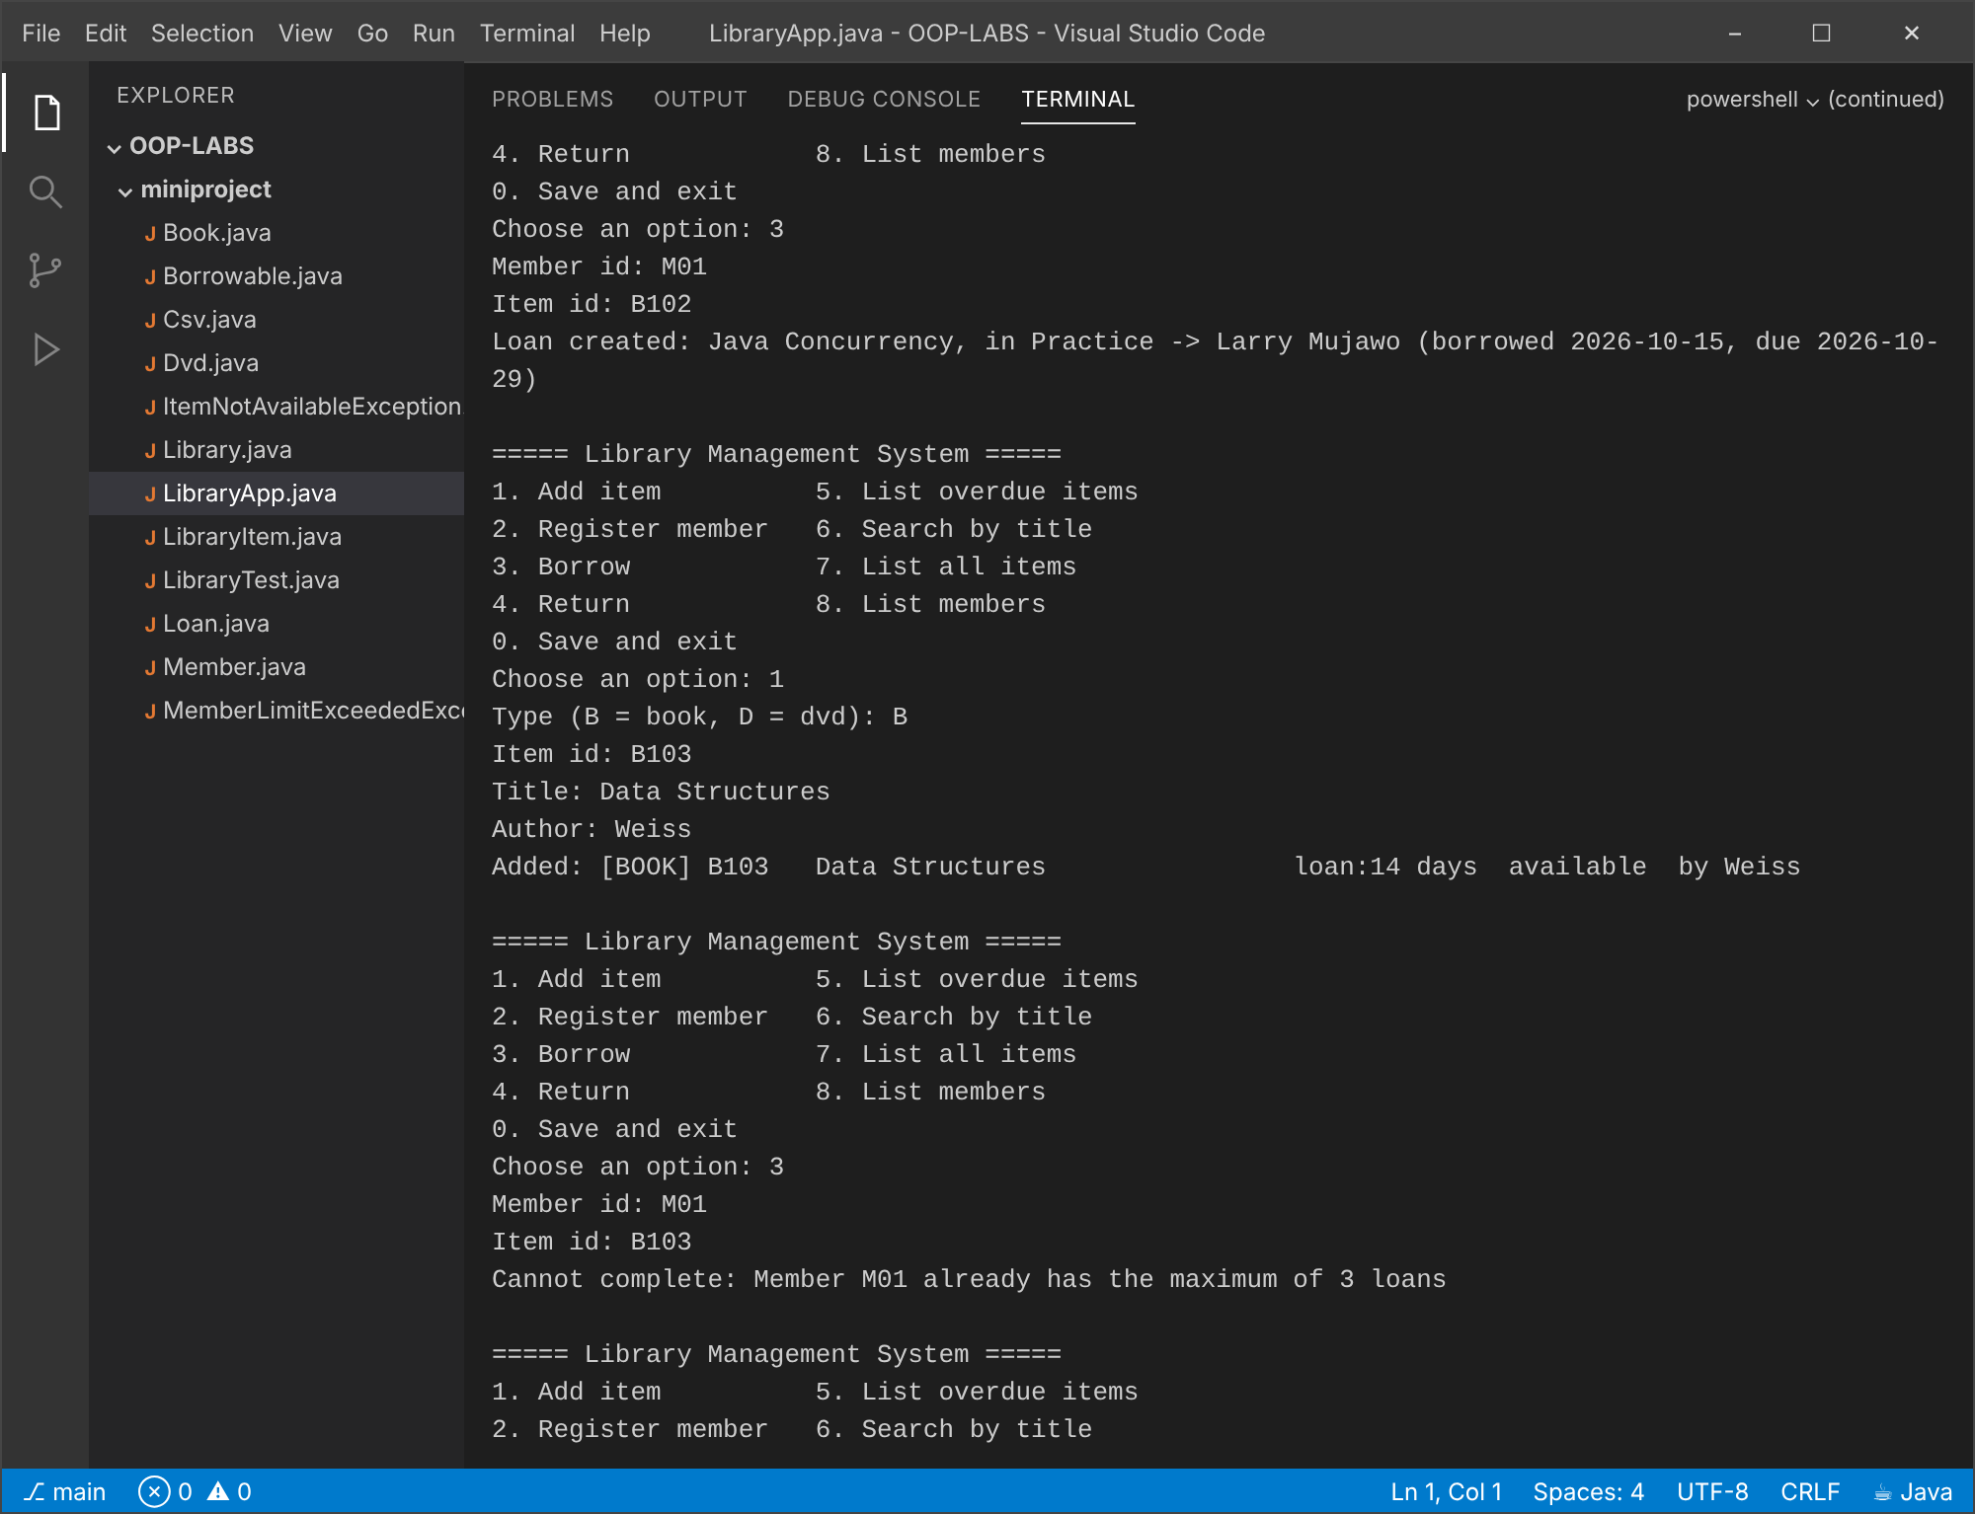
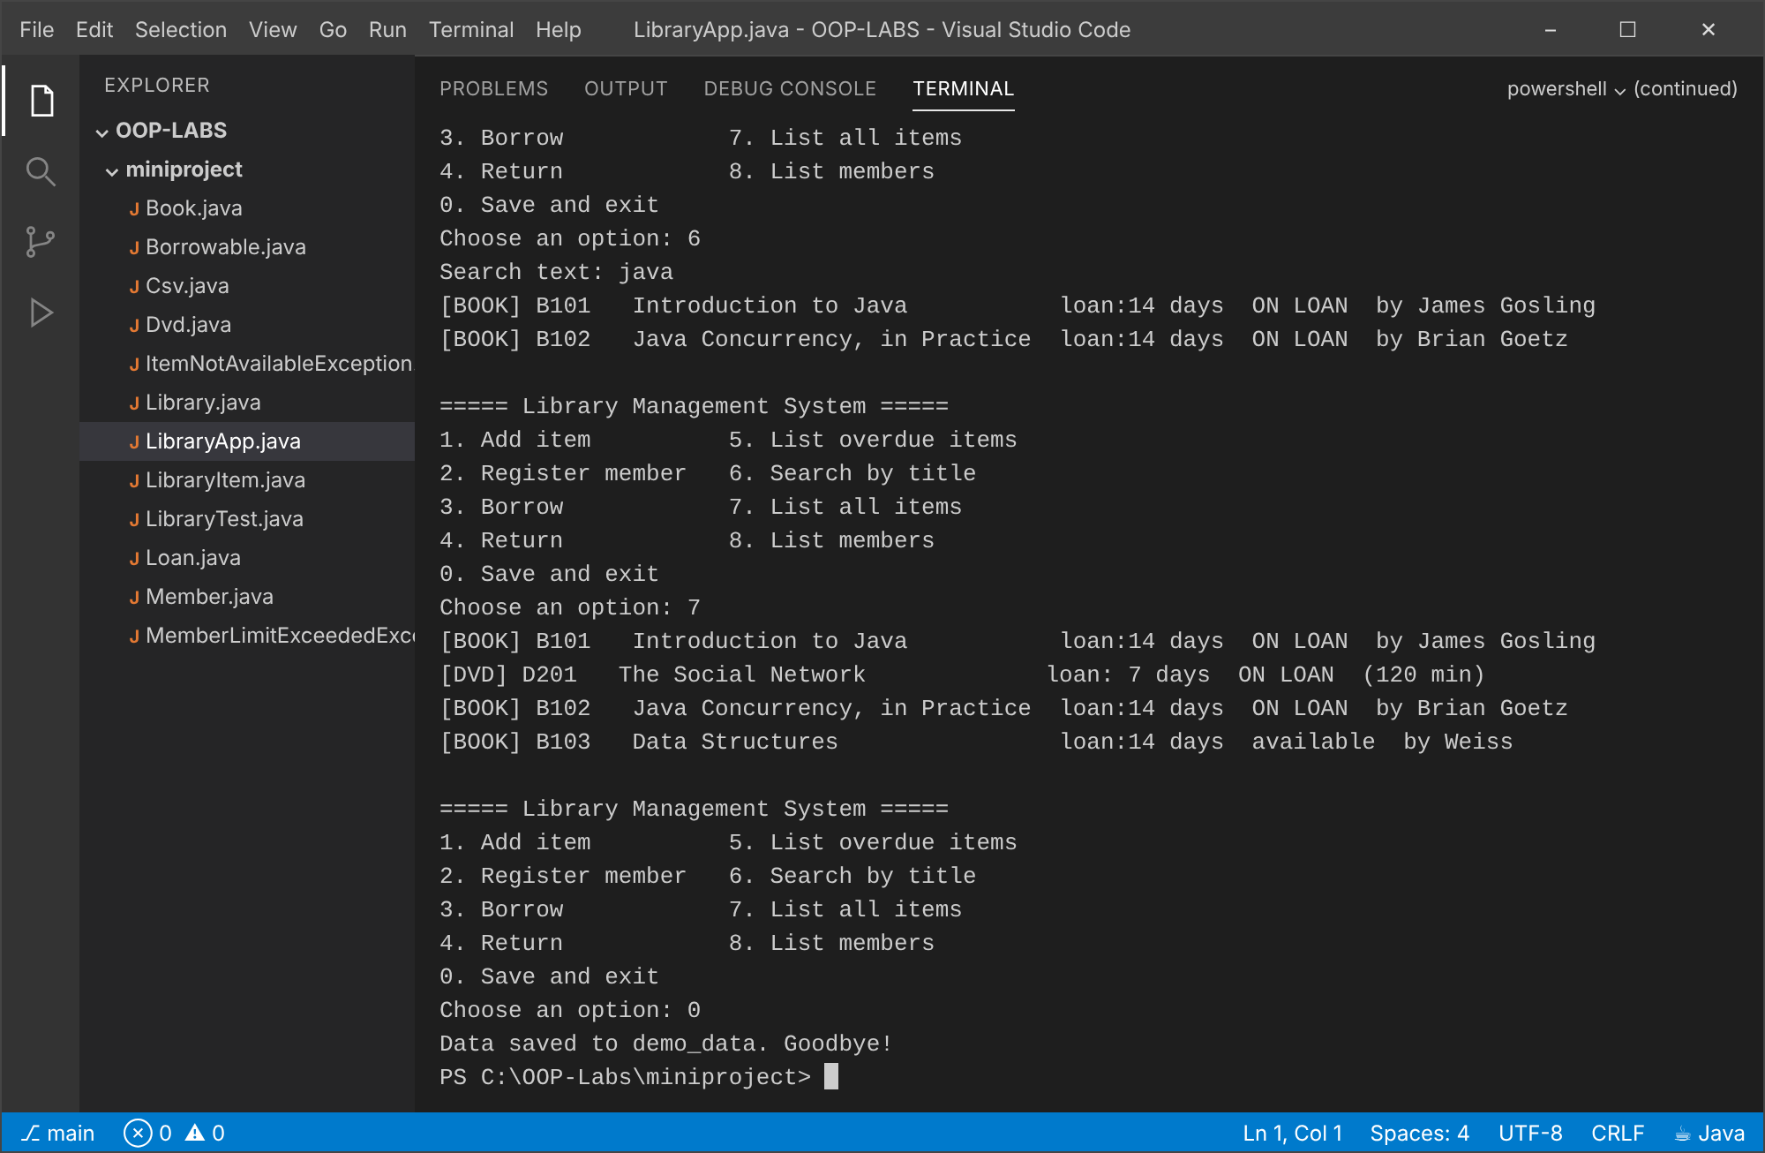
Run 2: restart: the data from Run 1 is reloaded; return and re-borrow a DVD
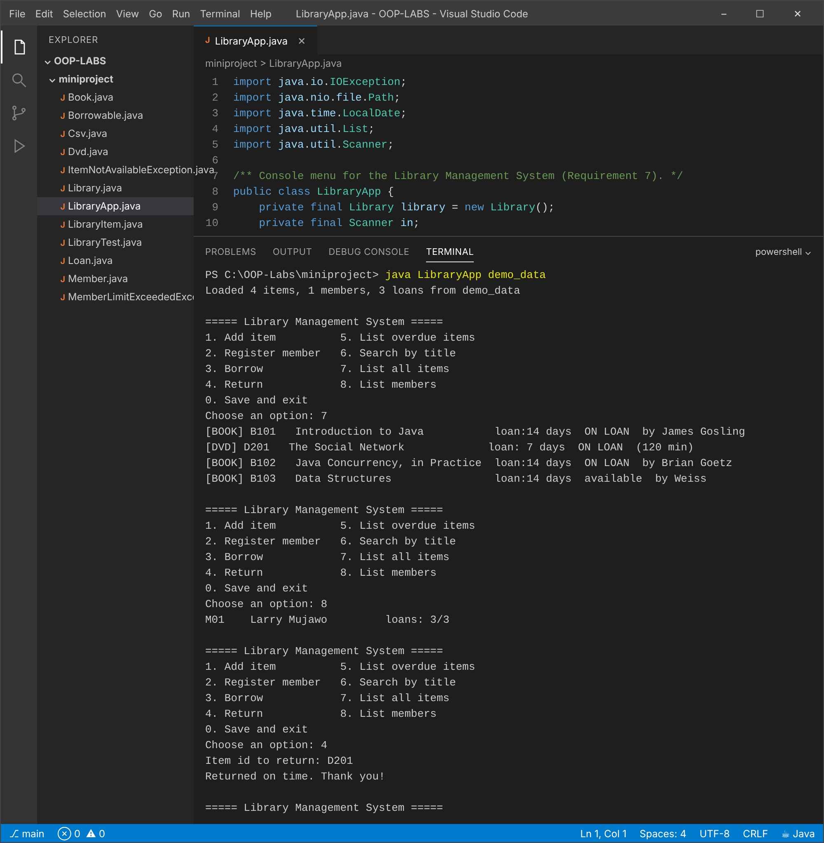
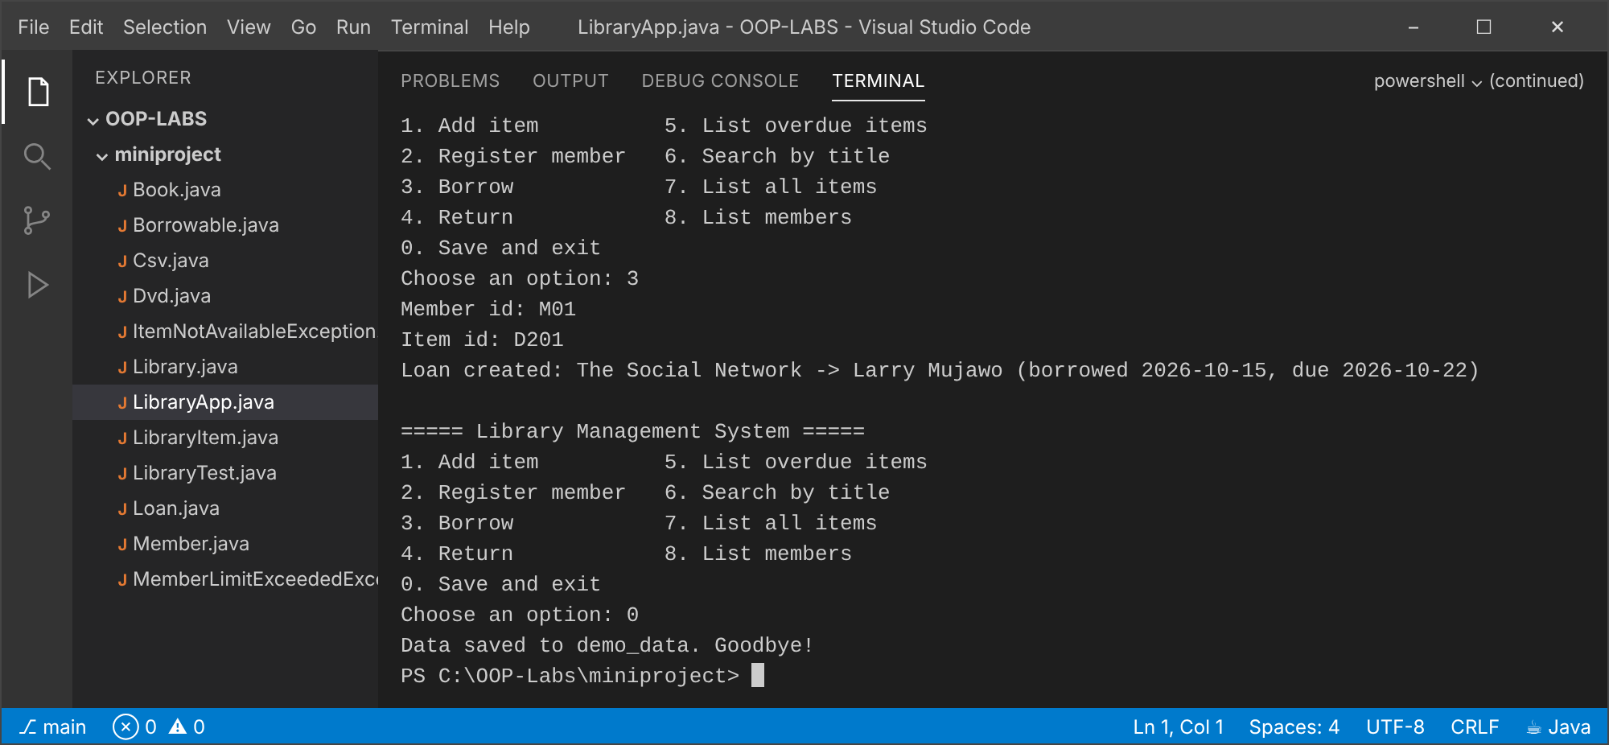
Run 3: restart again: a loan was backdated in loans.csv to show the overdue report and a late return
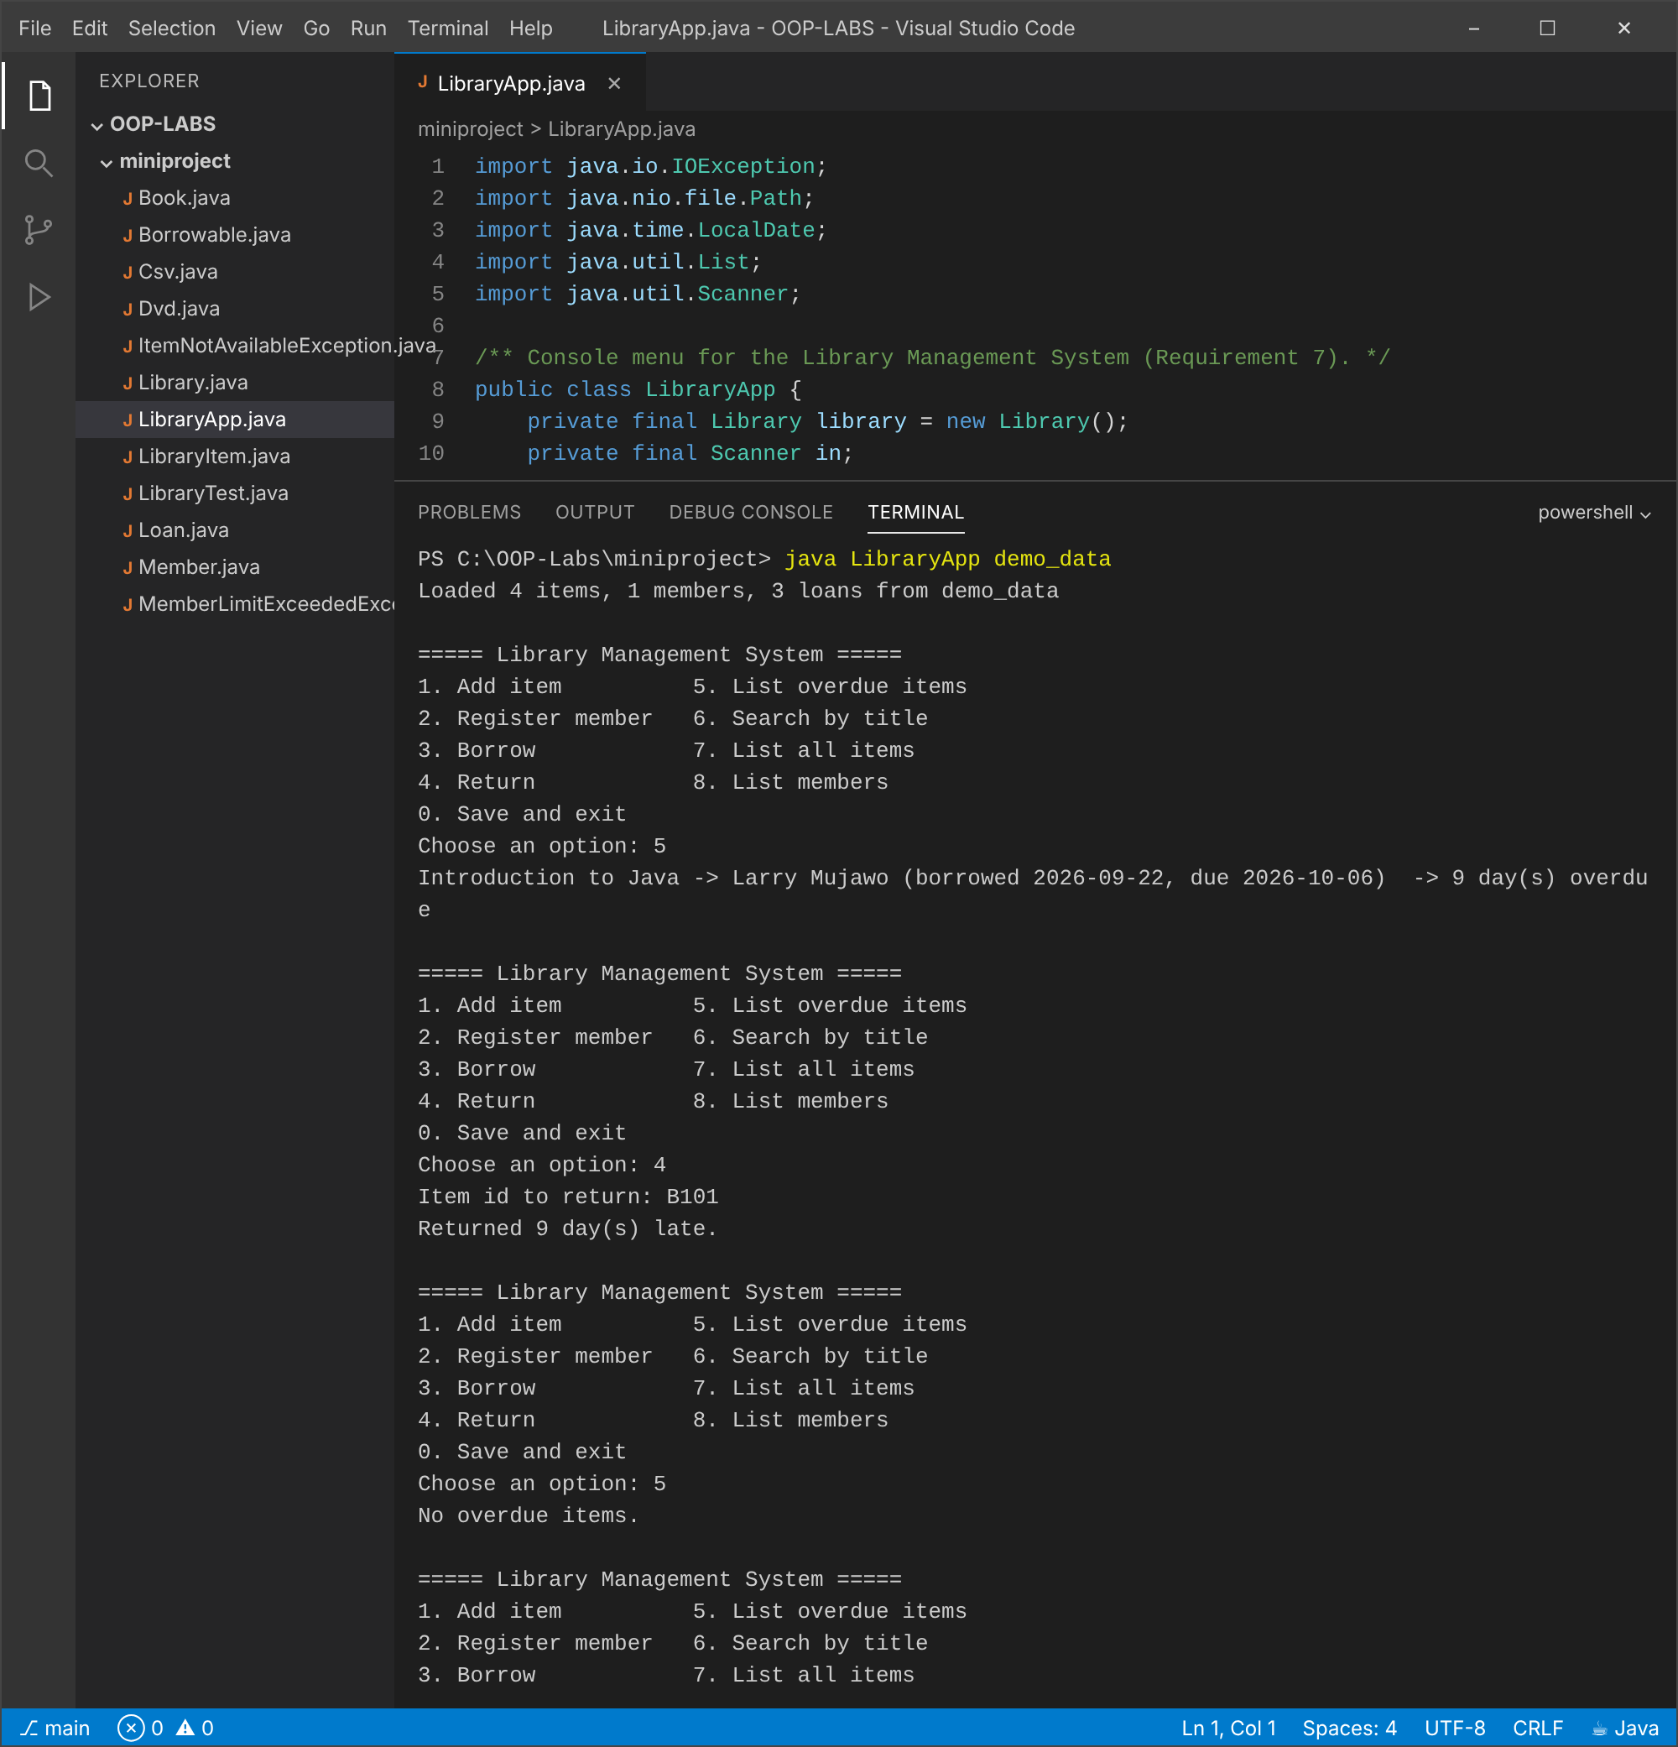
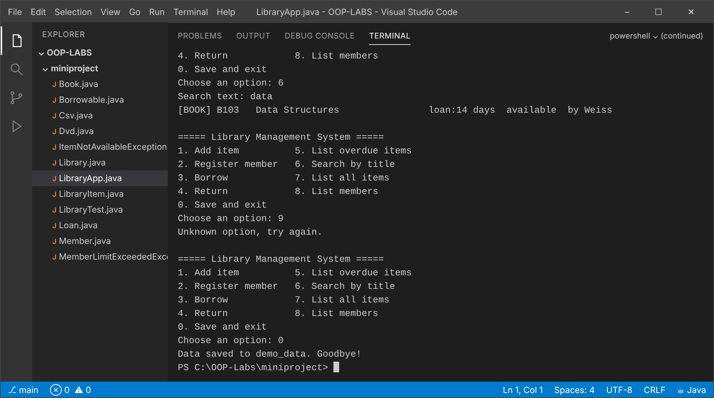
Saved file: items.csv, members.csv, loans.csv after Run 1
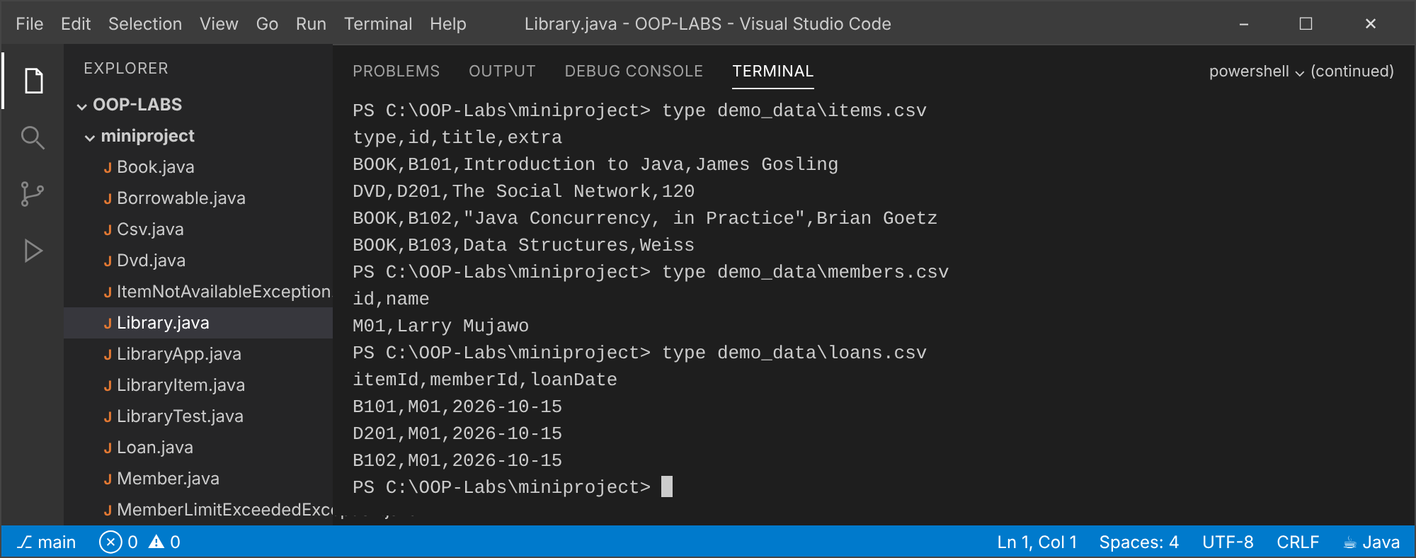

6. Conclusion
The system meets all seven requirements. Abstraction and inheritance remove duplication between books and DVDs, polymorphism keeps the service code free of type checks, checked exceptions make business-rule failures impossible to ignore, collections and streams keep the lookup, search and overdue code short, and the CSV files give persistence across runs. Possible extensions: fines for late returns, a loan history, reservations, and a JUnit test suite.

Source code of the mini-project
Borrowable.java
/** Contract for anything that can be lent to a Member (Requirement 3). */
public interface Borrowable {
/** Marks the item as lent to the member. @throws ItemNotAvailableException if already on loan. */
void borrow(Member member) throws ItemNotAvailableException;
/** Marks the item as back on the shelf. */
void giveBack();
}
LibraryItem.java
/**
* Abstract base class for everything the library lends (Requirement 2).
* Encapsulation: fields are private; subclasses define their own loan period.
*/
public abstract class LibraryItem implements Borrowable {
private final String id;
private final String title;
private boolean available = true;
protected LibraryItem(String id, String title) {
if (id == null || id.isBlank()) throw new IllegalArgumentException("Item id is required");
if (title == null || title.isBlank()) throw new IllegalArgumentException("Item title is required");
this.id = id.trim();
this.title = title.trim();
}
/** Each subclass decides how many days it may be borrowed (abstraction + polymorphism). */
public abstract int loanPeriodDays();
/** Short type label used in listings and in the CSV file. */
public abstract String type();
/** The one extra, subclass-specific CSV value (author or duration). */
public abstract String extraField();
public String getId() { return id; }
public String getTitle() { return title; }
public boolean isAvailable() { return available; }
@Override
public void borrow(Member member) throws ItemNotAvailableException {
if (!available) throw new ItemNotAvailableException(id, title);
available = false;
}
@Override
public void giveBack() { available = true; }
@Override
public String toString() {
return String.format("[%s] %-6s %-30s loan:%2d days %s",
type(), id, title, loanPeriodDays(), available ? "available" : "ON LOAN");
}
}
Book.java
public class Book extends LibraryItem {
private final String author;
public Book(String id, String title, String author) {
super(id, title);
if (author == null || author.isBlank()) throw new IllegalArgumentException("Author is required");
this.author = author.trim();
}
public String getAuthor() { return author; }
@Override public int loanPeriodDays() { return 14; }
@Override public String type() { return "BOOK"; }
@Override public String extraField() { return author; }
@Override public String toString() { return super.toString() + " by " + author; }
}
Dvd.java
public class Dvd extends LibraryItem {
private final int durationMinutes;
public Dvd(String id, String title, int durationMinutes) {
super(id, title);
if (durationMinutes <= 0) throw new IllegalArgumentException("Duration must be positive");
this.durationMinutes = durationMinutes;
}
public int getDurationMinutes() { return durationMinutes; }
@Override public int loanPeriodDays() { return 7; } // DVDs are lent for a shorter time
@Override public String type() { return "DVD"; }
@Override public String extraField() { return String.valueOf(durationMinutes); }
@Override public String toString() { return super.toString() + " (" + durationMinutes + " min)"; }
}
Member.java
import java.util.ArrayList;
import java.util.Collections;
import java.util.List;
/** A library member. Holds at most MAX_LOANS active loans. */
public class Member {
public static final int MAX_LOANS = 3;
private final String id;
private String name;
private final List<Loan> loans = new ArrayList<>();
public Member(String id, String name) {
if (id == null || id.isBlank()) throw new IllegalArgumentException("Member id is required");
this.id = id.trim();
setName(name);
}
public String getId() { return id; }
public String getName() { return name; }
public void setName(String name) {
if (name == null || name.isBlank()) throw new IllegalArgumentException("Member name is required");
this.name = name.trim();
}
/** Read-only view so outside code cannot bypass the loan limit. */
public List<Loan> getLoans() { return Collections.unmodifiableList(loans); }
public int loanCount() { return loans.size(); }
public boolean canBorrow() { return loans.size() < MAX_LOANS; }
void addLoan(Loan loan) throws MemberLimitExceededException {
if (!canBorrow()) throw new MemberLimitExceededException(id, MAX_LOANS);
loans.add(loan);
}
boolean removeLoan(Loan loan) { return loans.remove(loan); }
@Override
public String toString() { return String.format("%-6s %-20s loans: %d/%d", id, name, loans.size(), MAX_LOANS); }
}
Loan.java
import java.time.LocalDate;
import java.time.temporal.ChronoUnit;
/** One active loan of one item to one member. Immutable once created. */
public class Loan {
private final LibraryItem item;
private final Member member;
private final LocalDate loanDate;
private final LocalDate dueDate;
public Loan(LibraryItem item, Member member, LocalDate loanDate) {
if (item == null || member == null || loanDate == null)
throw new IllegalArgumentException("Loan needs an item, a member and a date");
this.item = item;
this.member = member;
this.loanDate = loanDate;
this.dueDate = loanDate.plusDays(item.loanPeriodDays()); // polymorphic call
}
public LibraryItem getItem() { return item; }
public Member getMember() { return member; }
public LocalDate getLoanDate() { return loanDate; }
public LocalDate getDueDate() { return dueDate; }
public boolean isOverdue(LocalDate today) { return today.isAfter(dueDate); }
public long daysOverdue(LocalDate today) { return Math.max(0, ChronoUnit.DAYS.between(dueDate, today)); }
@Override
public String toString() {
return String.format("%s -> %s (borrowed %s, due %s)", item.getTitle(), member.getName(), loanDate, dueDate);
}
}
ItemNotAvailableException.java
/** Checked exception: the requested item is already on loan (Requirement 4). */
public class ItemNotAvailableException extends Exception {
public ItemNotAvailableException(String itemId, String title) {
super("Item " + itemId + " (\"" + title + "\") is not available: it is already on loan");
}
}
MemberLimitExceededException.java
/** Checked exception: a member already holds the maximum number of loans (Requirement 4). */
public class MemberLimitExceededException extends Exception {
public MemberLimitExceededException(String memberId, int max) {
super("Member " + memberId + " already has the maximum of " + max + " loans");
}
}
Csv.java
import java.util.ArrayList;
import java.util.List;
/** Tiny CSV helper: quotes fields containing commas, quotes or newlines. */
final class Csv {
private Csv() {}
static String join(String... fields) {
StringBuilder sb = new StringBuilder();
for (int i = 0; i < fields.length; i++) {
if (i > 0) sb.append(',');
sb.append(escape(fields[i]));
}
return sb.toString();
}
static String escape(String f) {
if (f.contains(",") || f.contains("\"") || f.contains("\n")) {
return "\"" + f.replace("\"", "\"\"") + "\"";
}
return f;
}
static List<String> parse(String line) {
List<String> out = new ArrayList<>();
StringBuilder cur = new StringBuilder();
boolean quoted = false;
for (int i = 0; i < line.length(); i++) {
char c = line.charAt(i);
if (quoted) {
if (c == '"') {
if (i + 1 < line.length() && line.charAt(i + 1) == '"') { cur.append('"'); i++; }
else quoted = false;
} else cur.append(c);
} else if (c == '"') quoted = true;
else if (c == ',') { out.add(cur.toString()); cur.setLength(0); }
else cur.append(c);
}
out.add(cur.toString());
return out;
}
}
Library.java
import java.io.IOException;
import java.nio.file.*;
import java.time.Clock;
import java.time.LocalDate;
import java.util.*;
import java.util.stream.Collectors;
import java.util.stream.Stream;
/**
* Core service. Items and members live in Map<String, ...> keyed by id (Requirement 5).
* Data is saved to / loaded from three CSV files (Requirement 6).
*/
public class Library {
private final Map<String, LibraryItem> items = new LinkedHashMap<>();
private final Map<String, Member> members = new LinkedHashMap<>();
private final Clock clock;
public Library() { this(Clock.systemDefaultZone()); }
public Library(Clock clock) { this.clock = clock; } // injectable so tests can fix "today"
public LocalDate today() { return LocalDate.now(clock); }
// ---------- adding and looking up ----------
public void addItem(LibraryItem item) {
if (items.containsKey(item.getId()))
throw new IllegalArgumentException("An item with id " + item.getId() + " already exists");
items.put(item.getId(), item);
}
public void registerMember(Member member) {
if (members.containsKey(member.getId()))
throw new IllegalArgumentException("A member with id " + member.getId() + " already exists");
members.put(member.getId(), member);
}
public LibraryItem getItem(String id) { return items.get(id); }
public Member getMember(String id) { return members.get(id); }
public Collection<LibraryItem> allItems() { return Collections.unmodifiableCollection(items.values()); }
public Collection<Member> allMembers() { return Collections.unmodifiableCollection(members.values()); }
// ---------- borrowing and returning ----------
public Loan borrow(String memberId, String itemId)
throws ItemNotAvailableException, MemberLimitExceededException {
return borrow(memberId, itemId, today());
}
Loan borrow(String memberId, String itemId, LocalDate date)
throws ItemNotAvailableException, MemberLimitExceededException {
// 1. look up member and item
Member member = members.get(memberId);
if (member == null) throw new IllegalArgumentException("No such member: " + memberId);
LibraryItem item = items.get(itemId);
if (item == null) throw new IllegalArgumentException("No such item: " + itemId);
// 2. check availability and the loan limit BEFORE changing anything, so a failure leaves no half-done state
if (!item.isAvailable()) throw new ItemNotAvailableException(item.getId(), item.getTitle());
if (!member.canBorrow()) throw new MemberLimitExceededException(member.getId(), Member.MAX_LOANS);
// 3. create the loan, mark the item unavailable, record it on the member
Loan loan = new Loan(item, member, date);
item.borrow(member);
member.addLoan(loan);
return loan;
}
/** Returns the item; result is the number of days it was overdue (0 if on time). */
public long giveBack(String itemId) {
LibraryItem item = items.get(itemId);
if (item == null) throw new IllegalArgumentException("No such item: " + itemId);
if (item.isAvailable()) throw new IllegalStateException("Item " + itemId + " is not on loan");
Loan loan = findLoan(itemId).orElseThrow(() -> new IllegalStateException("No loan record for " + itemId));
loan.getMember().removeLoan(loan);
item.giveBack();
return loan.daysOverdue(today());
}
private Optional<Loan> findLoan(String itemId) {
return activeLoans().stream().filter(l -> l.getItem().getId().equals(itemId)).findFirst();
}
public List<Loan> activeLoans() {
return members.values().stream().flatMap(m -> m.getLoans().stream()).collect(Collectors.toList());
}
// ---------- streams ----------
public List<Loan> overdueLoans() {
LocalDate today = today();
return activeLoans().stream()
.filter(l -> l.isOverdue(today))
.sorted(Comparator.comparing(Loan::getDueDate))
.toList();
}
public List<LibraryItem> searchByTitle(String text) {
return items.values().stream()
.filter(i -> i.getTitle().toLowerCase().contains(text.toLowerCase()))
.sorted(Comparator.comparing(LibraryItem::getTitle))
.toList();
}
// ---------- persistence ----------
private static final String ITEMS = "items.csv", MEMBERS = "members.csv", LOANS = "loans.csv";
public void save(Path dir) throws IOException {
Files.createDirectories(dir);
List<String> itemLines = new ArrayList<>(List.of("type,id,title,extra"));
items.values().forEach(i -> itemLines.add(Csv.join(i.type(), i.getId(), i.getTitle(), i.extraField())));
Files.write(dir.resolve(ITEMS), itemLines);
List<String> memberLines = new ArrayList<>(List.of("id,name"));
members.values().forEach(m -> memberLines.add(Csv.join(m.getId(), m.getName())));
Files.write(dir.resolve(MEMBERS), memberLines);
List<String> loanLines = new ArrayList<>(List.of("itemId,memberId,loanDate"));
activeLoans().forEach(l -> loanLines.add(
Csv.join(l.getItem().getId(), l.getMember().getId(), l.getLoanDate().toString())));
Files.write(dir.resolve(LOANS), loanLines);
}
/** Loads whatever files exist. Missing files simply mean an empty library (first run). */
public void load(Path dir) throws IOException {
items.clear();
members.clear();
for (List<String> f : readCsv(dir.resolve(ITEMS))) {
switch (f.get(0)) {
case "BOOK" -> addItem(new Book(f.get(1), f.get(2), f.get(3)));
case "DVD" -> addItem(new Dvd(f.get(1), f.get(2), Integer.parseInt(f.get(3))));
default -> throw new IOException("Unknown item type in " + ITEMS + ": " + f.get(0));
}
}
for (List<String> f : readCsv(dir.resolve(MEMBERS))) registerMember(new Member(f.get(0), f.get(1)));
for (List<String> f : readCsv(dir.resolve(LOANS))) {
try {
borrow(f.get(1), f.get(0), LocalDate.parse(f.get(2))); // rebuilds item/member state
} catch (ItemNotAvailableException | MemberLimitExceededException e) {
throw new IOException("Corrupt loans file: " + e.getMessage(), e);
}
}
}
private static List<List<String>> readCsv(Path file) throws IOException {
if (!Files.exists(file)) return List.of();
try (Stream<String> lines = Files.lines(file)) {
return lines.skip(1).filter(l -> !l.isBlank()).map(Csv::parse).toList(); // skip header row
}
}
}
LibraryApp.java
import java.io.IOException;
import java.nio.file.Path;
import java.time.LocalDate;
import java.util.List;
import java.util.Scanner;
/** Console menu for the Library Management System (Requirement 7). */
public class LibraryApp {
private final Library library = new Library();
private final Scanner in;
private final Path dataDir;
public LibraryApp(Scanner in, Path dataDir) {
this.in = in;
this.dataDir = dataDir;
}
public static void main(String[] args) {
Path dir = Path.of(args.length > 0 ? args[0] : "data");
new LibraryApp(new Scanner(System.in), dir).run();
}
public void run() {
try {
library.load(dir());
System.out.println("Loaded " + library.allItems().size() + " items, "
+ library.allMembers().size() + " members, " + library.activeLoans().size() + " loans from " + dir());
} catch (IOException | RuntimeException e) {
System.out.println("Could not load saved data (" + e.getMessage() + "). Starting empty.");
}
boolean running = true;
while (running) {
printMenu();
String choice = prompt("Choose an option: ");
if (choice == null) choice = "0"; // end of input: save and leave
try {
switch (choice.trim()) {
case "1" -> addItem();
case "2" -> registerMember();
case "3" -> borrow();
case "4" -> giveBack();
case "5" -> listOverdue();
case "6" -> search();
case "7" -> library.allItems().forEach(System.out::println);
case "8" -> library.allMembers().forEach(System.out::println);
case "0" -> running = false;
default -> System.out.println("Unknown option, try again.");
}
} catch (ItemNotAvailableException | MemberLimitExceededException e) {
System.out.println("Cannot complete: " + e.getMessage());
} catch (IllegalArgumentException | IllegalStateException e) {
System.out.println("Error: " + e.getMessage());
}
}
try {
library.save(dir());
System.out.println("Data saved to " + dir() + ". Goodbye!");
} catch (IOException e) {
System.out.println("WARNING: could not save data: " + e.getMessage());
}
}
private Path dir() { return dataDir; }
private void printMenu() {
System.out.println("""
===== Library Management System =====
1. Add item 5. List overdue items
2. Register member 6. Search by title
3. Borrow 7. List all items
4. Return 8. List members
0. Save and exit""");
}
private String prompt(String label) {
System.out.print(label);
if (!in.hasNextLine()) return null;
String line = in.nextLine();
if (System.console() == null) System.out.println(line); // echo piped input so transcripts are readable
return line;
}
private String ask(String label) {
String s = prompt(label);
if (s == null) throw new IllegalStateException("Input ended");
return s.trim();
}
private void addItem() {
String type = ask("Type (B = book, D = dvd): ").toUpperCase();
String id = ask("Item id: ");
String title = ask("Title: ");
LibraryItem item;
if (type.equals("B")) {
item = new Book(id, title, ask("Author: "));
} else if (type.equals("D")) {
item = new Dvd(id, title, parseInt(ask("Duration (minutes): ")));
} else {
throw new IllegalArgumentException("Type must be B or D");
}
library.addItem(item);
System.out.println("Added: " + item);
}
private void registerMember() {
Member m = new Member(ask("Member id: "), ask("Name: "));
library.registerMember(m);
System.out.println("Registered: " + m);
}
private void borrow() throws ItemNotAvailableException, MemberLimitExceededException {
Loan loan = library.borrow(ask("Member id: "), ask("Item id: "));
System.out.println("Loan created: " + loan);
}
private void giveBack() {
String itemId = ask("Item id to return: ");
long late = library.giveBack(itemId);
System.out.println(late == 0 ? "Returned on time. Thank you!"
: "Returned " + late + " day(s) late.");
}
private void listOverdue() {
List<Loan> overdue = library.overdueLoans();
LocalDate today = library.today();
if (overdue.isEmpty()) System.out.println("No overdue items.");
else overdue.forEach(l -> System.out.println(l + " -> " + l.daysOverdue(today) + " day(s) overdue"));
}
private void search() {
List<LibraryItem> found = library.searchByTitle(ask("Search text: "));
if (found.isEmpty()) System.out.println("No matches.");
else found.forEach(System.out::println);
}
private static int parseInt(String s) {
try { return Integer.parseInt(s); }
catch (NumberFormatException e) { throw new IllegalArgumentException("'" + s + "' is not a whole number"); }
}
}
LibraryTest.java
import java.nio.file.*;
import java.time.*;
import java.util.*;
/** Plain-Java test runner (no JUnit needed). Exit code 1 if any test fails. */
public class LibraryTest {
static int passed = 0, failed = 0;
static void check(String name, boolean ok) {
if (ok) { passed++; System.out.println("PASS " + name); }
else { failed++; System.out.println("FAIL " + name); }
}
static Library fresh(LocalDate today) {
Clock fixed = Clock.fixed(today.atStartOfDay(ZoneId.systemDefault()).toInstant(), ZoneId.systemDefault());
Library lib = new Library(fixed);
lib.addItem(new Book("B1", "Clean Code", "Robert Martin"));
lib.addItem(new Book("B2", "Effective Java", "Joshua Bloch"));
lib.addItem(new Book("B3", "Java Concurrency", "Brian Goetz"));
lib.addItem(new Dvd("D1", "The Matrix", 136));
lib.addItem(new Book("B5", "Clean Architecture", "Robert Martin"));
lib.registerMember(new Member("M1", "Larry"));
lib.registerMember(new Member("M2", "Hillary"));
return lib;
}
public static void main(String[] args) throws Exception {
LocalDate day = LocalDate.of(2026, 10, 1);
// polymorphism / abstraction
Library lib = fresh(day);
check("Book loan period is 14", lib.getItem("B1").loanPeriodDays() == 14);
check("Dvd loan period is 7", lib.getItem("D1").loanPeriodDays() == 7);
// borrow and availability
Loan loan = lib.borrow("M1", "D1");
check("DVD due date = loan date + 7", loan.getDueDate().equals(day.plusDays(7)));
check("Borrowed item becomes unavailable", !lib.getItem("D1").isAvailable());
check("Member holds 1 loan", lib.getMember("M1").loanCount() == 1);
// ItemNotAvailableException
try { lib.borrow("M2", "D1"); check("ItemNotAvailableException thrown", false); }
catch (ItemNotAvailableException e) { check("ItemNotAvailableException thrown", true); }
// MemberLimitExceededException (max 3)
lib.borrow("M1", "B1");
lib.borrow("M1", "B2");
try { lib.borrow("M1", "B3"); check("MemberLimitExceededException thrown on 4th loan", false); }
catch (MemberLimitExceededException e) { check("MemberLimitExceededException thrown on 4th loan", true); }
check("Failed borrow left item available", lib.getItem("B3").isAvailable());
check("Failed borrow left member at 3 loans", lib.getMember("M1").loanCount() == 3);
// unknown ids
try { lib.borrow("NOPE", "B3"); check("Unknown member rejected", false); }
catch (IllegalArgumentException e) { check("Unknown member rejected", true); }
try { lib.borrow("M2", "NOPE"); check("Unknown item rejected", false); }
catch (IllegalArgumentException e) { check("Unknown item rejected", true); }
// return
long late = lib.giveBack("D1");
check("Return on time reports 0 days late", late == 0);
check("Returned item available again", lib.getItem("D1").isAvailable());
check("Member loan count drops to 2", lib.getMember("M1").loanCount() == 2);
// validation
try { new Member("", "x"); check("Blank member id rejected", false); }
catch (IllegalArgumentException e) { check("Blank member id rejected", true); }
try { new Dvd("D9", "Bad", 0); check("Zero-minute DVD rejected", false); }
catch (IllegalArgumentException e) { check("Zero-minute DVD rejected", true); }
try { lib.addItem(new Book("B1", "Dup", "X")); check("Duplicate item id rejected", false); }
catch (IllegalArgumentException e) { check("Duplicate item id rejected", true); }
// search with streams
List<LibraryItem> found = lib.searchByTitle("clean");
check("Search is case-insensitive and finds both 'clean' titles", found.size() == 2);
check("Search results sorted by title",
found.get(0).getTitle().equals("Clean Architecture") && found.get(1).getTitle().equals("Clean Code"));
// overdue (clock is moved by building a second library with a later date and the same data)
Path dir = Files.createTempDirectory("libtest");
lib.save(dir);
Library later = new Library(Clock.fixed(LocalDate.of(2026, 10, 20).atStartOfDay(ZoneId.systemDefault()).toInstant(),
ZoneId.systemDefault()));
later.load(dir);
check("Persistence: items reloaded", later.allItems().size() == 5);
check("Persistence: members reloaded", later.allMembers().size() == 2);
check("Persistence: loans reloaded", later.activeLoans().size() == 2);
check("Persistence: on-loan item still unavailable", !later.getItem("B1").isAvailable());
check("Persistence: loan date preserved", later.getMember("M1").getLoans().get(0).getLoanDate().equals(day));
check("Overdue on 20 Oct: both books (due 15 Oct) are overdue", later.overdueLoans().size() == 2);
check("Overdue days = 5", later.overdueLoans().get(0).daysOverdue(later.today()) == 5);
check("Late return reports 5 days", later.giveBack("B1") == 5);
// CSV with commas and quotes in a title
Library tricky = fresh(day);
tricky.addItem(new Book("B9", "Hello, \"World\"", "A, B"));
Path d2 = Files.createTempDirectory("libtest2");
tricky.save(d2);
Library reloaded = new Library();
reloaded.load(d2);
check("CSV round-trip keeps commas and quotes", reloaded.getItem("B9").getTitle().equals("Hello, \"World\""));
System.out.println("\n" + passed + " passed, " + failed + " failed");
System.exit(failed == 0 ? 0 : 1);
}
}

Appendix: Viva question hints
Question | Short answer
Class vs object | A class is a blueprint (code); an object is one instance created with new and stored on the heap. Variables hold references to objects.
Multiple inheritance | Java allows one superclass to avoid the diamond problem; a class can implement many interfaces instead (Lab 6, Exercise 5).
Overloading vs overriding | Overloading: same name, different parameters, chosen at compile time (PrintDemo). Overriding: subclass replaces an inherited method, chosen at run time (AnimalDemo).
Missing super(...) | If the superclass has no no-argument constructor, the subclass constructor fails to compile (Lab 4, Exercise 4).
Abstract class vs interface | Abstract class: shared state and partial code for related classes. Interface: a capability that unrelated classes can promise (Flyable).
equals and hashCode together | HashSet/HashMap use hashCode to find the bucket and equals to compare; equal objects must have equal hash codes (Lab 9, Exercise 3).
Checked vs unchecked | Checked (must handle or declare): IOException, InvalidAgeException. Unchecked (RuntimeException): NullPointerException, IllegalArgumentException.
Generics and primitives | Generics need reference types because of type erasure; use Integer instead of int (Lab 8, Exercise 5).
final | final variable: assigned once. final method: cannot be overridden. final class: cannot be extended (ImmutablePerson).
Dynamic dispatch | The JVM picks the method from the real object at run time; fields and static methods are bound to the declared type (FieldVsMethod).
Functional interface and lambda | An interface with one abstract method (Predicate, Comparator); a lambda is a short implementation of it.
try-with-resources vs try/finally | try-with-resources closes AutoCloseable resources automatically, even on exceptions, and handles suppressed exceptions correctly (GradeBands).

