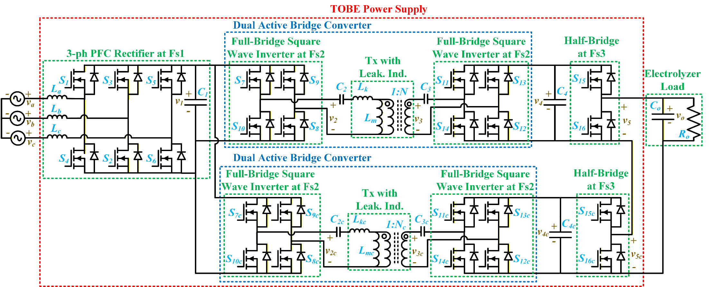
vabc = 60 Hz, 208 V (RMS) LL AC
Rectification through PFC at Fs1
v1 = 380 V Unregulated DC
Inversion by a full-bridge (NMOS-based) at Fs2
v2 = 380 V Square Wave at Fs2
Inversion by another full-bridge (NMOS-based) with a phase-shift at Fs2
v3 = 3 kV Square Wave at Fs2
Closed-loop control through phase-shift
v4 = 3 kV Regulated DC
Pulse generation by an NMOS half-bridge at Fs3
v5 = 3 kV Pulse at Fs3
Addition of two high-voltage pulses
vo = 6 kV Pulse at Fs3

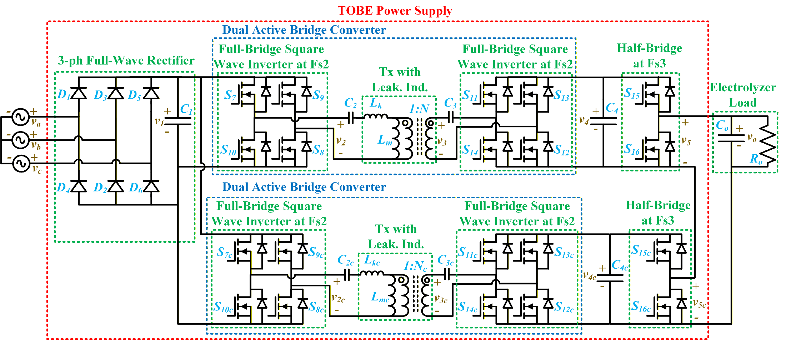
vabc = 60 Hz, 208 V (RMS) LL AC
Rectification through a full-wave diode bridge
v1 = 380 V Unregulated DC
Inversion by a full-bridge (NMOS-based) at Fs Hz
v2 = Fs Hz, 380 V Square Wave
Inversion by another full-bridge (NMOS-based) with a phase-shift at Fs Hz
v3 = Fs Hz, 3 kV Square Wave
Closed-loop control through phase-shift
v4 = 3 kV Regulated DC
Pulse generation by an NMOS half-bridge at Fs3
v5 = 3 kV Pulse at Fs3
Addition of two high-voltage pulses
vo = 6 kV Pulse at Fs3

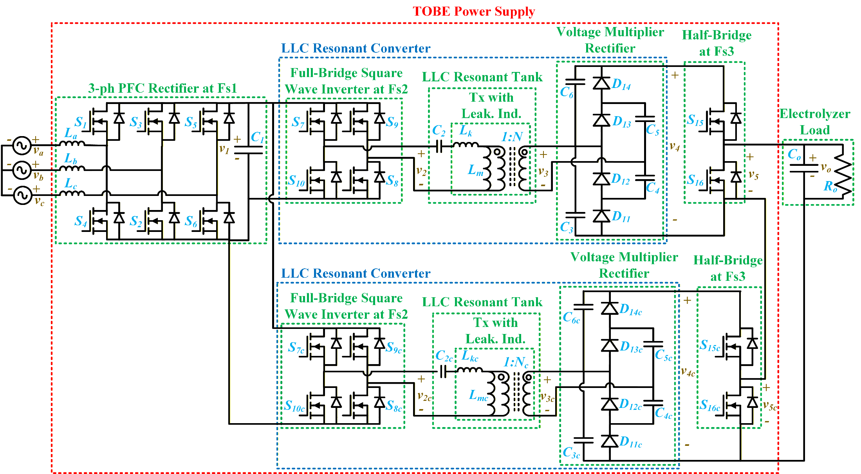
vabc = 60 Hz, 208 V (RMS) LL AC
Rectification through PFC at Fs1 Hz PWM
v1 = 380 V Unregulated DC
Inversion by a full-bridge (NMOS-based)
v2 = Fs Hz, 380 V Square Wave
Amplification by a resonant network and transformer
v3 = Fs Hz, 6.4 kV Square Wave
Rectification at high frequency by another full-bridge (diode-based)
v4 = 3 kV Regulated DC
Pulse generation by an NMOS half-bridge at Fs3
v5 = 3 kV Pulse at Fs3
Addition of two high-voltage pulses
vo = 6 kV Pulse at Fs3
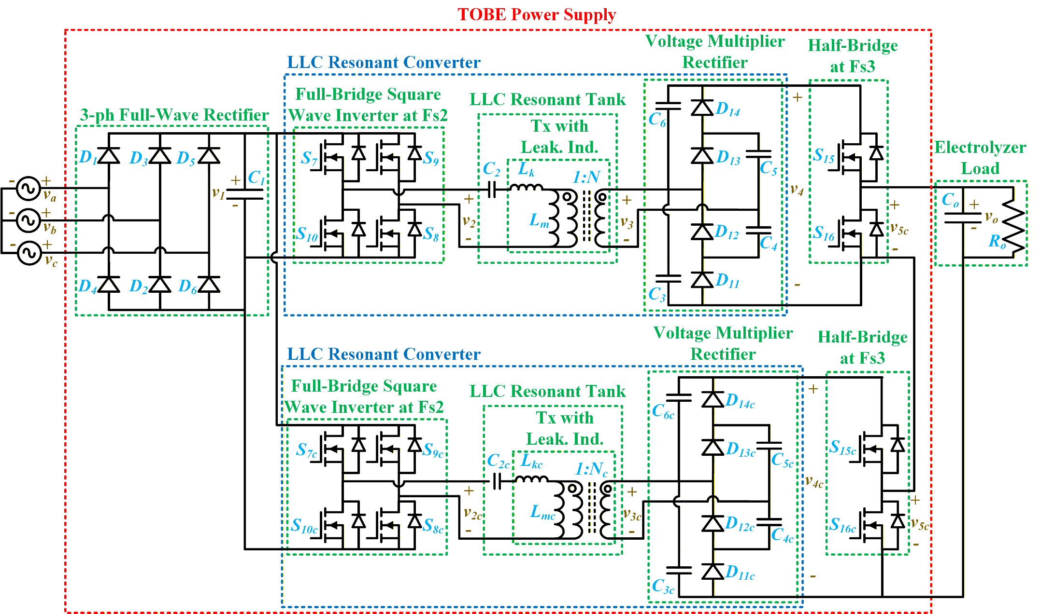
vabc = 60 Hz, 208 V (RMS) LL AC
Rectification through a full-wave diode bridge
v1 = 380 V Unregulated DC
Inversion by a full-bridge (NMOS-based)
v2 = Fs Hz, 380 V Square Wave
Amplification by a resonant network and transformer
v3 = Fs Hz, 6.4 kV Square Wave
Rectification at high frequency by another full-bridge (diode-based)
v4 = 3 kV Regulated DC
Pulse generation by an NMOS half-bridge at Fs3
v5 = 3 kV Pulse at Fs3
Addition of two high-voltage pulses
vo = 6 kV Pulse at Fs3

