Using GLM in H₂O Statistical Runtime for BigData

This is a brief description of how to use H₂O Statistical Runtime to ingest raw data and inspect the data for missing rows. We then use Generalized Linear Modeling (GLM) to identify the most important features for predicting conversions.

Introduction
Generalized Linear Modeling is the most powerful linear modeling toolkit at the hands of the modern data modeler. We present a simple REST-API for using the GLM on your datasets. This document describes using GLM via REST and JSON APIs.

We use the ADMM (Alternating Directions Method of Multipliers) technique for distributed version.

A simple web gui for GLM is also in the works and will be described in subsequent version.

Import dataset

- Import the dataset via, ImportFolder or clicking store view (incase of HDFS launch)

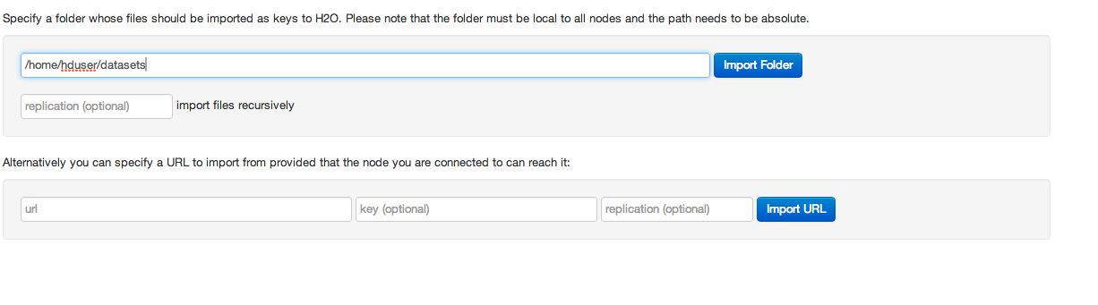
- Put operation can also be used for importing the dataset: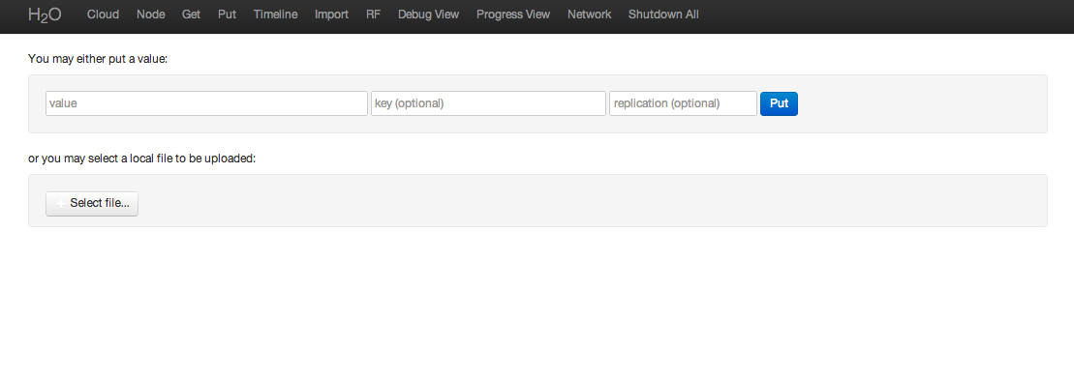
Standard file selection interface -
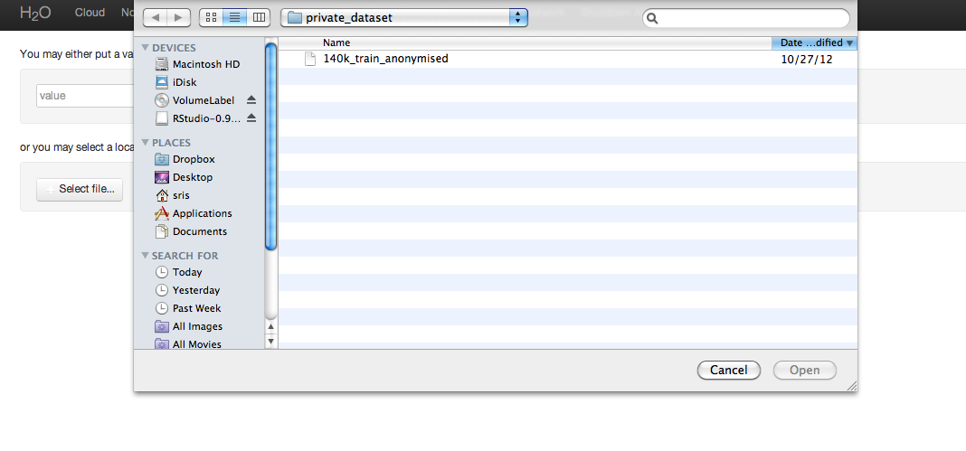
- Parse he dataset is a simple click through the link of the Key after Put or via the Store.

This takes a few minutes for large datasets.

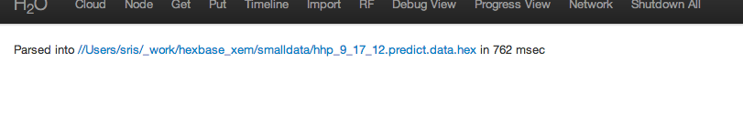

- Inspect the data for a summary:

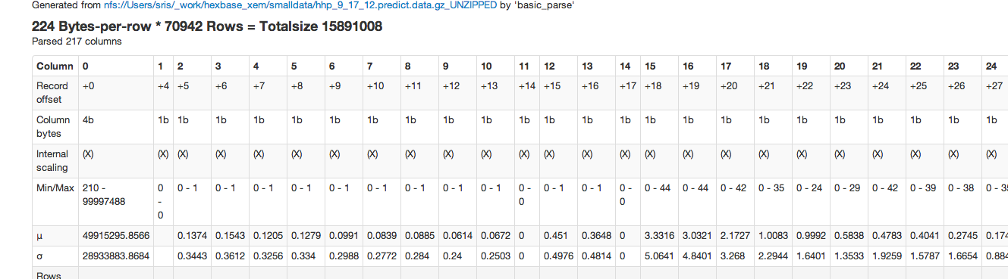

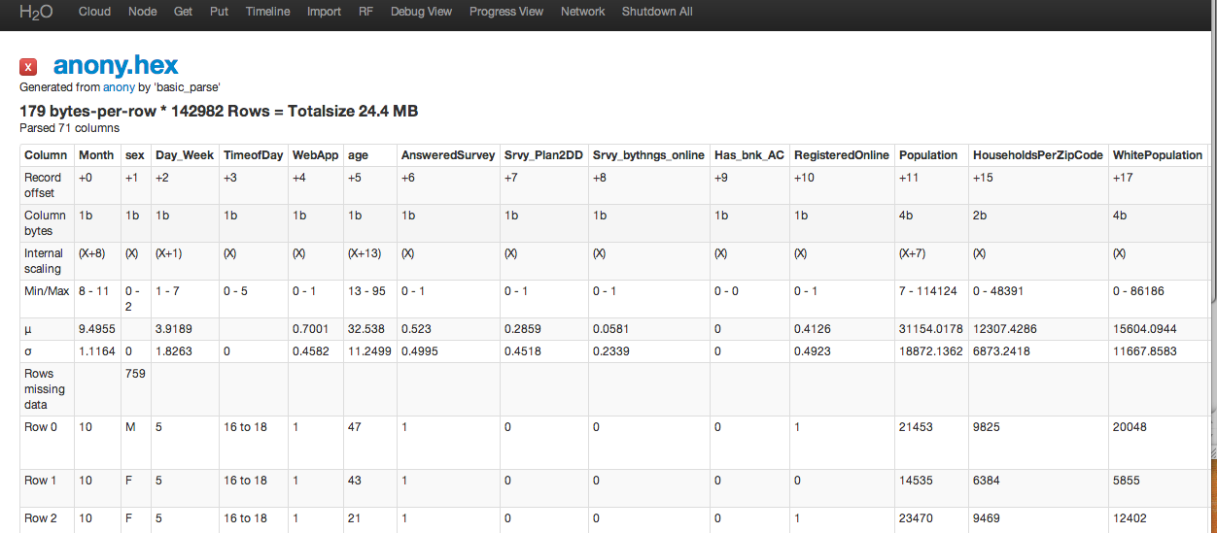

GLM

Generalized Linear Models are a powerful toolkit in any datamodeler’s hands.
We invoke GLM using REST-API call –
Using L1 Regularization and a lambda that is high – 0.01 – we are able to detect features that donot matter.

http://localhost:54321/GLM?Key=anony.hex&Y=Converted&norm=L1&lambda=1e-2&family=binomial&xval=10

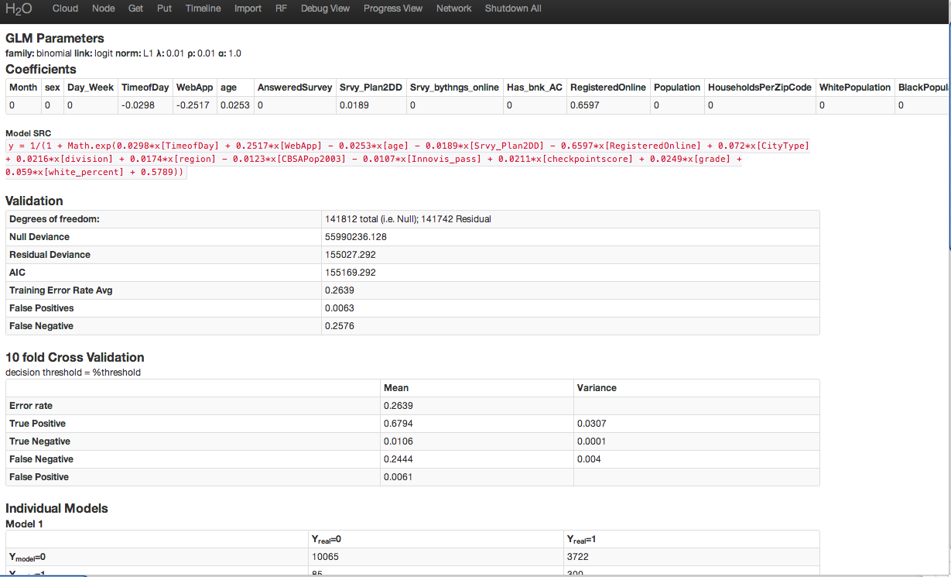

Table1: GLM with L1 Regularization produces a list of features that might not matter for predicting converted

Model SRC
y = 1/(1 + Math.exp(0.0298*x[TimeofDay] + 0.2517*x[WebApp] - 0.0253*x[age] - 0.0189*x[Srvy_Plan2DD] - 0.6597*x[RegisteredOnline] + 0.072*x[CityType] + 0.0216*x[division] + 0.0174*x[region] - 0.0123*x[CBSAPop2003] - 0.0107*x[Innovis_pass] + 0.0211*x[checkpointscore] + 0.0249*x[grade] + 0.059*x[white_percent] + 0.5789))

Regression REST-API
Logistic Regression can be invoked on h2o via simple REST API. Here are a few simple examples:
family=binomial, LASSO
http://localhost:54321/GLM?Key=140k_train_anonymised.hex&Y=Converted&norm=L1&family=binomial
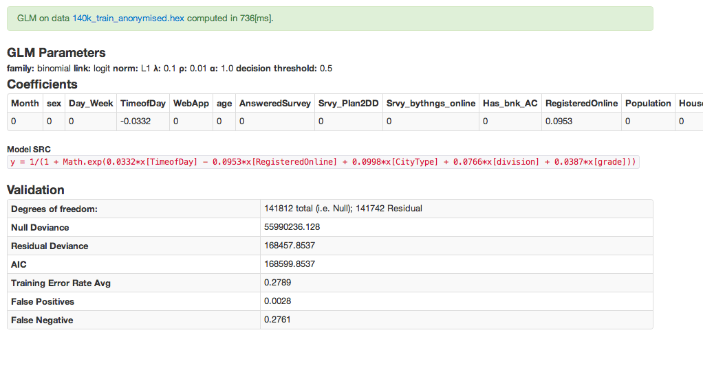

family=gaussian, linear regression
http://localhost:54321/GLM?Key=covtype.20k.hex&Y=12&family=gaussian&X=1:8 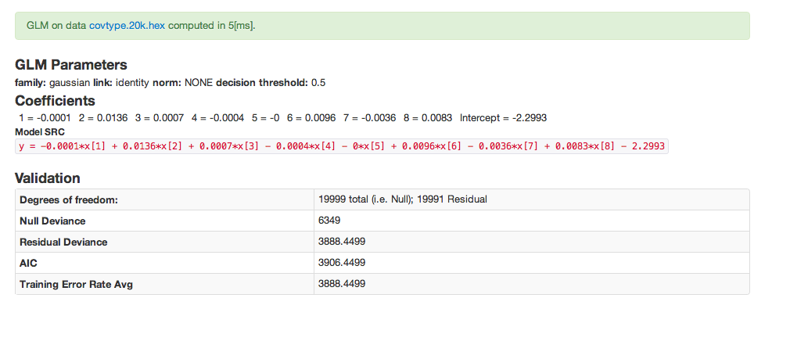

family=gaussian, linear regression
http://localhost:54321/GLM?Key=140k_train_anonymised.hex&Y=Converted&family=gaussian
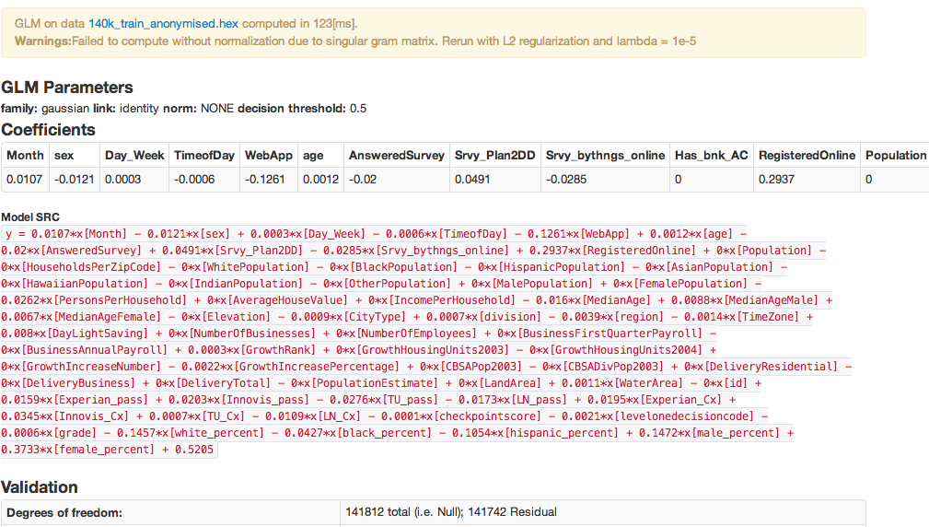

As prompted we now apply L2 regularization and lambda=1e-5 to get –

L2 regularization, Linear Regression, lambda=1e-5
http://localhost:54321/GLM?Key=140k_train_anonymised.hex&Y=Converted&family=gaussian&norm=L2&lambda=1e-5
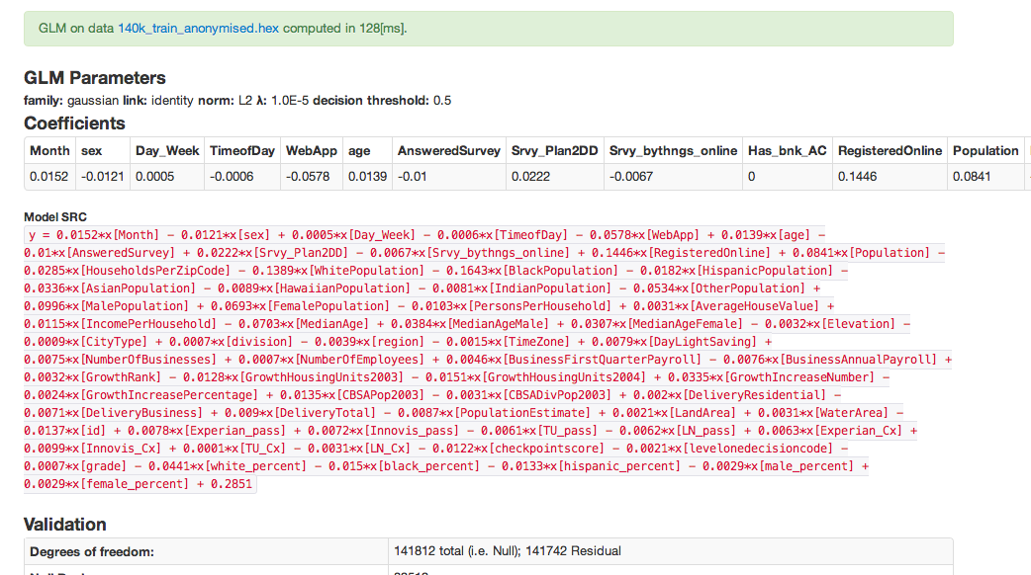

10-fold cross validation
http://localhost:54321/GLM.json?Key=140k_train_anonymised.hex&Y=Converted&norm=L1&family=binomial&xval=10
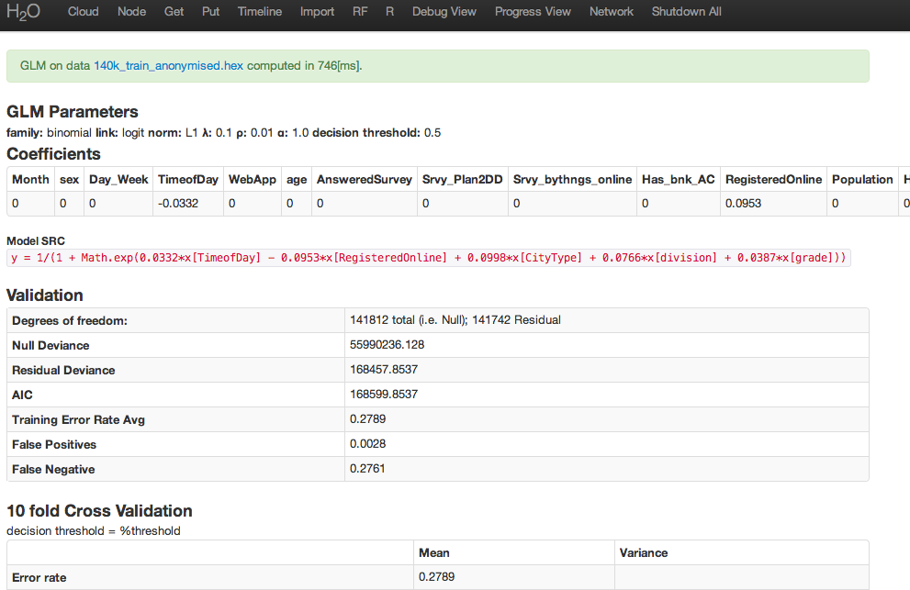

JSON
The same commands can be used with GLM.json?Key=data.key&Y=Converted to get the JSON output of the model.

http://localhost:54321/GLM.json?Key=140k_train_anonymised.hex&Y=Converted&norm=L1&family=binomial&xval=10

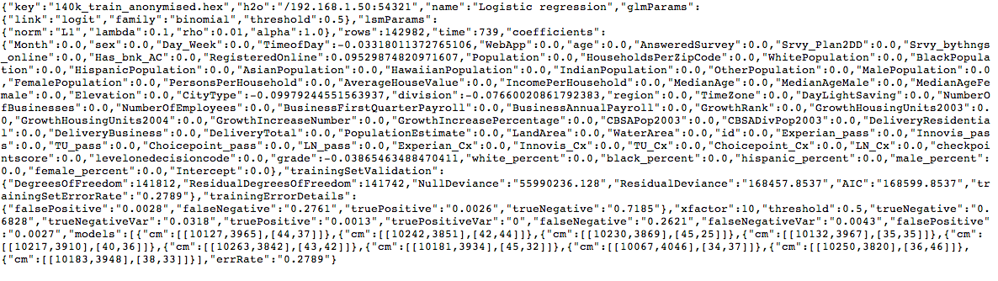
[1] Reference for the REST-API.
Key - (required) - key of the .hex data to run regression on

Y - (required) - column id / name of the response variable, if you run logistic regression it's values currently MUST be from {0,1}

X - (optional) - list of columns used as an input vector, either names or column indexes (or mixture of both), separated by ','.Ranges can be provided by supplying two values separated by ':', e.g. X=1:3,5:10 is equivalent to X=1,2,3,5,6,7,8,9,10. Default is all columns except for Y.

-X - (optional) - negative X, these columns will be subtracted from the set of selected columns. Thus, selected columns = X \ -X. Default is empty set.

family - (optional) - either "binomial" for logistic regression or "gaussian" for linear regression.Default is gaussian.

xval - (optional) - cross validation factor. supply 10 for 10fold cross validation. Default is 0 (no crossvalidation). Currently supported only for logistic regression.

threshold - (optional) - decision threshold used for prediction error rate computation. Only used by logistic regression. Default is 0.5.

norm - (optional) - norm for regularized regression. Possible values "L1", "L2", "NONE". Default is "NONE". If regularization is used, data will be REGULARIZED (so that it has zero mean and unit variance.)

lambda - (optional) - argument affecting the regularization, Default is 0.1.

rho - (optional) - used only with L1. Enhanced Lagrangian parameter. Default is 1.0.

alpha - (optional) - used only with L1. Over-relaxation parameter (typical values for alpha are between 1.0 and 1.8). Default is 1.0.

[2] ADMM: Distributed Optimization and Statistical Learning via the Alternating Direction Method of Multipliers http://www.stanford.edu/~boyd/papers/admm_distr_stats.html

