Using GLM to improve predictive capabilities of Random Forest on
H₂O Statistical Runtime for Big Data

This is a brief description of a technique used to build a model for real world dataset collected for credit card offer conversions. Data is dense about 71 cols, messy with a few features partially populated.

We use H₂O Statistical Runtime to ingest raw data and inspect the data for missing rows. We then use Generalized Linear Modeling (GLM) to identify the most important features for predicting conversions. Random Forest produces improved accuracy (0.26% to 0.17%) by ignoring features that did not matter. This workflow resulted in an accuracy improvement of up to 900 basis points over either of the techniques by themselves. (Prediction is better in comparison with best models via SPSS and SAS done by customer)

Introduction
We describe the technique of daisy chaining as two powerful algorithms to achieve better accuracy for Data Modeling. (We use the opportunity to describe operations in H₂O that help prove.)

H2O is an extensible statistical runtime on top of HDFS and big data. H2O scales machine learning and modeling over large datasets. H2O gives approximate results at each stage of computation for Adhoc analysis via familiar R-like syntax and workflows. It is easy to install and integrate via JSON & REST APIs. H2O is the new wave SAS for Big Data.

Business problem:
The goal of this model is to predict “Converts” from initial dataset of user population to actual activated credit card users. Best models in this space are 77% accurate in predicting conversions. Customer used SPSS and SAS to get best models to predict.

We use Out Of Bag Error estimate as presented by Breiman’s paper on Random Forest in this experiment. Validation of model was also done using a separate test and training dataset.

Import dataset

- Import the dataset via, Import Folder
Or clicking store view (incase of HDFS launch) HDFS files appear with hdfs://dataset/covtype.data

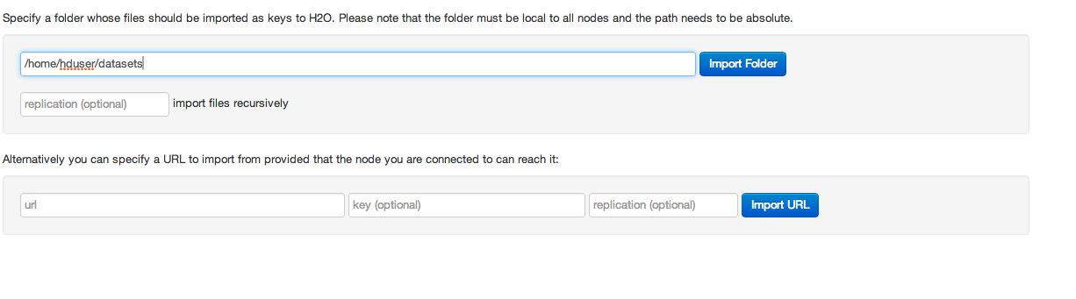
- Put operation can also be used for importing the dataset: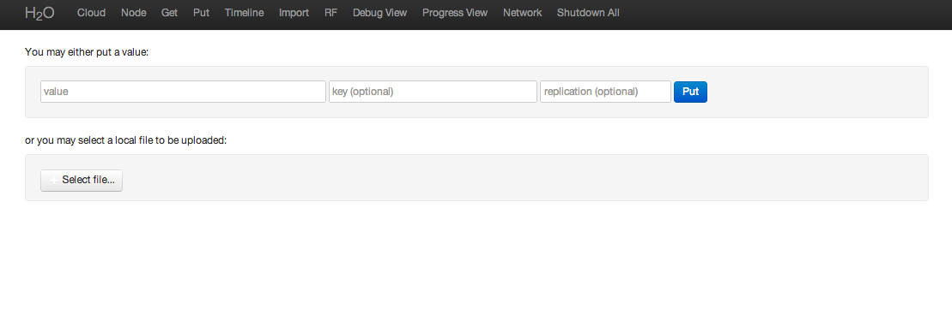
Standard file selection interface -
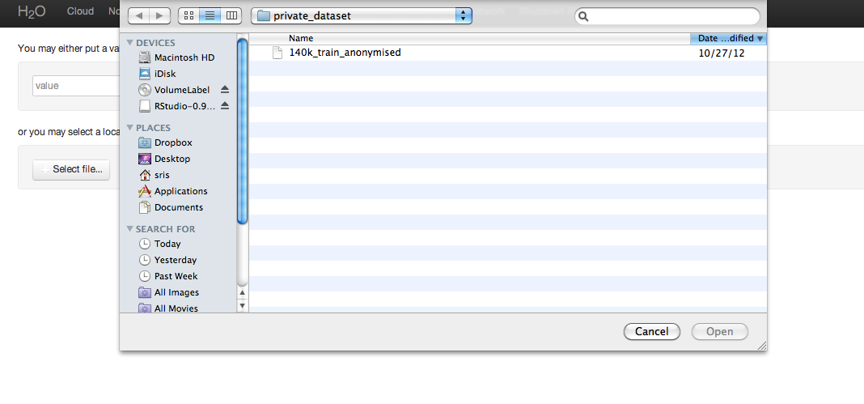
- Parse the dataset is a simple click through the link of the Key after Put or via the Store.

This takes a few minutes for large datasets.

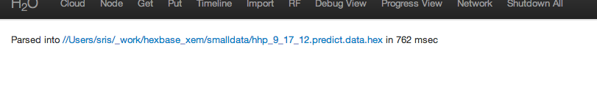

- Inspect the data for a summary:

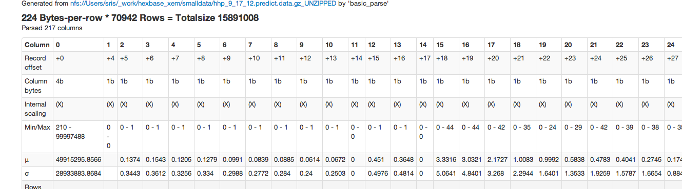

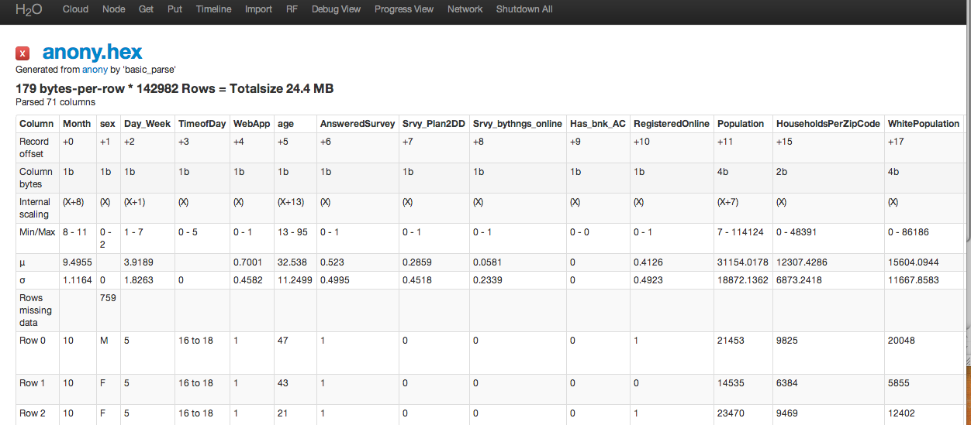

GLM

Generalized Linear Models are a powerful toolkit in any data modeler’s hands.
We now run GLM using REST-API call –
Using L1 Regularization and a lambda that is high – 0.01 – we are able to detect features that do not matter.

http://localhost:54321/GLM?Key=anony.hex&Y=Converted&norm=L1&lambda=1e-2&family=binomial&xval=10

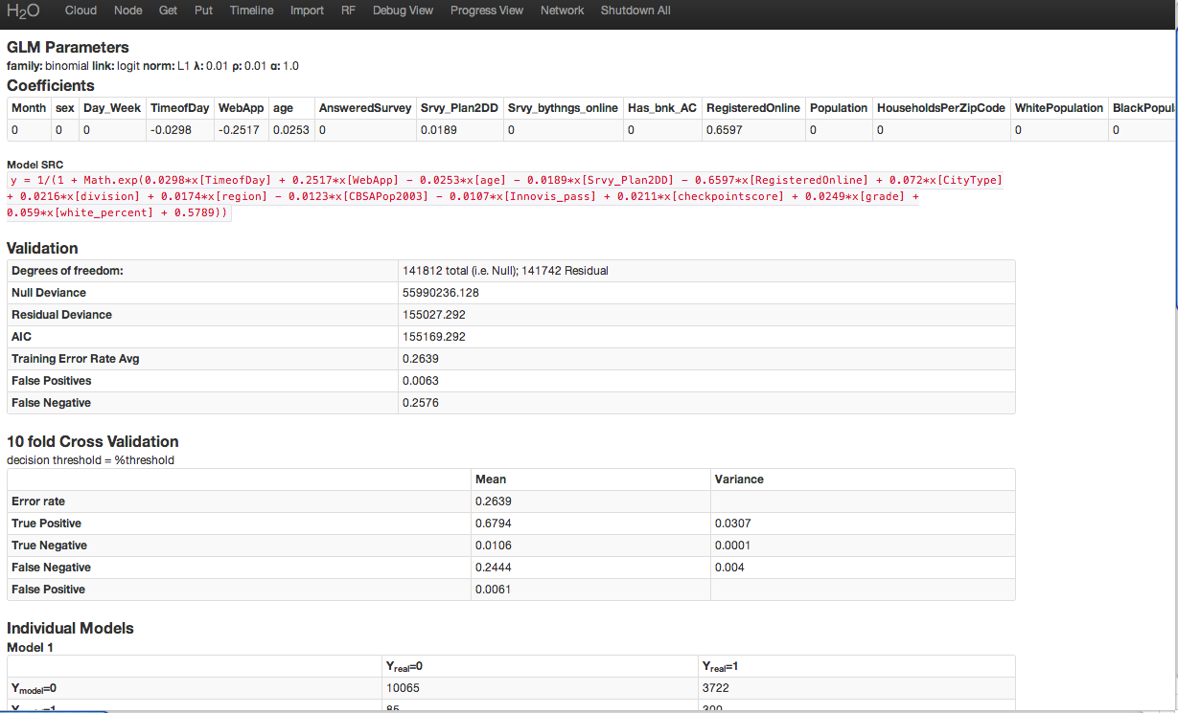

Table1: GLM with L1 Regularization produces a list of features that might not matter for predicting converted

Model SRC
y = 1/(1 + Math.exp(0.0298*x[TimeofDay] + 0.2517*x[WebApp] - 0.0253*x[age] - 0.0189*x[Srvy_Plan2DD] - 0.6597*x[RegisteredOnline] + 0.072*x[CityType] + 0.0216*x[division] + 0.0174*x[region] - 0.0123*x[CBSAPop2003] - 0.0107*x[Innovis_pass] + 0.0211*x[checkpointscore] + 0.0249*x[grade] + 0.059*x[white_percent] + 0.5789))

This gives a hint of the features that matter in this particular dataset. The thesis is that features with 0 coefficients, such as “Month”, “Sex”, “Day of Week” are not useful features in the prediction. Let’s see if that thesis holds in the next steps.

Random Forest (RF)

In order to use the Random Forest in H2O Click RF Tab – It gives a form for picking dataset.
Using the key name (anony.hex) from the parse page above.
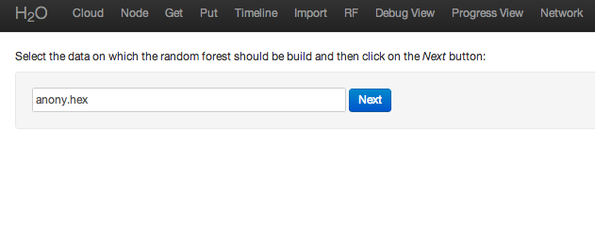

The RF query builder prompts you to suggest a class column.

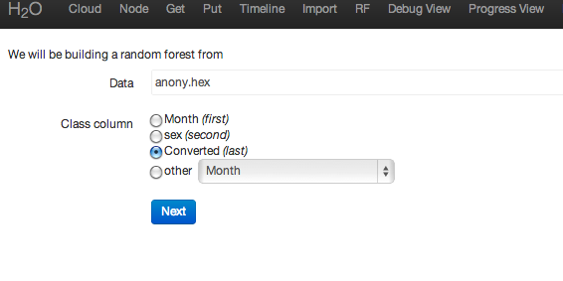

Based on the column the next page allows you to set model parameters
Number of Trees, Algorithm (Gini vs. Entropy), Depth, sample Columns to Ignore and Weighting Classes.

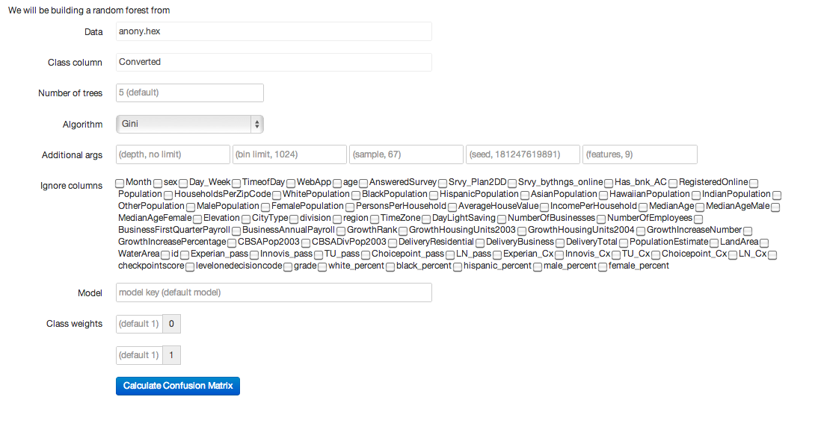

Here’s the default Random Forest error rate of 0.317

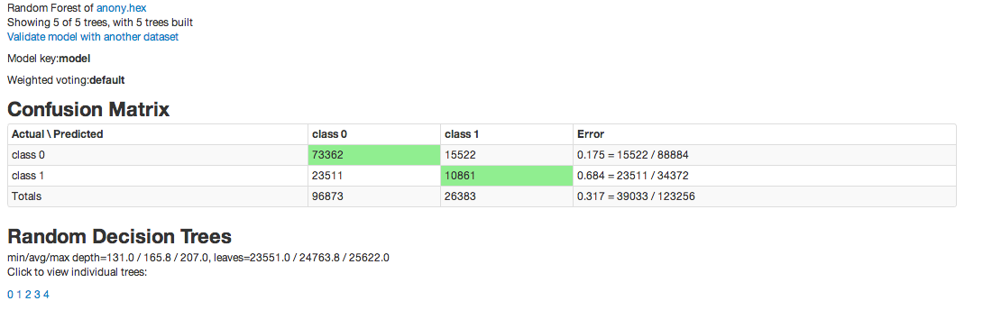

Increasing the number of trees to 10 improves accuracy.
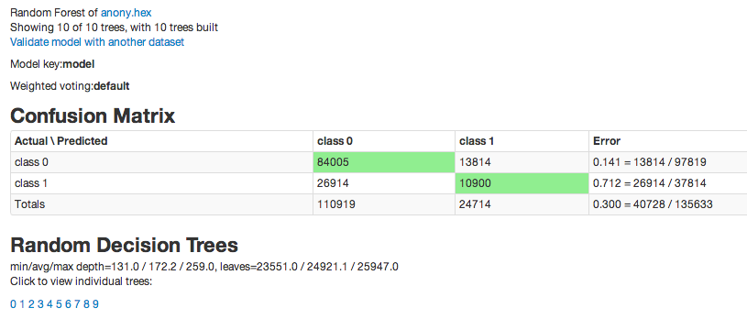

We now “ignore” features that were not significant.
One proposition is that these have strong correlation with features that had 0-coefficients from GLM.

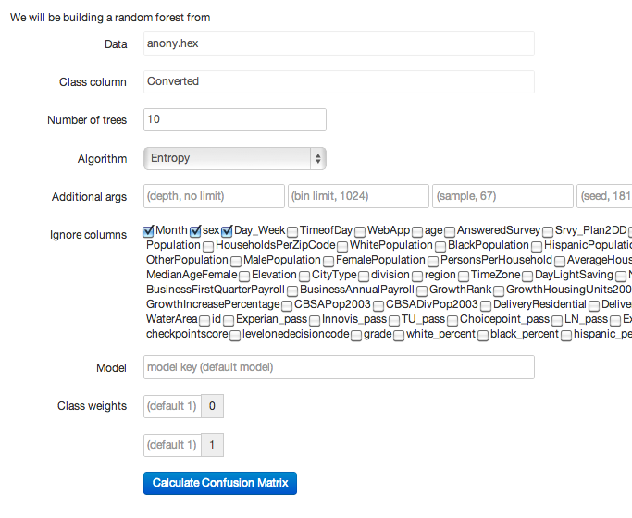

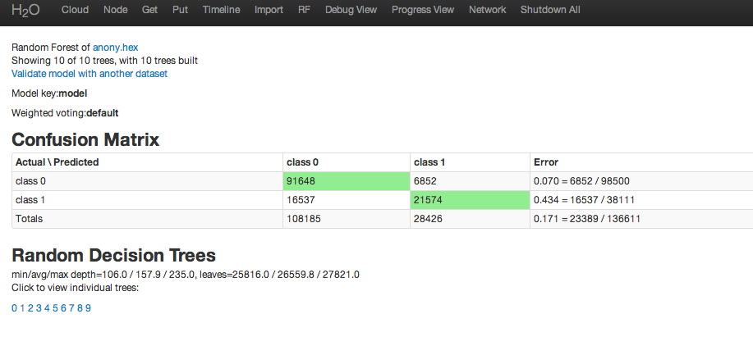
An interesting aspect of this dataset is that using entropy as the algorithm gives a model with even better error rate of 0.167 (lower is better)

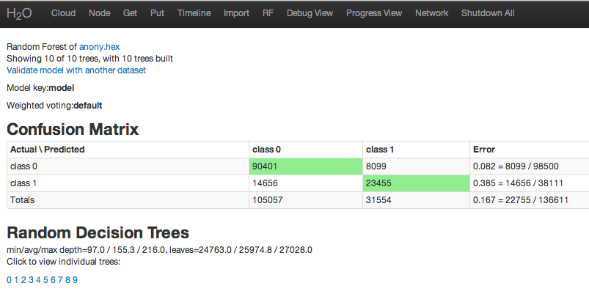

Additional Adhoc Data Manipulation can be achieved via, R or ExecQuery interface:
http://localhost:54321/ExecQuery

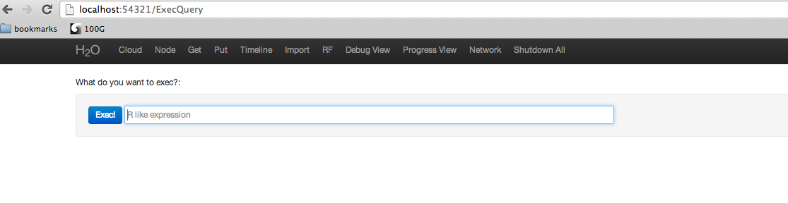

Slicing of dataset:
http://localhost:54321/Exec?Expr=slice%28anony.hex2%2C+1%2C+10000%29

