University Clinic Booking System – Design report
Introduction
The Health & Wellness Centre Portal is designed to help students easily book medical appointments with doctors and healthcare professionals at the university clinic. The system also allows doctors and clinic staff to manage appointments, schedules, and patient consultations. The user interface was designed to be simple, clear, and easy to navigate so that users with different levels of technical experience can use it without confusion. The following sections explain how each interface works and how the design choices help make the system user-friendly.

Student UI
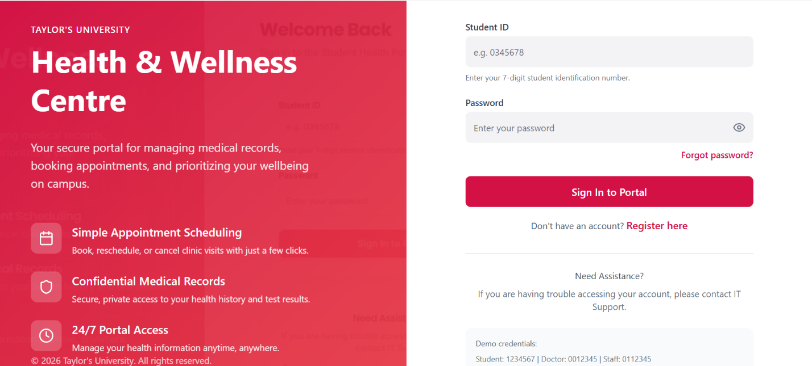
Login Page
Looking at the login interface, the design focuses on making the login process quick and simple for users. The layout only includes the most important information needed to access the system, which helps prevent confusion for first-time users.
• Users enter Student ID and Password
• Login box is positioned clearly so it is easy to find
• Clean layout reduces distractions
• Information about portal features is displayed
• Forgot Password option helps users recover access
• Simple structure allows users to log in quickly

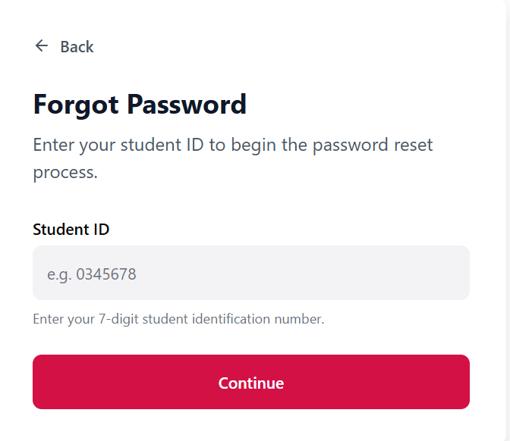
Forgot Password Page
When examining the password reset interface, the design clearly focuses on helping users recover their accounts in a straightforward way. The page avoids unnecessary elements so users can focus on completing the reset process.
• Users begin by entering their Student ID
• The system may request verification through email or code
• Only one main action is required on the page
• Minimal design reduces confusion
• Helps users quickly regain access to their account

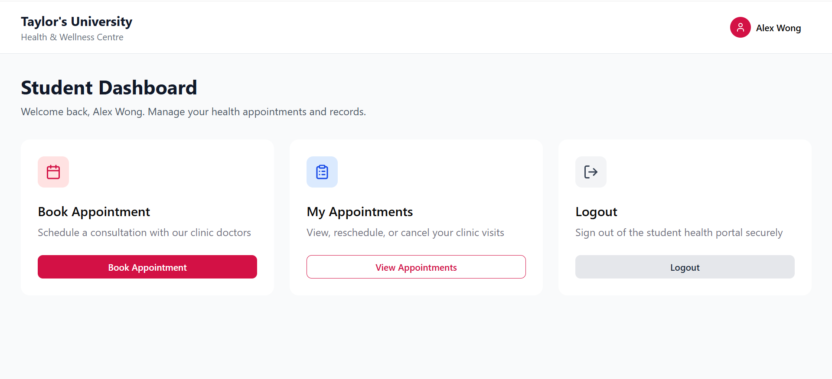
Student Dashboard
After logging in, users are directed to the student dashboard. This page acts as the main navigation area where students can access the key features of the portal. The layout keeps things simple so students can immediately see what actions they can take.
• Displays a welcome message
• Main options include:
• Book Appointment
• My Appointments
• Logout
• Large buttons improve visibility
• Simple layout prevents the page from looking crowded
• Helps students quickly navigate the system

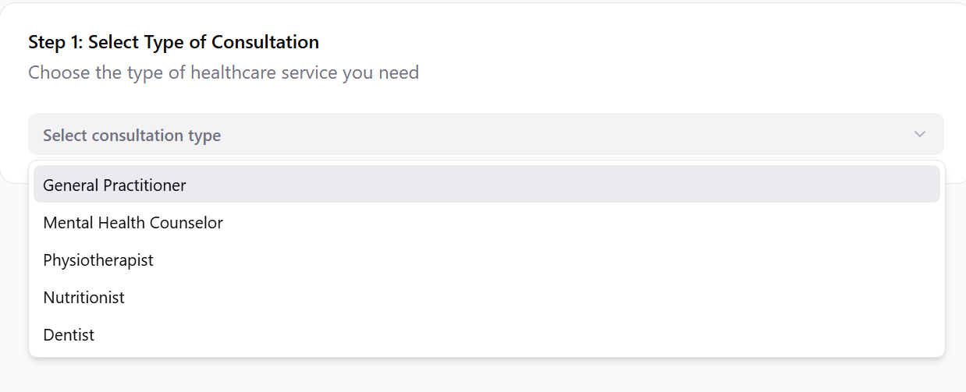

Selecting Consultation Type
During the appointment booking process, students first choose the type of consultation they need. This step helps the system determine which doctors and services are available for that appointment.
• Students select the type of consultation
• Options include:
• General Practitioner
• Mental Health Counselor
• Physiotherapist
• Nutritionist
• Dentist
• Options are displayed in a dropdown menu
• Keeps the interface organized
• Ensures only valid services are selected
Using a dropdown menu helps keep the interface organized and prevents the page from looking crowded with too many options. It also ensures that students can only choose valid services that are available at the clinic. This reduces mistakes during the booking process.
The design encourages a step-by-step approach to booking an appointment, which makes the system easier to understand and follow.
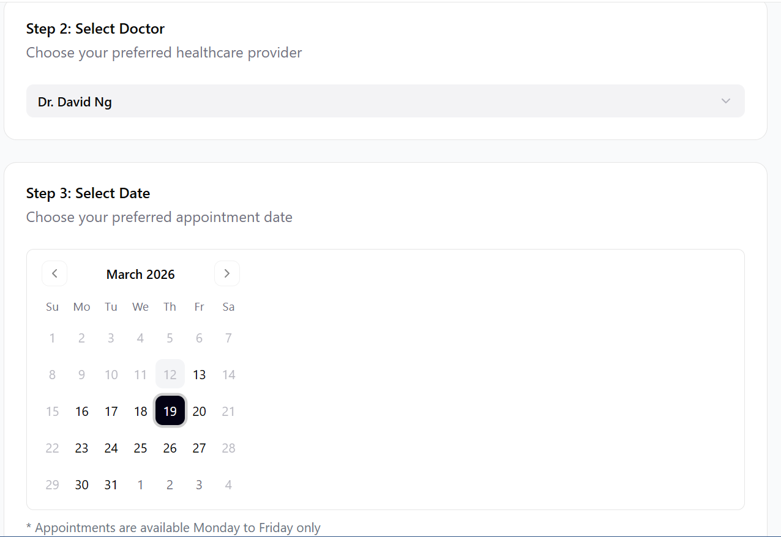
Selecting Appointment Date
The appointment date selection uses a calendar interface which is familiar to most users. This makes it easier for students to quickly choose the day that works best for them.
• Students select a preferred appointment date
• Calendar layout is easy to understand
• Navigation arrows allow moving between months
• Only available days can be selected
• Appointments are limited to weekdays
• Helps avoid booking errors

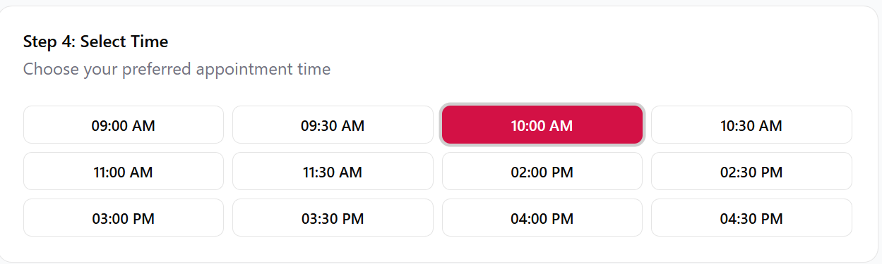
Selecting Appointment Time
Once a date is selected, students choose a time slot for their appointment. The time slots are displayed clearly so users can quickly pick a suitable option.
• Time slots are shown as clickable buttons
• Examples include 09:00, 09:30, 10:00
• Users simply select their preferred time
• Only available slots are displayed
• Reduces booking conflicts
• Makes the process quick and easy

Doctor UI
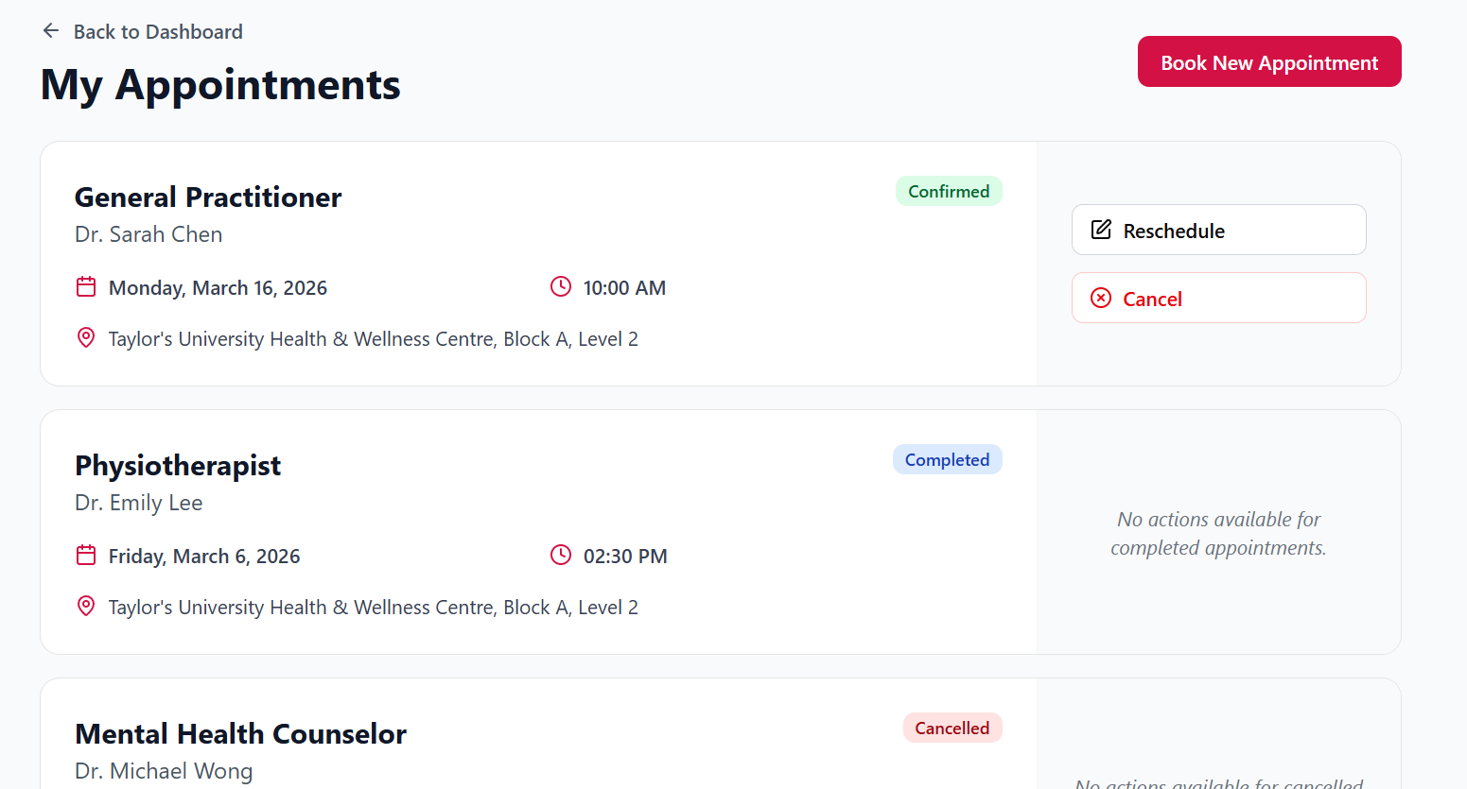
My Appointments Page
Students can view all their appointments through the appointment management page. The information is displayed in a structured way so users can easily review their upcoming and past bookings.
• Shows all student appointments
• Displays important details such as:
• Doctor name
• Appointment date
• Appointment time
• Clinic location
• Appointment status
• Students can reschedule or cancel upcoming appointments
• Clear layout improves readability
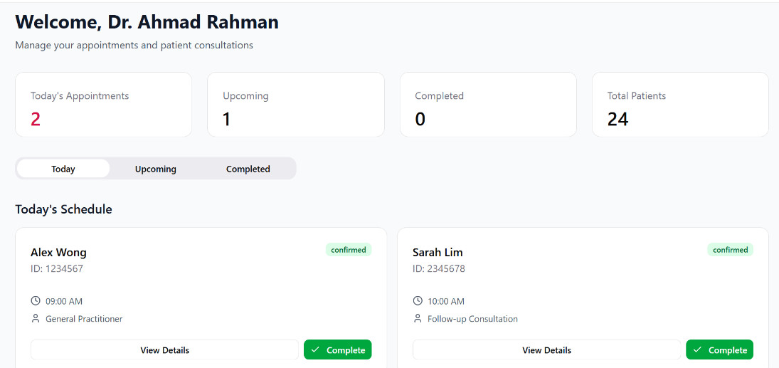
Doctor Dashboard
Doctors have their own dashboard which provides an overview of their daily activities. This allows them to quickly see upcoming appointments and manage patient consultations.
• Displays today’s appointments
• Shows upcoming consultations
• Lists completed appointments
• Includes patient information
• Helps doctors manage their schedule efficiently
• Organized layout improves workflow

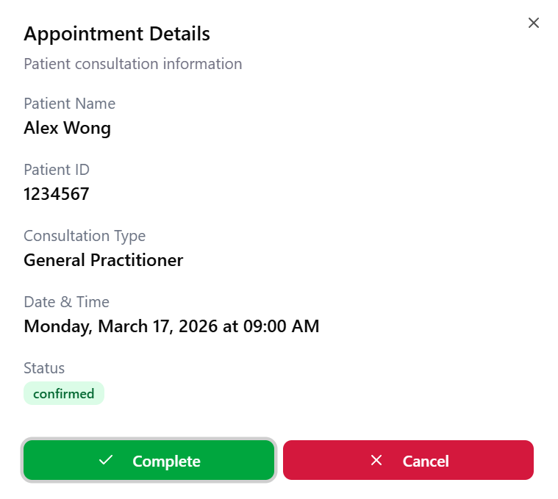

Appointment Details Page
The appointment details section provides doctors with more information about a specific consultation. This allows them to review patient details before meeting with the patient.
• Displays:
• Patient name
• Patient ID
• Consultation type
• Appointment date and time
• Appointment status
• Doctors can mark appointments as completed
• Helps doctors review important details quickly

Clinic staff UI:
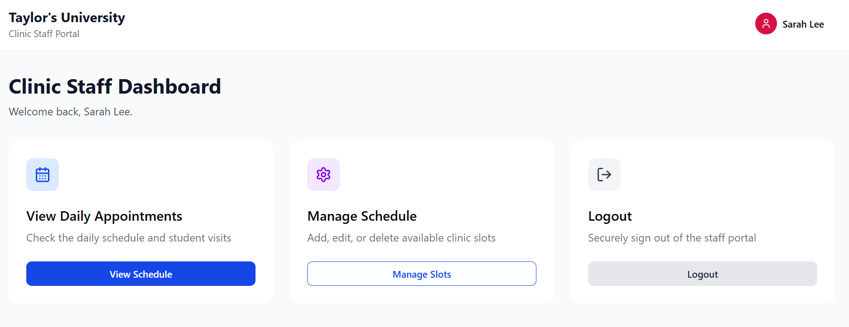
Clinic Staff Dashboard
Clinic staff also have access to their own dashboard. This interface focuses on managing the clinic schedule and monitoring appointments.
• Staff can view daily appointments
• Staff can manage schedules
• Interface focuses on administrative tasks
• Simple navigation makes tasks easier
• Helps staff maintain clinic organization

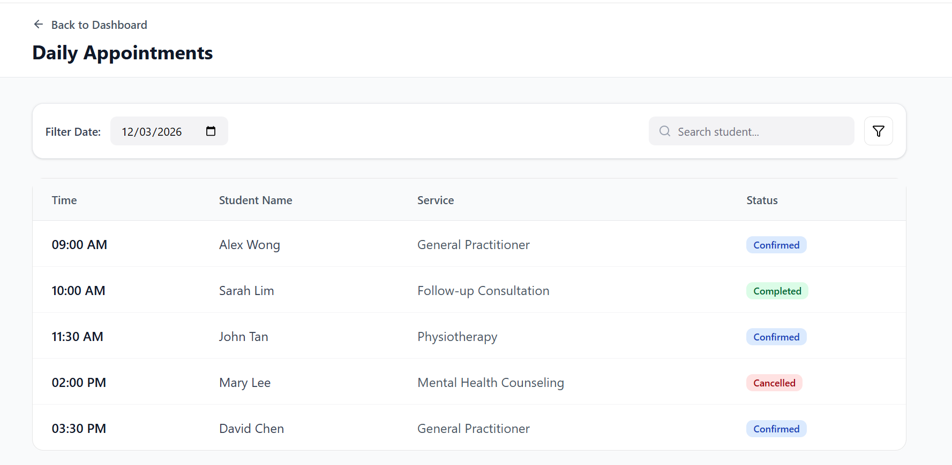.
A search and filter option is also included to help staff quickly find specific appointments. This feature is useful when the clinic has many bookings throughout the day.
The structured layout helps staff manage patient flow and maintain an organized clinic schedule.

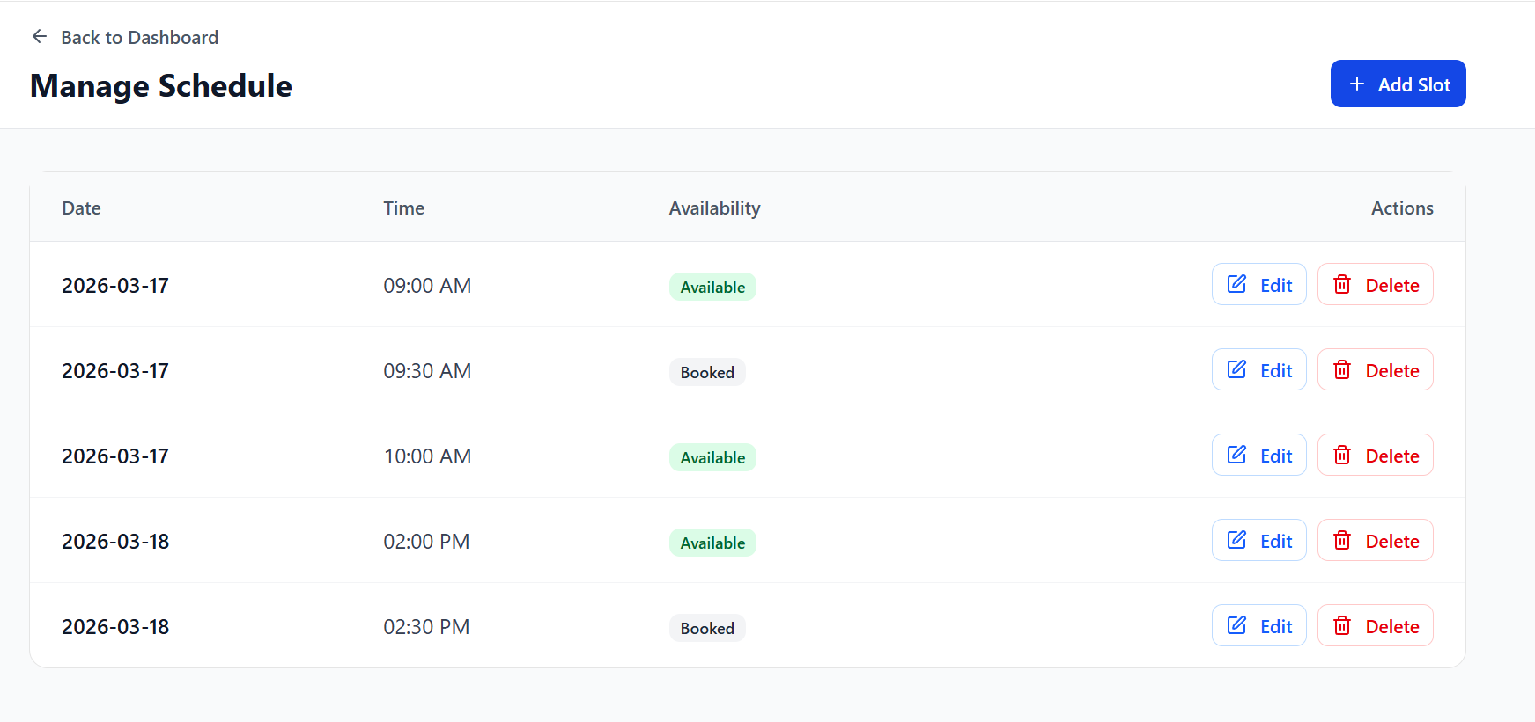

Schedule Management Page
The schedule management section allows clinic staff to control appointment availability. This ensures that students can only book time slots that are available.
• Staff can add new time slots
• Staff can edit existing slots
• Staff can delete unavailable slots
• Each slot shows whether it is available or booked
• Table layout makes the schedule easy to read
• Helps prevent double bookings
Conclusion
The Health & Wellness Centre Portal was designed with a strong focus on simplicity and usability. The interface uses clear layouts, simple navigation, and step-by-step processes to guide users through tasks such as booking appointments and managing schedules. By reducing unnecessary complexity and presenting information in an organized way, the system ensures that students, doctors, and clinic staff can use it efficiently. Overall, the design helps create a smooth and user-friendly experience for all users of the portal.

