ECE 242: Lab 1 Preparation

Henry Wang – 20565787

Pierre Eid – 20630314

|  |  |  |  |  |  |  |
| --- | --- | --- | --- | --- | --- | --- |
|  | VTest (V) | ITest (mA) | |VTest / ITest|  (Ω) | ΔVT (V) | ΔIT (mA) | ΔVT / ΔIT  (Ω) |
| VT1 | 0 | -26.7 | 0 |  |  |  |
| VT2 | 1 | -13.3 | 75.2 | 1 | 13.4 | 74.6 |
| VT3 | 2 | 0 | INF | 1 | 13.3 | 74.6 |
| VT4 | 3 | 13.3 | 225.6 | 1 | 13.3 | 74.6 |
| VT5 | 4 | 26.7 | 149.8 | 1 | 13.4 | 74.6 |
| Rout = 0.0746 kΩ | | | | | | |

**QUESTION 1)**

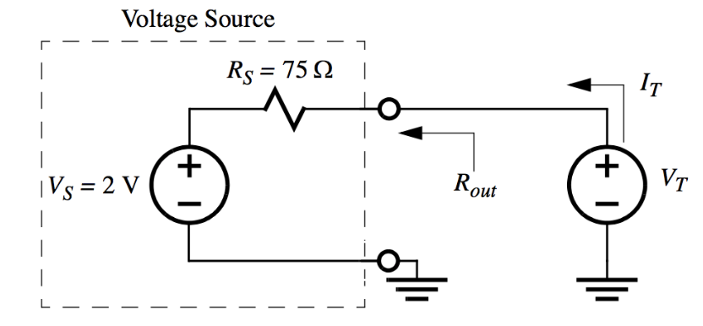

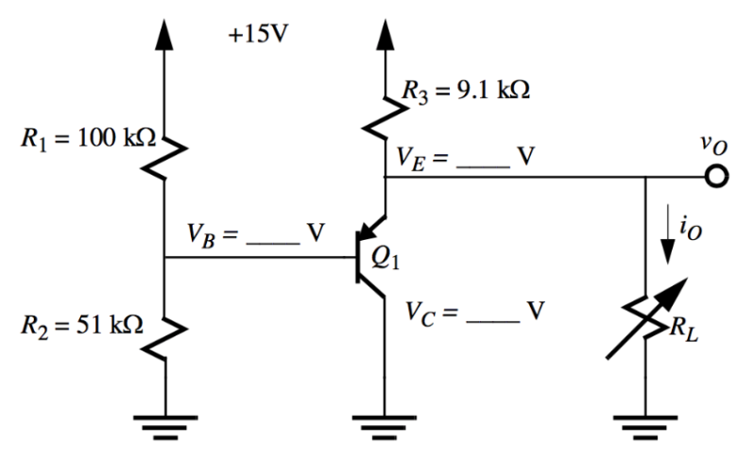**QUESTION 2)**

**Since the transistor current gain (Beta) is assumed to be infinite, this implies that the base current, IB is zero.**

$$I_{B}=\lim_{β→∞}{I_{E}/β}=0 mA$$

**This means that the voltage division principle can be applied to determine the base voltage VB.**

**For a PNP BJT in the active mode, the potential different between the base and the emitter (VBE) is assumed to be -0.7 V because of the I-V curve of PN junctions. The voltage at the emitter is then easily calculated.**

$$V_{E}=V_{B}- V_{BE} = V_{B}-\left(-0.7\right)=5.07+0.7=5.77V$$

**This op amp is a common collector setup, so the voltage at the collector is grounded.**

$$V_{C}=0V$$

**QUESTION 3)**

Pre-wired circuit.