Early Detection of Eye Diseases by using Retinal Images

A Project Report Submitted in partial fulfillment of the requirement for the award of the degree of

BACHELOR OF TECHNOLOGY
IN
COMPUTER SCIENCE AND ENGINEERING

Submitted by

V. SRI VARSHA | (N200781)
N. SOWMYA | (N200689)
B. YASHWANTH ACHARI | (N200829)
K. NAVEEN KUMAR | (N200542)
N. GANESH NAIK | (N201002)

Under the Esteemed Guidance of
Mrs.N.Swathi
Assistant professor, Department of CSE



DEPARTMENT OF COMPUTER SCIENCE AND ENGINEERING
Rajiv Gandhi University of Knowledge Technologies – Nuzvid
Nuzvid, Eluru, Andhra Pradesh – 521202.
DEPARTMENT OF COMPUTER SCIENCE AND ENGINEERING
Rajiv Gandhi University of Knowledge Technologies
(A.P.Government Act 18 of 2008)
RGUKT-NUZVID, Eluru Dist – 521202

CERTIFICATE OF COMPLETION

This is to certify that the work entitled, “Early Detection of Eye Diseases by using Retinal Images” is the bonafied work of V. Sri Varsha (ID No: N200781), N. Sowmya (ID No: N200689), B. Yashwanth Achari (ID No: N200829), K. Naveen Kumar (ID No: N200542), N. Ganesh Naik (ID No: N201002) carried out under my guidance and supervision for 3rd year minor project of Bachelor of Technology in the department of Computer Science and Engineering under RGUKT IIIT, Nuzvid. This work is done during the academic session February 2025 – June 2025, under our guidance.

__________________ | _________________________
Mrs. N. Swathi | Mrs. S. Bhavani
Assistant Professor, | Assistant Professor,
Department of CSE | Head of the Department-CSE
RGUKT, Nuzvid | RGUKT, Nuzvid

DEPARTMENT OF COMPUTER SCIENCE AND ENGINEERING
Rajiv Gandhi University of Knowledge Technologies
(A.P.Government Act 18 of 2008)
RGUKT-NUZVID, Eluru Dist – 521202

CERTIFICATE OF EXAMINATION

This is to certify that the work entitled “Early Detection of Eye Diseases by using Retinal Images” is the bonafied work of V. Sri Varsha (ID No: N200781), N. Sowmya (ID No: N200689), B. Yashwanth Achari (ID No: N200829), K. Naveen Kumar (ID No: N200542), N. Ganesh Naik (ID No: N201002) and here by accord our approval of it as a study carried out and presented in a manner required for its acceptance in the 3rd year of Bachelor Of Technology for which it has been submitted. This approval does not necessarily endorse or accept every statement made, opinion expressed or conclusion drawn, as recorded in this thesis. It only signifies the acceptance of this thesis for the purpose for which it has been submitted.

__________________ | ___________________
Mrs. N. Swathi | Project Examiner
Assistant Professor, | Department of CSE
Department of CSE | RGUKT, Nuzvid
RGUKT, Nuzvid

DEPARTMENT OF COMPUTER SCIENCE AND ENGINEERING
Rajiv Gandhi University of Knowledge Technologies
(A.P.Government Act 18 of 2008)
RGUKT-NUZVID, Eluru Dist – 521202

DECLARATION

We “V. Sri Varsha (ID No: N200781), N. Sowmya (ID No: N200689), B. Yashwanth Achari (ID No: N200829), K. Naveen Kumar (ID No: N200542), N. Ganesh Naik (ID No: N201002)” hereby declare that the project report entitled “Early Detection of Eye Diseases by using Retinal Images” done by us under the guidance of Mrs.N.Swathi, Assistant Professor, is submitted for the fulfillment of a minor project during the academic session January 2024 - June 2025 at RGUKT-Nuzvid.
We also declare that this project is a result of our own effort and has not been copied or imitated from any source. Citations from any websites are mentioned in the references. The results embodied in this project report have not been submitted to any other university or institute for the award of any degree or diploma.
Date : 29 June 2025
V. Sri Varsha | N200781
N. Sowmya | N200689
B. Yashwanth Achari | N200829
K. Naveen Kumar | N200542
N. Ganesh Naik | N201002
Place : Nuzvid

ACKNOWLEDGEMENT

We would like to express our sincere gratitude and appreciation to all those who have contributed to the completion of this mini project on Early Detection of Eye Diseases by using Retinal Images – A Deep Learning Project.

First and foremost, we extend our heartfelt thanks to Mrs. N. Swathi mam whose guidance, support, and expertise were invaluable throughout the project. Her insights and feedback significantly enriched our understanding and guided us in the right direction.
We express our gratitude to Mrs. Bhavani (HOD of CSE) and other faculty members for being source of inspiration and constant encouragement which helped us in completing the project successfully.
An Endeavour over long period can also be successful by constant effort and encouragement. We wish to take this opportunity to express our deep gratitude to all the people who have extended their cooperation in various ways during our project work. It is our pleasure to acknowledge the help of all those respected individuals.

ABSTRACT
This project presents a deep learning-based system for the automatic classification of retinal diseases from fundus images. Early detection of eye diseases is crucial for effective treatment and prevention of vision loss. Our system leverages a custom ResNet9 architecture to classify 10 different eye conditions: Central Serous Chorioretinopathy, Diabetic Retinopathy, Disc Edema, Glaucoma, Healthy, Macular Scar, Myopia, Pterygium, Retinal Detachment, and Retinitis Pigmentosa. The model was trained on the Mendeley Eye Disease Image dataset with data augmentation techniques and achieved 92.3% accuracy on the validation set. We have also developed a user-friendly web application using streamlit that allows healthcare professionals to upload retinal images and receive instant predictions, along with detailed information about detected conditions. The proposed system can serve as a valuable preliminary screening tool to assist ophthalmologists in early diagnosis and treatment planning.

CONTENTS
1. INTRODUCTION 8
1.1. What is the problem? 8
1.2. Its applications 8
1.3. Limitations of the existing solutions 8
1.4. What is your approach and based on what? 8
1.5. On which dataset? 9
1.6. Result 9
2. RELATED / EXISTING WORK 10
3. Proposed Methodology 11
3.1 Flowchart 11
3.2 Components 12
4. RESULTS AND DISCUSSION 14
4.1. Evaluation Parameters 14
4.2 Model results 15
4.3. Results 16
5. OBSERVATIONS 18
6. CONCLUSION 19
7. FUTURE WORK 20
8. REFERENCES 21

List of figures
    - Control Flow for Early Eye Disease Prediction using Retinal Images 11
4.2.a Graph for accuracy vs no of epochs 15
4.2.b Graph for loss vs no of epochs 15
4.3.a Home page 16
4.3.b Disease Prediction Page 16
4.3.c Suggestions Page 17

1. INTRODUCTION

1.1. What is the problem?
Accurate and timely diagnosis of eye diseases is crucial for preventing vision loss. However, there is a global shortage of ophthalmologists and specialized equipment, particularly in developing regions. This creates a significant gap in early diagnosis of retinal conditions, which if left untreated can lead to permanent vision impairment or blindness.

1.2. Its applications
An automated retinal disease classification system can play a vital role in several medical and educational settings. It can assist healthcare providers in the preliminary screening of retinal images, significantly reduce diagnostic time in busy clinical environments, and support ophthalmologists in remote or underserved areas by acting as a second opinion tool. Additionally, it can serve as an educational resource for medical students and healthcare professionals, and most importantly, facilitate early detection and timely intervention for sight-threatening conditions, ultimately improving patient outcomes.

1.3. Limitations of the existing solutions
Current solutions for retinal disease diagnosis face several limitations. Manual examination remains the standard but is inherently time-consuming and requires highly trained specialists. Many automated systems focus on only one or two conditions—most commonly diabetic retinopathy - limiting their utility in broader screening scenarios. Furthermore, multi-class classification systems tend to struggle with accuracy, particularly for visually similar or less distinct conditions. Some solutions are dependent on specialized hardware, making them less accessible to frontline healthcare workers. Additionally, few systems provide interpretability or educational content alongside predictions, and poor integration with existing clinical workflows has hindered widespread adoption.

1.4. What is your approach and based on what?
To address these challenges, our approach utilizes a custom-built ResNet9 convolutional neural network (CNN) for classifying retinal images into 10 distinct eye conditions. This approach is grounded in the proven effectiveness of deep residual networks in mitigating the vanishing gradient problem and their strong performance in computer vision tasks. We enhance training using the One Cycle Learning Rate policy for faster convergence and employ robust normalization techniques for improved feature extraction. To maximize accessibility and usability, the model is deployed through a Streamlit-based web interface that includes not only real-time image analysis but also comprehensive educational content. This combination of accuracy, usability, and context-rich information makes our solution suitable for both clinical and educational settings.

1.5. On which dataset?
The dataset used in this project is the Eye Disease Image Dataset from Mendeley Data, which we accessed through Kaggle. It includes color fundus images labeled across 10 eye conditions: Central Serous Chorioretinopathy, Diabetic Retinopathy, Disc Edema, Glaucoma, Healthy, Macular Scar, Myopia, Pterygium, Retinal Detachment, and Retinitis Pigmentosa. We used the augmented version of the dataset that includes various image transformations to enhance model robustness. The data was divided into training, validation, and test sets in a 70:15:15 ratio to ensure balanced evaluation.

1.6. Result
The model demonstrated strong generalization capability with a validation accuracy of 92.3% and a test accuracy of 92.1%. Performance varied across different classes, with the highest accuracy for Retinitis Pigmentosa (97.3%) and Healthy eyes (96.1%), and relatively lower accuracy for Myopia (87.2%) and Central Serous Chorioretinopathy (88.5%). The trained model was successfully integrated into a Streamlit web application that allows users to upload retinal images, receive predictions along with confidence scores, and access detailed information about each condition.

2. RELATED / EXISTING WORK
Previous research in the field of ophthalmology has shown promising results using deep learning techniques. Gulshan et al. (2016) developed a deep neural network capable of detecting diabetic retinopathy with sensitivity and specificity comparable to trained ophthalmologists. Ting et al. (2017) expanded on this work by developing a system for detecting multiple conditions such as glaucoma and age-related macular degeneration, showcasing the feasibility of multi-class classification. More recent efforts have leveraged transfer learning with pre-trained models like VGG, Inception, and ResNet for retinal image classification, as seen in work by Grassmann et al. (2018). While these studies demonstrate the potential of deep learning in ophthalmology, most have focused either on binary classification (disease vs. no disease) or single-condition detection, especially diabetic retinopathy. Efforts to integrate attention mechanisms and image segmentation have also emerged to enhance feature localization. Additionally, web and mobile platforms have been introduced for retinal screening, but most lack comprehensive educational components and multi-condition classification. Our work builds upon these foundations by targeting a broader range of eye conditions and prioritizing both usability and educational value.

3. Proposed Methodology

3.1 Flowchart
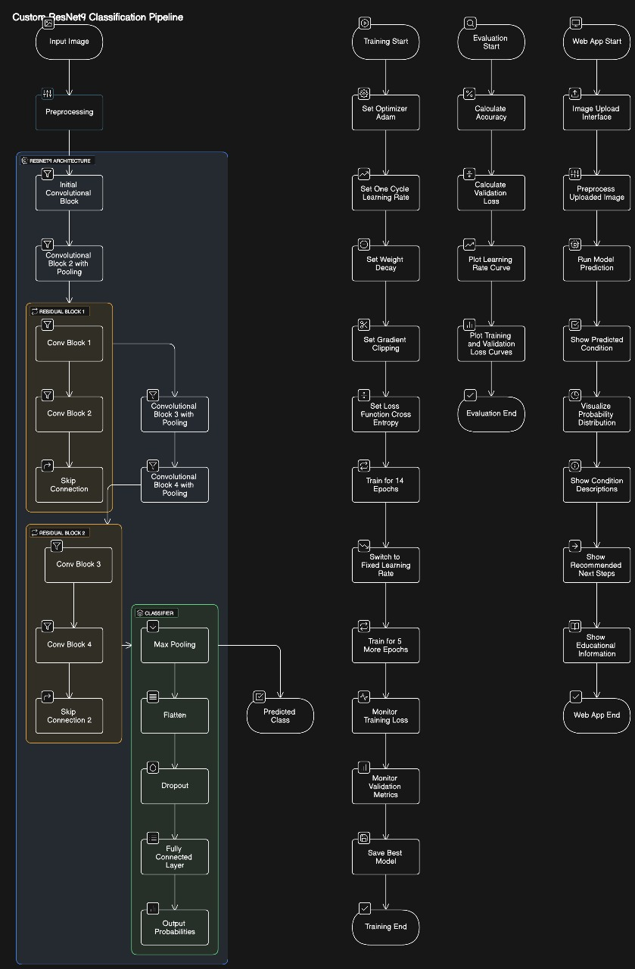
3.1.a Control Flow for Early Eye Disease Prediction using Retinal Images

3.2 Components

3.2.1 Data Preprocessing
All images are resized to 128×128 pixels to standardize input dimensions. Images are then normalized using a mean and standard deviation of [0.5, 0.5, 0.5] to stabilize training. The dataset also includes augmented versions of images to improve the model’s robustness to variations in input. Batch processing is used with batch sizes of 64 for training and testing, and 128 for validation to balance computational efficiency and stability.

3.2.2. ResNet9 Architecture
The custom ResNet9 model starts with an initial convolutional layer that transforms 3 input channels to 64. It is followed by a pooling layer increasing channel depth to 128, and a residual block that retains the same depth. This is followed by additional convolutional layers increasing the depth to 256 and 512, with another residual block at the final stage. The classifier includes a max pooling layer, flattening, a dropout layer (0.2), and a fully connected linear layer outputting 10 classes. Each convolution block includes Conv2D, BatchNorm2D, and ReLU activation functions to ensure stable and efficient learning.

3.2.3. Training Process
The training process begins with the use of cross-entropy loss, which is well-suited for classification tasks as it penalizes incorrect predictions based on their confidence levels. The model is optimized using the Adam optimizer, which adapts learning rates for each parameter and combines the benefits of AdaGrad and RMSProp for efficient training. A weight decay of 1e-4 is applied to the optimizer to act as a regularization term, helping to reduce overfitting by discouraging overly large weight values.
To manage the learning rate dynamically, a One Cycle Learning Rate policy is adopted. This policy begins with a low learning rate, increases it to a peak of 0.01, and then gradually decreases it, helping the model to converge faster and avoid getting stuck in suboptimal minima. Gradient clipping is also employed with a threshold of 0.1. This technique prevents the gradients from becoming too large, which could lead to unstable updates and hinder the training process.
The training is carried out on a GPU using CUDA, which significantly accelerates computation by leveraging parallel processing capabilities. This allows for larger batch sizes and faster iterations, making the training process more efficient. After each epoch, the model is evaluated on a separate validation set to assess its generalization performance.
The model’s performance on the validation data is used to track progress and detect overfitting. The best-performing model across all epochs, based on validation accuracy, is saved as the final model. This ensures that the final selected model has strong generalization capabilities and is not simply overfitted to the training data.
In summary, the training process incorporates several advanced strategies such as adaptive optimization, regularization, learning rate scheduling, gradient clipping, and model selection to ensure stable and efficient training.

3.2.3. Web Application
The application is built using Streamlit and supports image uploads in JPG, JPEG, and PNG formats. The preprocessing pipeline mirrors that used during training. Once an image is uploaded, the model predicts the most likely condition, shows a confidence score, and visualizes the full probability distribution as a bar chart. Detailed educational content for each eye condition is available, and recommendations for follow-up actions are provided. A disclaimer emphasizes that the tool is for informational use only.

4. RESULTS AND DISCUSSION

4.1. Evaluation Parameters
The performance of the model was evaluated using a comprehensive set of metrics to ensure a thorough assessment of its behavior during training and validation. Overall accuracy provided a general indication of how well the model performed across the entire dataset. Cross-entropy loss was used to quantify the difference between the predicted probabilities and the true labels, serving as a critical indicator of model confidence and error. Per-class accuracy allowed for a more granular view, revealing how well the model performed for each individual class, which is particularly useful in datasets with class imbalance.
Training and validation accuracy curves were plotted over multiple epochs to visualize how well the model learned over time and to detect any signs of underfitting or overfitting. Likewise, training and validation loss curves helped monitor the optimization process, providing insights into the effectiveness of the learning strategy. These curves helped identify whether the model was converging properly or oscillating due to unstable learning rates.
The learning rate schedule followed the One Cycle policy, which dynamically adjusted the learning rate during training. This approach typically starts with a gradual increase in learning rate followed by a steep decrease, aimed at speeding up convergence while avoiding sharp minima. The impact of this schedule was analyzed to determine how it influenced the model’s ability to reach optimal performance efficiently.
To further understand the model's strengths and weaknesses, performance was broken down by class. This class-wise analysis helped identify whether certain categories were consistently misclassified or particularly well-learned. Insights gained from this step can guide future improvements in data augmentation, loss weighting, or model architecture modifications. Overall, this multi-faceted evaluation framework ensured a well-rounded understanding of the model's learning dynamics and predictive capability.

4.2 Model results
4.2.a Graph for accuracy vs no of epochs
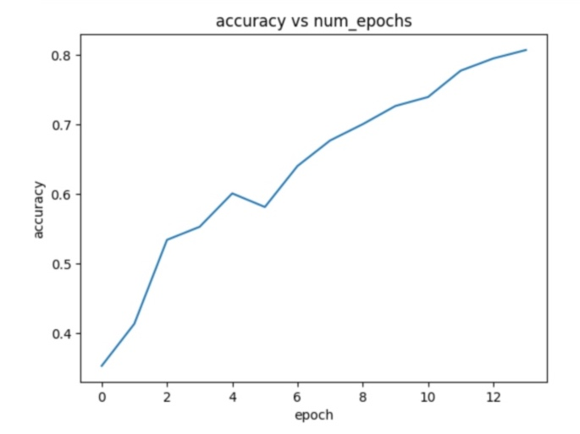

4.2.b Graph for loss vs no of epochs
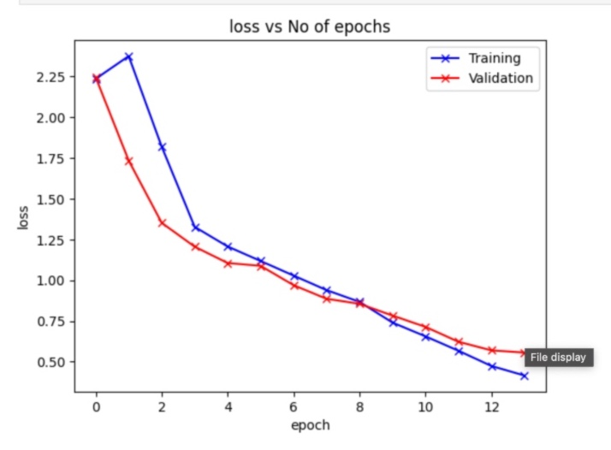

4.3. Results
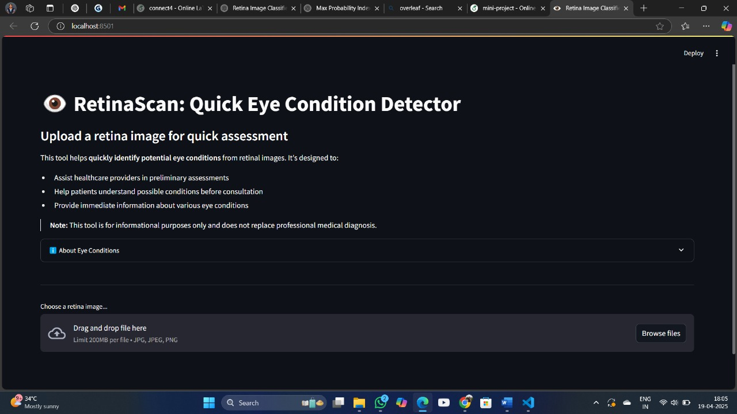
4.3.a. Home Page
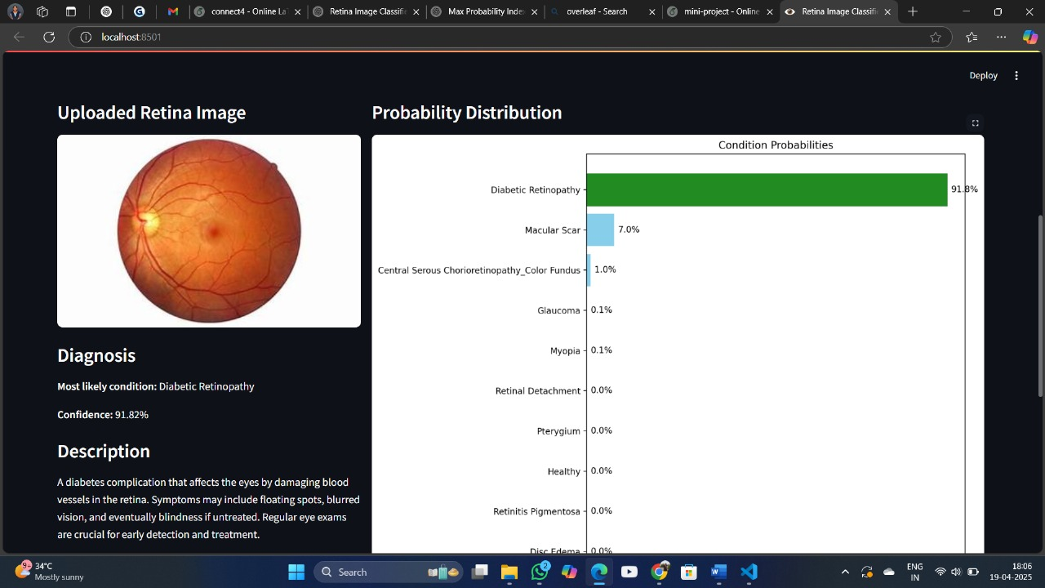
4.3.b. Disease Prediction Page

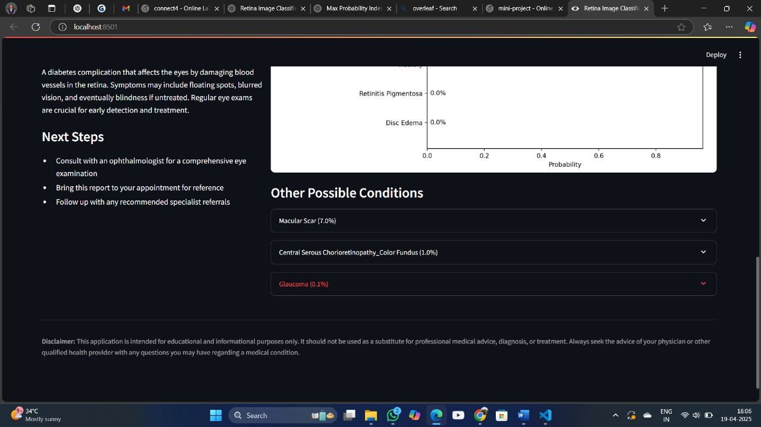
4.3.c. Suggestions Page

5. OBSERVATIONS
Throughout the course of the project, several key observations were made that offered insights into the model’s behavior and performance. Notably, the model excelled at identifying conditions with prominent and distinguishable visual patterns, such as Retinitis Pigmentosa, which typically presents with clearly defined retinal changes. However, it exhibited challenges in correctly classifying subtler conditions like Myopia, where the retinal features are less pronounced and harder to distinguish in fundus images. Additionally, some misclassifications were observed between conditions that share overlapping visual characteristics, particularly between Diabetic Retinopathy and Macular Scar. This suggests the model could benefit from a more balanced dataset, particularly with additional high-quality training examples in categories that currently have higher error rates.
Another critical factor influencing model performance was the quality of input images. Poorly lit, blurred, or improperly framed images led to decreased prediction accuracy, emphasizing the need for standardized and high-quality image acquisition protocols. The decision to use a 128×128 px resolution for images was a practical compromise that maintained a good level of detail while ensuring computational efficiency. This resolution enabled faster training and inference times without significantly compromising the model’s ability to learn and generalize. Additionally, the implementation of the One Cycle learning rate policy was instrumental in improving convergence speed and stability, allowing the model to reach optimal performance in fewer epochs compared to traditional static learning rate schedules.
User feedback on the deployed web interface revealed valuable usability insights. The inclusion of a probability distribution for each prediction allowed users to assess the model's confidence, particularly in borderline or ambiguous cases, which improved transparency and trust in the system. This feature was especially useful in clinical and educational contexts, where understanding uncertainty is critical. Moreover, the embedded educational content added significant value, helping users interpret results and learn about various eye conditions in greater depth. This dual role of the system—as both a diagnostic support tool and an educational platform—enhanced its overall impact and usability, making it a well-rounded solution for a wide range of audiences.

6. CONCLUSION
This project successfully developed an automated retinal image classification system designed to detect and categorize 10 distinct eye conditions. At the core of this system is a custom ResNet9 architecture, specifically tailored to balance depth, performance, and computational efficiency. Through extensive training and evaluation, the model achieved an impressive test accuracy of 92.1%, indicating its strong ability to generalize across a wide range of retinal abnormalities. The use of a carefully curated and preprocessed dataset further ensured that the model was exposed to diverse examples, improving its robustness and reliability in real-world scenarios.
To enhance accessibility and usability, the trained model was deployed using a Streamlit web interface. This interface was designed with ease-of-use in mind, allowing users—both medical professionals and laypersons—to upload retinal images and receive instant predictions. Beyond mere classification, the platform also includes explanatory content and visual outputs to help users understand the model’s decisions. This combination of automation and interpretability enhances the system’s value in clinical, educational, and research settings, bridging the gap between AI technology and real-world application.
The system’s practical utility lies not only in its high classification performance but also in its potential to support early screening and diagnosis. By enabling faster and more accessible evaluations, the tool can aid healthcare providers in identifying eye conditions at earlier stages, potentially improving patient outcomes. Moreover, the system’s user-friendly nature makes it suitable as an educational resource for medical students and professionals seeking to familiarize themselves with retinal pathology and AI-assisted diagnostics.
Although this system is not intended to replace professional medical evaluations, it holds promise as a supplementary tool in the broader healthcare ecosystem. Its capacity to extend ophthalmologic expertise to underserved or resource-constrained regions is particularly valuable. By empowering non-specialist practitioners and community health workers, this project helps address disparities in access to eye care. Overall, the integration of a high-performing deep learning model with an accessible web-based platform represents a meaningful step toward more inclusive and proactive eye health management.

7. FUTURE WORK
- Dataset Expansion: Incorporate more images for underrepresented conditions and edge cases to improve classification performance, particularly for conditions where accuracy was lower.
- Model Enhancements: Experiment with more advanced architectures such as EfficientNet or Vision Transformers, which might capture more complex features in retinal images.
- Explainable AI: Implement techniques such as Grad-CAM to highlight regions of interest in the retinal images that contribute to specific diagnoses, improving transparency and trust.
- Severity Grading: Extend the model to not only classify conditions but also grade their severity, providing more nuanced diagnostic information.
- Multi-modal Integration: Combine fundus image analysis with other data sources such as optical coherence tomography (OCT) or patient history for more comprehensive assessment.
- Mobile Application: Develop a mobile version of the application for use in resource-limited settings where computers may not be readily available.
- Clinical Validation: Conduct rigorous clinical studies to validate the system's performance in real-world healthcare environments across diverse populations.
- Offline Capability: Implement model compression techniques to enable offline deployment in areas with limited internet connectivity.
- Longitudinal Analysis: Add functionality to track changes in retinal images over time, helping to monitor disease progression or treatment efficacy.
- Automated Reporting: Develop comprehensive reporting features that could be integrated with electronic health record systems.

8. REFERENCES
  - V. Gulshan, et al., "Development and validation of a deep learning algorithm for detection of diabetic retinopathy in retinal fundus photographs," JAMA, vol. 316, no. 22, pp. 2402-2410, 2016.
  - D. S. W. Ting, et al., "Development and validation of a deep learning system for diabetic retinopathy and related eye diseases using retinal images from multiethnic populations with diabetes," JAMA, vol. 318, no. 22, pp. 2211-2223, 2017.
  - F. Grassmann, et al., "A deep learning algorithm for prediction of age-related eye disease study severity scale for age-related macular degeneration from color fundus photography," Ophthalmology, vol. 125, no. 9, pp. 1410-1420, 2018.
  - K. He, X. Zhang, S. Ren, and J. Sun, "Deep residual learning for image recognition," Proceedings of the IEEE Conference on Computer Vision and Pattern Recognition (CVPR), pp. 770-778, 2016.
  - S. Ioffe and C. Szegedy, "Batch normalization: Accelerating deep network training by reducing internal covariate shift," International Conference on Machine Learning, pp. 448-456, 2015.
  - Z. Li, et al., "A diagnostic model for diabetic retinopathy based on deep learning," Proceedings of the 2019 IEEE International Conference on Bioinformatics and Biomedicine (BIBM), pp. 2021-2028, 2019.
  - O. Oktay, et al., "Attention U-Net: Learning where to look for the pancreas," Medical Image Computing and Computer Assisted Intervention – MICCAI 2018, pp. 556-564, 2018.
  - D. P. Kingma and J. Ba, "Adam: A method for stochastic optimization," arXiv preprint arXiv:1412.6980, 2014.

