Notes STM32 Getting Receiver Signals from Joop Brokkings video
We will use the input capture mode in the STM32 chip. How does this mode work
- CNT counts from 0 to the value of the ARR register
- My setup is connected as follows
  - Channel 1 > T3C2 > PA7 > TIM3_CH1
  - Channel 2 > T3C1 > PA6 > TIM3_CH1
  - Channel 3 > T2C4 > PA3 (throttle) > TIM2_CH4
  - Channel 4 > T2C3 > PA2 > TIM2_CH3
  - Channel 5 > T2C2 > PA1 > TIM2_CH2
  - Channel 6 > T2C1E > PA0 > TIM2_CH1_ETR
- When this value is reached, the timer resets
- The pulse for this counter is determined by the prescaler PCS register
- The input from the receiver is connected to TIM1_CH1 for example
- When the input changes from low to high, this is detected by the CCMR2 and CCER registers and the counter value is stored in the CCR1 register
  - This only captures the rising edge of the signal
  - To capture the falling edge, we will have to reset the register value using the interrupt handling routing
- This generates an interrupt through the DIER register, which can be handled by our interrupt handler

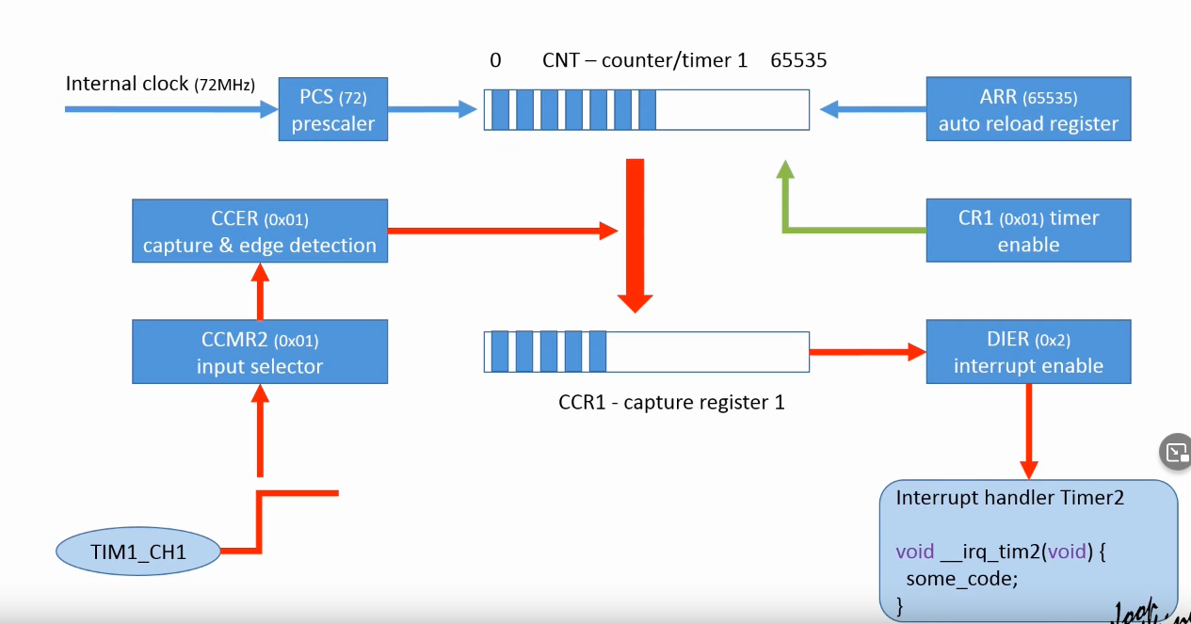
Example using Timer 2 register. Every register holds 4 bytes. So for example: TIMx_CR1 for Timer 2 has an address 0x4000 0000 and TIMx_CR2 has an address of 0x4000 0004

We need to set pointers for these registers using the line below:

#define TIM2_CR1 (*(__IO uint32_t *)0x40000000)

What registers to set:
