RAMPS V1.4板使用步骤：
- 先把此板下端插在arduono mega 2560板上，再把5块A4988驱动板依次插在板上面，驱动板的插接方向如图所示
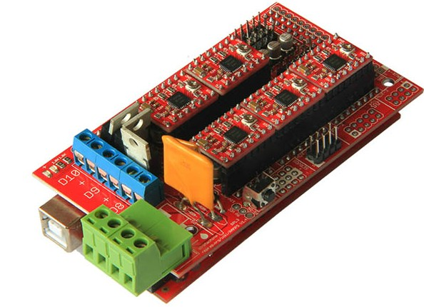

- 在板上绿色端上加上两套12V电源，电源正负极按板上表注连接即可

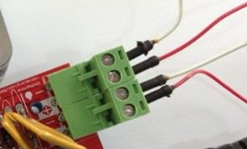

- 连接2相4线电机，1a 1b是1相，2a 2b是1相，根据自己电机的引脚定义连接到板上，注意此处引线连错的话电机通电后不会旋转，可能会损坏电机，例图：
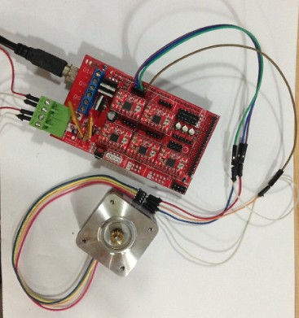

按此原则依次连接5个电机到板上的相应插口。

- 如果你想要接入液晶的话就按下图红框所示接入液晶
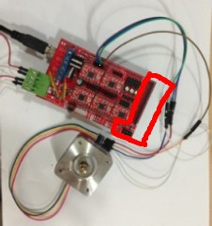

液晶测试教程
现在默认你已经按上面的教程连接好液晶屏，如果你想要脱机打印的话还可以插入2G容量以下的SD卡。使用arduino编程软件0022双击打开Marlin文件夹中的Marlin.ino文件，下载进2560板，就会看到液晶显示各项参数。如果有SD卡，转动旋钮，可以选中菜单，查看SD中的文件

步进电机测试
现在默认你已经按以上教程正确的插上电机驱动板并连接上电机，将测试程序下载进2560板，会看到电机循环正反转
#define X_STEP_PIN 54
#define X_DIR_PIN 55
#define X_ENABLE_PIN 38

#define Y_STEP_PIN 60
#define Y_DIR_PIN 61
#define Y_ENABLE_PIN 56

#define Z_STEP_PIN 46
#define Z_DIR_PIN 48
#define Z_ENABLE_PIN 62

#define E0_STEP_PIN 26
#define E0_DIR_PIN 28
#define E0_ENABLE_PIN 24

#define E1_STEP_PIN 36
#define E1_DIR_PIN 34
#define E1_ENABLE_PIN 30

void setup() {
pinMode(X_STEP_PIN, OUTPUT);
pinMode(X_DIR_PIN, OUTPUT);
pinMode(X_ENABLE_PIN, OUTPUT);

pinMode(Y_STEP_PIN, OUTPUT);
pinMode(Y_DIR_PIN, OUTPUT);
pinMode(Y_ENABLE_PIN, OUTPUT);

pinMode(Z_STEP_PIN, OUTPUT);
pinMode(Z_DIR_PIN, OUTPUT);
pinMode(Z_ENABLE_PIN, OUTPUT);

pinMode(E0_STEP_PIN, OUTPUT);
pinMode(E0_DIR_PIN, OUTPUT);
pinMode(E0_ENABLE_PIN, OUTPUT);

pinMode(E1_STEP_PIN, OUTPUT);
pinMode(E1_DIR_PIN, OUTPUT);
pinMode(E1_ENABLE_PIN, OUTPUT);

}

void step(int stepperPin, int steps, int dirPin, boolean dir){
digitalWrite(dirPin,dir);
delay(50);
for(int i=0;i<steps;i++){
digitalWrite(stepperPin, HIGH);
delayMicroseconds(800);
digitalWrite(stepperPin, LOW);
delayMicroseconds(800);
}
}

void loop()
{

digitalWrite(X_ENABLE_PIN, LOW );
digitalWrite(Y_ENABLE_PIN, LOW );
digitalWrite(Z_ENABLE_PIN, LOW );
digitalWrite(E0_ENABLE_PIN, LOW );
digitalWrite(E1_ENABLE_PIN, LOW );

step(X_STEP_PIN, 200, X_DIR_PIN, true);
step(Y_STEP_PIN, 200, Y_DIR_PIN, true);
step(Z_STEP_PIN, 200, Z_DIR_PIN, true);
step(E0_STEP_PIN, 200, E0_DIR_PIN, true);
step(E1_STEP_PIN, 200, E1_DIR_PIN, true);
delay(200);

step(X_STEP_PIN, 200, X_DIR_PIN, false);
step(Y_STEP_PIN, 200, Y_DIR_PIN, false);
step(Z_STEP_PIN, 200, Z_DIR_PIN, false);
step(E0_STEP_PIN, 200, E0_DIR_PIN, false);
step(E1_STEP_PIN, 200, E1_DIR_PIN, false);
delay(200);

}

Micro SD卡模块测试
此模块是插在板的AUX-3插针上的，组装成为3D打印机后，把需要打印的器件的cad文件放microSD卡里即可
AUX-3的引脚定义图：
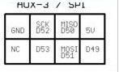

Micro SD卡模块单独测试方法：
插进micro SD卡，按测试程序中的引脚连接说明连接arduino板，下载测试程序后打开串口调试器
/*
SD card read/write

This example shows how to read and write data to and from an SD card file
The circuit:
* SD card attached to SPI bus as follows:
** MOSI - pin 11
** MISO - pin 12
** CLK - pin 13
** CS - pin 4

created Nov 2010
by David A. Mellis
modified 9 Apr 2012
by Tom Igoe

This example code is in the public domain.

*/

#include <SD.h>

File myFile;

void setup()
{
// Open serial communications and wait for port to open:
Serial.begin(9600);
while (!Serial) {
; // wait for serial port to connect. Needed for Leonardo only
}

Serial.print("Initializing SD card...");
// On the Ethernet Shield, CS is pin 4. It's set as an output by default.
// Note that even if it's not used as the CS pin, the hardware SS pin
// (10 on most Arduino boards, 53 on the Mega) must be left as an output
// or the SD library functions will not work.
pinMode(10, OUTPUT);

if (!SD.begin(53)) {
Serial.println("initialization failed!");
return;
}
Serial.println("initialization done.");

// open the file. note that only one file can be open at a time,
// so you have to close this one before opening another.
myFile = SD.open("test.txt", FILE_WRITE);

// if the file opened okay, write to it:
if (myFile) {
Serial.print("Writing to test.txt...");
myFile.println("testing 1, 2, 3.");
// close the file:
myFile.close();
Serial.println("done.");
} else {
// if the file didn't open, print an error:
Serial.println("error opening test.txt");
}

// re-open the file for reading:
myFile = SD.open("test.txt");
if (myFile) {
Serial.println("test.txt:");

// read from the file until there's nothing else in it:
while (myFile.available()) {
Serial.write(myFile.read());
}
// close the file:
myFile.close();
} else {
// if the file didn't open, print an error:
Serial.println("error opening test.txt");
}
}

void loop()
{
// nothing happens after setup
}
剩下的简单部分的连线请参考2000.png中的连接图

