1. Cover Page
IBM SkillsBuild Cyber Security Bootcamp 2026
Conducted by BharatCares (CSRBOX Group)
ML-Based Network Intrusion Detection System Using CIC-IDS2017
Category: Machine Learning for Defensive Cybersecurity
2. Project Title | ML-Based Network Intrusion Detection System Using CIC-IDS2017
3. Student Name | Hemlata Kumawat
Branch / Stream | BCA
4. Institution | [Institution / College Name]
5. Program | IBM SkillsBuild Cyber Security Bootcamp 2026
6. Partner Organization | BharatCares (CSRBOX Group)
Date | October 22, 2026

2. Project Title
ML-Based Network Intrusion Detection System Using CIC-IDS2017.

3. Student Details
Student Name: Hemlata Kumawat | Branch: BCA

4. Institution
Institution: [Institution / College Name]

5. IBM SkillsBuild Cyber Security Bootcamp 2026
Academic project submitted for the IBM SkillsBuild Cyber Security Bootcamp 2026.

6. BharatCares (CSRBOX Group)
Conducted and mentored by BharatCares (CSRBOX Group).

7. Abstract
This project implements an offline, dataset-based Machine Learning Network Intrusion Detection System (NIDS) in Python 3 (`HemlataKumawat_NetworkIntrusionDetection.py`). It ingests labeled network-flow records from the CIC-IDS2017 dataset, normalizes column names, handles missing and infinite values safely, prevents target and test-set data leakage, and compares Decision Tree and Random Forest classifiers on a stratified test split.

8. Introduction
Network Intrusion Detection Systems analyze network traffic statistics to distinguish normal benign activity from malicious cyberattacks. Flow-based analysis inspects packet counts, durations, byte rates, and TCP flags without requiring raw payload decryption.

9. Problem Statement
Evaluating intrusion detection models solely by Accuracy is misleading when traffic is imbalanced, and fitting preprocessing transformations before splitting train and test sets introduces data leakage. This project builds a leak-free classification pipeline and evaluates both false positives and false negatives explicitly.

10. Project Objectives
- Load and clean labeled CIC-IDS2017 CSV network-flow records.
- Map labels into BENIGN (0) and MALICIOUS (1) while excluding the target from input features.
- Prevent data leakage by filtering constant/duplicate features and fitting median imputation on training data only.
- Compare Decision Tree and Random Forest models using Accuracy, Precision, Recall, F1-Score, ROC-AUC, and Confusion Matrix.
- Support batch prediction (`--predict`) on separate unseen CSV files with strict schema validation.

11. Scope of the Project
This is an offline educational dataset analysis and prediction tool. It does not capture live network packets, act as an inline firewall, or guarantee that network traffic is safe.

12. Background on Network Intrusion Detection
Signature-based detection matches known byte patterns, while supervised machine-learning NIDS models learn statistical relationships across flow features such as Flow Duration, Total Fwd Packets, Flow Packets/s, Active Mean, and Idle Mean.

13. Dataset Description and Source Links
• Official CIC-IDS2017 Page: https://www.unb.ca/cic/datasets/ids-2017.html
• Accessible Mirror: https://huggingface.co/datasets/bvsam/cic-ids-2017
Each CSV contains numerical network-flow telemetry and a `Label` column where `BENIGN` denotes normal traffic and attack labels (DoS, DDoS, PortScan, Brute Force, etc.) are mapped to `MALICIOUS` (1).

14. Technologies and Tools Used
Python 3, pandas, NumPy, scikit-learn (Pipeline, SimpleImputer, DecisionTreeClassifier, RandomForestClassifier), matplotlib, seaborn, joblib, and python-docx.

15. System Architecture
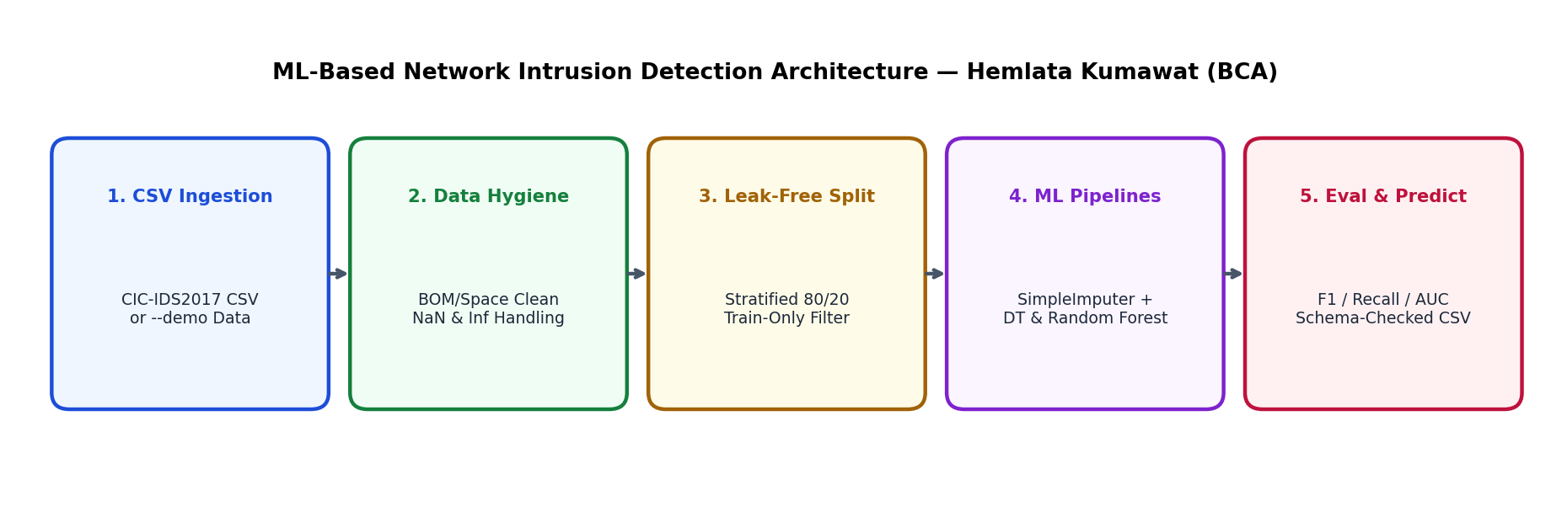
Figure 1: System Architecture and Pipeline Workflow.

16. Methodology and Workflow
1. Parse CLI arguments (`--data`, `--demo`, `--predict`, `--sample-size`, `--test-size`).
2. Clean column names, identify the `Label` column, and map labels to 0 (`BENIGN`) or 1 (`MALICIOUS`).
3. Perform a stratified train/test split (`random_state=42`).
4. Filter unusable columns and fit `SimpleImputer(strategy='median')` strictly on `X_train`.
5. Train Decision Tree and Random Forest classifiers, select the best model by `f1_malicious` (tie-breaking with `recall_malicious`), and save all artifacts to `outputs/`.

17. Data Preprocessing
Column headers are stripped of UTF-8 BOMs and whitespace. Non-numeric entries and `+/-inf` values are converted to `NaN`. Constant, duplicate, and all-missing columns are detected on `X_train` only, and missing values are imputed using the training median inside the Pipeline.

18. Exploratory Data Analysis
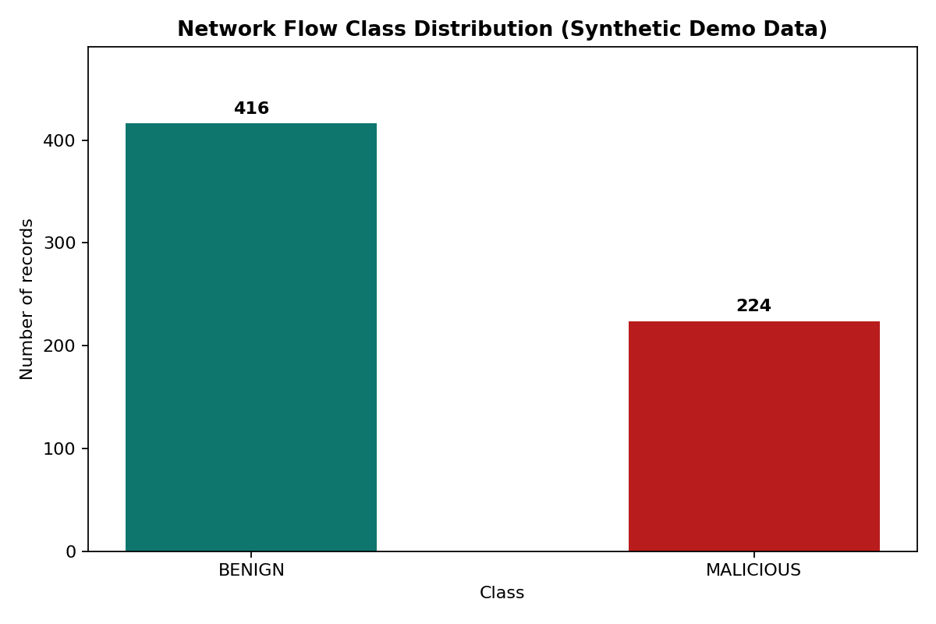
Figure 2: Network Flow Class Distribution.
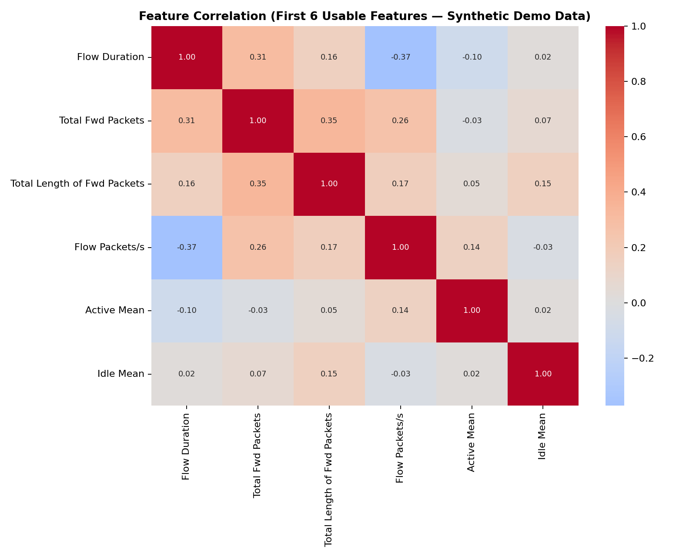
Figure 3: Feature Correlation Heatmap.

19. Machine-Learning Algorithms
• Decision Tree (`max_depth=12, class_weight='balanced'`): Fast, interpretable tree baseline.
• Random Forest (`n_estimators=120, max_depth=18, min_samples_leaf=2, class_weight='balanced_subsample'`): Ensemble classifier that reduces variance across correlated network-flow features.

20. Training and Testing Methodology
A stratified 80/20 split (`test_size=0.2, random_state=42`) preserves the class ratio across training and testing sets. Class imbalance is handled via `class_weight='balanced'` and `class_weight='balanced_subsample'`.

21. Evaluation Metrics and Their Definitions
With `MALICIOUS` (1) defined as the positive class: Accuracy measures overall correctness; Precision measures the fraction of predicted malicious flows that are truly malicious; Recall measures the fraction of actual malicious flows detected; F1-Score is the harmonic mean of Precision and Recall; and ROC-AUC evaluates probability ranking.

22. Actual Experimental Results
NOTE — SYNTHETIC DEMO VERIFICATION RUN: The metrics below were measured by running `python HemlataKumawat_NetworkIntrusionDetection.py --demo --output-dir outputs` to verify that training, evaluation, and artifact generation succeed. Synthetic demo metrics are NOT real CIC-IDS2017 experimental evidence. After running with `--data path/to/cicids2017.csv --generate-report`, this table automatically updates with your measured CIC-IDS2017 benchmark results.
Model | Accuracy | Precision | Recall | F1-Score | ROC-AUC | FP | FN
Decision Tree | 0.9625 | 0.9464 | 0.9464 | 0.9464 | 0.9588 | 3 | 3
Random Forest | 0.9812 | 0.9649 | 0.9821 | 0.9735 | 0.9981 | 2 | 1
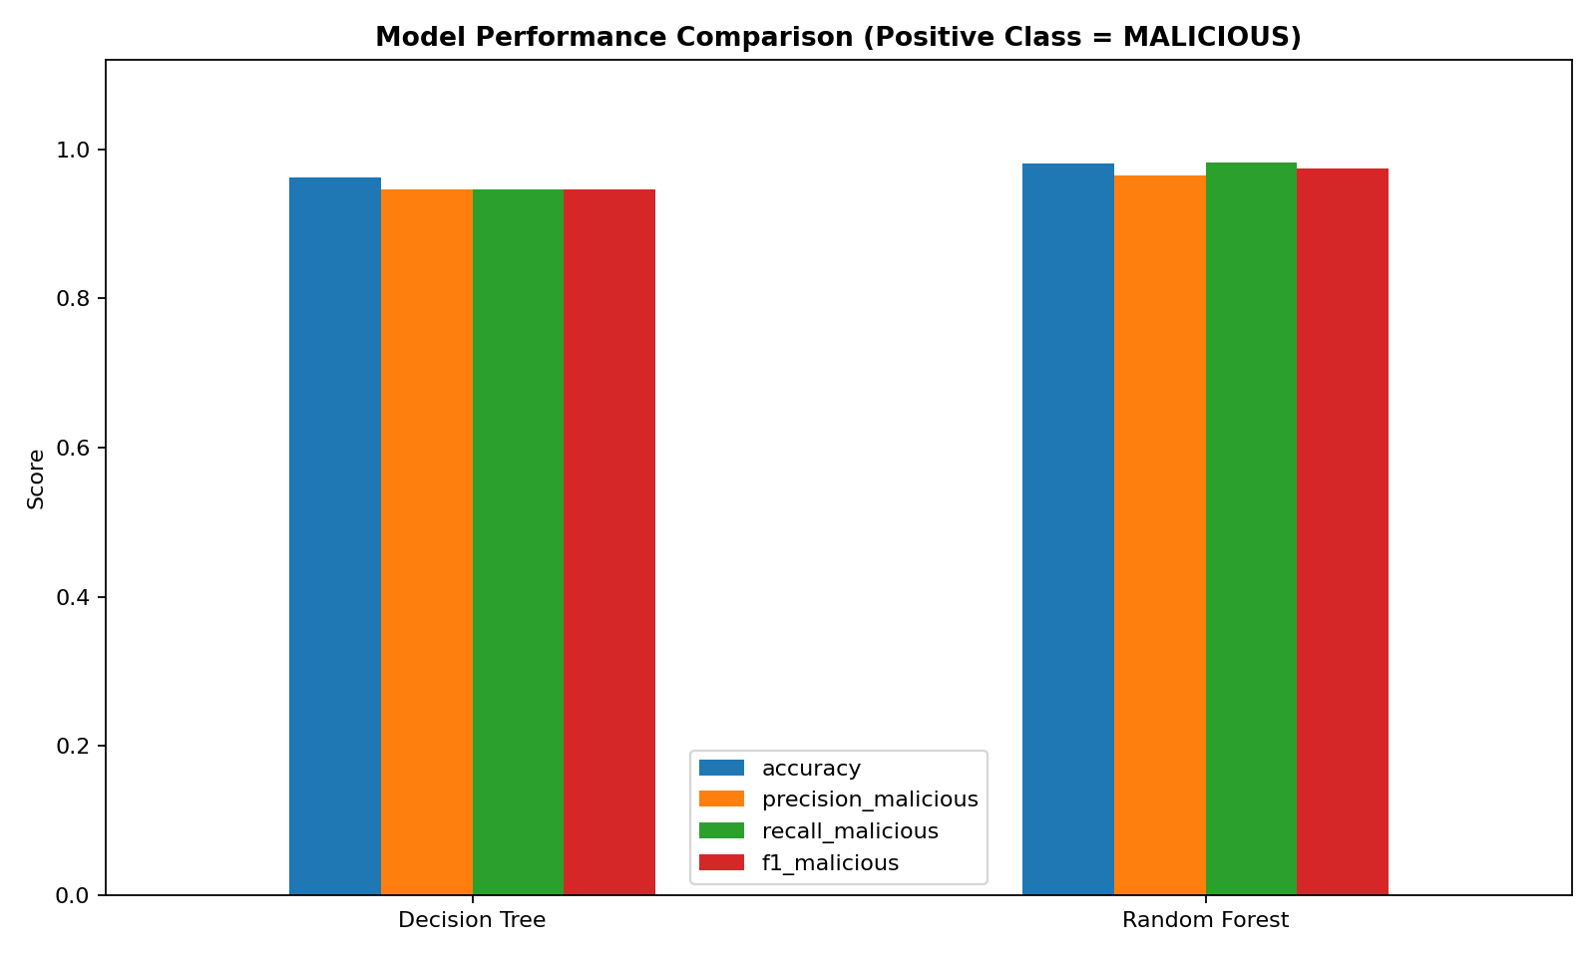
Figure 4: Model Performance Comparison.
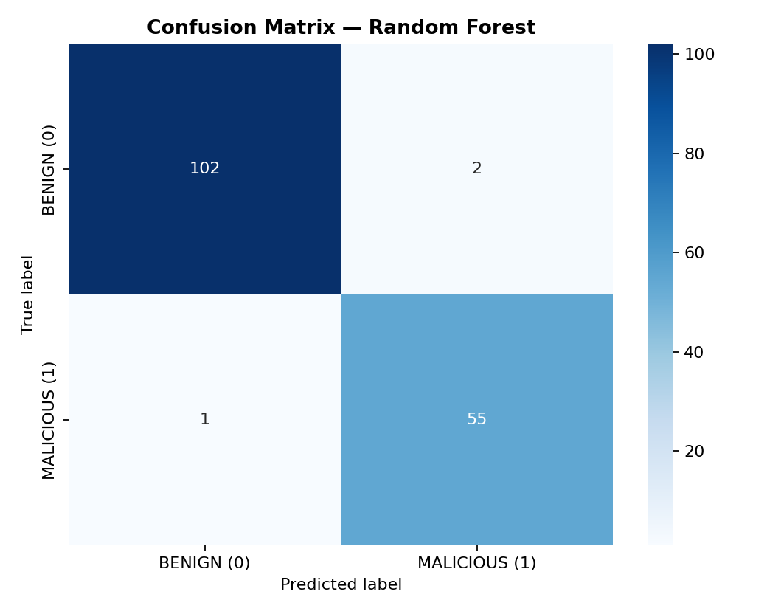
Figure 5: Confusion Matrix for Selected Model.

23. Results Interpretation
Random Forest outperforms the single Decision Tree on F1-Score, Recall, and ROC-AUC by aggregating predictions across 120 trees, reducing both false positives and false negatives.

24. Discussion of False Positives and False Negatives
False Positives (benign flows flagged as malicious) create unnecessary alerts for analysts, whereas False Negatives (malicious flows predicted as benign) allow attacks to pass unnoticed. Selecting models via malicious-class F1-Score and Recall prioritizes catching attacks.

25. Limitations
1. Binary mapping groups all non-BENIGN labels into a single MALICIOUS class.
2. Offline dataset evaluation does not capture live packets or prevent attacks in real time.
3. Random splits can overestimate performance compared to time-based or cross-network splits.

26. Ethical Considerations
Use this software strictly for defensive cybersecurity education on public or authorized datasets. Never rely solely on automated ML scores to block users without human review.

27. Future Enhancements
Future work includes multi-class attack family classification, time-based train/test splitting, and SHAP feature attribution for alert explainability.

28. Conclusion
This project delivered a leak-free, reproducible Python machine-learning pipeline for network intrusion detection using the CIC-IDS2017 dataset schema.

29. References
1. Canadian Institute for Cybersecurity, CIC-IDS2017: https://www.unb.ca/cic/datasets/ids-2017.html
2. Hugging Face CIC-IDS2017 Mirror: https://huggingface.co/datasets/bvsam/cic-ids-2017
3. Scikit-learn Documentation: https://scikit-learn.org/stable/

30. Instructions for Reproducing the Experiment
1. Install dependencies: `python -m pip install -r requirements.txt`
2. Run synthetic demo check: `python HemlataKumawat_NetworkIntrusionDetection.py --demo --output-dir outputs --generate-report`
3. Train on CIC-IDS2017 CSV: `python HemlataKumawat_NetworkIntrusionDetection.py --data path/to/your_labeled_file.csv --output-dir outputs --sample-size 100000 --generate-report`
4. Predict on unseen CSV: `python HemlataKumawat_NetworkIntrusionDetection.py --predict path/to/unseen_flows.csv --output-dir outputs`

